|  |  |
| --- | --- |
| **Practicum Case** |  |
| COMP6048 | COMP6048001 | COMP6048016 | COMP6048049  Data Structures |
| **Computer Science** | **O221-COMP6048-AM01-04** |
| ***Valid on*** *Even Semester Year 2021/2022* | **Revision 00** |

**Learning Outcomes**

* LO1 – Explain the concept of data structures and its usage in computer science
* LO2 – Illustrate any learned data structures and its usage in application
* LO3 – Apply data structures using C

## Topic

* Session 4 – Hash Table

## Sub Topics

* Push
* Pop
* Search

## Soal

*Case*

**Bluejack Library**

**Bluejack Library** isone of the popular libraries in the town. This library has more than 50.000 books. Sadly the senior librarian wants to resign and he doesn’t have time to teach the new librarian. **Bluejack Library** needs a simple program to help the new librarian so he can easily manage and search books. **Bluejack Library** hires you as a programmer to help them create a program that can help a new librarian find and manage books in this library easily using a **C programming language** and **hashtable data structure**. The criteria of the program are:

* The program consists of **4 menus**, there are:

1. **View Book**
2. **Insert Book**
3. **Remove Book**
4. **Exit**



Figure . Main Menu

* If the user chooses **View Book** (**Menu 1**), then:
* If there is **no book**, then show “**There is no book(s) !**” message.



Figure . There is No Book Message(View)

* **Otherwise**, the program will **show all the book** data.

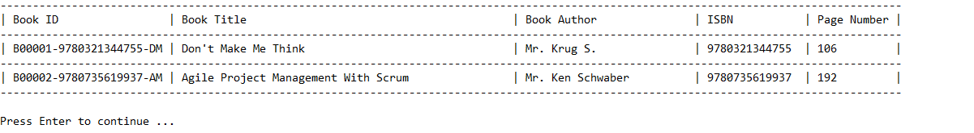

Figure . Show All Book Data

* If the user chooses **Insert Book** (**Menu 2**), then:
* The program will ask user to **input** the following data:
* **Book Title**
* Validate Book Title must be **between 5 and 50 characters**.
* ValidateBook Title must be **unique**.
* **Book Author**
* ValidateBook Author must **start with** “**Mr.** “ or “**Mrs.** “ and its length must be **between 3 and 25 characters**.
* **ISBN**
* ValidateISBN must be **numeric** and its length must be **between 10 and 13 digits**.
* **Page Number**
* ValidatePage Number must be **at least 16**.
* After that, the program will generate a **unique id** for the inputted book data. The format will follow the following formula.

|  |
| --- |
| [B**XXXXX**]-[ISBN]-[**A**][**T**]  **X** is the **last inserted Book Id** number **increased by 1**  **A** is the **first character** of **Book** **Author** in **uppercase** format  **T** is the **first character** of **Book Title** in **uppercase** format  **Example**: B00001-0123423123-JH, B00002-0123412341-AZ |

* Then, the program will **store the inputted new book data** to the **next item** of the **last item** of the **chaining hash table** with **size** **1007** using the following **hash function**.

|  |
| --- |
| **KEY** = **SUM** % **SIZE**  **KEY** : the **hash table index** that will store the data  **SUM** : the **sum of the ascii** from **Book Id**  **SIZE** : the **size** of the hash table  **Example**:  Book Id : B00001-0123423123-JH  SUM : 1044  SIZE : 1007  KEY : 1044 % 1007 = 37  Then, the book data will be **stored at index 37** of hash table. |

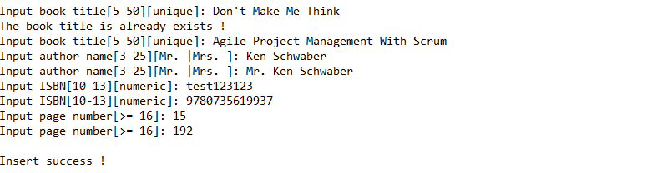

Figure . Insert Menu

* If user chooses **Remove Book** (**Menu 3**), then:
* The program will ask user to input a **Book ID**
* Validate if the inputted Book ID **doesn’t exists** then show “**Book not found**”.



Figure . The Inputted Book ID Doesn't Exists

* Otherwise, **show the book data** and ask the **user for confirmation**. Validate input mustbe **either** “**y**” or “**n**”.
* If user **chooses** “**y**”, then **delete** the data.
* Otherwise, if user **chooses** “**n**”, then **return** back to main menu.

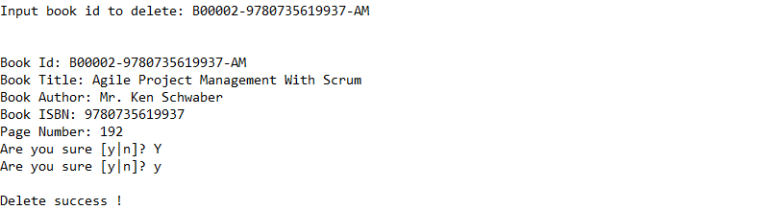

Figure . Confirmation To Delete

* If user chooses **Exit** (**Menu 4**), then **terminate** the program.

**Please run the EXE file to see the sample program**