|  |  |
| --- | --- |
| **Practicum Case** |  |
| COMP6048 | COMP6048001 | COMP6048016 | COMP6048049  Data Structures |
| **Computer Science** | **O221-COMP6048-AM01-02** |
| ***Valid on*** *Even Semester 2021/2022* | **Revision 00** |

**Learning Outcomes**

* LO1 – Explain the concept of data structures and its usage in computer science
* LO2 – Illustrate any learned data structures and its usage in application
* LO3 – Apply data structures using C

**Topic**

* Session 2 - Single Linked List & Stack

## Sub Topics

* Push Head, Mid, and Tail
* Pop Head, Mid, and Tail
* Search
* Stack

## Soal

*Case*

**Reverse Sentence**

**Reverse Sentence** is one of the interview questions in Bluejack Company. For you to get a job there, you must answer half of the total question correctly. You are asked to answer this question by creating a program to reverse a sentence using **stack data structures**. The criteria are:

* First, the program will ask you to **input a sentence**. Validate the inputted sentence must **consist of at least 5 words**.
* Then the program will **print the result** of the reversed sentence.
* After that, ask the user if he/she wants to **continue**. If the user **inputs “yes”** (**case insensitive**), then **loop the menu** back to the first step. Otherwise, if the user **inputs “no”**, then **terminate** the program.

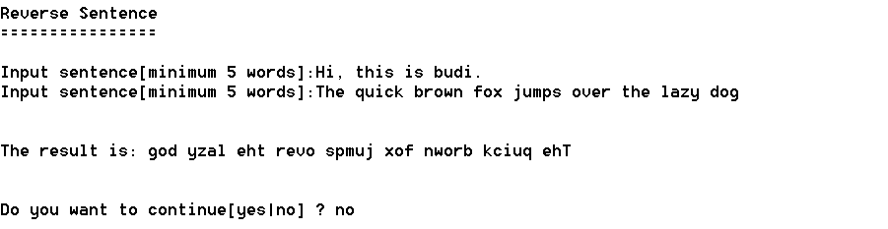

Figure . Example Program

**Please run the EXE file to see the sample program**