|  |  |
| --- | --- |
| **Practicum Case** |  |
| COMP6048 | COMP6048001 | COMP6048016 | COMP6048049  Data Structures |
| **Computer Science** | **O221-COMP6048-AM01-03** |
| ***Valid on*** *Even Semester 2021/2022* | **Revision 00** |

**Learning Outcomes**

* LO1 – Explain the concept of data structures and its usage in computer science
* LO2 – Illustrate any learned data structures and its usage in application
* LO3 – Apply data structures using C

**Topic**

* Session 3 – Doubly Linked List & Queue

## Sub Topics

* Push Head, Mid, and Tail
* Pop Head, Mid, and Tail
* Search
* Queue, Circular Queue, and Priority Queue

## Soal

*Case*

**Bluejack Hospital**

**Bluejack Hospital** is one of the oldest hospitals in your town. To register a new patient, the patient registrar uses a traditional method by writing the patient data manually using pen and paper. Sometimes the patient registrar having a hard time sorting the patient based on their priority. To improve the hospital services the company hires you as a junior programmer to create a simple program using C programming language and **priority queue data structures**. The criteria are:

* The program consists of **3 menus**, there are:

1. **Insert**
2. **View**
3. **Next Queue**
4. **Exit**

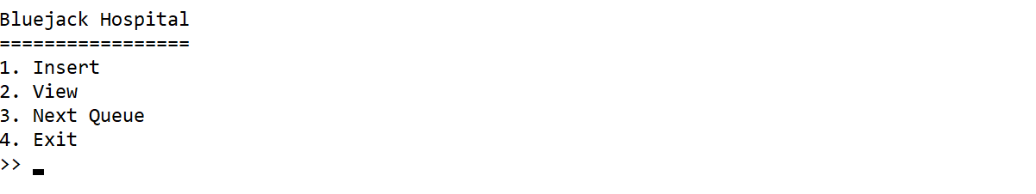

Figure . Main Menu

* If user chooses **Insert** (**Menu 1**), then:
* The program will ask user to input the following data
  + **Name**
* Validate the inputted name must be **between** **4 and 25 characters**.
  + **Age**
* Validatethe inputted age must be **at least 0**.
  + **Description/Symptoms**
* Validatethe inputted description/symptoms must be **at least** **6 characters**.
  + **Code**
* Validatethe inputted code must be “**Red**”, “**Yellow**” or “**Green**” (**case sensitive**).
* The color of the code represents the **patient’s priority**. The color “**Red**” represents the number **3** which means the patient needs to be **served first** **if possible**. The color “**Yellow**” represents the number **2** which means the patient needs to be **served after code** “**Red**”. And the last color is “**Green**” which represents number **1** which means the patient can be **served after code** “**Yellow**”.
* After that, **record** all the inputted data to the **priority queue data structure** with code as its priority**.**

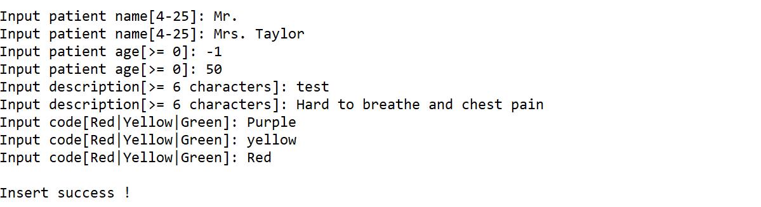

Figure . Insert Menu

* If user chooses **View** (**Menu 2**), then:
* Validate if there’s **no data**, show “**There is no queue yet!**” message.



Figure . There is No Queue Message (View)

* Otherwise, **show all the data** in the **priority queue**.

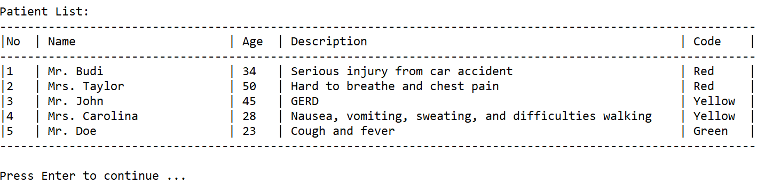

Figure . View All Patient

* If user chooses **Next Queue** (**Menu 3**), then:
* Validate if there’s **no data**, show “**There is no queue yet!**” message



Figure . There is No Queue Message (Next Queue)

* Otherwise, **remove the frontmost queue** based on its **priority** and **show the data**

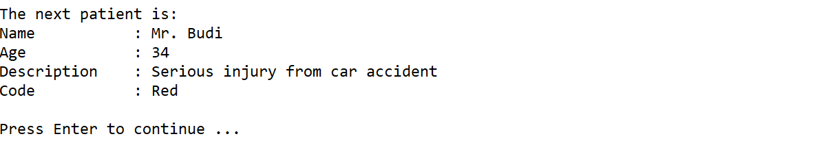

Figure . Remove the Frontmost Queue

* If user chooses **Exit** (**Menu 4**), then **terminate** the program.

**Please run the EXE file to see the sample program**