Hands-On Lab

Lab Manual

Install Java Development Kit and Tomcat

**Contents**

Install Java Development Kit and Tomcat i

Lab 01: Install Java Development Kit and Tomcat 3

Lab Objective 3

Exercise 1 – Install Java Development Kit 1.6 3

Task 1 – Run the JDK setup 3

1. Execute the JDK setup. 3

2. Deselect unnecessary features. 3

3. After the installer finished, click on Finish button. 4

Task 2 – Set environment variable JAVA_HOME 4

1. Set variable environment JAVA_HOME by value “C:\Program Files\Java\jdk1.6.0_04” 4

2. Run command “java –version” to check whether the java run time is available. 5

Exercise 2 – Run Tomcat from portable package 5

Task 1 – Extract the tomcat package 5

1. Extract the tomcat package apache-tomcat-x.y.z.zip (or apache-tomcat-x.y.z.tar.gz) 5

2. Execute batch file “startup.bat” in $TOMCAT_HOME\bin to start the Tomcat. 5

3. Using browser to open URL http://localhost:8080 5

4. Execute “shutdown.bat” in $TOMCAT_HOME\bin to stop the Tomcat. 6

Task 2 – Add user admin to Tomcat 6

1. Edit $TOMCAT_HOME\conf\tomcat-users.xml. For Tomcat 7, add 2 new below bold lines within tag “<tomcat-users>”: 6

2. Restart Tomcat by execute “shutdown.bat” and “startup.bat” 6

Lab 01: Install Java Development Kit and Tomcat

Estimated time to complete this lab: 10 minutes

## Lab Objective

The objective of this lab is to introduce you how to install Java Development Kit and Apache Tomcat.

* Run the JDK installer.

### Setup environment variable JAVA_HOME.

* Run the apache tomcat package.

**Note: You must have administrative privileges to install the JDK.**

## Exercise 1 – Install Java Development Kit 1.6

This exercise help you to install the JDK. The lab uses JDK 1.6.0_04 ([1]).

### Task 1 – Run the JDK setup

* 1. Execute the JDK setup.

Click **Setup** to continue.

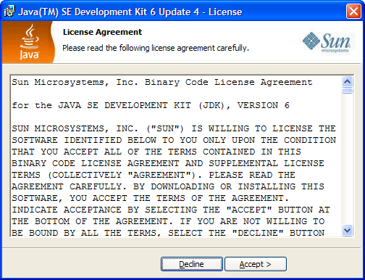

* 1. Deselect unnecessary features.

You can don’t install unnecessary features such as **Java DB**. Click on **Next** to continue.

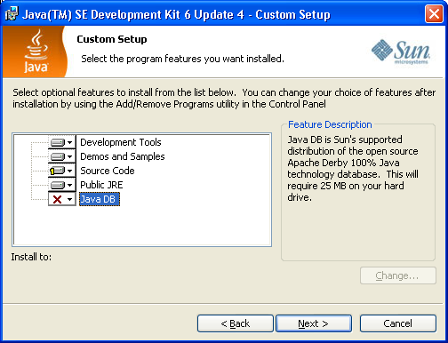

* 1. After the installer finished, click on Finish button.

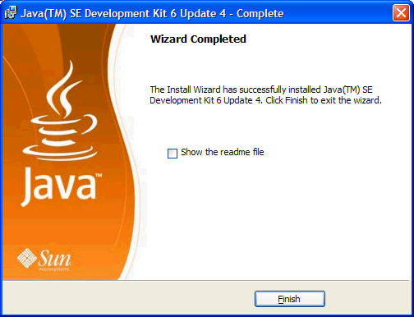

### Task 2 – Set environment variable JAVA_HOME

This exercise set the path for environment JAVA_HOME. It's used by Tomcat and many other Java programs.

* 1. Set variable environment JAVA_HOME by value “C:\Program Files\Java\jdk1.6.0_04”

: Click on Start → choose “Control Panel” → choose “System”. In the “System Properties” dialog, select tab “Advanced” → click on button “Environment Variable”. In the section “System variable”, click on “New” button”, input:

Variable name: JAVA_HOME

Variable value: C:\Program Files\Java\jdk1.6.0_04

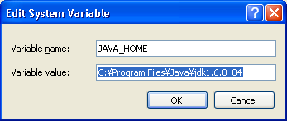

* 1. Run command “java –version” to check whether the java run time is available.

: Click on Start → choose “Run”, input command “cmd” (without double quotes). In window “Command Prompt”, run command “java –version”, the output is as below:

|  |
| --- |
| java version "1.6.0_04"  Java(TM) SE Runtime Environment (build 1.6.0_04-b12)  Java HotSpot(TM) Client VM (build 10.0-b19, mixed mode, sharing) |

## Exercise 2 – Run Tomcat from portable package

This exercise helps you extract and executes the apache-tomcat package ([2]).

### Task 1 – Extract the tomcat package

* 1. Extract the tomcat package apache-tomcat-x.y.z.zip (or apache-tomcat-x.y.z.tar.gz)

You should use a folder jPackages (such as D:\jPackages) to contain portable Java Packages.

After extract the tomcat package into the folder D:\jPackages, the home directory of Tomcat is “D:\jPackages\apache-tomcat-7.0.14”. It is abbreviated to $TOMCAT_HOME.

* 1. Execute batch file “startup.bat” in $TOMCAT_HOME\bin to start the Tomcat.

The console output is as below.

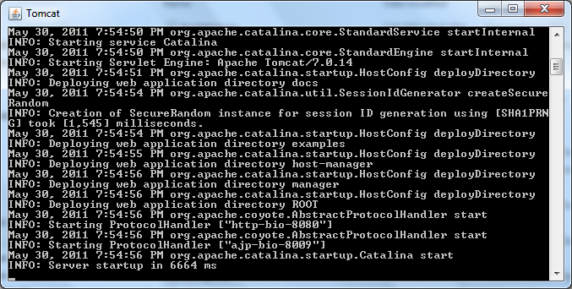

* 1. Using browser to open URL [http://localhost:8080](http://localhost:8080/)

The home page of Tomcat is as below:

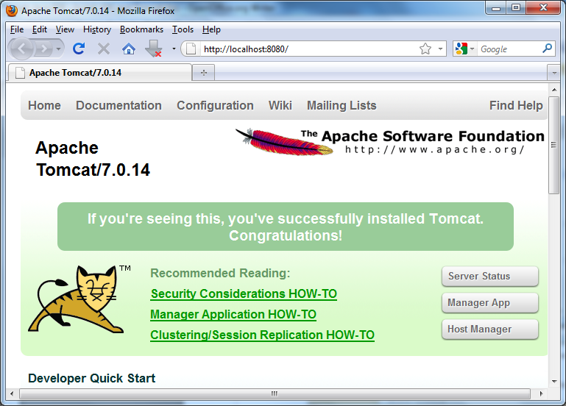

* 1. Execute “shutdown.bat” in $TOMCAT_HOME\bin to stop the Tomcat.

### Task 2 – Add user admin to Tomcat

Edit $TOMCAT_HOME\conf\tomcat-users.xml. For Tomcat 7, add 2 new below bold lines within tag “<tomcat-users>”:

|  |
| --- |
| ...  <tomcat-users>  **<role rolename="manager-gui, admin-gui"/>**  **<user username="admin" password="admin" roles="manager-gui, admin-gui"/>**  </tomcat-users> |

Restart Tomcat by execute “shutdown.bat” and “startup.bat”



Logon by account admin/admin

1. Download the latest version of JDK at http://www.oracle.com/technetwork/java/javase/downloads
2. Download the latest version of JDK at http://tomcat.apache.org/