Program tests

1.Pradinis langas

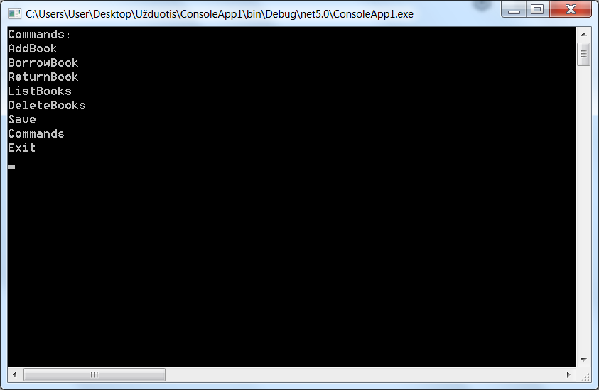

2. Successful Adding of book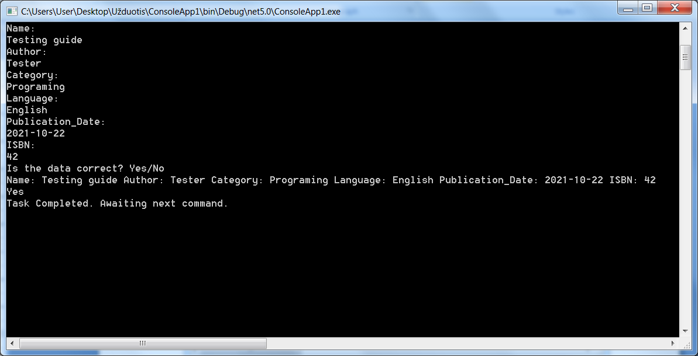

3.Bad data in the Publication_Date in AddBook function

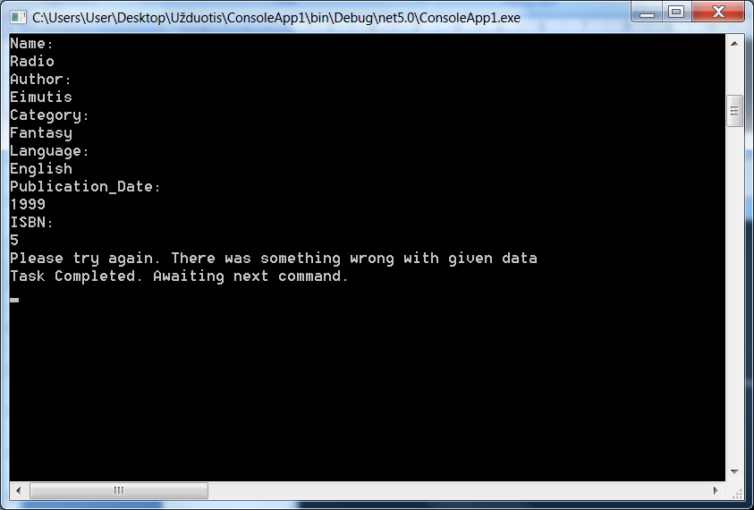

4.Bad ISBN in AddBook function

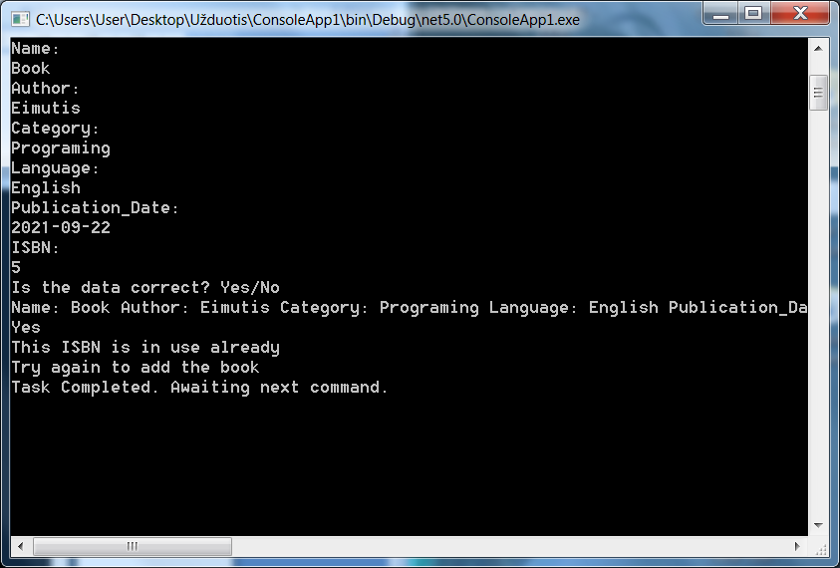

5. Successful Borrowing of a book with BorrowBook command

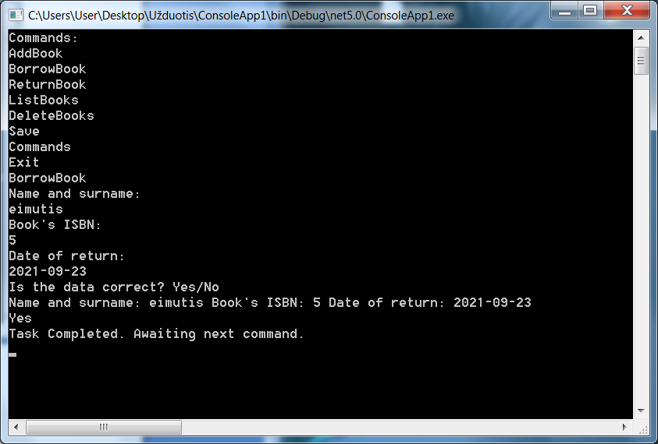

6.Cant borrow book longer than 2 months

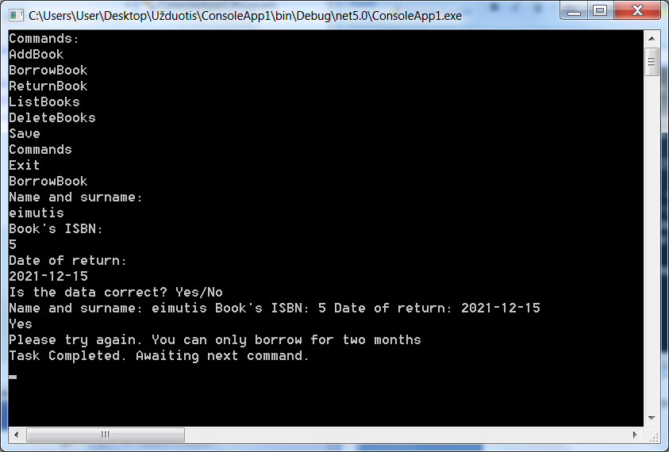

7. Successful ReturnBook function

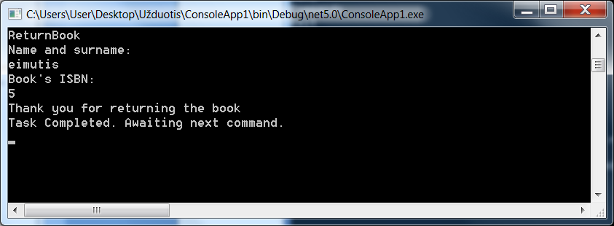

8.Returning book late results in:

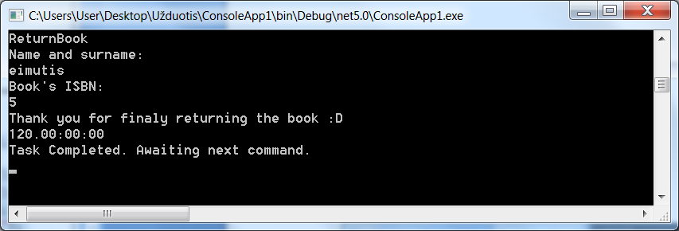

9. Successful ListBooks function

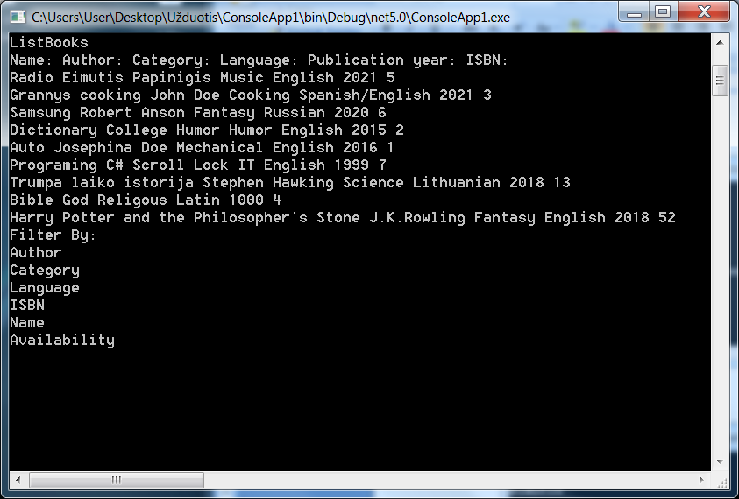

10. Successful DeleteBooks function

