SELECTS to demonstrate functional database

SELECT * FROM VEHICLE;



SELECT V.VEHICLEID, V.PRICE, V.YEAR, C.MODEL, T.TRANSMISSIONTYPE, M.MOTOR

FROM VEHICLE V, CARMODEL C, CARTRANSMISSION T, MOTOR M

WHERE V.CARMODEL_MODELID=C.MODELID AND V.CARTRANSMISSION_TRANSMISSIONID=T.TRANSMISSIONID AND V.MOTOR_MOTORID=M.MOTORID;

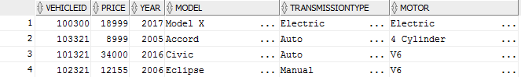

SELECT LNAME, FNAME, SALESPERSONID, SALES

FROM SALESPERSON

WHERE SALES=(SELECT MAX(SALES) FROM SALESPERSON);



SELECT CUSTOMERID, LNAME, FNAME

FROM CUSTOMER

WHERE SPENDLEVEL > 3;



SELECT * FROM DRIVETRAIN;

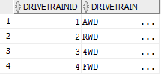

SELECT * FROM SALE

WHERE SALEID=422;



SELECT SALESPERSONID, LNAME, FNAME

FROM SALESPERSON

WHERE MANAGER=125;

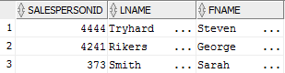

SELECT * FROM SALE

WHERE CUSTOMER_CUSTOMERID=1076;



SELECT S.SALEID, S.TAXESFEES, S.TOTALPRICE, S.FINANCING, C.LNAME, C.FNAME, E.SALESPERSONID

FROM SALE S, CUSTOMER C, SALESPERSON E

WHERE C.CUSTOMERID=1000 AND C.CUSTOMERID=S.CUSTOMER_CUSTOMERID AND S.SALESPERSON_SALESPERSONID=E.SALESPERSONID;

