**Name: Yap Kah Yong**

**Email: yapkahyongnet@gmail.com**

**Objective**

**Problem Statement**

Blockchain and cryptocurrencies have recently created a new technology boom in the market. Bitcoin is the first **decentralized** cryptocurrency created in about 16 years ago. Time Series analysis of these cryptocurrencies is a new emerging area nowadays. It can help people better understand about investing in cryptocurrencies and the nature of volatility of these currencies in the coming years. Our analysis gives a deep understanding about forecasting the prices of cryptocurrencies using time series analysis.

We also create a function that can analyze different cryptocurrencies to see how does the price of one cryptocurrency in different seasons, volatility prediction, technical indicator etc.... This can help an individual to understand about trading pairs and invest accordingly.  
  
 The Main crypto currency will be choosing for this report will be the mother of all coin – BITCOIN. (user still can change the coin they want to analyze)  
Reason to be chosen in this report

1. Oldest Crypto Currency, On 3 January 2009 by Nakamoto [1]
2. Difficult to be manipulate due to Largest market cap [2], around
   1. trillion USD +-
3. Yahoo finance data can be download Crypto data easily
4. Highest reputation compares to others crypto currencies.

**Caution: This tool is not financial advice from Yap Kah Yong, investing crypto will be risky, use at your own risk.**

**NOTE: Actual result will keep changing due to lates data from Yahoo Finance.**

**Reference**

1. (3, January 2009). “**2008–2009: Creation”** Retrieve from: <https://en.wikipedia.org/wiki/Bitcoin#:~:text=On%203%20January%202009%2C%20the,issue%20of%20The%20Times%20newspaper>.
2. Largest Market Cap: Retrieve from: <https://coinmarketcap.com/>
3. Yahoo finance. <https://finance.yahoo.com/> note: data will be download using R function.

Begin of Report

**Cryptocurrency Analysis Report**

USER INPUT - CHANGE The crypto_symbol to ANALYZE DIFFERENT CRYPTOS

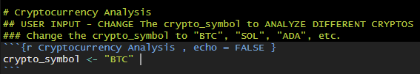

1. 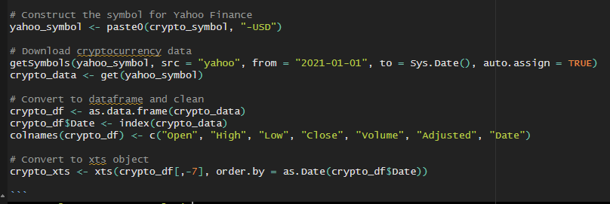**Data Download and Preprocessing**

**2. Exploratory Data Analysis**

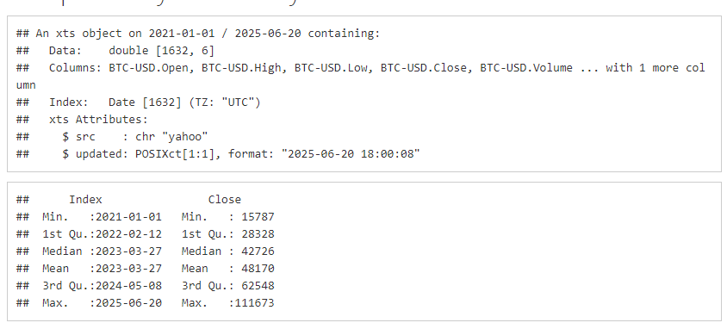

The Downloaded data having 1632 rows and 6 columns

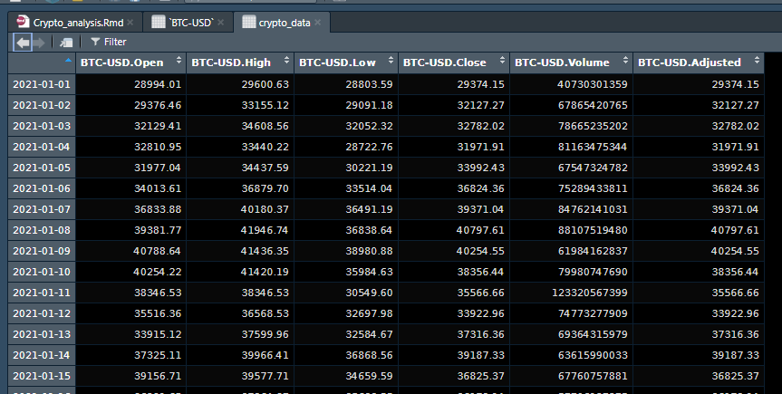

The other columns name are easy to understand, they are Date, BTC-USD open, High, Low, close and Volume,   
**the sixth column 🡪 “BTC-USD Adjusted” are not useful for crypto, because it indicate for stock splitting, dividend or share merging ‘s average price.**

We can later modify the function to predict shares/stocks.

**2.1 Bitcoin closing price all the years from Jan 01, 2021 until June 20, 2025**

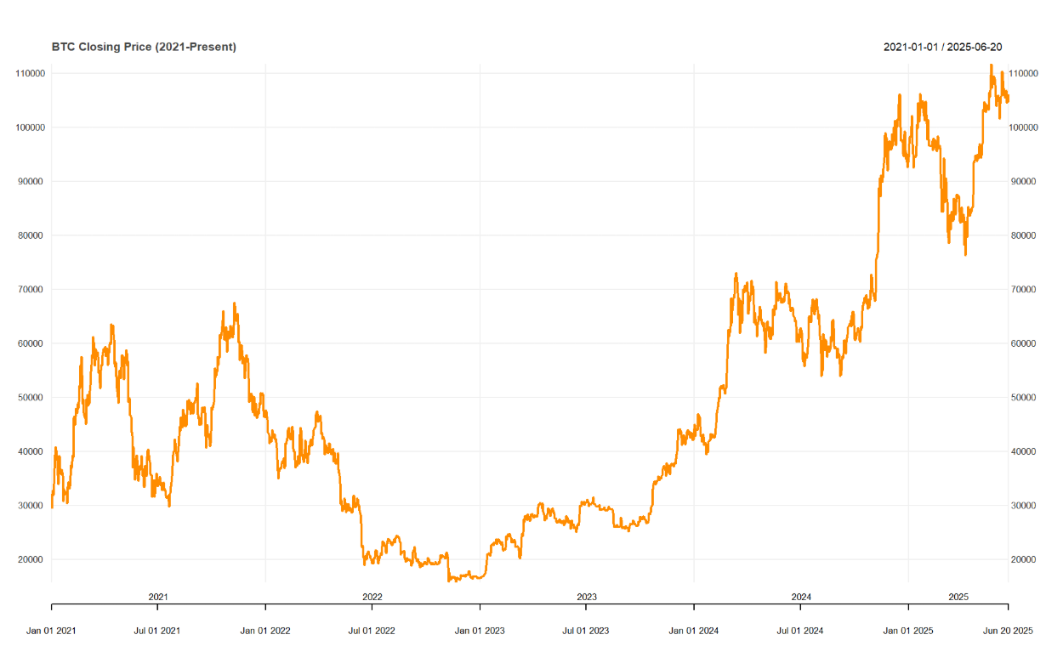

2.2 Bitcoin Daily returns all the years from Jan 01, 2021 until June 20, 2025

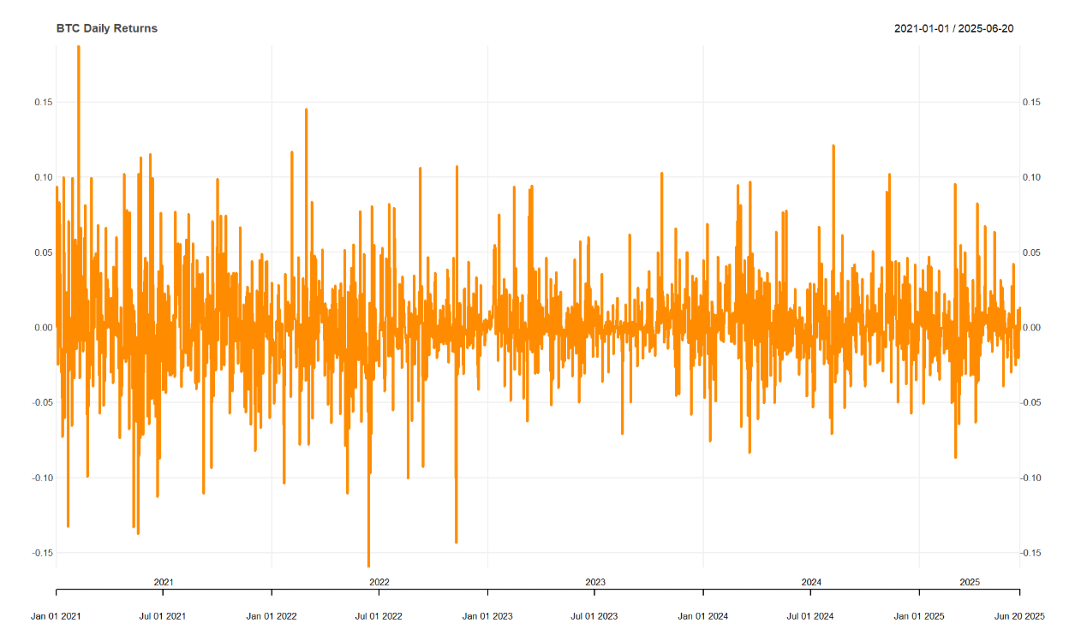

2.3 Bitcoin 30-Day Rolling Volatility (Annualized) all the years from Jan 01, 2021 until June 20, 2025

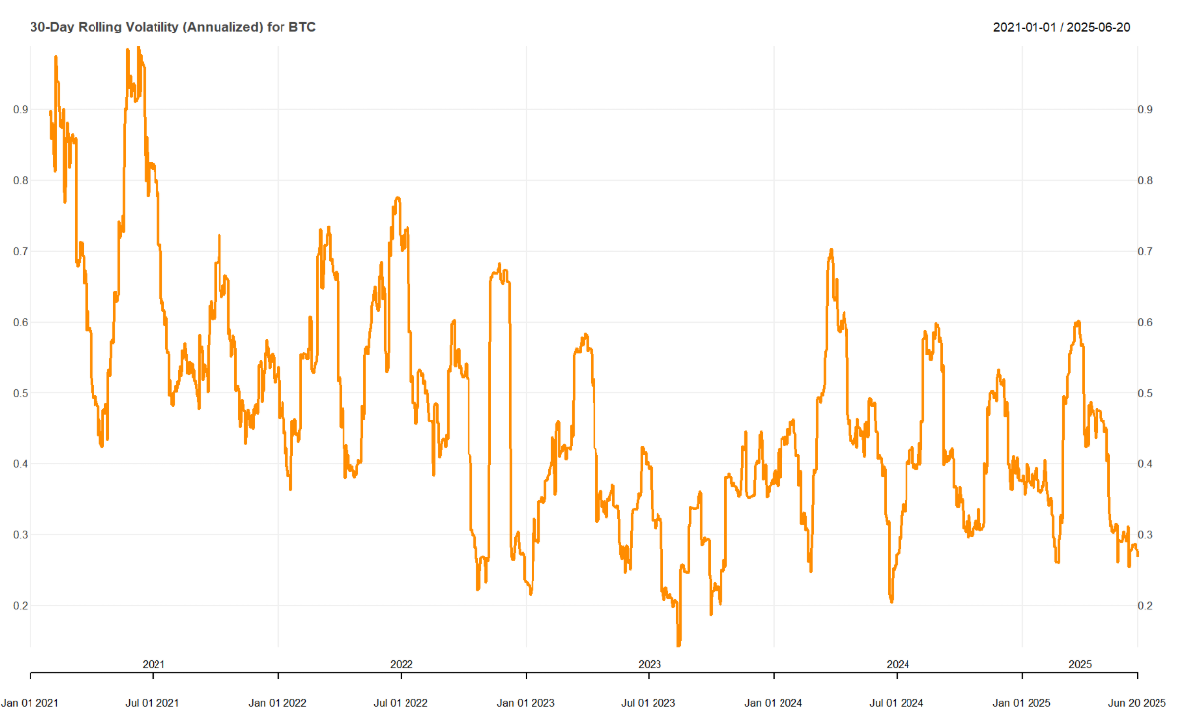

**3.Time Series Modeling**

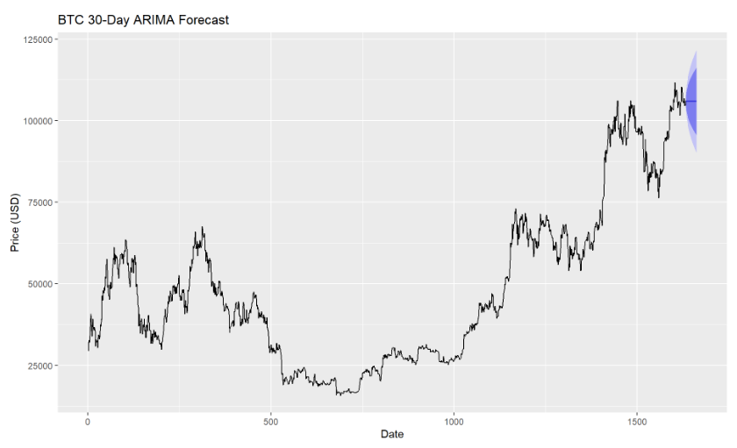**ARIMA Model Forecast**

With the Chart above, we can see the possible price of bitcoin will move in the positive and negative direction.

**Volatility Forecast**

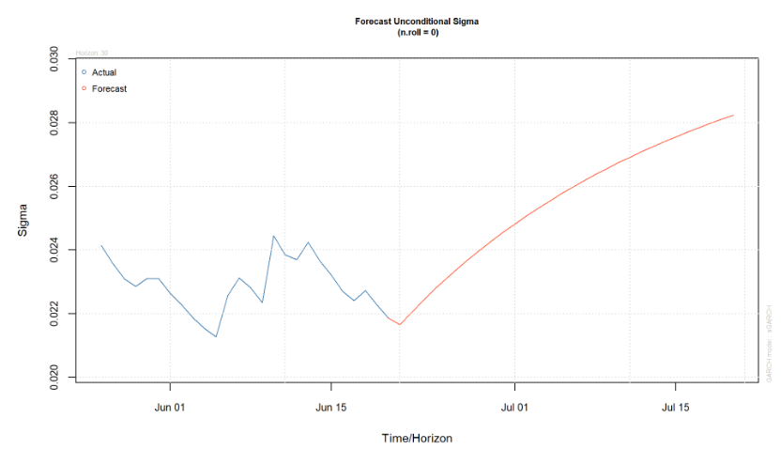

Combine with Volatility Forecast,  
We can predict the direction of bitcoin will go higher at 20 July 2025 , 30 days from 20 June 2025.

**4. Technical Analysis Indicators**

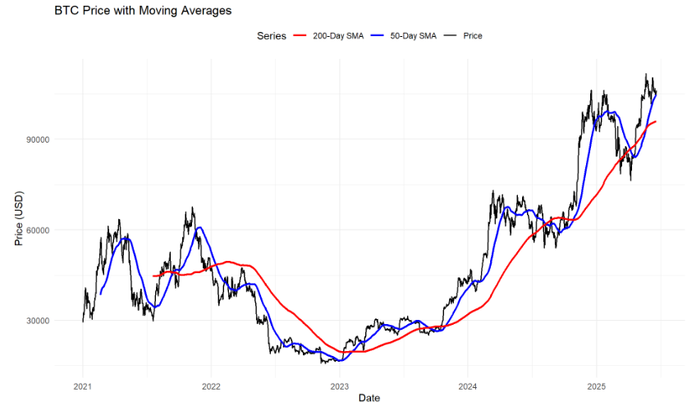

With the technical analysis, we can see the bitcoin still able to going future higher due to the trend is up and the Fast Simple Moving average (50 days average), is above the Slow Simple Moving average (200 Days moving average)

The opposite scenario will be happen as bear market if the Slow Simple moving average is above the fast-moving average.

**Relative Strength Index (RSI)**

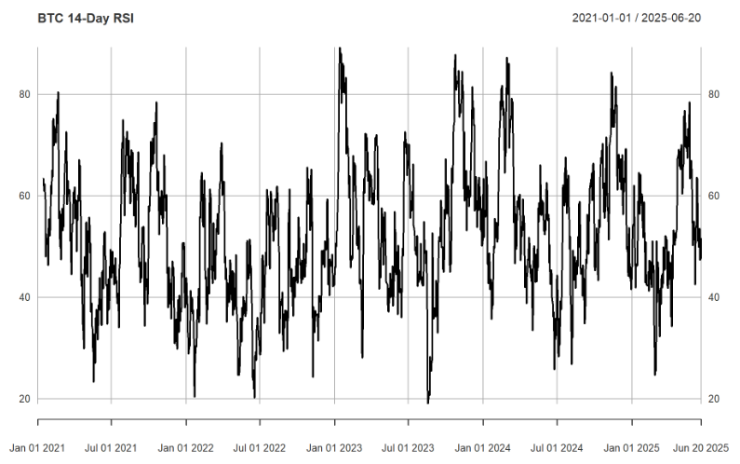

From the Relative Strength Index (RSI), We can see this indicator having no significant effect to the Bitcoin moving, this is because the Strength cannot manipulate the large market cap of the Bitcoin,   
Bitcoin having 2.1 Trillion Market cap [2], any individual or institutional want to change or manipulate even 1 % of the bitcoin price. It requires to pump at least 21 Billion USD to change the price. Hence this RSI cannot show us more info.

**5. Seasonality Analysis**

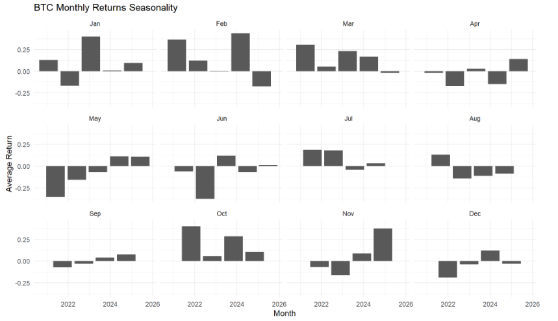

From this Seasonality Analysis, we can notice that the most of the time, Month September price will be ideal, and after invest at September (blue box), it will having high change to profit at Month of October (green box).

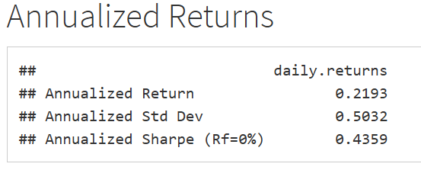**6.Performance Metrics**

1. **Annualized Return (21.92%)**

**What it means**: If Bitcoin’s daily returns were compounded for a year, you’d expect ~21.92% return on average.

**Context**:

* + **Positive return**: Historically profitable, but lower than Bitcoin’s early years (e.g., +100%+ in 2017, 2020).
  + **Compare to S&P 500**: ~10% annualized, so Bitcoin outperformed but with higher risk.

**b. Annualized Std Dev (50.32%)**

**What it means**: Bitcoin’s daily volatility, scaled to a yearly value.

**Interpretation**:

* + Extremely high (50% volatility means prices can swing ±50% in a year).
  + Example: A $10,000 investment could realistically swing between $5,000 and $15,000 in a year.

**c. Annualized Sharpe Ratio (0.436)**

**Formula**: (Return - Risk-Free Rate) / Volatility (Risk-Free Rate = 0% here).

**Interpretation**:

* + **0.436**: For every unit of risk, Bitcoin returned 0.436 units of reward.
  + **Rule of thumb**:
    - < 1: Poor risk-adjusted returns
    - 1–2: Good
    - 2: Excellent
  + Bitcoin’s Sharpe of 0.436 is mediocre—high returns but extremely high risk.

**Caution: This tool is not financial advice from Yap Kah Yong, investing crypto will be risky, use at your own risk.**

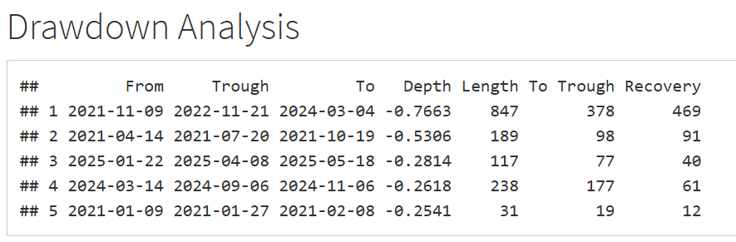

* **Depth**: Max loss from peak to trough (e.g., –76.63%).
* **Length**: Total days from peak to full recovery.
* **To Trough**: Days from peak to worst point.
* **Recovery**: Days from trough back to peak.

#### **Interpretation of Worst Drawdowns**

1. **2021-11-09 to 2024-03-04 (Depth: –76.63%)**
   * Bitcoin crashed **76.6%** from its Nov 2021 peak ($69K → ~$16K).
   * Took **378 days** to hit bottom (Nov 2022) and **469 more days** to recover (Mar 2024).
   * This was the "Crypto Winter" post-FTX collapse and Fed rate hikes.
2. **2021-04-14 to 2021-10-19 (Depth: –53.1%)**
   * China’s mining ban caused a **53% drop** ($64K → ~$30K).
   * Recovered faster (~3 months to bottom, 3 months to rebound).
3. **2025-01-22 to 2025-05-18 (Depth: –28.1%)**
   * Recent pullback (possibly due to ETF outflows or macroeconomic factors).

### **Conclusion**

1. **Bitcoin is high-risk/high-reward**:
   * 21.9% annualized returns are attractive, but 50% volatility means extreme swings.
   * Sharpe ratio (0.436) suggests poor risk-adjusted returns vs. traditional assets.
2. **Drawdowns are brutal**:
   * Even "small" drawdowns (–25% to –50%) happen frequently.
   * Worst-case scenarios (–76%) require **years to recover**.
3. **Practical Implications**:
   * Only invest what you can afford to lose.
   * Diversify to mitigate crypto-specific risks.
   * Use stop-losses to limit drawdown exposure.

**Caution: This tool is not financial advice from Yap Kah Yong, investing crypto will be risky, use at your own risk.**

Machine Learning Random Forest Vs LSTM

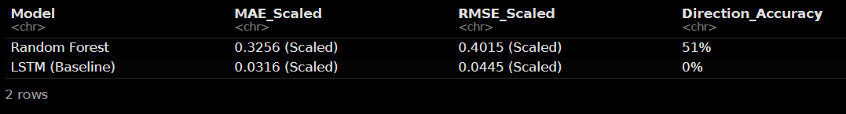

Key Insights:

* LSTM is quite good at getting numbers right, but it doesn't do a good job at capturing directional movements.
* When it comes to predicting direction, Random Forest works better than random chance.  
    
  The kinds have their own benefits: LSTM is good at making numbers more accurate.  
  Random Forest has a little edge when it comes to making directional predictions.  
  Ideas.
* Don't trust the 0% directional accuracy; it's probably a result of the scaling process.  
  For numerical performance assessment, focus on the scaled Mean Absolute Error/Root Mean Square Error.  
    
  The models may not be able to find important patterns in bitcoin data.
* A 0% result does not necessarily mean that the LSTM is not working; it only means that the baseline employed is not good enough for capturing directional movements, even if it is good at reducing numerical error.

**Caution: This tool is not financial advice from Yap Kah Yong, investing crypto will be risky, use at your own risk.**