

1. See KMeans.py
2. K=2: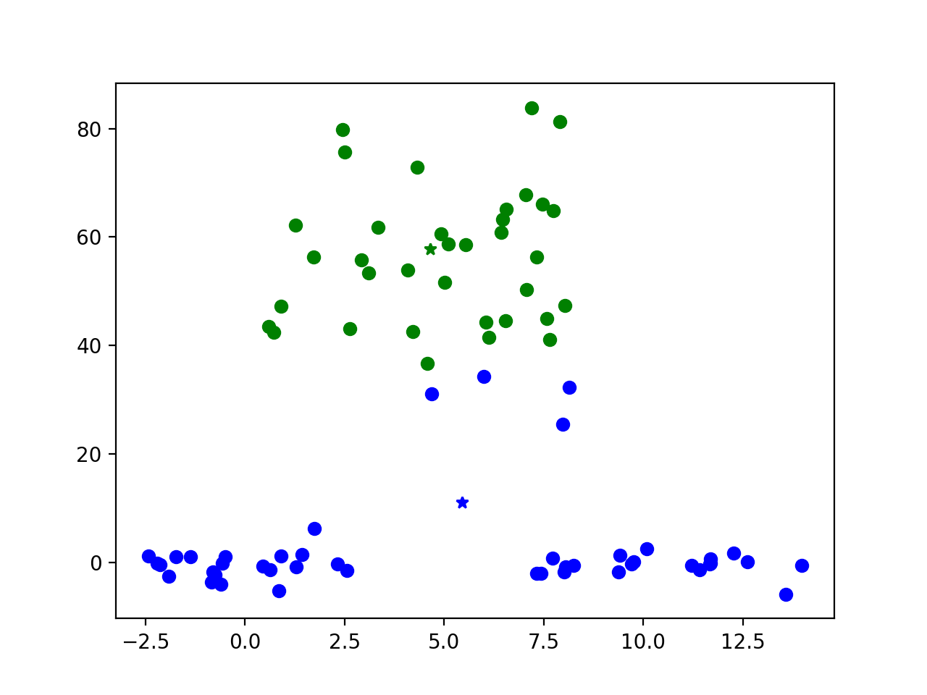

K=3: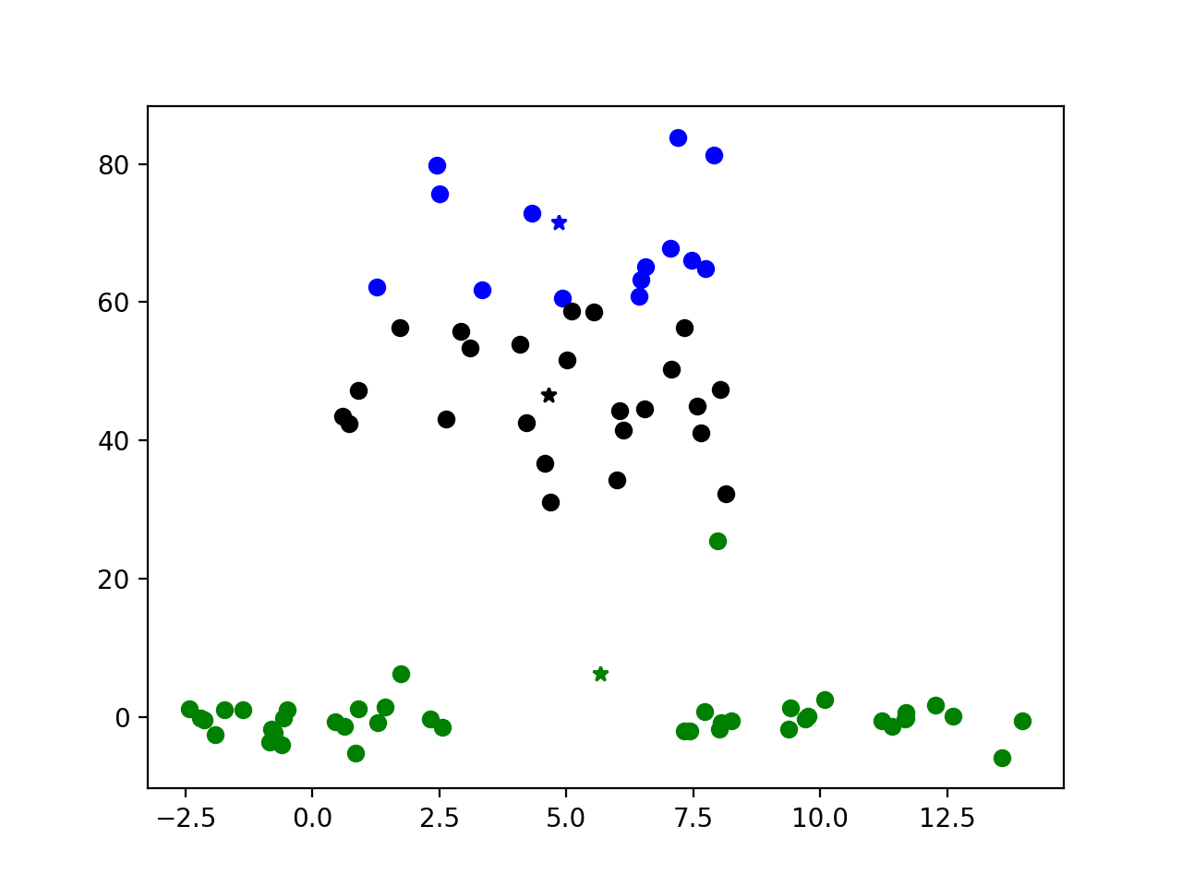

K=4: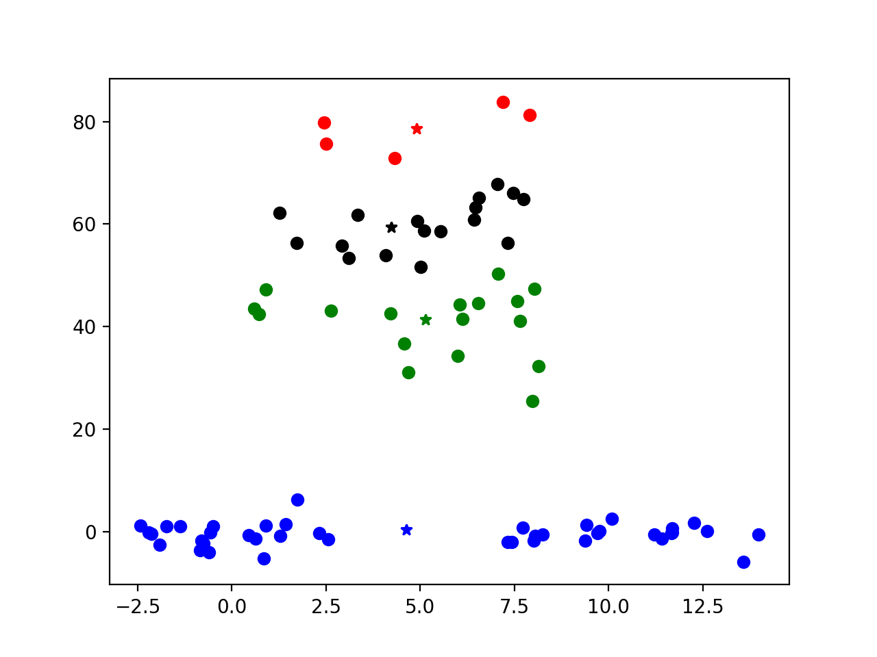

Compared with K=2, K=3, K=4 we can find the bottom points always in same cluster. As K goes up, the position of center point of bottom pile is lower.

1. K=2: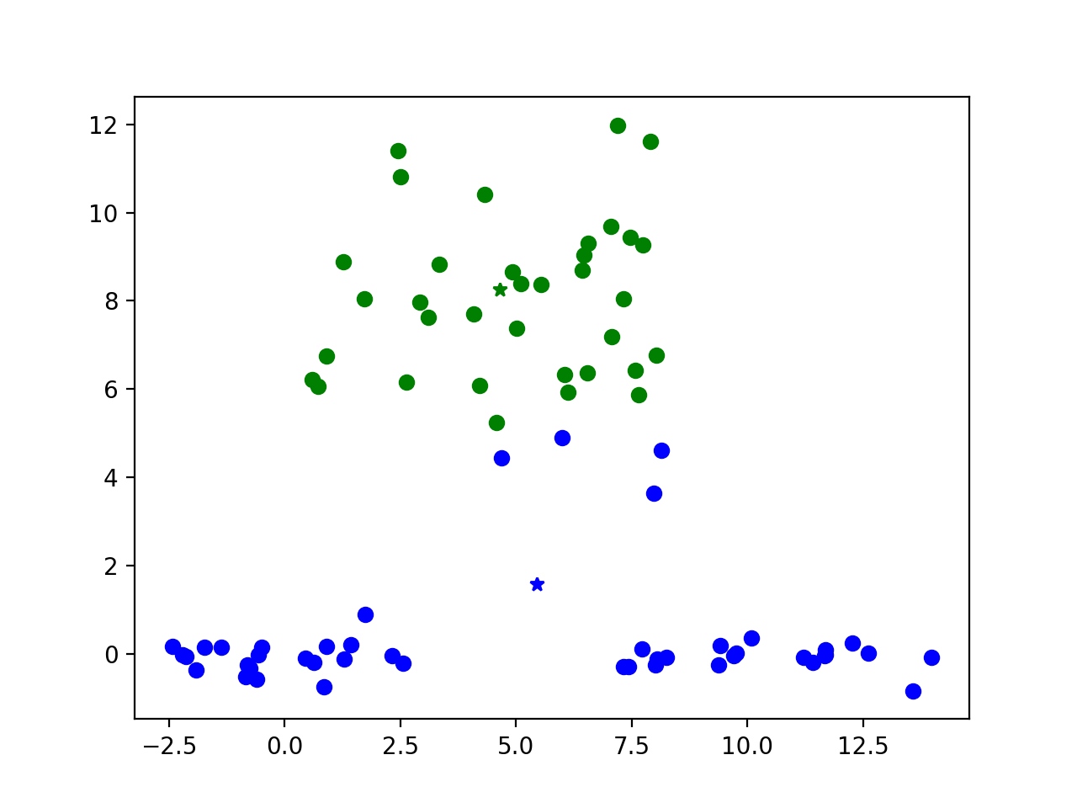

K=3: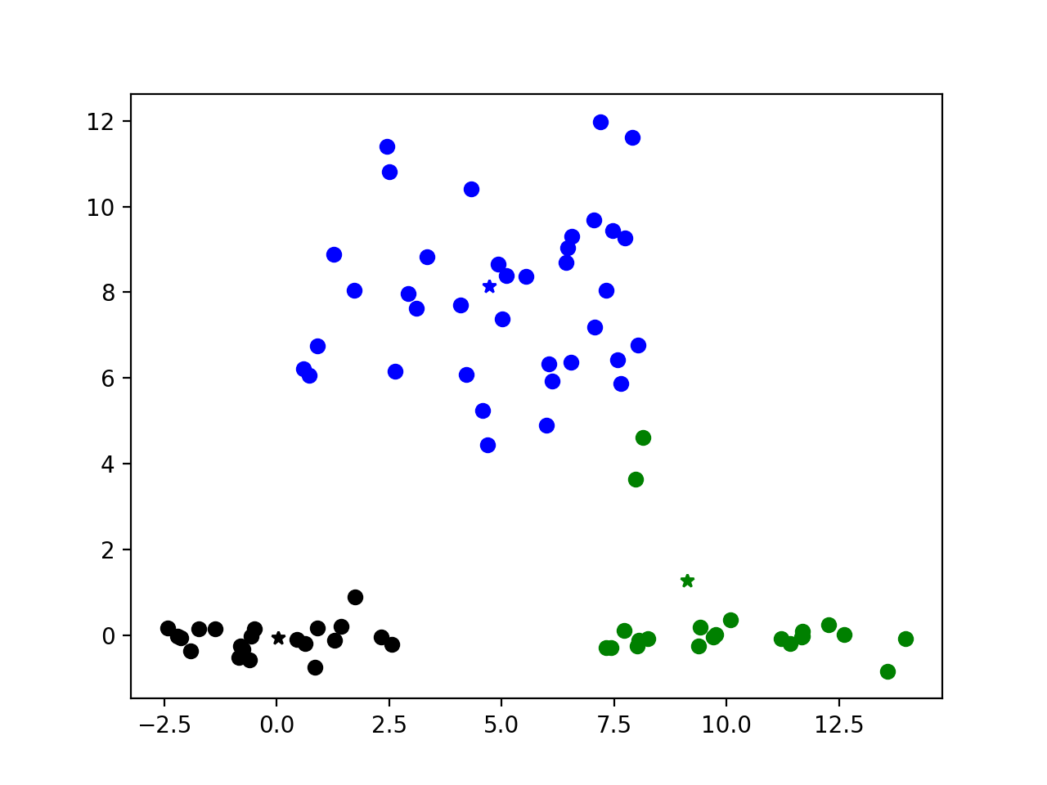

K=4: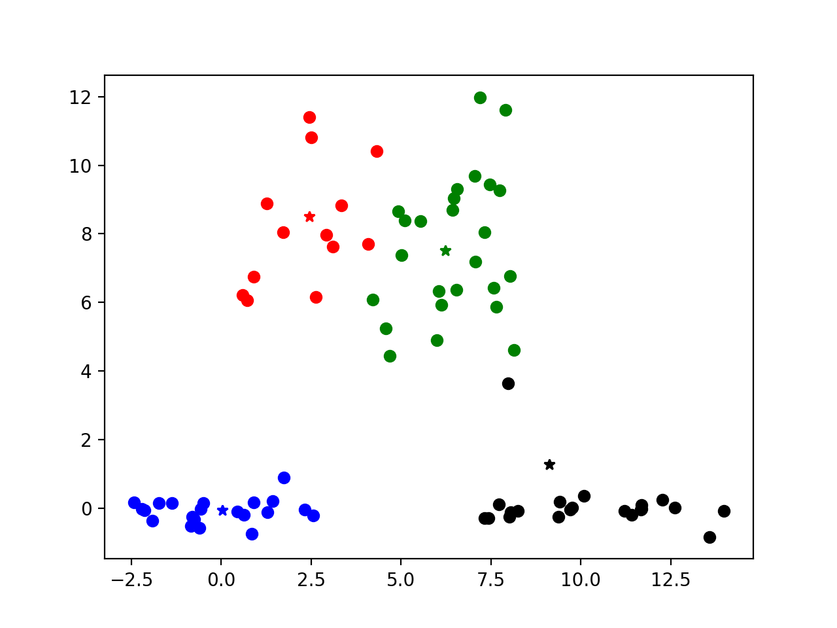

When y axis becomes y/7, the way of clustering is changed. Bottom piles separate when k=3. Higher points separate vertically instead of horizontally in original y axis.

1. Hierarchical cluster dendrogram:

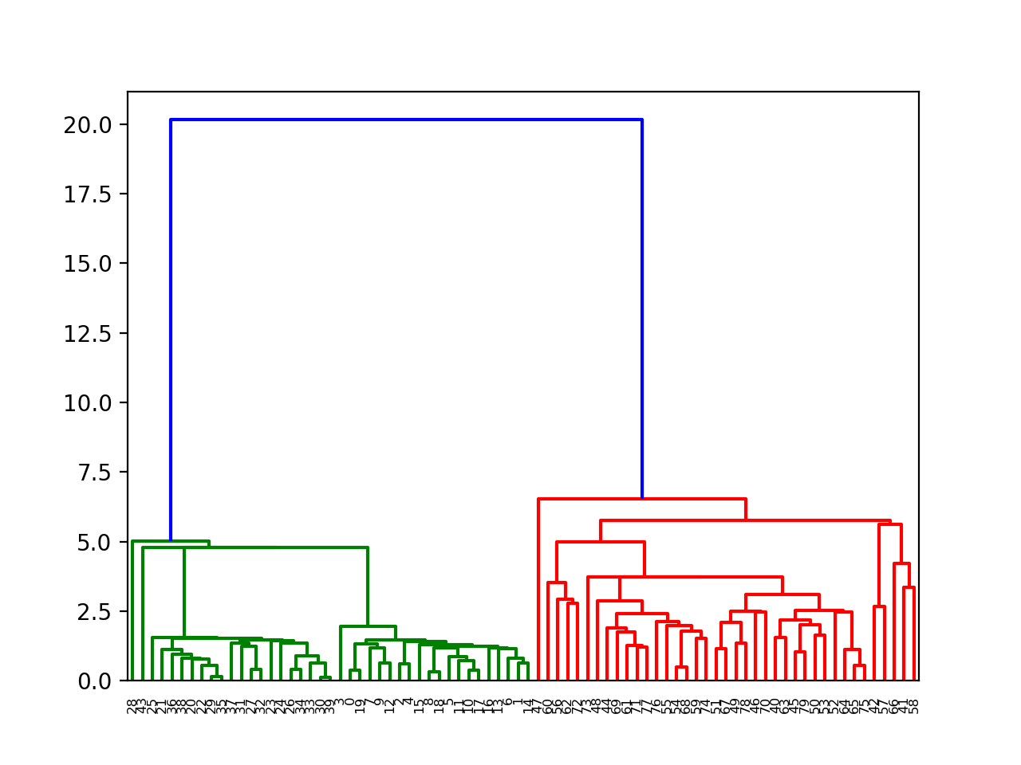

K=2: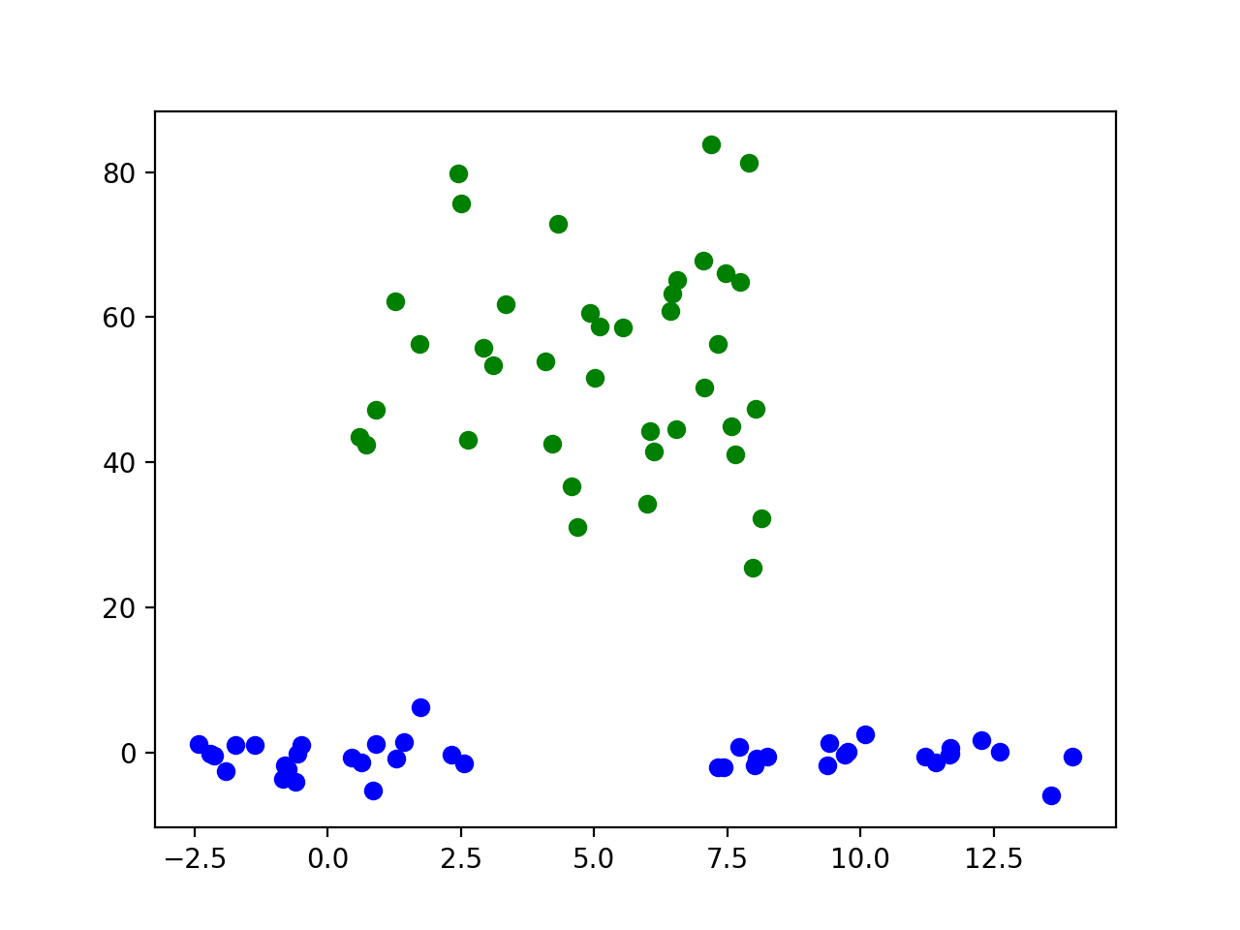

K=3: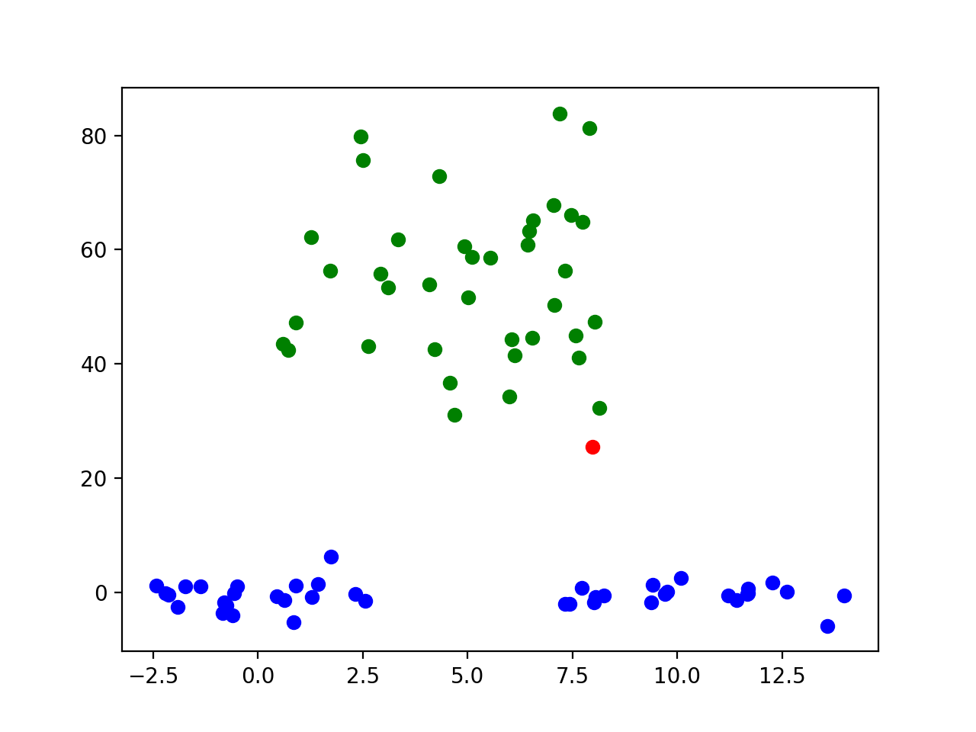

K=4:

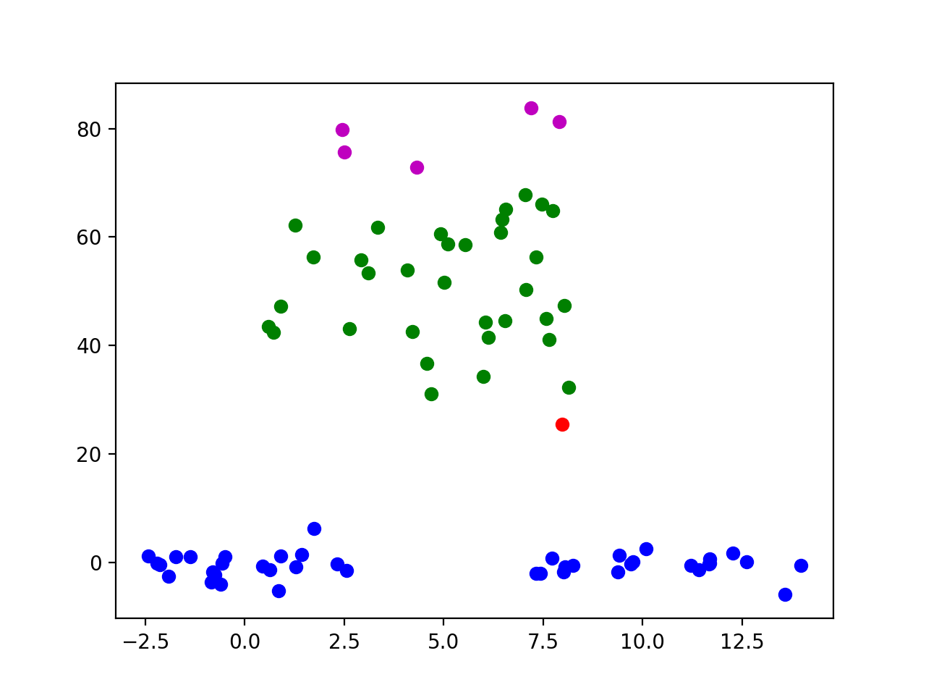

Compared with K-means, hierarchical clustering algorithm put points in one cluster according to distance between each other. It is more like people’s intuition. For example, when K=2, I will separate them like hierarchical clustering algorithm but Kmeans. When k increases, points in cluster at bottom never changes, but in Kmeans, they will change.

See Hierarchical.py