Comparison of HBV and WASMOD for Climate Change Scenarios

GEO4320

Eirik Storrud Røsvik



University Of Oslo

Contents
Introduction 3
Study Area and Data 3
Method and Hydrological Models 4
HBV Model 4
WASMOD 5
Model Calibration and Validation 5
Results and discussion 7
Climate Scenarios 7
Conclusion 10
Scources 11

Introduction
With the scientific consensus being that the earth is currently experiencing a period of global warming, questions regarding how this new climate will behave and how it will differ from the current is important answer. In this paper, data obtained between 1982 and 1991 from the Åkestad-Kvarn station will be applied to the hydrological models Hydrologiska Byråns Vattenbalansavdelning model (HBV) and WASMOD. These models will provide a framework to investigate the relationships between changing climate and the hydrological response. Models were first created for the original dataset, as this provides insight as to how accurate the model is. Later, three climate scenarios were created using the original dataset, modifying the average temperature and precipitation. The objective for this paper will be to analyze and compare the hydrological resource models created using HBV and WASMOD for the hypothetical climate scenarios.

Study Area and Data

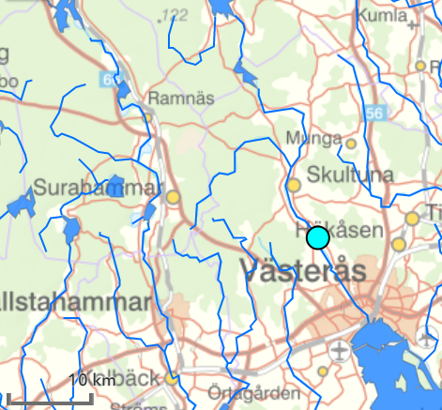
The data used in this paper where obtained from the Åkestad Kvarn cathcment situated in central Sweden. The catchment has an area of 727km², with a yearly mean precipitation of 60.1mm. Of this precipitation, approximately one third (21.6mm) flows into lake Mälaren, with two thirds (39.6mm) exiting through evapotranspiration. The region is characterized by cold winters and warm summers. As precipitation that falls during the winter months fall as snow, the highest discharge occurs during the spring melt in April and May, with the summer months having the lowest. As seen in table 1, the precipitation is highest during the summer months; this mostly exits the system through evapotranspiration. Precipitation falling during the colder months contributes more to the discharge, especially precipitation accumulated as snow. (Xu, 1998)
The Åkestad Kvarn station monitors the river exiting the catchment north of where it drains into Mälaren lake, shown in figure 1. The lake is used as the main freshwater source to Stockholm and its surrounding areas, and has been the subject of several studies.
Figure 1: Central sweeden. Åkestad Kvarn station (Light blue), with Lake Mälaren bottom right.
The data used in this paper is a time series gathered between 01.01.1981 and 31.12.1991 for the HBS model, and a monthly time series covering the same span for the WASMOD. As can be seen in figure 2, these datasets are not exactly identical as the observed discharge in the datasets differs quite a bit. The HBV and WASMOD includes measurements of precipitation in millimeters, the average temperature, and the observed discharge for each data point. For our three climate scenarios the data was modified in the following ways:
Figure 2: Average observed discharge by month
- Temperature increased by 3 ºC
- Temperature increased by ºC and precipitation increased by 15%
- Temperature increased by ºC and precipitation decreased by 15%

Method and Hydrological Models
Hydrological models are created in order to simulate the movement of water. This can be accomplished in several ways, and this paper utilizes two models with different approaches. The first one, HBV-mod is a computer simulation that uses routines in order to more accurately model the water movements. This approach can be called a semi-distributed conceptual model. The second model, WASMOD is a lumped conceptual model that uses two state-variables and five tunable parameters to model the entire water budget. (Eregno et al. 2013)

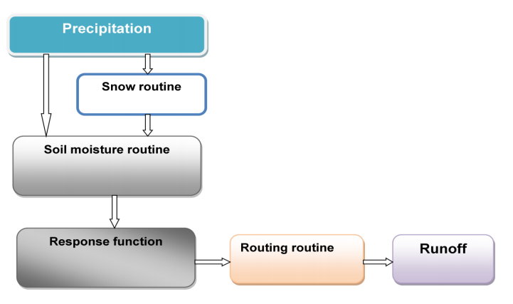
HBV Model
The HBV model was developed by the Swedish Meteorological and Hydrological institute. It models the water balance using a mathematical model that takes rainfall, temperature and runoff data in order to simulate the water movement in the catchment. The model consists of several routines that the data goes through in order for the model to create a day by day simulation of the hydrological properties. For the calculations performed by the model several parameters are fitted using the measured discharge as a test/validation dataset.
Figure 3: Data flow through the HBV model
The precipitation will be simulated as snowfall if the temperature is below the temperature threshold (TT), this adds an additional snow routine to the simulation. (Eregno, F. E., 2009)
During the melt phase, the calculation uses a degree day method to calculate the melt (equation 1) and refreezing (equation 2). To do these calculations, the model uses the fitted parameters CFR and CFMAX, as well as the threshold temperature parameter (TT) and the temperature for the calculated day (T(t)). (Eregno et al. 2013)
$Melt=CFMAX*\left(T\left(t\right)-TT\right)$ (1)
$Refreezing=CFR*CFMAX*TT-T(t))$ (2)
After the snow routine, the water, rainfall and/or snow melt, are divided into either groundwater recharge or added into the soil moisture. This depends on the water content of the modeled soil box (SM) and its largest value (FC). The Actual evapotranspiration is also calculated during this routine, being dependent on the ratio SM/FC and the parameter LP.
The groundwater recharge is added to a system of boxes to simulate the differing runoff and storage time in and from different depths of groundwater. The Model uses the parameters K0, K1 and K2 to fit the runoff from the groundwater. The groundwater contribution can be seen in a run of the dataset in figure 4. The QSUZ is the water content of the top layer, it reaches the highest levels during the melt phase, as it becomes saturated. The QSLZ is the deeper groundwater and it contributes more steadily to the discharge year round.
Figure 4: Height of simulated groundwater boxes (HBV)

WASMOD
The other model used in this paper is the Water and Soil MODeling system (WASMOD). WASMOD is a conceptual lumped modeling system developed by Chong-Yu Xu in 2002 (Xu, 2002). WASMOD calculates the monthly water balance and it requires input of monthly values of the areal precipitation, potential evapotranspiration and air temperature. WASMOD outputs the simulated monthly river flow as well as several other water balance components, such as actual evapotranspiration, snowpack size and soil moisture. This is accomplished using 6 tuned parameters.

Model Calibration and Validation

For any model, the calibration and validation are crucial steps to make the model applicable to a given scenario. For the models used in this paper, the calibration and validation process is an iterative procedure. The parameter values are adjusted and refined to create a simulation that as closely as possibly calculates the runoff.
For the HBV model, this was done using the Monte Carlo procedure. During the calibration, the model will look at the supplied portion of runoff data in order to refine the approach and adjusting the parameters to minimize the difference between simulated and actual runoff. For the validation, the remainder (01.01.1988 – 31-12.1991) of the time series is analyzed using the same parameters. The results the model produces for the validation timeseries will be an indicator of how well the model is able to generalize the hydrological situation in the modeled area. The reff value, the accuracy of the model, is calculated by the model as a value between 0 for no fit and 1, should the model match exactly. As the reff value indicates how well the model preforms, and all results produced by the model using the same parameters will at least carry over this error. The error is calculated using the residual between the observed and simulated runs of the model. The monthly residual is shown in figure 5. In the calculation of the reff values in HBV, the daily residual was used, while monthly was used in the WASMOD as it uses monthly data.
Figure 53: Residuals for monthly average runoff from the HBV calibration

Figure 8: Error during WASMOD Calibration
Figure 6 and 7 shows the results for MAXBAS and TT_1 parameters where the reff-value is greater than 0.7. The final parameters for the HBV model is shown in table 1.
Figure 7: Monte Carlo scatterplot for the TT_1 parameter
Figure 6: Monte Carlo scatterplot for the MAXBAS parameter
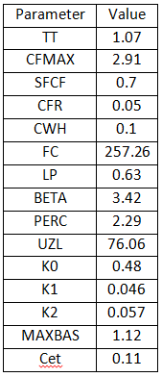
The calibration of the WASMOD model consists of tuning 6 parameters (A1-A6). This is again done by an iterative process. The iterations can be seen visualized in figure 8 and 9, with figure 8 showing that the least error occurred during the 20th iterative step. Figure 9 shows the value for each parameter for each step.
Figure 9: Parameter value through calibration process
Table 1: Parameters used in HBV model

Results and discussion

Original dataset
First the models were run for the observed dataset, testing between 01.01.1981 and 31.12.1987 and validating for the rest of the dataset. Running the models produced the following R² values:
Model | R² value
HBV Calibration | 0.898
HBV Validation | 0.888
WASMOD Calibration | 0.864
WASMOD Validation | 0.770
Table 2: Errors from the model runs

As can be seen in table 2, the HBV model produces the most accurate scores, and has the lower loss of accuracy between calibration and validation. This would suggest that the HBV model with the current parameters does a better job at moddelign the underlying procesees for this catchment.
The comparison of monthly mean values for observed and calculated discharge is shown in figure 10 and 11. The models produces results that fits quite well. Both models appears to overestimate the discharge during the winter and later melt phase, while it slightly underestimates during the summer months between june and august.
Figure 11: Observed and simulated discharge for the WASMOD model
Figure 10: Observed and simulated discharge for the HBV model

Climate Scenarios
Three different climate scenarios were analyzed with changes to the temperature and precipitation. The models were initiated for the modified datasets using the same parametrs obtained from running the observed dataset. This was done as using the original dataset is the only way to validate the parameters for this catchment. With well preforming models of the catchment, the only necessary step is to change the input data and run the model again.
Looking an the annual discharge in table 3 for the HBV, it can be seen that the climate scenarios has quite a large effect on the over all discharge. The higher temperature in scenario 1 leads to a drop in discharge of about 15%. This is likely du the the greater actual evapotranspiration, as a warmer athmosphere can hold more water vapor. In scenario 2, with an increase in temperature and precipitation, the resulting discharge was simulated to be higher than that of the original. The las scenario, with an increase to temperature and a decrease to the precipitation resulted in the lowest discharge of all the scenarios with a reduction of 42%
Scenario | Change in discharge
1 | -14%
2 | 16%
3 | -42%
Table 3: Change in discharge for the climate scenarios using the HBV model

For the WASMOD, all the climate scenarios resulted in a lower discharge as can be seen in table 4. For this model, the discharge decresed for all scenarios.
Scenario | Change in discharge
1 | -47%
2 | -65%
3 | -33%
Figure 12: Monthly average discharge for climate scenario 1
Figure 13: Monthly average discharge for climate scenario 2
Table 4: Change in discharge for the climate scenarios using the WASMOD model

Figure 14: Monthly average discharge for climate scenario 3
Figure 16: Snow pack height for climate scenario 1
Figure 15: Snow pack height for climate scenario 1

Figure 18: Modeled available evapotranspiration for original data and the climate scenarios
Figure 17: Snow pack height for climate scenario 1
Comparing the discharge in figures 12-14 and the snow pack height in figure 15-17, the difference in how the modellening techniques can be seen. The HBV model gives a smaller snowpack in general, while the discharge during the melt phase is higher. This shows that how such routines are applied in the model has a profound effect on the results. For the Available Evapotranspiration, illustrated in figure 18, the models are more in agreement, with all the scenarios producing similar results. The AET is naturraly higher during the summer months and lower during the winter as the study area sees large fluctiations in temperature over a year.
Figure 19: Modeled snow pack height for original data and climate scenarios
Comparing the snow depth for all the scenarios as well as the ones modelled from the original dataset (figure 19), it seems all the climate scenarios corresponds to a decrease in overall acumulated amount as well as a shorter snow cover. This is not surprising as air temperature is the largest factor during the melt phase. Again it can be seen that the WASMOD tends to simulate higher snow packs with the original run of the WASMOD providing the highest average snow cover.
The HBV and WASMOD moddels do not appear to agree on the resulting hydrological climate. As global warming is a complex process, changing almost all factors of a given catchment, this is not unexpected. The WASMOD model appears to calculate a far greater percentage of the precipitation to exit through evapotranspiration. This is likely due to the temperature increase being a higher weighted parameter for the WASMOD, as an increase in precipitation still led to a deacrease in runoff. For the HBV model, an increase in precipitation alongside the higher temperature actually increased the runoff. Wether this discrepancy is due to internal model characteristics or due to initial paramers in not nown.
In general the results prodused do not agree. Previous studies comparing the HBV and WASMOD have found similar results in the study of climate change scenarios. In general, it has been found that lumped conceptial models may lead to unreliable conclutions. (Eregno et al. 2013)
The HBV model had a superior accuracy to WASMOD. Thus the results given from the HBV would likely give a better representation for the climate scenarios. The climate chage applied to the scenarios were also applied as an arbitrary flat increase to the temperature. As global warming is not a flat increase, the results are better suited for being compared to each other, giving little information as to how actual climate change would affect the catchment.

Conclusion

Given an increase in temperature it can be concluded that the hydrological regime will be impacted. The snow cover will be reduced both in how much is accumulated as well as how long period the snow is acculumlated over, on this both models agree.
The two models gave very differing results as to how much discharge the cathment produces. As climate change is a very complex change to model, is is not surprising that these models give differing results. The results produced for the original datasets were within the acceptable accuracy to be regarded as a good aproximation of the hydrological regime. However, the only conclusion that can be made in regards to the climate scenarios is that the simple models used in this paper does not reliably simulate the changed hydrological regime.
The results from the models will only apply for the specific catchment (Åkestad Kvarn) as the parameters are set using the supplied data from only one catchment.

Scources

Boecsh, D et al. (2006) EUTROPHICATION OF SWEDISH SEAS
Eregno Fasil Ejigu, Chong-Yu Xu , Nils-Otto Kitterod (July, 2013) Modeling hydrological impacts of climate change in different climatic zones
Eregno, Fasil Ejigu (2009) Comparison of Hydrological Impacts of Climate Change Simulated by WASMOD and HBV Models in Different Climatic Zones China, Ethiopia, and Norway
Xu, Chong-Yu (1998), Estimation of Parameters of a Conceptual Water Balance Model for Ungauged Catchments
Xu, Chong-Yu (2002), WASMOD – The Water and Snow Balance and Modeling System

