Hand in 4. Eirik Storrud Røsvik
Task 1:
Exchange composition of the solution is shown in table 1, calculated from input1.pqi. Obtained from .out file.

Species | Moles | Equivalents | Equivalent Fraction | Log Gamma
CaX2 | 1.782e+02 | 3.563e+02 | 7.127e-01 | -0.163
NaX | 7.010e+01 | 7.010e+01 | 1.402e-01 | -0.041
KX | 2.978e+01 | 2.978e+01 | 5.955e-02 | -0.043
MgX2 | 2.189e+01 | 4.378e+01 | 8.755e-02 | -0.160

Task 2/3:
Using a solution similar to task 1, and saltwater was injected into the system.
Using 50 meq/kg with a density of 1.8 and a porosity of 0.3 gives a meq/L of 60
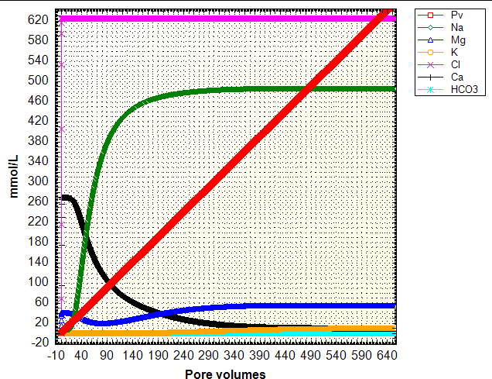
Figure 1
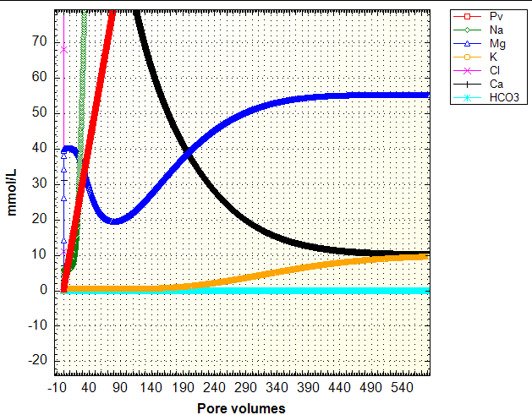
Figure 2 (focus on the lower consentrations)
As can be seen in figure 1 and 2, Na is the first cation to break through, after around 10 pore volumes, this is also where Ca starts to be removed. Ca anions are removed as Na rises. During the first phase, when Na rises, Mg falls, while K remains at low concentrations. While the Na concentration has a steep increase (pore volume 10-80) the Mg concentrations fall. When the Na concentration plateaus at 480, and Ca concentration still falls, the Mg concentrations starts to rise again. When Mg concentrations starts to rise sharply, after about 120 pore volumes, the K cations breaks through also, but follows a less steep curve than Mg, witch again is less steep than Na.
After running the simulation for 500 pore volumes, the concentrations resemble those of seawater, even though the Ca concentrations keep slowly diminishing further as it converges.
Cl brakes through immediately after the simulation has started. Ca is removed from the exchanger after around 500 pore volumes, at which time the Ca concentrations and K concentrations are almost equal. After 500 pore volumes, the concentrations are almost that of sea water.

Element | PHREEQC values (mmol/l | Actual sea water composition (mmol/l)
Cl | 625 | 546
Na | 485 | 469
Mg | 55 | 52.8
K | 10 | 10.2
Ca | 10.1 | 10.3
HCO3 | ~0.2 | 2(TOC)
