a)
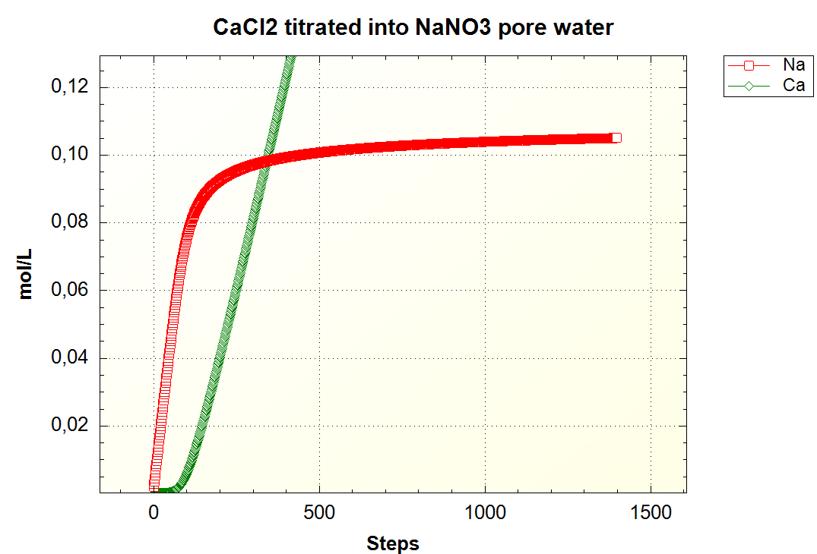
Figure 1
Figure 1 shows a reaction where 0.6 mol CaCl2 was added in 1400 steps into a solution of 1 mmol NaNO3. The solution had a cation exchange capacity of 1.1e-3 meq/kg. As can be seen in the graph, as Ca is added to the solution, it is preferably sorbed, freeing Na ions into the solution. Sodium is rapidly released in the beginning, just as the Ca is added. While Na concentrations is rising most rapidly, the Ca concentrations are still low, and doesn’t start rising before the rising Na concentrations begin to level off at around 100 time steps. After most of the negatively charged surfaces have been filled by Ca, the Ca concentrations rise more or less linearly, while Na concentrations flatten.

b)
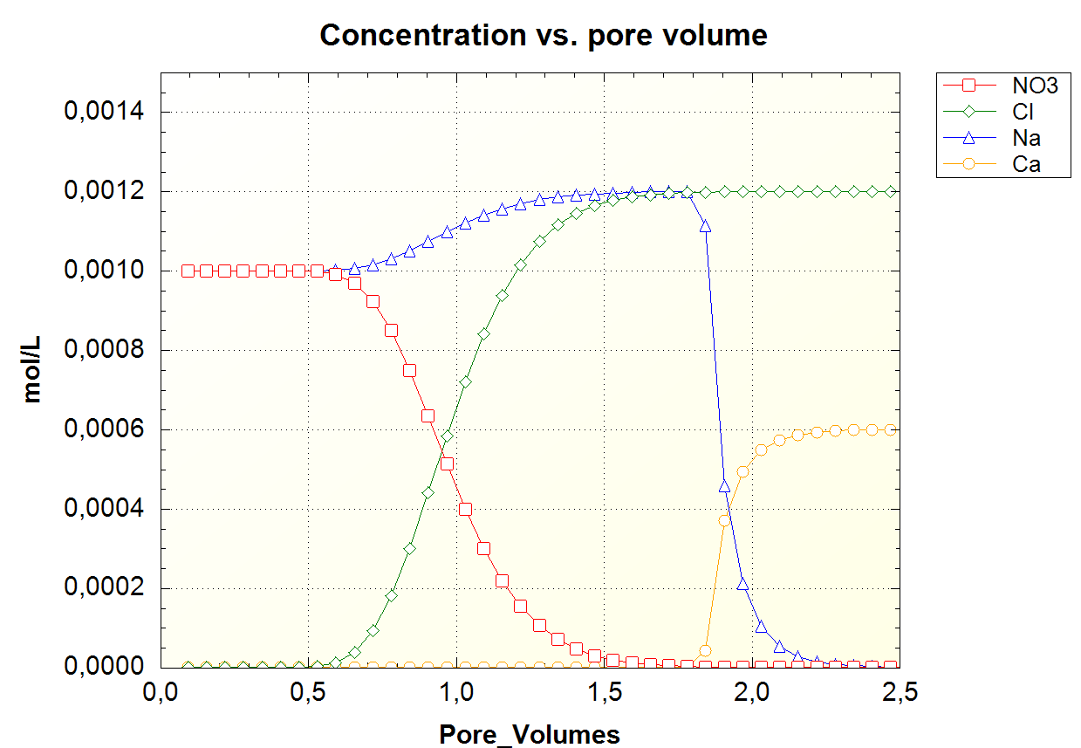
Figure 2
In figure 2, a column has been simulated, again adding 0.6 mol CaCl2 to a solution of 1 mol/L NaNO3. Using time steps of 630s and a diffusion coefficient of 0.3e-9. Observing the graph, we can see that the anions get exchanged before the cations. Cl and NO3 gets begins exchanged after 0.5 pore volumes, and Cl is by far dominant after 1.5 pore volumes. NO2 is completely sorbed by 2 pore volumes. The cations, Na and Ca follow the same behavior as seen in figure 1, with Ca breaking out at 1.78 pore volumes. The cation exchange appears to start just as the anion exchange is completed. The cation exchange occurs far more rapidly than the anion exchange, with Na being out of solution by 2.25 pore volumes.

c)
InI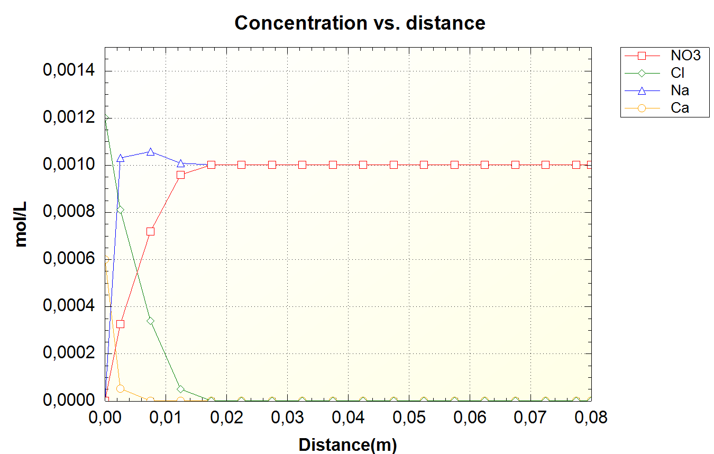
Figure 3
In figure 3, the same reaction as figure 2 has been plotted with regards to distance. The distance simulations are done using only one injection of the added solution. Here it can be observed that all the injected solution of CaCl2 penetrated to a distance less than 2cm. In this figure, the cation exchange happens more rapidly than the anion.

d)
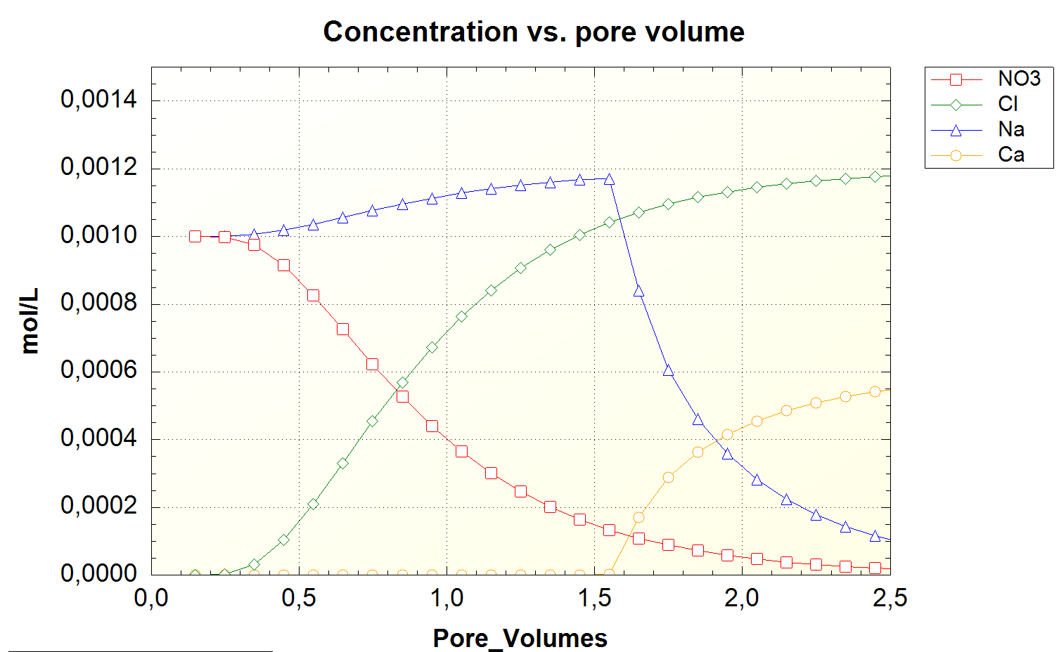
Figure 4
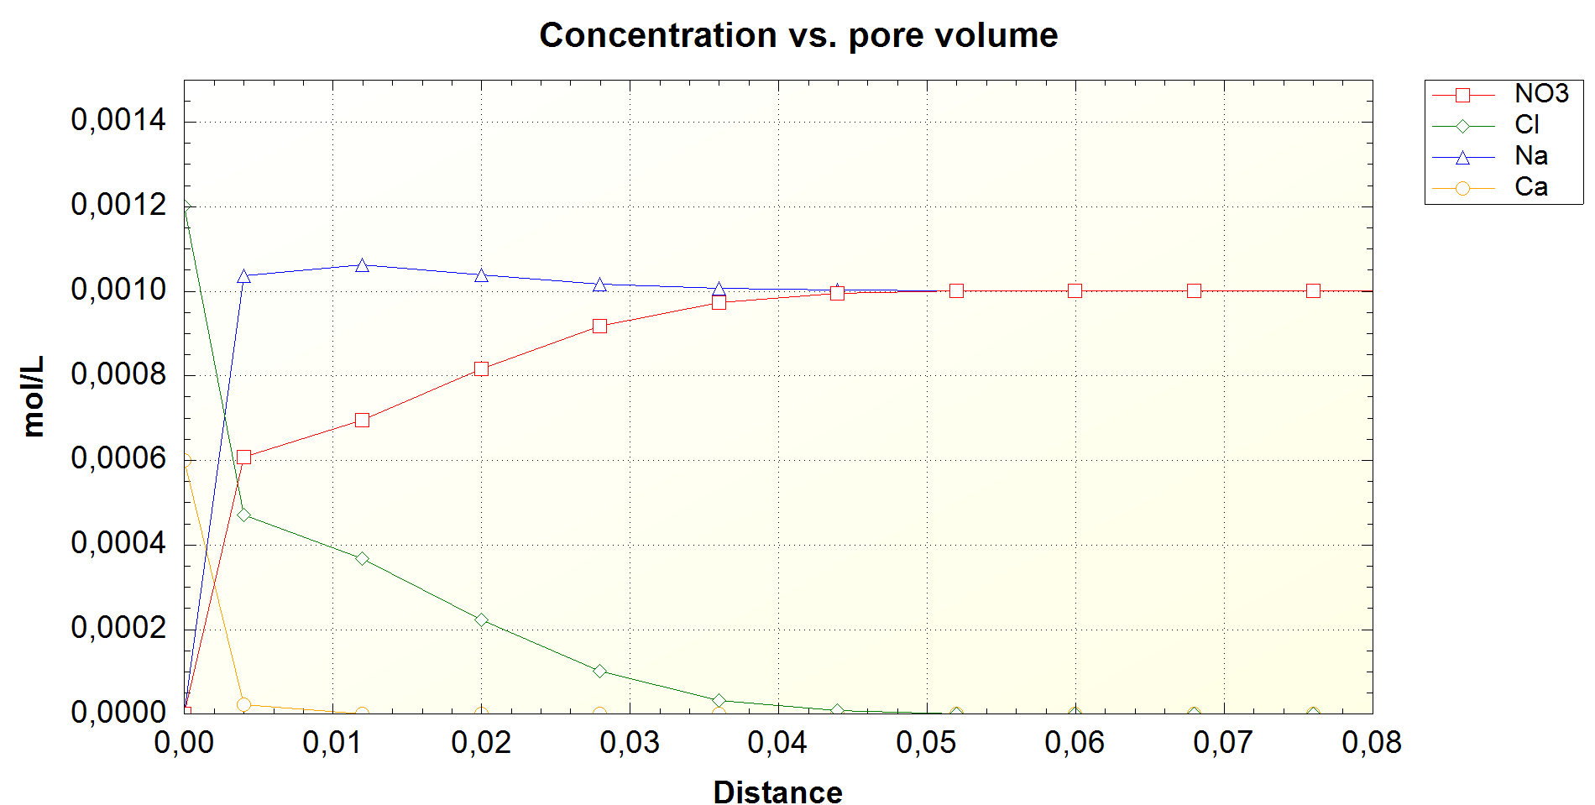
Figure 5
In Figure 4 and 5, the same reaction as Figure 2 was simulated, but the time steps is now set to 3.15e3 and the diffusion coefficient 3e-7. Using a greater time span, and a smaller diffusion coefficient, results in a smoother looking graph than figure 2. As opposed to figure 2, the anion exchange happens earlier, with Cl starting to break out at 0.25 pore volumes. The same goes for the cation exchange, starting at 1.6 pore volumes in figure 4, as opposed to 1.78 in figure 2. The exchanges also have greater overlap. While figure 2 showed the anion exchange being more or less complete before Ca broke through, this is not observed in figure 4. The exchange reactions in figure 4 also does not complete, with Na still being present at 2.5 pore volumes.
In figure 5, showing the distance of the injected solution reaches, it can be observed that the injected Ca and Cl penetrate some 5 cm into the column. The lower diffusion coefficient makes the Ca and Cl propagate further into the column than what was observed in figure 3.

e)
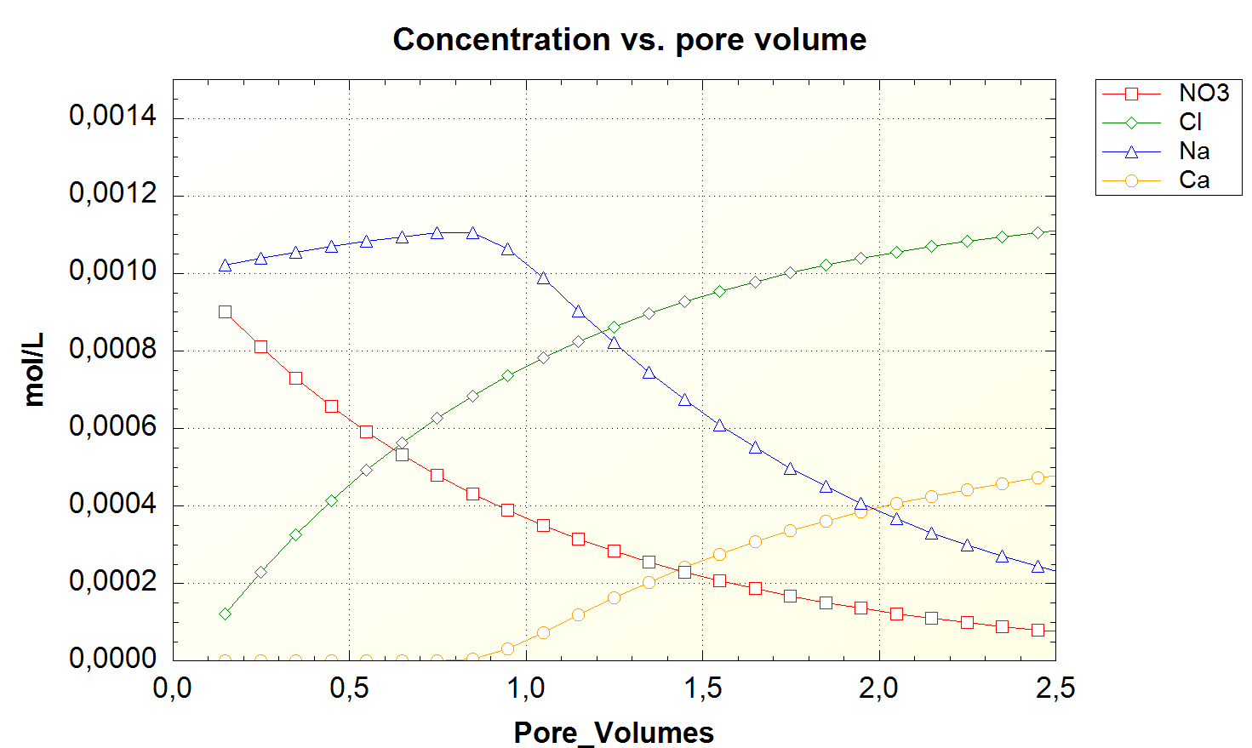
Figure 6
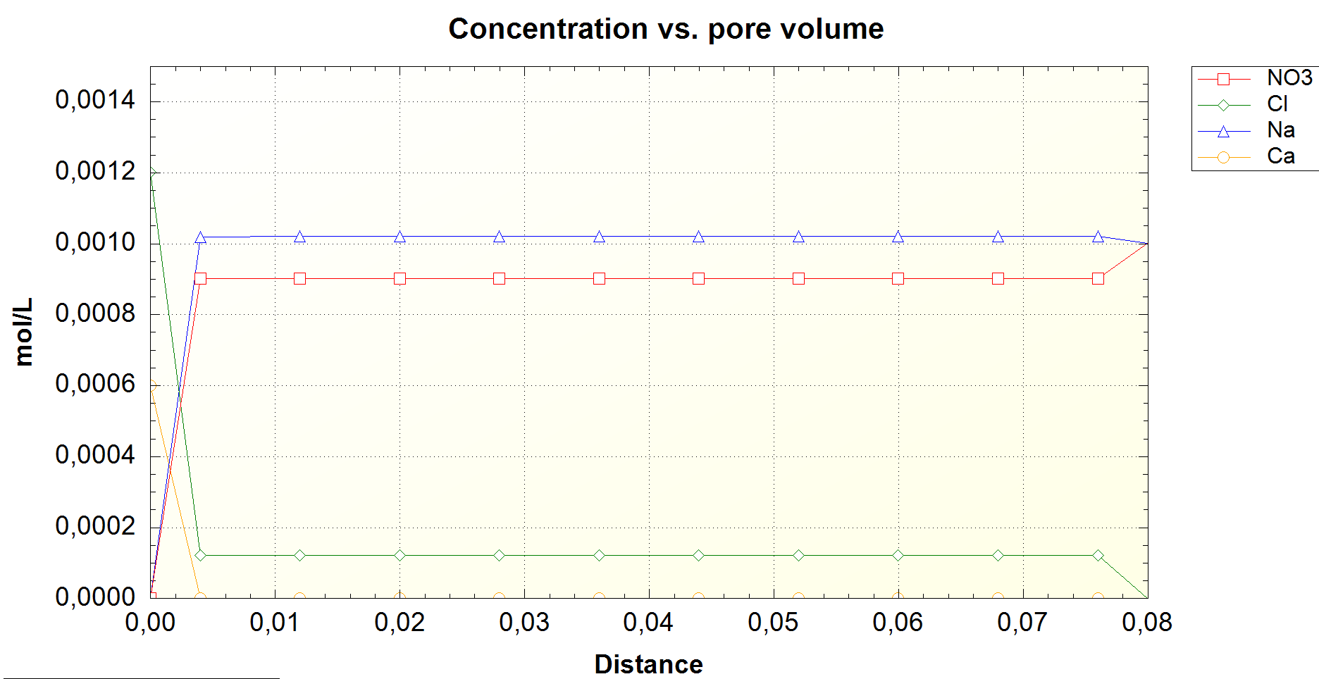
Figure 7
Lastly, in figure 6 and 7, the same reaction as figure 4 was simulated, but with the diffusion coefficient being 0.3e-9 and time step being 3.15e7. The same characteristics seen in figure 4 compared to figure 2 is seen again in figure 5, only more exaggerated. Cl now breaks free from the beginning, and Ca breaks free at 0.8. Further, none of the exchanges are completed at 2.5 pore volumes, with both NO3 and Na being present at 2.5 pore volumes.
With regards to distance, seen in figure 7, all the reactions occur in the first centimeter of the column. Due to the diffusion being so much higher the exchange does not penetrate far, with the sorbed ions being ‘cought’ at the entrance. Compared to figure 3 which were also simulated using a diffusion coefficient of 0.3e-9, the time span seems to matter in the way that a greater time span reduces the depth of penetration. With the time steps being the way to set the flow velocity, this can be translated to; slower flow velocity causes injected solution to disperse less.

