105 – DATA2410 Reliable Transport Protocol – DRTP

Introduction
This is a project used to transfer data over a network. The project uses a custom DATA2410 Reliable Transport Protocol, that provides reliable in-order delivery without duplicates or missing data, in order to reliably transfer files between two nodes in a network. The simple server will receive a file form a simple client through the DRTP/UDP socket and then write the received file to the server-side file system. The application allows for a file transfer of any datatype and will recreate an identical file on the server machine with a unique file name. the application allows the user to specify what Ip and Port number to use, as well as the option to discard packets at will, regulate the sending window size manually, and what file to transfer. After the transfer is complete, the server will calculate and display the throughput based on how much data was received and how much time elapsed during the connection. The connection supports sending of packets up to a size of 1000 bytes at a time and will take advantage of a go-back-n strategy in order to retransmit the lost packets.

Implementation
application.py
The application starts by running the application.py file, which houses the user argument checks then starts either in server mode or client mode if all the tests are cleared. It does so by using the argparse module. An ArgumentParser is defined, and the options of server, client, port, ip, window, file and discard are added. It then parses the arguments added by the user and calls the processInputs() function which houses the calls to the different argument tests. All the validator-functions takes in the arguments given by the user as an input.
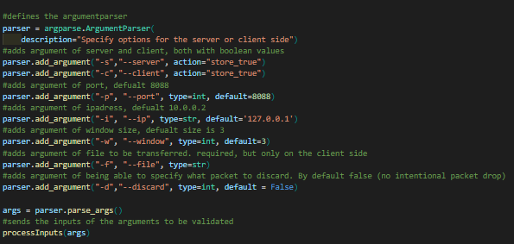
Firstly, the programme gets the mode which the programme is supposed to start in by calling the modeValid() function and storing its return value. The function checks whether the client and server option are given at a single time, or if none of them are. It returns false if the requirements are not met, which makes the programme close.
Next, the programme checks for a valid ip address with the ipValid() function, and returns false and terminates if its not a correct length of 4 different segments separated by dots “.” or the address contains a number which is not in the range 0-256.
Continuing forward, the programme then checks for a valid port number with the portValid() function by checking if the number is in the range 1024-65536, if it is not the function returns false and the programme terminates.
Now the programme checks for a valid window size that is a positive integer by calling the windowValid() function. If it is anything but a positive integer, the function returns false, and the programme terminates. If a window size is specified with the startup in server mode, it is simply ignored.
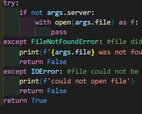
Thereafter, it checks the specified file that is wished to be transferred with the fileValid() function. A file may only be specified when in the client mode, and a file is needed to proceed into the main file transfer programme. It then checks whether the specified file exists on the client’s computer, and if its readable. If any of the statements are false it returns false, and the programme terminates. Else it returns True.
After checking the file, it then checks the –discard option by calling the discardValid() function. By default, this option is set to a False, but when specified it changes to an int. the programme checks if it is a positive integer, and if it is specified with anything but the server. If any of these statements returns False, the function returns false and the programme terminates, else it returns true.
If all the validation tests passed, the programme then prints the mode the application is running on as well as the IP and Port number the application is using. If the client mode was to be run, the programme then calls the imported Client() function from the client.py file. On the other hand, if the user was to launch the server, the programme calls the Server() function, which is also an imported function from the server.py file. Both the Server() and Client() function takes in the args argument, which is an object containing all the arguments passed by the user.
Note: this application.py file contains code from previous assignments in data2410 of my own. Especially Oblig1 where the argparse module was used extensively.

client.py
The client.py file contains all the code for the client side of the programme and contains only one function, the Client() function. Firstly, the socket, sys and collections modules are imported as well as a custom made utilityFunctions, which contains all the functions and other utility which are used by both the server and client side. Other functions were placed there as well to improve the readability of the code.
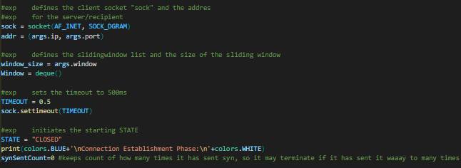
The Client() function takes in the args object which contains all the necessary user inputs to make the programme function. Firstly, the socket object is created and stored in the sock variable. The socket is defined with AF_INET which uses the tuple (ip, port) to make a connection. It also uses the SOCK_DGRAM which specifies the use of a datagram protocol. Together it defines a UDP socket object. It then defines the address which the connection is going to connect to, which uses the user ip and port number input. Then the window_size variable is set, which holds the user window size input. After that a deque is implemented in a Window variable which will be used to store the packets that are currently in the sending window. I used a double ended queue to pop and push from both sides. Then a default TIMEOUT variable is set and sent into the sock.settimeout() function, here the TIMEOUT variable is set to 500 milliseconds. Then the initial STATE of the programme is set, here to “closed”. A synSentCount Variable with value 0 is also initialised so that the programme can keep track of how many times it has sent a SYN packet at the beginning of a connection, so that it may time-out in a worst-case scenario where it doesn’t get a connection.
Then the programme enters an infinite while loop, a state-machine, which is the core client programme. Since the state is set to closed, the client enters the first “if-box”. The client tries to initiate a connection to a server by sending a SYN packet to the address given by the user. The sent packet has seq = 0 ack = 0 and the SYN flag set, which gives a decimal value of 8. Then the STATE is set to “SYN-SENT” which allows the programme to enter the next if-box.
When the STATE is SYN-SENT, the client tries to receive a packet. If it gets no packets, the client sends another SYN packet and waits again. If the client sends 4 SYN packets, the client closes. If the connection between the client and the server was closed by force, the client closes as well. The client tries to receive 1000 bytes at a time, of which the first 6 are the header, and the latter are the data. Now one of 2 situations may take place, if none of them take place, a timeout is raised, and the SYN packet is resent:
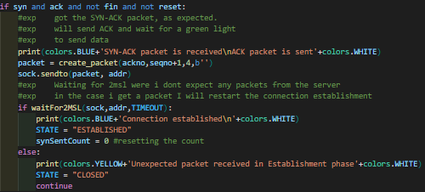
Case 1. If the client receives a SYN-ACK packet and only a SYN-ACK packet, the client sends another packet in return that has seq = received ack, ack = received seq+1 and the ACK flag set. Makin this an acknowledgement packet, which in this case has a sequence number of 1 and acknowledgement number of 1. After that is enters a waiting phase, which lasts 2 * the current timeout, which in this case is 500ms*2 = 1 second. If no packets are received by the client in this period, the client assumes that the server got the acknowledgement and that it is ready to receive data packets. The client will then move to the data transfer part of the programme by setting the STATE to ESTABLISHED. If the client gets a packet in the waiting period, the acknowledgement packet is simply retransmitted, and another waiting period commences.
Case 2. If the client receives a SYN packet something is assumed to be wrong. The client responds with a SYN-ACK packet with updated seq and ack numbers and then moves to a connection close by setting the STATE to be TEARDOWN. A state which is covered later.
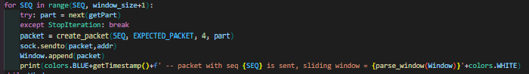
When the connection is established, and both the client and server is ready to receive and send packets, the programme moves to the established state. Firstly, the EXPECTED_PACKET variable, which holds the sequence number of the next expected packet received from the server. Then the SEQ variable is initiated, which is the current sequence number that the client is going to send out. Both of these are often 1 when entering the ESTABLISHED state. Next the getPart variable is initiated, a variable that houses an initiated generator function, with an argument of the file that is whished to be transferred, that sends out the next piece of a file as it is requested by generator.next(). Since the args.file is already been opened in the fileValid() function, it is safe to initiate without handling errors. Next a for loop is entered, where it starts from the current sequence number, often 1, then loops through all the numbers from the SEQ value to the window size, including the window size value. The purpose of this loop is to send the first few packets to start the file transfer. The programme tries to get the next part of the file, and if the file is now empty, it throws an error and breaks out of the early transmission phase. If not, a packet gets created with the current sequence number of the client, and the next expected packet from the server, often going to be 1. The ACK flag is still toggled on, and the next part of the file is added. The total size of the packet is not 1000 bytes, where the header contains 6 bytes, 2 for seq, 2 for ack and 2 for flags, and where the data part is 994 bytes. The packet then gets sent to the specified address, and the packet is also added to the sliding window queue, the Window variable. The loop then begins a new iteration if a window size amount of packets have been sent or the file is empty.
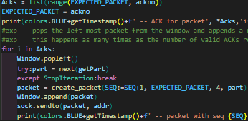
Now the programme enters a receiver phase by entering a while loop that runs as long as there are elements in the window. Firstly, the programme tries to receive a packet of 1000 bytes. If the programme never receives a packet, the client will assume all packets currently in the sending window to be lost, and they are to be retransmitted. It retransmits the packets in the window with the GBN() function from the utilityFunctions file. If the client receives a packet, it then parses the header and the flags in order to check what kind of packet it just got. If ack - 1 is the same as the packet that the client wants (which is also the left most packet in the sending window) that means that the server has received the left-most packet in the sending window and asks for the next packet in the sending window. If ack – 1 is greater than the expected packet number, that means the client just got a cumulative ack. A cumulative ack is when the server receives an ack that is an acknowledgement of more than one packet at a time. If the client got a valid ack, the client then makes a list of all the packets that got acknowledged, and sets the EXPECTED_PACKET variable to the next not-received ACK. The programme then enters a for loop that loops through as many times as the number of received acks. The for loop removes the left-most element and appends a new packet to the sending window if the file still contains unsent bytes. Then a packet gets created with the create_packet() function from the utilityFunctions file. The packet created has the current sequence number, the packet that it wants next as its acknowledgement number, the ACK flag is set, and the rest of the packet is the data. The client then sends the packet back to where it got the ACK packet, and the programme enters a new receiver phase. This continues as long as there are packets in the window, which will only run out if the file has no more unsent bytes. After the sending window is empty, the programme prints “data finished” to the console, and the closing of the connection is begun by setting the STATE to TEARDOWN.
When the state is set to teardown, which may only happen by receiving a SYN packet while waiting for a SYN-ACK in the connection establishment phase, data being finished transmitting, or a step back in the connection close phase due to unexpected packets. Here the programme creates a packet with create_packet() function and sends it to the sender. The sent packet has a sequence number, acknowledgement number, and the FIN flag toggled on. The programme then enters a “FIN_WAIT_1” state that expects to receive a response.
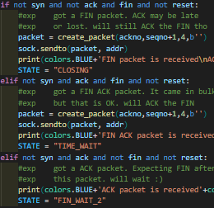
In the FIN_WAIT_1 state, the client tries to receive a response from the server. If no packets are received server sets the state to TEARDOWN yet again to retransmit the assumed to be lost FIN packet. If the client does receive a packet, it checks whether it’s a FIN packet, FIN-ACK packet or an ACK packet. If it is a FIN packet, the server will send an ack to the server, then go to a closing state that waits for another packet. If the received packet is a FIN-ACK packet, the server sends an ack for the received FIN and then enters a waiting period to ensure a proper close before exiting. Lastly, if the client receives an ACK packet, the client will wait for what is expects to be a FIN packet, which it does in the FIN_WAIT state. If the received packet is not a FIN, FIN-ACK or an ACK, the client will throw a timeout error and resend the first FIN packet.
When the STATE is equal to CLOSING, the server tries to receive a packet from the client. If no packets are received in a period of TIMEOUT, the server will resend a FIN packet and then try to receive another packet. If the client receives an ACK packet from the server, the client will change its state to TIME_WAIT, where it will wait for a longer period before closing the connection.
If the STATE is FIN_WAIT_2, then the client will try to receive a packet from the server with a size of 1000 bytes. If the client receives anything but a FIN packet, or no packet at all, then the programme enters a new period of waiting. If the client gets a FIN packet from the server, it will send an acknowledgement packet in return for the FIN packet, then go to the TIME_WAIT state where it will wait for a longer period before closing the connection with the server.

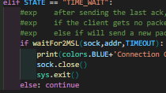
Lastly, when the STATE is TIME_WAIT, the client expects no packets from the server. The waitFor2MSL() gets called function from the utilityFunctions file which returns True if no packets where received and returns False if a packet that was not expected was received. If the client gets no packets,then the client will assume that the server got the last sent packet and will close the connection and end the programme. If the client were to receive a packet that was not expected in the longer waiting period, then the programme will simply do nothing and begin a new waiting period.

server.py
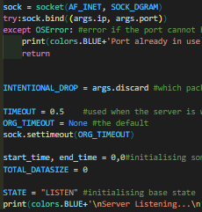
If the user wished to start the programme in server/receiver mode, then the Server() function will be called from the application.py file with the args passed from the user input as arguments. Firstly, the socket, sys, and time modules are imported for defining the socket object, access system functions, and to measure the total transfer time. When the Server() function is called, the arguments from the user are passed as an object and are used before the main loop of the programme is initiated. The socket object is defined with AF_INET which uses a tuple (ip, port) to make a connection, as well as using SOCK_DGRAM which specifies the use of a datagram protocol. This makes the socket object, stored in the sock variable, a UDP socket. The programme tries to bind the socket to the user specified ip and port number, which will throw an OSError if the address is already in use. If the address is already in use, the programme handles the exception by printing an error to the terminal and exiting the programme. Next, the INTENTIONAL_DROP variable is initiated, which holds the sequence number of a packet that the server-side user wants to get dropped. Then a timeout if defined. By default, the timeout is set to None, but in cases where the server sends a packet and expects a return, the TIMEOUT value of 500ms (same as client) will be used. The start and end time of the file transfer is initiated, and a TOTAL_DATASIZE variable is defined as well. Then the initial STATE of the server side is defined as “LISTEN” and a status message is printed to the terminal before entering the core of the server-side programme.
The core of the server-side programme is a state machine implemented as an infinite while loop. The first if-case is for when the STATE is LISTEN, which may only happen if the programme has just started, or if the programme has finished a data transfer and wants to accept a new connection. Here the server is listening for incoming packets, and if a received packet is a SYN packet, which means a client is trying to connect, the server will respond with a packet created with the create_packet() function from the utilityFunctions file. The response-packet has a sequence number, acknowledgement number and the SYN and ACK flags are set, 12 in decimal. The response-packet is then sent to the address where it got the SYN packet, and the STATE is set to SYN_RCVD.
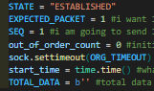
When the STATE is SYN_RCVD a timeout of 500 ms is set, where it expects a response for the previous sent SYN-ACK packet. The programme tries to receive a packet from the client, throws a timeout error if the timeout value of 500 ms is violated. In that case, the exception is handled by resending the SYN-ACK packet, and then waiting for a response again. If the server receives a packet, the packet gets parsed, and the server checks what kind of packet it is. If the received packet is an ACK packet, the connection is established, and the server will send nothing in return. If the received packet is not an ACK, then the programme will throw a timeout error, which gets handled same as previously. When a connection is established, an EXPECTED_PACKET variable is initiated, with value 1, and the sequence number of the server-side is initiated with a value of 1 as well. Since the server is expecting data packets at any time from this point and onwards, the star-time for the file transfer is noted down. The timeout of the server-side is set to None, since it is the client’s job to resend lost packets, and a TOTAL_DATA variable that stores all the in-order packet data is initiated as well. The STATE is also changed to ESTABLISHED.
When the STATE is established, the server is expecting packets at any given time. The server listens for packets and if a packet is received, the server parses the header and flags before storing the data of the packet in a temporary data variable. Here one of 2 cases may take place:
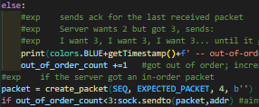
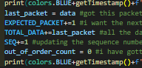
Case 1. The server receives a data packet from the client. Before the packet if processed and server-side information is changed, the programme checks if the user wants to drop this packet intentionally. If so, then a message is printed to the terminal and the intentional drop variable is toggled of before telling the server to listen to a new packet. If the packet is not to be dropped, then the programme checks if the received packet is an in-order packet, meaning that it is what the programme asked for most recently. If the received packet is an in-order packet, then the server will update the expected packet variable to the next packet which the server wants and saves the received data in a last_packet variable. Then the programme stores the data from the in-order packet and updates the sequence number of the server. the server then sends an acknowledgement to the client with updated acknowledgement number and sequence number. If the received packet is not an in-order packet, then the programme will not change any server-side variables but will note down how many times it has gotten an out-of-order packet in a row. If the server receives more than 3 out-of-order packets in a row, the server will not send anything, as to not overload the client. If it has not gotten more than 3 out-of-order packets, then the server will send a response to the client that it wants the in-order packet that is missing.
Case 2. The server receives a FIN packet form the client. This means that the client has finished the file transfer and has gotten an acknowledgement for all the sent packets and is now ready to close the connection. The programme takes note of the time at the end of the file transfer and sends an ACK packet in return to where it got the fin packet. The STATE now changes from ESTABLISHED to CLOSE_WAIT.
When the programme is waiting to close after sending ack for the received fin, then the server sends a fin packet of its own, where the sequence and acknowledgement number are equal to the previous ACK sent. Now the programme changes its STATE to LAST_ACK.
If the STATE is LAST_ACK, then the programme changes the socket timeout to be 500 ms. After that the server is trying to receive a packet which is expected to be an ACK from the previously sent FIN. If the timeout period of 500 ms is violated, or the server receives a packet that is not an ack, the programme will throw a timeout error. The timeout error gets handled by changing the state back to CLOSE_WAIT, which resends the FIN packet. If the server receives an ack packet, that means the client received the fin packet, and is now ready to close as well. The timeout is reset to None, and the STATE is set to CLOSING.

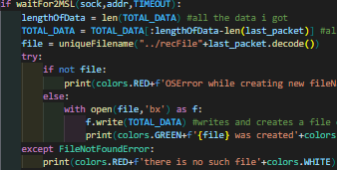
Lastly, if the state of the server is closing, then the server will start a longer waiting period of 1 second in this case. In this period, the server expects no packets to arrive, and if any packets do arrive, then the programme enters a new waiting period. If no packets arrive in the final waiting period, that means that the client is ready for closing. Firstly, the length of the transferred data is stored in a variable. Then the “redundant” filetype (which was the last packet sent and is currently stored in the last_packet variable) is removed from the total data size. The programme then finds a unique name for the recreated file + filetype by calling the uniqueFilename() function with the location of the new file as an argument. If there was an error in creating a location for the new file, then the programme prints the error and doesn’t save the transferred data. If the filename doesn’t exist, the programme exits the file saving and prints an error. If not, then the file gets opened in create and byte mode and the received file from the data transfer is written to the file. Then the total size of the received file is calculated. Since the size is originally in bytes, the size gets multiplied by 8 to go from bytes to bits, then divided by 1 million to convert from bits to Megabits. Then the throughput is calculated by dividing the data size (in Megabits) by the total time spent (in seconds) which is delta time = end time – start time. This takes place in the calcThroughput() function from the utilityFunctions file, which edits the length of the throughput value so that the value has at least 1 non-zero decimal point. Then all the transfer information is printed to the terminal before the connection and programme closes. If one wishes to keep the programme running, in case of multiple files being transferred, one simply has so comment out the sock.close() and sys.exit() lines. In that case the server-side variables are reset to what they were before the connection, and the STATE is set to LISTEN, so that the programme may handle a new client.
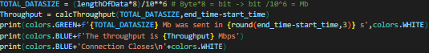

utilityFunctions.py
this file contains all the functions that gets used by the client-side code or the server-side code. It contains functions to define, create and parse the header and packet. It holds the go-back-n reliability function. A class that holds colours that is used to make clear and readable prints to the terminal. The readFile() function that returns the next iteration of the file. A function that returns the current time, so that prints to the terminal are clear. It contains a function to parse the packets that are currently in the sending window, where they get curly braces instead of brackets. The function that calculates the throughput of the transfer, in Megabits per second. There is a function that finds a unique name of the transferred file, so there won’t be any duplicate filename errors. And lastly, the function that both the server and client use to set a timeout period of 2MSL and wait for any unexpected packets. The struct, datetime, os, and socket modules are imported to construct and send packets to a recipient, get the current time for prints to the terminal, and access the OS to check whether a file with the same name already exists.
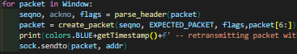
Firstly, the GBN() functions is used to resend the n amount of packets that are in the sending window. The function takes in the current Window, the socket object, the address of the recipient, and the expected packet that the client wants next. The function uses a for loop that loops through all the packets in the sending window. For each packet in the window, the programme parses the header to get the packet sequence number and flags. The programme creates a new packet with the old seq, flags and data, but with an updated ack to reflect what packet the server should send next in return. A message then gets printed to the terminal and the packet is sent to the server.
The header_format specifies how the programme wants the header to be created. H means 2 bytes, so the header will contain 2 bytes for sequence number, 2 bytes for the acknowledgement number and 2 bytes for the flags (4 bits for each flag). This format is used when creating packing and unpacking headers and packets.
Create_packet() takes sequence number, acknowledgement number, flags, and the data as arguments and uses them along with the pack() function from the struct module to create a packet with the current header format. It returns a finished packet that can be sent to a recipient.
Parse_header() takes only the packet as an argument and unpacks the header from the packet with the unpack() function from the struct module. it returns the header as a tuple, here it returns the tuple seq, ack, flags.
Parse_flags() takes only the packet flags as an argument and returns a tuple of the flags, in this case syn, ack, fin, reset. The flags variable is a decimal number that gets turned into a binary number. The programme then checks if the 1 in spot 3, a 1 in spot 2, a 1 in spot 1 and a 1 in spot 0. A 12 decimal number is equal to 1 1 0 0, in binary so the function would return a tuple containing (True, True, False, False).
The colors class is used to store different colour values used in prints to the terminal for better readability. One accesses the colours by calling the class and then using one of the attributes. E.g. colors.OKBLUE +’<instert coloured text here>’+colors.ENDC
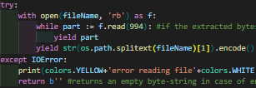
The readFile() generator function is used to yield the next chronological part of size 994 bytes. Since the header is 6 bytes and the total packet should be 1000 bytes, the function may only return a data size of 994 or smaller. The programme tries to open the file in read-byte mode and yield the next part of the file. To use this function, one must first invoke it by calling it with a parameter filename and then storing it in a value. To get the next part of the file one needs to call the generator function with the generator.next() function, which takes the variable the generator function is stored in as a parameter. In the case that the reading of the file causes an IOError, the function simply returns an empty byte-string and prints the error to the terminal. When there are no more parts left in the file, the function yields one more packet, which contains the filetype. This allows the transfer programme to transfer any file type, not just jpg pictures.
getTimestamp() is a function used to make the terminal output more readable. It returns the current time of the local machine in the format “Hours:Minutes:Seconds.Milliseconds”.
The function parse_window() takes in a list, most likely the current sending window, and returns the sequence numbers of the packets in the window as a string with curly brackets instead of brackets. “Why curly brackets you may ask? Well, because the examples provided in the assignment had it. Would be more practical to just return an array/list”. The function is used to make print to the terminal more readable.
The calcThroughput() function is used to calculate the throughput value in Megabits per second and return the value with the first non-zero decimal number + one decimal. Often, the result only has 2 decimals, but when testing with too big of a window size the throughput value becomes too close to zero to be readable as anything but 0,00.
uniqueFilename() takes the new wanted filename, f, as an argument and returns a unique version of that filename. E.g the file recPhoto.jpg already exists in the location, the function returns recPhoto_1.jpg. if an error creating the new filename is thrown, the function handles it by returning False. A return value of False will result, on the server-side, with not storing the transferred data.
Lastly, the waitFor2MSL() function takes the socket object, the address of the recipient and the current timeout value for either the client or server. The function is used to ensure that either the client or server has received the most recently sent packet without receiving an acknowledgement packet. The programme sets the current timeout to be double what the regular amount was, and then begins waiting for unexpected packets. Now one of 4 cases may take place:
Case 1. If no packets are received in the waiting period, the most recently packet is assumed to be received, and the function resets the timeout and will return True, moving the programme to a new STATE.
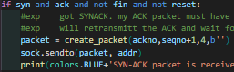
Case 2. If the programme receives a SYN-ACK, the function was called in the connection establishment phase of the client-side. The client just sent an ack for the received SYN-ACK packet and is waiting for the connection to be stable. It the client received a SYN-ACK, then it means that the ACK got lost. The client will retransmit the ACK for the SYN-ACK and then wait some more.
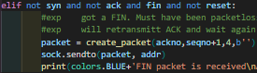
Case 3. If the programme receives an unexpected FIN, then the function was called at the end of the connection teardown process of either the client or server. since the programme got a fin packet, the programme should respond an ack in return, then restart the waiting period and hope that is it received by the recipient.
Case 4. The programme received a packet that was neither a FIN nor a SYN-ACK packet. That means something unexpected has happened, and it will be handled differently based on where in the code the wairFor2MSL() function was called. The programme sets the timeout variable back to what it was, then the function returns False.

Discussion

I executed three different file transfers, each with the same file sent, and on average same round-trip time, but with different sizes for the sending window. The file that was used was a jpg file with a size of 14,60 Megabits. The on-average round-trip time was 100 milliseconds. In the first file transfer I used a window size of three packets, and it took 66,78 seconds to fully transfer the file from client to server which gives us a throughput of 0.21 Megabits per second.
For the second transmission, I used a window size of 5 packets, which took 42,88 seconds equalling a throughput of 0,34 Megabits per second. This is a considerable increase in throughput considering that only two more in-air packets were allowed at a time. The information currently at our disposal is indicating that a 66% increase in window size yields a ~66% increase in throughput and a ~33% decrease in total transfer time. This statement only gets reinforced after retransmitting the file, but this time with a window size of 10 packets. Given the previous observations, the results should be a 100% increase in window size yields half the total transmission time and double the throughput. The actual results are a total transmission time of 22,63 seconds and a throughput of 0,64 Megabits per second.
Although these results are in-line with the previous statement, that window size and throughput are directly proportional to one another and window size is inversely proportional to total transmission time, it is not necessarily true. As the window size increases, more packets are allowed to be in transmission at any given time, which means more information being sent at once. When more packets are on the wire at a single time it increases the throughput, which may behave as the previous statement, but this trend does not continue. If one were to continuously increase the window size, it would reach a bottleneck in the connection. An increase in window size beyond this bottleneck would only decrease the throughput, as it would lead to packets being dropped, which induces a retransmission phase. On the other hand, utilizing too small of a window size is also not optimal due to an increase in waiting for acknowledgments of sent packets, which is time that should have been spent on sending more packets. Considering the window sizes 3, 5 and 10 are relatively low and close to 1, one may draw the conclusion that even a window size of 10 is enough to reach the bottleneck of the connection, hence why we can only observe a linear increase in throughput and a linear decrease in transfer time.
Results for discussion 1:
Round-trip time (ms) | Window size | Transfer time (s) | Throughput (Mbps)
100 | 3 | 66.78 | 0.21
100 | 5 | 42.88 | 0.34
100 | 10 | 22.63 | 0.64

I performed 3 separate file transfers, each with a different sliding window size. However, unalike the last test, this time I configured the round-trip time to be 50 milliseconds. The results which the file transfer gave were not out-of-line with previous observations, considering a halving the former round-trip time of 100 milliseconds gave half the transmission time and a double the throughput.
For a window size of 3 packets, I got a transfer time of 33,56 seconds and a throughput of 0,43 Megabits per second, which is in keeping with prior observations. Furthermore, a window size of 5 returns a transmission time of 20,63 seconds and a 0,70 Megabit per second throughput, and lastly a window size of 10 packets managed to transfer all the packets in 10,93 seconds, which equals a throughput of 1,33 Megabits per second. Here one can observe what was previously discussed in the last paragraph. It was made intelligible that the throughput kept increasing linearly with window size due to reducing the redundant time spent waiting for acknowledgements of sent packets, time that could have been better spent sending more packets. By reducing the round-trip time, it makes the sender wait for a shorter time intermediate of sending more packets. Considering a shorter waiting period affects the lowering of latency, which has a consistent positive effect on the throughput.
On the other hand, when I transferred 3 more files with a round-trip time of 200 milliseconds, each with a window size of 3, 5 and 10 respectively, one could observe the opposite effect the round-trip time could have on a connection and the total throughput. Even though the increase from 3 to 10 in-air packets at one time is substantial, one can still remark that a window size of 10 packets on a round-trip time of 200 milliseconds is less favourable than a 50-millisecond round-trip time with a window size of 3 packets. This is a consequence of an increase in waiting for acknowledgement packets.
In short, just as the amount of “on-the-wire” packets has a substantial effect on the end throughput value, so does the round-trip time of the connection. Earlier we concluded that one may not increase the window size on-to infinity due to bottlenecks in the connection that will result in packet loss. But from the results found in tests with different round-trip times, one can deduce that an increase in window size can make up for an increase in round-trip time. To be able to maximize the efficiency of a connection, one should try to estimate the available bandwidth. This could be done in a number of ways, but what they have in common is that they start with a small value and increase the window size when there is no packet loss and decrease the window size when they experience packet loss.

Results for discussion 2:
Round-trip time (ms) | Window size | Transfer time (s) | Throughput (Mbps)
50 | 3 | 33.56 | 0.43
50 | 5 | 20.63 | 0.70
50 | 10 | 10.93 | 1.33
200 | 3 | 141.45 | 0.10
200 | 5 | 85.34 | 0.17
200 | 10 | 46.48 | 0.31

Here I chose to send a smaller file of only 0,15 Megabit rather than the higher quality jpg file of 14,60 Megabit so that I may see output of the programme in its entirety when a packet is dropped intentionally. The client side splits the file up into 20 packets, where I chose to drop packet 8. I initiate the server by sending:
python3 ./application.py --server --ip 10.0.1.2--port 8088 --discard 8
Then, when the server is up and listening to the correct port, I start the client with:
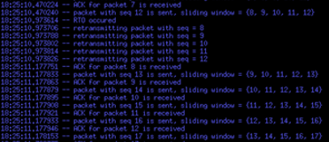
python3 ./application.py --client --ip 10.0.1.2 --port 8088 --file ./Photo.jpg --window 5
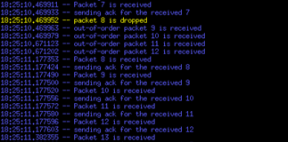

As the output shows, the client sends packets and after 200 milliseconds, which is the RTT, the client receives an ack for the first packet that was sent. This continues steadily where it only sends a new packet when it receives a packet with the acknowledgement number that is not lower than the to be sent packet’s sequence number.
In this case, when the server receives sequence number 7 from the client, it sends an acknowledgement for 7 by asking for the next in-order packet, which is 8. But when the server receives 8 it discards it and does nothing. So now the server gets a packet with sequence number 9, but it needs 8 to move along, so it sends a packet in return with an acknowledgement number of 8. When the client receives the acknowledgement packet with ack 8, it will not accept it. Since the ack is lower than the previously sent packet, the client enters a timeout period of 500 milliseconds, which one may observe in the difference in the timestamp of the last in-order ack packet received and whenever the RTO occurred. Since the client does not get any acknowledgements in this period, the client assumes all the packets currently in the window to be lost, and they are to be retransmitted.
When all the packets in the window is retransmitted, the client goes back to waiting for acknowledgments for the packets in the window. If the same problem where to occur, the client would yet again enter a timeout period of 500 milliseconds and retransmit all the packets in the window if no acknowledgement packets where to arrive during the timeout.

When previously discussing the effects window size and round-trip time had on the end throughput value, an anomaly occurred. It seemed like as the window size increased so did the throughput value, and it did so linearly. I concluded that the bottlenecks of the connection never appeared due to the low number of bytes that were on the wire at any given time, and that one would run into packet loss if one were to transmit data over the available bandwidth.
To begin with, I tested the connection by transmitting a file of 14,60 Megabits over a connection with 2% packet loss, 100-millisecond round-trip time and different window sizes. The first file transfer, with a window size of 3 packets, took 89,66 seconds to complete which results in a throughput of 0,16 Megabits per second. When comparing these results to the earlier file transfer with 3 as window size and 100-millisecond RTT, we can observe a significant downgrade in performance. Going from 0% to 2% packet loss gave a decrease of 24% in throughout, and a 34% increase in transfer time.
Furthermore, I transferred the same file, but now with a window size of 5. Although there was some improvement from window size 3 to 5, there are still a lot left to be wanted. The file transfer took 65,50 seconds and had a throughput of 0,22 Megabits per second. This time around we can see an increase of 52,7% in transfer time, and a decrease of 35,3% in throughput when compared to the same transfer but with 0% packet loss. Even though there was a significant downgrade from 0% to 2% packet loss when sending with a window size of 5, there was still some improvement from the same amount of packet loss but from window size 3 to 5. There was a decrease in transfer time of 27% and an increase of 37,5% in the throughput. Despite the fact that there was an increase from 0% to 2% packet loss, there was still some positive changes from the increase in window size. This time though, the correlation between window size and throughput is not as strong, considering an increase of 66% in window size used to give an increase of ~60% but now only results in an increase of ~37%. This observation strongly supports what was previously discussed, that the connection was not heavily enough loaded to reveal the bottlenecks, and therefore not show any negatives of increasing window size infinitely.
This is clear once you note the results following the file transfer with 10 in-air packets at a time. This time the transfer took 48,67 seconds and had a throughput of 0.29 Megabits per second. The results here are in-line with the previous statements, considering that the difference from 0% to 2% loss results in half as big of a throughput and over double the transfer time. The difference from window size 5 to 10 with 2% loss gave a 25% decrease in time and a 31% increase in throughput but take note that this is with a 100% increase in window size. Going from 3 to 5 in window size gave the same positive change as going from 5 to 10 in size, percent wise. So, when packet loss is introduced, the throughput has reached the available bandwidth, and the growth curve will no longer look like a linear graph like y = a*x + b, but more like y = x². At a certain point, an increase in window size will negatively affect the throughput, as demonstrated by a graph like y=x^2. Enlarging a window size that is already producing packet loss will only escalate the number of packets lost, amplifying the current problem at hand. We may verify this idea by doing the same file transfer test, but this time we may use a loss constant of 5% instead of the previous 2%.
After finishing the file transfer with all three window sizes we can see the following: With a window size of 3 it took 140 s and had a throughput of 0,10 Mbps. When transferring with a size 5 window it took 110 s to transfer the entire file giving a throughput of 0,13 Mbps. Lastly a window size of 10 used 78 s to transfer the file and the throughput was 0,18 Mbps. These results are in-line with what was previously stated, and if compared with previous results, emphasises the problem of flow control when overloading a connection. When the window size was 3, it got 100% slower and had a 50% lower throughput compared to when the loss was at 0%. While the window size was 5, the transfer got 157% slower and the throughput was 61% slower. Lastly, during the transfer with a window size of 10, the file transfer took 245% longer and had a 71% worse throughput value. With these values we can clearly see that the file transfer has taken a major hit and has slowed by a sizable amount. However, we can still see that enlarging the window size increases the throughput value, but it increases with smaller and smaller increments. From size 3 to 5 it got 21% faster and bettered the throughput by 30%. From size 5 to 10 it got ~30% faster and bettered the throughput by 38%.
In conclusion, by adding packet loss to a file transfer, even a relatively small amount, will slow the transfer drastically. When one continuously increases the sending window size, without a regard for overload, the sender will begin to experience packet loss most likely due to, but not exclusive by, the bandwidth capacity being reached. In a case like this, where the sending capacity has been reached, and the sender begins to experience packet loss, the programme should use congestion control to alter the size of the sending window so packet loss will occur less frequently.

Results for discussion 4:
Packet loss | Window size | Transfer time (s) | Throughput (Mbps)
2% | 3 | 89.66 | 0.16
2% | 5 | 65.50 | 0.22
2% | 10 | 48.67 | 0.29
5% | 3 | 140.07 | 0.10
5% | 5 | 110.32 | 0.13
5% | 10 | 78.01 | 0.18

References

Islam, Safiqul (2024) DATA2410-1 24V Networking and Cloud Computing. Lectures and lecture notes

My own code from Oblig 1 and Oblig 2.

