Nginx负载均衡

1. 下载Nginx
2. 目录结构如下  
   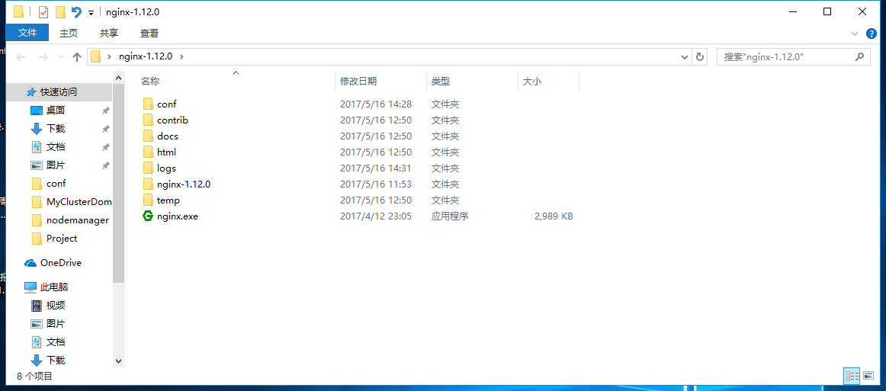
3. 双击nginx.exe即可运行(窗口闪过) 在浏览器输入localhost可以看到nginx页面表示运行成功
4. 配置conf  
   在conf文件夹下配置nginx.conf配置文件如下

#user nobody;

worker_processes 2;

#error_log logs/error.log;

#error_log logs/error.log notice;

#error_log logs/error.log info;

#pid logs/nginx.pid;

events {

worker_connections 1024;

}

http {

include mime.types;

default_type application/octet-stream;

#log_format main '$remote_addr - $remote_user [$time_local] "$request" '

# '$status $body_bytes_sent "$http_referer" '

# '"$http_user_agent" "$http_x_forwarded_for"';

#access_log logs/access.log main;

sendfile on;

#tcp_nopush on;

#keepalive_timeout 0;

keepalive_timeout 65;

#gzip on;

upstream server_7003{

server 192.168.1.107:7003;

}

upstream server_7004{

server 192.168.1.107:7004;

}

upstream server_7005{

server 192.168.1.85:7005;

}

upstream server_7006{

server 192.168.1.85:7006;

}

# upstream server{

# server 192.168.1.107:7003;

# server 192.168.1.107:7004;

#

# server 192.168.1.85:7005;

# server 192.168.1.85:7006;

#

# }

server {

listen 80;

# server_name localhost;

location /server1.jsp {

proxy_pass http://server_7003;

}

location /server2.jsp {

proxy_pass http://server_7004;

}

location /server3.jsp {

proxy_pass http://server_7005;

}

location /server4.jsp {

proxy_pass http://server_7006;

}

#charset koi8-r;

#access_log logs/host.access.log main;

location / {

# root html;

# index index.html index.htm;

proxy_pass http://server_7006;

}

#error_page 404 /404.html;

# redirect server error pages to the static page /50x.html

#

error_page 500 502 503 504 /50x.html;

location = /50x.html {

root html;

}

1. 重启nginx应用配置文件即可配合刚才搭建的集群运行