# Experiment No. 8

**Problem Statement:**

Create a JavaScript application with Loops to incorporate the concept of iteration

**Theory:**

**Source code :**

**HTML:**

<!DOCTYPE html>

<html lang="en">

<head>

    <meta charset="UTF-8">

    <meta name="viewport" content="width=device-width, initial-scale=1.0">

    <title>Number Squares</title>

    <link rel="stylesheet" href="style.css">

</head>

<body>

    <div class="container">

        <h1>Squares of Numbers</h1>

        <p>Click the button to display squares of numbers from 1 to 10:</p>

        <button id="generateBtn">Generate Squares</button>

        <ul id="numberList"></ul>

    </div>

    <script src="app.js"></script>

</body>

</html>

**CSS:**

body {

    font-family: Arial, sans-serif;

    background-color: #f0f8ff;

    text-align: center;

    margin: 0;

    padding: 20px;

}

.container {

    background-color: white;

    border-radius: 10px;

    box-shadow: 0px 0px 15px rgba(0, 0, 0, 0.1);

    max-width: 500px;

    margin: 0 auto;

    padding: 20px;

}

h1 {

    color: #333;

}

button {

    background-color: #000;

    color: white;

    border: none;

    padding: 10px 20px;

    font-size: 16px;

    border-radius: 5px;

    cursor: pointer;

}

button:hover {

    background-color: #343434;

}

ul {

    list-style-type: none;

    padding: 0;

    margin-top: 20px;

}

li {

    background-color: ghostwhite;

    padding: 10px;

    margin-bottom: 5px;

    border-radius: 5px;

    border: 1px solid #ddd;

}

**JavaScript:**

function generateSquares() {

    const numberList = document.getElementById('numberList');

    numberList.innerHTML = ''; // clear the list before generating

    for (let i = 1; i <= 10; i++) {

        const listItem = document.createElement('li');

        listItem.textContent = `Number: ${i}, Square: ${i * i}`;

        numberList.appendChild(listItem);

    }

}

document.getElementById('generateBtn').addEventListener('click', generateSquares);

**Output:**

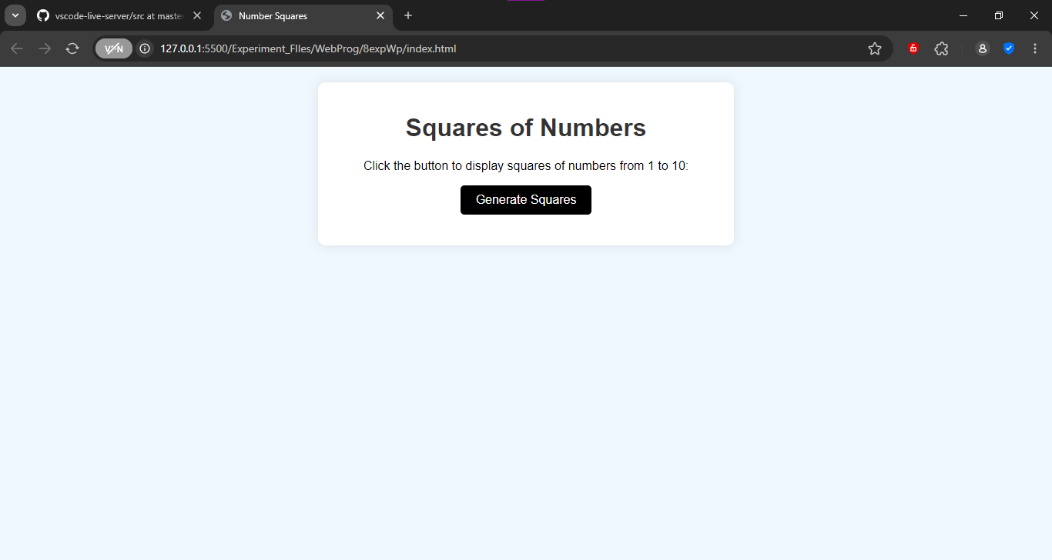

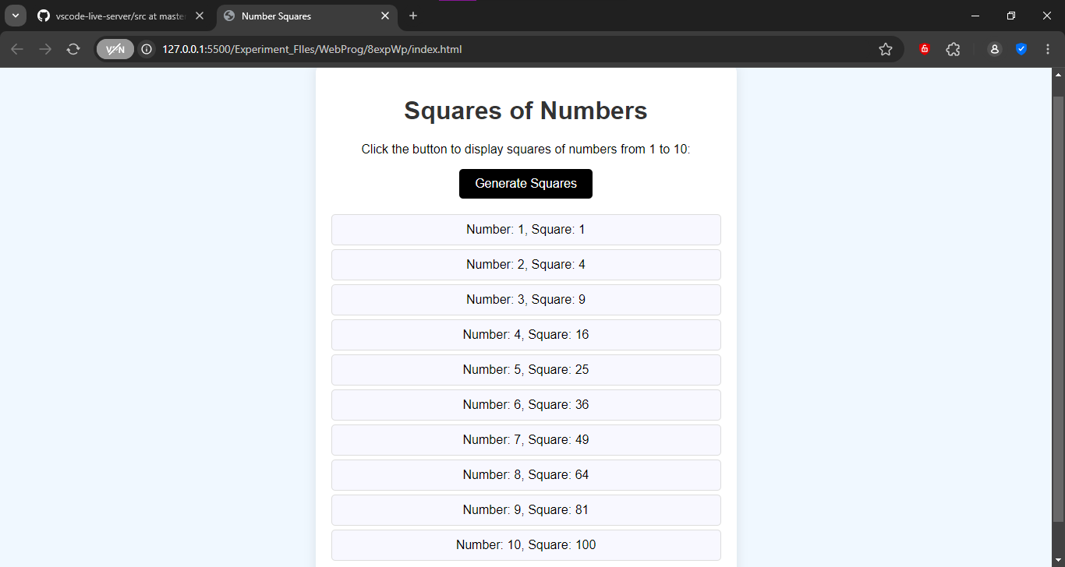

**Learning Outcome:**