

National Textile University

**Department of Computer Science**

Subject: Operating System

Submitted to: Sir Nasir Mahmood

Submitted by:Eisha Muzaffar

Reg. number: 23-NTU-CS-1147

Lab no.: lab6

semester:5th

**Operating Systems – COC 3071L**

**SE 5th A – Fall 2025**

# Objective

The purpose of this assignment is to:

1. Configure **Ubuntu** inside **WSL2 (Windows Subsystem for Linux v2)**.
2. Install and configure **Git** in Ubuntu.
3. Generate and set up **SSH keys** to connect with GitHub.
4. Install the **C development environment** in Ubuntu.

5

.

Write a

**Hello World**

program in

C

.

# Part A: WSL2 & Ubuntu Setup

1. **Verify WSL2 and Ubuntu installation**

Verify installation by running the following command in powershell:

wsl

--

list

--

ver

b

ose

Submit a screenshot showing Ubuntu installed and running on WSL2.

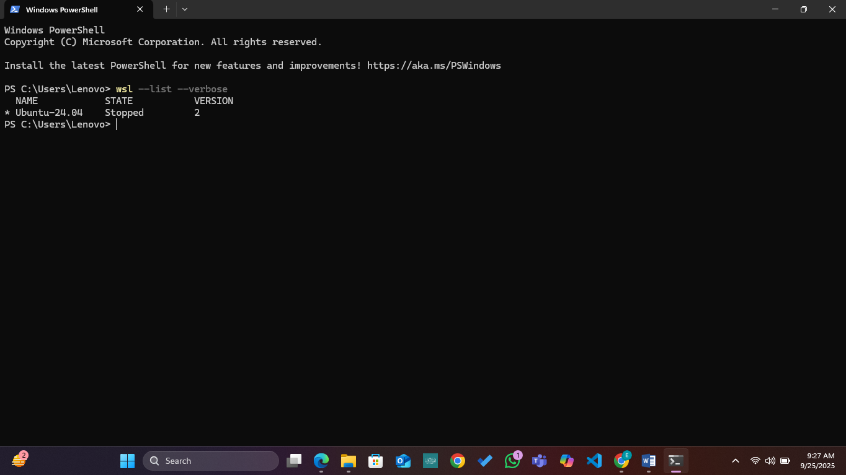

1. **Update Ubuntu environment**

Run the following command in Ubuntu:

sudo

a

pt

upd

a

te

&&

sudo

a

pt

upgr

a

de

-

y

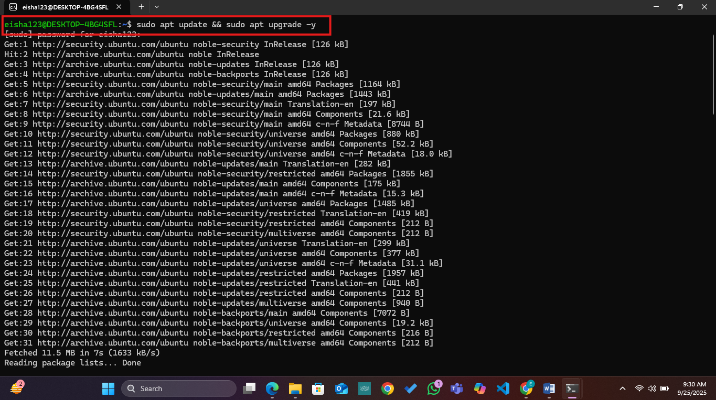

# Part B: Git & GitHub SSH Setup

.

1

**Configure Git**

Set your name and email:

git

c

onfig

--

glo

ba

l

user

.

n

a

me

"

Y

our

Na

me

"

git

c

onfig

--

glo

ba

l

user

.

em

a

il

"

your

@

em

a

il

.

c

om

"

Show your config:

git

c

onfig

--

list

Submit a screenshot.

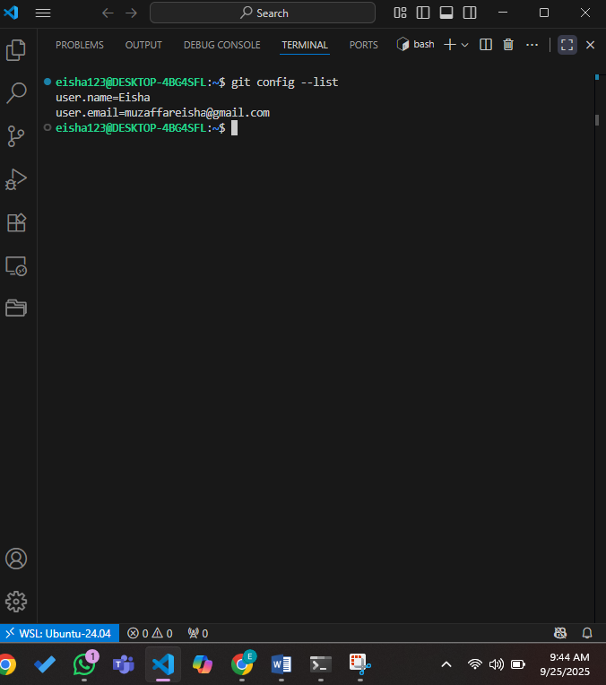

.

2

**Generate SSH Keys**

Run:

ssh

-

keygen

-

t

ed

25519

Copy the public key:

ca

t

~

/.

ssh

/

id

_

ed

25519

.

pu

b

Add this key to your GitHub account under

**Settings → SSH and GPG keys**

.

3

.

**Test Connection**

ssh

-

T

git

@

githu

b

.

c

om

Submit a screenshot showing successful authentication.

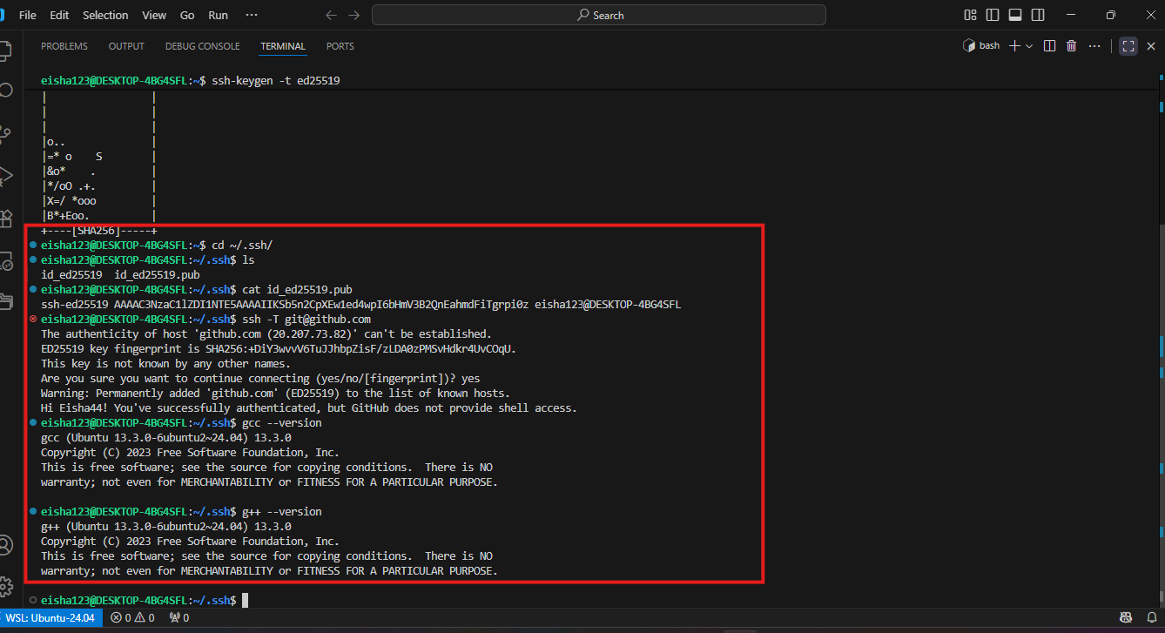

# Part C: C Programming Environment & Practice

## Step 1: Install Build Tools

Before writing C programs, install the **build-essential** package which contains gcc , g++ , and other tools required for compiling.

Run:

Verify installation by checking the version of

g

cc

:

sudo

a

pt

inst

a

ll

b

uild

-

essenti

a

l

g

cc

--

version

Submit a screenshot of successful installation and version output.



## Step 2: How to run a C Program

1. First write a C program in a file with .c extension.
2. Compile the file using gcc filename.c -o filename.out
3. Execute it using ./filename.out

**Breakdown**

This is the GNU Compiler Collection command.

g

cc

It compiles C (and other languages like C++) programs into machine code that can be executed by the computer.

filename.c

This is the source code file you wrote in C.

Example: hello.c contains your C program.

-o filename.out

The option -o means “output.”

By default, gcc creates an executable file named a.out if you don’t specify anything.

With -o, you can choose the name of the output executable.

In this case, the compiled file will be named filename.out.

## Step 3: Write a C Program

Write a simple C program of your choice. It can be a **Hello World** program or any other.

**Submission:**

For the program, submit:

The C source code (

.

c

file).

Screenshot of execution (

./

progr

a

m

)

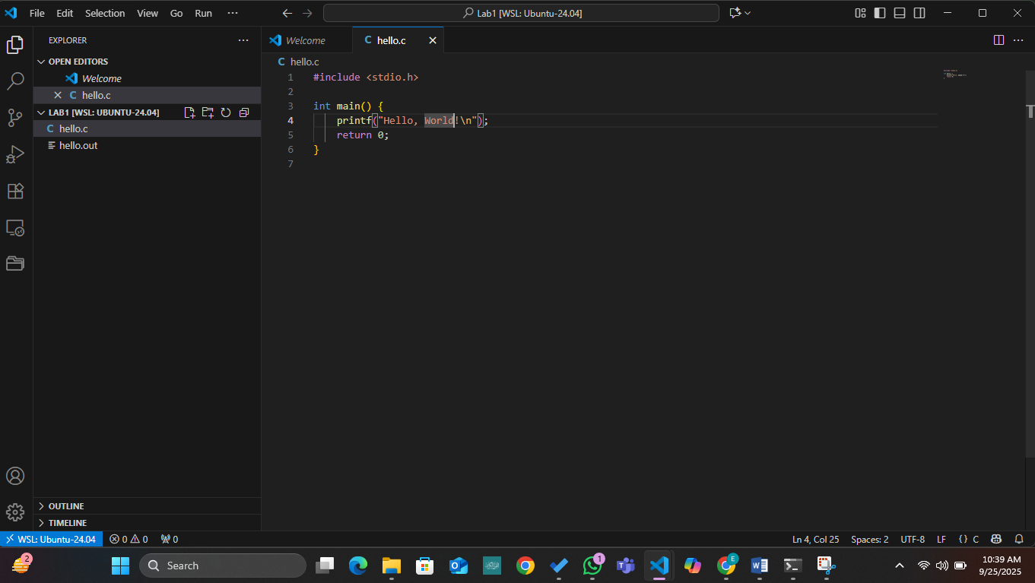

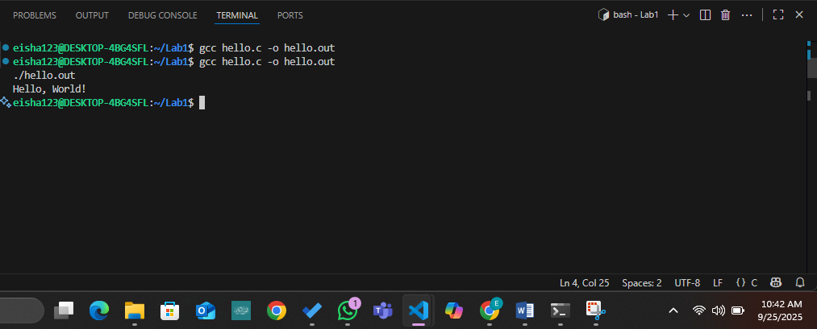

# Deadline

Submit before **12:00 AM, 25 September, 2025**.