#### 

National Textile University

**Department of Computer Science**

Subject: Operating System

Submitted to: Sir Nasir Mahmood

Submitted by: Eisha Muzaffar

Reg. number: 23-NTU-CS-1147

Lab no.: lab2(Hometask)

semester:5th

## Part 5: Text Processing and Utilities

### 5.1 Essential Text Commands

**Commands to demonstrate:**

grep

"

p

a

ttern

"

file

.

txt

#

S

e

a

r

c

h

for

p

a

tterns

grep

-

i

"

p

a

ttern

"

file

.

txt

#

Ca

se

-

insensitive

se

a

r

c

h

grep

-

n

"

p

a

ttern

"

file

.

txt

#

S

how

line

num

b

ers

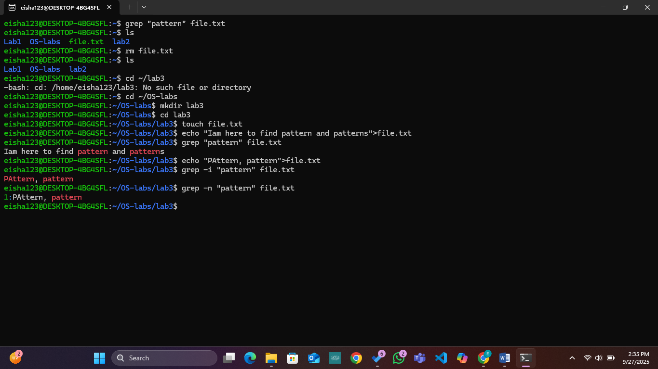

### 5.2 Pipes and Redirection

**Concepts and commands:**

ls

-

l

|

grep

".

txt

"

#

P

ipe

output

ca

t

file

1

.

txt

file

2

.

txt

>

c

om

b

ined

.

txt

#

R

edire

c

t

output

e

c

ho

"

new

line

"

>>

file

.

txt

#

A

ppend

to

file

sort

file

.

txt

|

uniq

#

C

h

a

in

c

omm

a

nds

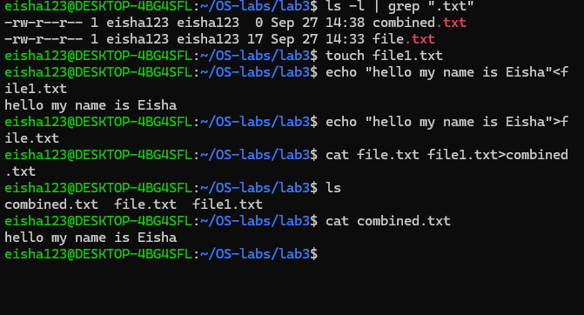

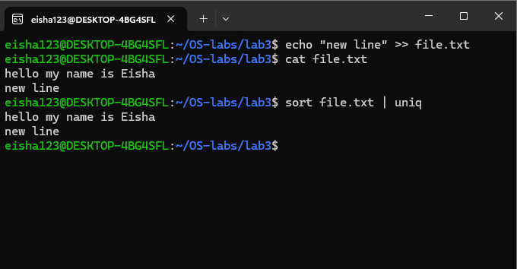

## Part 6: Introduction to Processes

### 6.1 Understanding Processes

**Concepts to Cover:**

What is a process?

Process ID (PID)

Parent-child relationships

Process states

**Commands to demonstrate:**

ps

#

S

how

c

urrent

pro

c

esses

ps

a

ux

#

D

et

a

iled

pro

c

ess

list

ps

-

ef

#

F

ull

form

a

t

listing

pstree

#

P

ro

c

ess

tree

top

#

R

e

a

l

-

time

pro

c

ess

viewer

htop

#

E

nh

a

n

c

ed

pro

c

ess

viewer

(

if

a

v

a

il

ab

le

)

kill

PID

#

T

ermin

a

te

pro

c

ess

b

y

PID

kill

a

ll

pro

c

ess

_

n

a

me

#

K

ill

pro

c

esses

b

y

n

a

me

pkill

p

a

ttern

#

K

ill

pro

c

esses

m

a

t

c

hing

p

a

ttern

