

National Textile University

**Department of Computer Science**

Subject: Operating System

Submitted to: Sir Nasir Mahmood

Submitted by: Eisha Muzaffar

Reg. number: 23-NTU-CS-1147

Lab no.: lab2

semester:5th

**Operating Systems – COC 3071L**

**SE 5th A – Fall 2025**

# Lab 2: Linux Basics and Introduction

## Part 1: Linux Environment Orientation

### 1.1 Understanding the Linux Environment

**Concepts to Cover:**

What is Linux? Brief history and distributions

Linux vs Windows: Key differences

Understanding the shell (bash)

WSL2 as a Linux environment

**Hands-on Activity:**

#

S

tudents

open

WSL

2

termin

a

l

a

nd

explore

who

a

mi

#

C

he

c

k

c

urrent

user

pwd

#

P

rint

working

dire

c

tory

un

a

me

-

a

#

S

ystem

inform

a

tion

d

a

te

#

C

urrent

d

a

te

a

nd

time

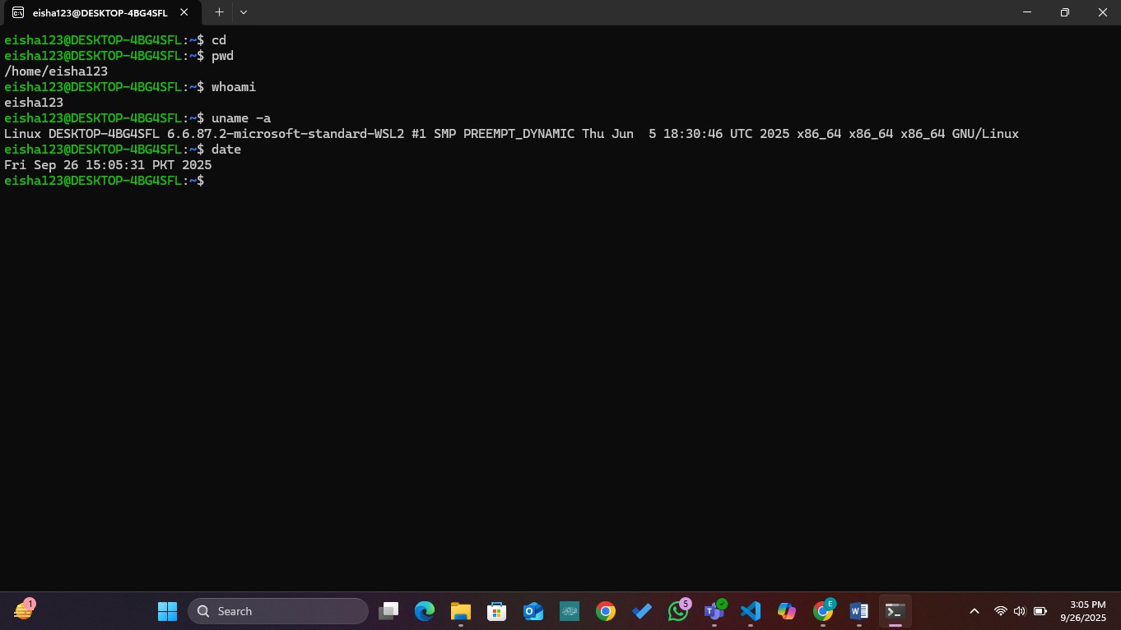

### 1.2 Getting Help in Linux

**Commands to demonstrate:**

m

a

n

ls

#

Ma

nu

a

l

p

a

ges

ls

--

help

#

B

uilt

-

in

help

whi

c

h

ls

#

L

o

ca

tion

of

c

omm

a

nds

type

ls

#

C

omm

a

nd

type

inform

a

tion

Man ls:

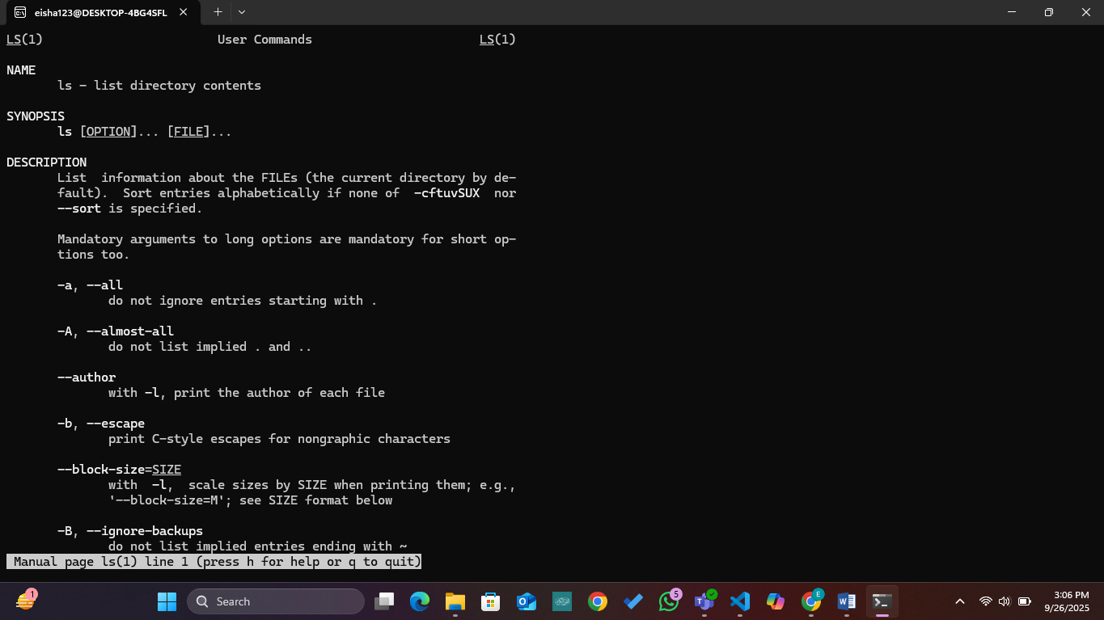

Ls –help:

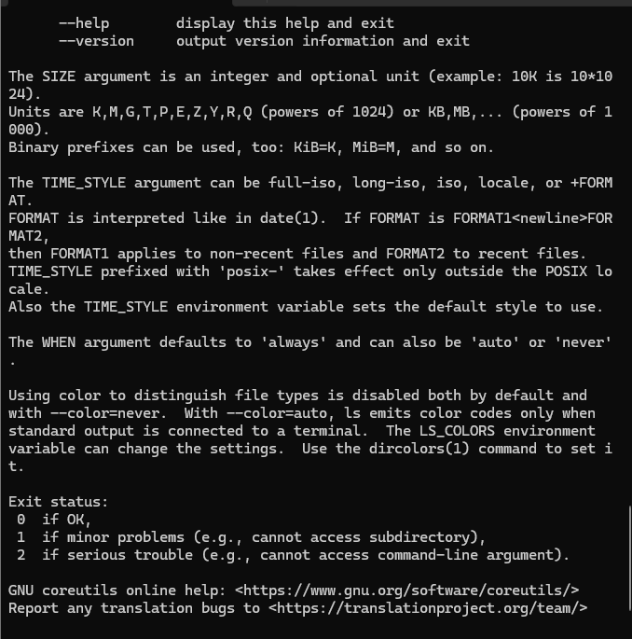

Which ls, type ls:

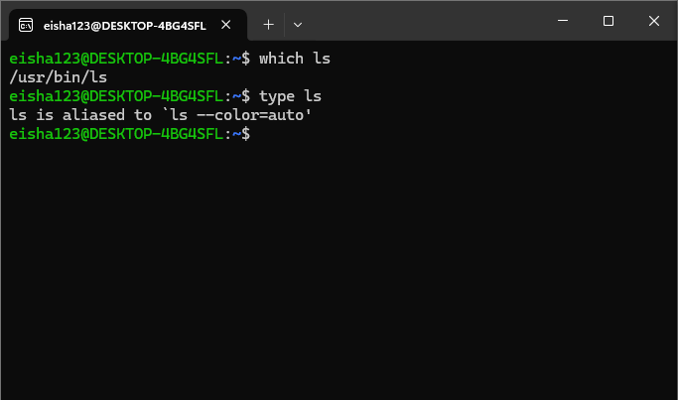

## Part 2: File System Navigation

### 2.1 Understanding Linux Directory Structure

**Concepts to Cover:**

Root directory (/)

Important directories: /home, /usr, /etc, /var, /tmp

Absolute vs relative paths

Hidden files and directories

**Demonstration:**

ls

/

#

R

oot

dire

c

tory

c

ontents

ls

-

l

a

#

L

ong

listing

with

hidden

files

c

d

/

home

#

C

h

a

nge

dire

c

tory

c

d

~

#

H

ome

dire

c

tory

short

c

ut

c

d

-

#

P

revious

dire

c

tory

Ls/ , ls -la:

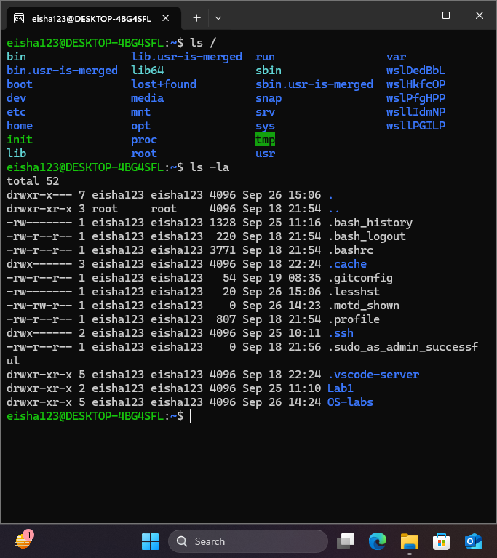

Cd /home:

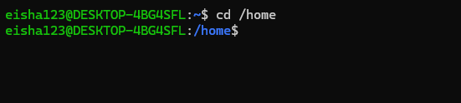

Cd ~, cd-:

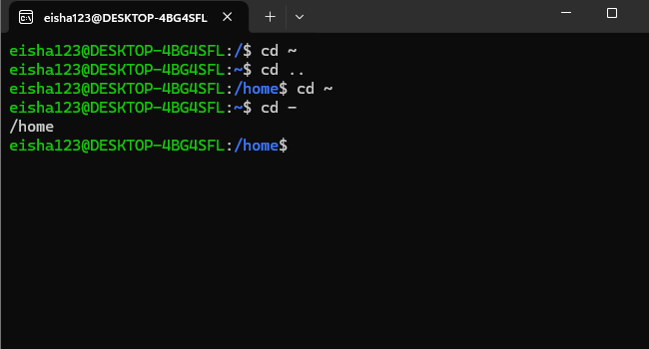

### 2.2 Basic Navigation Commands (15 minutes)

**Commands to practice:**

pwd

#

P

resent

working

dire

c

tory

ls

#

L

ist

dire

c

tory

c

ontents

ls

-

l

#

L

ong

form

a

t

ls

-

l

a

#

I

n

c

lude

hidden

files

ls

-

lh

#

H

um

a

n

re

a

d

ab

le

sizes

c

d

#

C

h

a

nge

dire

c

tory

c

d

..

#

Pa

rent

dire

c

tory

c

d

~

#

H

ome

dire

c

tory

c

d

/

#

R

oot

dire

c

tory

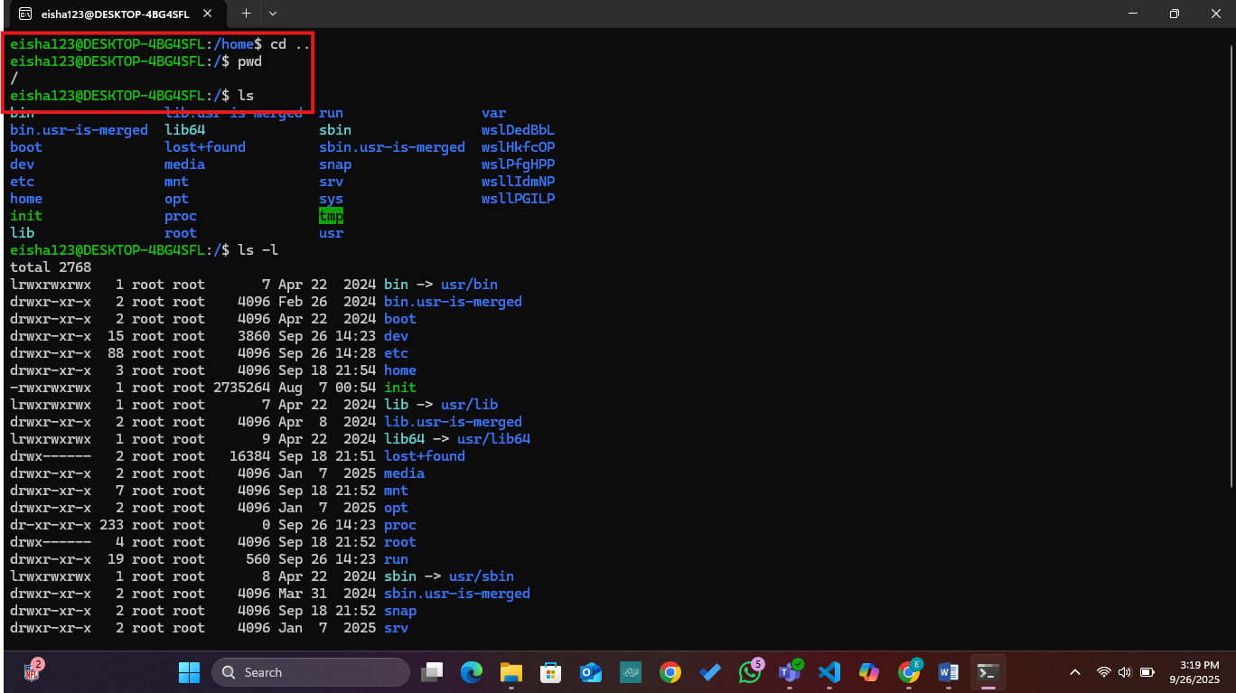

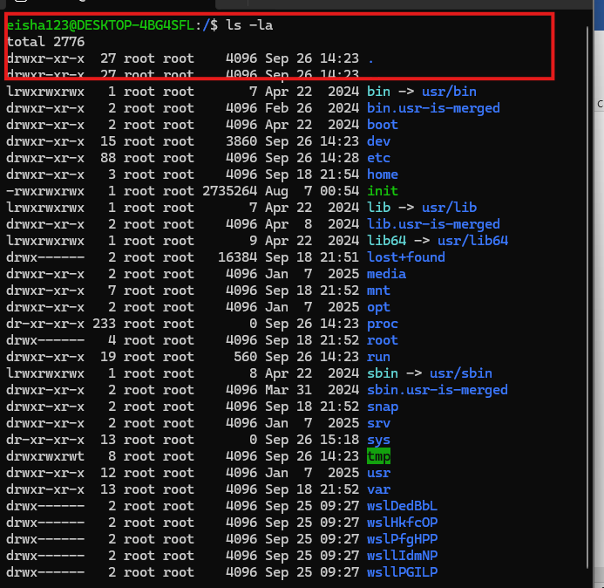

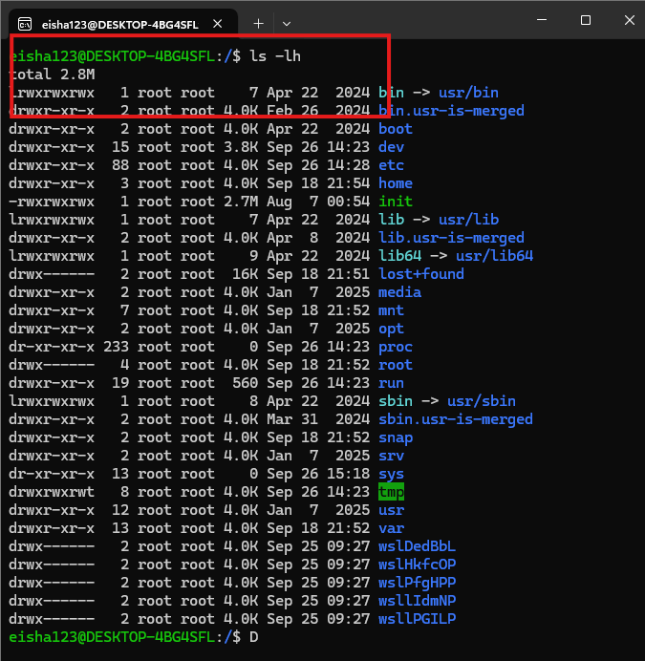

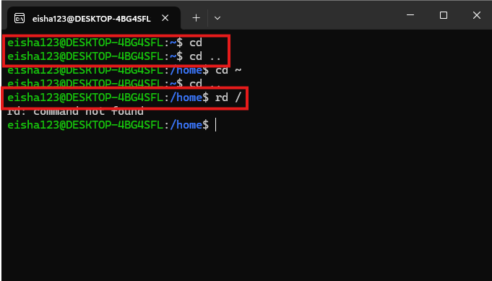

## Part 3: File and Directory Operations

**\*\*3.1 Creating and Managing Files/Directories**

**Commands to demonstrate:**

mkdir

myl

ab

2

#

C

re

a

te

dire

c

tory

mkdir

-

p

test

/

su

b

/

dir

#

C

re

a

te

nested

dire

c

tories

tou

c

h

file

1

.

txt

#

C

re

a

te

empty

file

tou

c

h

file

2

.

txt

file

3

.

txt

#

M

ultiple

files

#

T

ext

editors

introdu

c

tion

n

a

no

hello

.

txt

#

S

imple

text

editor

#

OR

e

c

ho

"

H

ello

L

inux

"

!

>

hello

.

txt

#

R

edire

c

t

output

to

file

**File viewing commands:**

ca

t

hello

.

txt

#

D

ispl

a

y

file

c

ontents

less

hello

.

txt

#

Pa

ge

through

file

he

a

d

hello

.

txt

#

F

irst

10

lines

t

a

il

hello

.

txt

#

La

st

10

lines

w

c

hello

.

txt

#

W

ord

c

ount

Commands to demonstrate:  
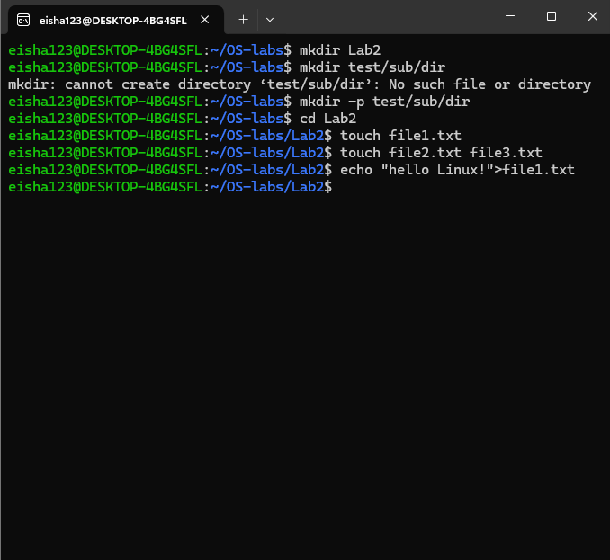

NANO command:

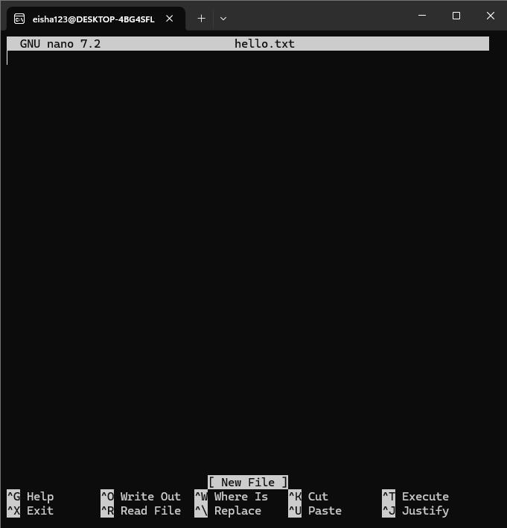

File Viewing Commands:

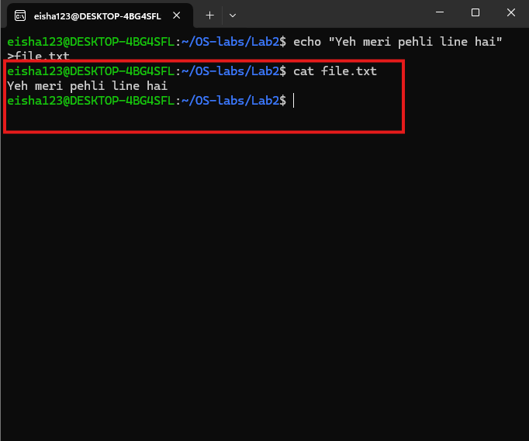

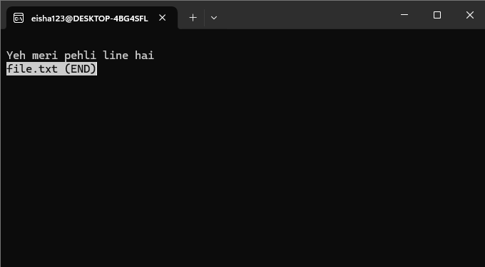

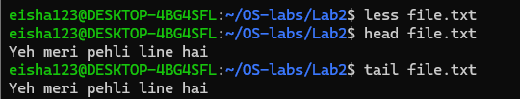

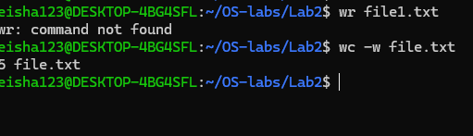

### 3.2 Copying, Moving, and Deleting

**Commands to practice:**

c

p

hello

.

txt

bac

kup

.

txt

#

C

opy

file

c

p

-

r

myl

ab

2

myl

ab

2

_

bac

kup

#

C

opy

dire

c

tory

re

c

ursively

mv

bac

kup

.

txt

ren

a

med

.

txt

#

M

ove

/

ren

a

me

file

rm

ren

a

med

.

txt

#

R

emove

file

rm

-

r

myl

ab

2

_

bac

kup

#

R

emove

dire

c

tory

rmdir

empty

_

dire

c

tory

#

R

emove

empty

dire

c

tory

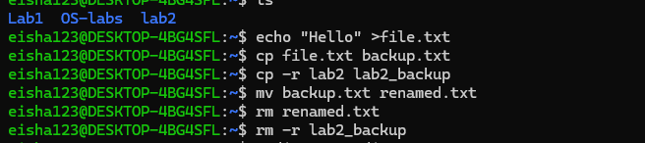

**Hands-on Exercise:** Students create a directory structure, add files, and practice file operations.

## Part 4: File Permissions and Ownership

### 4.1 Understanding File Permissions

**Concepts to Cover:**

Permission types: read (r), write (w), execute (x)

Permission groups: user (u), group (g), others (o)

Numeric notation: 755, 644, etc.

**Commands to demonstrate:**

ls

-

l

#

V

iew

permissions

c

hmod

755

file

.

txt

#

C

h

a

nge

permissions

(

numeri

c

)

c

hmod

u

+

x

file

.

txt

#

A

dd

exe

c

ute

permission

for

user

c

hmod

g

-

w

file

.

txt

#

R

emove

write

permission

for

group

c

hown

user

:

group

file

.

txt

#

C

h

a

nge

ownership

(

if

a

ppli

cab

le

)

