#### 

National Textile University

**Department of Computer Science**

Subject: Operating System

Submitted to: Sir Nasir Mahmood

Submitted by: Eisha Muzaffar

Reg. number: 23-NTU-CS-1147

Lab no.: lab3

semester:5th

**Task1:**

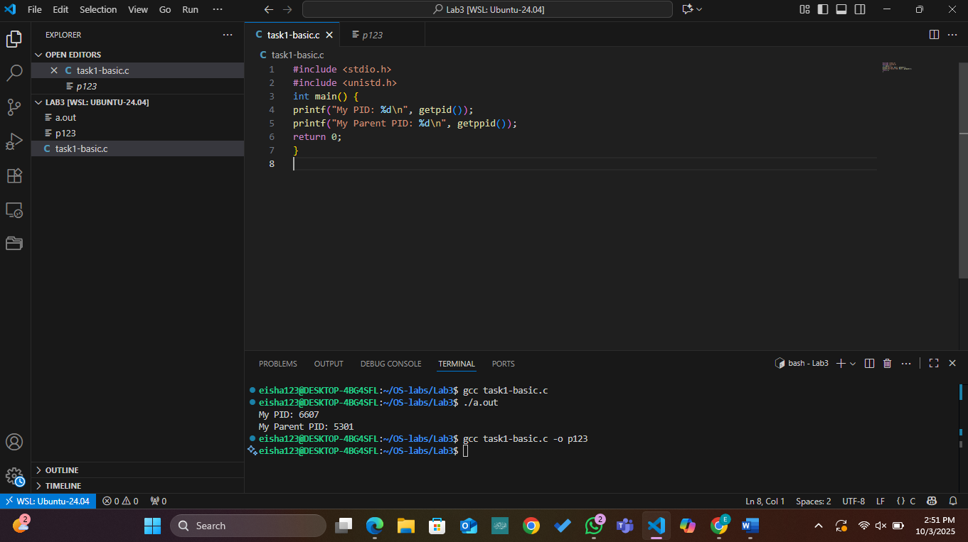

**Task2:**

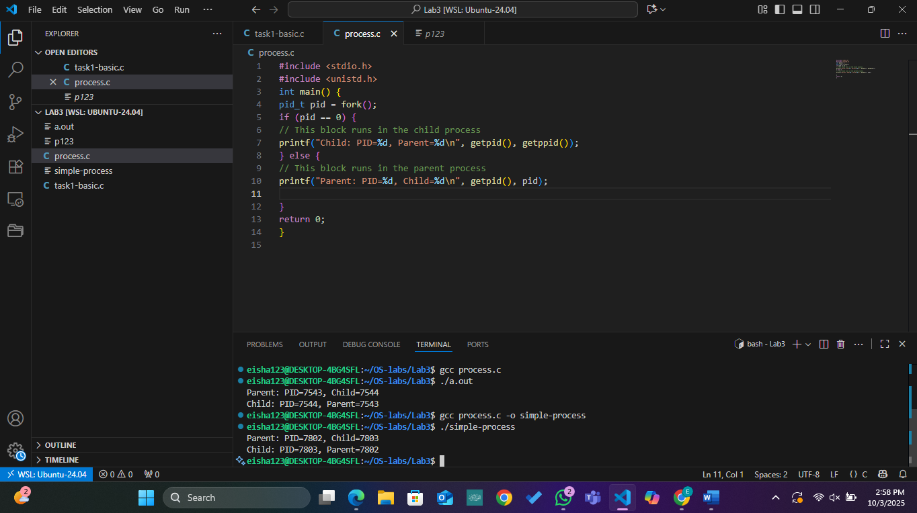

**Task3:**

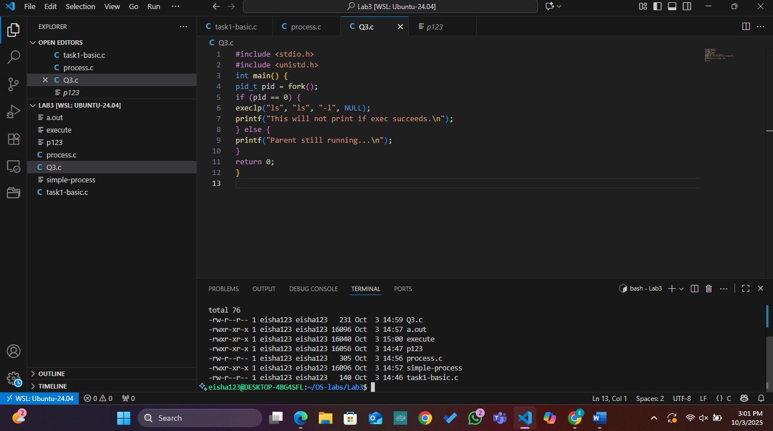

**Task4:**

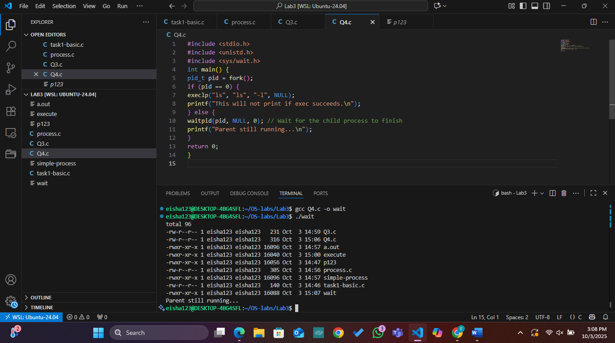

**Commands:**

**Ps:**

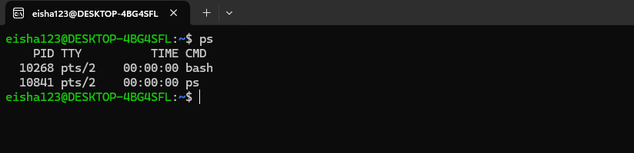

**Ps -ef:**

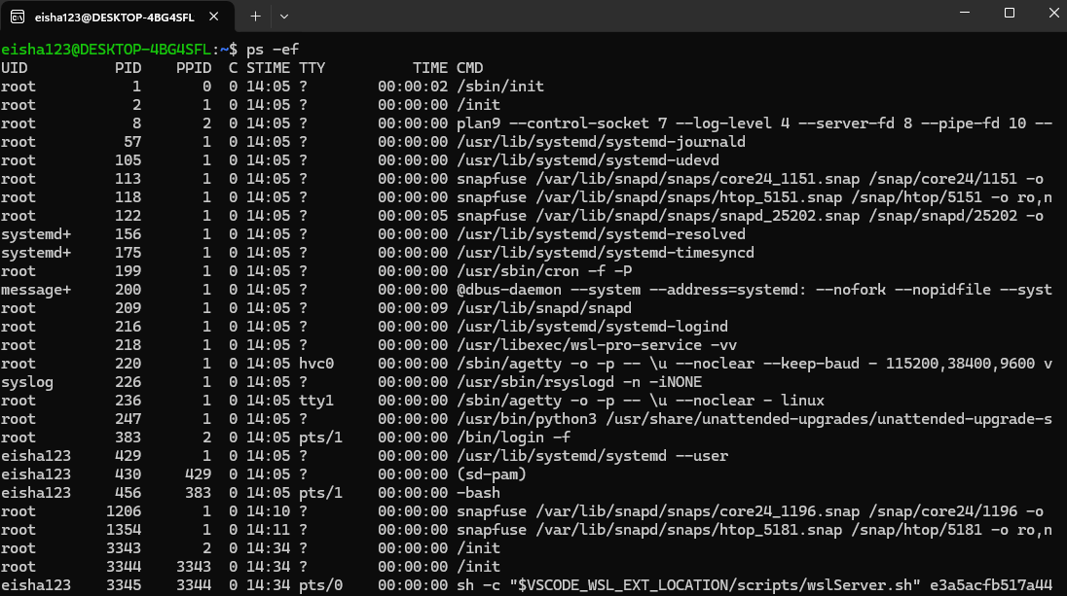

**Ps -ef | grep bash:**

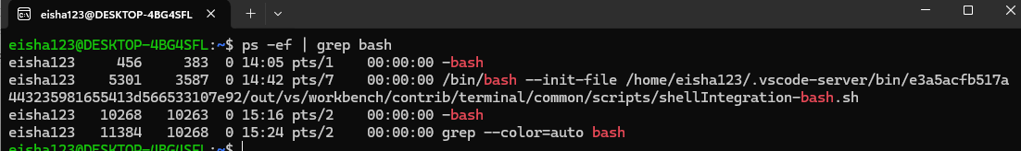

**Top:**

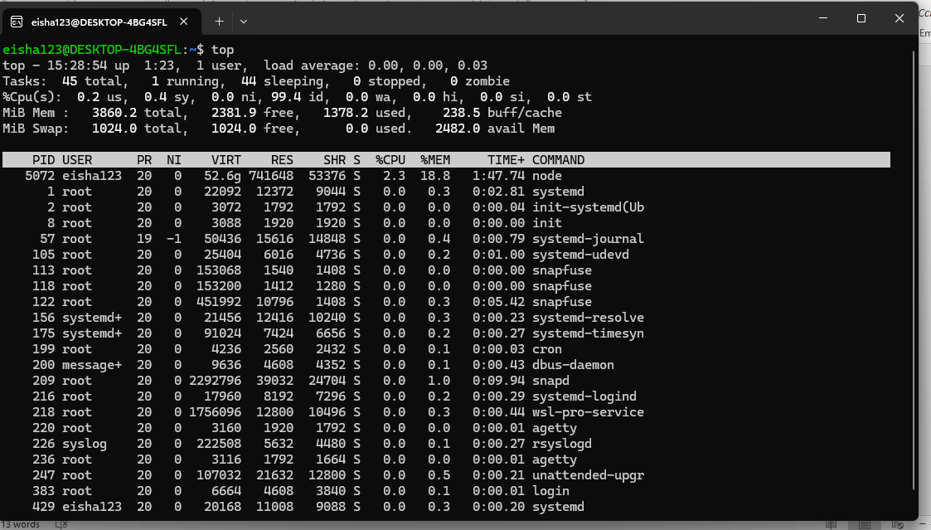

**Sleep 5:**

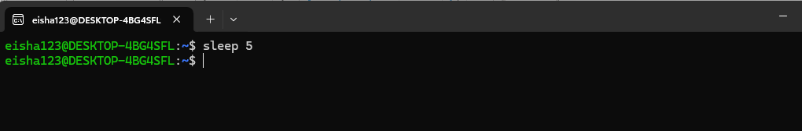

**Sleep 5 &:**

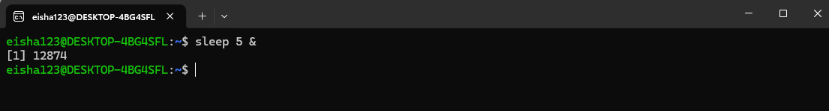

**Jobs:**

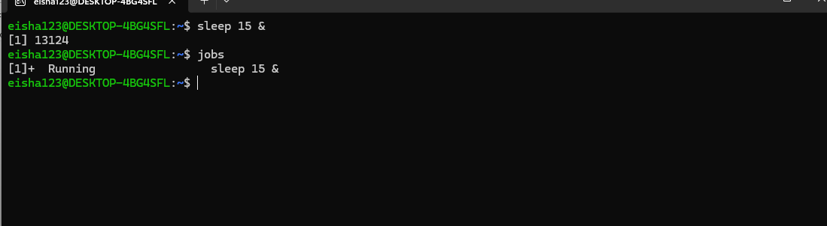

**Fg 1:**

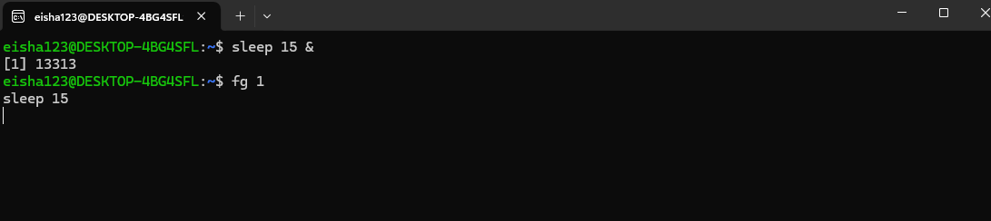

**Pidof ,kill,jobs:**

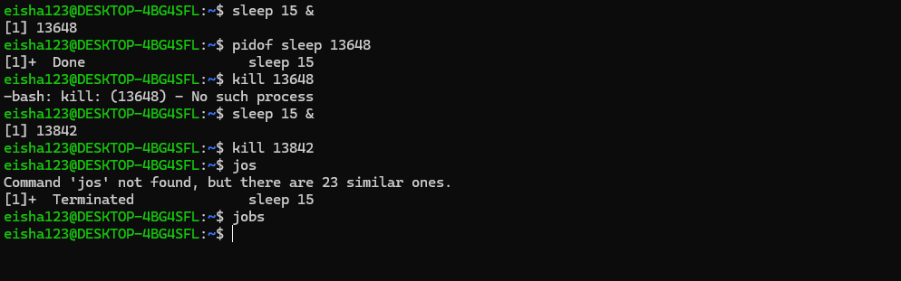

**Killall sleep:**

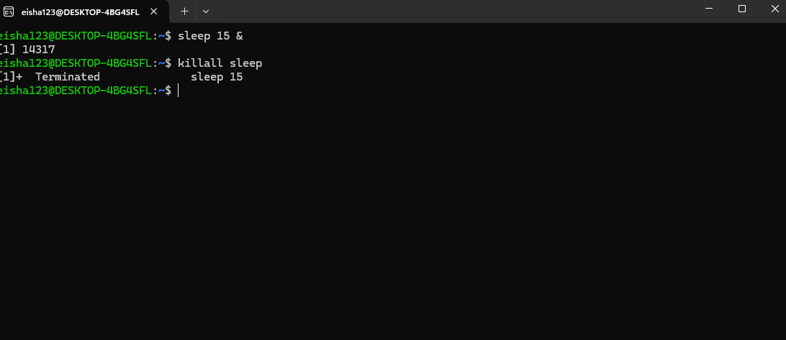

**Yes >/dev/null &:**



**Command terminated using k command in top:**

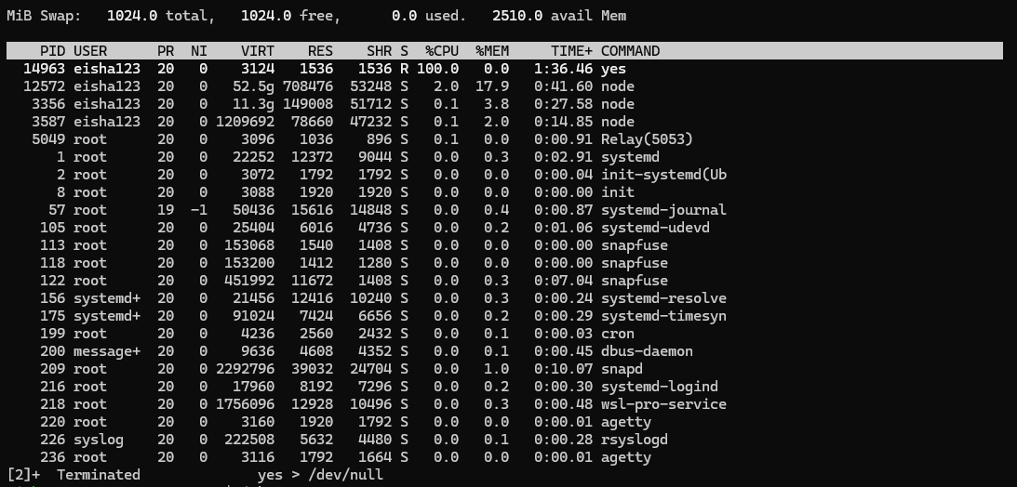

**ps -ef | grep yes**

**Kill it with: kill -9**

