

National Textile University

**Department of Computer Science**

Subject: Operating System

Submitted to: Sir Nasir Mahmood

Submitted by: Eisha Muzaffar

Reg. number: 23-NTU-CS-1147

Lab 4 (Home task)

Semester:5th

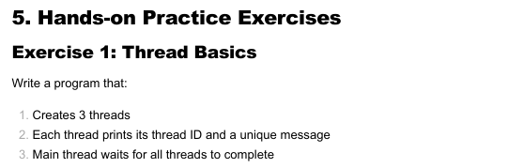

Code:

#include <stdio.h>

#include <pthread.h>

#include <unistd.h>

void* print_message(void* arg) {

    int thread_num = *(int*)arg;

    pthread_t tid = pthread_self();

    printf("[Thread %d] ID: %lu - Hello from thread %d!\n", thread_num, tid, thread_num);

    sleep(1);

    printf("[Thread %d] Finished!\n", thread_num);

    return NULL;

}

int main() {

    pthread_t threads[3];

    int thread_nums[3] = {1, 2, 3};

    printf("Main: creating 3 threads...\n");

    for (int i = 0; i < 3; i++) {

        pthread_create(&threads[i], NULL, print_message, &thread_nums[i]);

        printf("Main: started thread %d\n", i + 1);

    }

    for (int i = 0; i < 3; i++) {

        pthread_join(threads[i], NULL);

        printf("Main: joined thread %d\n", i + 1);

    }

    printf("All threads completed. Main thread exiting.\n");

    return 0;

}

Terminal:

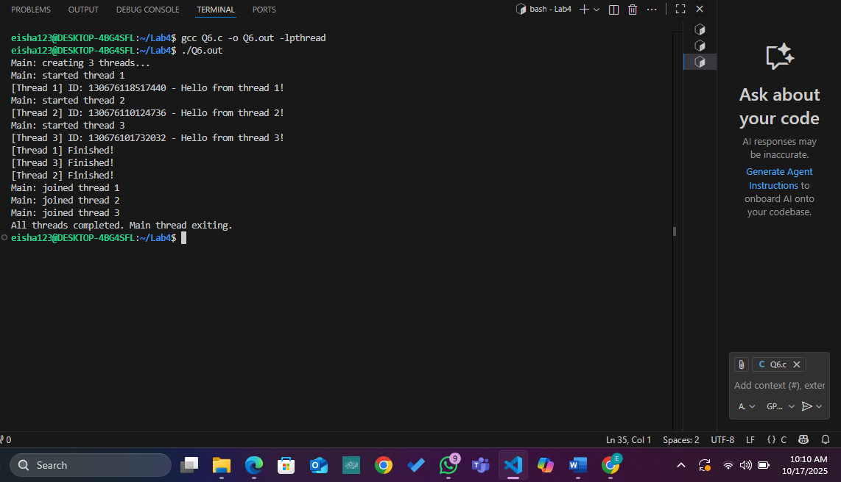  
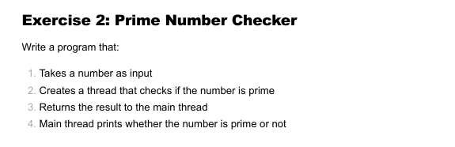

Code:

#include <stdio.h>

#include <pthread.h>

#include <stdbool.h>

#include <math.h>

typedef struct {

    int number;

    bool is_prime;

} PrimeData;

void* check_prime(void* arg) {

    PrimeData* data = (PrimeData*)arg;

    int n = data->number;

    if (n <= 1) {

        data->is_prime = false;

        return NULL;

    }

    data->is_prime = true;

    for (int i = 2; i <= sqrt(n); i++) {

        if (n % i == 0) {

            data->is_prime = false;

            break;

        }

    }

    return NULL;

}

int main() {

    PrimeData data;

    pthread_t thread;

    printf("Enter a number to check for prime: ");

    scanf("%d", &data.number);

    pthread_create(&thread, NULL, check_prime, &data);

    pthread_join(thread, NULL);

    if (data.is_prime)

        printf("%d is a prime number.\n", data.number);

    else

        printf("%d is NOT a prime number.\n", data.number);

    return 0;

}

