

National Textile University
Department of Computer Science
Subject: Operating System

Submitted to: Sir Nasir Mahmood

Submitted by: Eisha Muzaffar

Reg. number: 23-NTU-CS-1147

Lab no.: lab3
semester:5th

#include <stdio.h>
#include <pthread.h>
#include <semaphore.h>
#include <unistd.h>
sem_t parking_spaces;
void* car(void* arg) {
int id = *(int*)arg;
printf("Car %d is trying to park...\n"
, id);
sem_wait(&parking_spaces); // Try to get a space
printf("Car %d parked successfully!\n"
, id);
sleep(2); // Stay parked for 2 seconds
printf("Car %d is leaving.\n"
, id);
sem_post(&parking_spaces); // Free the space
return NULL;
}
int main() {
pthread_t cars[10];
int ids[10];
// Initialize: 3 parking spaces available
sem_init(&parking_spaces, 0, 3);
// Create 10 cars (more than spaces!)
for(int i = 0; i < 10; i++) {
ids[i] = i + 1;
pthread_create(&cars[i], NULL, car, &ids[i]);
}
// Wait for all cars
for(int i = 0; i < 10; i++) {
pthread_join(cars[i], NULL);
}
sem_destroy(&parking_spaces);
return 0;
}

Terminal:
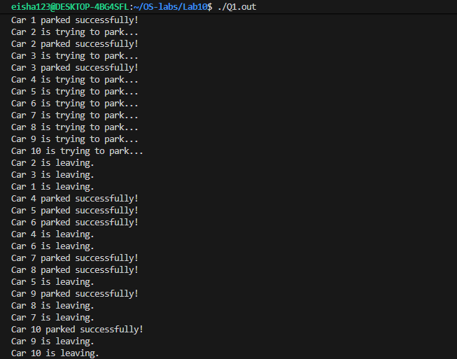
Question no:02
#include <stdio.h>
#include <pthread.h>
#include <semaphore.h>
#include <unistd.h>
#define BUFFER_SIZE 5
int buffer[BUFFER_SIZE];
int in = 0; // Producer index
int out = 0; // Consumer index
sem_t empty; // Counts empty slots
sem_t full; // Counts full slots
pthread_mutex_t mutex;
void* producer(void* arg) {
int id = *(int*)arg;
for(int i = 0; i < 3; i++) { // Each producer makes 3 items
int item = id * 100 + i;
// TODO: Wait for empty slot
sem_wait(&empty);
// TODO: Lock the buffer
pthread_mutex_lock(&mutex);
// Add item to buffer
buffer[in] = item;
printf("Producer %d produced item %d at position %d\n"
,
id, item, in);
in = (in + 1) % BUFFER_SIZE;
// TODO: Unlock the buffer
pthread_mutex_unlock(&mutex);
// TODO: Signal that buffer has a full slot
sem_post(&full);
sleep(1);
}
return NULL;
}
void* consumer(void* arg) {
int id = *(int*)arg;
for(int i = 0; i < 3; i++) {
// TODO: Students complete this similar to producer
sem_wait(&full);
pthread_mutex_lock(&mutex);
int item = buffer[out];
printf("Consumer %d consumed item %d from position %d\n"
,
id, item, out);
out = (out + 1) % BUFFER_SIZE;
pthread_mutex_unlock(&mutex);
sem_post(&empty);
sleep(2); // Consumers are slower
}
return NULL;
}
int main() {
pthread_t prod[2], cons[2];
int ids[2] = {1, 2};
// Initialize semaphores
sem_init(&empty, 0, BUFFER_SIZE); // All slots empty initially
sem_init(&full, 0, 0); // No slots full initially
pthread_mutex_init(&mutex, NULL);
// Create producers and consumers
for(int i = 0; i < 2; i++) {
pthread_create(&prod[i], NULL, producer, &ids[i]);
pthread_create(&cons[i], NULL, consumer, &ids[i]);
}
// Wait for completion
for(int i = 0; i < 2; i++) {
pthread_join(prod[i], NULL);
pthread_join(cons[i], NULL);
}
// Cleanup
sem_destroy(&empty);
sem_destroy(&full);
pthread_mutex_destroy(&mutex);
return 0;
}

Terminal:
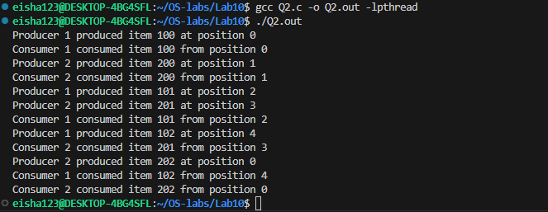
Technical Explanation:
this Program implements producer Consumer problem using:
Thread
Mutex(lock and unlock)
Semaphore(wait and post)
Consumer is consuming the items producer is producing without the race condition occurring
Questions:
Q1:
int item = id * 100 + i;

- Producers ids 1 and 2 (given in code)
- Every producer is producing 3 items(0,1,2)
- We have a total of 2 producers so,
- So the items are (100,101,102,200,201,202)
Q2: Total number of threads?
There are 4 total threads(two producers,two consumers)
Q3:if consumers are bigger than producers,
The Consumers will keep waiting causing deadlock condition

