

National Textile University
Department of Computer Science
Subject: Operating System

Submitted to: Sir Nasir

Submitted by:Eisha Muzaffar

Reg. number: 23-NTU-CS-1147
Hometask
Semester:5th

Operating Systems – COC 3071
SE 5th A – Fall 2025
After-mid Homework -1

Part 1: Semaphore theory
- A counting semaphore is initialized to 7. If 10 wait() and 4 signal() operations are performed, find the final value of the semaphore.
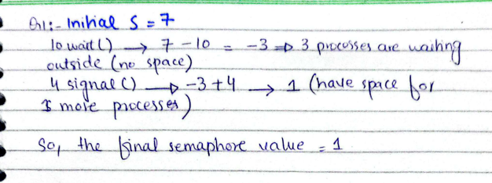

- A semaphore starts with value 3. If 5 wait() and 6 signal() operations occur, calculate the resulting semaphore value.
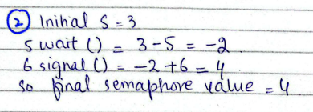

- A semaphore is initialized to 0. If 8 signal() followed by 3 wait() operations are executed, find the final value.
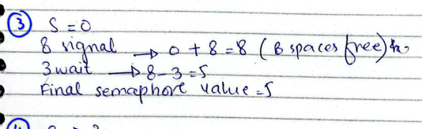
- A semaphore is initialized to 2. If 5 wait() operations are executed:
- How many processes enter the critical section?
- How many processes are blocked?
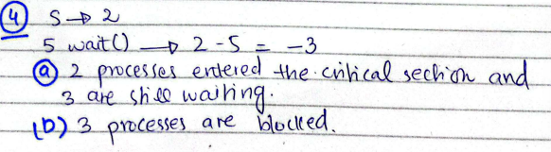

5. A semaphore starts at 1. If 3 wait() and 1 signal() operations are performed:
- How many processes remain blocked?
- What is the final semaphore value?
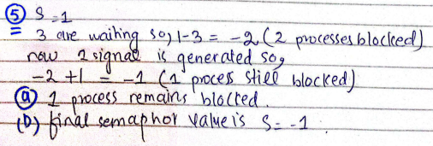
6.
semaphore S = 3;
wait(S); wait(S); signal(S); wait(S); wait(S);

- How many processes enter the critical section?
- What is the final value of S?
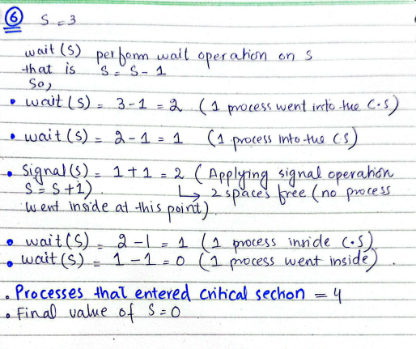

7.
semaphore S = 1;
wait(S); wait(S); signal(S); signal(S);

- How many processes are blocked?
- What is the final value of S?
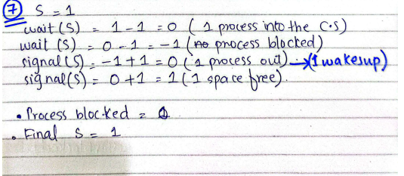
- A binary semaphore is initialized to 1. Five wait() operations are executed without any signal(). How many processes enter the critical section and how many are blocked?
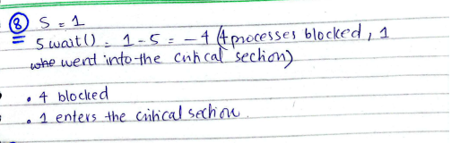

- A counting semaphore is initialized to 4. If 6 processes execute wait() simultaneously, how many proceed and how many are blocked?
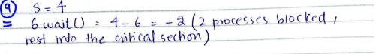
- A semaphore S is initialized to 2. wait(S); wait(S); wait(S); signal(S); signal(S);
wait(S);

- Track the semaphore value after each operation.
- How many processes were blocked at any time?
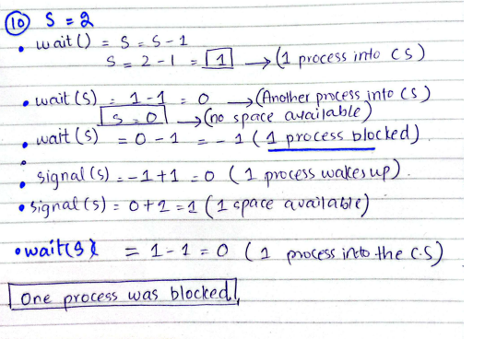

11. A semaphore is initialized to 0. Three processes execute wait() before any signal(). Later, 5 signal() operations are executed. a) How many processes wake up?
b) What is the final semaphore value?
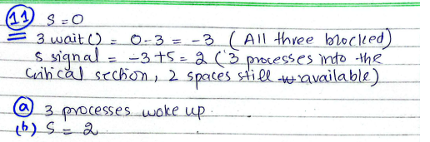

Part 2: Semaphore Coding
Consider the Producer–Consumer problem using semaphores as implemented in Lab-10 (Lab-plan attached). Rewrite the program in your own coding style, compile and execute it successfully, and explain the working of the code in your own words.
Submission Requirements:
- Your rewritten source code
- A brief description of how the code works
- Screenshots of the program output showing successful execution

#include <stdio.h>
#include <pthread.h>
#include <semaphore.h>
#include <unistd.h>
#define BUFFER_SIZE 5
int buffer[BUFFER_SIZE];
int in = 0;
int out = 0;

sem_t empty;
sem_t full;
pthread_mutex_t mutex;

void* producer(void* arg) {
int id = *(int*)arg;

for(int i = 0; i < 3; i++) {
int item = id * 100 + i;

sem_wait(&empty);
pthread_mutex_lock(&mutex);

buffer[in] = item;
printf("Producer %d produced %d at %d\n", id, item, in);
in = (in + 1) % BUFFER_SIZE;
pthread_mutex_unlock(&mutex);
sleep(1);
}
return NULL;
}

void* consumer(void* arg) {
int id = *(int*)arg;

for(int i = 0; i < 3; i++) {
sem_wait(&full);
pthread_mutex_lock(&mutex);
int item = buffer[out];
printf("Consumer %d consumed %d from %d\n", id, item, out);
out = (out + 1) % BUFFER_SIZE;

pthread_mutex_unlock(&mutex);
sem_post(&empty);

sleep(2);
return NULL;
}
}

int main() {
pthread_t prod[2], cons[2];
int ids[2] = {1, 2};

sem_init(&empty, 0, BUFFER_SIZE);
sem_init(&full, 0, 0);
pthread_mutex_init(&mutex, NULL);
for(int i = 0; i < 2; i++) {
pthread_create(&prod[i], NULL, producer, &ids[i]);
pthread_create(&cons[i], NULL, consumer, &ids[i]);
}
for(int i = 0; i < 2; i++) {
pthread_join(prod[i], NULL);
pthread_join(cons[i], NULL);
}
sem_destroy(&empty);
sem_destroy(&full);
pthread_mutex_destroy(&mutex);

printf("All done!\n");
return 0;
}

Terminal:
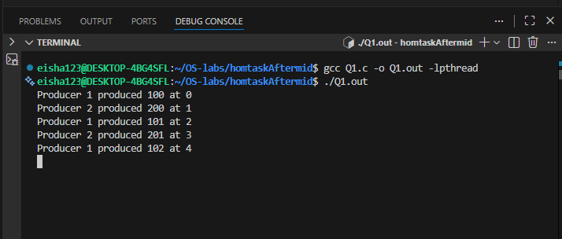
How It Works:
Buffer:
- A small array where producers put items and consumers take items.
- in tells where the next item goes, out tells where the next item is taken from.
Producer:
- Waits if the buffer is full.
- Locks the buffer to safely put an item.
- Unlocks the buffer and tells consumers that there’s a new item.
Consumer:
- Waits if the buffer is empty.
- Locks the buffer to safely take an item.
- Unlocks the buffer and tells producers that there’s space.
Synchronization:
- Semaphore empty -> Counts empty spaces.
- Semaphore full ->Counts items in the buffer.
- Mutex-> Ensures only one thread touches the buffer at a time.
Circular Buffer:
When in or out reach the end of the array, they go back to the start.
Part 3: RAG (Recourse Allocation Graph)
- Convert the following graph into matrix table ,

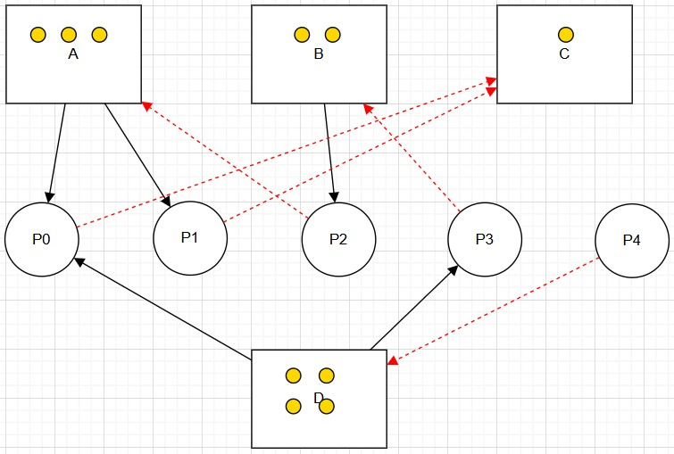
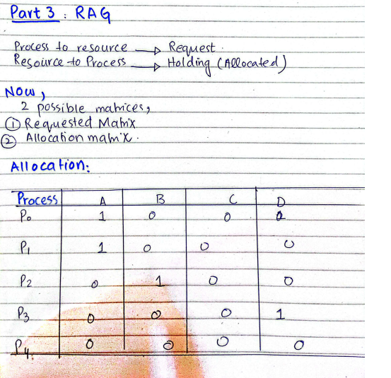
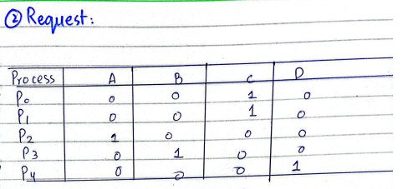

Part 4: Banker's Algorithm
System Description:
- The system comprises four processes (P0–P3) and four resources (A,B,C,D).
- Total Existing Resources:

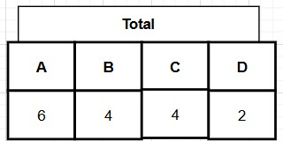

- Snapshot at the initial time stage:
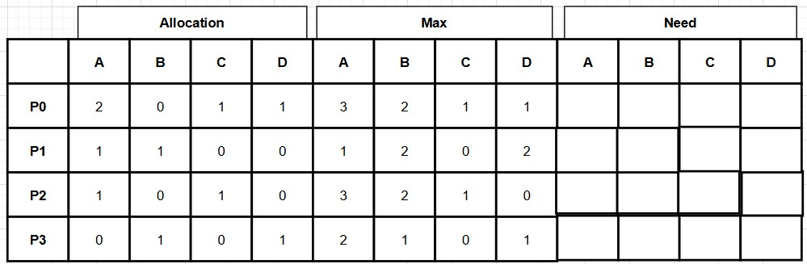

•
Questions:
- Compute the Available Vector:

• Calculate the available resources for each type of resource.
Total Allocation of each resource,
A=P0(2)+P1(1)+P2(1)+P3(0)=4
B=P0(0)+P1(1)+P2(0)+P3(1)=2
C=P0(1)+P1(0)+P2(1)+P3(0)=2
D=P0(1)+P1(0)+P2(0)+P3(1)=2
Now Available value of each resource =Total- Allocated
A=6-4=2
B=4-2=2
C=4-2=2
D=2-2=0
Available Vector=(2,2,2,0)

2.Compute the Need Matrix:
• Determine the need matrix by subtracting the allocation matrix from the maximum matrix.
Need(Max -Allocated):
 | A | B | C | D
P0 | 1 | 2 | 0 | 0
P1 | 0 | 1 | 0 | 2
P2 | 2 | 2 | 0 | 0
P3 | 2 | 0 | 0 | 0

3.Safety Check:
  - Determine if the current allocation state is safe. If so, provide a safe sequence of the processes.
  - Show how the Available (working array) changes as each process terminates.
Answer:
Safe when Need ≤ Available
Initially available vector=(2,2,2,0)
For P0:
Need(1,2,0,0) ≤Available(2,2,2,0)
thus P0 process can be completed
Now once completed,
Available vector= Previously Available+ AllocationP0
=(2,2,2,0)+(2,0,1,1)=(4,2,3,1)
For P1:
Need(0,1,0,2) ≤Available(4,2,3,1) (X)
thus P1 process cant be completed
We need D(2) available=1

THUS THE GIVEN SEQUENCE IS NOT FEASIBLE THE CORRECT SEQUENCE IS,

Safe when Need ≤ Available
Initially available vector=(2,2,2,0)
For P0:
Need(1,2,0,0) ≤Available(2,2,2,0)
thus P0 process can be completed
Now once completed,
Available vector= Previously Available+ AllocationP0
=(2,2,2,0)+(2,0,1,1)=(4,2,3,1)
For P2:
Need(2,2,0,0) ≤Available(4,2,3,1)
thus P2 process completed
Now once completed,
Available vector= Previously Available+ AllocationP2
=(4,2,3,1)+(1,0,1,0)=(5,2,4,1)
For P3:
Need(2,0,0,0) ≤Available(5,2,4,1)
thus P3 process completed
Now once completed,
Available vector= Previously Available+ AllocationP2
=(5,2,4,1)+(0,1,0,1)=(5,3,4,2)
For P1:
Need(0,1,0,2) ≤Available(5,3,4,2)
thus P1 process completed
Now once completed,
Available vector= Previously Available+ AllocationP2
=(5,3,4,2)+(1,1,0,0)=(6,4,4,2)
Thus the system is in safe state
P0->P2->P3->P1

Submission Guidelines:
  - Ensure all answers are well-explained and calculations are shown step-by-step.
  - Submit your assignment on MS Team and GitHub in a PDF format.
  - VIVA based Evaluation so Develop your own solution after getting help.

