

National Textile University
Department of Computer Science
Subject: Operating System

Submitted to: Sir Nasir

Submitted by:Eisha Muzaffar

Reg. number: 23-NTU-CS-1147
Lab 13
Semester:5th

Docker Lab 02

Data Persistence, Custom Images, Networking & Docker Compose

Types of Docker Storage

1. Volumes :

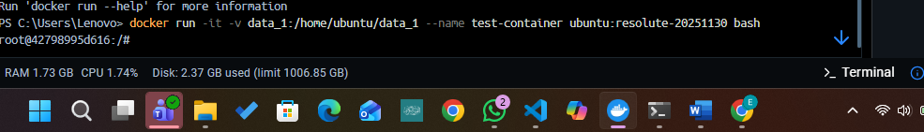
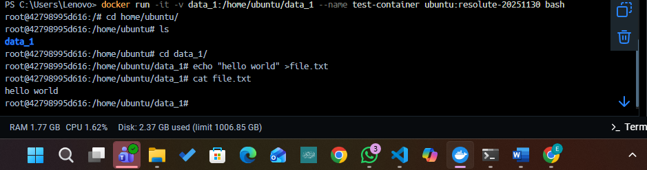
Bind Mount:
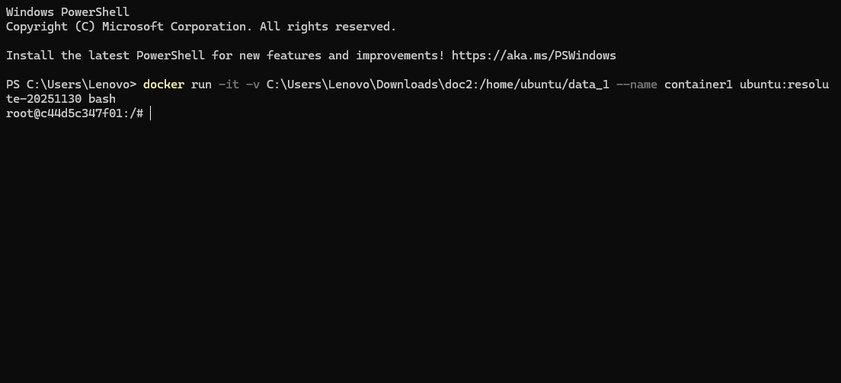

Part 2: Building Custom Images with Dockerfile:
Npm init -y:
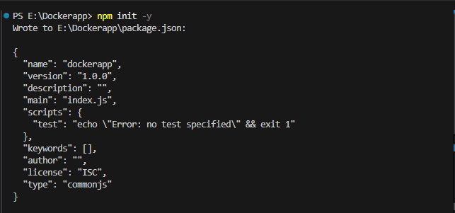

Npm I express:

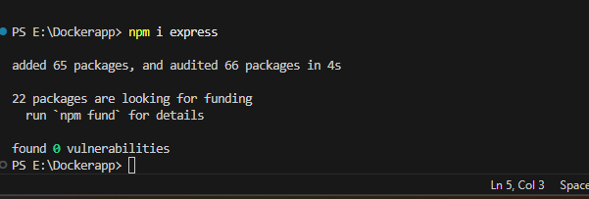

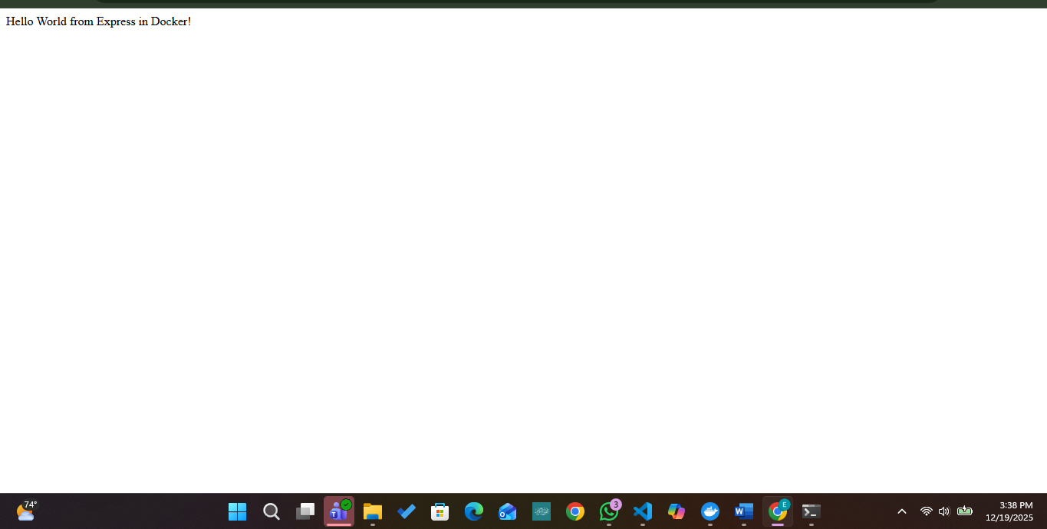

Commands in Docker File:
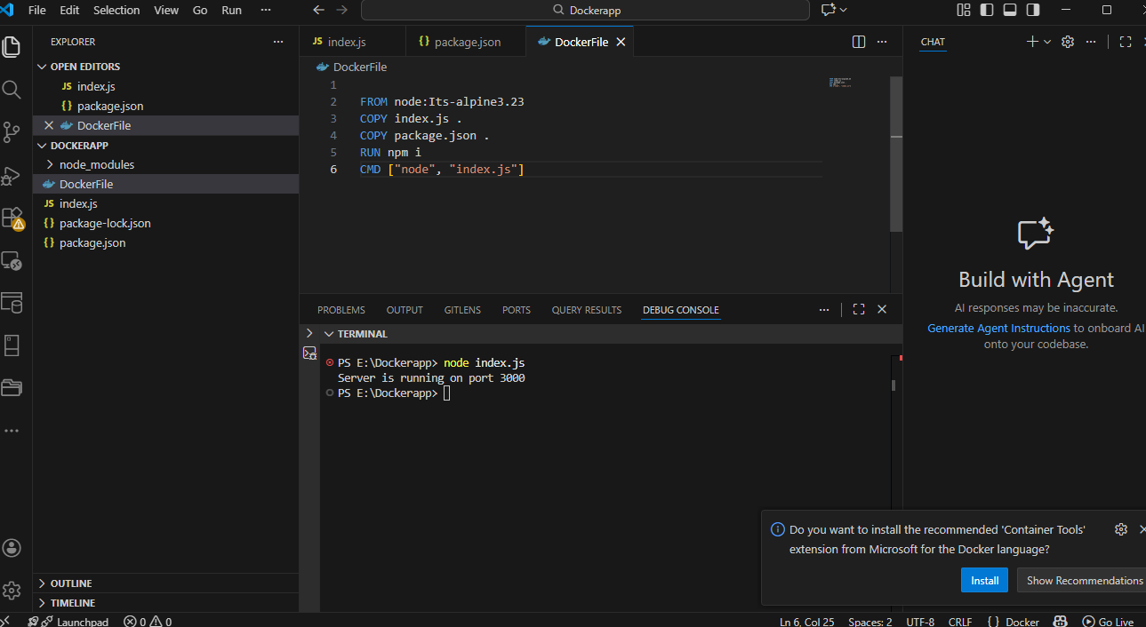

Making Image:
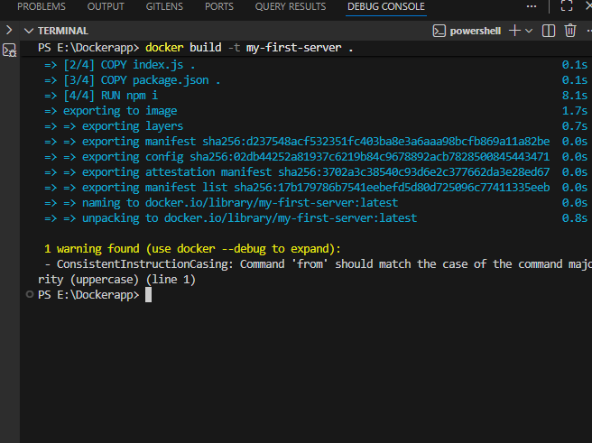
Image Running:
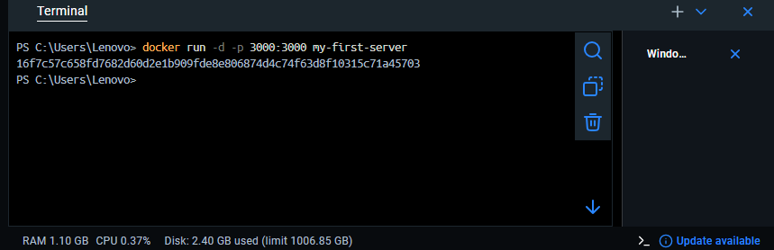

Practice Exercise: Build Your Own Image
Challenge: Serve static HTML files from our previously build node server!

