

National Textile University
Department of Computer Science
Subject: Operating System

Submitted to: Sir Nasir

Submitted by: Eisha Muzaffar

Reg. number: 23-NTU-CS-1147
Lab 14
Semester:5th

Docker Lab 03

Multi-Container Applications, Docker Compose & Best Practices

Step 1: Project Structure

Picture of entire project structure:
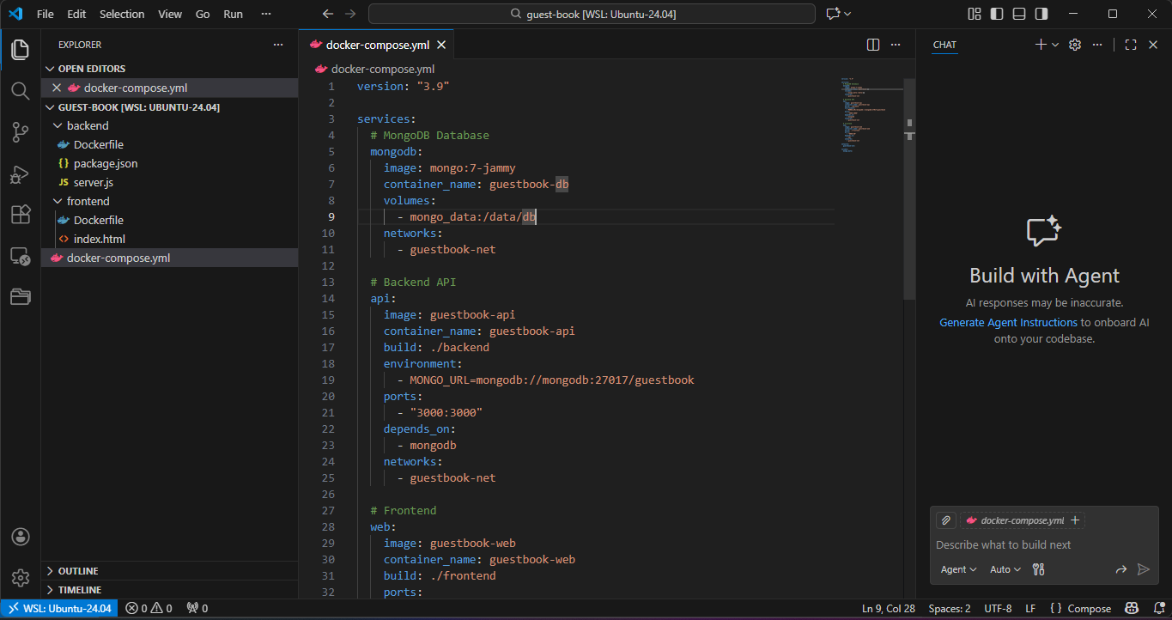
c
d

~
mkdir

guest
-
b
ook
c
d

guest
-
b
ook
Create the following structure:
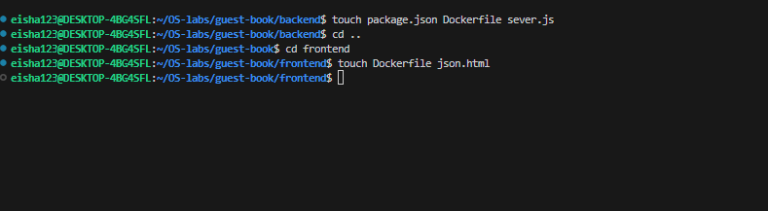

Step 2: Backend Service (Express + MongoDB)
Create backend/package.json :

Package.json:
{
"name": "guest-book-backend",
"version": "1.0.0",
"type": "module",
"scripts": {
"start": "node server.js"
},
"dependencies": {
"express": "^4.18.2",
"mongoose": "^8.0.0",
"cors": "^2.8.5"
}
}

Sever.js

import express from 'express';
import mongoose from 'mongoose';
import cors from 'cors';

const app = express();
const PORT = 3000;

app.use(cors());
app.use(express.json());

// MongoDB connection URL
const MONGO_URL =
process.env.MONGO_URL || 'mongodb://localhost:27017/guestbook';

// Connect to MongoDB
mongoose
.connect(MONGO_URL)
.then(() => console.log('✅ MongoDB Connected'))
.catch((err) => console.error('❌ MongoDB Error:', err));

// Define Mongoose Schema
const messageSchema = new mongoose.Schema({
name: {
type: String,
required: true,
},
message: {
type: String,
required: true,
},
timestamp: {
type: Date,
default: Date.now,
},
});

// Create Mongoose Model
const Message = mongoose.model('Message', messageSchema);

// Routes

// Get all messages
app.get('/messages', async (req, res) => {
const messages = await Message.find().sort({ timestamp: -1 });
res.json(messages);
});

// Add new message
app.post('/messages', async (req, res) => {
const { name, message } = req.body;

const newMessage = new Message({ name, message });
await newMessage.save();

res.status(201).json({ success: true });
});

// Start server
app.listen(PORT, () => {
console.log(`🚀 Server running on http://localhost:${PORT}`);
});

Backend Image:

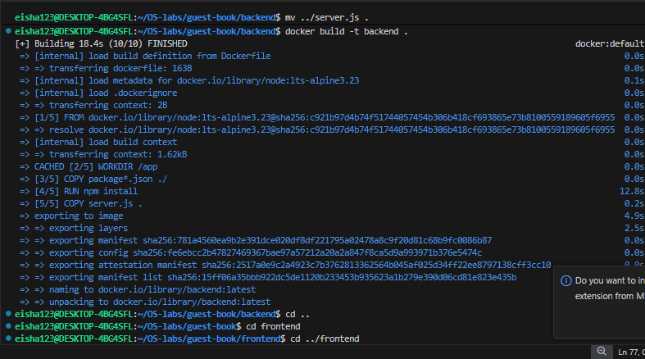

Step 3: Frontend Service
Index.html:
<!DOCTYPE html>
<html lang="en">
<head>
<meta charset="UTF-8">
<meta name="viewport" content="width=device-width, initial-scale=1.0">
<title>Guest Book</title>

<style>
body {
font-family: Arial, sans-serif;
background: linear-gradient(135deg, #667eea 0%, #764ba2 100%);
min-height: 100vh;
padding: 20px;
margin: 0;
}
.container {
max-width: 600px;
margin: 40px auto;
background: white;
padding: 30px;
border-radius: 10px;
box-shadow: 0 10px 40px rgba(0,0,0,0.3);
}
h1 { color: #333; text-align: center; }
.subtitle { text-align: center; color: #666; margin-bottom: 30px; }
.form-group { margin-bottom: 15px; }
input, textarea {
width: 100%;
padding: 10px;
border: 2px solid #e0e0e0;
border-radius: 5px;
font-size: 16px;
}
button {
background: #667eea;
color: white;
border: none;
padding: 12px;
font-size: 16px;
border-radius: 5px;
cursor: pointer;
width: 100%;
}
button:hover { background: #5568d3; }
.messages { margin-top: 30px; }
.message {
background: #f8f9fa;
padding: 15px;
border-radius: 5px;
margin-bottom: 10px;
}
.message-name {
font-weight: bold;
color: #667eea;
}
.message-time {
font-size: 12px;
color: #999;
margin-top: 5px;
}
</style>
</head>

<body>
<div class="container">
<h1>Guest Book</h1>
<p class="subtitle">Powered by Docker Compose</p>

<div class="form-group">
<input type="text" id="nameInput" placeholder="Your name">
</div>

<div class="form-group">
<textarea id="messageInput" placeholder="Leave a message..." rows="3"></textarea>
</div>

<button onclick="addMessage()">Sign Guest Book</button>

<div class="messages" id="messagesList">
<p style="text-align:center;color:#999;">Loading messages...</p>
</div>
</div>

<script>
const API_URL = 'http://localhost:3000/api/messages';

async function loadMessages() {
const response = await fetch(API_URL);
const messages = await response.json();
const messagesList = document.getElementById('messagesList');

if (messages.length === 0) {
messagesList.innerHTML =
'<p style="text-align:center;color:#999;">No messages yet. Be the first!</p>';
return;
}

messagesList.innerHTML = messages.map(msg => `
<div class="message">
<div class="message-name">${escapeHtml(msg.name)}</div>
<div>${escapeHtml(msg.message)}</div>
<div class="message-time">
${new Date(msg.timestamp).toLocaleString()}
</div>
</div>
`).join('');
}

async function addMessage() {
const name = document.getElementById('nameInput').value.trim();
const message = document.getElementById('messageInput').value.trim();

if (!name || !message) {
alert('Please enter both name and message');
return;
}

await fetch(API_URL, {
method: 'POST',
headers: { 'Content-Type': 'application/json' },
body: JSON.stringify({ name, message })
});

document.getElementById('nameInput').value = '';
document.getElementById('messageInput').value = '';
loadMessages();
}

function escapeHtml(text) {
const div = document.createElement('div');
div.textContent = text;
return div.innerHTML;
}

loadMessages();
</script>
</body>
</html>

Frontend Image:
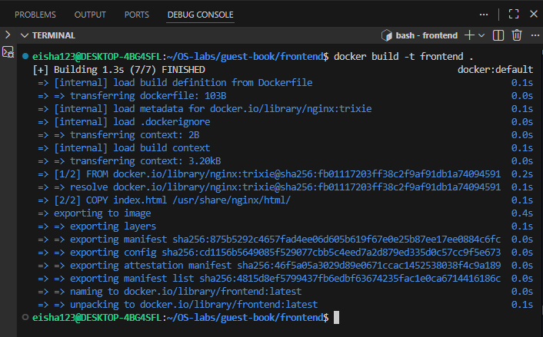
Docker yml file:
version: "3.9"

services:
# MongoDB Database
mongodb:
image: mongo:7-jammy
container_name: guestbook-db
volumes:
- mongo_data:/data/db
networks:
- guestbook-net

# Backend API
api:
image: guestbook-api
container_name: guestbook-api
build: ./backend
environment:
- MONGO_URL=mongodb://mongodb:27017/guestbook
ports:
- "3000:3000"
depends_on:
- mongodb
networks:
- guestbook-net

# Frontend
web:
image: guestbook-web
container_name: guestbook-web
build: ./frontend
ports:
- "8080:80"
depends_on:
- api
networks:
- guestbook-net

networks:
guestbook-net:

volumes:
mongo_data:

localhost 8080:
