Docker Lab 01

Introduction to Docker & Container Fundamentals
Command:
Docker images:
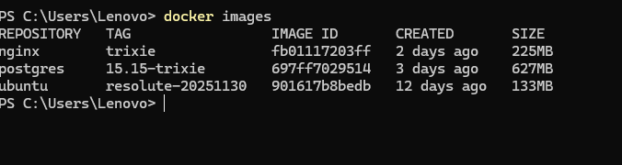

Exploring Inside the Container
You should see a prompt that looks like: root@abc123def456:/#
Now try these commands to explore:

You’ll see a full Linux filesystem:
/
b
in
,
/
usr
,
/
li
b
, etc
.
Shows you’re in
/
(root directory)
ls
pwd
who
a
mi
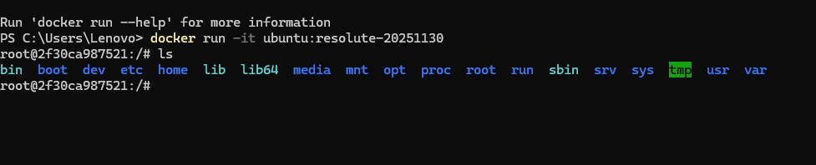

Viewing All Containers (Including Stopped)
do
c
ker
ps
-
a
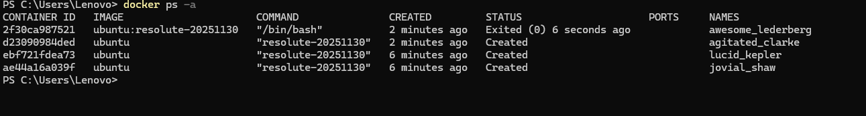

Essential Container Commands

Removing a Container
To delete a container permanently:
do
c
ker
rm

CONTAINER
_
ID
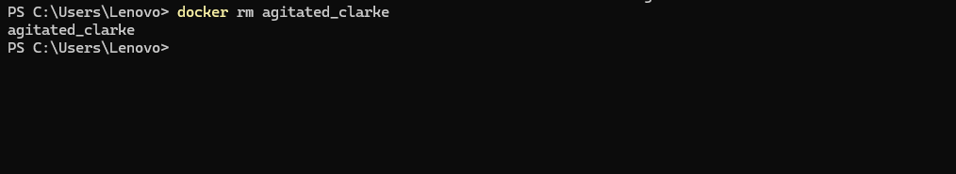
Some other commands done in lab:
