**ASSIGNEMENT-1**

**PROBABILITY AND STATISTICS (MT- 206)**

|  |  |  |
| --- | --- | --- |
| ID | Name: | Section : |

Q1. Certain Car Number Plates in Muscat and Oman consist of a sequence of four letters followed by five digits.

1. If no repetitions of letters are permitted, how many possible Car Number Plates are there?
2. If no letters and no digits are repeated, how many Car Number Plates are possible?

c) Find the value of “n”

$5*P_{2}^{\left(n-1\right)} = 24*C_{3}^{(n-2)}$

Q2. a) How many number of permutations and combination of three letters can you make from the letters M to Q ? Display the samples

b) How many distinct permutation can be made from the word SPLENDED?

Q3. A fair coin is to be flipped four times.

1. Draw the sample space.
2. Find the probability of showing at least three heads.
3. Find the probability of showing at most one tail.
4. Find the probability of showing not more than two tails.

Q4. A pair of dice is rolled, find the probability of showing

1. Sum of 6.
2. Multiples of 4 on the first die
3. The products at least12
4. Sum of 5 given that both Sum of dots is at most 9.

Q5. There are 5 white balls, 7 red balls, 11 yellow balls and 12 green balls in a container. A ball is chosen at random

1. What is the probability of choosing red?
2. What is the probability of choosing neither green nor red?
3. What is the probability of choosing either red or White?
4. What is the probability of choosing other than yellow?

Q6. a) From group of 18 Boys and 8 girls, 6 are chosen at random.Find the probability that there will be more man chosen then women

b) Four letters are picked from the word Sophisticated.

What is probability that there is at least one vowel among the letters?

Q7. Given that $P\left(A\right)=0.4$, $P\left(A∪B\right)=0.7$, Find $P\left(B\right)$ if

1. A and B are mutually exclusive
2. A and B are independent

Q8. Show that $P\left(\overline{A}∩B\right)=P\left(B\right)-P(A∩B)$

Q9. Given a class of 10 Women and 8 Men.

1. How many of the possible committees of five have no girls?
2. In how many ways can a committee of five consisting of 4 girls and 5 boys be chosen?
3. What is the probability that a committee of eight, if chosen at random from the class,
4. At most of three girls.
5. Consists only of girls
6. Consists at least five girl

Q10. The question, "Do you play football?" was asked of 110 students. Results are shown in the table.

|  |  |  |  |
| --- | --- | --- | --- |
|  | Play | Don’t Play | Total |
| Boys | 42 |  | 75 |
| Girls |  |  |  |
| Total |  | 56 |  |

i. What is the probability of randomly selecting an individual who is a boy and who plays football? This is just a joint probability.

ii. What is the probability of a randomly selecting an individual that is a boy?

iii. What is the probability of a randomly selecting an individual that plays football given that a girl?

iv. What is the probability that a player don’t play football given that he is a boy?

v. What is the probability a player don’t play football or she is a girls?

vi. What is the probability of a randomly selecting a boy or a girl?

Q#11.

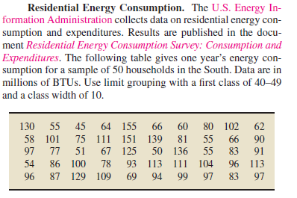

Also find mean,median and mode using group data formula.Form dot plot, histogram,pareto diagram, stem leaf plot and boxplot.find skewness and kurtosis

Q#12.

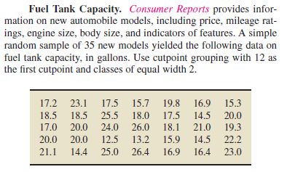

Also find mean,median and mode using group data formula. Form dot plot, histogram, pareto diagram, stem leaf plot and boxplot.Find skewness and kurtosis.