Calculus-2
Ms. Fareeha Sultan

FAST-NUCES
Karachi Campus

Final Assignment
Due on: Final Exam Day

Submission instructions: This assignment should be done individually. Make sure that student name and I.D. are listed on the submission. If you receive help from someone outside your study group, excluding the course staff, you must also acknowledge them on your assignment.

Cylindrical and Spherical Coordinates Ex# 11.8
Questions: 1-12, 19-46, 51
Directional Derivatives Ex#13.6
Questions 1-8: Find the directional derivative of f at P in the direction of a.
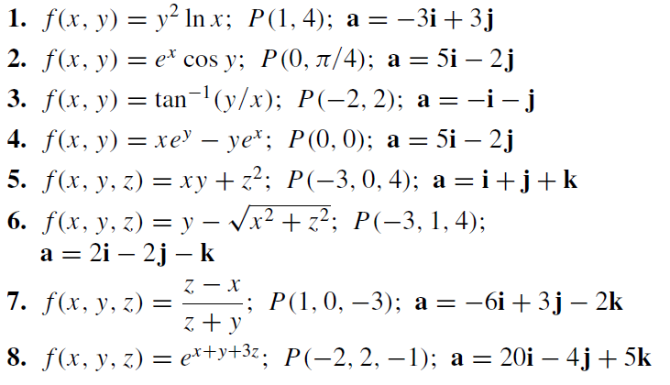
Questions 9-15: Find the directional derivative of f at P in the direction of a vector making the counterclockwise angle θ with the positive x-axis.
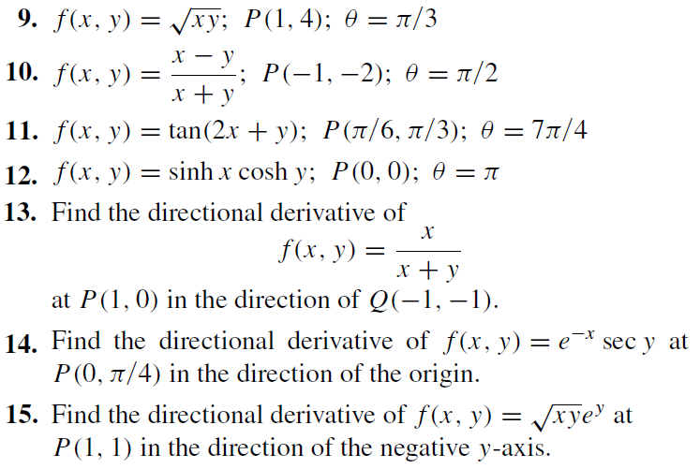

Tangent Planes and Normal Vectors Ex# 13.7
Questions: 1-12
Maxima and Minima of the Functions of Two Varibales Ex# 13.8
Questions: 9-18

Double Integrals over Rectangular Regions Ex#14.1
Questions: 1-16, 29-32
Double Integrals over Nonrectangular Regions Ex#14.2
Questions: 1-26
Triple Integrals Ex#14.5
Questions: 1-12
Vector Fields Ex#15.1
Questions: 17-28

Complex Numbers
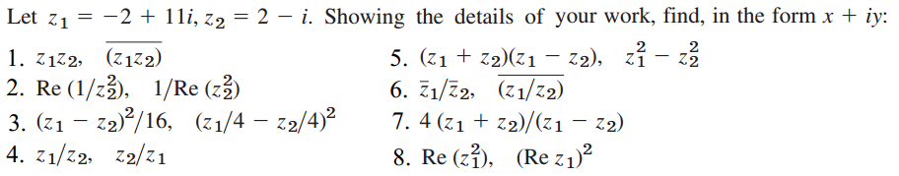

****GOOD LUCK****

