Introduction to Finite Automata
http://www.cs.odu.edu/~toida/nerzic/390teched/regular/fa/intr_2_fa.html

In this chapter we are going to study a class of machines called finite automata. Finite automata are computing devices that accept/recognize regular languages and are used to model operations of many systems we find in practice. Their operations can be simulated by a very simple computer program. Kinds of systems finite automata can model and a computer program to simulate their operations are discussed later.

Let us consider the operation of a soft drink vending machine which charges 15 cents for a can. Pretend that you are the machine. Initially you are waiting for a customer to come and put some coins, that is, you are in the waiting-for-customer state. Let us assume that only nickels and dimes are used for simplicity. When a customer comes and puts in the first coin, say a dime, you are no longer in the waiting-for-customer state. You have received 10 cents and are waiting for more coins to come. So we might say you are in the 10-cents state. If the customer puts in a nickel, then you have now received 15 cents and you wait for the customer to select a soft drink. So you are in another state, say 15-cents state. When the customer selects a soft drink, you must give the customer a can of soft drink. After that you stay in that state until another coin is put in to start the process anew or you may terminate the operation and start all over from the initial state. The states and the transitions between them of this vending machine can be represented with the diagram below. In the figure, circles represent states and arrows state transitions. Ds on arrows represent a dime and Ns a nickel. It is assumed that the machine terminates its operation when it receives 15 cents or more. Click "NICKEL" or "DIME" in the figure and see how it operates (see how arrows turn red).
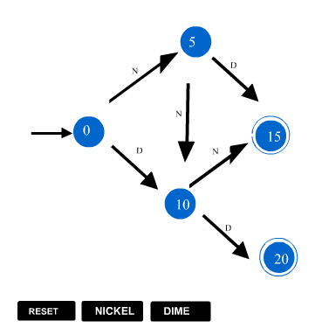

In this example you as a vending machine have gone through (transitions between) a number of states responding to the inputs from the customer (coins in this case). A vending machine looked at this way is an example of finite automaton.

We have learned that regular languages are represented by regular expressions and conversely. In the next few chapters, first we are going to learn different kinds of finite
automata, and equivalence and conversions between them. Then we are going to see that for every regular language a unique finite automaton can be constructed which can recognize the language (i.e. tell whether or not a given string belongs to the regular language). We are then going to study how finite automata can be used to simulate operations of systems we see in practice.

Unfortunately not all languages and systems are simple like regular languages or finite automata. There are languages which are not regular and which, therefore, can not be recognized by finite automata. We are going to learn languages which are not regular and ways to test languages for non-regularity.

Later we are going to learn an extension of finite automata called Turing machines. Though Turing machines are simple modification of finite automata, they are much more powerful computing devices than finite automata. In fact Turing machines are as powerful as computers and it is generally believed, though not proven, that any computation human beings do (with or without computers) can be performed by Turing machines.

In this chapter we are going to study definitions and properties of deterministic finite automata which are one of several types of finite automata.

Definition of Deterministic Finite Automata

Subjects to be Learned
- Finite automata
- State transition diagram
- State transition table

Contents
Here we are going to formally define finite automata, in particular deterministic finite automata and see some examples. Finite automata recognize regular languages and, conversely, any language that is recognized by a finite automaton is regular. There are other types of finite automata such as nondeterministic finite automata and nondeterministic automata with and they are going to be studied later.
Let us now formally define deterministic finite automaton.
Definition of deterministic finite automaton
Let Q be a finite set and let be a finite set of symbols. Also let be a function from Q X to Q, let q₀ be a state in Q and let A be a subset of Q. We call the elements of Q a state, the transition function, q₀ the initial state and A the set of accepting states.
Then a deterministic finite automaton is a 5-tuple < Q,, q₀, , A >.

Notes on the definition
- The set Q in the above definition is simply a set with a finite number of elements. Its elements can, however, be interpreted as a state that the system (automaton) is in. Thus in the example of vending machine, for example, the states of the machine such as "waiting for a customer to put a coin in", "have received 5 cents" etc. are the elements of Q. "Waiting for a customer to put a coin in" can be considered the initial state of this automaton and the state in which the machine gives out a soda can be considered the accepting state.
- The transition function is also called a next state function meaning that the automaton moves into the state (q, a) if it receives the input symbol a while in state q.
Thus in the example of vending machine, if q is the initial state and a nickel is put in, then (q, a) is equal to "have received 5 cents".
- Note that is a function. Thus for each state q of Q and for each symbol a of , (q, a) must be specified.
- The accepting states are used to distinguish sequences of inputs given to the finite automaton. If the finite automaton is in an accepting state when the input ceases to come, the sequence of input symbols given to the finite automaton is "accepted". Otherwise it is not accepted. For example, in the Example 1 below, the string a is accepted by the finite automaton. But any other strings such as aa, aaa, etc. are not accepted.
- A deterministic finite automaton is also called simply a "finite automaton". Abbreviations such as FA and DFA are used to denote deterministic finite automaton.
DFAs are often represented by digraphs called (state) transition diagram. The vertices (denoted by single circles) of a transition diagram represent the states of the DFA and the arcs labeled with an input symbol correspond to the transitions. An arc ( p, q ) from vertex p to vertex q with label represents the transition (p, ) = q. The accepting states are indicated by double circles.
Transition functions can also be represented by tables as seen below. They are called transition table.
Examples of finite automaton
Example 1: Q = { 0, 1, 2 }, = { a }, A = { 1 }, the initial state is 0 and is as shown in the following table.

A state transition diagram for this DFA is given below.
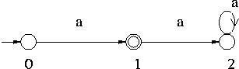
If the alphabet of the Example 1 is changed to { a, b } in stead of { a }, then we need a DFA such as shown in the following example to accept the same string a. It is a little more complex DFA.
Example 2: Q = { 0, 1, 2 }, = { a, b }, A = { 1 }, the initial state is 0 and is as shown in the following table.
State (q) | Input (a) | Next State ( (q, a) )
0 | a | 1
1 | a | 2
2 | a | 2
Note that for each state there are two rows in the table for corresponding to the symbols a and b, while in the Example 1 there is only one row for each state.
A state transition diagram for this DFA is given below.
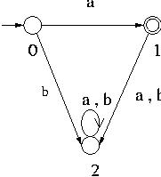
A DFA that accepts all strings consisting of only symbol a over the alphabet { a, b } is the next example.
Example 3: Q = { 0, 1 }, = { a, b }, A = { 0 }, the initial state is 0 and is as shown in the following table.
State (q) | Input (a) | Next State ( (q, a) )
0 | a | 1
0 | b | 2
1 | a | 2
1 | b | 2
2 | a | 2
2 | b | 2
A state transition diagram for this DFA is given below.
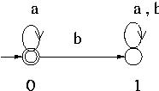
Example 4: For the example of vending machine of the previous section, Q = { 0, 5, 10, 15, 20 }, = { D, N }, A = { 15, 20 }, the initial state q₀ = 0. If we make it a DFA, its transition function is as shown in the following table.
State (q) | Input (a) | Next State ( (q, a) )
0 | a | 0
0 | b | 1
1 | a | 1
1 | b | 1
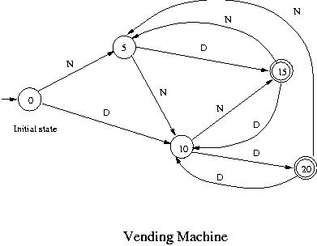
A finite automaton as a machine
State (q) | Input (a) | Next State ( (q, a) )
0 | N | 5
0 | D | 10
5 | N | 10
5 | D | 15
10 | N | 15
10 | D | 20
15 | N | 5
15 | D | 10
20 | N | 5
20 | D | 10
A finite automaton can also be thought of as the device shown below consisting of a tape and a control circuit which satisfy the following conditions:
- The tape has the left end and extends to the right without an end.
- The tape is divide into squares in each of which a symbol can be written prior to the start of the operation of the automaton.
- The tape has a read only head.
- The head is always at the leftmost square at the beginning of the operation.
- The head moves to the right one square every time it reads a symbol.
It never moves to the left. When it sees no symbol, it stops and the automaton terminates its operation.
- There is a finite control which determines the state of the automaton and also controls the movement of the head.
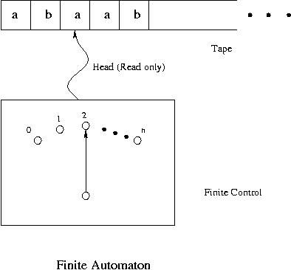
Operation of finite automata
Let us see how an automaton operates when it is given some inputs. As an example let us consider the DFA of Example 3 above.
Initially it is in state 0. When zero or more a's are given as an input to it, it stays in state 0 while it reads all the a's (without breaks) on the tape. Since the state 0 is also the accepting state, when all the a's on the tape are read, the DFA is in the accepting state. Thus this automaton accepts any string of a's. If b is read while it is in state 0 (initially or after reading some a's), it moves to state 1. Once it gets to state 1, then no matter what symbol is read, this DFA never leaves state 1. Hence when b appears anywhere in the input, it goes into state 1 and the input string is not accepted by the DFA. For example strings aaa, aaaaaa etc. are accepted but strings such as aaba, b etc. are not accepted by this automaton.

* of DFA and its Properties

Subjects to be Learned
- *
- Language accepted by DFA

Contents
Here we are going to formally describe what is meant by applying a transition repeatedly, that is the concept of *.
For a state q and string w, *( q, w ) is the state the DFA goes into when it reads the string w starting at the state q. In general a DFA goes through a number of states from the state q responding to the symbols in the string w. Thus for a DFA < Q, , q₀, , A >, the function
* : Q X* -> Q
is defined recursively as follows:
Definition of *:
Basis Clause: For any state q of Q, *( q, ) = q, where denotes the empty string.
Inductive Clause: For any state q of Q, any string y * and any symbol a ,
*( q, ya ) = ( *( q, y ), a ).
In the definition, the Basis Clause says that a DFA stays in state q when it reads an empty string at state q and the Inductive Clause says that the state DFA reaches after reading string ya starting at state q is the state it reaches by reading symbol a after reading string y from state q.
Example
For example suppose that a DFA contains the transitions shown below.
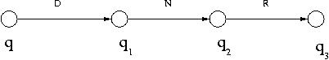
Then *( q, DNR ) can be calculated as follows:
*( q, DNR ) = ( *( q, DN ), R ) by the Inductive Clause.
= ( ( *( q, D ), N ), R ) by applying the Inductive Clause to *( q, DN ).
= ( ( *( q, D ), N ), R ) since D = D.
= ( ( ( *( q, ), D ), N ), R ) by applying the Inductive Clause to *( q, D ).
= ( ( ( q, D ), N ), R ), since *( q, ) = q.
= ( ( q₁, N ), R ), since ( q, D ) = q₁ as seen from the diagram.
= ( q₂, R ), since ( q₁, N ) = q₂ as seen from the diagram.
= q₃ since ( q₂, R ) = q₃ as seen from the diagram.
Properties of *
We can see the following two properties of *.
Theorem 1: For any state q of Q and any symbol a of for a DFA < Q, , q₀, , A >,
*( q, a ) = ( q, a )
Proof : Since a = a,
*( q, a ) = *( q, a ).
By the definition of *,
*( q, a ) = ( *( q, ), a )
But *( q, ) = q by the definition of *.
Hence ( *( q, ), a ) = ( q, a ).
The next theorem states that the state reached from any state, say q, by reading a string, say w, is the same as the state reached by first reading a prefix of w, call it x, and then by reading the rest of the w, call it y.
Theorem 2: For any state q of Q and any strings x and y over * for a DFA < Q, , q₀, , A >,
*( q, xy ) = *( *( q, x ), y ).
Proof : This is going to be proven by induction on string y. That is the statement to be proven is the following:
For an arbitrary fixed string x, *( q, xy ) = *( *( q, x ), y ) holds for any arbitrary string y.
First let us review the recursive definition of *.
Recursive definition of *:
Basis Clause: *.
Inductive Clause: If x * and a , then xa *.
Extremal Clause: Nothing is in * unless it is obtained from the above two clauses.
Now the proof of the theorem.
Basis Step: If y = , then *( q, xy ) = *( q, x ) = *( q, x ).
Also *( *( q, x ), y ) = *( *( q, x ), ) = *( q, x ) by the definition of *. Hence the theorem holds for y = .
Inductive Step: Assume that *( q, xy ) = *( *( q, x ), y ) holds for an arbitrary string y. This is the induction hypothesis.
We are going to prove that *( q, xya ) = *( *( q, x ), ya ) for any arbitrary symbol a of .
*( q, xya ) = ( *( q, xy ), a ) by the definition of *
= ( * ( *( q, x ), y ), a ) by the induction hypothesis.
= *( *( q, x ), ya ) by the definition of *.
Thus the theorem has been proven.

Language Accepted by DFA

Subjects to be Learned
- Language accepted by DFA

Contents
- Here we are going to formally define what is meant by a DFA (deterministic finite automaton) accepting a string or a language.
A string w is accepted by a DFA < Q, , q₀, , A >, if and only if *( q₀, w ) A. That is a string is accepted by a DFA if and only if the DFA starting at the initial state ends in an accepting state after reading the string.
A language L is accepted by a DFA < Q, , q₀, , A >, if and only if L = { w | *( q₀, w ) A }. That is, the language accepted by a DFA is the set of strings accepted by the DFA.

Example 1:
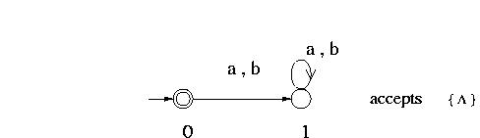
This DFA accepts {} because it can go from the initial state to the accepting state (also the initial state) without reading any symbol of the alphabet i.e. by reading an empty string. It accepts nothing else because any non-empty symbol would take it to state 1, which is not an accepting state, and it stays there.
Example 2:
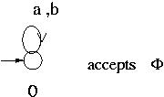
This DFA does not accept any string because it has no accepting state. Thus the language it accepts is the empty set Ø.
Example 3: DFA with one cycle
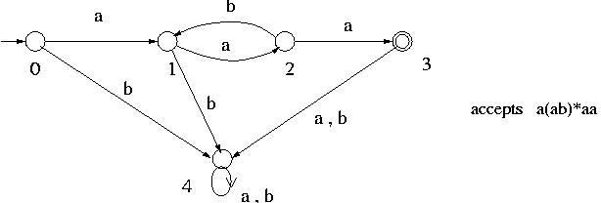
This DFA has a cycle: 1 - 2 - 1 and it can go through this cycle any number of times by reading substring ab repeatedly.
To find the language it accepts, first from the initial state go to state 1 by reading one a. Then from state 1 go through the cycle 1 - 2 - 1 any number of times by reading substring ab any number of times to come back to state 1. This is represented by (ab)*. Then from state 1 go to state 2 and then to state 3 by reading aa. Thus a string that is accepted by this DFA can be represented by a(ab)*aa.

Example 4: DFA with two independent cycles
(Please see below a note about Kleene Notation)
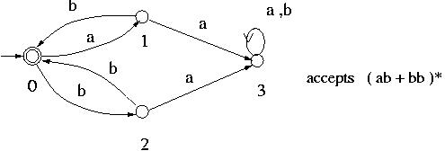
This DFA has two independent cycles: 0 - 1 - 0 and 0 - 2 - 0 and it can move through these cycles any number of times in any order to reach the accepting state from the initial state such as 0 - 1 - 0 - 2 - 0 - 2 - 0. Thus a string that is accepted by this DFA can be represented by ( ab + bb )*.
Example 5: DFA with two interleaved cycles
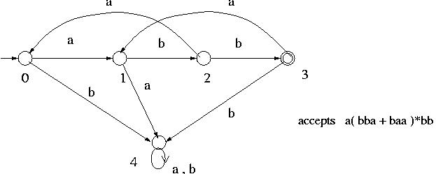
This DFA has two cycles: 1 - 2 - 0 - 1 and 1 - 2 - 3 - 1.
To find the language accepted by this DFA, first from state 0 go to state 1 by reading a ( any other state which is common to these cycles such as state 2 can also be used instead of state 1 ). Then from state 1 go through the two cycles 1 - 2 - 0 - 1 and 1 - 2 - 3 - 1 any number of times in any order by reading substrings baa and bba, respectively. At this point a substring a( baa + bba )* will have been read. Then go from state 1 to state 2 and then to state 3 by reading bb. Thus altogether a( baa + bba )*bb will have been read when state 3 is reached from state 0.
Kleene Notation An expression of the form (x + y)* in which x and y are strings is in fact a short form of {x, y}* (i.e. + symbol is interpreted as or / union) and it is collection of all strings of all lengths make up of x and y in any order. So
(x + y)* = {x, y}* = {, x, y, xx, xy, yx, yy, xxx, xxy, xyx, xyy, yxx, yxy, yyx, yyy, …. }. The symbol * is called Kleene symbol.
Example 6:
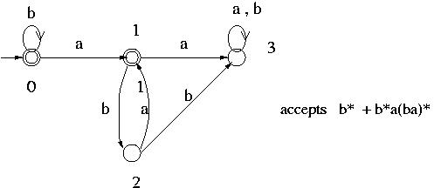

This DFA has two accepting states: 0 and 1. Thus the language that is accepted by this DFA is the union of the language accepted at state 0 and the one accepted at state 1. The language accepted at state 0 is b*. To find the language accepted at state 1, first at state 0 read any number of b's. Then go to state 1 by reading one a. At this point (b*a) will have been read. At state 1 go through the cycle 1 - 2 - 1 any number of times by reading substring ba repeatedly. Thus the language accepted at state 1 is b*a(ba)*.

There is a systematic way of finding the language accepted by a DFA and we are going to learn it later. So we are not going to go any further on this problem here.
Definition of Nondeterministic Finite Automata

Subjects to be Learned
- Nondeterministic finite automata
- State transition diagram
- State transition table

Contents
In the previous section we have seen DFAs that accept some simple languages such as Ø, {}, and { a }. As you might have noticed, those DFAs have states and transitions which do not contribute to accepting strings and languages. For example all we need about an FA that accepts { a } is the following regardless of the alphabet (whether be it { a }, { a, b } or any other).
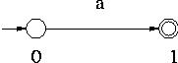
This is so to say the essence of such an FA. But it is not DFA. A DFA that accepts { a } would need more states and transitions as you can see below for example.
Without those extra state and transitions it is not a DFA if the alphabet is { a, b }.
To avoid those redundant states and transitions and to make modeling easier we use finite automata called nondeterministic finite automata (abbreviated as NFA). Below we are going to formally define nondeterministic finite automata (abbreviated as NFS) and see some examples. As we are going to see later, for any NFA there is a DFA which accepts the same language and vice versa.
NFAs are quite similar to DFAs. The only difference is in the transition function. NFAs do not necessarily go to a unique next state. An NFA may not go to any state from the current state on reading an input symbol or it may select one of several states nondeterministically (e.g. by throwing a die) as its next state.
Definition of nondeterministic finite automaton

Let Q be a finite set and let be a finite set of symbols. Also let be a function from Q X to 2^{Q}, let q₀ be a state in Q and let A be a subset of Q. We call the elements of Q a state, the transition function, q₀ the initial state and A the set of accepting states.
Then a nondeterministic finite automaton is a 5-tuple < Q, , q₀, , A >.
Notes on the definition
- As in the case of DFA the set Q in the above definition is simply a set with a finite number of elements. Its elements can be interpreted as a state that the system (automaton) is in.
- The transition function is also called a next state function. Unlike DFAs an NFA moves into one of the states given by (q, a) if it receives the input symbol a while in state q. Which one of the states in (q, a) to select is determined nondeterministically.
- Note that is a function. Thus for each state q of Q and for each symbol a of (q, a) must be specified. But it can be the empty set, in which case the NFA aborts its operation.
- As in the case of DFA the accepting states are used to distinguish sequences of inputs given to the finite automaton. If the finite automaton is in an accepting state when the input ends i.e. ceases to come, the sequence of input symbols given to the finite automaton is "accepted". Otherwise it is not accepted.
- Note that any DFA is also a NFA.
Examples of NFA
Example 1: Q = { 0, 1 }, = { a }, A = { 1 }, the initial state is 0 and is as shown in the following table.
State (q) | Input (a) | Next State ( (q, a) )
0 | a | { 1 }
1 | a
A state transition diagram for this finite automaton is given below.
If the alphabet is changed to { a, b } in stead of { a }, this is still an NFA that accepts { a }.
Example 2: Q = { 0, 1, 2 }, = { a, b }, A = { 2 }, the initial state is 0 and is as shown in the following table.
Note that for each state there are two rows in the table for corresponding to the symbols a and b, while in the Example 1 there is only one row for each state.
A state transition diagram for this finite automaton is given below.
State (q) | Input (a) | Next State ((q, a) )
0 | a | { 1, 2 }
0 | b
1 | a
1 | b | { 2 }
2 | a
2 | b
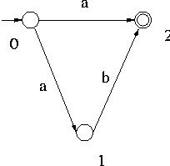
Operation of NFA
Let us see how an automaton operates when some inputs are applied to it. As an example let us consider the automaton of Example 2 above.
Initially it is in state 0. When it reads the symbol a, it moves to either state 1 or state 2. Since the state 2 is the accepting state, if it moves to state 2 and no more inputs are given, then it stays in the accepting state. We say that this automaton accepts the string a. If on the other hand it moves to state 1 after reading a, if the next input is b and if no more inputs are given, then it goes to state 2 and remains there. Thus the string ab is also accepted by this NFA. If any other strings are given to this NFA, it does not accept any of them.
Let us now define the function * and then formalize the concepts of acceptance of strings and languages by NFA.

Language Accepted by NFA

Subjects to be Learned
- * for NFA
- Language accepted by NFA
- Properties of *

Contents
Here we are going to formally define what is meant by an NFA (nondeterministic finite automaton) accepting a string or a language. We start with the concept of *.
Definition of *.
For a state q and string w, *( q, w ) is the set of states that the NFA can reach when it reads the string w starting at the state q. In general an NFA nondeterministically goes through a number of states from the state q as it reads the symbols in the string w. Thus for an NFA < Q, , q₀, , A >, the function
*: Q X* -> 2^{Q}
is defined recursively as follows:
Definition of *:
Basis Clause: For any state q of Q, *( q, ) = { q }, where denotes the empty string.
Inductive Clause: For any state q of Q, any string y * and any symbol a ,
*( q, ya ) = 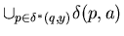
In the definition, the Basis Clause says that an NFA stays in state q when it reads an empty string at state q and the Inductive Clause says that the set of states NFA can reach after reading string ya starting at state q is the set of states it can reach by reading symbol a after reading string y starting at state q.
Example
For example consider the NFA with the following transition table:
The transition diagram for this NFA is as given below.
State (q) | Input (a) | Next State ( (q, a) )
0 | a | { 0, 1, 3 }
0 | b | { 2 }
1 | a
1 | b | { 3 }
2 | a | { 3 }
2 | b
3 | a
3 | b | { 1 }
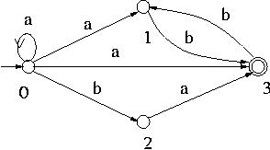
Suppose that the state 3 is an accepting state of this NFA.
Then *( 0, ab ) can be calculated as follows:
*( 0, ab ) is the union of ( p, b ) for all p*( 0, a ) by the Inductive Clause of the definition of *.
Now *( 0, a ) is the union of ( p, a ) for all p *( 0, ) again by the Inductive Clause of the definition of *.
By the Basis Clause of the definition of *, *( 0, ) = { 0 }.
Hence *( 0, a ) = ( 0, a ) = { 0, 1, 3 }.
Hence *( 0, ab ) = ( 0, b ) ( 1, b ) ( 3, b ) = { 2 } { 3 } { 1 } = { 1, 2, 3 }.
We say that a string x * is accepted by an NFA < Q, , q₀, , A > if and only if *( q₀, x ) A is not empty, that is, if and only if it can reach an accepting state by reading x starting at the initial state. The language accepted by an NFA < Q, , q₀, , A > is the set of strings that are accepted by the NFA.
Some of the strings accepted by the NFA given above are , a, ab, aaa, abbbb etc. and the language it accepts is a*( ab + a + ba )(bb)*.
* for NFA has properties similar to that for DFA.
Theorem 1: For any state q of Q and any symbol a of for an NFA < Q, , q₀, , A >,
*( q, a ) = ( q, a )
Theorem 2: For any state q of Q and any strings x and y over for an NFA < Q, , q₀, , A >,
*( q, xy ) = 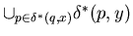
These theorems can be proven in a manner similar to those for Theorems 1 and 2 for DFA.
Definition of Nondeterministic Finite Automata with -Transitions

Subjects to be Learned
- Nondeterministic finite automata with -Transitions
- State transition diagram
- State transition table

Contents
One of the objectives of this chapter is to show that there is a one-to-one correspondence between regular languages and finite automata. We are going to do that by showing that a finite automaton can be constructed from a given regular expression by combining simpler FAs using union, concatenation and Kleene star operations. These operations on FAs can be described conveniently if -Transitions are used. Basically an NFA with -Transitions is an NFA but can respond to an empty string and move to the next state. Here we are going to formally define NFA with -Transitions (abbreviated as NFA-) and see some examples. As we are going to see later, for any NFA- there is a NFA (hence DFA) which accepts the same language and vice versa.
Definition of nondeterministic finite automaton with -Transitions
Let Q be a finite set and let be a finite set of symbols. Also let be a function from Q X{} to 2^{Q}, let q₀ be a state in Q and let A be a subset of Q. We call the elements of Q a state, the transition function, q₀ the initial state and A the set of accepting states.
Then a nondeterministic finite automaton with -Transitions is a 5-tuple < Q, , q₀, , A >.
Notes on the definition
- A transition on reading means that the NFA- makes the transition without reading any symbol in the input. Thus the tape head does not move when is read.
- Note that any NFA is also a NFA-.
Example of NFA-
Q = { 0, 1, 2, 3, 4, 5 }, = { a, b }, A = Ø, the initial state is 0 and is as shown in the following table.
Here the transitions to Ø are omitted from the table. A state transition diagram for this finite automaton is given below.
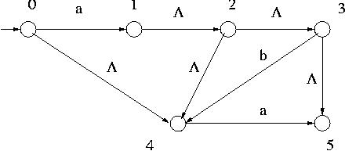
State (q) | Input (a) | Next State ( (q, a) )
0 | a | { 1 }
0 |  | { 4 }
1 |  | { 2 }
2 |  | { 3, 4 }
3 |  | { 5 }
3 | b | { 4 }
4 | a | { 5 }
When a symbol a is read at the initial state 0, for example, it can move to any of the states other than 0. For once you are in state 1, for example, you can go to state 2, 3, 4 and 5 without reading any symbol on the tape. If you read string ab, then you come to state 4. For though you go to states 1, 2, 3, 4 and 5 by reading a, there are no transitions on reading b except from state 3. Thus 4 is the only state you can go to from the initial state by reading ab.

Language Accepted by NFA-

Subjects to be Learned
- -closure
- * for NFA-
- Language accepted by NFA-
- Properties of *

Contents
To formally define * for NFA-, we start with the concept of -closure for a state which is the set of states reachable from the state without reading any symbol. Using that concept we define * and then strings and languages accepted by NFA-.
Definition of -closure
Let < Q, , q₀, , A > be an NFA-. Let us denote the -closure of a set S of states of Q by ( S ). Then ( S ) is defined recursively as follows:
Basis Clause: S 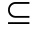( S )
Inductive Clause: For any state q of Q, if q ( S ), then ( q, ) ( S ).
Extremal Clause: Nothing is in ( S ) unless it is obtained by the above two clauses.
For the NFA- of the above figure, ( { 2 } ) is obtained as follows:
First { 2 } ( { 2 } ), that is, 2 ( { 2 } ). Then since 2 ( { 2 } ), by the Inductive Clause, ( 2, ) ( { 2 } ).
Since ( 2, ) = { 3, 4 }, we now have { 2, 3, 4 } ( { 2 } ).
Since 3 and 4 have been added to ( { 2 } ), ( 3, ) = { 5 } and ( 4, ) = must be included in ( { 2 } ). Thus now { 2, 3, 4, 5 } ( { 2 } ).
Though 5 has become a member of the closure, since ( 5, ) is empty, no new members are added to ( { 2 } ). Since ( q, ) has been examined for all the states currently in ( { 2 } ) and no more elements are added to it, this process of generating the closure terminates and ( { 2 } ) = { 2, 3, 4, 5 } is obtained.
As we can see from the example, ( S ) is the set of states that can be reached from the states of S by traversing any number of arcs. That is, it is the set of states that can be reached from the states of S without reading any symbols in .
Now with this -closure, we can define * recursively as follows:
As in the cases of DFA and NFA, * gives the result of applying the transition function repeatedly as dictated by the given string.

Definition of *
* is going to be defined recursively.
Let < Q, , q₀, , A > be an NFA-.
Basis Clause: For any state q of Q,
*( q, ) = ( { q } ).
Inductive Clause: For any state q, a string y in * and a symbol a in ,
*( q, ya ) = ( ).
What the Inductive Clause means is that *( q, ya ) is obtained by first finding the states that can be reached from q by reading y ( *( q, y ) ), then from each of those states p by reading a (i.e. by finding ( p, a ) ), and then by reading 's ( i.e. by taking the closure of the ( p, a )'s ).
Example : For the NFA- of the following figure, *( 0, ab ) can be obtained as below:
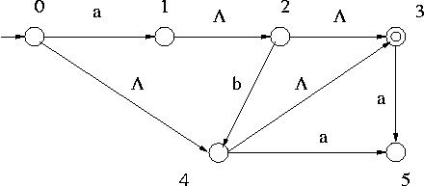
First let us compute *( 0, a ).
For that we need ( { 0 } ).
Since it is the set of states reached by traversing the arcs from state 0, ( { 0 } ) = { 0, 3, 4 }.
Next from each of the states in ( { 0 } ) we read symbol a and move to another state (i.e. apply ). They are ( 0, a ) = { 1 }, ( 3, a ) = ( 4, a ) = { 5 }.
Hence = { 1, 5 } for q = 0.
We then traverse the arcs from { 1, 5 } to get to the states in *( 0, a ). Since ( { 1 } ) = { 1, 2, 3 } and ( { 5 } ) = { 5 }, *( 0, a ) = { 1, 2, 3, 5 }.
Then to find *( 0, ab ) read b from each of the states in *( 0, a ) and then take the arcs from there.
Now ( 1, b ), ( 3, b ) and ( 5, b ) are empty sets, and ( 2, b ) = { 4 }. Thus Since ( { 4 } ) = { 3, 4 }, *( 0, ab ) = { 3, 4 }.
A string x is accepted by an NFA- < Q, , q₀, , A > if and only if *( q₀, x ) contains at least one accepting state.
The language accepted by an NFA- < Q, , q₀, , A > is the set of strings accepted by the NFA-.

For example the NFA- of the figure given above accepts the language { , a, ab }.

Equivalence of DFAs, NFAs and NFA-s

Subjects to be Learned
- Conversion of NFA- to (equivalent) NFA
- Conversion of NFA to (equivalent) DFA
- Equivalence of DFAs, NFAs and NFA-

Contents
One major objective in our study of FAs and regular languages is to learn that any language recognized by a DFA is regular and that any regular language is recognized by a DFA. To prove the former, we are going to show that simple regular languages are recognized by some simple DFAs and then show that using union, concatenation and Kleene star operations, DFAs to recognize more complex languages can be constructed from those simple DFAs. Since those operations on FAs can be described conveniently using NFA-s, they are going to be used to construct complex FAs from simple ones. These NFA-s are then converted to equivalent NFAs (without s ), then to DFAs so that nondeterminisms are removed and computer programs can be written for simulating them. Finally we are going to learn that the DFAs that recognize a regular language can be transformed into a unique DFA by minimizing the number of their states.
In this and the next sections we are going to study the conversion of NFA-s to equivalent NFAs then to DFAs. The construction of NFA-s for regular languages is discussed in the next chapter. The minimization of states is going to be discussed a little later in another chapter.
Conversion of NFA- to NFA
Let M₁ = < Q₁, , q_{1,0}, ₁, A₁ > be an NFA- that recognizes a language L. Then the NFA M₂ = < Q₂, , q_{2,0}, ₂, A₂ > that satisfies the following conditions recognizes L:
Q₂ = Q₁,
q_{2,0} = q_{1,0},
₂( q, a ) = ₁*( q, a ) =( 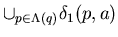)
A₂ = A₁ { q_{1,0} } if ( { q_{1,0} } ) A₁
= A₁ otherwise.
Thus to obtain an NFA M₂ = < Q₂, , q_{2,0}, ₂, A₂ > which accepts the same language as the given NFA- M₁ = < Q₁, , q_{1,0}, ₁, A₁ > does, first copy the states of Q₁ into Q₂.
Then for each state q of Q₂ and each symbol a of find ₂( q, a ) as follows:
Find ( {q} ), that is all the states that can be reached from q by traversing arcs. Then collect all the states that can be reached from each state of ( {q} ) by traversing one arc labeled with the symbol a. The closure of the set of those states is ₂( q, a ).
The set of accepting states A₂ is the same as A₁ if no accepting states can be reached from the initial state q_{1,0} through arcs in M₁. Otherwise, that is if an accepting state can be reached from the initial state q_{1,0} through arcs in M₁, then all the accepting states of M₁ plus state q_{1,0} are the accepting states of M₂.
Example 1: Let us convert the following NFA- to NFA.
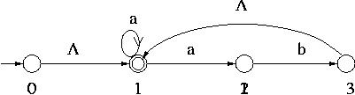
The set of states Q₂ of NFA is { 0, 1, 2, 3 ), the initial state is 0 and the accepting states are 1 and 0, since 1 is in ( { 0 } ). The transition function ₂ is obtained as follows:
₂( 0, a ):
First ( { 0 } ) = { 0, 1 }. Then from the transition function of the NFA-
₁( 0, a ) = Ø, and ₁( 1, a ) = { 1, 2 }.
Hence ₂( 0, a ) = ( { 1, 2 } ) = { 1, 2 }.
For ₂( 0, b ), since ( { 0 } ) = { 0, 1 } and ₁( 0, b ) = ₁( 1, b ) = Ø, ₂( 0, b ) = Ø.
Similarly ₂ can be obtained for other states and symbols. They are given in the table below together with ( { q } ) and 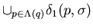.
State q | Input | ( { q } ) |  | ₂ ( q, ) ( = ( ) )
0 | a | { 0, 1 } | { 1, 2 } | { 1, 2 }
0 | b | { 0, 1 }
1 | a | { 1 } | { 1, 2 } | { 1, 2 }
1 | b | { 1 }
2 | a | { 2 }
2 | b | { 2 } | { 3 } | { 1, 3 }
3 | a | { 1, 3 } | { 1, 2 } | { 1, 2 }
3 | b | { 1, 3 }
The NFA thus obtained is shown below.
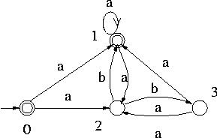
Example 2: Let us convert the following NFA- to NFA.
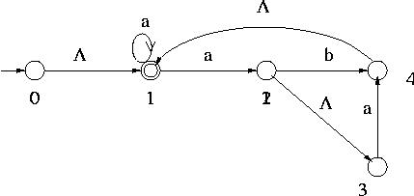
The set of states Q₂ of NFA is { 0, 1, 2, 3, 4 ), the initial state is 0 and the accepting states are 1 and 0, since 1 is in ( { 0 } ). The transition function ₂ is obtained as for Example 1. ₂ is given in the table below together with ( { q } ), ₁ ( p, ) and
State q | Input | ( { q } ) |  | ₂ ( q, ) ( = ( ) )
0 | a | { 0, 1 } | { 1, 2 } | { 1, 2, 3 }
0 | b | { 0, 1 } | Ø | Ø
1 | a | { 1 } | { 1, 2 } | { 1, 2, 3 }
1 | b | { 1 } | Ø | Ø
2 | a | { 2, 3 } | { 4 } | { 1, 4 }
2 | b | { 2, 3 } | { 4 } | { 1, 4 }
3 | a | { 3 } | { 4 } | { 1, 4 }
3 | b | { 3 } | Ø | Ø
4 | a | { 1, 4 } | { 1, 2 } | { 1, 2, 3 }
4 | b | { 1, 4 } | Ø | Ø
The NFA thus obtained is shown below.
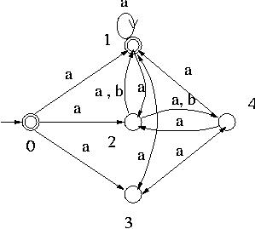

Exercise:- Convert the following NFA- to NFA.

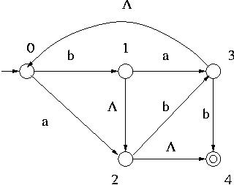

Conversion of NFA to DFA
Let M₂ = < Q₂, , q_{2,0}, ₂, A₂ > be an NFA that recognizes a language L. Then the DFA M = < Q, , q₀, , A > that satisfies the following conditions recognizes L:
Q = 2^{Q}₂, that is the set of all subsets of Q₂,
q₀ = { q_{2,0} },
( q, a ) = 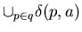for each state q in Q and each symbol a in and
A = { q Q | q A₂ 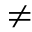 Ø}
To obtain a DFA M = < Q, , q₀, , A > which accepts the same language as the given NFA M₂ = < Q₂, , q_{2,0}, ₂, A₂ > does, you may proceed as follows:
Initially Q = Ø.
First put { q_{2,0} } into Q. { q_{2,0} } is the initial state of the DFA M.
Then for each state q in Q do the following:
add the set , where here is that of NFA M₂, as a state to Q if it is not already in Q for each symbol a in .
For this new state, add ( q, a ) = to , where the on the right hand side is that of NFA M₂.
When no more new states can be added to Q, the process terminates. All the states of Q that contain accepting states of M₂ are accepting states of M.
Note: The states that are not reached from the initial state are not included in Q obtained by this procedure. Thus the set of states Q thus obtained is not necessarily equal to 2^{Q}₂.
Example 1: Let us convert the following NFA to DFA.
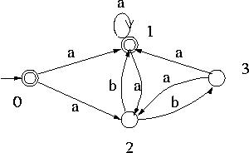
Initially Q is empty. Then since the initial state of the DFA is {0}, {0} is added to Q.
Since ₂( 0, a ) = { 1, 2 }, { 1, 2 } is added to Q and ( { 0 }, a ) = { 1, 2 }.
Since ₂( 0, b ) = Ø, Ø is added to Q and ( { 0 }, b ) = Ø.
At this point Q = { {0}, { 1, 2 }, Ø }.
Then since { 1, 2 } is now in Q, the transitions from { 1, 2 } on symbols a and b are computed. Since ₂( 1, a ) = { 1, 2 }, and ₂( 2, a ) = Ø, ( { 1, 2 }, a ) = { 1, 2 }.
Similarly ( { 1, 2 }, b ) = { 1, 3 }. Thus { 1, 3 } is added to Q.
Similarly ( { 1, 3 }, a ) = { 1, 2 } and ( { 1, 3 }, b ) = Ø. Thus no new states are added to Q. Since the transitions from all states of Q have been computed and no more states are added to Q, the conversion process stops here.
Note that there are no states of Q₂ in Ø. Hence there are no states that M₂ can go to from Ø. Hence ( Ø, a ) = ( Ø, b ) = Ø.
For the accepting states of M, since states 0 and 1 are the accepting states of the NFA, all the states of Q that contain 0 and/or 1 are accepting states. Hence { 0 }, { 1, 2 } and { 1, 3 } are the accepting states of M. The DFA thus obtained is shown below.
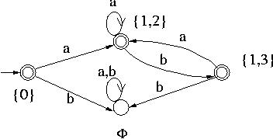
Example 2: Similarly the NFA
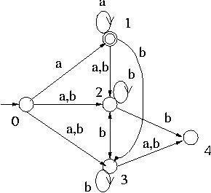
is converted to the following DFA:
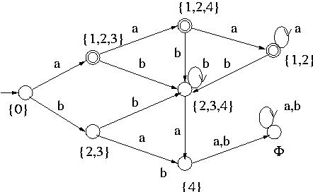

Exercise:- Converting the following NFA to DFA.

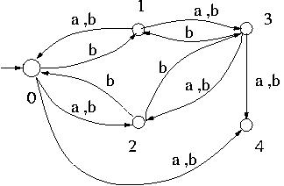

Proof of Equivalence of NFA- and NFA
We are going to prove that the NFA obtained from NFA- by the conversion algorithm accepts the same language as the NFA-.
NFA- that recognizes a language L is denoted by M₁ = < Q₁, , q_{1,0}, ₁, A₁ > and NFA obtained by the conversion is denoted by M₂ = < Q₂, , q_{2,0}, ₂, A₂ >
First we are going to prove that ₁*( q, w ) = ₂*( q, w ) for any non-empty string w.
When it is proven, it implies that NFA- M₁ and NFA M₂ accept the same non-empty strings. The case when w is an empty string is going to be proven separately.
Claim 1: For any non-empty string w and for any state q,
₁*( q, w ) = ₂*( q, w ).
Proof: This is going to be proven by induction on w. Recall that the set of strings is defined recursively. Thus we first prove that it is true for any arbitrary symbol, then assuming it holds for any arbitrary string w we prove it for any of the children of w, that is wa for any symbol a in the alphabet.
Basis Step: We need to show that for any symbol a in
₁*( q, a ) = ₂*( q, a ).
We are going to prove it by showing that both of them are equal to ₂( q, a ).
Firstly ₂( q, a ) = ₁*( q, a ) --- (1)
because of the way NFA is constructed from NFA-.
Secondly ₂*( q, a ) = ₂*(q, a ) = 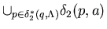
by the definition of ₂* for NFA
Since ₂*(q, ) = { q }, = 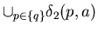= ₂( q, a ).
Hence ₂*( q, a ) = ₂( q, a ). --- (2)
Hence from (1) and (2),
₁*( q, a ) = ₂*( q, a ).
Inductive Step: We need to show that if ₁*( q, w ) = ₂*( q, w ) for an arbitrary string w (Induction Hypothesis),
then ₁*( q, wa ) = ₂*( q, wa ) holds for any arbitrary symbol a in . First we show that ₂*( q, wa ) = 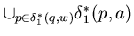 --- (1)
using the definition of ₂*, the induction hypothesis and the construction of NFA from NFA-.
Then we show that = ₁*( q, wa ) --- (2)
basically using the definition of ₁*.
Then from (1) and (2) we can see that ₁*( q, wa ) = ₂*( q, wa ).
Let us first prove (1).
By the definition of ₂*
₂*( q, wa ) = 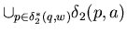
Since ₂*( q, w ) = ₁*( q, w ) by the induction hypothesis,
= 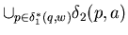
Since ₂( q, a ) = ₁*( q, a ) by the way NFA is constructed from NFA-.
=
Hence ₂*( q, wa ) = , that is (1) has been proven.
Let us next prove (2), that is = ₁*( q, wa ).
By the definition of ₁* for NFA-,
₁*( p, a ) = 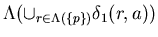
Substituting this into the left hand side of (2) produces
= 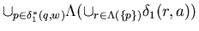.
The right hand side of this equality is equal to
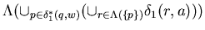( the first and have been swapped to get this),
as proven below in Claim 3,
This can be shown to be equal to 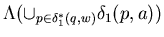, because 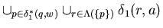= 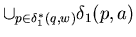.
To see an explanation for this click here.
Hence = .
On the other hand = ₁*( q, wa ), by the definition of ₁*.
Hence = ₁*( q, wa ).
Hence we have proven (2).
Thus from (1) and (2) ₁*( q, wa ) = ₂*( q, wa ). End of Induction
With this Claim 1 we can see that any non-empty string w is accepted by NFA if and only if it is accepted by the corresponding NFA-.
As for the empty string , if it is accepted by an NFA-, then ( { q₁₀ } ) A₁ Ø. Hence by the way A₂ is constructed, q₂₀ A₂. Hence is accepted by NFA.
Conversely if is accepted by NFA, then q₂₀ A₂. By the way NFA is constructed from NFA- this means that ( { q₁₀ } ) A₁Ø. Hence is accepted by NFA-.
Thus NFA- and the corresponding NFA accept the same language.
As a preparation for the proof of commutativity of union and -closure operations, let us prove the following claim.
Claim 2: ( S T ) = ( S ) ( T ).
We are going to prove this in two parts:
( S T ) ( S ) ( T ) and
( S ) ( T ) ( S T ).
Part 1 : ( S T ) ( S ) ( T )
This is going to be proven by induction on ( S T ).
For that let us restate the statement so that the induction becomes clearer.
What Part 1 states is that all the elements of ( S T ) have the property of being in the set ( S ) ( T ).
Since ( S T ) is defined recursively, in the Basis Step of our proof we prove the property for the elements of the basis of ( S T ) and in the Inductive Step we prove that if an arbitrary element of ( S T ) has that property, then its children also have it.
Let us review the definition of the -closure of the set of states of an NFA-. Let X be the set of states of an NFA-. Then the -closure of X is defined recursively as
Basis Clause: X ( X ).
Inductive Clause: If q ( X ), then ( q, ) ( X ).
Extremal Clause: Nothing is in ( X ) unless it is obtained by the Basis and Inductive Clauses.
Proof of Part 1:
Basis Step: We need to prove that ( S T ) ( S ) ( T ).
Since S ( S ) and T ( T ), S and T are subsets of ( S ) ( T ). Hence (ST) ( S ) ( T ).
Inductive Step: We need to prove that if q is an arbitrary element of ( S T ) with the property of being in ( S ) ( T ), then ( q, ) ( S ) ( T ).
Let q be an arbitrary element of ( ST ) with the property of being in ( S ) ( T ).
Since q ( S ) ( T ), q ( S ) or q ( T ).
If q ( S ), then ( q, ) ( S ) by the definition of ( S ). Hence ( q, ) ( S ) ( T ).
Similarly if q ( T ), then ( q, ) ( S ) ( T ).
Hence if q is an arbitrary element of ( S T ) with the property of being in ( S ) ( T ), then ( q, ) ( S ) ( T ).
Thus all the elements of ( S T ) have the property of being in ( S ) ( T ) which is to say that ( S T ) ( S ) ( T ).
End of Proof for Part 1
Part 2 : ( S ) ( T ) ( S T ).
Proof of Part 2: We are going to prove ( S ) ( S T ) and ( T ) ( S T ). That would imply that ( S ) ( T ) ( S T ).
Proof of ( S ) ( S T ) :
By induction on ( S ).
Basis Step: We need to show that S ( S T ).
Since S ( S T ), and ( S T ) ( S T ), S ( S T ).
Inductive Step: We need to prove that for an arbitrary element q in ( S ), if q is in ( S T ), then ( q, ) ( S T ).
Since q is in ( S T ) and since ( S T ) is a -closure, by the definition of -closure ( q, ) ( S T ).
Thus ( S ) ( S T ) has been proven.
Similarly ( T ) ( S T ) holds.
Hence ( S ) ( T ) ( S T ) holds.
End of Proof of Part 2
End of Proof of Claim 2
Claim 3: ( 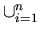S_{i} ) = ( S_{i} ).
Proof : Proof by induction on n.
Basis Step: n = 1. If n = 1, then ( S_{i} ) = ( S₁ ) and
( S_{i} ) = ( S₁ ).
Hence ( S_{i} ) = ( S_{i} ) holds for n = 1.
Inductive Step: Assume that ( S_{i} ) = ( S_{i} ) holds for n. --- Induction Hypothesis
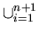( S_{i} ) = ( ( S_{i} ) ) ( S_{n+1} ) by the definition of union.
= ( S_{i} ) ( S_{n+1} ) by the induction hypothesis.
= ( ( S_{i} ) S_{n+1} ) by Claim 2 above, since S_{i} is a set as well as S_{n+1}.
= ( S_{i} ) by the definition of union. End of Proof for Claim 3

Kleene's Theorem --- Part 1

Subjects to be Learned
- Union of FAs
- Concatenation of FAs
- Kleene Star of FAs
- Acceptance of regular languages by FAs

Contents
In this unit we are going to learn Kleene's theorem. It states that any regular language is accepted by an FA and conversely that any language accepted by an FA is regular.
Theorem 1 (Part 1 of Kleene's theorem): Any regular language is accepted by a finite automaton.
Proof: This is going to be proven by (general) induction following the recursive definition of regular language.
Basis Step: As shown below the languages Ø, {} and { a } for any symbol a in are accepted by an FA.
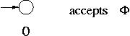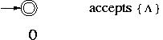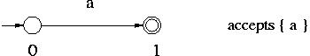
Inductive Step: We are going to show that for any languages L₁ and L₂ if they are accepted by FAs, then L₁ L₂, L₁L₂ and L₁* are accepted by FAs. Since any regular language is obtained from {} and { a } for any symbol a in by using union, concatenation and Kleene star operations, that together with the Basis Step would prove the theorem.
Suppose that L₁ and L₂ are accepted by FAs M₁ = < Q₁, , q_{1,0}, ₁, A₁ > and M₂ = < Q₂, , q_{2,0}, ₂, A₂ >, respectively. We assume that Q₁ Q₂ = Ø without loss of generality since states can be renamed if necessary.
Then L₁ L₂, L₁L₂ and L₁* are accepted by the FAs M_{u} = < Q_{u}, , q_{u,0}, _{u}, A_{u} >, M_{c} = < Q_{c}, , q_{c,0}, _{c}, A_{c} > and M_{k} = < Q₂, , q_{k,0}, _{k}, A_{k} >, respectively, which are given below.
M_{u} = < Q_{u}, , q_{u,0}, _{u}, A_{u} > :
Q_{u} = Q₁Q₂ { q_{u,0} }, where q_{u,0} is a state which is neither in Q₁ nor in Q₂.
_{u} = ₁₂ { (q_{u,0}, , { q_{1,0}, q_{2,0} } ) }, that is _{u}(q_{u,0}, ) = { q_{1,0}, q_{2,0} }. Note that _{u}(q_{u,0}, a ) = Ø for all a in .

A_{u} = A₁ A₂
M_{c} = < Q_{c}, , q_{c,0}, _{c}, A_{c} > :
Q_{c} = Q₁ Q₂
q_{c,0} = q_{1,0}
_{c} = ₁ ₂ { (q, , { q_{2,0} } ) | q A₁ }
A_{c} = A₂
M_{k} = < Q_{k}, , q_{k,0}, _{k}, A_{k} > :
Q_{k} = Q₁ { q_{k,0} }, where q_{k,0} is a state which is not in Q₁.
_{k} = ₁ { (q_{k,0}, , { q_{1,0} } ) } { (q, , { q_{k,0} } ) | q A₁ }
A_{k} = { q_{k,0} }
These NFA-s are illustrated below.
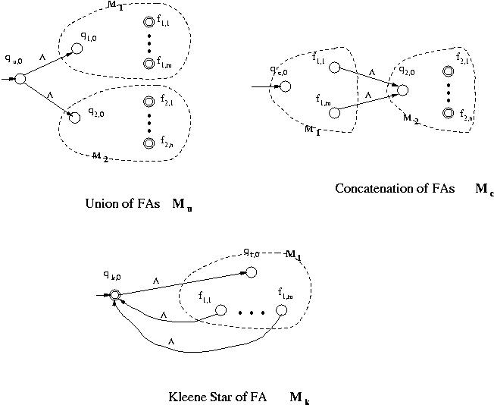
It can be proven, though we omit proofs, that these NFA-s, M_{u}, M_{c} and M_{k}, in fact accept L₁ L₂, L₁L₂ and L₁*, respectively. End of Proof
Examples of M_{u}, M_{c} and M_{k}:
Example 1: An NFA- that accepts the language represented by the regular expression (aa + b)* can be constructed as follows using the operations given above.
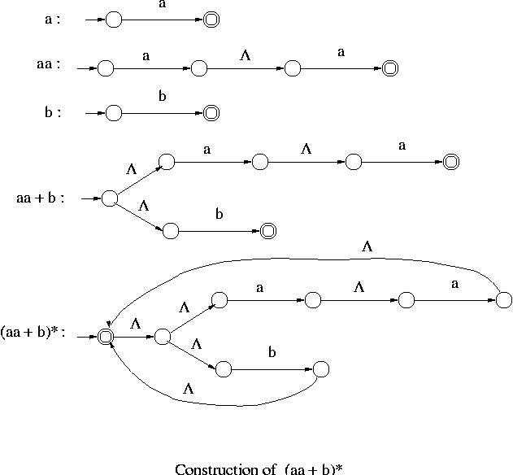
Example 2: An NFA- that accepts the language represented by the regular expression ((a + b)a*)* can be constructed as follows using the operations given above.

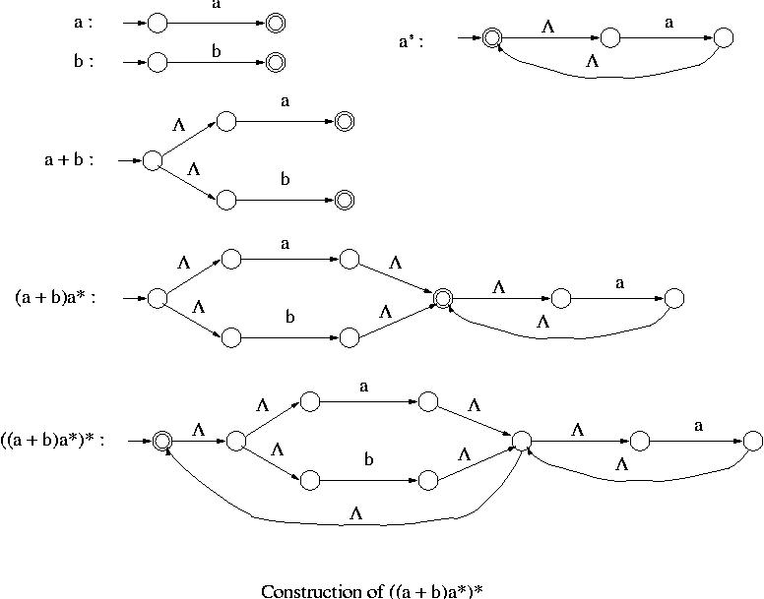

Kleene's Theorem -- Part 2

Subjects to be Learned
- Languages accepted by FAs are regular

Contents
The converse of the part 1 of Kleene’s Theorem also holds true. It states that any language accepted by a finite automaton is regular.
Before proceeding to a proof outline for the converse, let us study a method to compute the set of strings accepted by a finite automaton.
Given a finite automaton, first relabel its states with the integers 1 through n, where n is the number of states of the finite automaton. Next denote by L(p, q, k) the set of strings representing paths from state p to state q that go through only states numbered no higher than k. Note that paths may go through arcs and vertices any number of times.
Then the following lemmas hold.
Lemma 1: L(p, q, k+1) = L(p, q, k) L(p, k+1, k)L(k+1, k+1, k)*L(k+1, q, k).
What this lemma says is that the set of strings representing paths from p to q passing through states labeled with k+1 or lower numbers consists of the following two sets:
1. L(p, q, k) : The set of strings representing paths from p to q passing through states labeled with k or lower numbers.
2. L(p, k+1, k)L(k+1, k+1, k)*L(k+1, q, k) : The set of strings going first from p to k+1, then from k+1 to k+1 any number of times, then from k+1 to q, all without passing through states labeled higher than k.
See the figure below for the illustration.
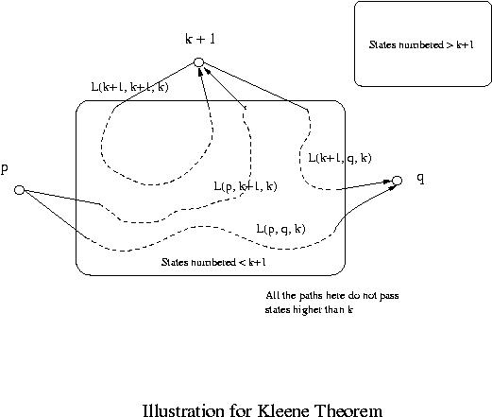
Lemma 2: L(p, q, 0) is regular.
Proof: L(p, q, 0) is the set of strings representing paths from p to q without passing any states in between. Hence if p and q are different, then it consists of single symbols representing arcs from p to q. If p = q, then is in it as well as the strings representing any loops at p (they are all single symbols). Since the number of symbols is finite and since any finite language is regular, L(p, q, 0) is regular.
>From Lemmas 1 and 2 by induction the following lemma holds.
Lemma 3: L(p, q, k) is regular for any states p and q and any natural number k.
Since the language accepted by a finite automaton is the union of L(q₀, q, n) over all accepting states q, where n is the number of states of the finite automaton, we have the following converse of the part 1 of Kleene’s Theorem.
Theorem 2 (Part 2 of Kleene's Theorem): Any language accepted by a finite automaton is regular.
Example : Let us find the language accepted by the following finite automaton using the lemmas.
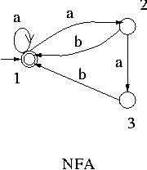
Let us denote by r(p, q, k) the regular expression for the set of strings L(p, q, k).
Then the language accepted by this NFA is r(1, 1, 3).
By Lemma 1, r(1, 1, 3) = r(1, 1, 2) + r(1, 3, 2)r(3, 3, 2)*r(3, 1, 2).
r(1, 1, 2):
r(1, 1, 2) = r(1, 1, 1) + r(1, 2, 1)r(2, 2, 1)*r(2, 1, 1)
r(1, 1, 1) = r(1,1,0) + r(1,1,0)r(1,1,0)*r(1,1,0) = a*, since r(1,1,0) = a +.
r(1, 2, 1) = r(1,2,0) + r(1,1,0)r(1,1,0)*r(1,2,0) = a⁺, since r(1,2,0) = a.
r(2, 2, 1) = r(2,2,0) + r(2,1,0)r(1,1,0)*r(1,2,0) = ba⁺ +, since r(2,2,0) =and r(2,1,0) = b.
r(2, 1, 1) = r(2,1,0) + r(2,1,0)r(1,1,0)*r(1,1,0) = ba*.
Hence r(1, 1, 2) = a* + a⁺(b a⁺)*b a*.
r(1, 3, 2):
r(1, 3, 2) = r(1, 3, 1) + r(1, 2, 1)r(2, 2, 1)*r(2, 3, 1)
r(1, 3, 1) = Ø
r(2, 3, 1) = a
Hence r(1, 3, 2) = a⁺(b a⁺ + )*a = a⁺(b a⁺ )*a.
r(3, 3, 2):
r(3, 3, 2) = r(3, 3, 1) + r(3, 2, 1)r(2, 2, 1)*r(2, 3, 1)
r(3, 3, 1) =
r(3, 2, 1) = r(3,2,0) + r(3,1,0)r(1,1,0)*r(1,2,0) = ba⁺, since r(3,2,0) = Ø and r(3,1,0) = b.
Hence r(3, 3, 2) = + ba⁺( ba⁺ + )*a = + ( ba⁺)⁺a
r(3, 1, 2):
r(3, 1, 2) = r(3, 1, 1) + r(3, 2, 1)r(2, 2, 1)*r(2, 1, 1)
r(3, 1, 1) = r(3,1,0) + r(3,1,0)r(1,1,0)<SUP*< SUP>r(1,1,0) = ba*
Hence r(3, 1, 2) = ba* + ba⁺( ba⁺ + )*ba*= ( ba⁺ )*ba*.
Hence r(1, 1, 3) = a* + a⁺(b a⁺)*ba* + ( a⁺( ba⁺ )*a )( + ( ba⁺)⁺a )*( ba⁺ )*ba*.
This can be further simplified to (a + ab + abb)*, then to (a + ab)*. The detail is left as an exercise though it would be quite challenging.
In this example there is only one accepting state. If there are more accepting states, then r(p, q, n) must be found for each accepting state q, where p is the initial state and n is the number of states in the given finite automaton, and all the r(p, q, n)'s must be added together to get the regular expression for the language accepted by the automaton.

Complements and Intersection of Regular Language

Subjects to be Learned
- Complement of Regular Language
- Complement of DFA
- Intersection of Regular Languages

Contents
Complement
Let M = < Q, , q₀, , A > be a DFA that accepts a language L. Then a DFA that accepts the complement of L, i.e. *– L, can be obtained by swapping its accepting states with its non-accepting states, that is M_{c} = < Q, , q₀, , Q – A > is a DFA that accepts * – L.
For example the following DFA accepts the language a⁺ over = { a, b }.
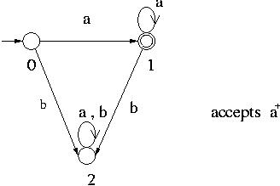
A DFA that accepts its complement is obtained from the above DFA by changing all single circles to double circles and vice versa as shown below.
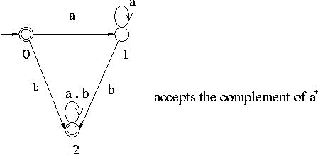
Remark 1: If we have NFA rather than DFA, we must first convert it to DFA before swapping states to get its complement.
Remark 2: Since a language is regular if and only if it is accepted by some NFA, the complement of a regular language is also regular.
Intersection of Regular Languages
Languages are sets. Therefore all the properties of sets are inherited by languages. In particular De Morgan's law also applies to languages. By Remark 2 above, if L₁ and L₂ are regular languages, then their complements are regular languages. Since L₁L₂ = 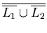
by De Morgan's law, L₁ L₂ is regular.
Thus summing all this up we can say that the set of regular languages over an alphabet is closed with respect to union, intersection, difference, concatenation and Kleene’s star operations.

Regular Grammar

Subjects to be Learned
- Production and Grammar
- Regular Grammar
- Context-Free, Context-Sensitive and Phrase Structure Grammars

Contents (Left as an assignment)

Minimization of DFA
One important result on finite automata, both theoretically and practically, is that for any regular language there is a unique DFA having the smallest number of states that accepts it. Let M = < Q, , q₀, , A > be a DFA that accepts a language L. Then the following algorithm produces the DFA, denote it by M₁, that has the smallest number of states among the DFAs that accept L.
Minimization Algorithm for DFA
Construct a partition = { A, Q - A } of the set of states Q ;
_{new} := new_partition(};
while (_{new} )
:= _{new} ;
_{new} := new_partition()
_{final} := ;
function new_partition()
for each set S of do
partition S into subsets such that two states p and q of S are in the same subset of S
if and only if for each input symbol, p and q make a transition to (states of) the same
set of .
The subsets thus formed are sets of the output partition in place of S.
If S is not partitioned in this process, S remains in the output partition.
end
Minimum DFA M₁ is constructed from _{final} as follows:
- Select one state in each set of the partition _{final} as the representative for the set. These representatives are states of minimum DFA M₁.
- Let p and q be representatives i.e. states of minimum DFA M₁. Let us also denote by p and q the sets of states of the original DFA M represented by p and q, respectively. Let s be a state in p and t a state in q. If a transition from s to t on symbol a exists in M, then the minimum DFA M₁ has a transition from p to q on symbol a.
- The start state of M₁ is the representative which contains the start state of M.
- The accepting states of M₁ are representatives that are in A.
Note that the sets of _{final} are either a subset of A or disjoint from A.
Remove from M₁ the dead states and the states not reachable from the start state, if there are any. Any transitions to a dead state become undefined.
A state is a dead state if it is not an accepting state and has no out-going transitions except to itself.
Example 1 :
Let us try to minimize the number of states of the following DFA.
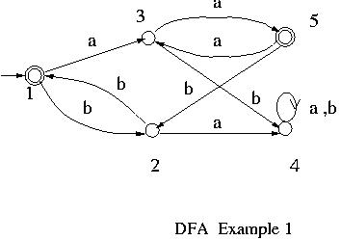
Initially = { { 1, 5 }, { 2, 3, 4 } }.
new_partition is applied to .
Since on b state 2 goes to state 1, state 3 goes to state 4 and 1 and 4 are in different sets in , states 2 and 3 are going to be separated from each other in _{new}.
Also since on a sate 4 goes to sate 4, state 3 goes to state 5 and 4 and 5 are in different sets in , states 3 and 4 are going to be separated from each other in _{new}.
Further, since on b 2 goes to 1, 4 goes to 4 and 1 and 4 are in different sets in , 2 and 4 are separated from each other in _{new}.
On the other hand 1 and 5 make the same transitions. So they are not going to be split.
Thus the new partition is { { 1, 5 }, { 2 }, { 3 }, { 4 ] }. This becomes the in the second iteration.
When new_partition is applied to this new , since 1 and 5 do the same transitions, remains unchanged.
Thus _{final} = { { 1, 5 }, { 2 }, { 3 }, { 4 } }.
Select 1 as the representative for { 1, 5 }. Since the rest are singletons, they have the obvious representatives.
Note here that state 4 is a dead state because the only transition out of it is to itself.
Thus the set of states for the minimized DFA is { 1, 2, 3 }.
For the transitions, since 1 goes to 3 on a, and to 2 on b in the original DFA, in the minimized DFA transitions are added from 1 to 3 on a, and 1 to 2 on b. Also since 2 goes to 1 on b, and 3 goes to 1 on a in the original DFA, in the minimized DFA transitions are added from 2 to 1 on b, and from 3 to 1 on a.
Since the rest of the states are singletons, all transitions between them are inherited for the minimized DFA.
Thus the minimized DFA is as given in the following figure:
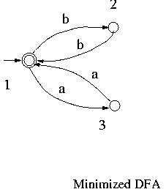
Example 2 :
Let us try to minimize the number of states of the following DFA.
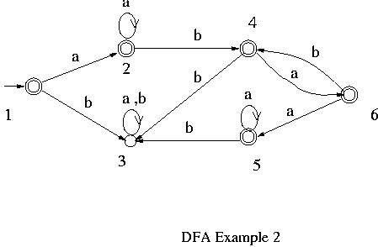
Initially = { { 3 }, { 1, 2, 4, 5, 6 } }.
By applying new_partition to this , _{new} = { { 3 }, { 1, 4, 5 }, { 2, 6 } } is obtained.
Applyting new_partition to this , _{new} = { { 3 }, { 1, 4 }, { 5 }, { 2 }, { 6 } } is obtained.
Applyting new_partition again, _{new} = { { 1 }, { 2 }, { 3 }, { 4 }, { 5 }, { 6 } } is obtained.
Thus the number of states of the given DFA is already minimum and it can not be reduced any further.

Application of Finite Automata

Subjects to be Learned
- Reactive system
- Modeling reactive systems with FA

Contents (Left as an assignment)

Non-Regular Languages

Subjects to be Learned
- Existence of non-regular languages
- Myhill - Nerode Theorem for non-regularity test
- Pumping Lemma

Contents
We have learned regular languages, their properties and their usefulness for describing various systems. There are, however, languages that are not regular and therefore require devices other than finite automata to recognize them. In this section we are going to study some of the methods for testing given languages for regularity and see some of the languages that are not regular. The main idea behind these test methods is that finite automata have only finite amount of memory in the form of states and that they can not distinguish infinitely many strings. For example to recognize the language { a^{n}b^{n} | n is a natural number}, a finite automaton must remember how many a's it has read when it starts reading b's. Thus it must be in different states when it has read different number of a's and starts reading the first b. But any finite automaton has only finite number of states. Thus there is no way for a finite automaton to remember how many a's it has read for all possible strings a^{n}b^{n}. That is the main limitation of finite automata. Since a regular language must be recognized by a finite automaton, we can conclude that { a^{n}b^{n} | n is a natural number} is not regular. This is the basis of two of the regularity test methods we are going to study below: Myhill-Nerode Theorem and Pumping Lemma.

Non-regularity test based on Myhill-Nerode's theorem
Indistinguishability of strings: Strings x and y in * are indistinguishable with respect to a language L if and only if for every string z in *, either xz and yz are both in L or they are both not in L.
For example, a and aa are indistinguishable with respect to the language a^{n} over alphabet { a }, where n is a positive integer, because aa^{k} and aaa^{k} are in the language a^{n} for any positive integer k. However, with respect to the language a^{n}b^{n}, a and aa are not indistinguishable (hence distinguishable), because ab is in the language a^{n}b^{n} while aab is not in the language.
Using this concept of indistinguishability, the following theorem by Myhill and Nerod gives a criterion for (non)regularity of a language. It is stated without a proof. For more on Myhill-Nerode theorem click here.
Theorem : A language L over alphabet is nonregular if and only if there is an infinite subset of *, whose strings are pairwise distinguishable with respect to L.
Example 1: L₁ = { a^{n}b^{n} | n is a positive integer } over alphabet { a, b } can be shown to be nonregular using Myhill-Nerode as follows:
Consider the set of strings S₁ = { a^{n} | n is a positive integer }. S₁ is over alphabet { a, b } and it is infinite. We are going to show that its strings are pairwise distinguishable with respect to L₁. Let a^{k} and a^{m} be arbitrary two different members of the set S₁, where k and m are positive integers and k m. Select b^{m} as a string to be appended to a^{k} and a^{m}. Then a^{k}b^{m} is not in L₁ while a^{m}b^{m} is in L₁. Hence a^{k} and a^{m} are distinguishable with respect to L₁. Since a^{k} and a^{m} are arbitrary strings of S₁, S₁ satisfies the conditions of Myhill-Nerode theorem. Hence L₁ is nonregular.
Example 2: L₂ = { ww | w {a, b}* } is nonregular.
Consider the set of strings S₂ which is the same as S₁ of Example 1 above. It can be shown to be pairwise distinguishable with respect to L₂ as follows.
Let a^{k} and a^{m} be arbitrary two different members of the set, where k and m are positive integers and k m. Select ba^{k}b as a string to be appended to a^{k} and a^{m}. Then a^{k}ba^{k}b is in L₂ while a^{m}ba^{k}b is not in L₂. Hence a^{k} and a^{m} are distinguishable with respect to L₂. Since a^{k} and a^{m} are arbitrary strings of S₂, S₂ satisfies the conditions of Myhill-Nerode theorem. Hence L₂ is nonregular.
Example 3: Let L₃ be the set of algebraic expressions involving identifiers x and y, operations + and * and left and right parentheses.
L₃ can be defined recursively as follows:
Basis Clause: x and y are in L₃.
Inductive Clause: If and 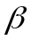 are in L₃, then ( + ) and ( * ) are in L₃.
Extremal Clause: Nothing is in L₃ unless it is obtained from the above two clauses.
For example, x, (x*y), ( ( x + y ) * x ) and (( (x*y) + x ) + (y*y) ) are algebraic expressions.
Consider the set of strings S₃ = { (^{k} x | k is a positive integer }, that is, the set of strings consisting of one or more right parentheses followed by identifier x. This set is infinite and it can be shown to be pairwise distinguishable with respect to L₃ as follows:
Let (^{k} x and (^{m} x be arbitrary two strings of S₃, where k and m are positive integers and k m. Select [ + x ) ]^{k} as a string to be appended to (^{k} and (^{m}. For example [ + x ) ]³ is +x)+x)+x).
Then (^{k} x + [ + x ) ]^{k} is in L₃ but (^{m} x + [ + x ) ]^{k} is not in L₃ because the number of ('s is not equal to the number of )'s in the latter string. Hence S₃ is pairwise distinguishable with respect to L₃. Hence L₃ is not regular.

Pumping Lemma
Let us consider the NFA given below.

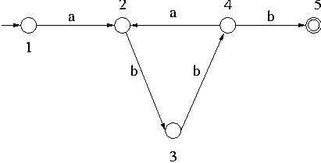

This NFA accepts among others some strings of length greater than 5 such as abbabbb, abbabbabbb etc. Those strings which are accepted by this NFA and whose length is greater than 5 have a substring which can be repeated any number of times without being rejected by the NFA. For example the string abbabbb is accepted by the NFA and if one of its substrings bba is repeated any number of times in abbabbb, the resultant strings such as abbb (bba repeated 0 times), abbabbabbb, abbabbabbabbb etc. are also accepted by the NFA.
In general if a string w (such as abbabbb in the example above) is accepted by an NFA with n states and if its length is longer than n, then there must be a cycle in the NFA along some path from the initial state to some accepting state (such as the cycle 2-3-4-2 in the above example). Then the substring representing that cycle (bba in the example) can be repeated any number of times within the string w without being rejected by the NFA.

The following theorem which is called Pumping Lemma is based on this observation. It states that if a language is regular, then any long enough string of the language has a substring which can be repeated any number of times with the resultant strings still in the language. It is stated without a proof here.
Pumping Lemma : Suppose that a language L is regular. Then there is a positive integer n such that for any string x in L with |x| n, there are strings u, v and w which satisfy the following relationships:
x = uvw
|uv| n
|v| > 0 and

for every integer m 0, uv^{m}w L.
Note that Pumping Lemma gives a necessity for regular languages and that it is not a sufficiency, that is, even if there is an integer n that satisfies the conditions of Pumping Lemma, the language is not necessarily regular. Thus Pumping Lemma can not be used to prove the regularity of a language. It can only show that a language is nonregular.
Example 4: As an example to illustrate how Pumping Lemma might be used to prove that a language is nonregular, let us prove that the language L = a^{k}b^{k} is nonregular, where k is a natural number.
Suppose that L is regular. Then there is a positive integer n that satisfies the conditions of Pumping Lemma. Consider a string x = a^{n}b^{n} for that n. Then there must be strings u, v, and w such that
x = uvw,
|uv| n
|v| > 0, and
for every m 0, uv^{m}w L.
Since |v| > 0, v has at least one symbol. In string x = a^{n}b^{n}, v can be inside a^{n}, inside b^{n} or straddle a^{n} and b^{n}.
Hence there are the following three possibilities for v:
1. v = a^{p}, p > 0,
2. v = b^{p}, p > 0 or
3. v = a^{p}b^{q}, p, q > 0.
Let us now consider the string uv^{m}w for m = 2 for each of these three cases.

In case 1, uv²w = a^{n-p}a^{2p}b^{n} = a^{n+p}b^{n}. Since p > 0, n + p n. Hence a^{n+p}b^{n} can not be in the language L represented by a^{k}b^{k}.
Similarly in case 2, since uv²w = a^{n} b^{n + p}, it can not be in L.
In case 3, uv²w = a^{n-p}(a^{p}b^{q})²b^{n-q} = a^{n-p}(a^{p}b^{q}a^{p}b^{q})b^{n-q} = a^{n}b^{q}a^{p}b^{n}, which can not be in L.
Thus in all three cases uv²w is not in L. This violates the condition that for every m 0, uv^{m}w L. Hence L is not a regular language.

Context-Free Grammar

Subjects to be Learned
- Context-Free Grammar
- Context-Free Languages
- Push Down Automata

Contents (Left as an assignment)

The Chomsky Hierarchy
(http://www.cs.may.ie/~jpower/Courses/parsing/node21.html)
Obviously languages exist which are not regular; Noam Chomsky categorised regular and other languages as follows:
Language Class | Grammar | Automaton
3 | Regular | NFA or DFA
2 | Context-Free | Push-Down Automaton
1 | Context-Sensitive | Linear-Bounded Automaton
0 | Unrestricted (or Free) | Turing Machine
This is a hierarchy, so every language of type 3 is also of types 2, 1 and 0; every language of type 2 is also of types 1 and 0 etc.
The distinction between languages can be seen by examining the structure of the production rules of their corresponding grammar, or the nature of the automata which can be used to identify them.
- Type 3 - Regular Languages
As we have discussed, a regular language is one which can be represented by a regular grammar, described using a regular expression, or accepted using an NFA or a DFA.
- Type 2 - Context-Free Languages
A Context-Free Grammar (CFG) is one whose production rules are of the form:
where is any single non-terminal, and is any combination of terminals and non-terminals.
A NFA/DFA cannot recognize strings from this type of language since we must be able to "remember" information somehow. Instead we use a Push-Down Automaton which is like a DFA except that we are also allowed to use a stack.
- Type 1 - Context-Sensitive Languages
Context-Sensitive grammars may have more than one symbol on the left-hand-side of their production rules (provided that at least one of them is a non-terminal). However, the production rules must now obey the following:
CS1
The number of symbols on the left-hand-side must not exceed the number of symbols on the right-hand-side

CS2
We do not allow rules of the form unless is the start symbol and does not occur on the right-hand-side of any rule.
Since we allow more than one symbol on the left-hand-side, we refer to those symbols other than the one we are replacing as the context of the replacement.
The automaton which recognizes a context-sensitive language is called a linear-bounded automaton: this is basically a NFA/DFA which can store symbols in a list.
Conditions CS1 and CS2 above mean that the sentential form in any derivation must always increase in length every time a production rule is applied. This basically means that the size of a sentential form is bounded by the length of the sentence (i.e. word) we are deriving.
Since the sentential form cannot thus grow infinitely large before deriving a sentence, a linear-bounded automaton always uses a finitely-long list as its store.

- Type 0 - Unrestricted (Free) Languages
Free grammars have absolutely no restrictions on their grammar rules, (except, of course, that there must be at least one non-terminal on the left-hand-side).
The type of automata which can recognize such a language is basically a NFA/DFA with an infinitely-long list at its disposal to use as a store; this is called a Turing machine.

Turing Machines

Subjects to be Learned
- Definition of Turing Machine
- Configuration
- Operation of Turing Machine

Contents
Introduction
We have studied two types of languages from the Chomsky hierarchy: regular languages and context-free languages. These languages can describe many practically important systems and so they are heavily used in practice. They are, however, of limited capability and there are many languages that they can not process. In this chapter we are going to study the most general of the languages in Chomsky hierarchy, the phrase structure languages (also called Type 0 languages), and the machines that can process them:

Turing machines - Turing machines were conceived of by the English mathematician Alan Turing as a model of human "computation". Later Alonzo Church conjectured that any computation done by humans or computers can be carried out by some Turing machine.

This conjecture is known as Church's thesis and today it is generally accepted as true. Computers we use today are as powerful as Turing machines except that computers have finite memory while Turing machines have infinite memory.
We are going to study Turing machines here and through that limitations of computers and computation as we know today.
Definition
Conceptually a Turing machine, like finite automata, consists of a finite control and a tape. At any time it is in one of the finite number of states. The tape has the left end but it extends infinitely to the right. It is also divided into squares and a symbol can be written in each square. However, unlike finite automata, its head is a read-write head and it can move left, right or stay at the same square after a read or write.
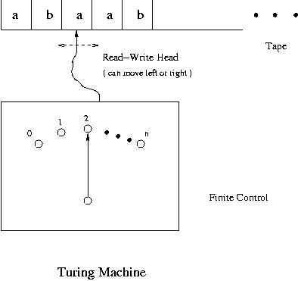
Given a string of symbols on the tape, a Turing machine starts at the initial state. At any state it reads the symbol under the head, either erases it or replaces it with a symbol (possibly the same symbol). It then moves the head to left or right or does not move it and goes to the next state which may be the same as the current state. One of its states is the halt state and when the Turing machine goes into the halt state, it stops its operation.
Formally a Turing machine is a 5-tuple T = < Q, , , q₀, >, where
Q is a finite set of states, which is assumed not to contain the symbol h. The symbol h is used to denote the halt state.
is a finite set of symbols and it is the input alphabet.
is a finite set of symbols containing as its subset and it is the set of tape symbols.
q₀ is the initial state.
is the transition function but its value may not be defined for certain points.
It is a mapping from Q ( {} ) to ( Q { h } ) ( {} ) { R, L, S }.
Heredenotes the blank and R, L and S denote move the head right, left and do not move it, respectively. A transition diagram can also be drawn for a Turing machine. The states are represented by vertices and for a transition ( q, X ) = ( r, Y, D ), where D represents R, L or S, an arc from q to r is drawn with label ( X/Y, D ) indicating that the state is changed from q to r, the symbol X currently being read is changed to Y and the tape head is moved as directed by D.
Example 1 : The following Turing machine < Q₁, , , q₀, > accepts the language aba*, where Q₁ = { q₀, q₁, q₂, q₃ }, = { a, b }, = { a, b } and is as given by the table below.

State (q) | Input (X) | Move ( (q, X) )
q₀ |  | ( q₁, , R )
q₁ | a | ( q₂, a, R )
q₂ | b | ( q₃, b, R )
q₃ | a | ( q₃, a, R )
q₃ |  | ( h, , S )

A transition diagram of this Turing machine is given below. It is assumed that the tape has at the left end and the head is initially at the left end of the tape.
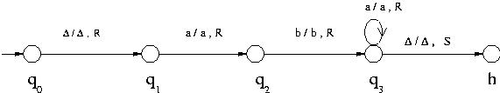

Turing Machine that accepts aba*
To describe the operation of Turing machine we use configuration. A configuration for a Turing machine is an ordered pair of the current state and the tape contents with the symbol currently under the head marked with underscore. For example ( q, aababb ) shows that the Turing machine is currently in state q, the taper contents are the string aababb and the head is reading the last a of the string. We write ( p, xay ) ( q, zbw ) if the Turing machine goes from the first configuration to the second in one move, and ( p, xay ) * ( q, zbw ) if the Turing machine goes from the first configuration to the second in zero or more moves. If the Turing machine needs to be explicitly indicated _{T} or _{T}* is used.
A string x is said to be accepted by a Turing machine* T = < Q, , , q₀, > if
( q₀, 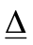x ) * ( h, yaz ) for some symbol a {} and some strings y and z in ( {} )*. In this case we also say that the Turing machine halts on input x. The set of strings accepted by a Turing machine is the language accepted by the Turing machine. Note that the Turing machine does not stop if a string is not in the language. A Turing machine T is said to decide a language L if and only if T writes "yes" and halts if a string is in L and T writes "no" and halts if a string is not in L.
For example the Turing machine of Example 1 above goes through the following sequence of configurations to accept the string aba:
( q₀, aba )
( q₁,aba )
( q₂,aba )
( q₃,aba )
( h,aba )
The first of the following figures shows a Turing machine that accepts but does not decide the language { a }, the second is a Turing machine that accepts { a } but goes into a loop if a string is not in the language (hence it accepts but doe not decide { a }) and the third decides { a }, where = { a }.

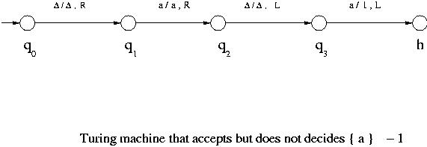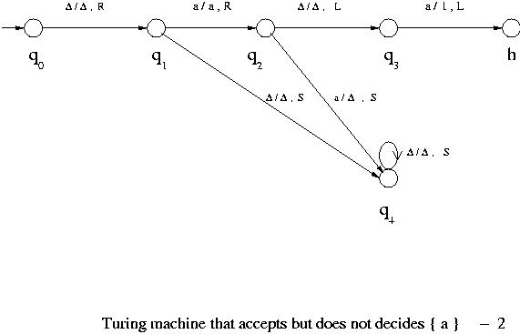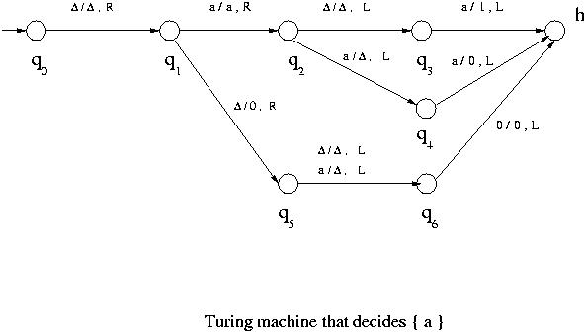
Example 2 : The following Turing machine moves the head to the first to the right of the current position. It is denoted by T_{R}.
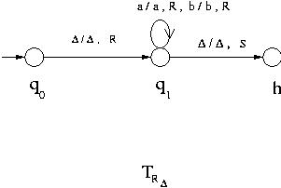
Example 3 : The following Turing machine erases the string on the tape and moves the head to the left end. It is assumed that initially the tape has at the left end. This Turing machine is denoted by T_{E}.
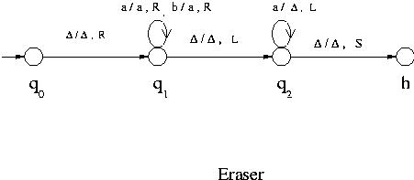
Strings not Accepted by Turing Machines
When a string is not accepted by a Turing machine, that is when a Turing machine does not halt on a string, one of the following three things happens:
(1) The Turing machine goes into an infinite loop,
(2) no transition is specified for the current configuration and
(3) the head is at the left end and it is instructed to move left.
In cases (2) and (3), the operation of the Turing machine is aborted. For example the following Turing machine accepts the language a⁺, but it goes into an infinite loop for any strings that are not in the language.
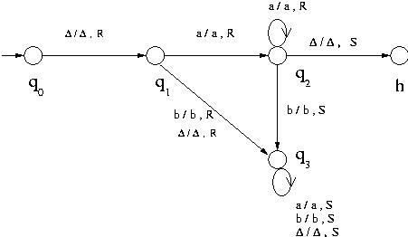

Turing machine accepting a⁺
Computabler Function
Let S * and let f be a function f : S -> *. Then we say T computes f or f is computable if for every x S,
( q₀, x ) * ( h, f(x) )
and for every x * that is not in S, T does not halt on x.
* Note on "Turing-acceptable": Some books define "acceptance by Turing machine" slightly differently. That is, in the Turing machines those books define, there are two halt states: "accept halt" and "reject halt". A Turing machine thus may accept a string and halt, reject a string and halt, or loop. With this definition, a string is accepted by a Turing machine if given the string, the Turing machine eventually goes into the accept halt state.
As far as the material discussed in this class note, there is no difference between these two definitions of "accept".
A languages is a phrase structure (type 0) langauage if and only if it is Turing-acceptable in either sense and it has no effects on decidablility.

Combination of Turing Machines

Subjects to be Learned
- Combination of Turing Machines

Contents
Combination of Turing Machines
We have seen the definition of Turing machine and a few simple examples. One can construct many more Turing machines that perform various functions. In fact Turing machines that simulate computers and Turing machines that perform computations done by any algorithm can be constructed. Furthermore according to the Church's thesis, any "computation" done by human beings or machines can be done by some Turing machine. Here we are going to study how complex Turing machines can be constructed using simple Turing machines and how computers can be simulated by Turing machines.
Let us start with some basic Turing machines.
We have already seen T_{R} . It moves the head to the first symbol (which may be ) to the right of the current position. Similarly by T_{L} we denote a Turing machine that moves the head to the first symbol (which may be ) to the left of the current position. Then by Twe denote a Turing machine that writes symbol at the current position and does not move the head (stays). Also by T_{R} and T_{L} we denote Turing machines that move the head to right and left one position, respectively.
To combine Turing machines we use the following conventions:
Let T₁ and T₂ represent arbitrary Turing machines.
T₁T₂ and T₁ -> T₂ denote the Turing machine that behaves initially like T₁ and when T₁ halts T₂ takes over inheriting the head position and the tape contents of T₁. The halt state of T₁ becomes the initial state of T₂.
T₁ -> T₂ denote the Turing machine that first executes T₁. Then if T₁ halts and if the symbol currently under the head is , then T₂ is started as in the case of T₁T₂. Otherwise it crashes.
Using these basic machines and the convention, let us construct a little more complex Turing machines. Below is assumed to be at the left end of the tape initially.
Example 4: The following machine shifts the tape contents to the left one position, takes the head to the right end of the string and halts.
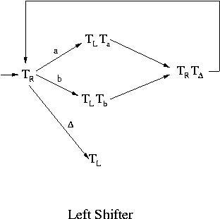
For example with the initial tape contents of ab, it goes through the following sequence of tape contents and ends with ab:
ab
-> ab
-> aab
-> ab
-> ab
-> abb
-> ab
-> ab
-> ab
Example 5: The left-shift machine of Example 4 can be used to construct an adder for natural numbers. First, natural numbers are represented on a Turing machine using symbol I. For example the number 3 is represented by three consecutive I's on the tape and 5 by five I's. In general to represent a natural number k, k consecutive I's are put on the tape. To add two numbers m and n, m I's and n I's with a blank between them are placed on the tape. So the initial configuration for adding 2 and 3 is ( q₀, IIIII ). After the addition the configuration becomes ( h, IIIII ).
An adder can be constructed for example as T_{R} -> T_{SL} T_{L}. After adding two numbers placed on the tape it moves the head to the left end and halts.
Example 6:
The following Turing machine copies the tape contents at the left end to their right separated by a blank , that is ( q₀, x ) * ( h, xx ).
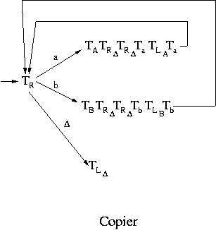
Today's computers are very complex machines and their instruction sets contain complicated operations. However, all of those instructions can be realized using combinations of a small number of basic instructions. In fact many of the earlier computers had a much smaller instruction set but still could do everything today's computers can do albeit much more slowly. A bare minimum instruction set would contain addition, branching, store and load operations. All the other operations can be realized by using those basic operations. On the other hand as we have seen above, there is a Turing machine that performs addition; the branch operation is already in Turing machines because next configurations are determined based on the current state and tape symbol being looked at; and store and load operations can be taken care of by a Turing machine that copies tape contents. Furthermore if the subtraction operation is necessary, it is not difficult to construct a Turing machine that performs subtraction using the same representation of numbers as for the addition. Thus by combining appropriate Turing machines a computer with a minimal instruction set can be constructed. Since any complex computer instructions can be realized using those basic instructions, one can say that computers can be simulated by Turing machines.

Types of Turing Machines

Subjects to be Learned
- Variation of Turing Machine

Contents
There are a number of other types of Turing machines in addition to the one we have seen such as Turing machines with multiple tapes, ones having one tape but with multiple heads, ones with two dimensional tapes, nondeterministic Turing machines etc. It turns out that computationally all these Turing machines are equally powerful. That is, what one type can compute any other can also compute. However, the efficiency of computation, that is, how fast they can compute, may vary.

Turing Machines with Two Dimensional Tapes
This is a kind of Turing machines that have one finite control, one read-write head and one two dimensional tape. The tape has the top end and the left end but extends indefinitely to the right and down. It is divided into rows of small squares. For any Turing machine of this type there is a Turing machine with a one dimensional tape that is equally powerful, that is, the former can be simulated by the latter.
To simulate a two dimensional tape with a one dimensional tape, first we map the squares of the two dimensional tape to those of the one dimensional tape diagonally as shown in the following tables:
Two Dimensional Tape
Here the numbers indicate the correspondence of squares in the two tapes: square i of the two dimensional tape is mapped to square i of the one dimensional tape. h and v are symbols which are not in the tape alphabet and they are used to mark the left and the top end of the tape, respectively.
v | v | v | v | v | v | v | . . . | . . .
h | 1 | 2 | 6 | 7 | 15 | 16 | . . . | . . .
h | 3 | 5 | 8 | 14 | 17 | 26 | . . . | . . .
h | 4 | 9 | 13 | 18 | 25 | . . . | . . . | . . .
h | 10 | 12 | 19 | 24 | . . . | . . . | . . . | . . .
h | 11 | 20 | 23 | . . . | . . . | . . . | . . . | . . .
h | 21 | 22 | . . .< .> | . . . | . . . | . . . | . . . | . . .
. . . | . . . | . . . | . . . | . . . | . . . | . . . | . . . | . . .
One Dimensional Tape
v | 1 | v | 2 | 3 | h | 4 | 5 | 6 | v | 7 | 8 | 9 | 10 | h | 11 | . . . | . . .

The head of a two dimensional tape moves one square up, down, left or right.
Let us simulate this head move with a one dimensional tape.
Let i be the head position of the two dimensional tape. If the head moves down from i, then move the head of the one dimensional tape to right until it hits h or v counting the number of squares it has visited after i. Let k be the number of squares visited by the head of the one dimensional tape. If h was hit first, then from h move the head of the one dimensional tape further right to the k-th square from h. That is the square corresponding to the square below i in the two dimensional tape. If v was hit first, then (k+1)-th square to the right from v is the new head position.
For example, suppose that the head position is at 8 for the two dimensional tape in the above table, that is i = 8. If the head moves down to position 13, then for the one dimensional tape, the head moves from position 8 to right. Then it meets h first, which is the third square from 8. Thus from h, move 3 positions to the right. That is the head position of the one dimensional tape corresponding to 13 on the two dimensional tape.
If i = 5 and the head moves down on the other hand, then on the one dimensional tape the head moves to the right and it hits v first, which is the second square from i = 5. Thus this time the third square is the head position of the one dimensional tape corresponding to 9 on the two dimensional tape.
Similarly formulas can be found for the head position on the one dimensional tape corresponding to move up, right or left on the two dimensional tape. Details are omitted. Thus some Turing machines with a one dimensional tape can simulate every move of a Turing machine with one two dimensional tape. Hence they are at least as powerful as Turing machines with a two dimensional tape. Since Turing machines with a two dimensional tape obviously can simulate Turing machines with a one dimensional tape, it can be said that they are equally powerful.

Turing Machines with Multiple Tapes:
This is a kind of Turing machines that have one finite control and more than one tapes each with its own read-write head. It is denoted by a 5-tuple < Q, , , q₀, >. Its transition function is a partial function
: Q ( {} )^{n} -> ( Q { h } ) ( {} )^{n} { R, L, S }^{n}.
A configuration for this kind of Turing machine must show the current state the machine is in and the state of each tape. It can be proven that any language accepted by an n-tape Turing machine can be accepted by a one tape Turing machine and that any function computed by an n-tape Turing machine can be computed by a one tape Turing machine. Since the converses are obviously true, one can say that one tape Turing machines are as powerful as n-tape Turing machines.

Turing Machines with Multiple Heads:
This is a kind of Turing machines that have one finite control and one tape but more than one read-write heads. In each state only one of the heads is allowed to read and write. It is denoted by a 5-tuple < Q, , , q₀, >.
The transition function is a partial function
: Q { H₁, H₂ ..., H_{n} } ( {} ) -> ( Q { h } ) ( {} { R, L, S },
where H₁, H₂ ..., H_{n} denote the tape heads.
It can be easily seen that this type of Turing machines are as powerful as one tape Turing machines.

Turing Machines with Infinite Tape:
This is a kind of Turing machines that have one finite control and one tape which extends infinitely in both directions.
It turns out that this type of Turing machines are only as powerful as one tape Turing machines whose tape has a left end.

Nondeterministic Turing Machines
A nondeterministic Turing machine is a Turing machine which, like nondeterministic finite automata, at any state it is in and for the tape symbol it is reading, can take any action selecting from a set of specified actions rather than taking one definite predetermined action. Even in the same situation it may take different actions at different times. Here an action means the combination of writing a symbol on the tape, moving the tape head and going to a next state. For example let us consider the language L = { ww : w { a, b }* }. Given a string x, a nondeterministic Turing machine that accepts this language L would first guess the midpoint of x, that is the place where the second half of x starts. Then it would compare the first half of x with the second half by comparing the i-th symbol of the first half with the i-th symbol of the second half for i = 1, 2, ... . A deterministic Turing machine, on the other hand, can not guess the midpoint of the string x. It must find the midpoint by for example pairing off symbols from either end of x.
Formally a nondeterministic Turing machine is a Turing machine whose transition function takes values that are subsets of ( Q { h } ) ( {} { R, L, S }.
As in the case of NFA, it is understood that a nondeterministic Turing machine at any configuration selects one combination of next state, tape symbol and head movement out of the set of triples without following any specific predetermined rule.
It can be shown that a nondeterministic Turing machine is only as powerful as a deterministic Turing machine.
Theorem Any language accepted by a nondeterministic Turing machine is also accepted by some deterministic Turing machine.
Proof : Let T_{N} denote a nondeterministic Turing machine. Given a string x, T_{N} starts at the initial configuration and goes through a sequence of configurations until it reaches a halt configuration, goes into an infinite loop or aborts. At any point in the process T_{N} is in some configuration and has a finite set of configurations to choose from for its next configuration. The set of all possible computations that T_{N} can perform for a given string x can be represented by a rooted tree as follows. The root of the tree is the initial configuration and it is the only vertex of level 0. All possible configurations that are reachable by applying the transition function of T_{N} once form the children of the initial configuration. They form level 1. In general for each vertex of level i all possible configurations that are reachable by applying the transition function of T_{N} are its children. The children of all the vertices of level i form level i+1. Note that the number of children for a vertex in this tree is finite because the number of states is finite and there are a finite number of tape symbols.
For example consider the following nondeterministic Turing machine that accepts a⁺.
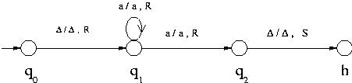
Turing machine accepting a⁺
Given the string aa, it would proceed as follows to accept it:
( q₀, aa ) ( q₁, aa ) ( q₁, aa ) ( q₂, aa) ( h, aa).
At the second and third configurations in the above sequence, it has two candidates for the next configuration: ( q₁, aa ) and ( q₂, aa ) for the second, and ( q₁, aa ) and ( q₂, aa ) for the third.
The tree for this case would be as follows:
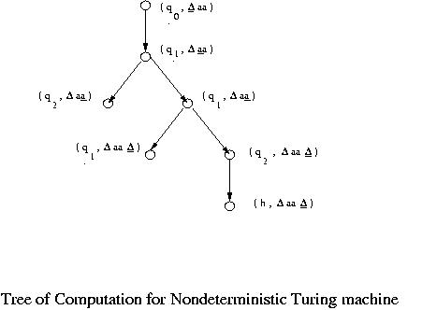
One way to simulate a nondeterministic Turing machine, call it T₁, with a deterministic one, call it T₂, is to traverse this tree breadth-first way from the root until the halt state is reached. At each level of the tree, T₂ applies the transition function of T₁ to each configuration at that level and computes its children. These children are the configurations of the next level and they are stored on the tape (if necessary a second tape may be used). If there is the halting state among these children, then T₂ accepts the string and halts. It can be easily seen that T₂ accepts a string if and only if T₁ accepts it. Thus any language accepted by a nondeterministic Turing machine is also accepted by a deterministic Turing machine, though a deterministic Turing machine might take much more time than a nondeterministic Turing machine to accept a string.
Many other variations of Turing machine are possible. However, it has been shown that none of them exceed the capability of basic deterministic Turing machine as far as accepting languages is concerned. In fact the Church's thesis conjectures that any so called computation done by humans or computers can be performed by a basic deterministic Turing machine.

Problem Solving as Language Recognition

Subjects to be Learned
- problem instance
- problem as language
- problem solving as language recognition

Contents
In the previous section the concept of language was introduced and its properties have been briefly studied. You might be wondering why we study language. The main reason for studying language is that solving problems can be viewed as a language recognition problem as explained below that is, the problem of checking whether or not a string belongs to a language. Thus instead of studying what kind of problems can be solved by what kind of computational devices and how, we can study languages and devices to recognize them which are simpler to deal with uncluttered with variations in actual devices, programming languages etc.
Below an example is given to illustrate how solving a problem can be viewed as recognizing a language.
Consider the following problem:
Is the longest of the distances between two nodes (i.e. the diameter) of a given graph less than a given integer k? Here the distance is the smallest number of edges (or hops) between the nodes.
Some of the instances of this problem are as shown below:
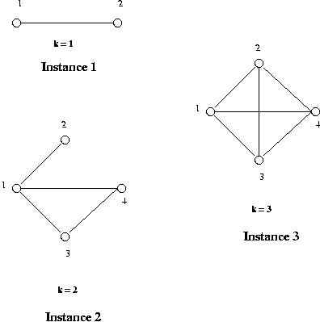
Instance 1 asks whether or not the diameter of the given graph with one edge and two nodes is less than 1. Instance 2 asks whether or not the diameter of the given graph with four edges and four nodes is less than 2. Similarly for Instance 3.
These problem instances can be represented by a string as follows:
Instance 1: 1,2;(1,2);1
Instance 2: 1,2,3,4;(1,2)(1,3)(1,4)(3,4);2
Instance 3: 1,2,3,4;(1,2)(1,3)(1,4)(2,3)(2,4)(3,4);2
Here the set of nodes, the set of edges and k are separated by; in that order in the strings.
The solutions to these instances are:
Instance 1: No
Instance 2: No
Instance 3: Yes
There are infinitely many 'Yes' instances and 'No' instances for this problem. The set of 'Yes' instances is a language and so is the set of 'No' instances as well as the set of all instances and many others for this problem.
We can thus see that solving the problem for a given instance is equivalent to checking whether or not the string representing the given instance belongs to the language of 'Yes' instances of the problem. That is, the problem solving is the same as the language recognition. A problem can be solved if and only if the language of its 'Yes' instances is recognizable or decidable by a Turing machine. It is not solvable if the language is merely acceptable but not recognizable, or even worse if it is not even acceptable.

Decidable problem
Definition: A decision problem that can be solved by an algorithm that halts on all inputs in a finite number of steps. The associated language is called a decidable language.
Also known as totally decidable problem, algorithmically solvable, recursively solvable. Note: For emphasis, the equivalent term totally decidable problem is sometimes used.

Undecidable problem
Definition: A problem that cannot be solved for all cases by any algorithm whatsoever---equivalently, whose associated language cannot be recognized by a Turing machine that halts for all inputs.
OR
If a problem has an algorithm that always tells correctly whether an instance of the problem has a answer “yes” or “no”, then the problem is said to be “decidable.”, Otherwise the problem is “undecidable”.
Some Solvable Problems for Turing Machines
- Given the encoding of a Turing machine, we can determine the number of states it has.
- Given the encoding of a Turing machine and an input for that Turing machine, we can determine what are the first 100 configurations of its computation on that input.
In particular, we can build a Turing machine that can simulate the operation of any Turing machine.
- Given the encoding of a Turing machine, we can determine whether it halts within 1000 steps on any input (or on every input).
Undecidable problems are those problems that no computer can solve. A number of problems that are easy to express are in fact undecidable. Undecidable problems are also called unsolvable problems.
Unsolvable Problems
By looking at the cardinality of sets, we find that:
1. The number of Turing machines is countable (same as the number of integers).
2. The number of problems is uncountable (same as the number of real numbers).
Hence there are far more problems than there are Turing machines to solve them.
We must conclude that there exist unsolvable problems.
We will present some actual examples of unsolvable problems, not just demonstrate their existence.

Unsolvable Problems

Subjects to be Learned
- Halting Problem
- Languages not Accepted by Turing Machines
- Other Unsolvable Problems

Contents
We have learned that deterministic Turing machines are capable of doing any computation that computers can do, that is computationally they are equally powerful, and that any of their variations do not exceed the computational power of deterministic Turing machines. It is also conjectured that any "computation" human beings perform can be done by Turing machines (Church's thesis).
In this chapter we are going to learn that there are problems that can not be solved by Turing machines hence by computers. Here "unsolvability" is in the following sense. First recall that solving a problem can be viewed as recognizing a language (see Problem Solving as Language Recognition). So we are going to look at the unsolvability in terms of language recognition. Suppose that a language is acceptable but not decidable. Then given a string a Turing machine that accept the language starts the computation. At any point in time, if the Turing machine is running, there is no way of telling whether it is in an infinite loop or along the way to a solution and it needs more time. Thus if a language is not decidable, the question of whether or not a string is in the language may not be answered in any finite amount of time. Since we can not wait forever for an answer, the question is unanswerable that is the problem is unsolvable. Below we are going to see some well known unsolvable problems and see why we can say they are unsolvable.
Halting Problem
One of well known unsolvable problems is the halting problem. It asks the following question: Given an arbitrary Turing machine M over alphabet = { a, b }, and an arbitrary string w over , does M halt when it is given w as an input?
It can be shown that the halting problem is not decidable, hence unsolvable.
Theorem 1: The halting problem is undecidable.
Proof : This is going to be proven by "proof by contradiction". That is, we will show that the existence of a Turing machine that solves the Halting Problem leads to a logical fallacy. During the proof we will construct a number of intermediate Turing machines.
Suppose that the halting problem is decidable. Then there is a Turing machine T that solves the halting problem. That is, given a description of a Turing machine M (over the alphabet ) and a string w, T writes "yes" if M halts on w and "no" if M does not halt on w, and then T halts. (Note- Below d(M)*w is the input to T and it means the description of M along with the string w.)
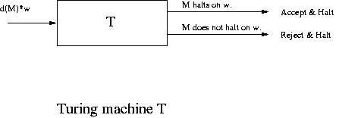
We are now going to construct the following new Turing machine T_{c}.
Before that, we first construct a Turing machine T_{m} by modifying T so that if T accepts a string and halts, then T_{m} goes into an infinite loop (T_{m} halts if the original T rejects a string and halts).
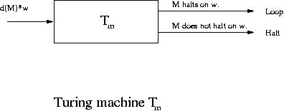
Next using T_{m} we are going to construct another Turing machine T_{c} as follows:
T_{c} takes as input a description of a Turing machine M, denoted by d(M), copies it to obtain the string d(M)*d(M), where * is a symbol that separates the two copies of d(M) and then supplies d(M)*d(M) to the Turing machine T_{m}.
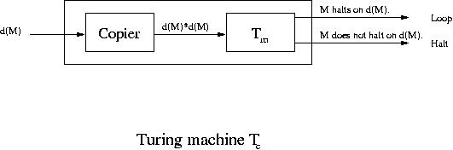
Let us now see what T_{c} does when a string describing T_{c} itself is given to it.
When T_{c} gets the input d(T_{c}), it makes a copy, constructs the string d(T_{c})*d(T_{c}) and gives it to the modified T. Thus the modified T is given a description of Turing machine T_{c} and the string d(T_{c}).
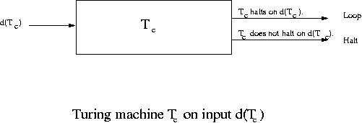
The way T was modified the modified T is going to go into an infinite loop if T_{c} halts on d(T_{c}) and halts if T_{c} does not halt on d(T_{c}).
Thus T_{c} goes into an infinite loop if T_{c} halts on d(T_{c}) and it halts if T_{c} does not halt on d(T_{c}). This is a contradiction. This contradiction has been deduced from our assumption that there is a Turing machine that solves the halting problem. Hence that assumption must be wrong. Hence there is no Turing machine that solves the halting problem.

Program correctness and Halting Problem
Note that for any computer program a Turing machine can be constructed that performs the task of the program. Thus the question of whether or not a program halts for a given input is nothing but the halting problem. Thus one implication of the halting problem is that there can be no computer programs (Turing machines) that check whether or not any arbitrary computer program stops for a given input.
The next unsolvable problem is in a sense more difficult than the halting problem. It is presented as a language and it can be shown that there are no Turing machines that accept the language.

More Unsolvable Problems

Subjects to be Learned
- Languages not Accepted by Turing Machines
- Other Unsolvable Problems

Contents
The next unsolvable problem is in a sense more difficult than the halting problem. It is presented as a language and it can be shown that there are no Turing machines that accept the language.
Language NonSelfAccepting
Let us first define two languages NSA₁ and NSA₂ as follows:
NSA₁ = { w | w { a, b }*, w = d(T) for a Turing machine T and T does not accept w }
NSA₂ = { w | w { a, b }*, w d(T) for any Turing machine T },
where d(T) is a description of the Turing machine T.
NSA₁ is the set of strings that describe a Turing machine but that are not accepted by the Turing machine they describe. NSA₂ is the set of strings that do not describe any Turing machine.
Neither NSA₁ nor NSA₂ is empty. For let T be a Turing machine that accepts { a } and let w = d(T). Then this w is a description of a Turing machine but it must be longer than one symbol. Hence it is not accepted by T. Hence w is in NSA₁. For NSA₂, let w = a. Then there is no Turing machine that can be described by the string a. Certainly more symbols than a single a are needed to describe even the simplest Turing machine. Hence a is in NSA₂. Thus neither NSA₁ nor NSA₂ is empty.
Let us define the language NonSelfAccepting as NonSelfAccepting = NSA₁ NSA₂. Then we can prove the following theorem:
Theorem 2 There are no Turing machines that accept the language NonSelfAccepting.
Proof: This is going to be proven by contradiction.
Suppose there is a Turing machine, call it T₀, that accepts NonSelfAccepting. Let w₀ = d( T₀ ), that is w₀ is a description of the Turing machine T₀. We are going to see that T₀ neither accepts w₀ nor rejects it, which is absurd. This means that there can not be any Turing machine that accepts the language NonSelfAccepting.
Since NonSelfAccepting is a language, either w₀ is in NonSelfAccepting or it isn't. Hence either T₀ accepts w₀ or rejects it.
(1) If T₀ accepts w₀, then w₀ NonSelfAccepting because T₀ accepts NonSelfAccepting. However, by the definitions of NSA₁ and NSA₂, w₀ is in neither NSA₁ nor NSA₂. Hence w₀ is not in NonSelfAccepting. This is a contradiction. Hence T₀ can not accept w₀.
(2) If T₀ does not accept w₀, then w₀ is not in NonSelfAccepting because T₀ accepts NonSelfAccepting. But w₀ = d( T₀ ) because that is how we selected w₀. Also T₀ does not accept w₀. Hence by the definition of NSA₁, w₀ is in NSA₁. Hence it is in SelfAccepting. This is again a contradiction.
Thus there can not be Turing machine T₀ that accepts the language SelfAccepting.
Knowing the unsolvability of the halting problem some other problems can be shown to be unsolvable.
Problem Accepts()
The problem Accepts() asks whether or not a given Turing machine T accepts . It can be shown to be unsolvable.
Suppose that Accepts() is solvable. Then there is a Turing machine that solves it. Let A be a Turing machine that solves Accepts(). We are going to show that the halting problem becomes solvable using this A.
Let a Turing machine T' and a string w be an instance of the halting problem. Consider a Turing machine T = T_{w}T', where machine T_{w} is a Turing machine that writes w. This T halts on if and only if T' halts on w. Using this T, a Turing machine, call it M, that solves the halting problem can be constructed as follows:
Given a description d(T') of a Turing machine T' and a string w as inputs, which is an instance of the halting problem, M writes the string d( T ) on the tape and let A take over. 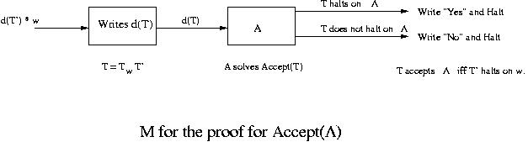
Then M halts on d(T') and w if and only if T' halts on w. That is, M solves the halting problem. Thus if Accepts() is solvable, the halting problem can be solved. Since the halting problem is unsolvable, this means that Accepts() is unsolvable.
Using a similar idea the following problem can also be shown to be unsolvable.
Problem AcceptsEverything
The problem AcceptsEverything asks whether or not a given Turing machine T halts on every string over a given alphabet .
Suppose that AcceptsEverything is solvable. Let A be a Turing machine that solves AcceptsEverything. We are going to show that Accepts() can be solved using the solution to it.
Let T' be an instance of Accepts(). Then consider the Turing machine T = T_{erase}T', where T_{erase} is a Turing machine that erases the input on the tape and halts. This T halts on every string over if and only if T₁ halts on .
Using this T, a Turing machine, call it M, that solves Accepts() can be constructed as shown below.
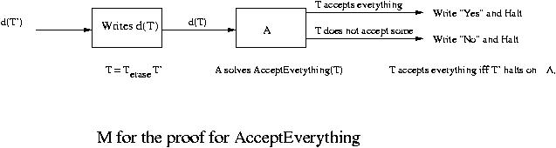
Since Accepts() is unsolvable, it means that AcceptsEverything is unsolvable.
By similar arguments the following problems can be shown to be unsolvable.
AcceptsNothing
This problem asks whether or not a Turing machine accepts nothing.
It can be shown to be unsolvable using Accepts().
Equivalence
This problem asks whether or not two Turing machines accept the same language.
It can be shown to be unsolvable using AcceptsEverything.
Other Unsolvable Problems
Let G₁ and G₂ be context-free grammars and let L(G) denote the language generated by grammar G. Then the following problems are all unsolvable.
Is L( G₁ ) L( G₂ )? Is L( G₁ ) L( G₂ ) = ? finite? infinite? context-free? Is L( G₁ ) = L( G₂ )? Is L( G₁ ) = *? Is the complement of L( G₁ ) context-free?

Time Complexity

Subjects to be Learned
- Time Complexity of Problems
- Decision Tree
- Class NP
- Polynomial Time Transformation
- NP-Complete Problems

Contents
In the previous sections we have learned that some problems are unsolvable by Turing machines hence by computers. No one can write computer programs that solve those problems and halt after a finite amount of time. A problem is solvable if some Turing machine can solve it in finite time. Even if it takes a million years to solve a problem, it is still solvable. However, in practice if it takes a million years, it is as good (or bad) as unsolvable. For many problems a day or even an hour would be too long. In this section we are going to study solvable problems and learn a hierarchy of solvable problems based on the computation time required to solve them. The measure for computation time we use is the worst case time. It is estimated by counting the largest possible number of key operations to be performed in terms of the input size. For more detailed review of this, O(f(x)) (big-oh) and other related subjects click here.
Among the solvable problems there are problems that can be solved by algorithms with the worst case time which is a polynomial in the problem size (polynomial time algorithms). For example a binary search takes O(lg n) time, a quick sort needs O(n²) time, a heap sort needs O(n lg n) time. They are all polynomial time algorithms. There are also problems that must be solved at best by exponential time algorithms in the worst case. For example, as we are going to see below, the satisfiability problem for the propositional dynamic logic is proven to take exponential time to solve in the worst case. They take much more time to execute than polynomial time algorithms. Then there are problems that require double exponential ( e.g. 2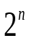 ) time algorithms, problems that need k-exponential time algorithms, where k is a natural number, etc. and there are problems that require algorithms with the worst case time worse than k-exponential time for any natural number k. The problems that can not be solved with any polynomial time algorithm are called intractable problems.
Let us see some of those intractable problems. In logic there is a well known problem of "satisfiability". This is the problem of asking whether or not a given formula can take the value true for some values of its variables. For example the formula (P V ~P) is always true (a tautology), where P is a propositional variable. So it is certainly satisfiable. Similarly (P V Q) is also satisfiable. But (P ^ ~P) is always false (a contradiction). So it is not satisfiable. One can ask the same question for formulas of first order predicate logic, second order logic, etc.
Before proceeding to predicate logic let us consider the following logic called propositional dynamic logic (PDL for short). This is a propositional logic with an extra construct (proposition) after(A, S), where A is an algorithm and S is a statement. after(A, S) says that S is true after executing A. For example "after( if P then Q else ~Q, ~Q )" and "if P then after( if P then Q else ~Q, Q )", where P and Q are propositions, are propositions of PDL. They are both satisfiable.
The satisfiability problem for PDL is known to take at least exponential time to solve in the worst case.
The satisfiability problem becomes even harder when logic becomes more complex. For example the satisfiability problem for Presburger arithmetic is double-exponential (2-fold exponentail), that is it requires at least O( a^{an} ) time to solve in the worst case. Presburger arithmetic is a logic that allows statements involving positive integers, variables taking positive integers as their values, the addition operation +, the equality symbol = and quantifiers and , as well as all the connectives such as and, or etc.
For example, X [ if ~( X = 1 ), then Y Z [ X = Y + Z ] ] is a proposition of Presburger arithmetic.
In Presburger arithmetic (minus addition operation), if, in addition, sets of integers and the predicate "belongs to" (an element X belongs to a set S) are allowed, the logic is called WS1S (Weak Second-order theory of 1 Successor). For the satisfiability problem of WS1S, there are no K-fold exponential time algorithms to solve it for any number K. Such a problem (having no K-fold exponential time algorithms) is called nonelementary.
Now let us go back to the satisfiability problem of propositional logic. This problem belongs to a peculiar class of problems called NP-Complete problems. For the problems of this class there are no known polynomial time algorithms for solving them nor are they known to be unsolvable with polynomial time algorithms. At the moment, however, the consensus is that they ca not be solved with polynomial time algorithms. Below we are going to characterize this class of problems.
First, there are problems that are solved by answering with yes or no. For example, "Is a string w in the language a*b? ", "Is it possible to schedule committee meetings without conflicts into a given number of time slots? ", " Is it possible to assign colors to vertices of a given graph using a given number of colors or less so that no two vertices connected directly by an edge have the same color assigned? " etc. These problems are called decision problems. Some of these decision problems are NP-complete problems.
Let us here review nondeterministic Turing machines. Consider the problem of coloring vertices of a graph with a given number of colors or less so that no two vertices connected directly by an edge have the same color assigned. This problem is called "Graph Coloring" problem or more precisely "Vertex Color" problem. Let us try to solve the following instances of this graph coloring problem:
Given the following graph, is it possible to color its vertices with three or less colors?
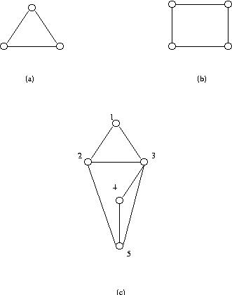
For the graphs of (a) and (b), you could find a solution very easily by inspection. You could see a right coloring as soon as you saw the graphs. However, you can most likely not tell how you arrived at your solutions. You probably don't have any algorithms you could use to solve them. You could somehow see the solutions. This is basically the idea of nondeterministic (Turing) machine. There is no fixed procedure which you can use repeatedly to solve instance after instance of this problem. But you can somehow solve them.
Let us move on to a slightly more complex example of (c). For this graph to find a right coloring you could start with vertex 1 and assign color a. Then move on to vertex 2 and assign color b(it has to be something other than a ). Then go to vertex 3 and assign a third color, say c. Then at vertex 4 select color b and for vertex 5 use color a.
In this process we make a decision as to what color to use for each vertex and when a decision is made for all the vertices we have a solution to the problem. This process applies to any decision problem. That is to solve a decision problem a number of smaller decisions are made one after another and as a result a solution to the problem is obtained. This process can be represented by a tree called decision tree. For example, for the graph coloring problem let us first decide on the order of vertices we color in, say 1, 2, 3, 4 and 5 for the graph of (c) above. Then the root of its decision tree corresponds to the vertex we assign a color to first (vertex 1 in this example). Then for each possible color for the first vertex, a child is created for the first vertex of the tree. So the second level of the decision tree corresponds to the second vertex to be colored. Then in general, for each possible color for each vertex of level i of the decision tree, a child is created. Those children form level i+1 of the decision tree. The decision tree for the graph of (c) is given below. Since any color can be assigned to vertex 1 without loss of generality, it has just one child in the actual decision tree. Also since in this case the i-th and (i+1)-th vertices are connected by an edge for i = 1, 2, 3, 4, they can not have the same color. So each vertex after vertex 1 has two colors to choose from. So they each have two children in the decision tree.
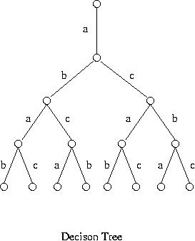
Thus during the process of solving the problem a decision is made at each level and when all levels are covered, the problem is solved. A path from the root to a leaf corresponds to a coloring of the vertices of the given graph. A decision tree, however, does not tell us how to make decisions. Also a decision tree does not tell how to order the vertices for coloring, that is which vertex to color first, second etc.
A deterministic machine (or algorithm) has a specific fixed set of rules for making a decision at each level of the decision tree. Although it knows what to do at every stage of problem solving, the decisions it makes are not necessarily the right ones. When it makes wrong decisions, it must retract earlier decisions and try different paths, which is called backtracking.
For the graph coloring problem a deterministic algorithm might first order the vertices of the graph in decreasing order of their degree and also order colors. Then, following the order of the vertices, assign to each vertex the highest order color available for the vertex. Since that kind of algorithm is not guaranteed to use the minimum number of colors, it may produce a wrong answer unless there is some provision for backtracking.
A nondeterministic (Turing) machine, on the other hand, is a fictitious machine and somehow knows which branch (child) to select at each step. It always makes a right selection.
A decision problem is said to belong to class NP if each vertex in its decision tree has a finite number of children and if it can be solved by a nondeterministic (Turing) machine in polynomial time.
The graph coloring problem is in class NP, so are the satisfiability problem for propositional logic and most of the scheduling problems just to name a few. Also there are other characterizations of class NP. Interested readers click here.
At this moment it is not known whether or not problems in class NP can be solved with a polynomial time algorithm in the worst case. The consensus is that there is no polynomial time algorithm to solve them. It would take at least exponential time. Among the problems in class NP, there are problems which all problems of class NP can be transformed to in polynomial time. Those problems are called NP-complete problems. If a polynomial time algorithm is found for any one of the NP-complete problems, all the problems in NP can be solved in polynomial time. Below we are going to study NP-complete problems. We start our discussion with the concept of polynomial time transformation (reduction). Basically we say a decision problem Q₁ is polynomially reducible to a decision problem Q₂ if and only if there is a transformation that transforms any arbitrary instance of Q₁ into an instance of Q₂ in polynomial time such that the answer to Q₁ is yes if and only if the answer to Q₂ is yes.
A little more formally we define this in terms of languages. Note that a decision problem can be viewed as a language of its instances and that solving it can be considered as recognizing the language as we have seen earlier.
Let L₁ and L₂ be languages over alphabets ₁ and ₂, respectively. We say that L₁ is polynomial-time reducible to L₂ if and only if there is a function f from ₁* to ₂* such that for any string x ₁*, x L₁ if and only if f(x) L₂ and f can be computed in polynomial time.
For example let us consider the following two problems: graph coloring and scheduling of committee meetings.
The graph coloring problem is as given above. In the scheduling of committee meetings problem, committees with their members and a positive integer k are given. The problem is whether or not the meetings of the committees can be scheduled in k or less time slots so that everyone can attend one's meetings. Note that some people may be in more than one committee.
Let us try to show that this scheduling problem is polynomial time reducible to the graph coloring problem.
What we need to do is given an instance of the scheduling problem construct an instance of the graph coloring problem, that is construct a graph and give the number of colors to be used to color its vertices so that the meetings can be scheduled if and only if graph can be colored.
Let us consider the following transformation:
For each committee add a vertex to the graph, and if and only if two committee have some members in common, connect with an edge the vertices corresponding to the committees. Then the meetings can be scheduled in k or less time slots if and only if the graph can be colored with k or less colors.
For example suppose that we are given the committees 1, 2, 3 and 4 with the memberships { a, b }, {a, c, d }, { b, d } and { a, c }, respectively. Suppose also that k = 3. Thus the scheduling problem asks whether or not the meetings of the given committees can be scheduled in 3 time slots without any conflicts.
The corresponding graph for the graph coloring problem can be constructed as follows:
Corresponding to the committees 1, 2, 3 and 4, add vertices 1, 2, 3 and 4 to the graph. Then since committees 1 and 2 share a, an edge is inserted between vertices 1 and 2. Similarly since committees 1 and 3, and 1 and 4 share members, edges are added between 1 and 3, and 1 and 4. Proceeding similarly the following graph is obtained corresponding to the committee memberships.
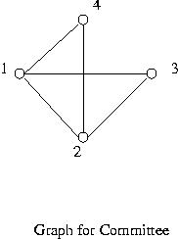
Suppose that the meetings can be scheduled in p time slots, where p k. Then the committees can be grouped into p groups so that the committees in the same group can meet at the same time. Corresponding to this grouping assign colors to the vertices of the graph so that the vertices in the same group are given the same color and those in different groups are given different colors. This coloring uses p colors which does not exceed k, and vertices connected with an edge have different colors. For if any two vertices are connected with an edge, then that means that the corresponding committees share some members and that they are scheduled to meet in different time slots. Thus these two vertices must get different colors.
Conversely if the graph can be colored with k or less colors, then it can be easily seen that the committees can meet in k or less time slots.
It is also easily seen that the transformation, that is the construction of graph for a given set of committees, can be done in time polynomial in the size of the problem, which in this case can be taken as the number of committees.
We are now ready to discuss NP-completeness.
It was first proven by S. Cook that the problems of class NP can be polynomial time reducible to the satisfiability problem of propositional logic. Subsequently the satisfiability problem was found to be polynomial time reducible to many other problems. As a consequence if a polynomial time algorithm is found for any one of those problems, all the problems can be solved with polynomial time algorithms. This group of problems are called NP-complete problems. Formally a problem is NP-hard if every problem in class NP can be polynomial time reducible to it. A problem is NP-complete if it is in class NP and NP-hard.
It can be easily seen that if a problem P at hand is NP-hard and if a problem known to be NP-complete can be polynomial time reducible to P, then P is also NP-complete. For all the problems in class NP can be reduced to P through the known NP-complete problem in polynomial time.
If a problem is NP-complete, then the consensus today is that it is most likely that no polynomial time algorithms i.e. fast algorithms exist to solve it.
Today hundreds of problems are known to be NP-complete. Some of them are listed below.
NP-complete Problems
- Satisfiability Problem for Propositional Logic
- Graph Color Problem
- Committee Meeting Schedule Problem In fact most scheduling problems are NP-complete.
- Traveling Salesman Problem Given cities and traveling times between cities, a traveling salesman wants to know a shortest route to visit all cities exactly once and come back to where he/she started.
- Bin Packing Problem Given a set of objects, their sizes and a number of bins of the same size, find out whether or not the objects can be put into the bins.
- Partition Problem Given a set of integers, group them into two groups so that the sum of the numbers of one group is equal to that of the other group.
- Subgraph Isomorphism Problem Given two graphs, find out whether or not one is a subgraph of the other.
- Set Cover Problem Given a set S, a collection of subsets of S and an integer k, find out whether or not there are k or less subsets in the collection whose union is S.
- Knapsack Problem Given a knapsack of size S, a set of objects, their sizes, their values and an integer V, is it possible to select objects so that the sum of their sizes does not exceed S and the sum of their values is V or larger?
- 3-Dimensional Matching
Given three sets A, B and C of the same size, and a subset S of the Cartesian product A X B X C.
Is there a subset T, called a matching, of S such that every element of A, B, and C appears exactly once in T?
For example, let A = {1,2}, B = {a,b}, and C = {x,y}, and S = {(1,b,x),(1,b,y), (2,a,x), (2,b,y)}.
Then T = {(1,b,y), (2,a,x)} is a desired set satisfying all the requirements. Note that {(1,b,x),(2,a,x)} is not a matching.
Back to Study Schedule
Back to Table of Contents
~

