CN LAB ASSIGNMENT

## 

## Name: Eisha Tir Raazia

## Id: 17K-3730

## Section: C

**Q.1 What is Routing and on which OSI layer it happens?**

The process of selecting a path for traffic in a network or between or across multiple networks is called as routing.

Where does routing takes place? It takes place at the network layer.

**Q.2 Write any two advantages of static routing.**

1. It causes less load on the CPU of the router, and produces no traffic to other routers.
2. It leaves the network administrator with full control over the routing behavior of the network.

**Q.3 What happens when default routing is applied in networks other than stub networks?**

The default routing is used when no network route or the host route matches. The router which is listed as a next hop of a default route is the default gateway which is the gateway of the last resort.

Noe default routing is mostly only in stub networks. Stub are the networks that have only one output interface and everything going through these networks has to cross the single exit point.

**Q.4 What DCE & DTE stand for?**

1. DCE stands for **Data Communications Equipment**
2. DTE stands for **Data Terminal Equipment**

**Q.5 What OSPF stands for and what is its Metric?**

OSPF stands for Open Shortest Path First. Its metrics can be cost, distance of a router (round-trip time), data throughput of a link, or link availability and reliability, link throughput, and network bandwidth.

**Q.6 What is the difference between subnet mask and wildcard mask?**

**Subnet mask**:

A 32-bit combination used to describe which portion of an address refers to the subnet/network and which part refers to the host. It is used along with IP Address.

**Wildcard Mask**:

It is used to indicate to the IOS software whether to check or ignore corresponding IP address bits when comparing the address bits in an access list entry , OSPF/EIGRP network command. A wildcard mask is sometimes referred to as an inverted mask because a 1 and 0 mean the opposite of what they mean in a subnet (network) mask.

e.g.

/30 : 255.255.255.252 subnet mask

0 . 0 . 0 . 3 wildcard mask

/24 : 255.255.255.0 subnet mask

0 . 0 . 0 . 255 wildcard mask

**Q.7 Differentiate Distance Vector and Link State routing protocols.**

The prior difference between Distance vector and link state routing is that in distance vector routing the router share the knowledge of the entire autonomous system whereas in link state routing the router share the knowledge of only their neighbour routers in the autonomous system.

**Q.8 Write one example each of Distance Vector, Link State & Hybrid IGPs.**

1. **Example of Distance Vector:** IGRP (Interior Gateway Routing Protocol)
2. **Example of Link State:** OSPF protocol (Open Shortest Path First)
3. **Example of Hybrid IGPs:** BGP,EIGRP

**OSPF lab task screenshot:**

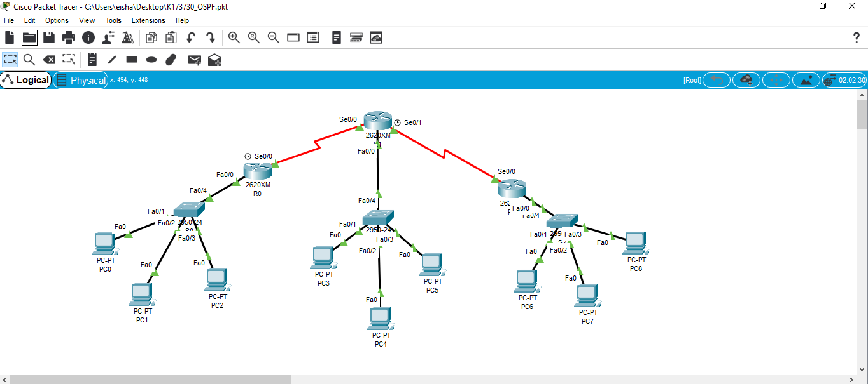

**( .pkt file attached )**

