
API SECURITY TESTING
Assignment Report

Prepared by:
Eisha Nawaz
MSCS22007 | System Security Engineering (SSE)
Information Technology University
Date: APRIL 16, 2025

Labs Covered
Lab 1: Exploiting Unused API Endpoint
Lab 2: Exploiting Mass Assignment Vulnerability
Platform: PortSwigger Web Security Academy

LAB 1
Exploiting Unused API Endpoint

1. Lab Information

Lab Name | Exploiting Unused API Endpoint
Lab URL | https://portswigger.net/web-security/api-testing/lab-exploiting-unused-api-endpoint
Platform | PortSwigger Web Security Academy
Date Performed | APRIL 16, 2025
Category | API Testing

2. Objective
The objective of this lab is to exploit an unused HTTP method exposed by the API to modify the price of a product and purchase it for free. The lab simulates a real-world scenario where developers leave unprotected API endpoints accessible with HTTP verbs beyond GET/POST, allowing attackers to perform unauthorized actions such as price manipulation.

3. Testing Environment

Browser | chromium (Burp Suite built-in browser)
Proxy Tool | Burp Suite Community / Community Edition
Operating System | Kali Linux
Network | Lab-isolated environment provided by PortSwigger

4. Step-by-Step Methodology

4.1 Setup & Preparation
Step | Action
1 | Open Burp Suite and navigate to Proxy > Intercept tab. Ensure Intercept is turned ON.  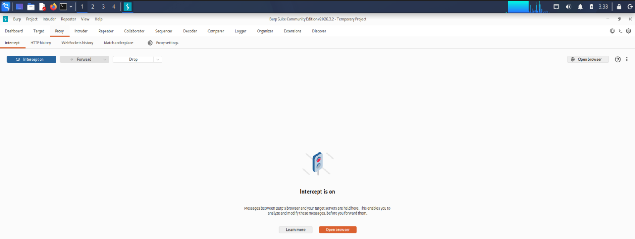
2 | Open the Burp Suite built-in Chromium browser by clicking 'Open Browser' inside Proxy > Intercept.  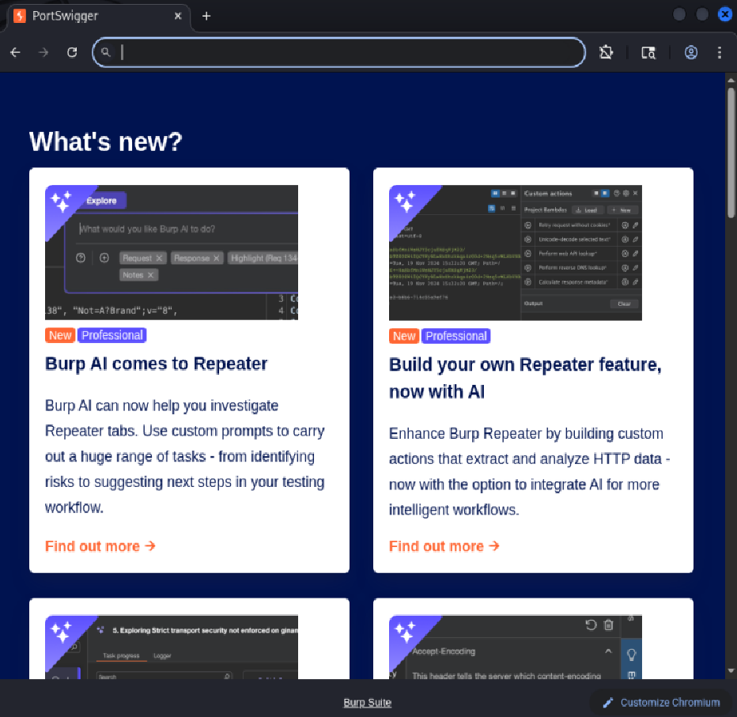
3 | Navigate to the lab URL provided by PortSwigger and click 'Access the Lab' to launch the environment.  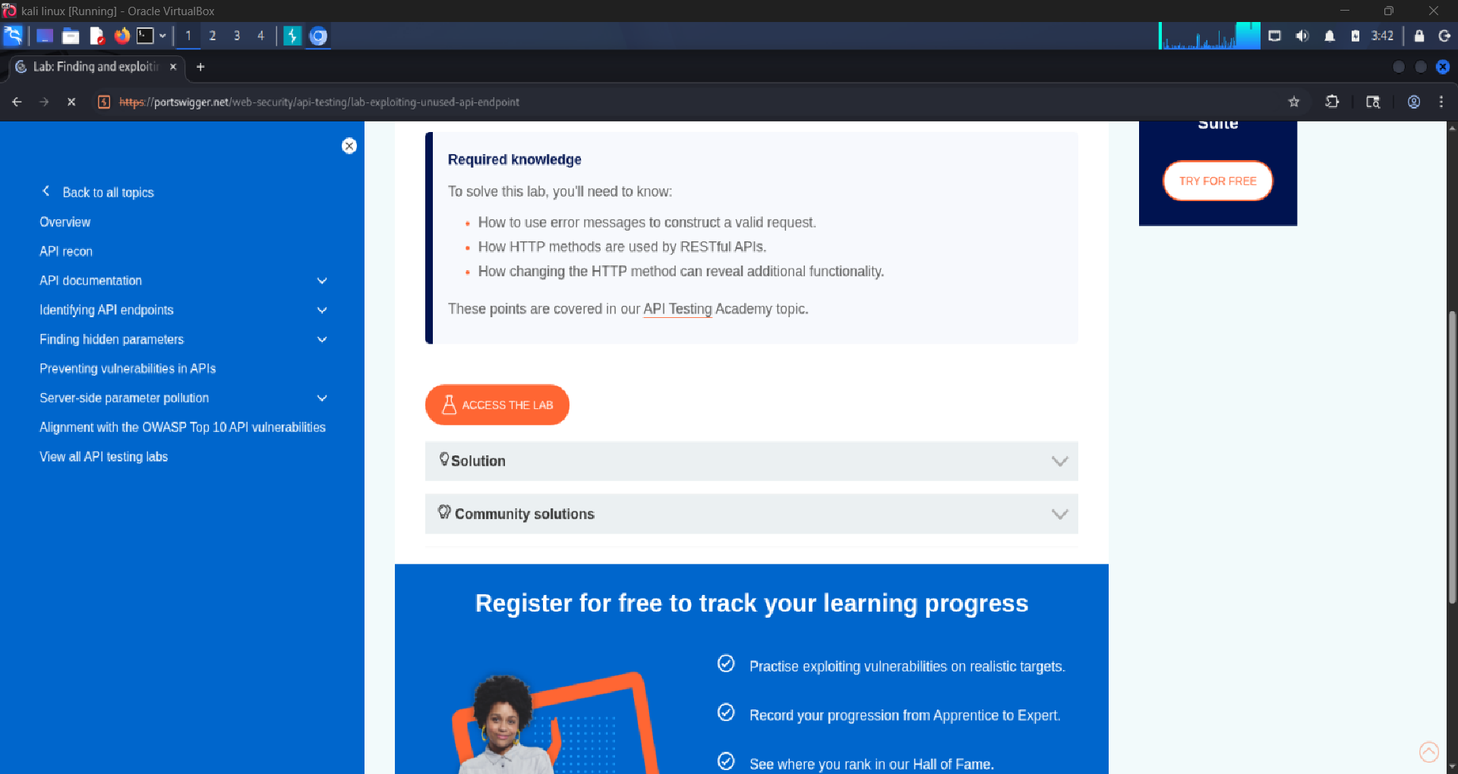
4 | Turn Intercept OFF so traffic flows freely. Switch to Proxy > HTTP History to observe all requests.  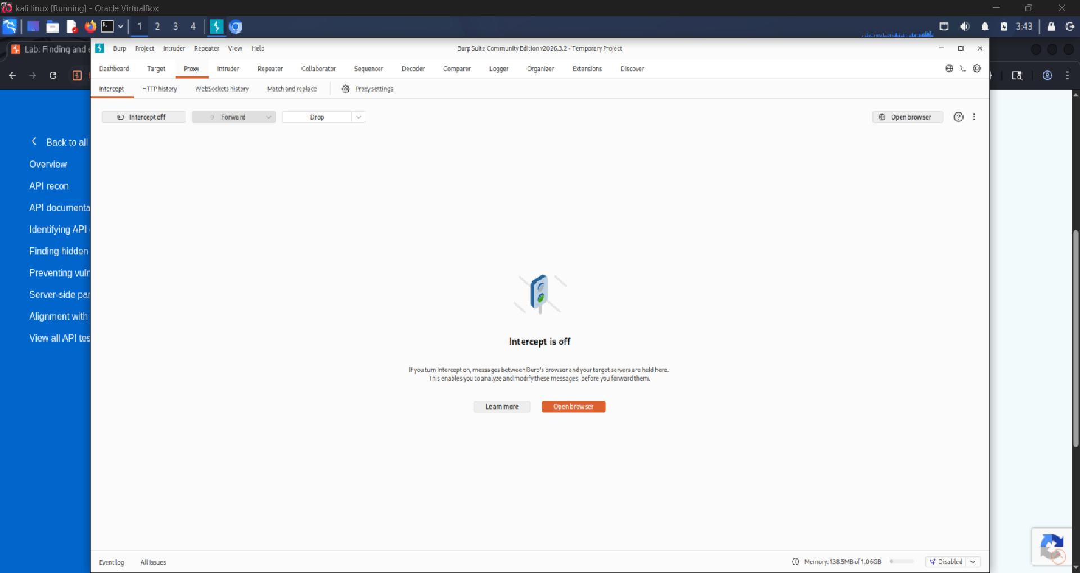

4.2 Application Reconnaissance
Step | Action
5 | Browse the shop homepage. Click on several products to view their details pages and trigger API calls.  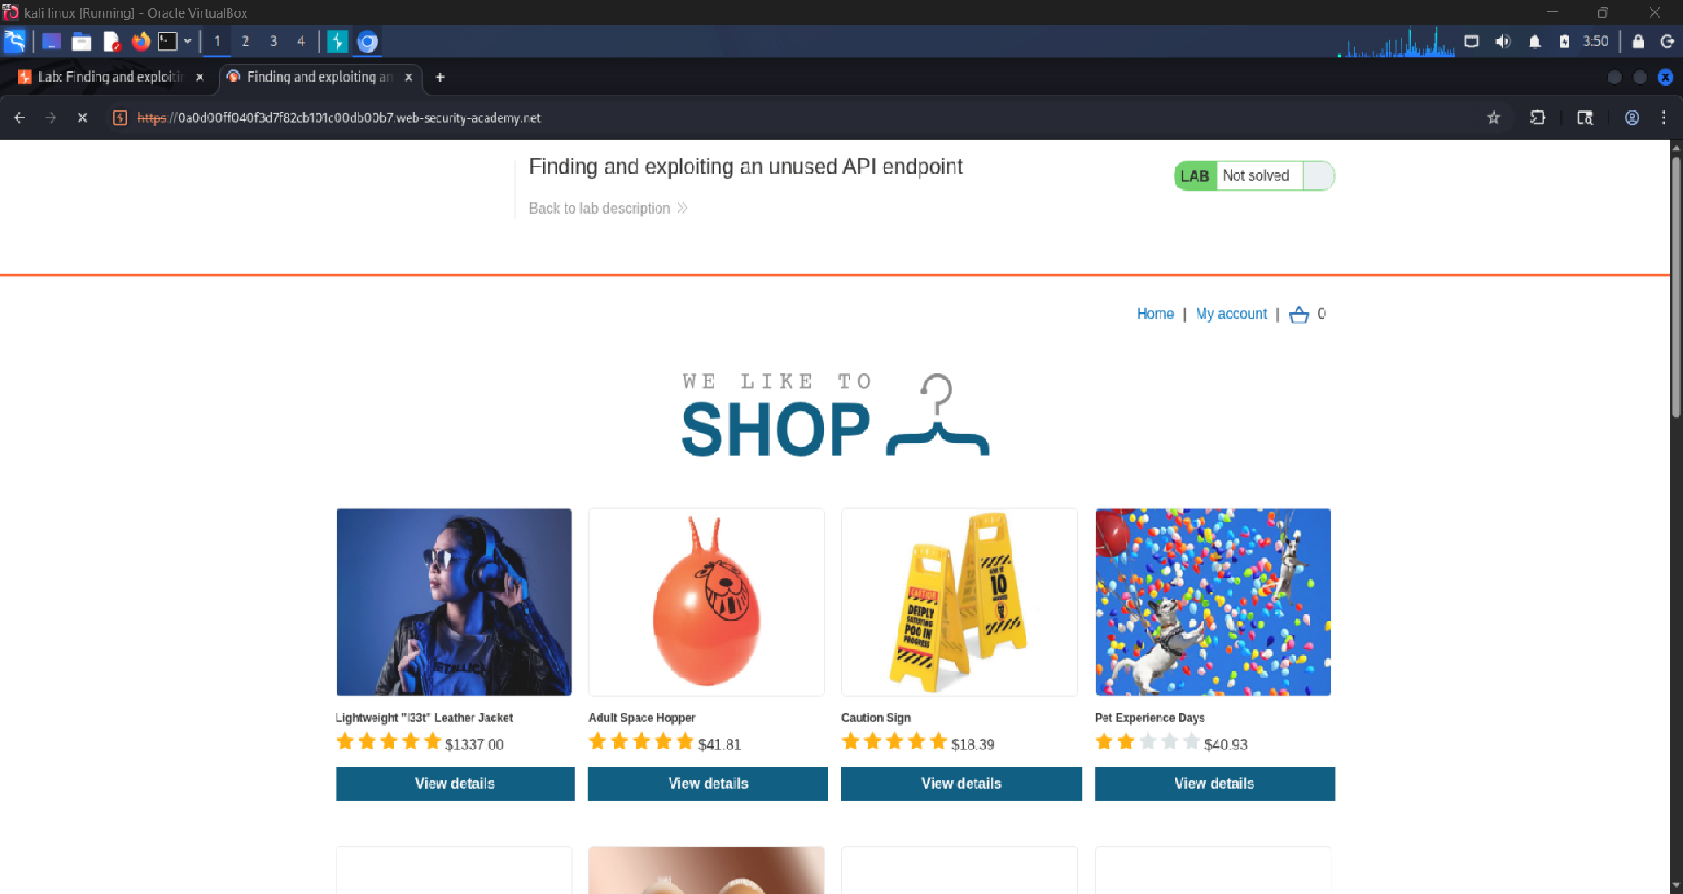
6 | Click specifically on the leather jacket product to load its detail page.  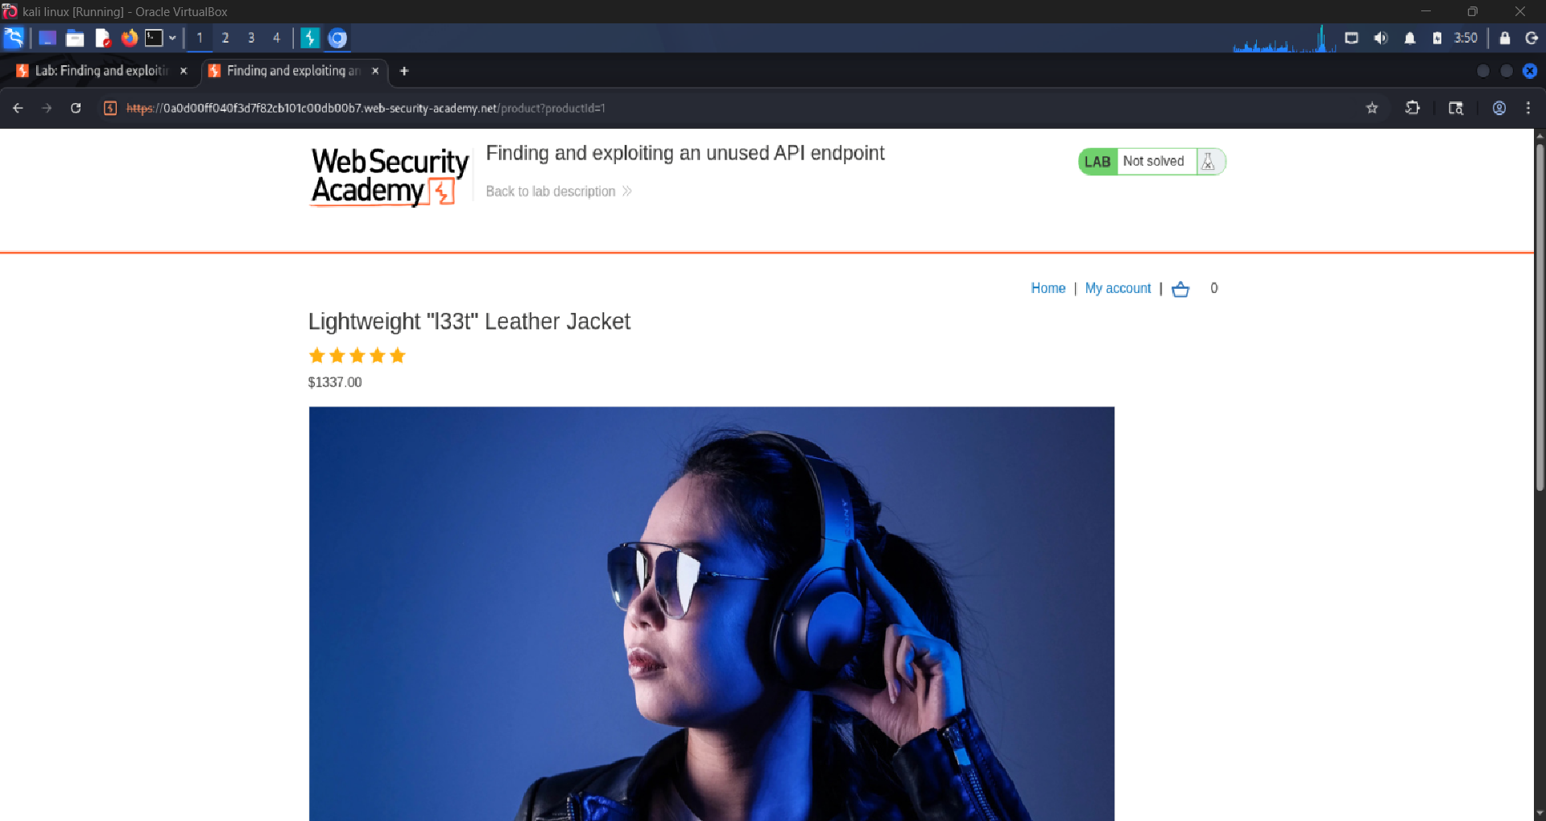
7 | In Burp Suite HTTP History, locate the API request: GET /api/products/1/price. This is the price-fetching endpoint.  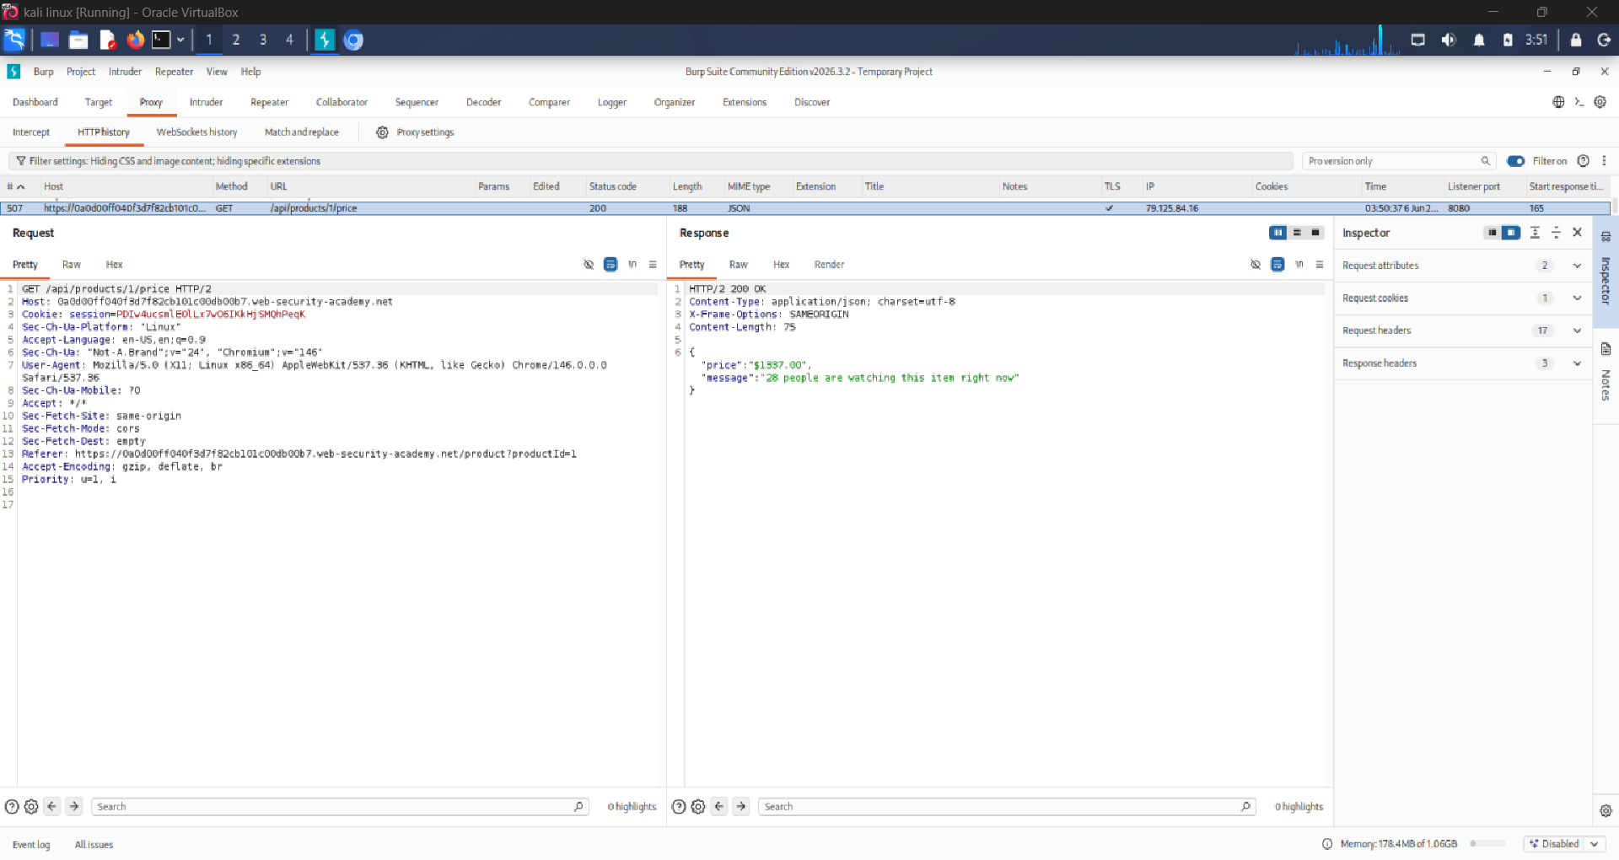
8 | Right-click the GET /api/products/1/price request and select 'Send to Repeater'.  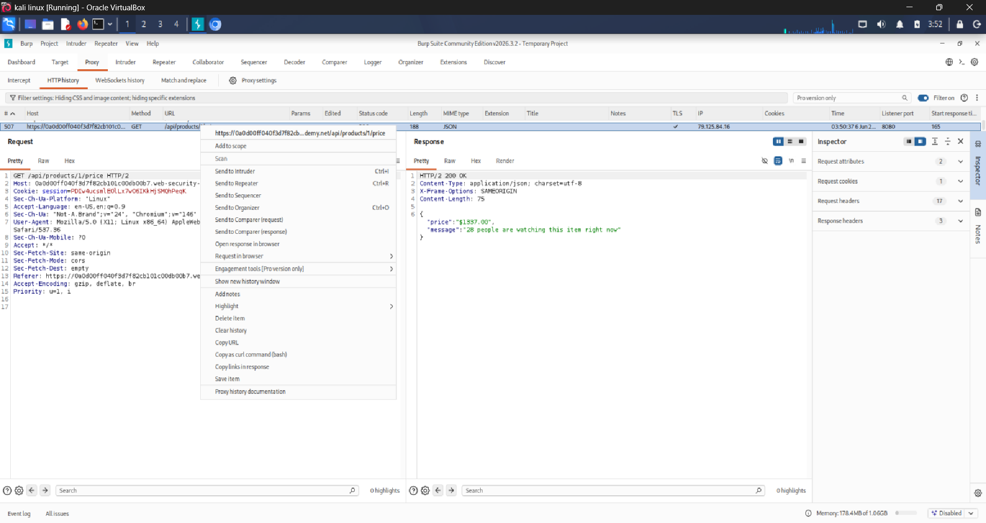

4.3 HTTP Method Discovery
Step | Action
9 | In the Repeater tab, change the HTTP method from GET to OPTIONS and click 'Send'. Examine the response headers for an Allow: header listing permitted methods.  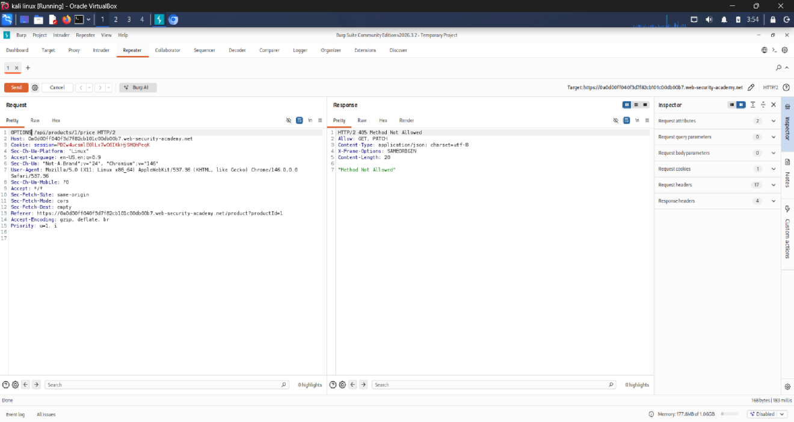
10 | Note which HTTP methods are allowed by the server (e.g., GET, PATCH). The PATCH method is significant as it allows partial updates.  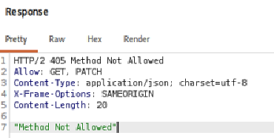
11 | Change the method to PATCH. Notice Unauthorized Message. And content Type that is allowed is application/json.  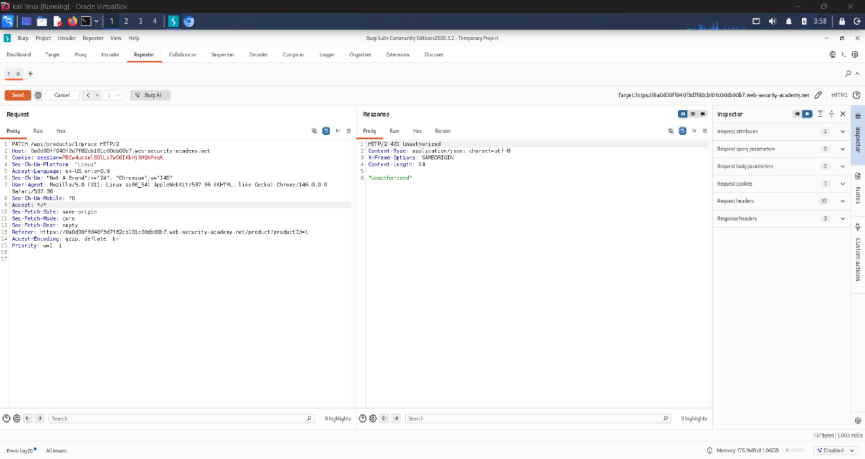
12 | Observe when we are trying to add to cart the login required  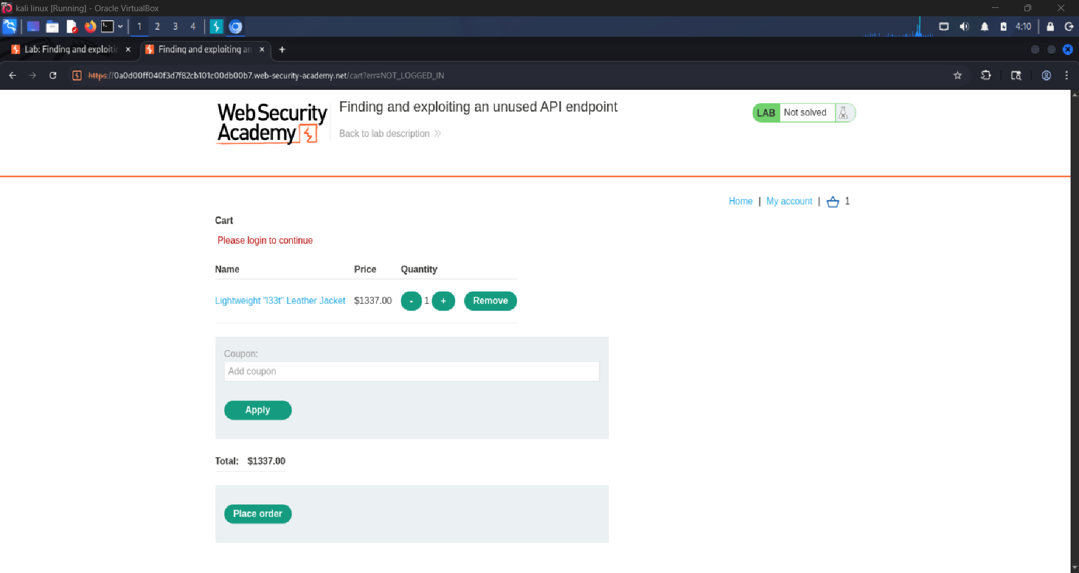
13 | Log in to the Account using provided credentials wiener:peter.  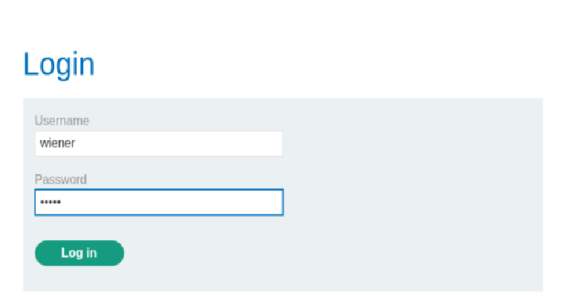  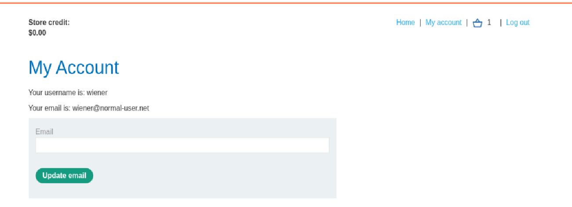  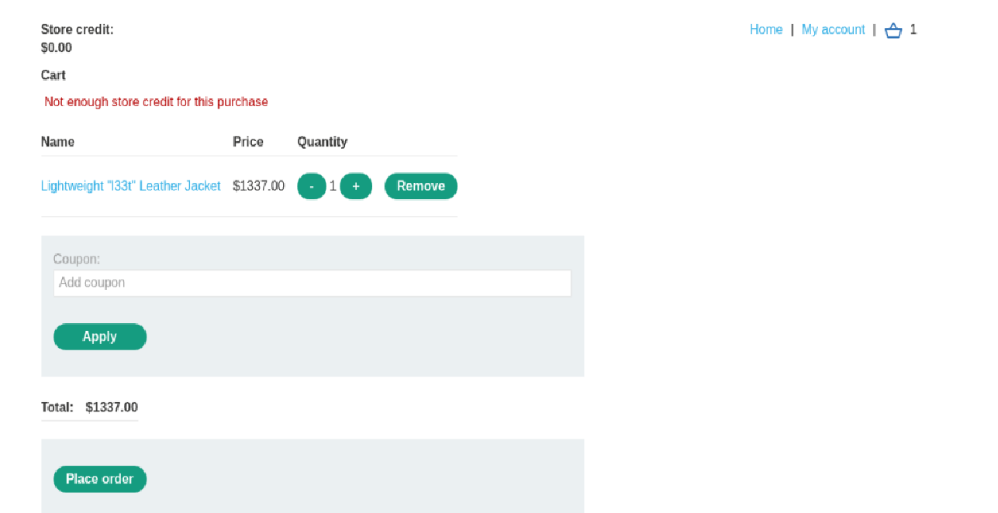
141 | Repear step 8 and 11 and observe the content type error.  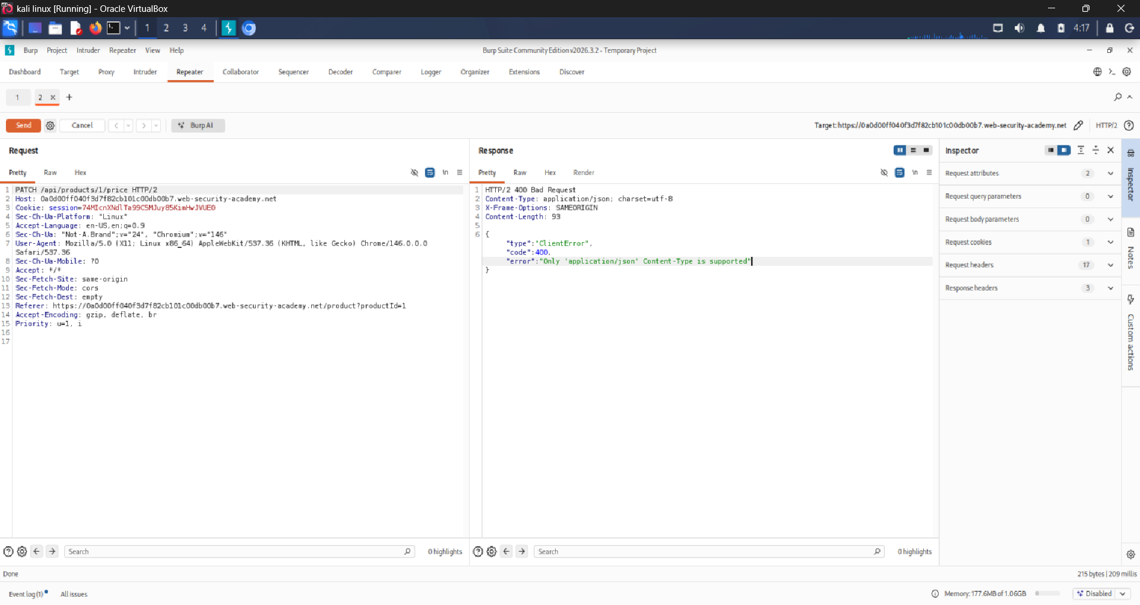
15 | Add Content-Type header and set the value to application/json. Add an empty JSON object {} as the request body, then send the request. Notice that this causes an error due to the request body missing a price parameter.  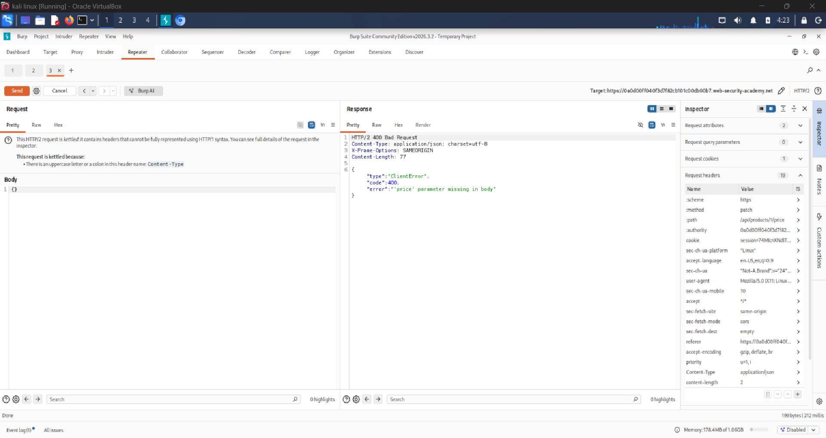
16 | Add a price parameter with a value of 0 to the JSON object {"price":0}. Send the request. Observe the server returns a 200 OK response confirming the price was updated to $0.00.  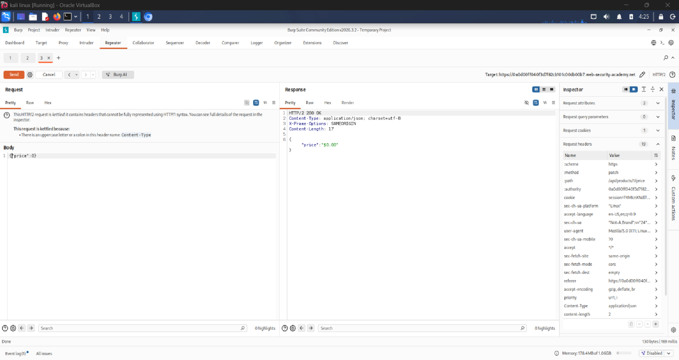

4.4 Exploitation
Step | Action
13 | Return to the browser. Refresh the product page for the leather jacket. Observe the price now shows $0.00.  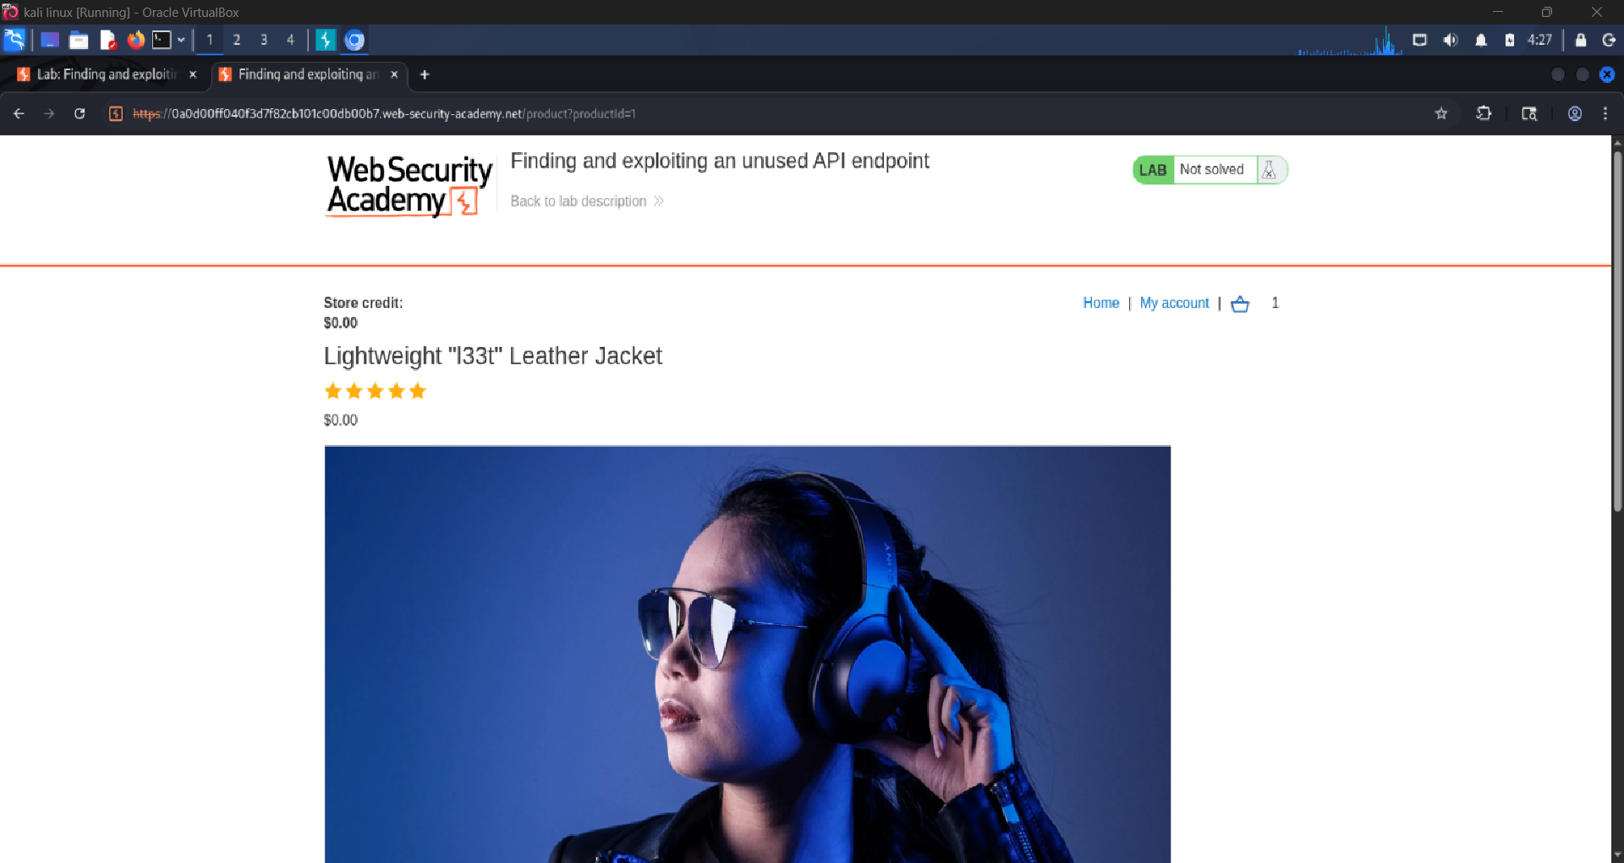
14 | Click 'Add to Cart' to add the free jacket to your shopping cart. Navigate to the cart and proceed to checkout. Place the order at $0.00. The lab banner displays 'Congratulations, you solved the lab!' confirming successful exploitation.  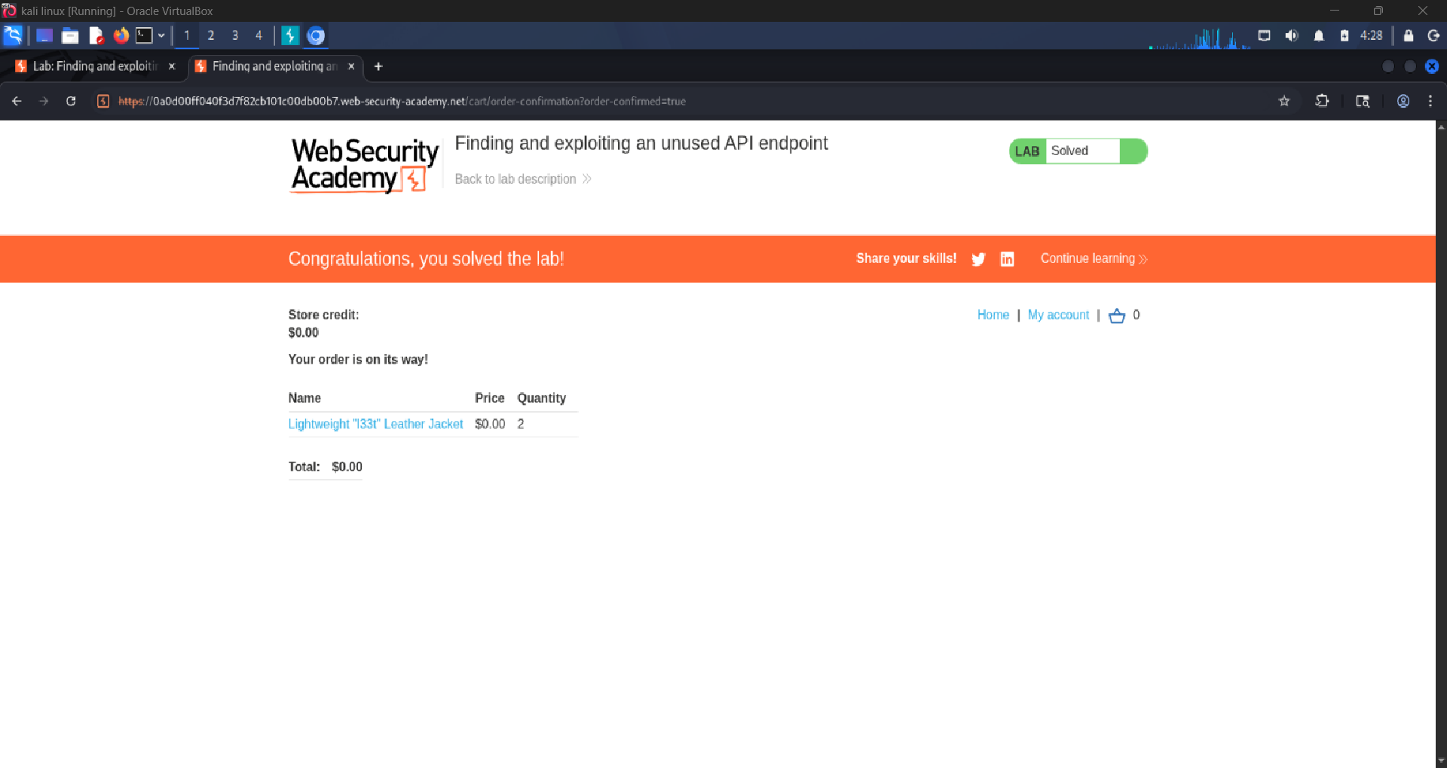

5. Evidence / Screenshots

5.1 Intercepted Original Request
The following GET request was captured in Burp Suite HTTP History when the product page was loaded:

Intercepted Request: GET /api/products/1/price
GET /api/products/1/price HTTP/2
Host: 0a0d00ff040f3d7f82cb101c00db00b7.web-security-academy.net
Cookie: session=74MIcnXNdlTa99CSMJuy85KimHwJVUE0
User-Agent: Mozilla/5.0 ...
Accept: */*

Screenshot 1: HTTP History showing GET /api/products/1/price

5.2 OPTIONS Method Probe
Method changed to OPTIONS in Repeater to enumerate allowed HTTP methods:
OPTIONS Request & Response
OPTIONS /api/products/1/price HTTP/2
Host: 0a0d00ff040f3d7f82cb101c00db00b7.web-security-academy.net
Response Headers:
Allow: GET, PATCH
HTTP/2 405 Method Not Allowed

Screenshot 2: OPTIONS response showing Allow: GET, PATCH header

5.3 Modified PATCH Request (Exploitation)
The request was modified to use the PATCH method with a JSON body setting the price to 0:
PATCH Request: Price Set to $0.00
PATCH /api/products/1/price HTTP/2
Host: 0a0d00ff040f3d7f82cb101c00db00b7.web-security-academy.net
Content-Type: application/json
Cookie: session=74MIcnXNdlTa99CSMJuy85KimHwJVUE0
{"price": 0}
--- Response ---
HTTP/2 200 OK
Content-Type: application/json
{"price": 0}

Screenshot 3: Repeater showing PATCH request and 200 OK response

5.4 Lab Solved Confirmation
Screenshot 4: Browser showing jacket priced at $0.00 and checkout complete

Screenshot 5: 'Congratulations, you solved the lab!' banner

6. Vulnerability Analysis

Field | Details
Vulnerability | Improper HTTP Method Restriction (CWE-749)
OWASP Category | API3:2023 Broken Object Property Level Authorization
Severity | HIGH; allows unauthorized price modification
Root Cause | PATCH endpoint not restricted or authenticated
Remediation | Restrict PATCH to admin roles; validate server-side

LAB 2
Exploiting Mass Assignment Vulnerability

1. Lab Information

Lab Name | Exploiting Mass Assignment Vulnerability
Lab URL | https://portswigger.net/web-security/api-testing/lab-exploiting-mass-assignment-vulnerability
Platform | PortSwigger Web Security Academy
Date Performed | APRIL 16, 2025

2. Objective
The objective of this lab is to exploit a mass assignment vulnerability in the checkout API. By intercepting a POST request to the checkout endpoint and injecting an additional JSON field (chosen_discount.percentage = 100), the attacker can apply an unauthorized 100% discount and purchase the jacket for free. This demonstrates the risk of accepting all client-supplied fields without server-side filtering.

3. Testing Environment

Browser | Chromium (Burp Suite built-in browser)
Proxy Tool | Burp Suite Community / Community Edition
Operating System | Kali Linux
Network | Lab-isolated environment provided by PortSwigger

4. Step-by-Step Methodology

4.1 Setup & Preparation
Step | Action
1 | Open Burp Suite. In Proxy > Intercept, enable intercept mode and launch the built-in Chromium browser.
2 | Navigate to the lab URL and start the lab environment.  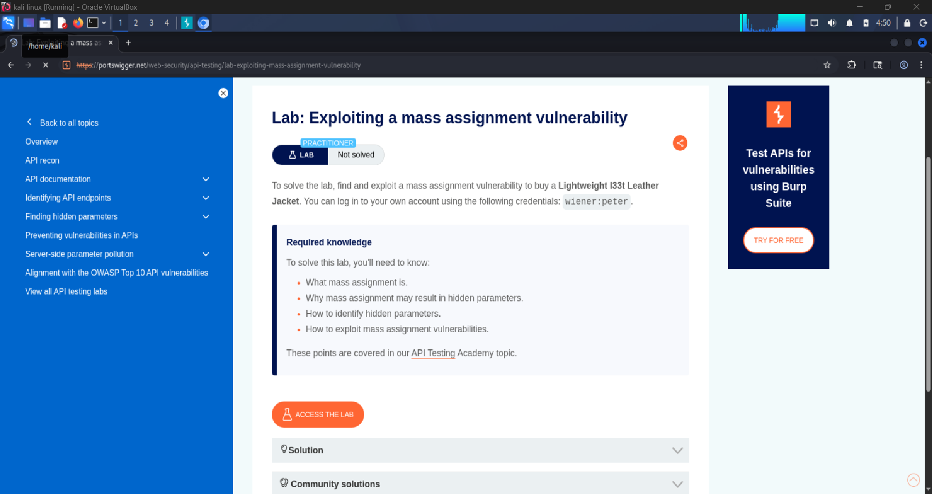
3 | Turn Intercept OFF and let traffic flow so HTTP History captures all requests.  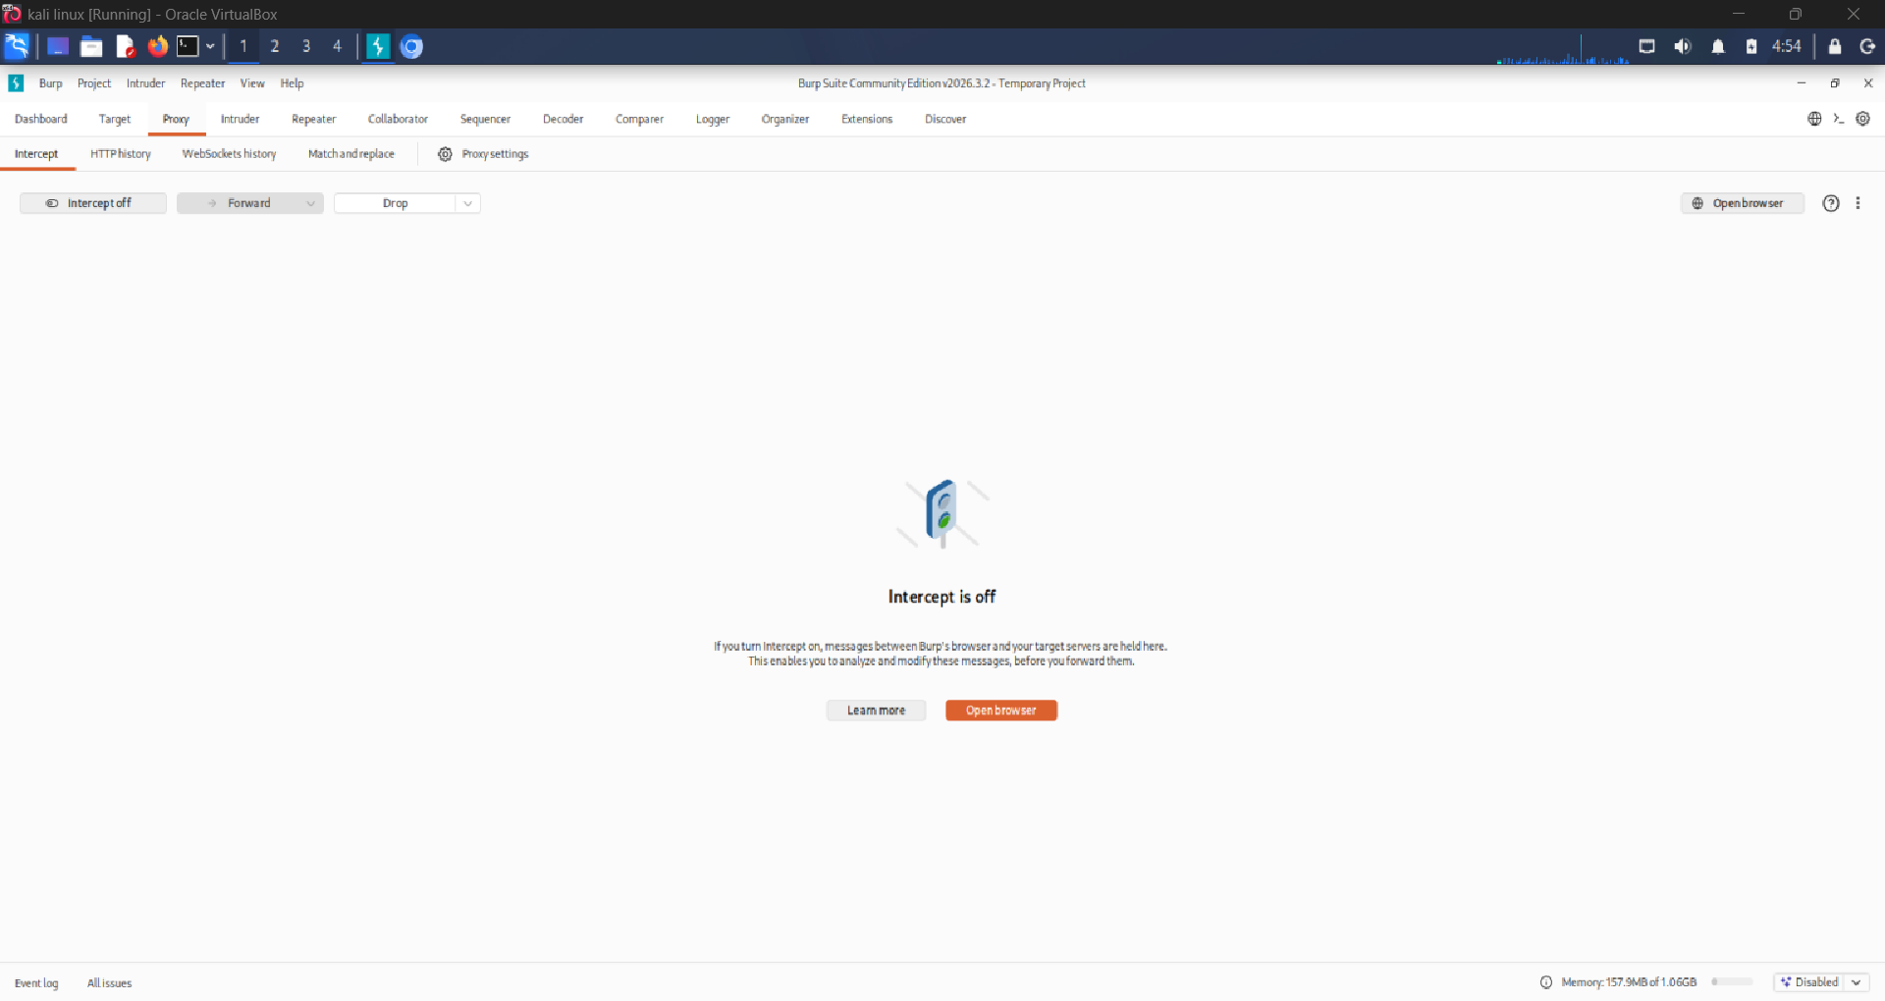

4.2 Application Reconnaissance
Step | Action
4 | Browse the shop and add the leather jacket to the cart.  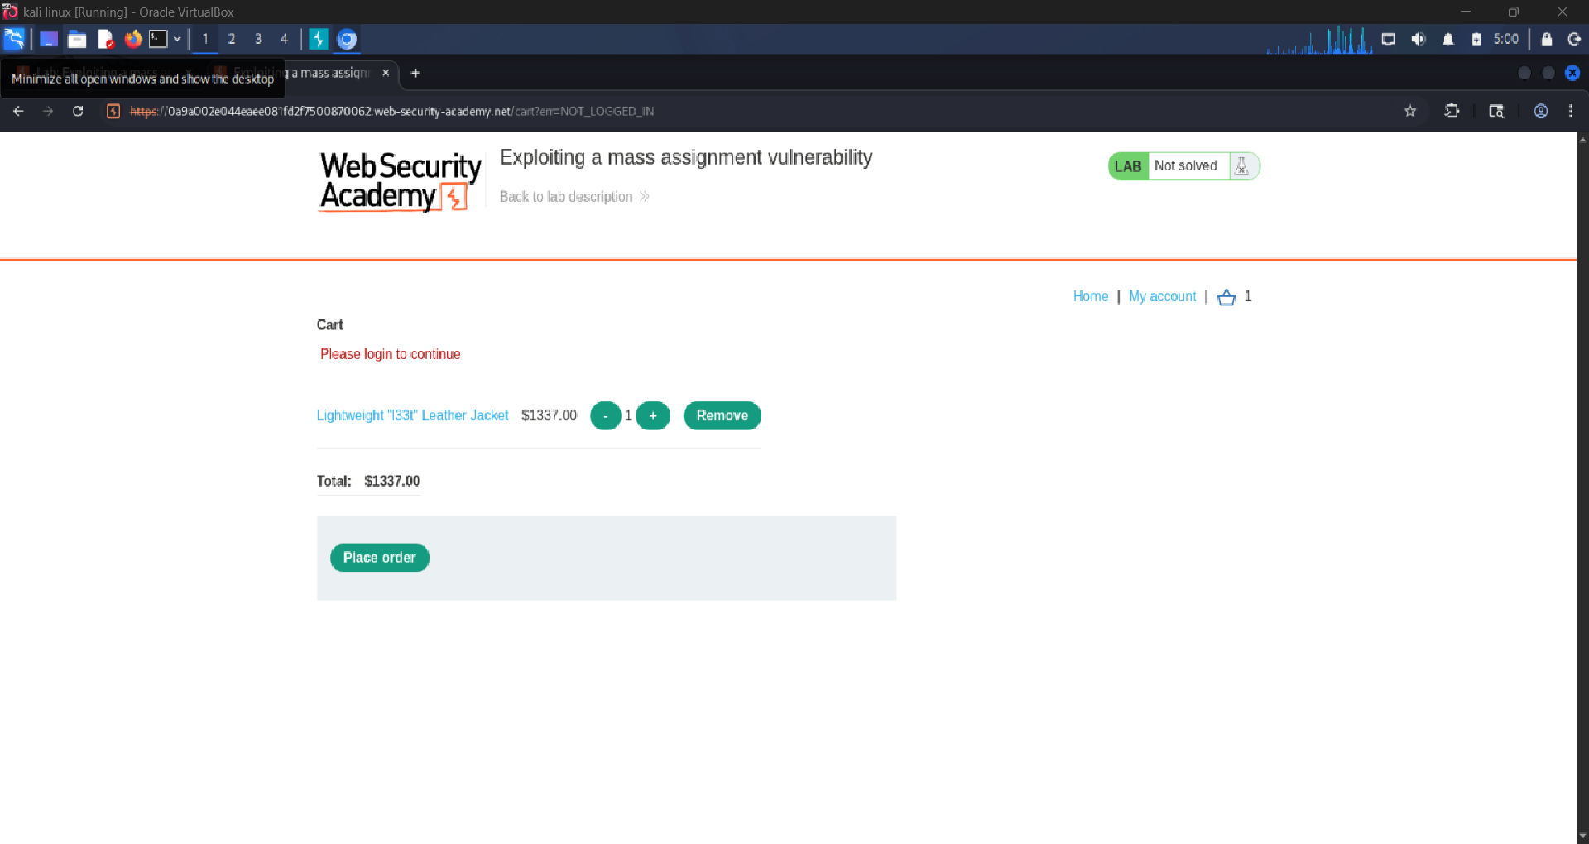  After Login.  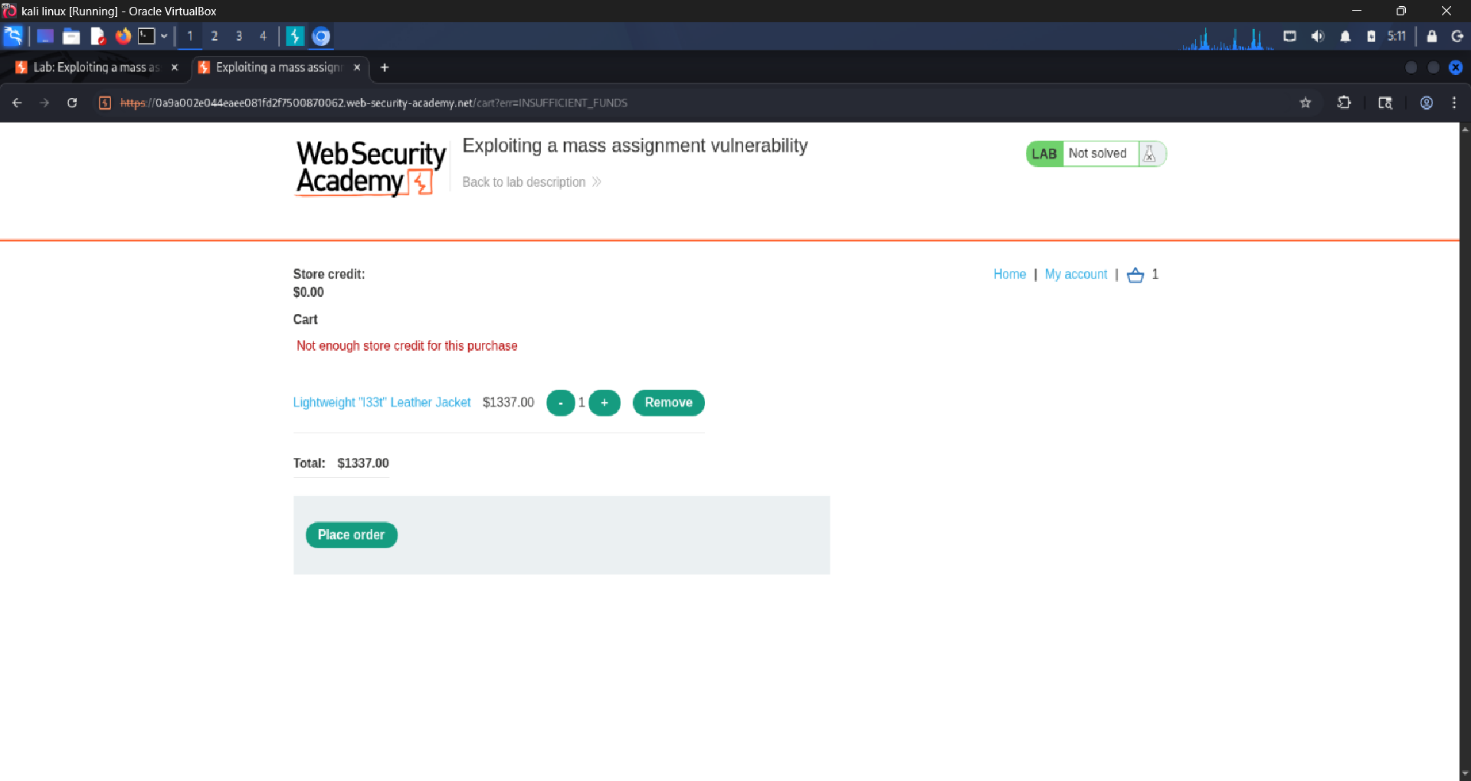
5 | Proceed to checkout. observe the checkout flow and watch for API calls in HTTP History.  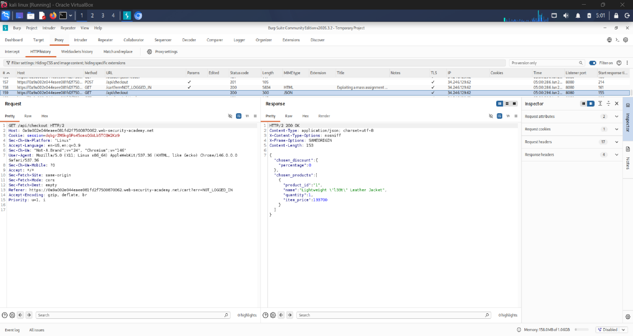
6 | In HTTP History, locate the GET /api/checkout request and send it to Repeater.  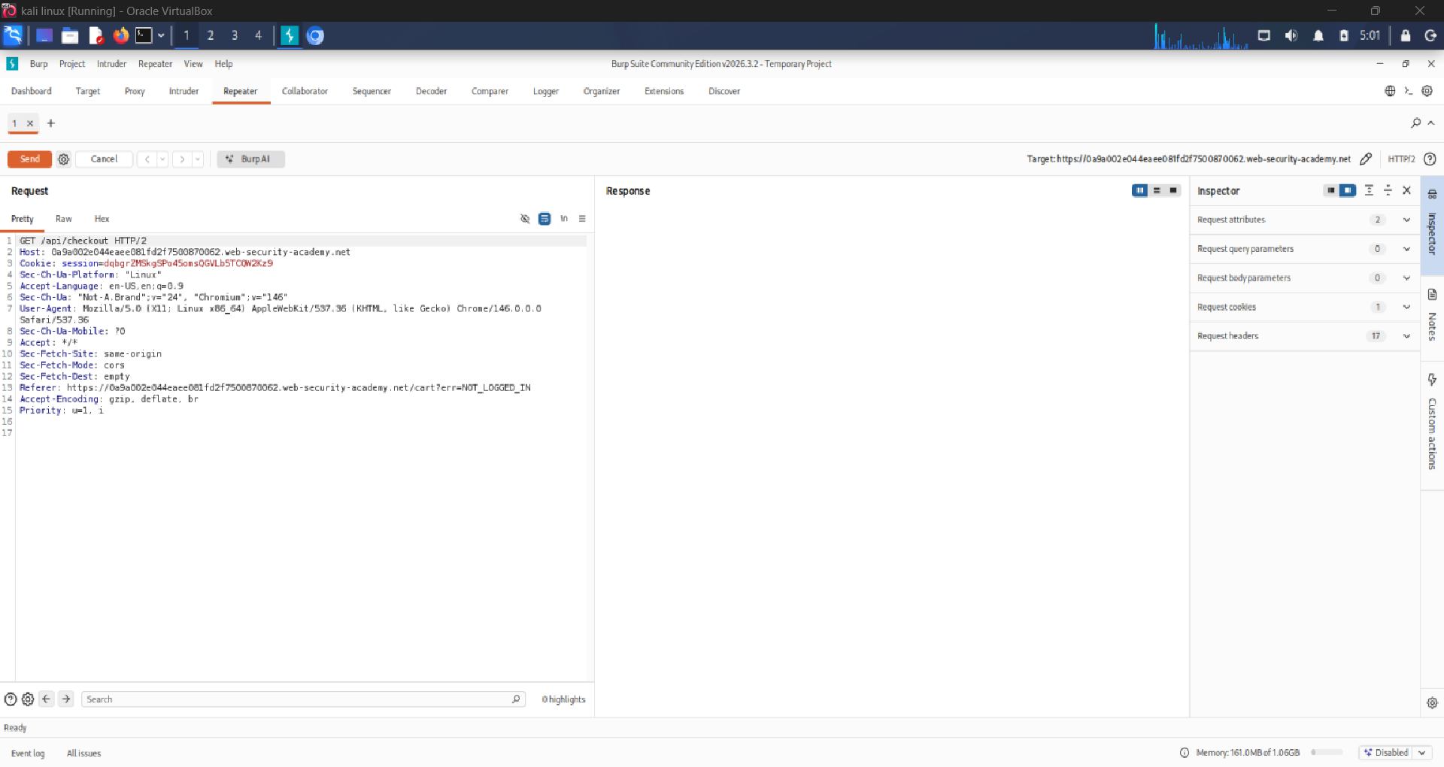
7 | In Repeater, send a GET to /api/checkout. Examine the JSON response carefully. note the 'chosen_discount' object containing a 'percentage' field set to 0.  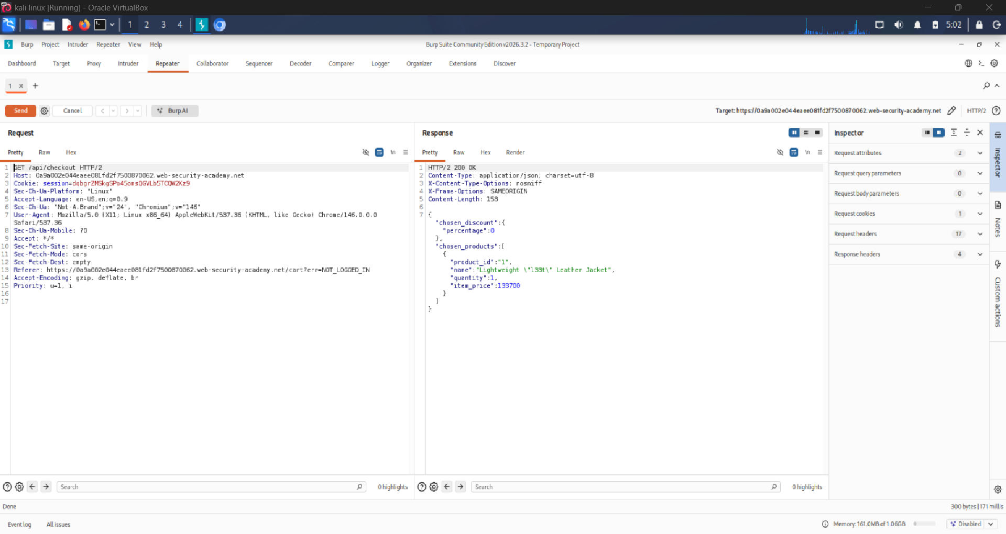

4.3 Identifying the Hidden Field
Step | Action
8 | The GET response reveals internal fields the application uses, including: {"chosen_discount":{"percentage":0}, "chosen_products":[...]}. The 'percentage' field is not exposed in the UI but is present in the API schema.  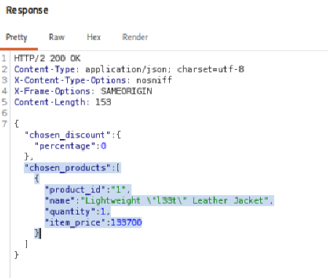
9 | Locate the POST /api/checkout request in HTTP History (sent when you confirmed your order). Send it to Repeater.  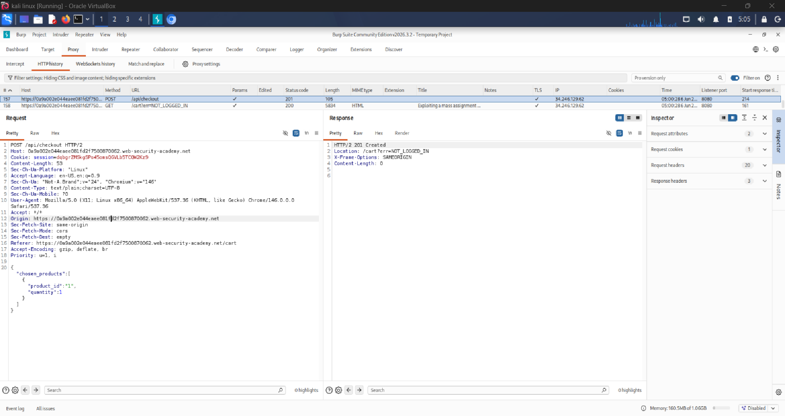  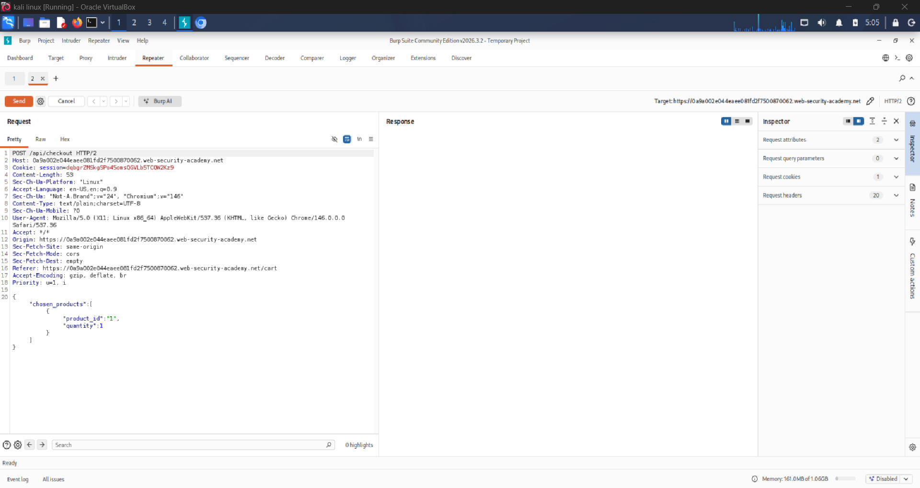
10 | Add the chosen_discount in the POST body: {"chosen_products":[{"product_id":"1","quantity":1}]}.  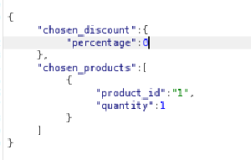

4.4 Exploitation
Step | Action
11 | In Repeater, modify the POST /api/checkout request body. Change the percentage value from 0 to 100: {"chosen_discount":{"percentage":100},"chosen_products":[{"product_id":"1","quantity":1}]}.  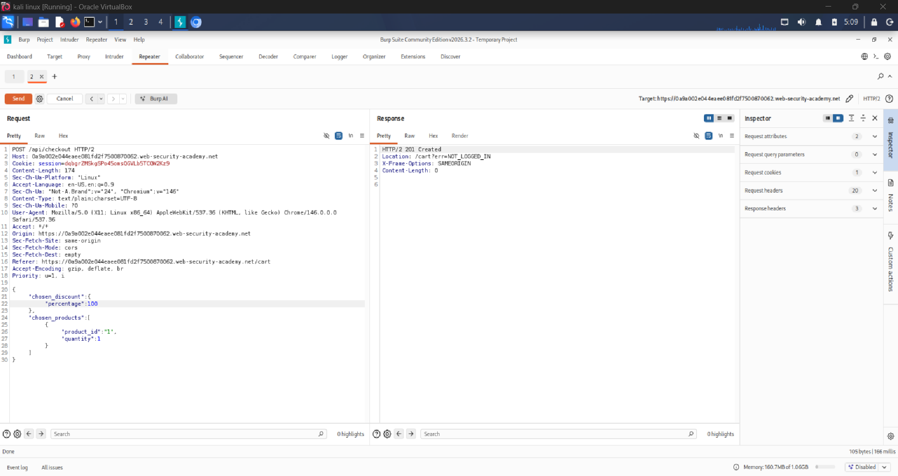
12 | Click 'Send'. Observe the server returns 200 OK and applies the 100% discount.  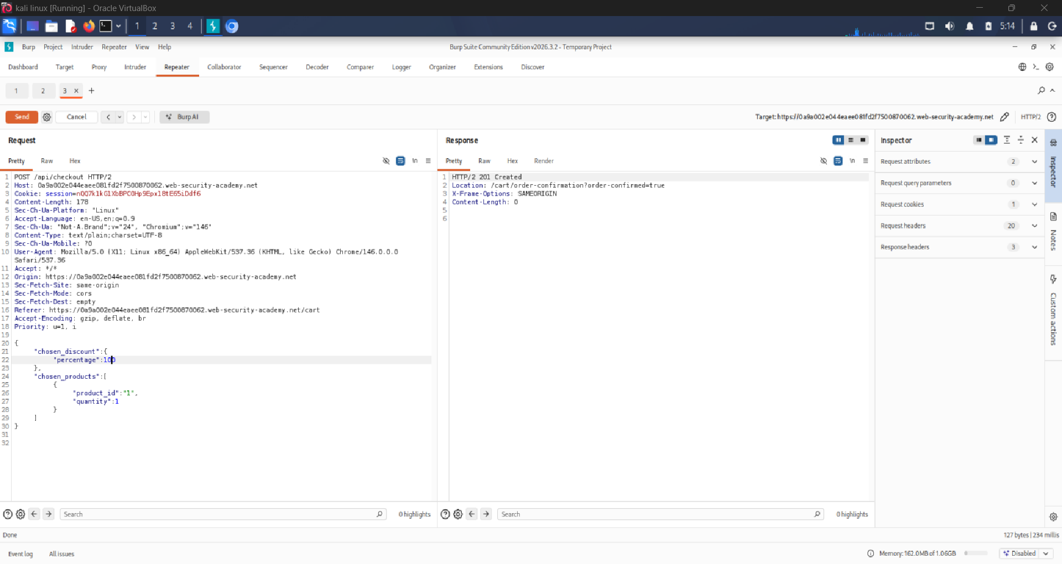
13 | Return to the browser. Complete the checkout with the 100% discount applied the jacket costs $0.00.
14 | The lab banner displays 'Congratulations, you solved the lab!' confirming successful exploitation.  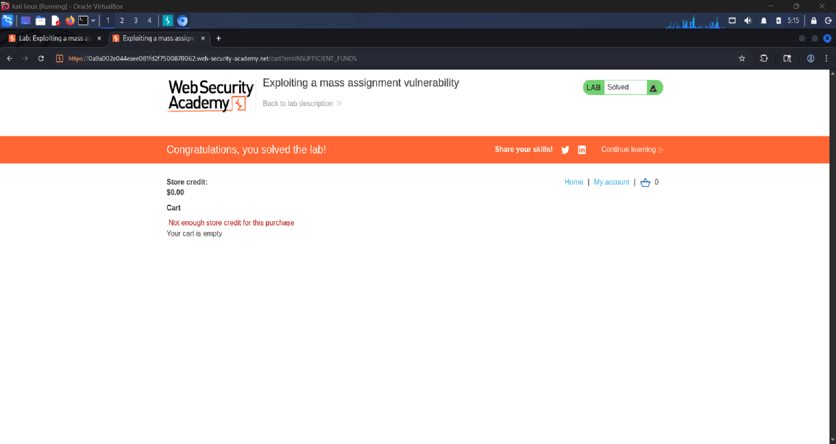

5. Evidence / Screenshots

5.1 GET /api/checkout Response; Hidden Field Discovery
Sending a GET request to /api/checkout reveals the internal data structure including the discount percentage field:
GET /api/checkout; Response revealing 'percentage' field
GET /api/checkout HTTP/2
Host: 0a9a002e044eaee081fd2f7500870062.web-security-academy.net
Cookie: session=n007klkGlXbBPO0HpSEpxl8tE65iDdf6
--- Response (200 OK) ---
{
"chosen_discount": { "percentage": 0 },
"chosen_products": [
{ "product_id": "1", "name": "Lightweight l33t Leather Jacket",
"quantity": 1, "item_price": 133370 }
]
}

Screenshot 1: GET /api/checkout response showing chosen_discount.percentage field

5.2 Original POST /api/checkout Request
Default checkout POST request captured from normal user flow:
Original POST Request; percentage: 0
POST /api/checkout HTTP/2
Host: 0a9a002e044eaee081fd2f7500870062web-security-academy.net
Content-Type: application/json
Cookie: session=n007klkGlXbBPO0HpSEpxl8tE65iDdf6
{
"chosen_discount": { "percentage": 0 },
"chosen_products": [{ "product_id": "1", "quantity": 1 }]
}

Screenshot 2: Original POST /api/checkout in Burp Repeater

5.3 Modified POST Request; Mass Assignment Exploit
The request was modified in Repeater to inject percentage: 100, applying a full discount:
Modified POST Request — percentage: 100 (Exploit)
POST /api/checkout HTTP/2
Host: 0a9a002e044eaee081fd2f7500870062web-security-academy.net
Content-Type: application/json
Cookie: session=n007klkGlXbBPO0HpSEpxl8tE65iDdf6
{
"chosen_discount": { "percentage": 100 },
"chosen_products": [{ "product_id": "1", "quantity": 1 }]
}
--- Response ---
HTTP/1.1 200 OK
{ "status": "order placed", "total": 0 }

Screenshot 3: Modified POST request in Repeater with percentage: 100

5.4 Lab Solved Confirmation

Screenshot 4: 'Congratulations, you solved the lab!' banner

6. Vulnerability Analysis

Field | Details
Vulnerability | Mass Assignment / Parameter Pollution (CWE-915)
OWASP Category | API3:2023 Broken Object Property Level Authorization
Severity | HIGH; attacker controls privileged internal fields
Root Cause | API binds all client JSON fields to internal object without allowlist filtering
Remediation | Use allowlists for accepted fields; never expose or accept privileged fields from clients

Conclusion
Both labs demonstrated critical API security weaknesses that are common in real-world applications. The exercises reinforced the importance of thorough API reconnaissance using HTTP interception tools like Burp Suite.

Lab | Vulnerability | Impact | Severity
Lab 1 | Unused API Endpoint (HTTP Verb Tampering) | Price Manipulation | HIGH
Lab 2 | Mass Assignment Vulnerability | Unauthorized Discount | HIGH

Key Lessons Learned
- Always restrict HTTP methods to only those required by the application (GET/POST) and deny everything else.
- API responses often leak internal fields that can be used for mass assignment attacks audit what the GET responses return.
- Server-side validation must independently verify all input; never trust client-supplied data for privileged fields like price or discount.
- Burp Suite Repeater is an essential tool for manual API manipulation and security testing.
- OWASP API Security Top 10 provides a structured framework for identifying and categorizing API vulnerabilities.

