System Security
MS Cyber Security — ITU Lahore
Assignment: Advanced Network Reconnaissance with Nmap

Target IP Address: 10.0.2.3
Victim IP Address: 10.0.2.15

Advanced Scanning Techniques
Question 1 (4 Points)
- Scan Strategy Design

- Which scan type will you use and why? (SYN, TCP connect, UDP, FIN, XMAS, NULL — discuss the differences and when each is appropriate)
Scan Type | Logic | Command | Speed | Best Use Case | Downside
SYN | SYNSYN/ACK | -sS | Fast | For speed and Accuracy | Require root privileges
TCP Connect | SYNSYN/ACKACK | -sT | Slow | Don’t have sudo privileges | least stealthy scan
UDP | No Response/Data | -sU | Very slow | For non-web services (DNS,etc) | painfully slow
FIN | MalformedNo Response | -sF | Fast | For bypassing a basic firewall | High rates of false positives, rely on outdated implementation, high visibility to intrusion detection system
XMAS | EmptyNo Response | -sX | Fast | For highest stealth on Linux | High rates of false positives, rely on outdated implementation, high visibility to intrusion detection system
NULL | FINNo Response | -sN | Fast | When probe without a SYN flag required | High rates of false positives, rely on outdated implementation, high visibility to intrusion detection system

I would first perform a SYN scan (-sS) on the Kali Linux target to quickly map the system. In order to determine whether a firewall is "lazy" and just filters SYN packets, I would switch to an XMAS scan (-sX) if I noticed it was dropping my packets.

- What timing template (-T0 to -T5) will you choose and what is the tradeoff between speed and detectability?

Choice: -T4 (Aggressive)
If the network is relatively fast and dependable, it speeds up the scan by shortening the time Nmap waits for individual packet responses. It achieves a perfect balance between being quick enough to maintain productivity and having enough temporal logic to avoid blasting the target.
Detectability: Traffic “bursts” produced by high-speed scans (T4/T5) readily set off IDS warnings.
Stealth: Although low-speed scans (T0/T1) are covert, a thorough port scan may take months to finish.

- Will you randomize host/port order (--randomize-hosts, --randomize-ports)? Why or why not?

Yes, I would leave port randomization on by default in order to prevent simple threshold-based warnings from being triggered. The traffic appears to be background noise when the order is randomized.
Since randomize-hosts is only helpful when scanning an entire subnet, I wouldn't use it if I was only targeting one particular computer.

- Full-Spectrum Port Scan — Perform a full TCP + UDP scan of the target:
nmap -sS -sU -p- --open -T3 --reason -oA full_scan <target-ip>
Full-Spectrum Port Scan
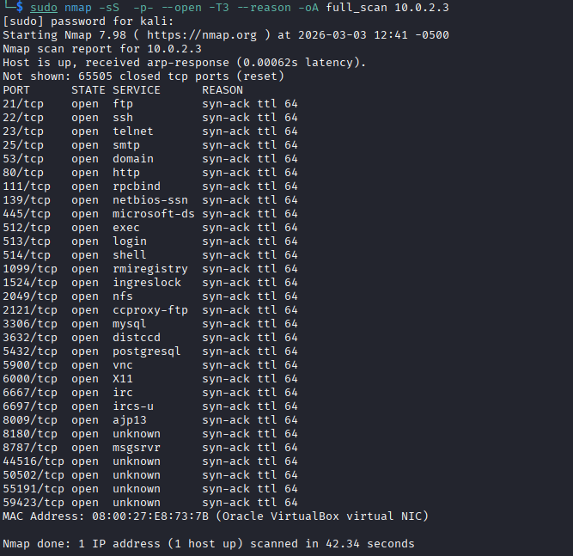

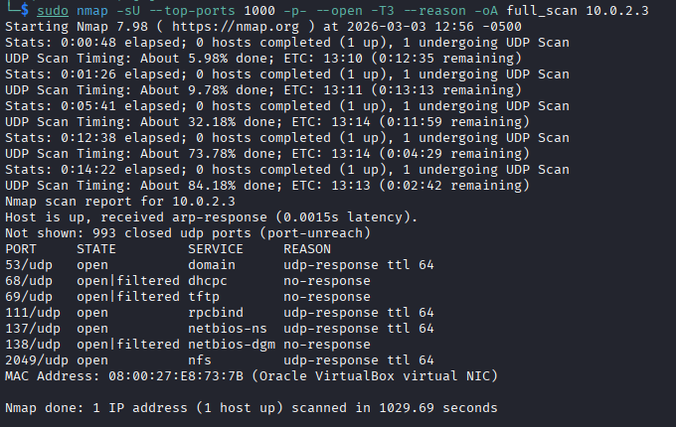

- Document every open TCP and UDP port with its reason (RST, SYN-ACK, etc.)
Open TCP Ports:
Scan Results — All Open TCP Ports:
Port | State | Service | Reason
21/tcp | open | ftp | syn-ack ttl 64
22/tcp | open | ssh | syn-ack ttl 64
23/tcp | open | telnet | syn-ack ttl 64
25/tcp | open | smtp | syn-ack ttl 64
53/tcp | open | domain (DNS) | syn-ack ttl 64
80/tcp | open | http | syn-ack ttl 64
111/tcp | open | rpcbind | syn-ack ttl 64
139/tcp | open | netbios-ssn | syn-ack ttl 64
445/tcp | open | microsoft-ds (SMB) | syn-ack ttl 64
512/tcp | open | exec | syn-ack ttl 64
513/tcp | open | login | syn-ack ttl 64
514/tcp | open | shell | syn-ack ttl 64
1099/tcp | open | rmiregistry | syn-ack ttl 64
1524/tcp | open | ingreslock | syn-ack ttl 64
2049/tcp | open | nfs | syn-ack ttl 64
2121/tcp | open | ccproxy-ftp | syn-ack ttl 64
3306/tcp | open | mysql | syn-ack ttl 64
3632/tcp | open | distccd | syn-ack ttl 64
5432/tcp | open | postgresql | syn-ack ttl 64
5900/tcp | open | vnc | syn-ack ttl 64
6000/tcp | open | X11 | syn-ack ttl 64
6667/tcp | open | irc | syn-ack ttl 64
6697/tcp | open | ircs-u | syn-ack ttl 64
8009/tcp | open | ajp13 | syn-ack ttl 64
8180/tcp | open | unknown | syn-ack ttl 64
8787/tcp | open | msgsrvr | syn-ack ttl 64
44516/tcp | open | unknown | syn-ack ttl 64
50502/tcp | open | unknown | syn-ack ttl 64
55191/tcp | open | unknown | syn-ack ttl 64
59423/tcp | open | unknown | syn-ack ttl 64

Total: 30 open TCP ports

Open UDP Ports:

Port | State | Service | Reason
53/udp | open | domain (DNS) | udp-response ttl 64
68/udp | open|filtered | dhcp | no-response
69/udp | open|filtered | tftp | no-response
111/udp | open | rpcbind | udp-response ttl 64
137/udp | open | netbios-ns | udp-response ttl 64
138/udp | open|filtered | netbios-dgm | no-response
2049/udp | open | nfs | udp-response ttl 64

Total: 7 UDP ports found (3 confirmed open, 4 open|filtered)

- Identify and explain any filtered vs closed ports — what does the difference tell you?

The scan shows 1983 closed ports and 2 filtered ports:
State | Meaning | What it tells you
Closed | Port replied with RST | Host is reachable, no service is listening — but port is accessible
open|filtered | no-response | No reply received, either firewall blocking OR service present but not responding to probe
Filtered | No reply / ICMP unreachable | A firewall is silently dropping packets — can't determine if service exists

No filtered ports were discovered during this scan, indicating that this system is completely unprotected by a firewall. A direct answer was obtained for each port probe.

65,505 closed ports: these replied with RST packets meaning the host is reachable but no service is listening on those ports.
993 closed UDP ports all replied with ICMP port-unreachable messages, confirming the host is reachable and those ports are genuinely empty.

- Aggressive Service & Version Fingerprinting — Go beyond -sV:
nmap -sV --version-intensity 9 -p <open_ports> <target-ip>
Aggressive Service & Version Fingerprinting
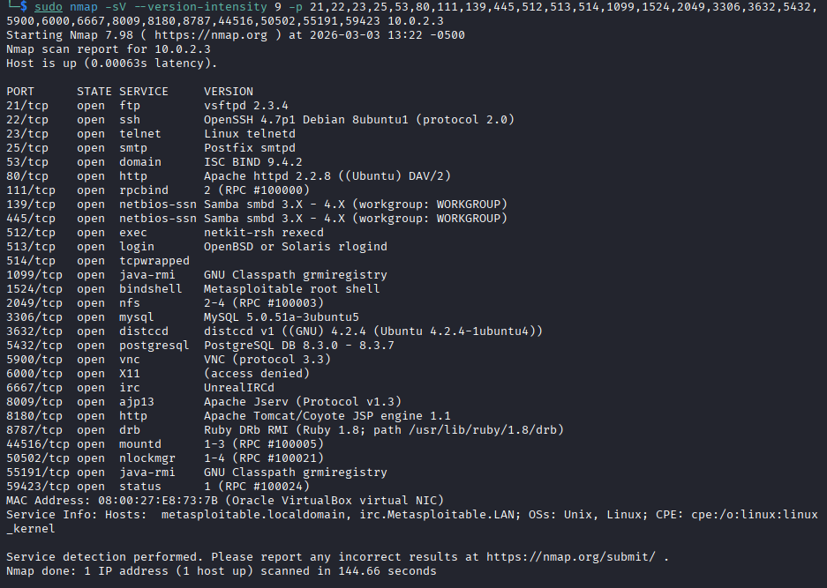

- For each discovered service: record the exact version string, compare it against the NVD (nvd.nist.gov) and document at least one known CVE per service if one exists.

Discovered Services & CVE Analysis:
Port/Service | Version Detected | Risk Level | CVE | Potential Exploit
21/tcp FTP | vsftpd 2.3.4 | Critical | CVE-2011-2523 CVSS: 10.0 | Backdoor triggered by smiley face in username, opens root shell on port 6200 with zero authentication
22/tcp SSH | OpenSSH 4.7p1 Debian 8ubuntu1 | Medium | CVE-2008-5161 CVSS: 2.6 | CBC mode cipher allows partial plaintext recovery from encrypted session
23/tcp Telnet | Linux telnetd | High | No CVE needed | Protocol transmits ALL data including passwords in plaintext, trivial credential theft via packet capture
25/tcp SMTP | Postfix smtpd | Medium | CVE-2008-2937 CVSS: 4.4 | Open relay possible, can send spam/phishing emails through server
53/tcp DNS | ISC BIND 9.4.2 | High | CVE-2008-1447 CVSS: 5.0 | DNS cache poisoning (Kaminsky attack), redirects traffic to malicious servers
80/tcp HTTP | Apache httpd 2.2.8 Ubuntu DAV/2 | High | CVE-2007-6750 CVSS: 5.0 | WebDAV enabled, arbitrary file upload possible leading to web shell
111/tcp RPC | rpcbind 2 RPC#100000 | Medium | CVE-2017-8779 CVSS: 7.8 | RPC enumeration, exposes all RPC services, gateway to NFS attacks
139/tcp SMB | Samba smbd 3.X-4.X | Critical | CVE-2007-2447 CVSS: 10.0 | Username map script injection, unauthenticated remote root command execution
445/tcp SMB | Samba smbd 3.X-4.X | Critical | CVE-2007-2447 CVSS: 10.0 | Same as port 139, Samba command injection via SMB authentication
512/tcp EXEC | netkit-rsh rexecd | Critical | No CVE | r-services trust authentication, IP spoofing bypasses all authentication
513/tcp LOGIN | rlogind | Critical | No CVE | rlogin trust-based auth, .rhosts file allows passwordless login from trusted hosts
514/tcp SHELL | tcpwrapped | Critical | No CVE | rsh sends commands with no encryption and no strong authentication
1099/tcp RMI | GNU Classpath grmiregistry | Medium | CVE-2011-3556 CVSS: 7.5 | Java RMI registry exposed, remote class loading leads to arbitrary code execution
1524/tcp SHELL | Metasploitable root shell | Critical | Intentional Backdoor CVSS: 10.0 | Direct root bindshell, nc 10.0.2.3 1524 gives instant root shell, zero authentication
2049/tcp NFS | NFS 2-4 RPC#100003 | High | CVE-2004-0230 CVSS: 5.0 | Filesystem exported to everyone, mount and read/write any file including /etc/shadow
3306/tcp MySQL | MySQL 5.0.51a-3ubuntu5 | High | CVE-2008-0226 CVSS: 7.5 | Blank root password, complete database access from any host with no credentials
3632/tcp DISTCC | distccd v1 GNU 4.2.4 | High | CVE-2004-2687 CVSS: 9.3 | Unauthenticated remote code execution via malicious compiler job submission
5432/tcp PostgreSQL | PostgreSQL 8.3.0-8.3.7 | Medium | CVE-2013-1903 CVSS: 7.2 | Default credentials postgres:postgres, database access and command execution via COPY
5900/tcp VNC | VNC protocol 3.3 | Critical | CVE-2006-2369 CVSS: 7.5 | Weak challenge-response auth cryptographically broken, password is "password"
6000/tcp X11 | access denied | High | CVE-1999-0526 CVSS: 7.5 | Remote keystroke capture, screenshot theft, mouse/keyboard injection
6667/tcp IRC | UnrealIRCd | Critical | CVE-2010-2075 CVSS: 10.0 | Intentional backdoor, sending AB; prefix executes arbitrary OS commands instantly
8009/tcp AJP | Apache Jserv v1.3 | High | CVE-2020-1938 CVSS: 9.8 | Ghostcat, reads any file from web application including config files with credentials
8180/tcp HTTP | Apache Tomcat 5.5 | High | CVE-2009-3548 CVSS: 7.5 | Default credentials tomcat:tomcat, deploy malicious WAR file for remote code execution
8787/tcp DRb | Ruby DRb RMI Ruby 1.8 | High | No CVE | Unauthenticated Ruby code execution, any client can invoke arbitrary Ruby methods remotely
44516/tcp | mountd 1-3 RPC#100005 | Medium | CVE-2017-8779 CVSS: 7.8 | NFS mount daemon, confirms NFS exports accessible to any host
50502/tcp | nlockmgr 1-4 RPC#100021 | Low | Informational | NFS lock manager, exposes NFS infrastructure details
55191/tcp | java-rmi grmiregistry | Medium | CVE-2011-3556 CVSS: 7.5 | Secondary Java RMI registry, same risk as port 1099
59423/tcp | status RPC#100024 | Low | Informational | RPC status service, leaks internal RPC service information

Risk Level Summary:
Risk Level | Count | Ports
Critical | 8 | 21, 139, 445, 512, 513, 514, 1524, 6667
High | 11 | 23, 53, 80, 2049, 3306, 3632, 6000, 8009, 8180, 8787, 5900
Medium | 6 | 22, 25, 111, 1099, 5432, 44516
Low | 2 | 50502, 59423
Total | 27 | Massive attack surface

- Explain the difference between --version-intensity levels 0–9 and why intensity affects accuracy vs noise.
Nmap uses its nmap-service-probes database to send probes when it finds a service, then compares the replies to predefined patterns. A rarity score (1–9) is assigned to each probe. Nmap determines which probes to send based on the intensity level:
lower intensity = only common probes
higher intensity = all probes, even rare ones.

Level-by-Level Breakdown
Level | Name | Probes Sent | Accuracy | Noise/Time | Best Used When
0 | Lightest | Only rarity-1 probes (most common matches) | Very Low | Minimal | Only need basic service names, speed is critical
1 |  | Rarity 1–2 probes | Low | Very Low | Quick reconnaissance, low interaction needed
2 |  | Rarity 1–3 probes | Low-Medium | Low | Faster scans on well-known services
3 |  | Rarity 1–4 probes | Medium | Low-Medium | Standard internal audits
4 |  | Rarity 1–5 probes | Medium | Medium | Balanced general scanning
5 | Default | Rarity 1–5 probes (optimized) | Good | Moderate | Everyday scans -sV without specifying intensity uses this
6 |  | Rarity 1–6 probes | Better | Medium-High | When default misses a service
7 |  | Rarity 1–7 probes | High | High | Thorough audits on suspicious ports
8 |  | Rarity 1–8 probes | Very High | Very High | Near-complete fingerprinting
9 | Maximum | ALL probes (rarity 1–9) | Maximum | Maximum | CTFs, lab work, when exact version is critical

- OS & Device Fingerprinting — Perform OS detection with full detail:
nmap -O --osscan-guess --fuzzy <target-ip>
OS & Device Fingerprinting
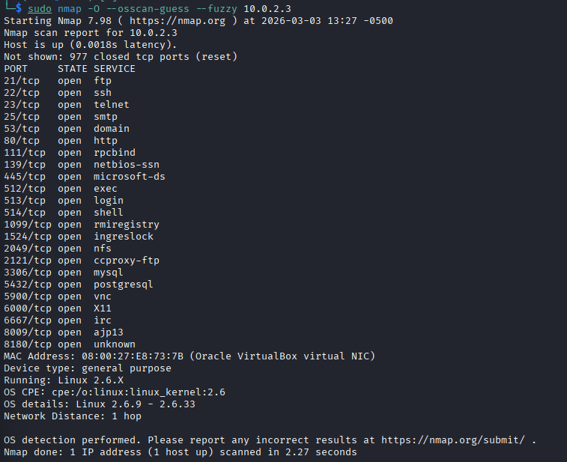

Scan Output Analysis:
Field | Value | Meaning
Device Type | General Purpose | Standard computer/server, not a router or printer
Running | Linux 2.6.X | Linux kernel family confirmed
OS CPE | cpe:/o:linux:linux_kernel:2.6 | Standardized identifier for Linux 2.6
OS Details | Linux 2.6.9 – 2.6.33 | Kernel version range matched
Network Distance | 1 hop | One router between Kali and target, normal for NAT Network setup
Latency | 0.0018s | Very low, both VMs on same host machine
MAC Address | 08:00:27:E8:73:7B | Oracle VirtualBox NIC confirmed

- Document the OS match percentage and what it means.
Linux kernel 2.6.9 – 2.6.33 was found by Nmap without the need for fuzzy guessing, indicating a clear and reliable match. Kernels from 2004 to 2010 are covered by the range 2.6.9 – 2.6.33, which is compatible with Metasploitable 2, which uses kernel 2.6.24 and is based on Ubuntu 8.04
Why this kernel is critical security finding:
CVE | Description | CVSS
CVE-2016-5195 | Dirty COW, local privilege escalation | 7.8
CVE-2010-3333 | Remote kernel exploit | 9.3
CVE-2012-0056 | /proc/pid/mem privilege escalation | 6.9
CVE-2009-1185 | udev local privilege escalation | 7.2

- Explain how Nmap performs TCP/IP stack fingerprinting — what probes does it send and what fields does it analyze?
- TTL Value = 64:
All packets from target arrived with TTL=64, the default for Linux kernels. This immediately identifies the OS family as Linux/Unix.
- TCP SEQ Probes:
Nmap sent 6 SYN packets to open port 21 and analyzed the TCP Initial Sequence Numbers returned. Linux 2.6.x uses a specific time-based ISN generation algorithm that differs from Windows and BSD implementations.
- TCP Window Size:
Linux 2.6.x uses characteristic TCP receive window sizes in SYN-ACK responses. The specific window size value matched the 2.6.x fingerprint range in Nmap's database.
- TCP Options Ordering:
The order of TCP options (MSS SACK Timestamps NOP Window Scale) in SYN-ACK packets is OS-specific. Linux 2.6.x has a known consistent ordering that Nmap matched precisely.
- ICMP Response Analysis:
Nmap sent ICMP echo requests with unusual TOS and TTL values. The way Linux 2.6.x formats ICMP replies including which header fields it copies from the request matched known fingerprints.
- RST Packet Structure:
Nmap probed closed ports and analyzed the RST packets returned. The IP ID value, DF bit setting, and RST packet formatting confirmed Linux 2.6.x behavior.
- Packet-Level Verification (Defender Perspective) — While running any one of the above scans, capture traffic simultaneously in Wireshark.
- Show the raw packets (SYN, RST, ICMP unreachable, etc.) and correlate them with the Nmap output.
Packet-Level Verificatio
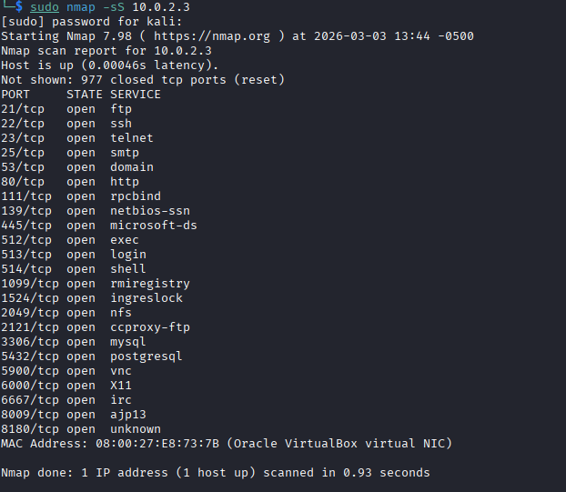

Wireshark Packet Capturing
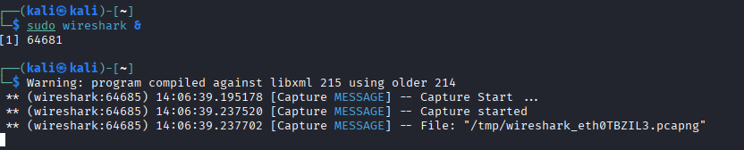

Wireshark Packet Capturing
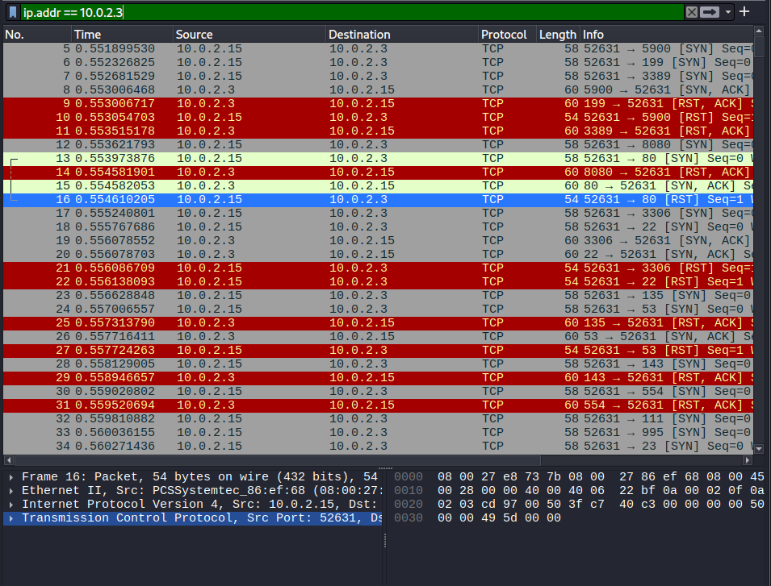

SYN-ACK
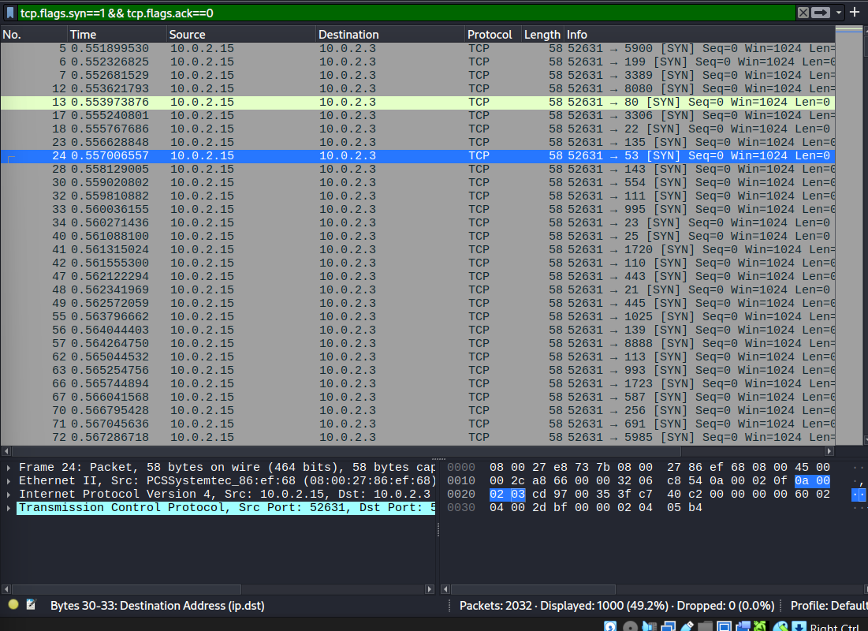

RST
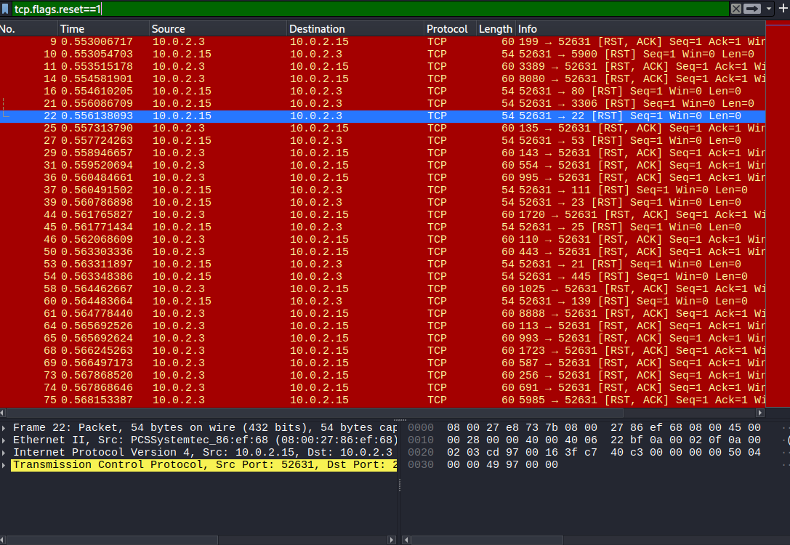

ICMP unreachable
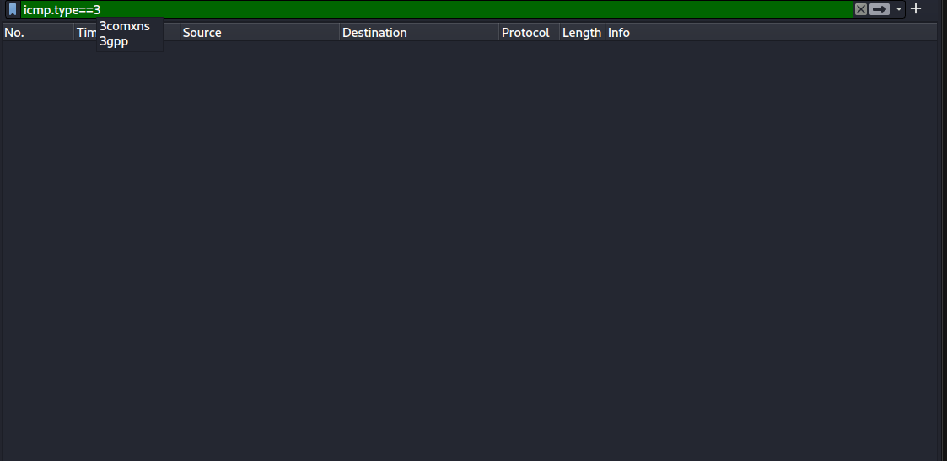

Critical Nmap Signatures visible in every packet:

Field | Value | Significance
Win=1024 | Every single SYN packet | Nmap's hardcoded default window size, dead giveaway
Seq=0 | Every single SYN packet | Nmap uses 0 as initial sequence number
Len=0 | Every single SYN packet | No data payload, pure probe packets
Same source port 52631 | All packets | Nmap reuses source port across probes
Speed | Multiple packets per millisecond | Impossible for human/normal traffic

- Answer: What would an IDS see? What signatures would trigger? What would a blue team analyst conclude from this traffic?

What an IDS Would See:

IDS Rule | Trigger | Evidence from Wireshark
ET SCAN NMAP SYN | Win=1024 on SYN packets | Every SYN shows Win=1024
GPL SCAN Nmap TCP | Seq=0 on all probes | Every packet shows Seq=0
ET SCAN Rapid Port Scan | 1000+ ports per second | Packets 5,6,7 within same millisecond
ET SCAN Potential VNC Scan | SYN to port 5900 | Packet 5: 5900 SYN
ET SCAN Potential MySQL Scan | SYN to port 3306 | Packet 17: 3306 SYN
ET SCAN Potential SSH Scan | SYN to port 22 | Packet 18: 22 SYN
ET SCAN Potential DNS Scan | SYN to port 53 | Packet 24: 53 SYN
No Firewall Detected | Zero ICMP type 3 | ICMP filter returned empty
Likewise there are multiple potential ET SCAN which IDS can see.

Blue Team Analyst:
From Wireshark evidence:

Tool Identified: Nmap (Win=1024 + Seq=0 signature)
Scan Type: SYN Stealth Scan (-sS)
Attacker IP: 10.0.2.15
Target IP: 10.0.2.3
Total Packets: 2032
Firewall Status: NONE (zero ICMP unreachable)
Open Ports Found: 30 (confirmed by SYN-ACK packets)
Closed Ports: 65,505 (confirmed by RST packets)

NSE Scripting, Evasion & Reporting
Question 2 (6 Points)
An advanced penetration tester does not rely solely on default Nmap output. In this question you will use Nmap Scripting Engine (NSE) for targeted enumeration, attempt evasion techniques, and write a custom NSE script. Finally, you will produce a professional findings report.

- Targeted NSE Enumeration — Run at least four of the following NSE script categories against the target, documenting findings for each:
- vuln: nmap --script vuln -p <ports> <target-ip>
NSE Scripting
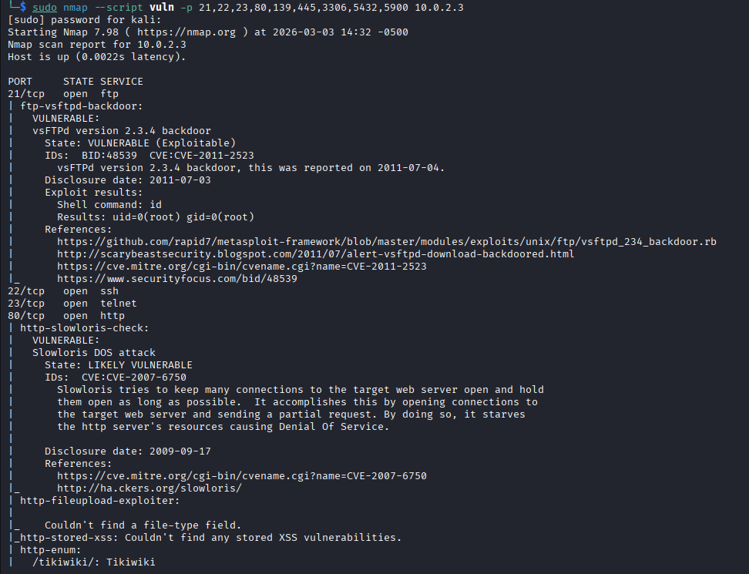
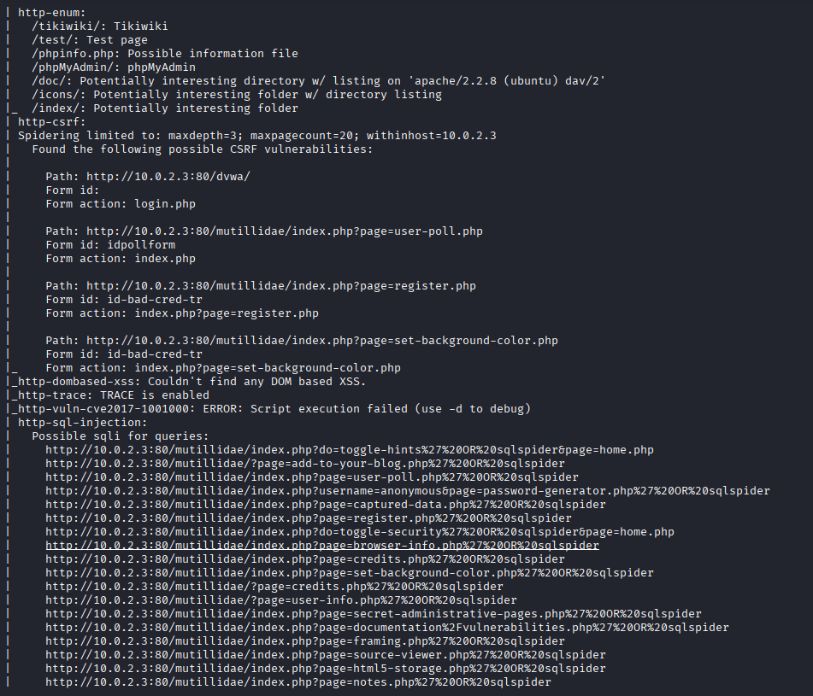
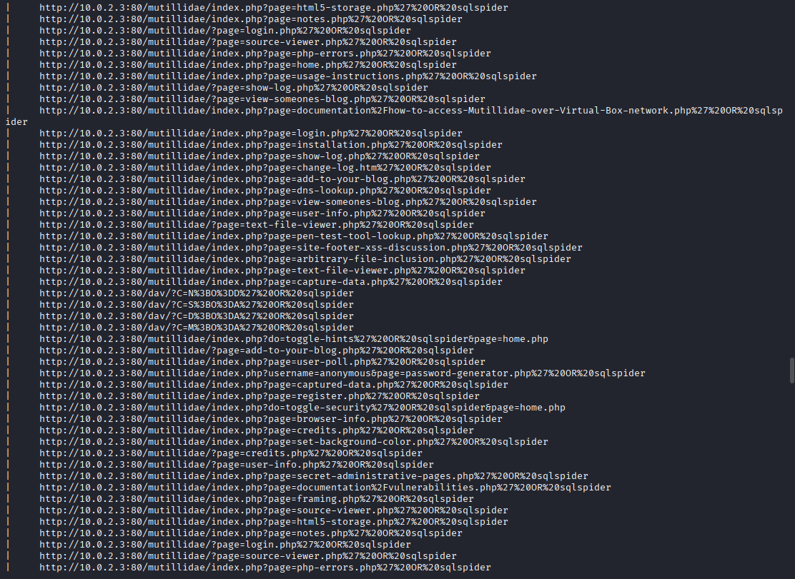
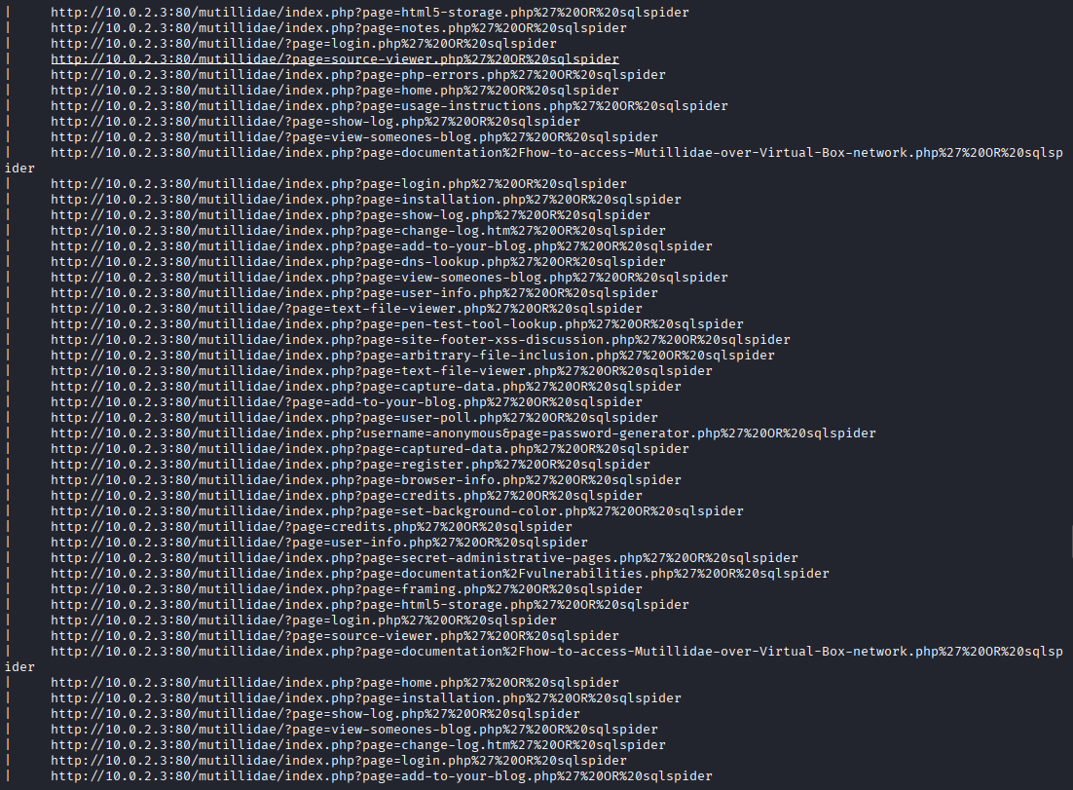
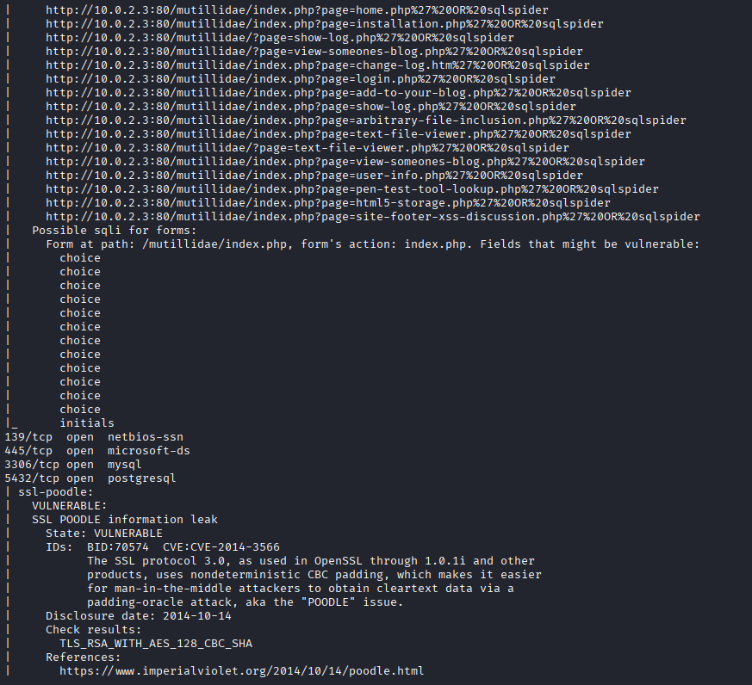
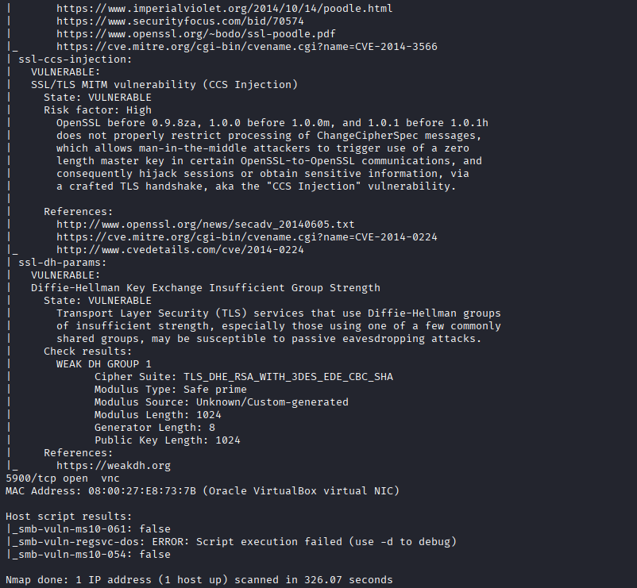

- auth: nmap --script auth -p <ports> <target-ip> (check for default/empty credentials)

Auth
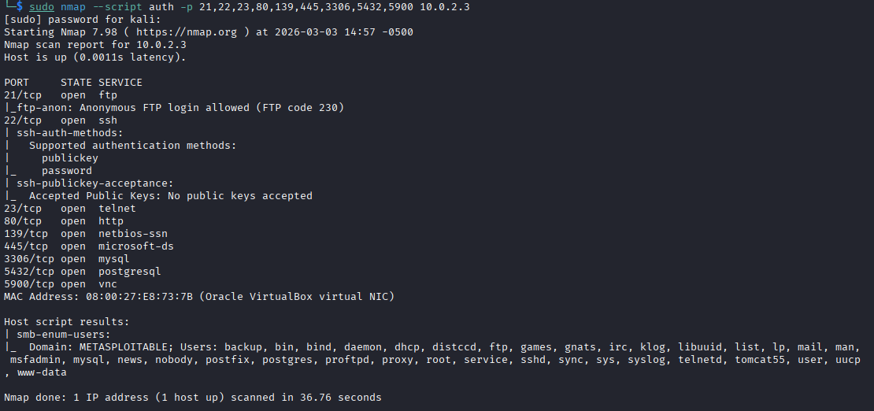

- brute: nmap --script ftp-brute or ssh-brute (document results, do NOT brute-force aggressively)
Brute Force
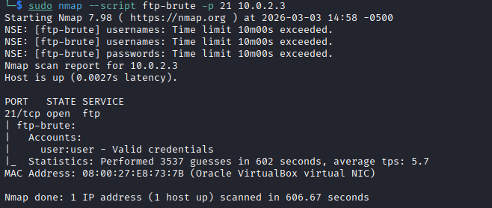

- exploit (safe only): nmap --script exploit --script-args=unsafe=0
exploit (safe only):
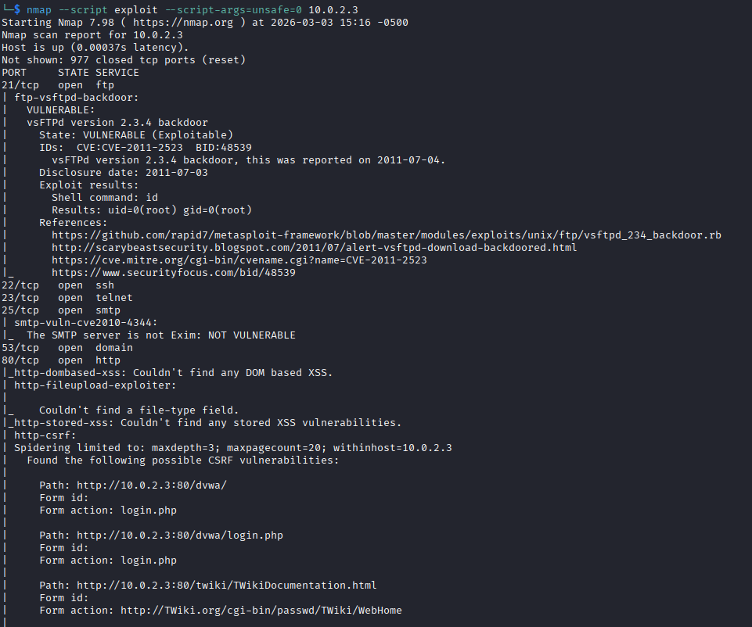
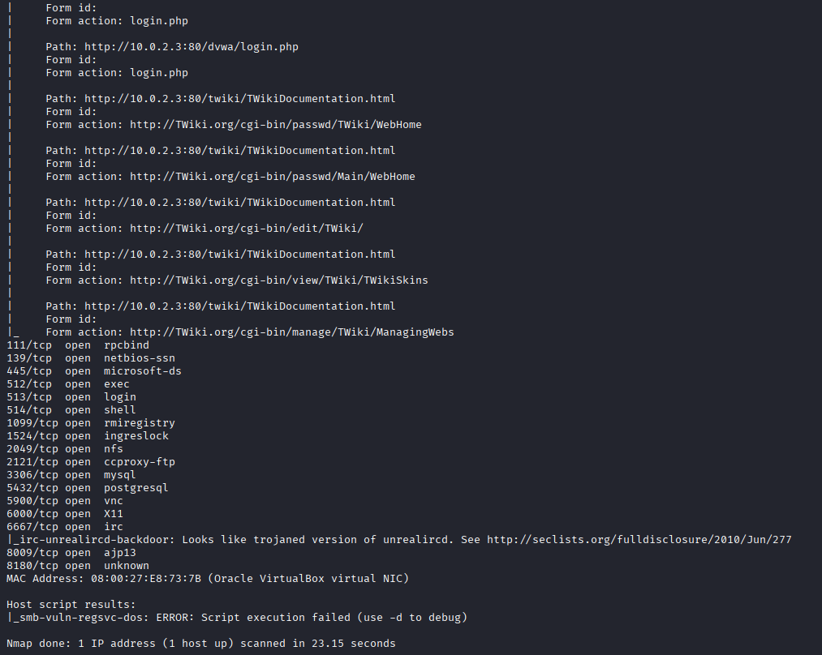

- discovery: nmap --script discovery <target-ip> (SNMP, SMB, DNS enumeration)
Explanation
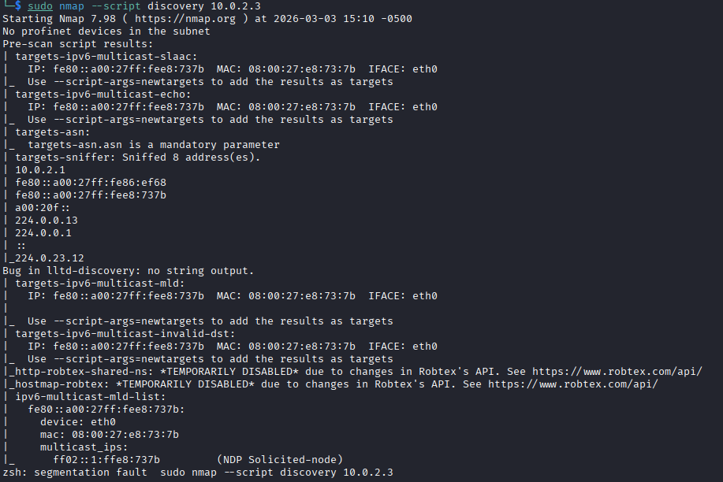

- smb-*: nmap --script smb-enum-shares,smb-enum-users,smb-os-discovery <target-ip>
smb
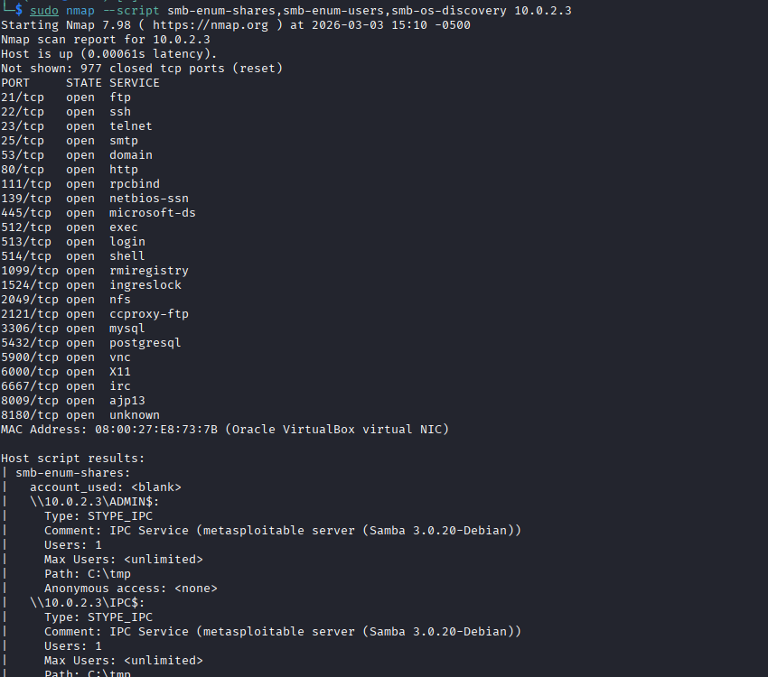
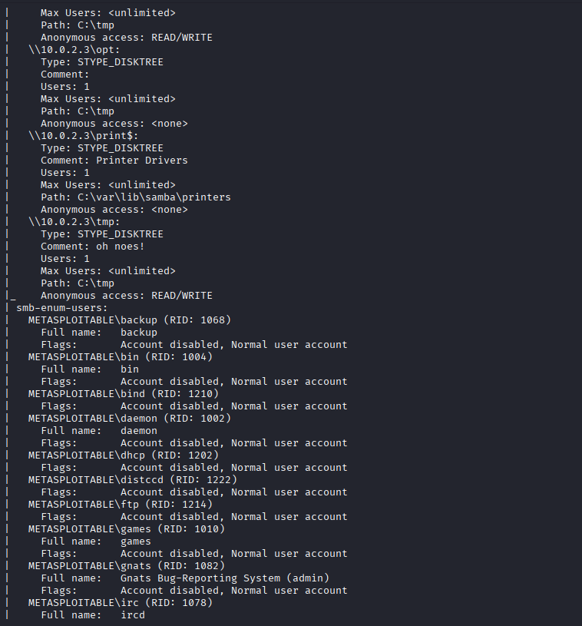
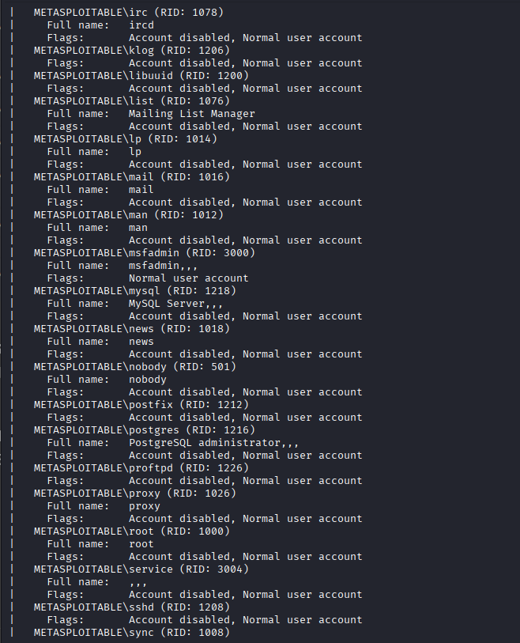
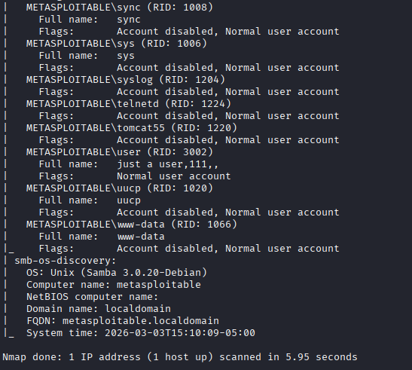

For each script run: show the command, screenshot the output, and write 3–4 sentences explaining what the script found and its security implication.

- Evasion Techniques — Perform the following evasion attempts and document whether they affect detection or scan results:

Base Normal Scan Capture

- Decoy scan: nmap -D RND:10 <target-ip> — Explain what decoys do at the packet level.

- Fragmentation: nmap -f --mtu 8 <target-ip> — What does packet fragmentation achieve against firewalls/IDS?

- Source port spoofing: nmap --source-port 53 <target-ip> — Why does this sometimes bypass firewalls?

Explanation
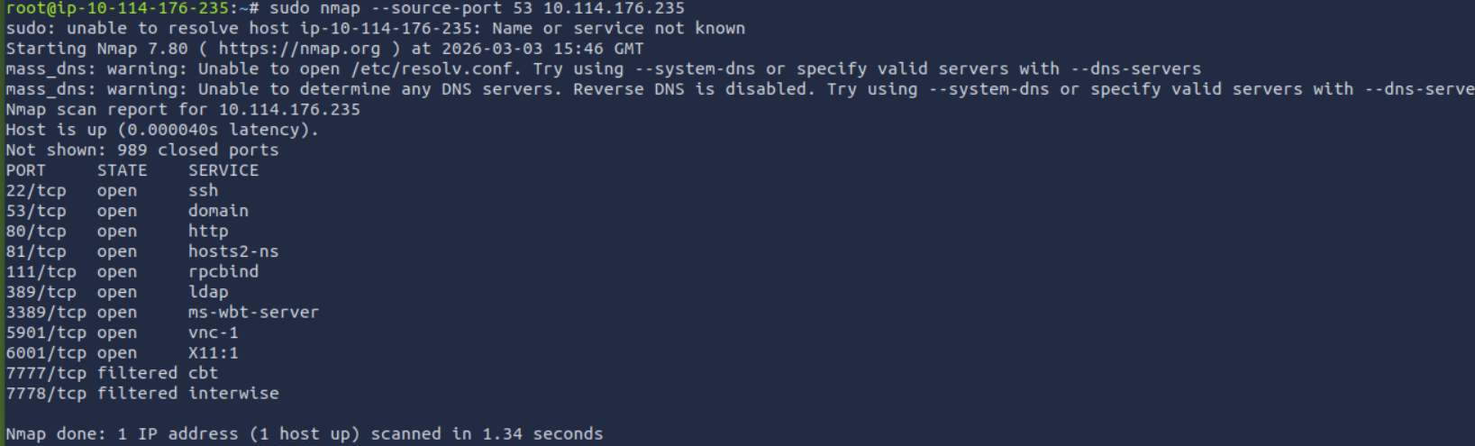

- Idle/Zombie scan: nmap -sI <zombie-ip> <target-ip> — Explain the mechanics of an idle scan. Why is it considered 'truly blind'?
Idle/Zombie scan
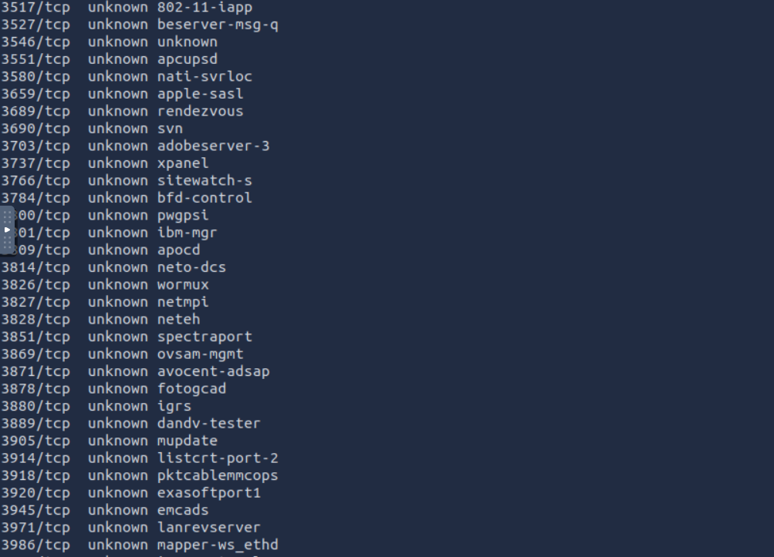
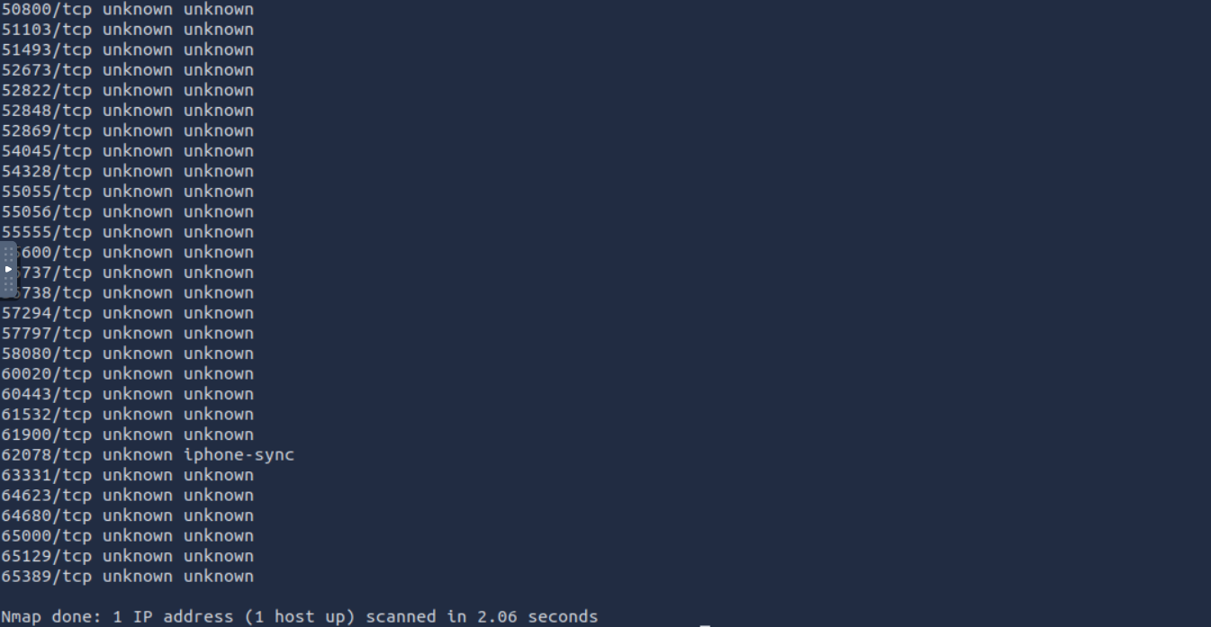

Note: For each technique, capture Wireshark output alongside the Nmap command and explain the difference in packets compared to a normal scan.

- Custom NSE 

