INFORMATION TECHNOLOGY UNIVERSITY
MS Cyber Security | System Security
LAB 10
MOBILE APPLICATION SECURITY

Submitted By | Eisha Nawaz
Roll No. | MSCS22007
Submitted To | Muhammad Shehryar Raza
Lab Phase | Phase 1 ,The Silent Reconnaissance
Analysis Tool | MobSF (Mobile Security Framework) on Docker
Analysis Type | Static Analysis (No Execution)

1. Executive Summary & Methodology
This Static Analysis Report (SAR) presents the findings of a comprehensive security audit conducted on four deliberately vulnerable Android applications: InjuredAndroid, DIVA, InsecureBankv2, and AndroGoat. The analysis was performed using Mobile Security Framework (MobSF) deployed via Docker, following a structured methodology without executing any application code.

1.1 Methodology
The static analysis followed a three-phase structured approach for each application:
- Blueprint Audit ,AndroidManifest.xml analysis for exported components, permissions, and backup settings.
- Code Analysis ,Scanning for hardcoded credentials, insecure URLs, and debug logging.
- Cryptography Audit ,Identifying use of deprecated or broken encryption algorithms.

1.2 Target Applications Summary
Application | Primary Focus | Risk Rating | Key Finding
DIVA | Data Storage | HIGH | Plaintext credential storage
InsecureBankv2 | Authentication | HIGH | Hardcoded server URL & weak crypto
InjuredAndroid | Logic Flaws | HIGH | Exported activities & intent leaks
AndroGoat | Permission Model | MEDIUM | Excessive permissions & insecure defaults

2. Environment Setup ,Launching MobSF

2.1 Toolkit Checklist
- Workstation: Windows/macOS/Linux
- Analysis Engine: MobSF running on Docker (http://localhost:8000)
- Target APKs: InjuredAndroid, DIVA, AndroGoat, InsecureBankv2

2.2 MobSF Launch Command
docker run -it -p 8000:8000 opensecurity/mobsf:latest
Once MobSF launches, navigate to http://localhost:8000 in web browser. This serves as the Central Analysis Control Center for uploading and analyzing APK files.
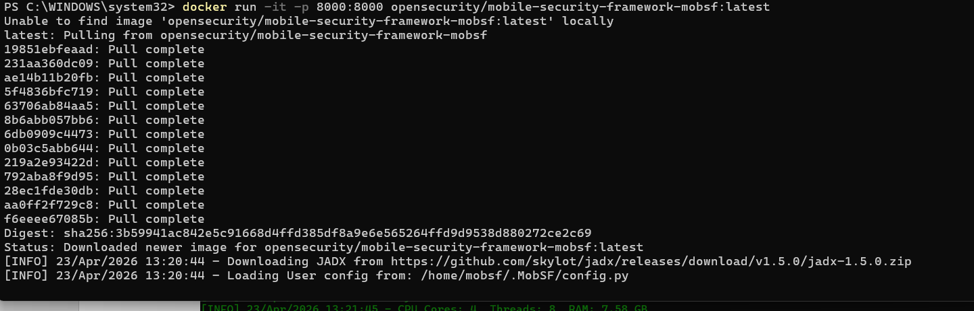
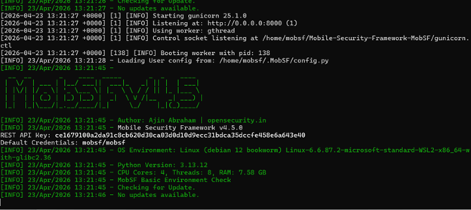
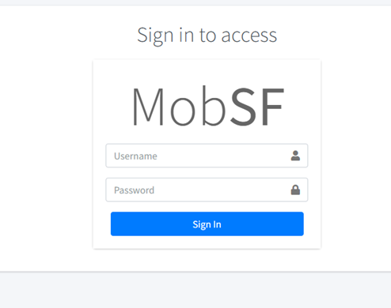
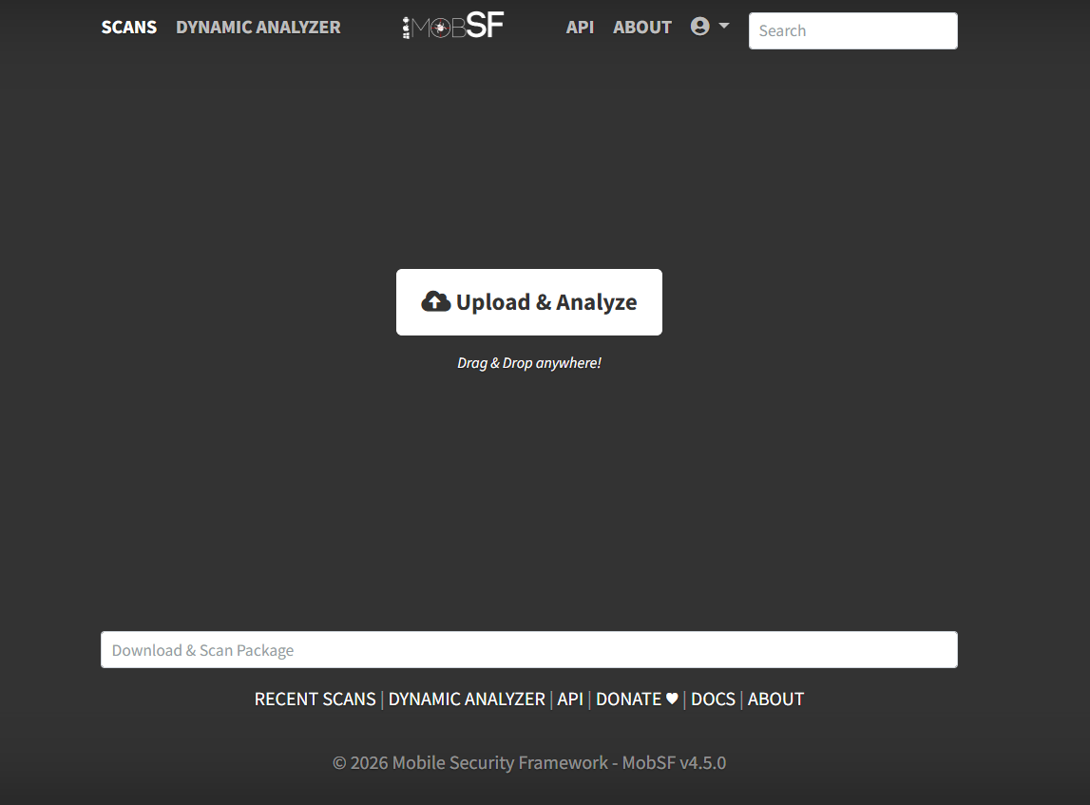

3. Target 1: InjuredAndroid (Logic Flaws)
InjuredAndroid is a deliberately vulnerable Android application designed to teach security concepts through hands-on flag-based challenges. The primary focus of this analysis is logic flaws, specifically exported activities and intent leaks that can allow unauthorized access to application components.
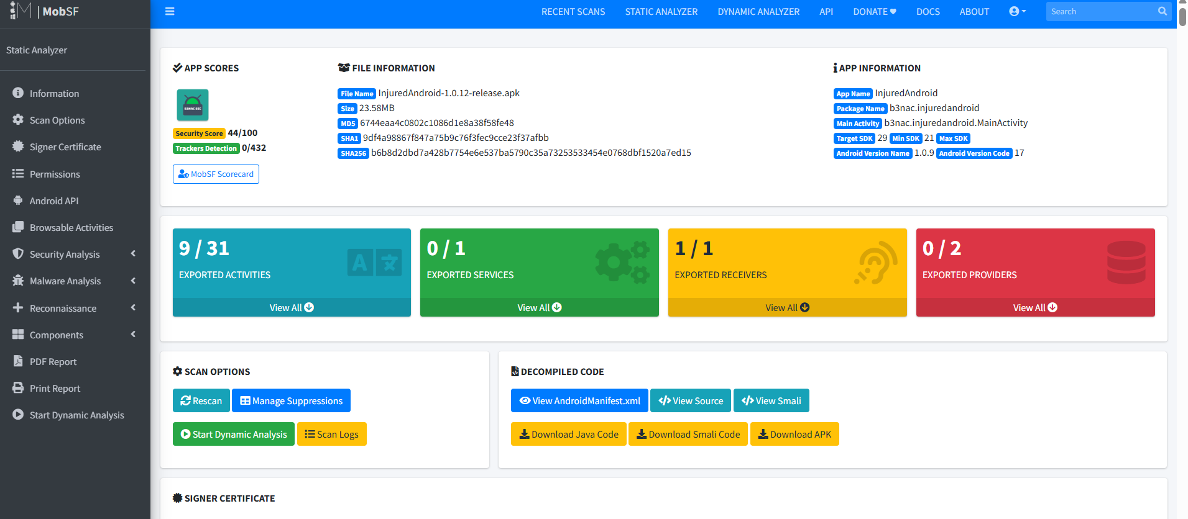

3.1 Step 1: Blueprint Audit (Manifest Analysis)
Navigating to the Manifest Analysis tab in MobSF for InjuredAndroid reveals critical misconfigurations. The AndroidManifest.xml exposes several dangerous attributes:

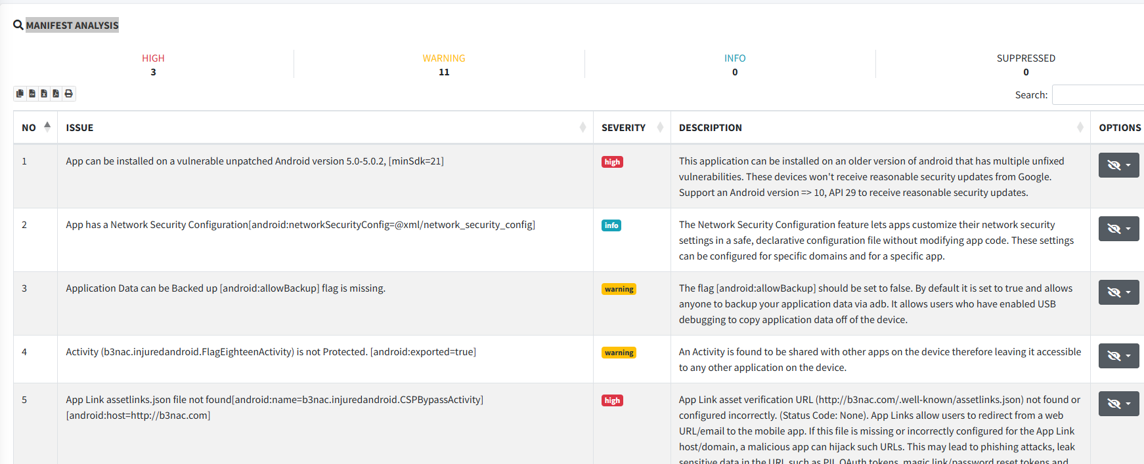

Permissions Identified:
- READ_EXTERNAL_STORAGE ,Allows the app to read files from external storage.
- WRITE_EXTERNAL_STORAGE ,Allows the app to write to external storage. Risk: Sensitive data could be written unencrypted to a world-readable location.
- READ_PHONE_STATE ,Grants access to device identifiers (IMEI, phone number). Risk: Enables device fingerprinting.

Exported Activities Identified:
android:exported="true" was found on multiple activities including flag challenge activities. This means any other application on the device can launch these activities directly without authentication, a classic Intent Hijacking vulnerability.
android:allowBackup="true" is also set, allowing an attacker with physical access and ADB to extract all application data without rooting the device.
VULNERABILITY | Exported Activity (Unauthorized Component Access
FILE / PATH | AndroidManifest.xml → Multiple Activity declarations
RISK LEVEL | HIGH
DESCRIPTION | Multiple activities are declared with android:exported='true' without any intent-filter requirement or permission check. This allows any third-party malicious app to invoke sensitive activities (e.g., login bypass, flag capture screens) directly via startActivity() without user consent or credentials.
RECOMMENDATION | Set android:exported='false' for all activities that are not intended to be accessed from external apps. If external access is required, implement signature-level permissions: android:permission='com.example.CUSTOM_PERMISSION'.
Evidence Snapshot:
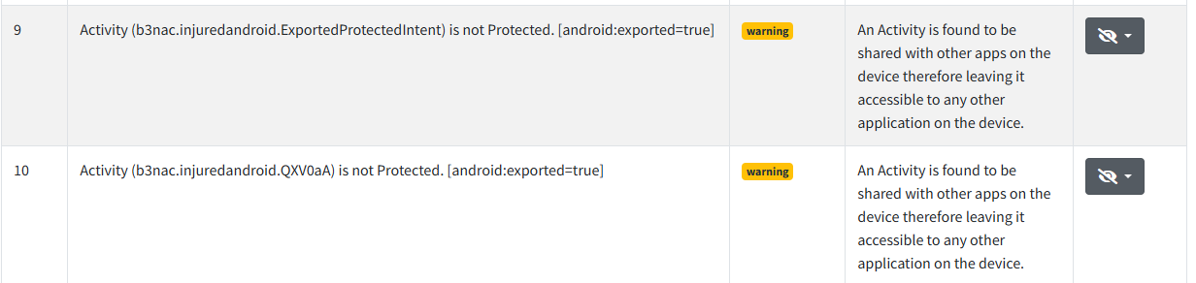
VULNERABILITY | Insecure Backup Enabled (android:allowBackup)
FILE / PATH | AndroidManifest.xml → <application> tag
RISK LEVEL | HIGH
DESCRIPTION | The android:allowBackup='true' attribute permits full application data extraction via ADB backup without root privileges. An attacker with physical access or via a malicious USB charger can run 'adb backup -apk com.b3nac.injuredandroid' and extract SharedPreferences, SQLite databases, and internal files containing flags and session tokens.
RECOMMENDATION | Set android:allowBackup='false' in the <application> tag. If backup is required for legitimate purposes, implement Android's Auto Backup with exclude rules using a backup_rules.xml file to exclude sensitive files.
Evidence Snapshot:

3.2 Step 2 ,Code Analysis
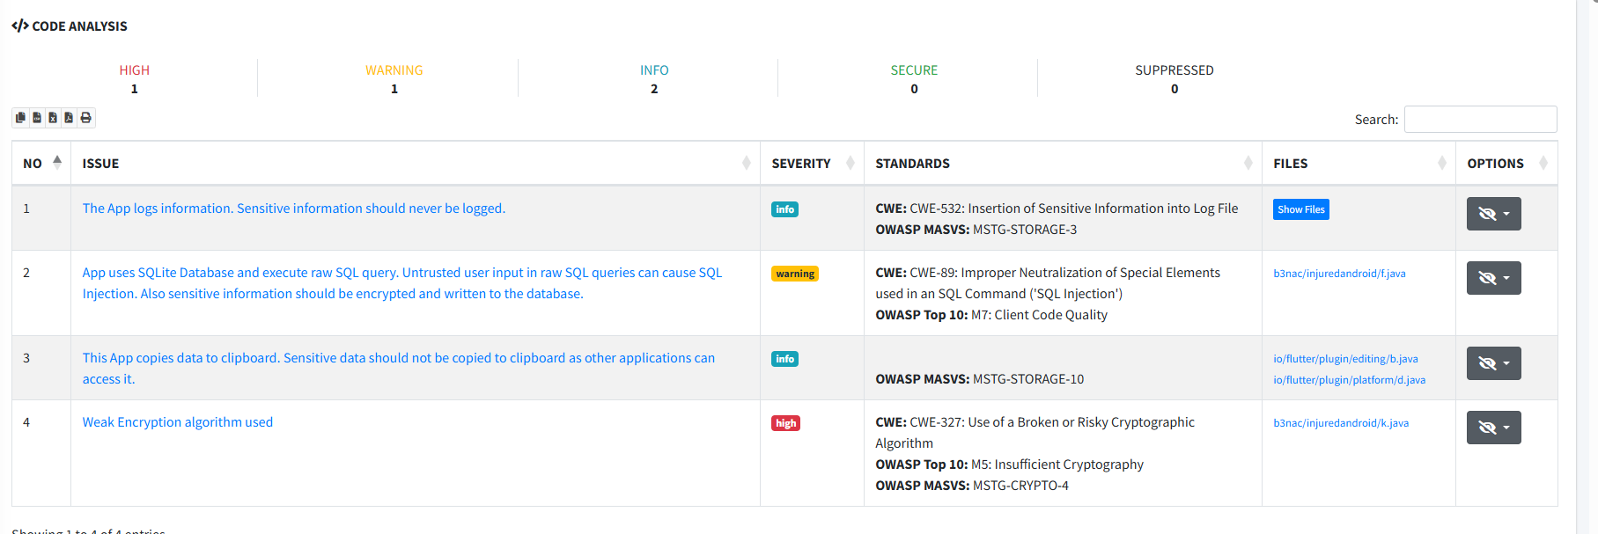
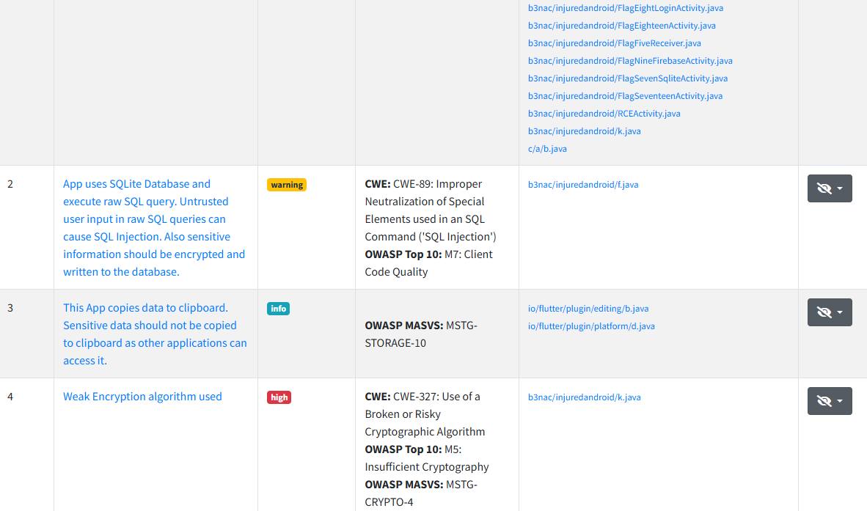
The Code Analysis tab in MobSF was used to search for hardcoded secrets, insecure URLs, and dangerous logging practices.
VULNERABILITY | Hardcoded Flags & Secret Strings
FILE / PATH | res/values/strings.xml, com/b3nac/injuredandroid/*.java
RISK LEVEL | HIGH
DESCRIPTION | MobSF's code analysis reveals hardcoded flag values and secret strings embedded directly in the application's resource files and Java source code. Keywords such as 'flag', 'secret', and 'token' appear in multiple source files. This allows a static analyst to extract all challenge answers without executing the application.
RECOMMENDATION | Never hardcode secrets, flags, or credentials in source code or resource files. Use Android Keystore System for storing sensitive keys. For production apps, implement server-side validation and fetch secrets from a secure backend API using certificate pinning.
Evidence Snapshot:
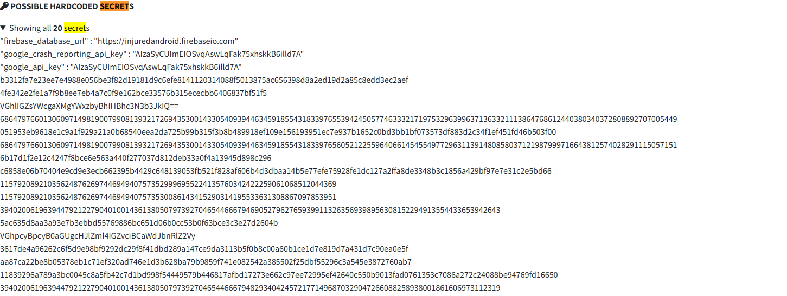
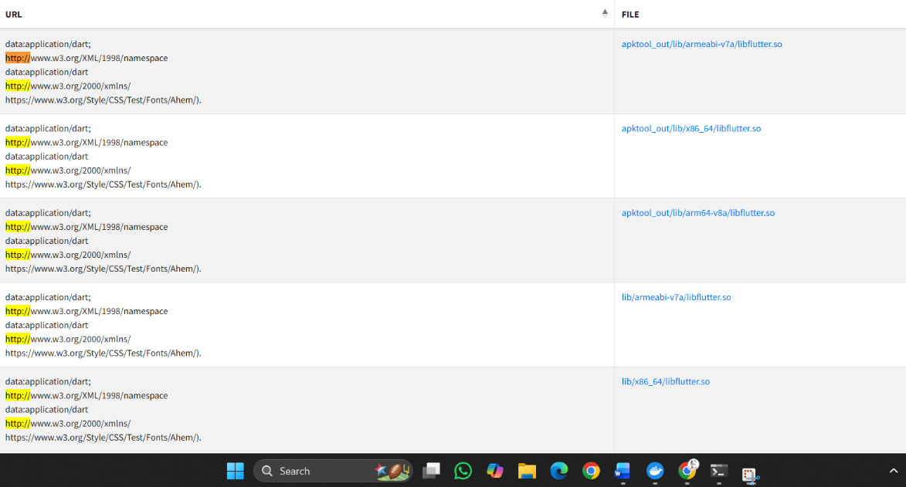
VULNERABILITY | No Log.d / Log.e Sensitive Logging ,POSITIVE FINDING
FILE / PATH | Application-wide code scan
RISK LEVEL | LOW
DESCRIPTION | The analysis confirms absence of Log.d() and Log.e() calls that expose sensitive data to Android logcat. This is a positive security control. However, this alone does not eliminate all information disclosure risks as other mechanisms (stack traces, crash reporters) may still leak data.
RECOMMENDATION | Continue ensuring no sensitive data is passed to any logging method. Implement ProGuard/R8 to strip all log calls in release builds using -assumenosideeffects for android.util.Log methods. Add CI pipeline checks to flag any new Log.* calls with sensitive parameters.
Evidence Snapshot:
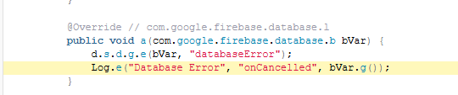
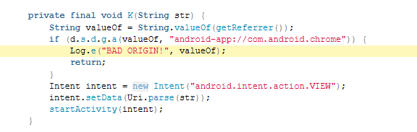
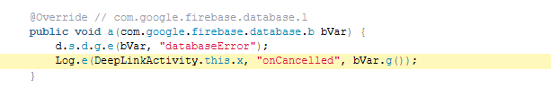

3.3 Step 3 ,Cryptography Audit
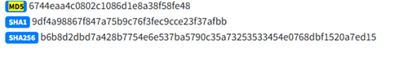
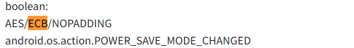
The cryptographic practices in InjuredAndroid were audited using MobSF's automated scanner:
VULNERABILITY | Use of Weak Cryptographic Algorithm (MD5/Base64 for Flags)
FILE / PATH | com/b3nac/injuredandroid/FlagThirteenActivity.java
RISK LEVEL | MEDIUM
DESCRIPTION | Some flag challenges in InjuredAndroid use Base64 encoding as an obfuscation mechanism and MD5 for hash-based flag verification. Base64 is encoding, not encryption, and provides zero security. MD5 is a broken hash function vulnerable to collision attacks and preimage attacks. Any attacker can reverse Base64 trivially and crack MD5 hashes using rainbow tables.
RECOMMENDATION | Replace MD5 with SHA-256 minimum or bcrypt/Argon2 for password hashing. Replace Base64 obfuscation with proper AES-256-GCM encryption. Never use encoding as a substitute for encryption. Audit all cryptographic usage using MobSF's findings and replace deprecated algorithms.

4. Target 2: DIVA (Insecure Data Storage)
DIVA (Damn Insecure and Vulnerable App) is specifically designed to showcase insecure data storage vulnerabilities, one of the most prevalent and dangerous issues in mobile security (OWASP Mobile Top 10: M2). As a security auditor, the objective is to identify all locations where credentials and sensitive data are stored without adequate protection.

4.1 Step 1: Blueprint Audit (Manifest Analysis)
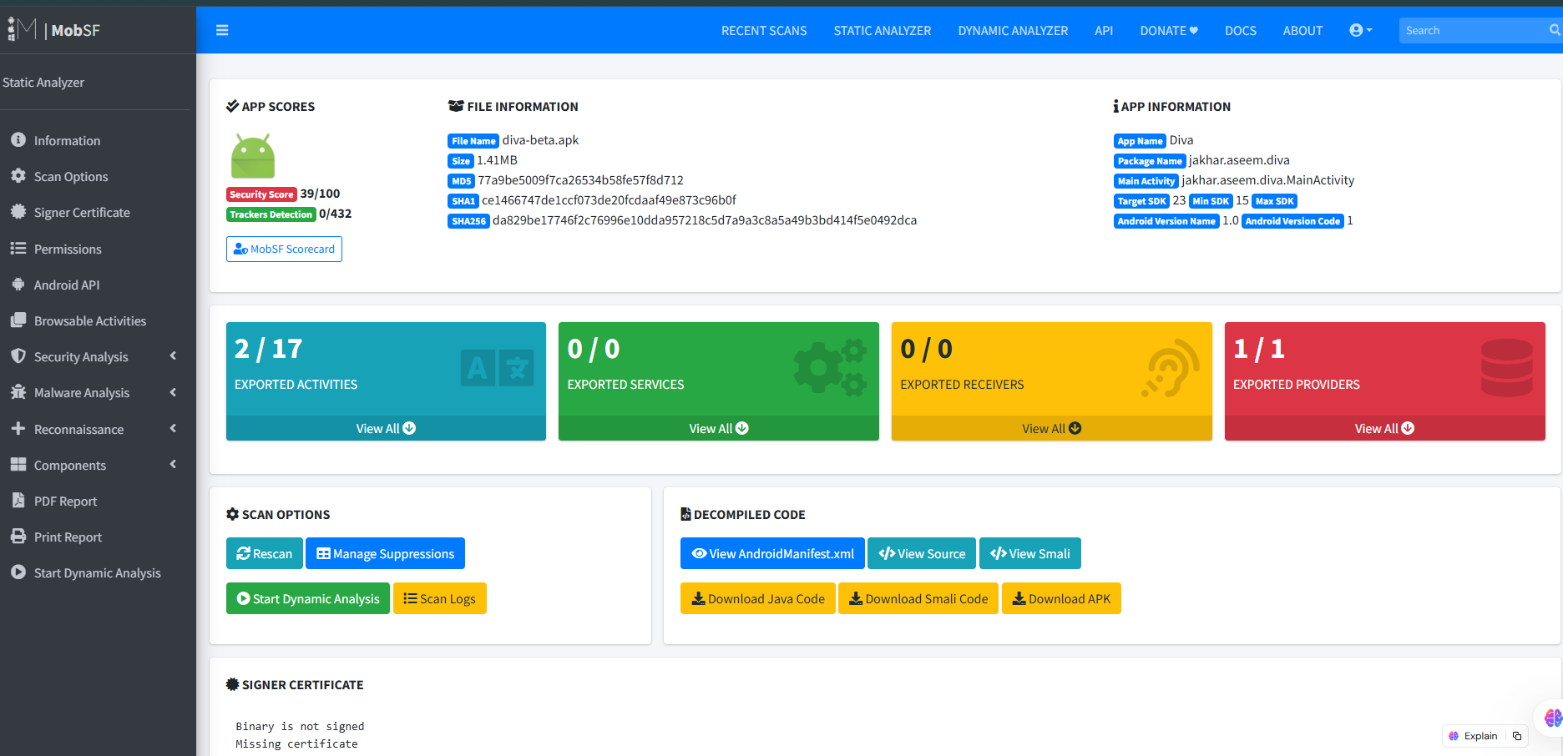
DIVA (MobSF Manifest Analysis Tab)
The DIVA manifest was analyzed for dangerous configurations:
VULNERABILITY | android:allowBackup='true', Full Data Extraction Risk
FILE / PATH | AndroidManifest.xml → <application android:allowBackup='true'>
RISK LEVEL | HIGH
DESCRIPTION | DIVA's application backup is enabled. Given that DIVA stores credentials in plaintext (SharedPreferences, SQLite, files), this backup setting compounds the data storage vulnerabilities significantly. An attacker can extract the entire app data directory, recovering all stored credentials without any encryption barrier.
RECOMMENDATION | Disable backup immediately: android:allowBackup='false'. If backup is needed, use Android's Auto Backup with exclusion rules to protect sensitive files. This is a defense-in-depth measure that prevents data loss even if storage vulnerabilities are later introduced.
Evidence Snapshot:
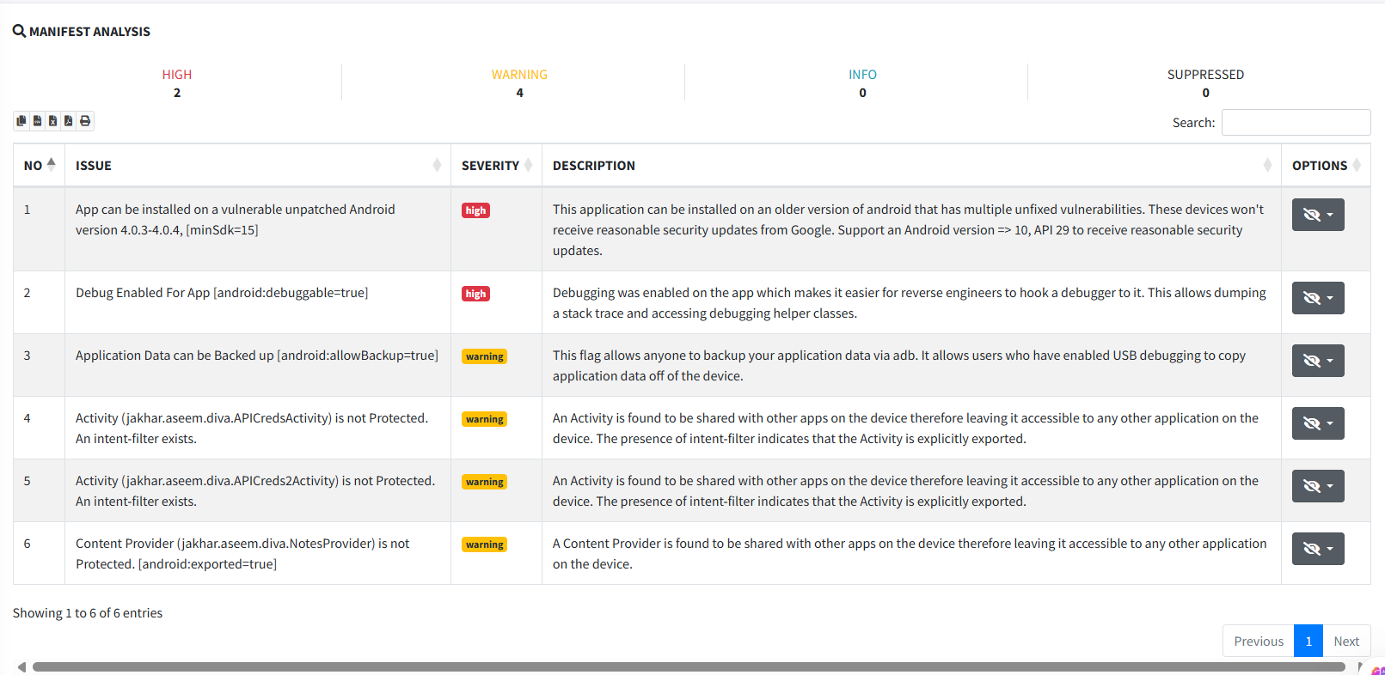
DIVA ,allowBackup vulnerability in Manifest Analysis

4.2 Step 2 ,Code Analysis (Insecure Storage Patterns)
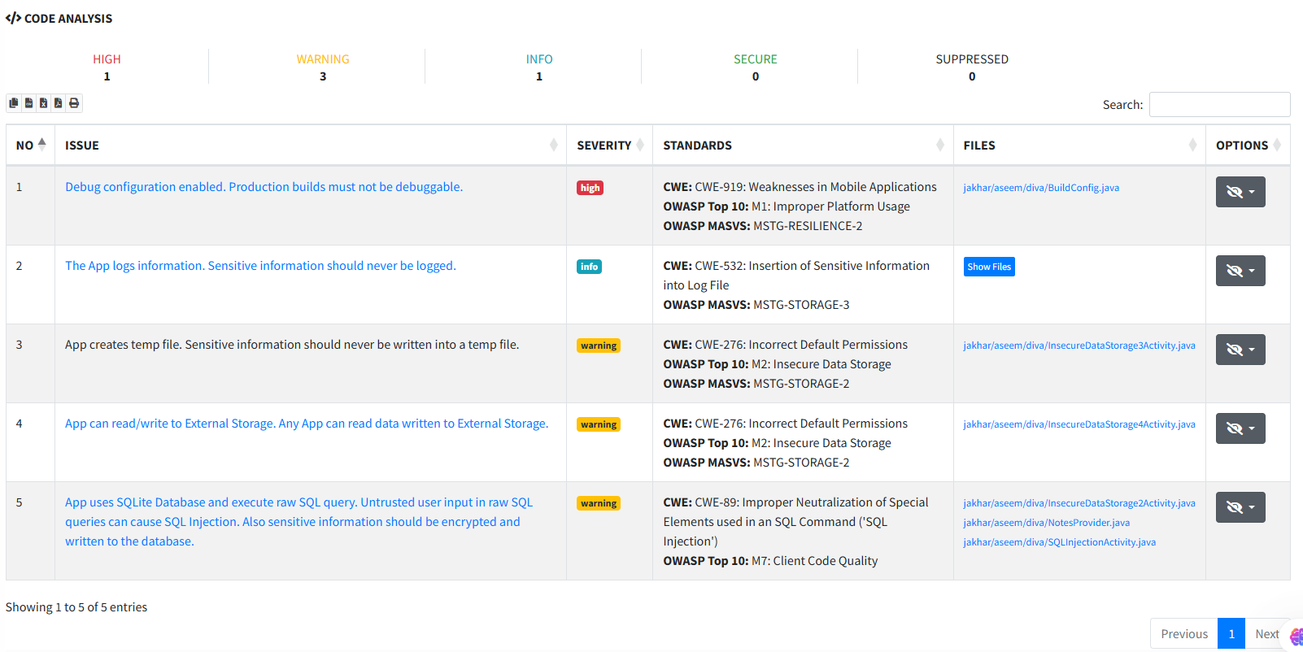
DIVA ,MobSF Code Analysis Tab showing storage vulnerabilities
The code analysis phase revealed DIVA's multiple approaches to insecure data storage:
VULNERABILITY | Credentials Stored in Plaintext SharedPreferences
FILE / PATH | com/payatu/diva/InsecureDataStorage1Activity.java
RISK LEVEL | HIGH
DESCRIPTION | Credentials (username and password) are stored directly in Android SharedPreferences without encryption using SharedPreferences.Editor.putString(). SharedPreferences are stored as XML files in /data/data/[package]/shared_prefs/ which are readable by any process with root access or via ADB backup. An attacker extracting this file gains immediate credential access.
RECOMMENDATION | Use Android's EncryptedSharedPreferences from the Jetpack Security library (androidx.security.crypto). This transparently encrypts all values using AES-256-GCM and encrypts keys using AES-256-SIV, protecting data even if the device storage is accessed directly.
Evidence Snapshot:
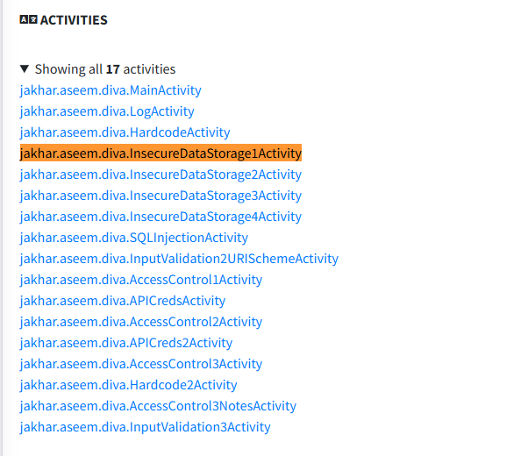
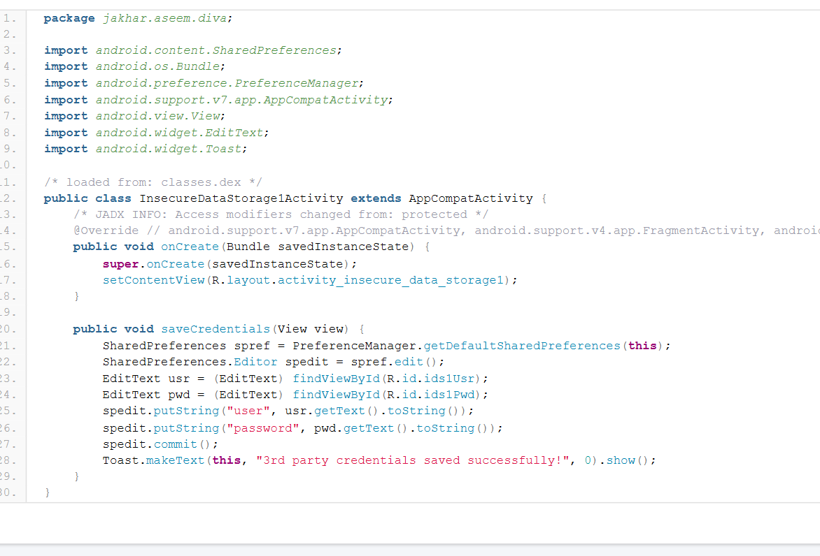
DIVA ,Plaintext SharedPreferences storage in Code Analysis

VULNERABILITY | Credentials Stored in Plaintext SQLite Database
FILE / PATH | com/payatu/diva/InsecureDataStorage2Activity.java
RISK LEVEL | HIGH
DESCRIPTION | User credentials are persisted in an unencrypted SQLite database created via openOrCreateDatabase() and stored at /data/data/jakhar.aseem.diva/databases/. The database has no encryption and can be directly opened with any SQLite browser after ADB extraction. This violates the principle of data minimization and secure storage.
RECOMMENDATION | Use SQLCipher for Android to encrypt the entire SQLite database with AES-256. Alternatively, encrypt sensitive fields before storage using the Android Keystore System. Apply principle of data minimization ,do not store passwords at all; store only bcrypt/Argon2 password hashes.
Evidence Snapshot:
DIVA ,Plaintext SQLite database storage in Code Analysis

VULNERABILITY | Sensitive Data Written to Plaintext File on External Storage
FILE / PATH | com/payatu/diva/InsecureDataStorage3Activity.java
RISK LEVEL | HIGH
DESCRIPTION | User credentials are written to a text file on external storage (/sdcard/) which is world-readable by any app with READ_EXTERNAL_STORAGE permission. This is the least secure storage location in Android. Any app on the device, or any user with cable access, can trivially read this file.
RECOMMENDATION | Never write sensitive data to external storage. Use internal storage (/data/data/) with MODE_PRIVATE and additionally encrypt the file using AES-256-GCM with a key stored in Android Keystore. For truly sensitive data, consider storing it only in memory during the session.
Evidence Snapshot:
DIVA ,External storage file write in Code Analysis

4.3 Step 3 ,Cryptography Audit
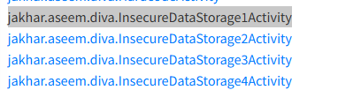
DIVA ,MobSF Cryptography Findings
VULNERABILITY | Absence of Encryption ,No Cryptographic Protection Applied
FILE / PATH | All InsecureDataStorage Activities
RISK LEVEL | HIGH
DESCRIPTION | Across all data storage implementations in DIVA, there is a complete absence of cryptographic protection. No encryption algorithm (strong or weak) is applied to credentials before storage. This represents the most severe category of data storage vulnerability ,data is stored in the clear, accessible to any party who can access the storage layer.
RECOMMENDATION | Implement a defense-in-depth data protection strategy: (1) Encrypt data at rest using AES-256-GCM via Android Keystore. (2) Use EncryptedSharedPreferences and SQLCipher. (3) Apply certificate pinning to protect data in transit. (4) Implement secure memory handling to prevent data from appearing in memory dumps.
Evidence Snapshot:
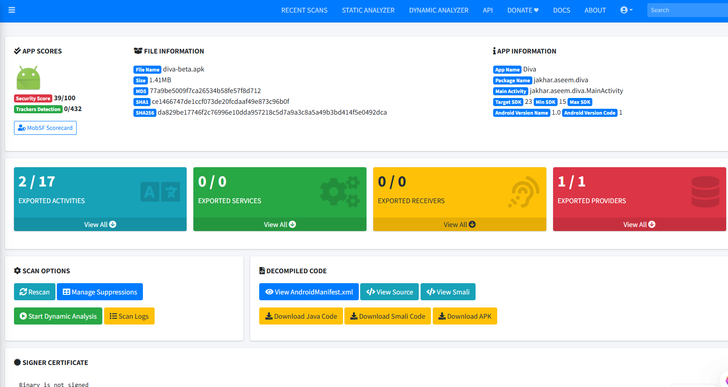
DIVA ,No encryption on stored credentials (MobSF overview)

5. Target 3: InsecureBankv2 ,Authentication Flaws
InsecureBankv2 is a deliberately vulnerable banking application that simulates real-world authentication vulnerabilities found in mobile banking apps. The audit focuses on identifying hardcoded server configurations, weak authentication logic, and cryptographic misuse that could allow account takeover.

5.1 Step 1 ,Blueprint Audit (Manifest Analysis)
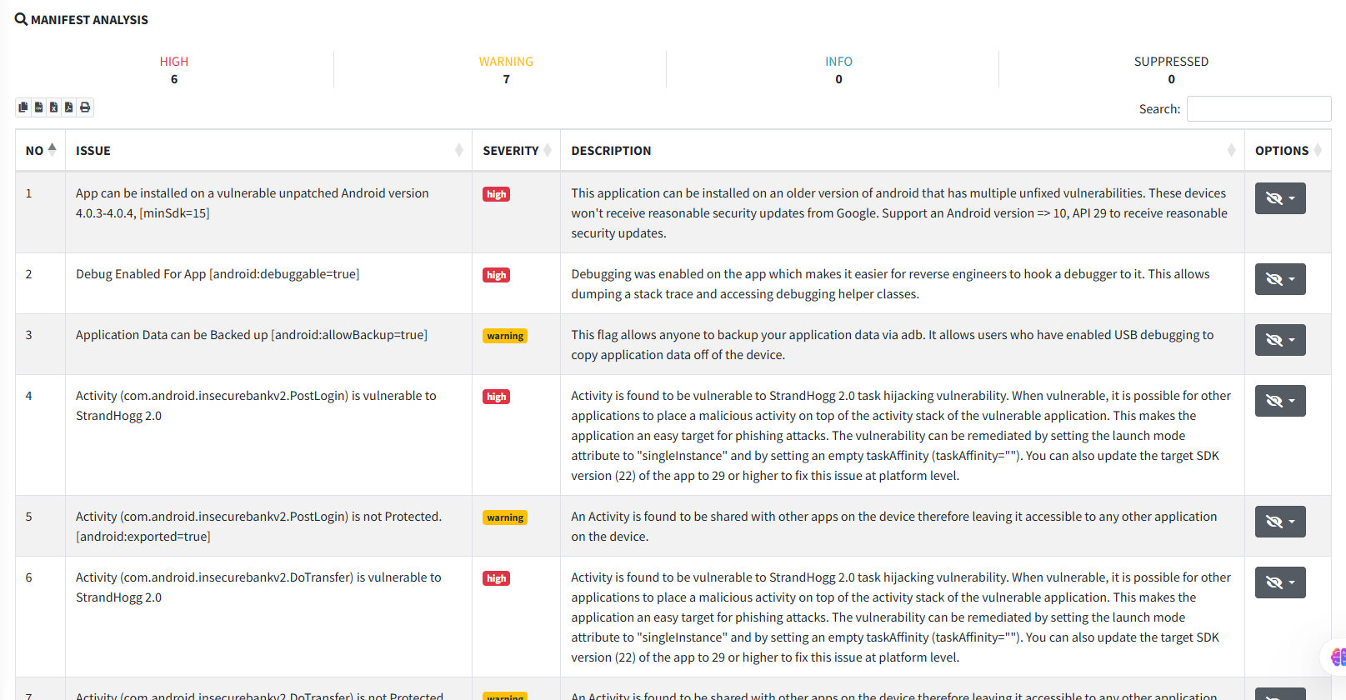
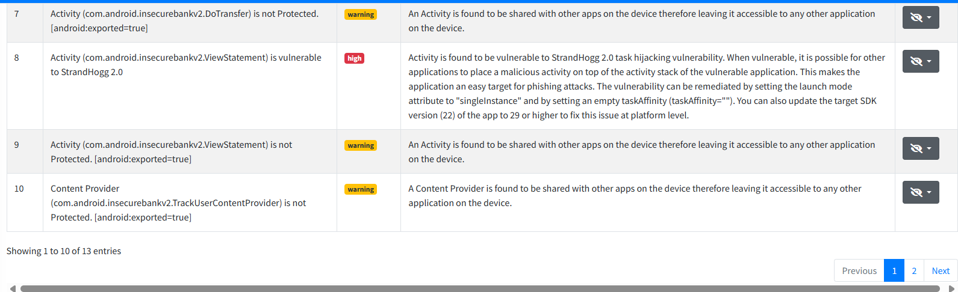
InsecureBankv2 ,MobSF Manifest Analysis Tab
VULNERABILITY | Exported Activity ,LoginActivity Accessible Without Authentication
FILE / PATH | AndroidManifest.xml → com.android.insecurebankv2.LoginActivity
RISK LEVEL | HIGH
DESCRIPTION | The LoginActivity and several post-authentication activities are exported without permission requirements. In a real banking application, this would allow a malicious app to invoke post-login activities (e.g., transfer funds, change password) by directly sending an Intent, entirely bypassing the authentication mechanism.
RECOMMENDATION | Set android:exported='false' for all activities that require prior authentication. Implement authentication state verification at the beginning of every sensitive Activity's onCreate() method. Use Android's FLAG_SECURE flag to prevent screenshots and screen recording of financial screens.
Evidence Snapshot:
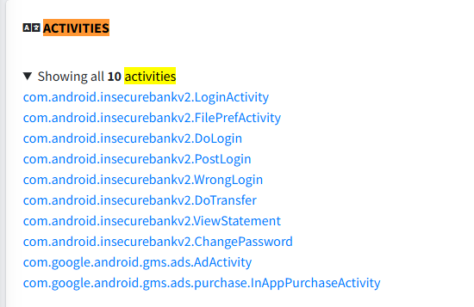
InsecureBankv2 ,Exported Activities in Manifest Analysis

5.2 Step 2 ,Code Analysis
Evidence Snapshot:
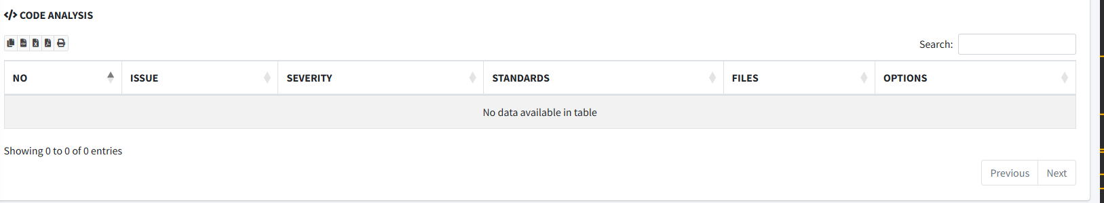
InsecureBankv2 , Code Analysis

5.3 Step 3 ,Application Permissions Audit
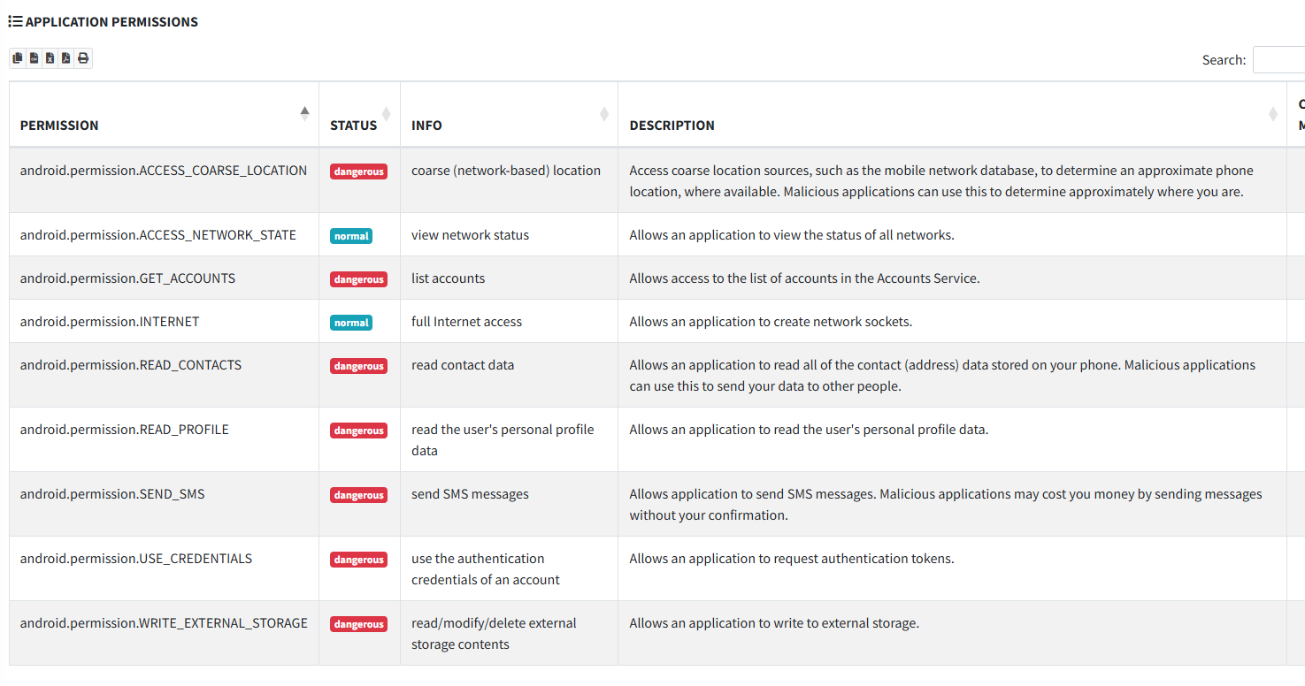
InsecureBankv2 ,MobSF Application Permission Analysis

6. Target 4: AndroGoat ,Excessive Permissions
AndroGoat is a purposely insecure Android application covering multiple OWASP Mobile security categories. For this analysis, the primary focus is on the permission model ,specifically identifying excessive privilege grants that violate the principle of least privilege, which is fundamental to Android's security model.

6.1 Step 1 ,Blueprint Audit (Manifest Analysis)
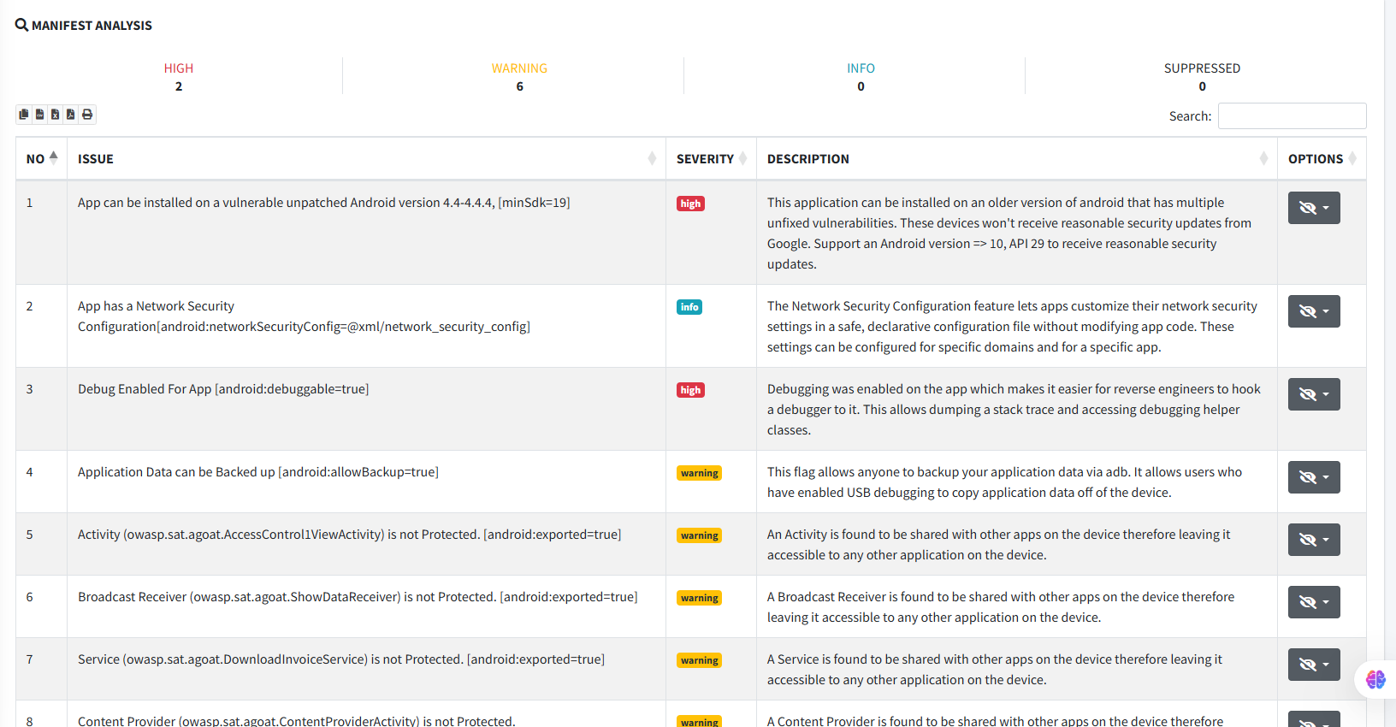
AndroGoat ,MobSF Manifest Analysis Tab
The AndroGoat manifest reveals an alarming number of permissions that far exceed what any legitimate application would require:
VULNERABILITY | Excessive Permissions ,Principle of Least Privilege Violated
FILE / PATH | AndroidManifest.xml → <uses-permission> declarations
RISK LEVEL | MEDIUM
DESCRIPTION | AndroGoat requests an extensive list of permissions including: CAMERA, READ_CONTACTS, ACCESS_FINE_LOCATION, ACCESS_COARSE_LOCATION, READ_CALL_LOG, PROCESS_OUTGOING_CALLS, READ_SMS, SEND_SMS, RECEIVE_SMS, and RECORD_AUDIO. These permissions grant access to the most sensitive device data (location, contacts, microphone, SMS) and are grossly excessive for any single application. This represents a classic Excessive Privilege attack vector.
RECOMMENDATION | Apply the Principle of Least Privilege: request only permissions absolutely required for core functionality. Defer permission requests to the point of use with clear contextual explanations. Use Android's permission groups to request minimal scope. Remove all permissions not essential to the app's stated purpose. Conduct a permission audit before every release.
Evidence Snapshot:
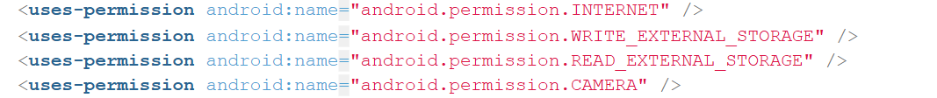
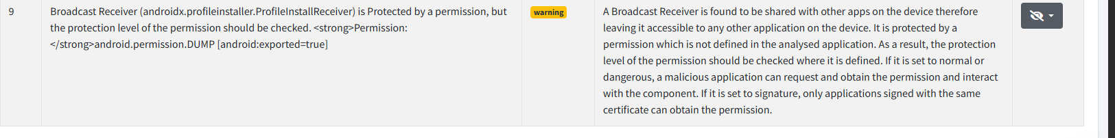 AndroGoat ,Excessive permissions in Manifest Analysis

VULNERABILITY | Dangerous Permission Combination ,SMS + Location + Contacts
FILE / PATH | AndroidManifest.xml → RECEIVE_SMS, ACCESS_FINE_LOCATION, READ_CONTACTS
RISK LEVEL | HIGH
DESCRIPTION | The combination of SMS (RECEIVE_SMS, READ_SMS, SEND_SMS), Location (ACCESS_FINE_LOCATION), and Contacts (READ_CONTACTS) permissions creates an extremely dangerous attack surface. A compromised AndroGoat application (via a vulnerability in another part of the code) could exfiltrate SMS messages (including OTP codes), track physical location, harvest contacts list, and potentially intercept 2FA authentication codes ,enabling complete account takeover of linked online services.
RECOMMENDATION | Perform threat modeling to identify which permission combinations create dangerous attack surface. Separate high-privilege features into isolated components or even separate applications. Implement runtime permission checks with user-facing justification. Use WorkManager and JobScheduler patterns to minimize background access periods.

6.2 Step 2 ,Code Analysis
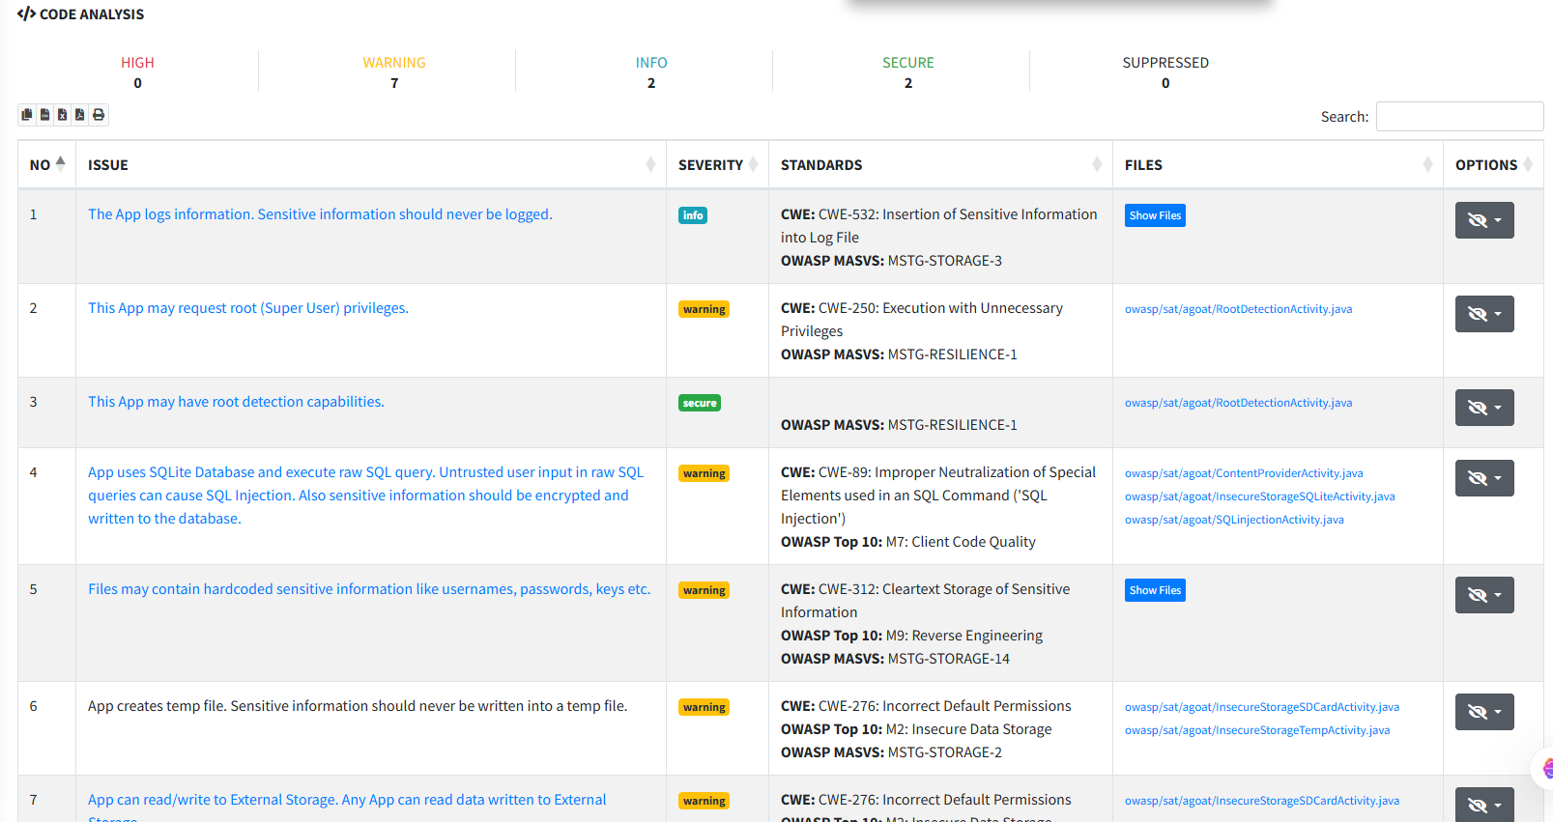
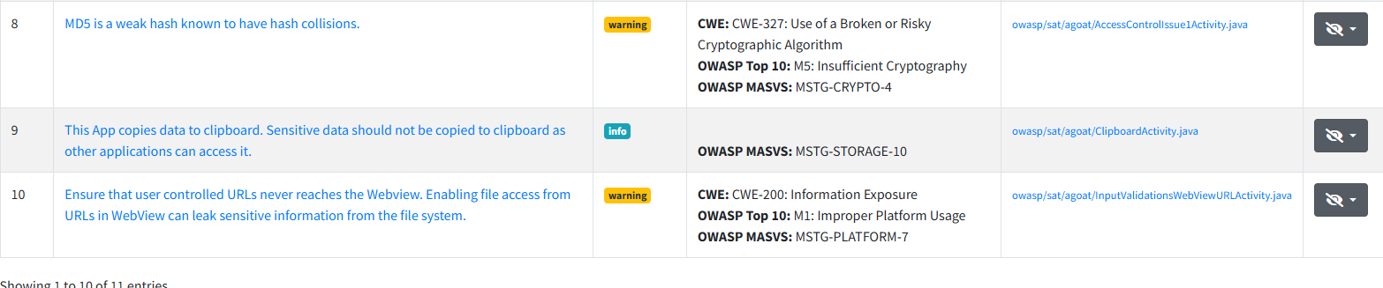
AndroGoat ,MobSF Code Analysis Tab
VULNERABILITY | Insecure Direct Object Reference (IDOR) in Content Provider
FILE / PATH | owasp.sat.agoat.ContentProviderActivity.java
RISK LEVEL | HIGH
DESCRIPTION | AndroGoat's Content Provider is exported without proper read/write permissions. An external application can query the Content Provider directly and access sensitive user data. The content URI does not implement proper authorization checks, allowing any application to perform CRUD operations on the provider's data store, which may include credentials and personal information.
RECOMMENDATION | Set android:exported='false' on Content Providers not intended for external use. For shared providers, implement signature-level permissions: android:readPermission and android:writePermission. Implement URI-level access controls and validate caller identity using Binder.getCallingUid() before serving any data.
Evidence Snapshot:
AndroGoat ,Insecure Content Provider in Code Analysis

VULNERABILITY | Insecure WebView Configuration ,JavaScript Enabled
FILE / PATH | owasp.sat.agoat.WebViewActivity.java
RISK LEVEL | MEDIUM
DESCRIPTION | AndroGoat's WebView has JavaScript enabled (setJavaScriptEnabled(true)) without restricting the URLs that can be loaded. Additionally, addJavascriptInterface() is used in a manner that exposes native Java methods to JavaScript content. This combination creates a JavaScript Interface Bridge attack vector, where malicious JavaScript (from a redirected URL or XSS) can call native Android methods to access the filesystem or execute OS commands.
RECOMMENDATION | Disable JavaScript unless absolutely required. If JavaScript is needed, implement a strict URL allowlist using shouldOverrideUrlLoading(). Remove dangerous JavaScript interfaces. Use WebViewClient.shouldInterceptRequest() to validate all resource loading. Upgrade the target SDK to enforce modern WebView security defaults. Never pass sensitive data through WebView-to-Java bridges.
Evidence Snapshot:
AndroGoat ,JavaScript enabled WebView in Code Analysis

6.3 Step 3 ,Cryptography Audit
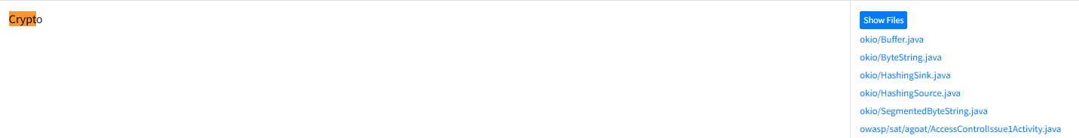AndroGoat ,MobSF Cryptography Findings
VULNERABILITY | Hardcoded Cryptographic Key and Use of SHA-1
FILE / PATH | owasp.sat.agoat.InsecureCryptographyActivity.java
RISK LEVEL | HIGH
DESCRIPTION | AndroGoat uses SHA-1 for password hashing ,a deprecated algorithm since 2017, vulnerable to collision attacks (SHAttered attack demonstrated in 2017). A hardcoded cryptographic key is also found embedded in the Java source code. SHA-1 collisions can be computed efficiently, and a hardcoded key means any attacker who decompiles the APK (trivial with apktool + jadx) immediately has the master decryption key.
RECOMMENDATION | Replace SHA-1 with SHA-256 (minimum) or use Argon2id/bcrypt for password hashing with appropriate cost factors. Remove all hardcoded keys from source code. Use Android Keystore System for key generation and storage ,keys generated in Keystore never leave the secure hardware element. Implement key rotation policies and use envelope encryption patterns for long-lived data.

7. Consolidated Findings & Risk Matrix
App | Vulnerability | Category | Risk | OWASP Mobile
InjuredAndroid | Exported Activities (Intent Hijacking) | Logic Flaw | HIGH | M1: Improper Platform Usage
InjuredAndroid | android:allowBackup=true | Data Exposure | HIGH | M2: Insecure Data Storage
InjuredAndroid | Hardcoded Flag Strings | Hardcoded Secrets | HIGH | M9: Reverse Engineering
InjuredAndroid | Weak Crypto (MD5/Base64) | Cryptography | MEDIUM | M5: Insufficient Cryptography
DIVA | Plaintext SharedPreferences | Data Storage | HIGH | M2: Insecure Data Storage
DIVA | Plaintext SQLite Database | Data Storage | HIGH | M2: Insecure Data Storage
DIVA | External Storage Write | Data Storage | HIGH | M2: Insecure Data Storage
DIVA | No Encryption Applied | Cryptography | HIGH | M5: Insufficient Cryptography
InsecureBankv2 | Exported LoginActivity | Authentication | HIGH | M1: Improper Platform Usage
InsecureBankv2 | Hardcoded Server URL + Creds | Hardcoded Secrets | HIGH | M9: Reverse Engineering
InsecureBankv2 | HTTP (No TLS/HTTPS) | Network Security | HIGH | M3: Insecure Communication
InsecureBankv2 | AES/ECB + Hardcoded Key | Cryptography | HIGH | M5: Insufficient Cryptography
AndroGoat | Excessive Permissions (SMS/Loc) | Permission Model | MEDIUM | M1: Improper Platform Usage
AndroGoat | Insecure Content Provider | Access Control | HIGH | M6: Insecure Authorization
AndroGoat | WebView JS Interface Attack | Web Security | MEDIUM | M1: Improper Platform Usage
AndroGoat | SHA-1 + Hardcoded Key | Cryptography | HIGH | M5: Insufficient Cryptography

Report Submitted By: Eisha Nawaz | MSCS22007
Course: System Security | ITU Lahore
Instructor: Muhammad Shehryar Raza

