System Security: Lab

MS Cyber Security



Submitted To:
Muhammad Shehryar Raza

Submitted By:
Eisha Nawaz

Roll No:
MSCS22007
Lab 3: Stack-Based Buffer Overflow & Binary
Hardening

Tools:

- GCC
- GDB
- checksec
- Linux VM

Learning Objectives
Students will:

  - Understand stack memory layout
  - Exploit a buffer overflow
  - Observe modern mitigations in action

Vulnerable Program
Create vuln.c:

#include <stdio.h> #include <string.h>

void vuln(char *input) { char buf[64]; strcpy(buf, input);
printf("You entered: %s\n", buf);
}

int main(int argc, char *argv[]) { vuln(argv[1]);
return 0;
}
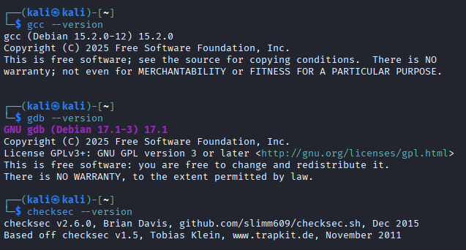

Tools Required

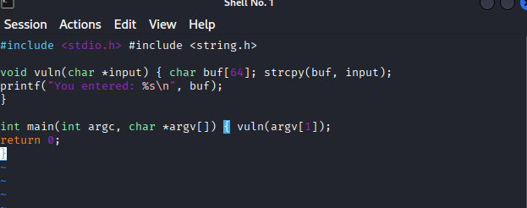

File creation Vuln.c

Compile without protections:

gcc -fno-stack-protector -z execstack -no-pie vuln.c -o vuln

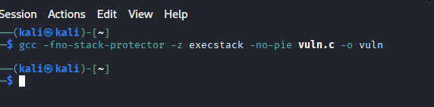

Step-by-Step Tasks

Task 1: Crash the Program (15 minutes)
Run:

./vuln $(python3 -c 'print("A"*200)')

Observe segmentation fault.

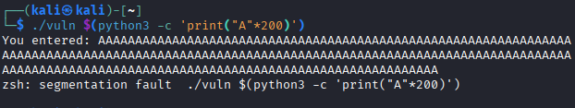

Task 2: Stack Analysis with GDB (25 minutes)
Launch:

gdb ./vuln
run $(python3 -c 'print("A"*100)')
info registers

Identify:

- Instruction pointer overwrite
- Offset to return address

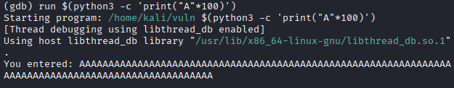

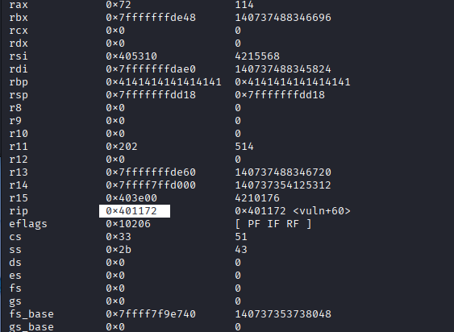
Identification | Value/Observation
Instruction Pointer (RIP) | Currently 0x401172, but the RBP is already corrupted with 0x4141414141414141.
Offset to Return Address | 76 bytes (72 bytes for buf + 4 bytes for RBP).

Task 3: Control Execution Flow (20 minutes)
Replace return address with junk value: run $(python3 -c 'print("A"*76 + "BBBB")')

Observe instruction pointer change.

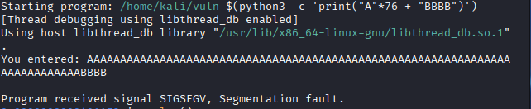

Task 4: Binary Hardening (25 minutes)
Recompile with protections:

gcc vuln.c -o vuln_hardened checksec vuln_hardened

Enable:

- Stack canaries
- NX
- ASLR

Run exploit again → observe failure
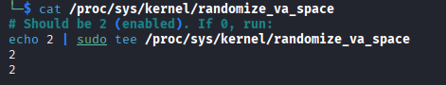

Task 5: Defense Analysis (15 minutes)

- Which mitigation stopped the attack?
Three mitigations worked together as layers of defense:
Stack Canary was the first and most direct defense that stopped the attack. When you ran ./vuln_hardened $(python3 -c 'print("A"*72 + "B"*8)'), the program printed *** stack smashing detected *** and aborted.
When our overflow of 72+ bytes crossed over the canary value and changed it, the program checked the canary before executing ret and found it corrupted so, it killed itself before the attacker could hijack RIP.
NX (No-Execute / DEP) was the second layer. Even if the canary were somehow bypassed, the stack is marked non-executable in the hardened binary. Any shellcode injected into the buffer would immediately cause a fault when the CPU tried to execute it, because the hardware enforces that data regions cannot be run as code.
ASLR (Address Space Layout Randomization) was the third layer. Every time the hardened binary runs, the stack, heap, and library addresses are randomized. This means even if an attacker knew the exact offset to overwrite RIP, they would not know where to point it, the target address changes on every execution.

- Why exploitation is harder today?
In the early days buffer overflow was straightforward overflow the buffer, overwrite the return address with the address of your shellcode sitting in the buffer, and get a shell. Today that same attack fails because of multiple stacked defenses:
To successfully exploit a modern binary an attacker must first leak the canary value without crashing the program. Then they must defeat ASLR by leaking a memory address to calculate where things are loaded. Then they must bypass NX by not injecting shellcode at all, but instead chaining together existing code fragments already in the binary called ROP (Return Oriented Programming) gadgets. Each of these steps requires chaining multiple bugs together, deep knowledge of the binary, and the exploit often only works on a specific version of the OS and binary. A single patch or recompile can break the entire exploit chain. This is why modern exploitation is considered a highly specialized skill compared to the simple overflows of the past.

- Why memory-safe languages exist?

Because mitigations only make exploitation harder, not impossible. Languages like Rust and Python eliminate buffer overflows entirely at the language level making this whole class of attack structurally impossible rather than just difficult. Since approx. 70% of real-world CVEs are memory safety bugs, switching languages removes the root cause rather than patching symptoms.

