**Web Technology**

**Lab Assignment 9**

**Name** : Eishaan Khatri **Rollno** : 22MC3014

**Q1 Connect to a MongoDB server using MongoDB Compass.**

**Ans**

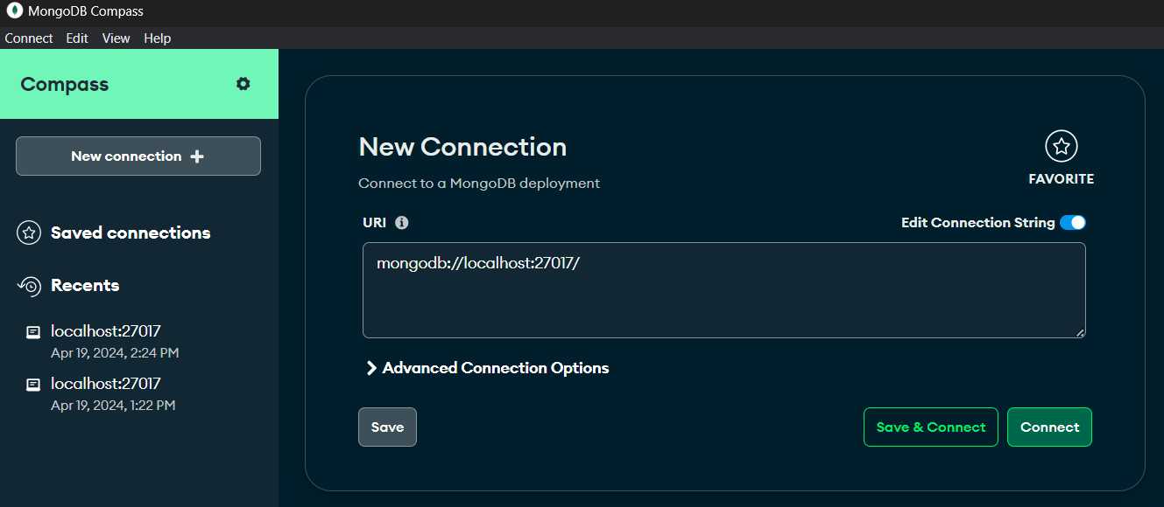

**Q2. Create a new database named "testdb" in MongoDB Compass.**

**Ans**

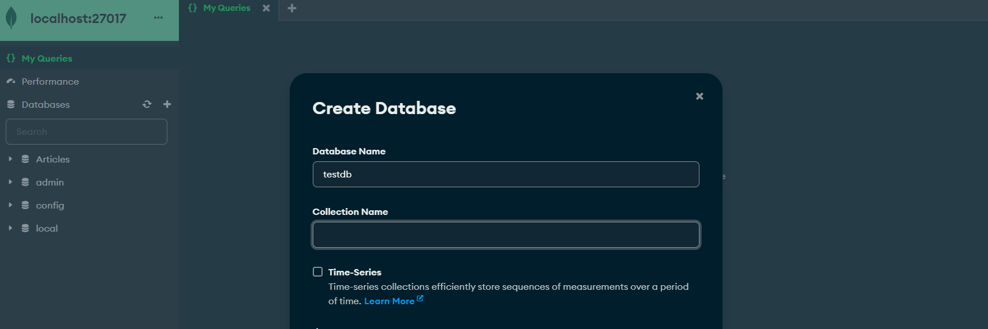

**Q3. Create a new collection named "students" in the "testdb" database.**

**Ans**

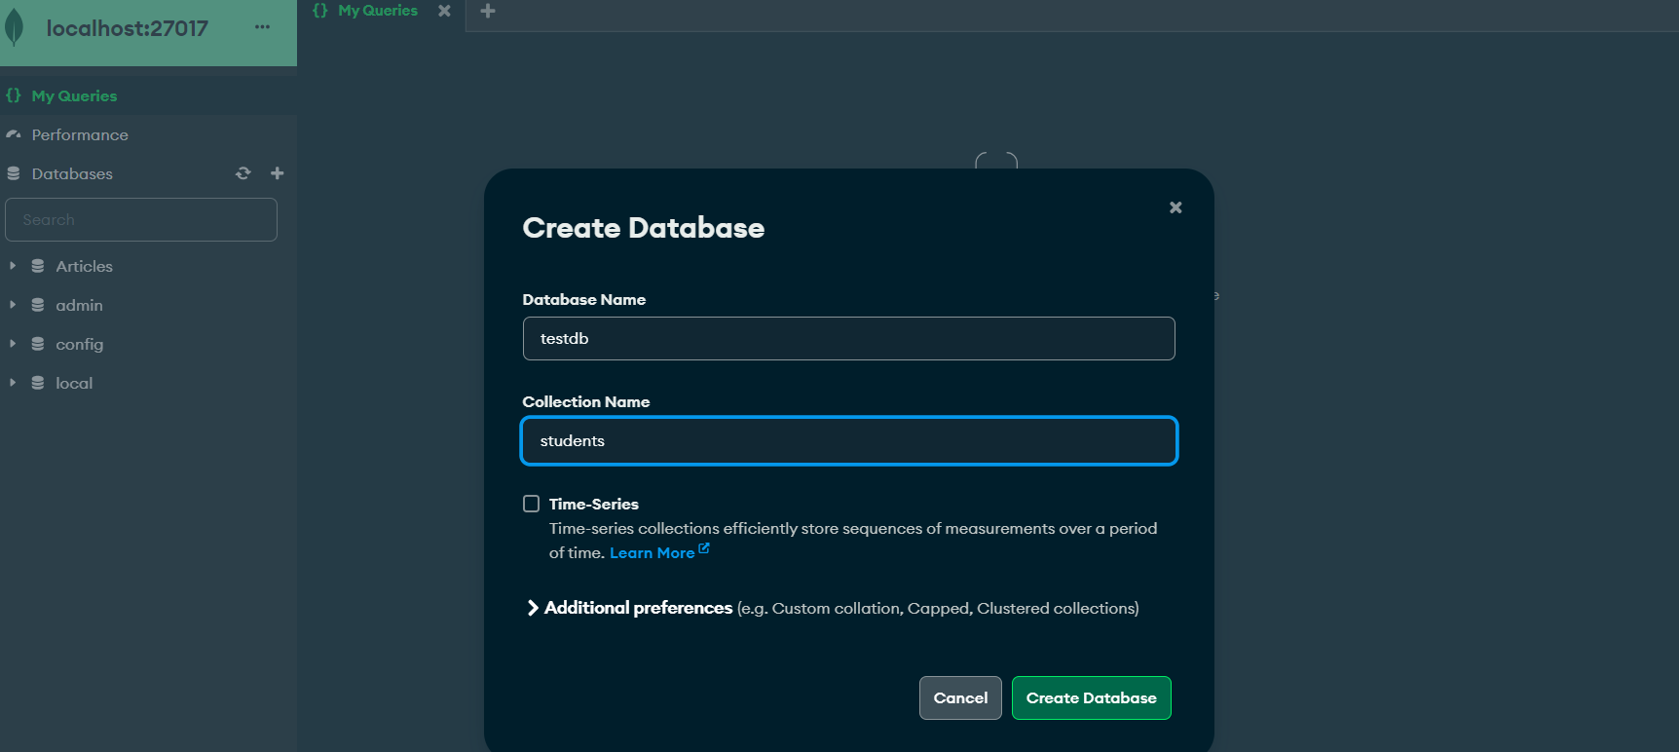

**Q4. Insert ten documents into the "students" collection with the following fields:**

**name, age, and email.**

**Ans**

[

{

"name": "A",

"age": 25,

"email": "a@example.com"

},

{

"name": "B",

"age": 22,

"email": "b@example.com"

},

{

"name": "C",

"age": 28,

"email": "c@example.com"

},

{

"name": "D",

"age": 30,

"email": "d@example.com"

},

{

"name": "E",

"age": 26,

"email": "e@example.com"

},

{

"name": "F",

"age": 24,

"email": "f@example.com"

},

{

"name": "G",

"age": 27,

"email": "g@example.com"

},

{

"name": "H",

"age": 29,

"email": "h@example.com"

},

{

"name": "I",

"age": 23,

"email": "i@example.com"

},

{

"name": "J",

"age": 31,

"email": "j@example.com"

}

]

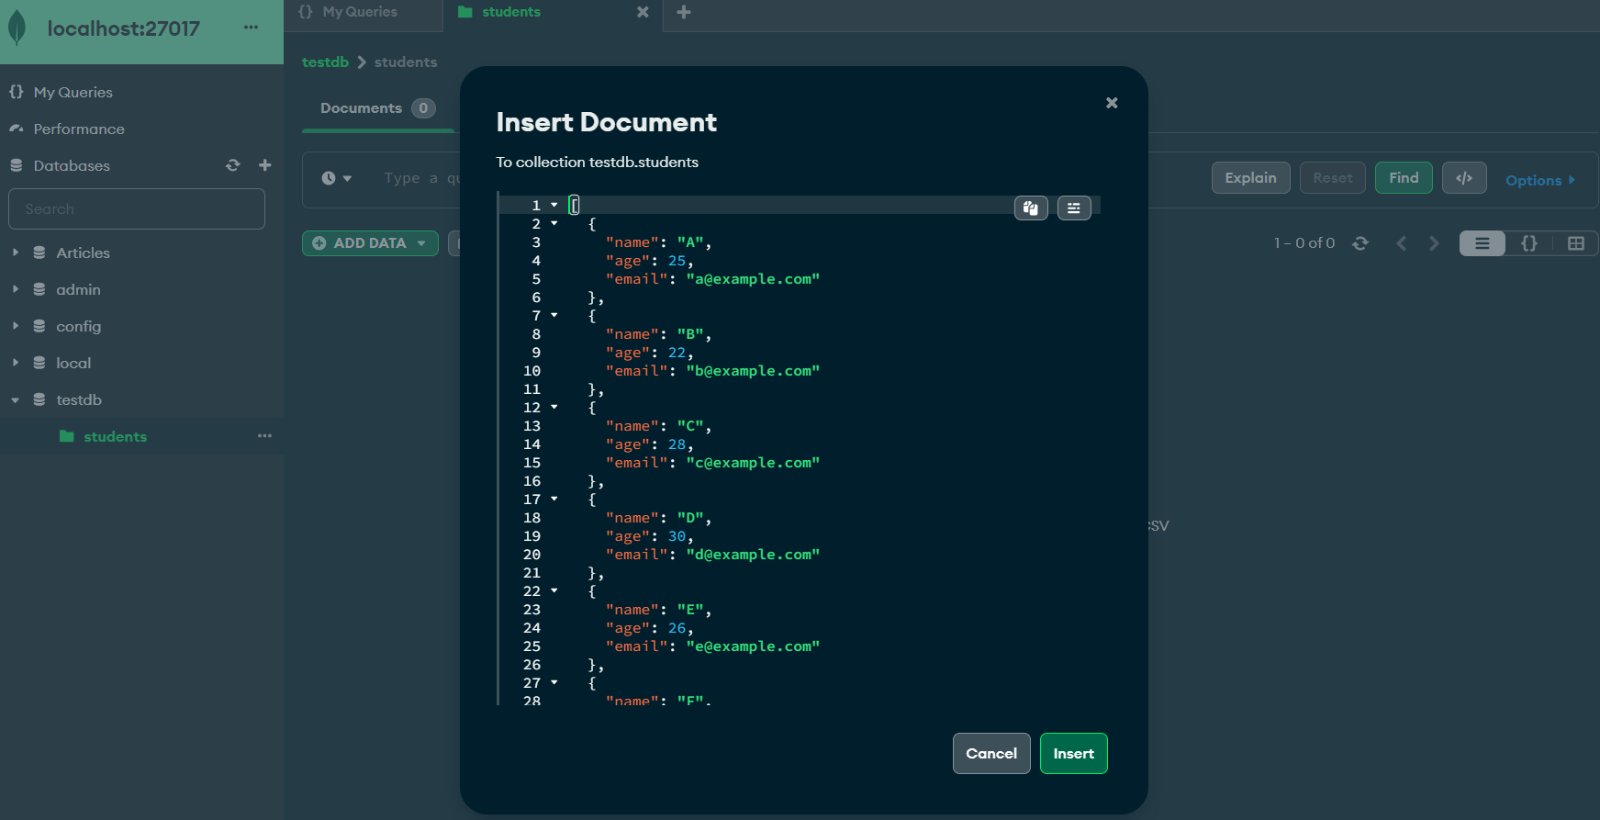

**Q5. View the contents of the "students" collection.**

**Ans**

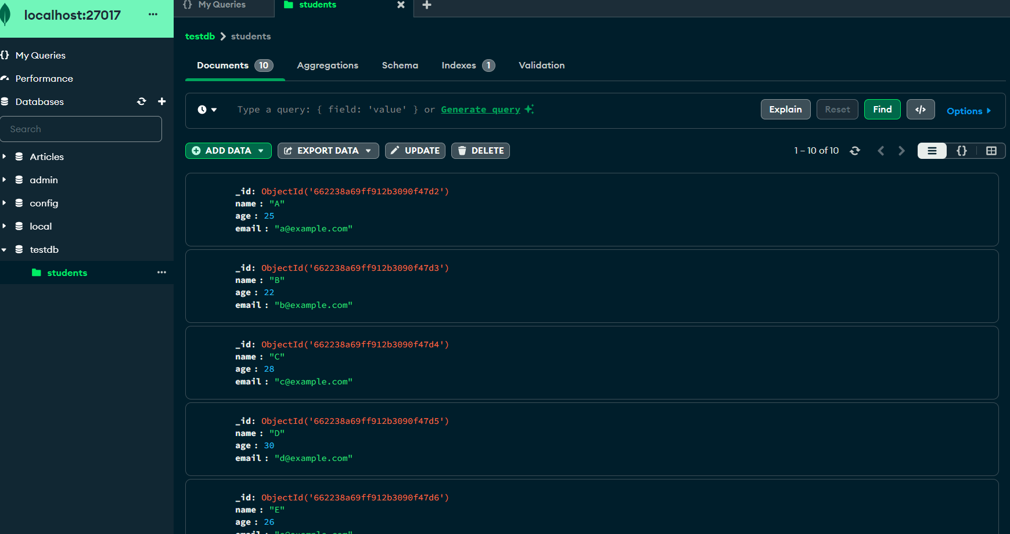

**Q6. Update the age of a specific student in the "students" collection.**

**Ans**

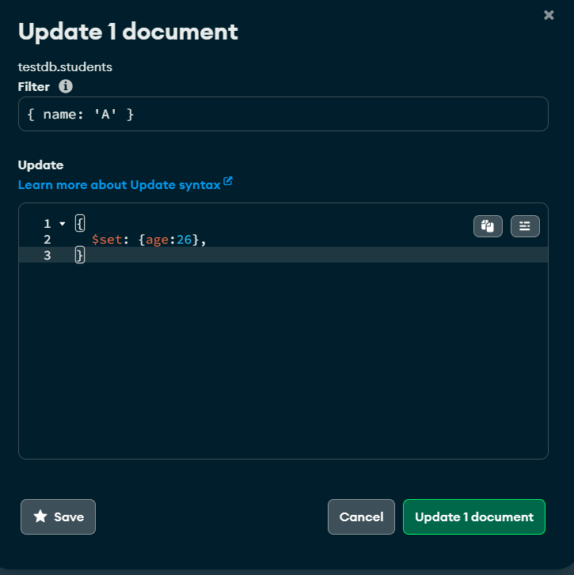

**Q7. Delete a document from the "students" collection based on a specific condition.**

**Ans**

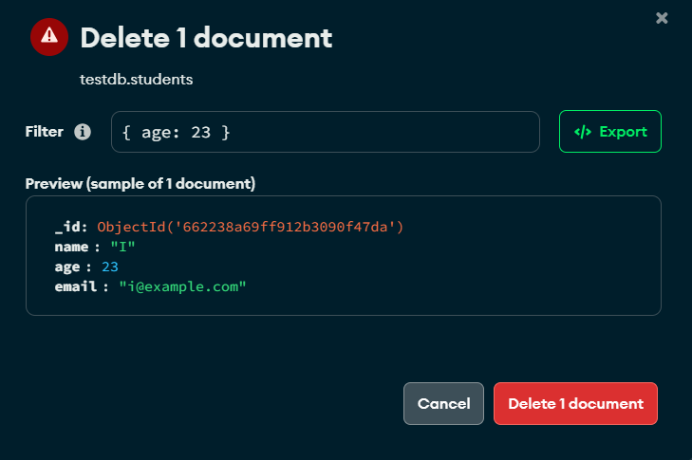

**Q8. Use the aggregation pipeline to calculate the average age of all students in the "students" collection.**

**Ans**

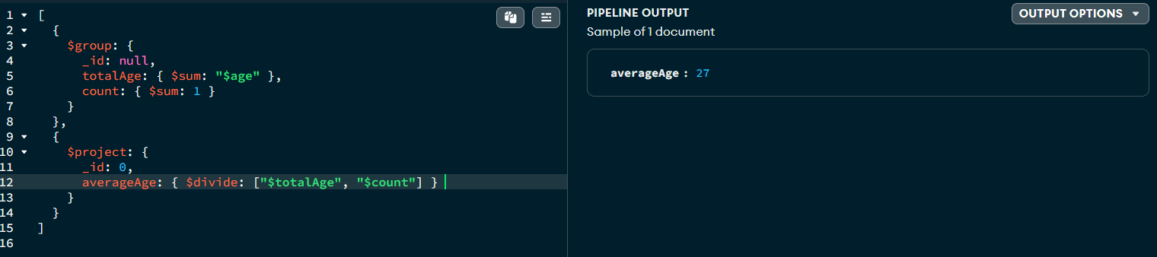

**Q9. Create an index on the "name" field in the "students" collection.**

**Ans**

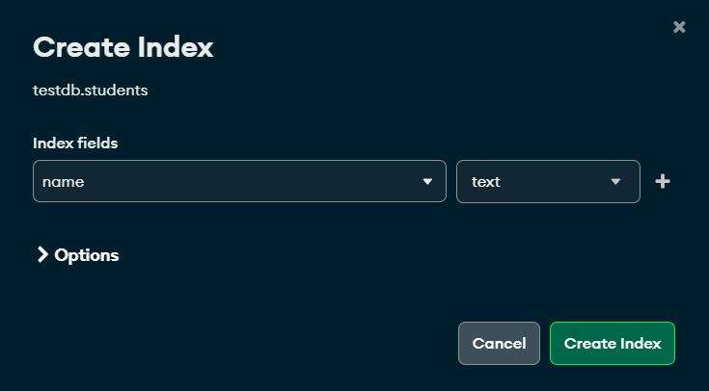

**Q10. Export the contents of the "students" collection to a JSON file.**

**Ans**

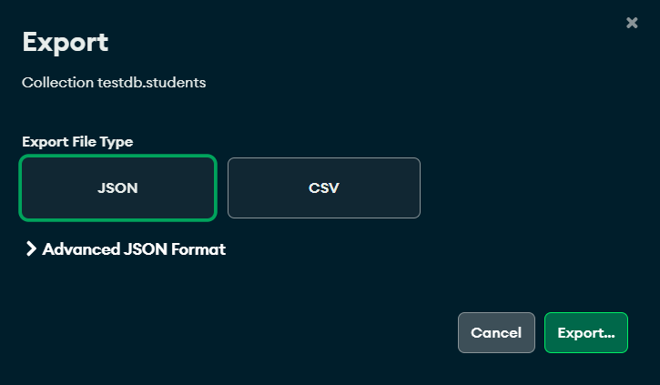

**Q11. Perform a complex aggregation operation to find the top 5 oldest students in the "students" collection.**

**Ans**

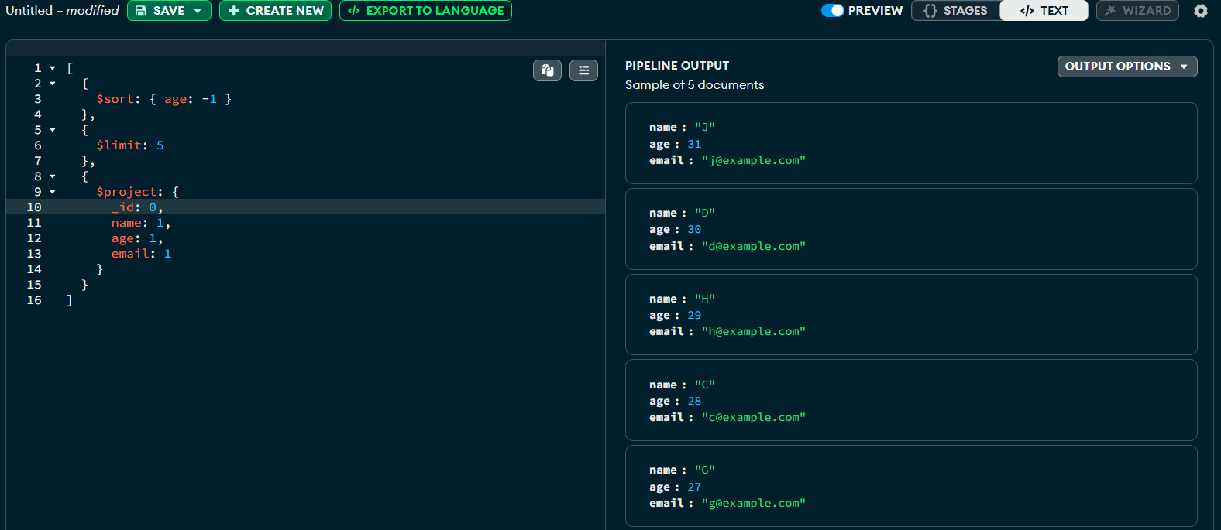

**Q12. Create a geospatial index on a field representing the location of students.**

**Ans**

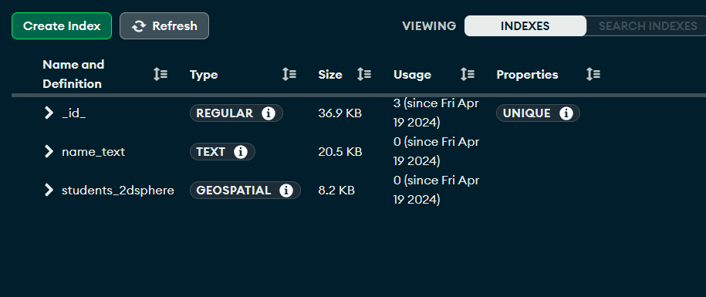

**Q13. Use MongoDB Compass to visualize the data distribution in the "students" collection.**

**Ans**

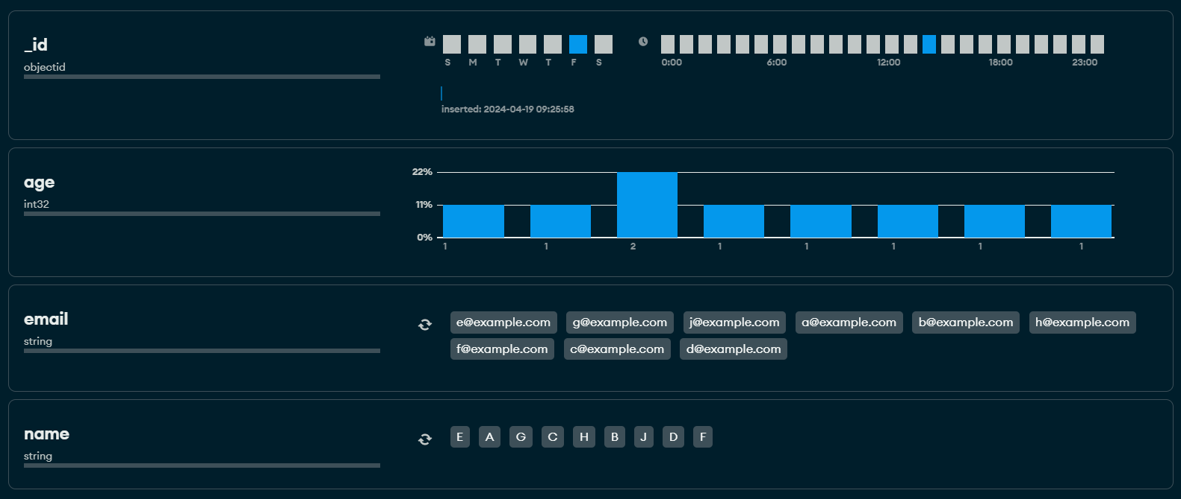

**Q14. Set up a data validation rule to ensure that documents in the "students" collection must have a non-empty name field.**

**Ans**

