**UNIVERSITI TUNKU ABDUL RAHMAN**

**LEE KONG CHIAN FACULTY OF ENGINEERING AND SCIENCE**

**UECS2344 SOFTWARE DESIGN**

**ASSIGNMENTS (Part 1, Part 2(a) and Part 2(b))**

**January 2022 Trimester**

|  |  |  |  |
| --- | --- | --- | --- |
| **No.** | **STUDENT NAME** | **STUDENT ID** | **Practical Group** |
| **1.** | **Harry Liow Ming Heng** | **2002435** | **P3** |
| **2.** | **Benny Kwan Zhang Le** | **2003232** | **P3** |
| **3.** | **Hon Wen Xuan** | **2001171** | **P3** |
| **4.** | **Tan Yan Kidd** | **1800208** | **P3** |
| **5.** | **Tan Swee Yang** | **1904180** | **P1** |

**Use Case Diagram:**

**Analysis Class Diagram:**

**Use Case Description:**

|  |  |  |  |
| --- | --- | --- | --- |
| Use Case Name: Login account | | ID: 1 | Importance Level: High |
| Primary Actor: Client, admin | Use Case Type: Detailed, Essential | | |
| Stakeholders and Interests:   Client – wants to login into their account to access the part time maid booking system and create a booking.  Admin – wants to login into their account to manage the maid list | | | |
| Brief Description:   This use case describes how the users login into their account in order to access the functions of the maid booking app | | | |
| Trigger: Client and admin open the part time maid booking system | | | |
| Relationships:  Association: Client, admin  Include: -  Extend: Create user profile  Generalization: - | | | |
| Normal Flow of Events:   1. Clients want to book a cleaning service appointment for their house. 2. Clients open the part time maid booking system. 3. Clients type in their username and password in the login page.        If the client doesn’t have an account,          the S-1: Create User Profile sub-flow is performed.       If the client has an account but enter the wrong username or password,          the S-2: Error Message sub-flow is performed.       If the client has an account and enter the correct username and password,          the S-3: Login Successfully sub-flow is performed. | | | |
| Sub-flows:   S-1: Create User Profile   1. The system brings the client to the create user profile page when they choose the sign-up option.     S-2: Error message   1. The system prompts the client to enter the username and password again. 2. The system will suggest to the client to renew the password or create a new user profile if the client enters the wrong username or password with the maximum of three times.     S-3: Login Successfully   1. The system will bring the client to the home page and given full access to the part time maid booking system. | | | |
| Alternate/Exceptional Flows:   1. Admin wants to modify the maid list in the part time maid booking app. 2. Admin opens the part time maid booking system. 3. Admin type in their username and password on the login page.   If the admin doesn’t have an account,          the S-1: Create User Profile sub-flow is performed.       If the admin has an account but enters the wrong username or password,          the S-2: Error Message sub-flow is performed.       If the admin has an account and enters the correct username and password,          the S-3: Login Successfully sub-flow is performed. | | | |

|  |  |  |  |
| --- | --- | --- | --- |
| Use Case Name: Create user profile | | ID: 2 | Importance Level: High |
| Primary Actor: Client, admin | Use Case Type: Overview, essential | | |
| Stakeholders and Interests:   Client – wants to create a user profile to login into the system and to book a cleaning service maid.  Admin – wants to create a user profile to login into the system and manage the maid list. | | | |
| Brief Description: This use case describes how clients and admins create a user account for the system. | | | |
| Trigger: Client and admin choose the “Create account” option | | | |
| Relationships:  Association: Client, admin  Include: -  Extend: -  Generalization: - | | | |
| Normal Flow of Events:   1. Client wants to book a cleaning service. 2. Client opens the part time maid booking system. 3. Client chooses the “Create account” option from the menu page. 4. Client being brought to the “Create account” page. 5. Client fills in the personal information needed for his/her account.   If client enters an existing username:  S-1: username taken is performed.   1. After creating a profile, the client should be able to login into their account. | | | |
| Sub-flows:   S-1: username taken   1. Users are asked to enter another username. | | | |
| Alternate/Exceptional Flows:   1. Admin wants to modify the maid list. 2. Admin opens the part time maid booking system. 3. Admin chooses the “Create account” option from the menu page. 4. Admin being brought to the “Create account” page. 5. Admin fills in the personal information needed for his/her account.   If client enters an existing username:  S-1: username taken is performed.   1. After creating a profile, the client should be able to login into their account. | | | |

|  |  |  |  |
| --- | --- | --- | --- |
| Use Case Name: Create booking | | ID: 3 | Importance Level: High |
| Primary Actor: Client | Use Case Type: Detailed, Essential | | |
| Stakeholders and Interests:  Client – wants to request or create a booking to hire a part time maid. | | | |
| Brief Description:  This use case describes how clients request or create a booking to hire a part time maid. | | | |
| Trigger: The client uses the system to create or request a booking. | | | |
| Relationships:  Association: Client  Include: -  Extend: Update/Maintain booking, Cancel booking  Generalization: - | | | |
| Normal Flow of Events:   1. The client opens the software and looks for the “Create Booking” button 2. The system shows all the available maids. 3. The client selects the maid they want by maid id.   If the client enters an invalid maid id:  S-1: invalid maid id message is performed.   1. The client chooses the booking date and time they want. 2. The booking was created successfully after the client enter all information. | | | |
| Sub-flows:   S-1: Invalid maid id   1. The system asks the client to reenter the maid id. | | | |
| Alternate/Exceptional Flows:  N/A | | | |

|  |  |  |  |
| --- | --- | --- | --- |
| Use Case Name: View Bookings | | ID: 4 | Importance Level: High |
| Primary Actor: Client, admin | Use Case Type: Detailed, Essential | | |
| Stakeholders and Interests:  Client views their own booking details  Admin wishes to view all the booking details | | | |
| Brief Description:  This use case allows clients to view their own booking details.  This use case also allows the admin to view all the active bookings. | | | |
| Trigger: Client or Admin choose the “View Bookings” option | | | |
| Relationships:  Association: Client, Admin  Include: -  Extend: -  Generalization: - | | | |
| Normal Flow of Events:   1. The system shows the menu page. 2. **Client** chooses the “View Bookings” option. 3. System displays the client’s booking details. | | | |
| Sub-flows:   N/A | | | |
| Alternate/Exceptional Flows:   1. The system shows the menu page 2. **Admin** chooses the “View Bookings” option 3. System displays all booking details | | | |

|  |  |  |  |
| --- | --- | --- | --- |
| Use Case Name: Search Booking | | ID: 5 | Importance Level: High |
| Primary Actor: Admin | Use Case Type: Detailed, Essential | | |
| Stakeholders and Interests: Admin wants to search for a specific booking | | | |
| Brief Description: This use case allows admin to search for a specific booking | | | |
| Trigger: The admin chooses the “Search Booking” option | | | |
| Relationships:  Association: Admin  Include: -  Extend: -  Generalization: - | | | |
| Normal Flow of Events:   1. System shows the menu page 2. Admin chooses the “Search Booking” option 3. System asks for a booking id of the booking 4. Admin types in the **correct** booking id 5. System displays booking details of the booking id | | | |
| Sub-flows:   N/A | | | |
| Alternate/Exceptional Flows:   1. System shows the menu page 2. Admin chooses the “Search Booking” option 3. System asks for a booking id 4. Admin types in a **wrong** booking id 5. System displays the error message and returns to the menu page | | | |

|  |  |  |  |
| --- | --- | --- | --- |
| Use Case Name: Update/Maintain Booking | | ID: 6 | Importance Level: High |
| Primary Actor: Client | Use Case Type: Detailed, Essential | | |
| Stakeholders and Interests:   Client – wants to update or maintain booking. | | | |
| Brief Description:   This use case describes how the client can update or maintain their booking. | | | |
| Trigger: The client clicks the update/maintain booking button. | | | |
| Relationships:  Association: Client  Include: -  Extend: -  Generalization: - | | | |
| Normal Flow of Events:   1. Client wants to update or maintain bookings. 2. Client opens the part-time maid booking system. 3. Client chooses the “Update or Maintain Booking” button. 4. Client being brought to the update or maintain booking page. 5. Client selects the time or date button for updating the following booking.                   If the user selects the time button:                     The S-1: Update/Maintain Time sub-flow is performed.                  If the user selects the date button:                     The S-2: Update/Maintain Date sub-flow is performed.   1. The system will then update the booking. | | | |
| Sub-flows:  S-1: Update/Maintain Time  1. Client selects the time they wish to update.      S-2: Update/Maintain Date  1. Client selects the date they wish to update. | | | |
| Alternate/Exceptional Flows:   N/A | | | |

|  |  |  |  |
| --- | --- | --- | --- |
| Use Case Name: Cancel Booking | | ID: 7 | Importance Level: High |
| Primary Actor: Client | Use Case Type: Detailed, Essential | | |
| Stakeholders and Interests:  Client – wants to cancel a booking due to the client accidentally proceed the bookings. | | | |
| Brief Description:  This use case describes how client cancels their booking. | | | |
| Trigger: The client uses the system to cancel their previous booking. | | | |
| Relationships:  Association: Client  Include: -  Extend:  Generalization: - | | | |
| Normal Flow of Events:   1. The client clicks on the “Cancel Booking” option. 2. The system warns the client if they really want to cancel the bookings.                          If client regrets or accidentally clicked on the “Cancel” button:                            The S-1: Undo Decision sub-flow is performed.                         If client confirms to cancel the booking:                             The S-2: Confirm Decision sub-flow is performed.   1. The system finds the booking that the client wants to cancel and terminate it. | | | |
| Sub-flows:  S-1: Undo Decision   1. The system rejects the cancel booking operation. 2. The system back to the view booking page.     S-2: Confirm Decision   1. The system executes the client's decision. | | | |
| Alternate/Exceptional Flows:  N/A | | | |

|  |  |  |  |
| --- | --- | --- | --- |
| Use Case Name: Add Maid | | ID: 8 | Importance Level: High |
| Primary Actor: Admin | Use Case Type: Detailed, Essential | | |
| Stakeholders and Interests:  Admin wants to add a maid to the booking app. | | | |
| Brief Description:  This use case describes how the admin adds a part-time maid for the booking service. | | | |
| Trigger:  Admin wishes to add a maid to the maid list. | | | |
| Relationships:  Association: Client  Include:  Extend: -  Generalization: - | | | |
| Normal Flow of Events:   1. A new maid joins the part-time maid company. 2. The admin login into the maid booking app. 3. The admin selects the add maid option. 4. The admin enters the maid information into the app. 5. The maid will be added to the maid list once the admin enters all the maid information. | | | |
| Sub-flows:  N/A | | | |
| Alternate/Exceptional Flows:  N/A | | | |

|  |  |  |  |
| --- | --- | --- | --- |
| Use Case Name: Delete Maid | | ID: 9 | Importance Level: High |
| Primary Actor: Admin | Use Case Type: Detailed, Essential | | |
| Stakeholders and Interests:  The company no longer needs a maid for the booking service. | | | |
| Brief Description:  This use case describes how the admin deletes a part-time maid from the available part-time maid list for the booking service. | | | |
| Trigger:  Admin wishes to delete a maid from the booking app. | | | |
| Relationships:  Association: Client  Include:  Extend: -  Generalization: - | | | |
| Normal Flow of Events:  1. A maid decided to leave the cleaning service company.  2. The admin login into the maid booking service app.  3. The admin chooses the delete maid option.  4. The admin enters the maid id to delete.  If the maid id didn’t match any of the maids:  S-1: Maid not found message is performed.  If the maid id matches a maid but that maid is currently unavailable (booked by a client):  S-2: Maid unavailable message is performed.  5. Maid deleted from the app if the id matches 1 of the maids. | | | |
| Sub-flows:   S-1: Maid not found Message  1. The admin is asked to reenter the maid id.  S-2: Maid unavailable message  1. The admin is asked to delete the maid later when the maid is available. | | | |
| Alternate/Exceptional Flows:  N/A | | | |

**Sequence Diagram**

1. **User Login Sequence Diagram**

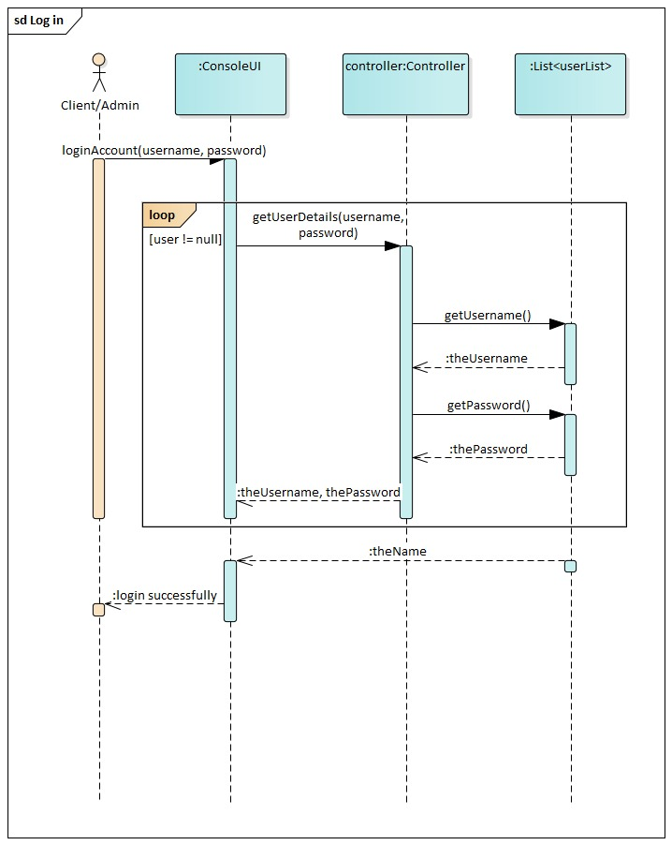

1. **User Create Account Sequence Diagram**

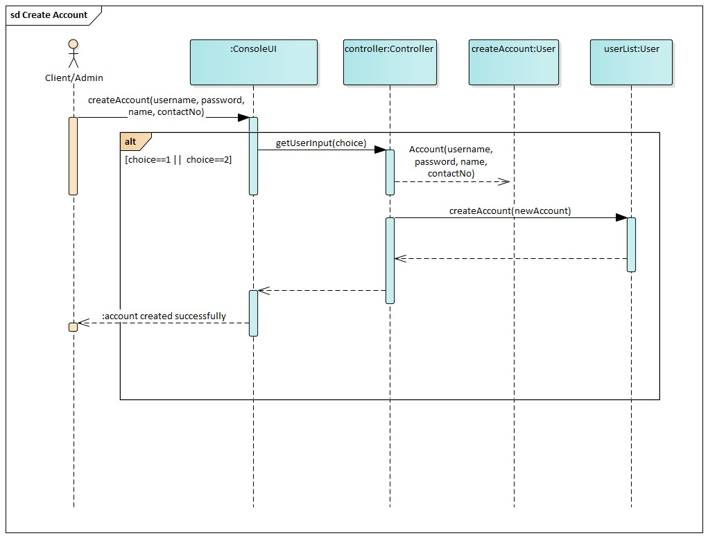

1. **Admin Add Maid Sequence Diagram**

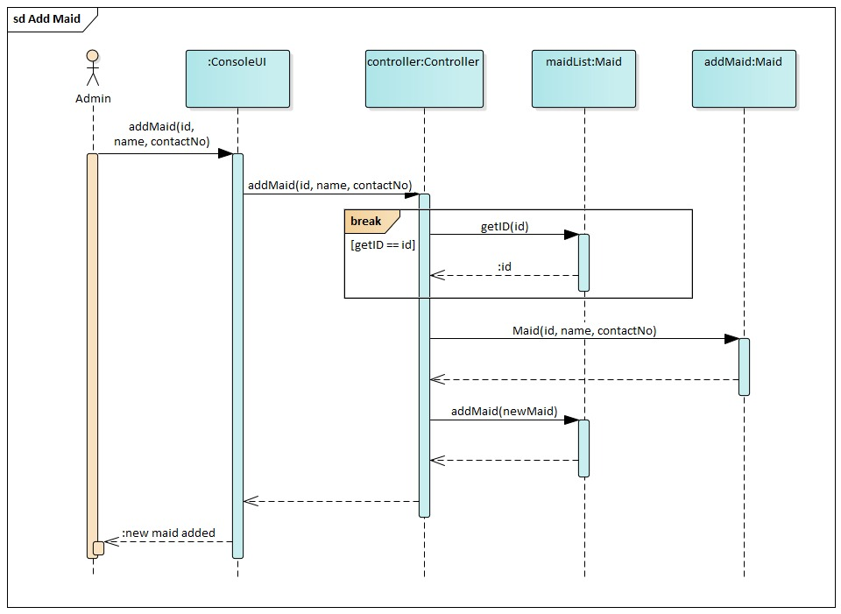

1. **Admin Delete Maid sequence diagram**

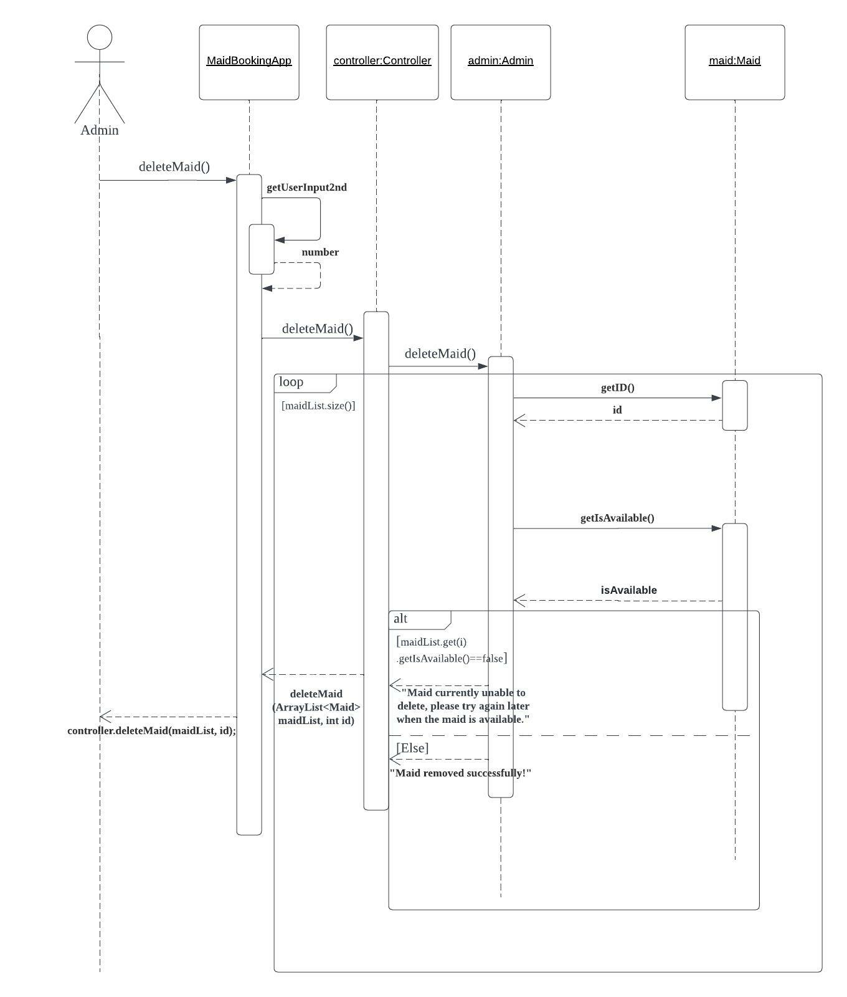

1. **Client Create booking sequence diagram**

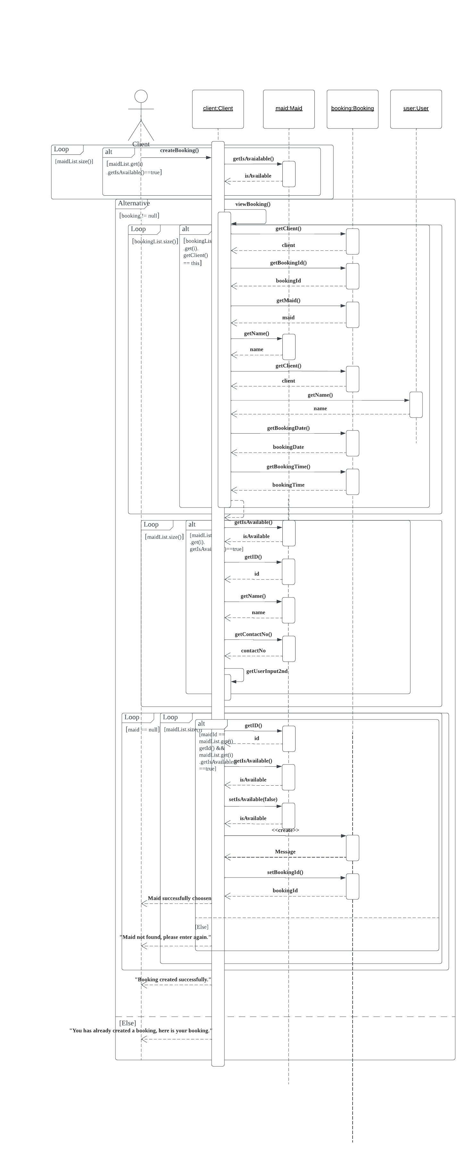

1. **Client Update booking sequence diagram**

1. **Admin Search Booking Sequence Diagram**

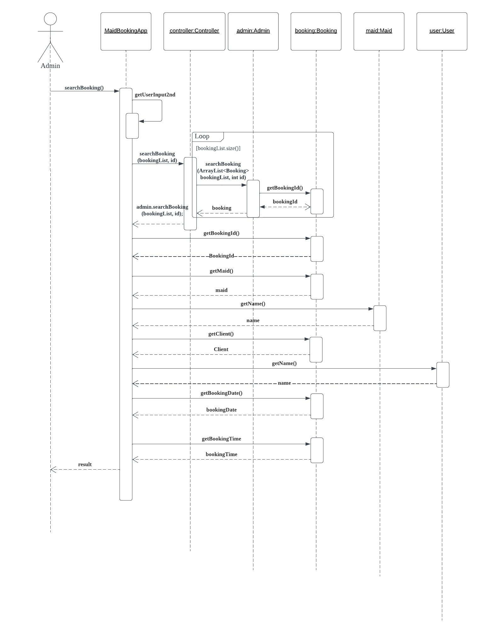

1. **Admin View Booking Sequence Diagram**

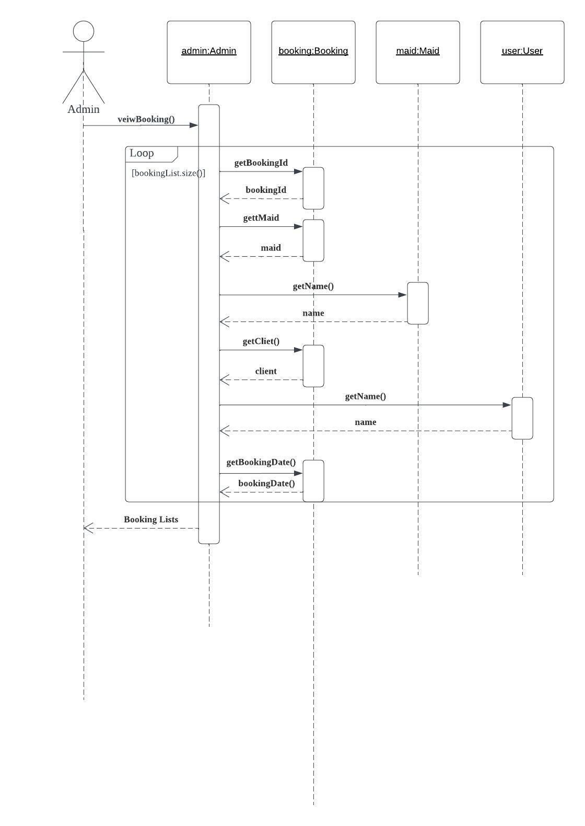

1. **Client View Booking Sequence Diagram**Diagram, schematic

   Description automatically generated
2. **Client Cancel Booking Sequence Diagram**

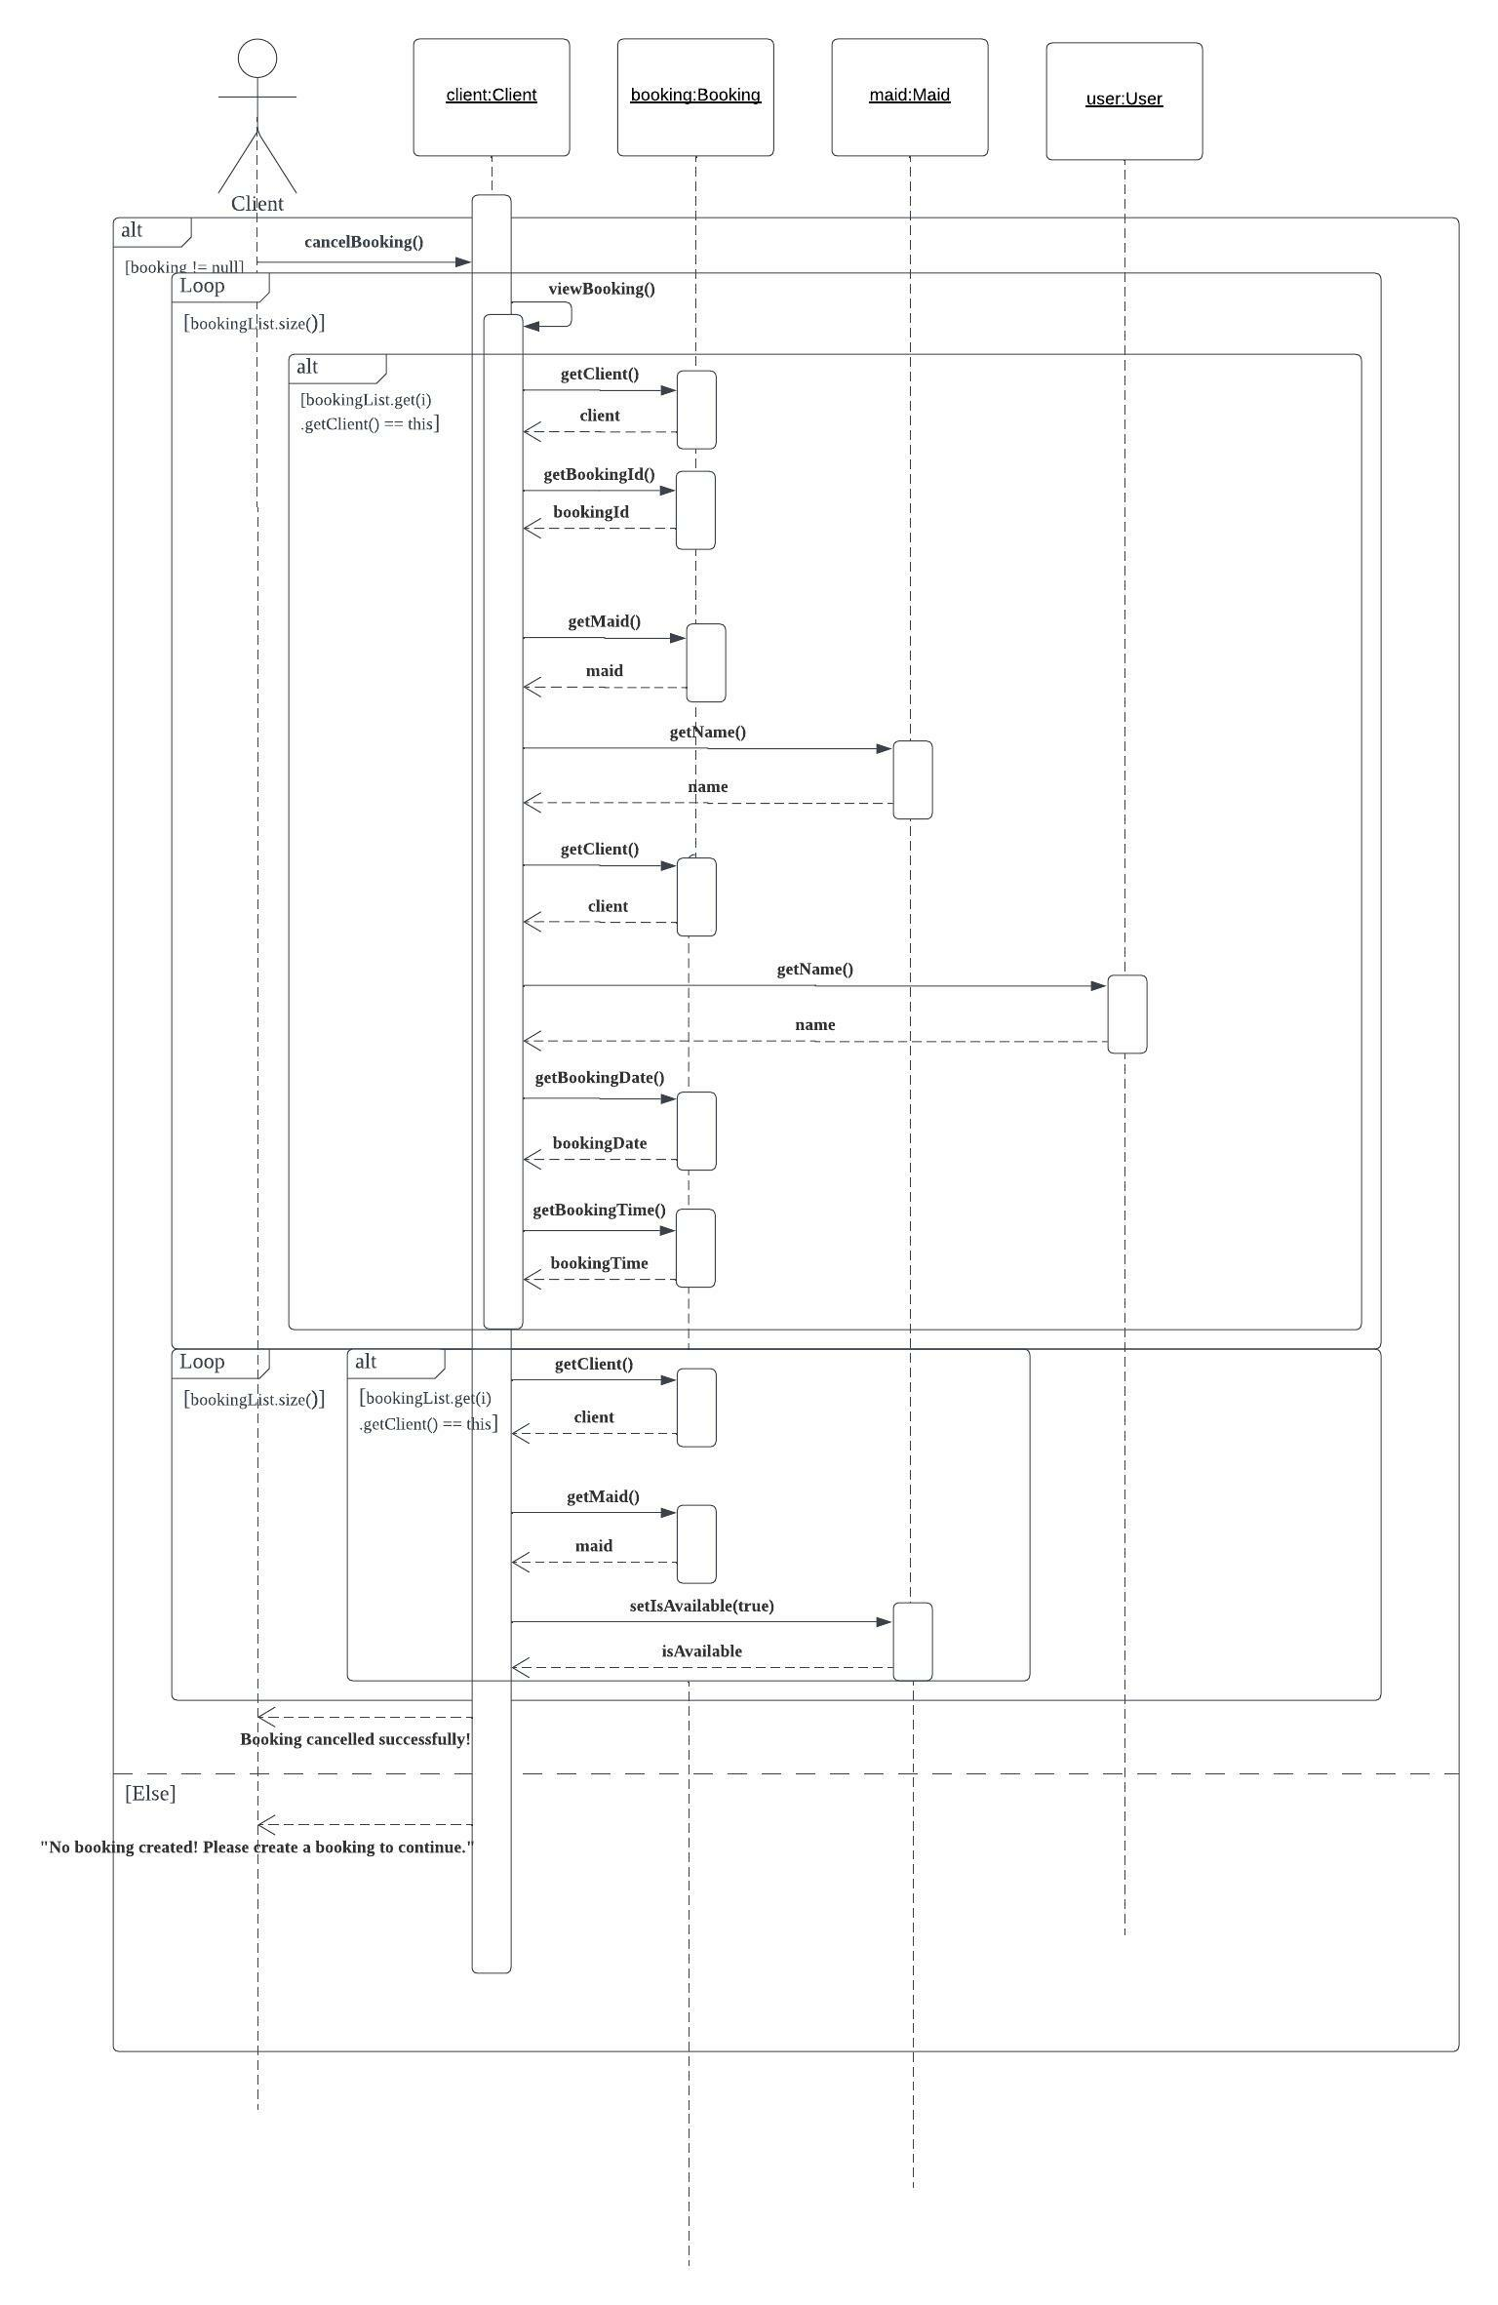

**Design Class Diagram**

**1st version design class diagram**

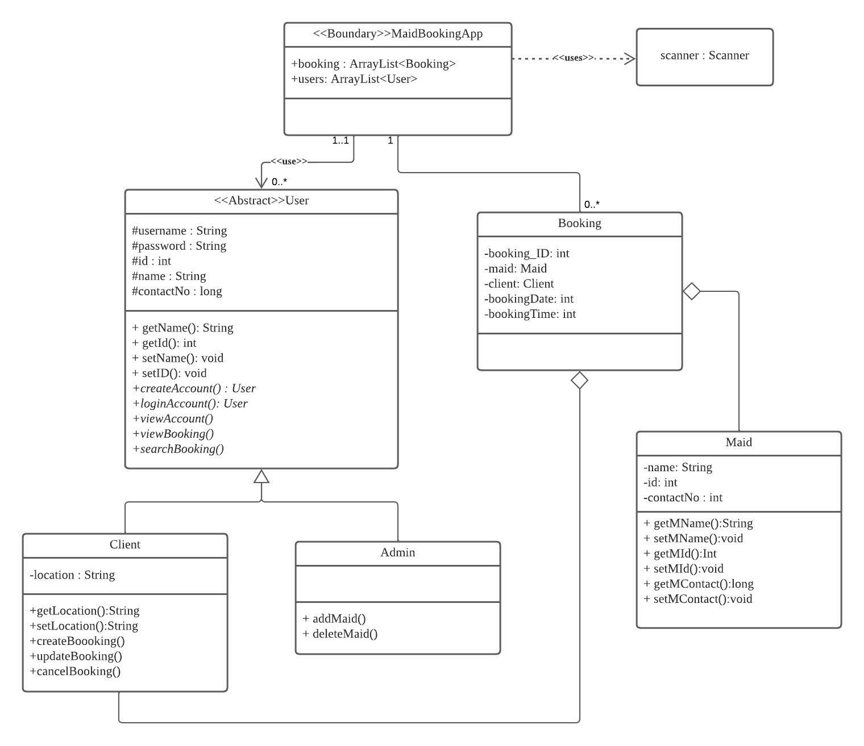

**Design Class Diagram**

**2nd version design class diagram**

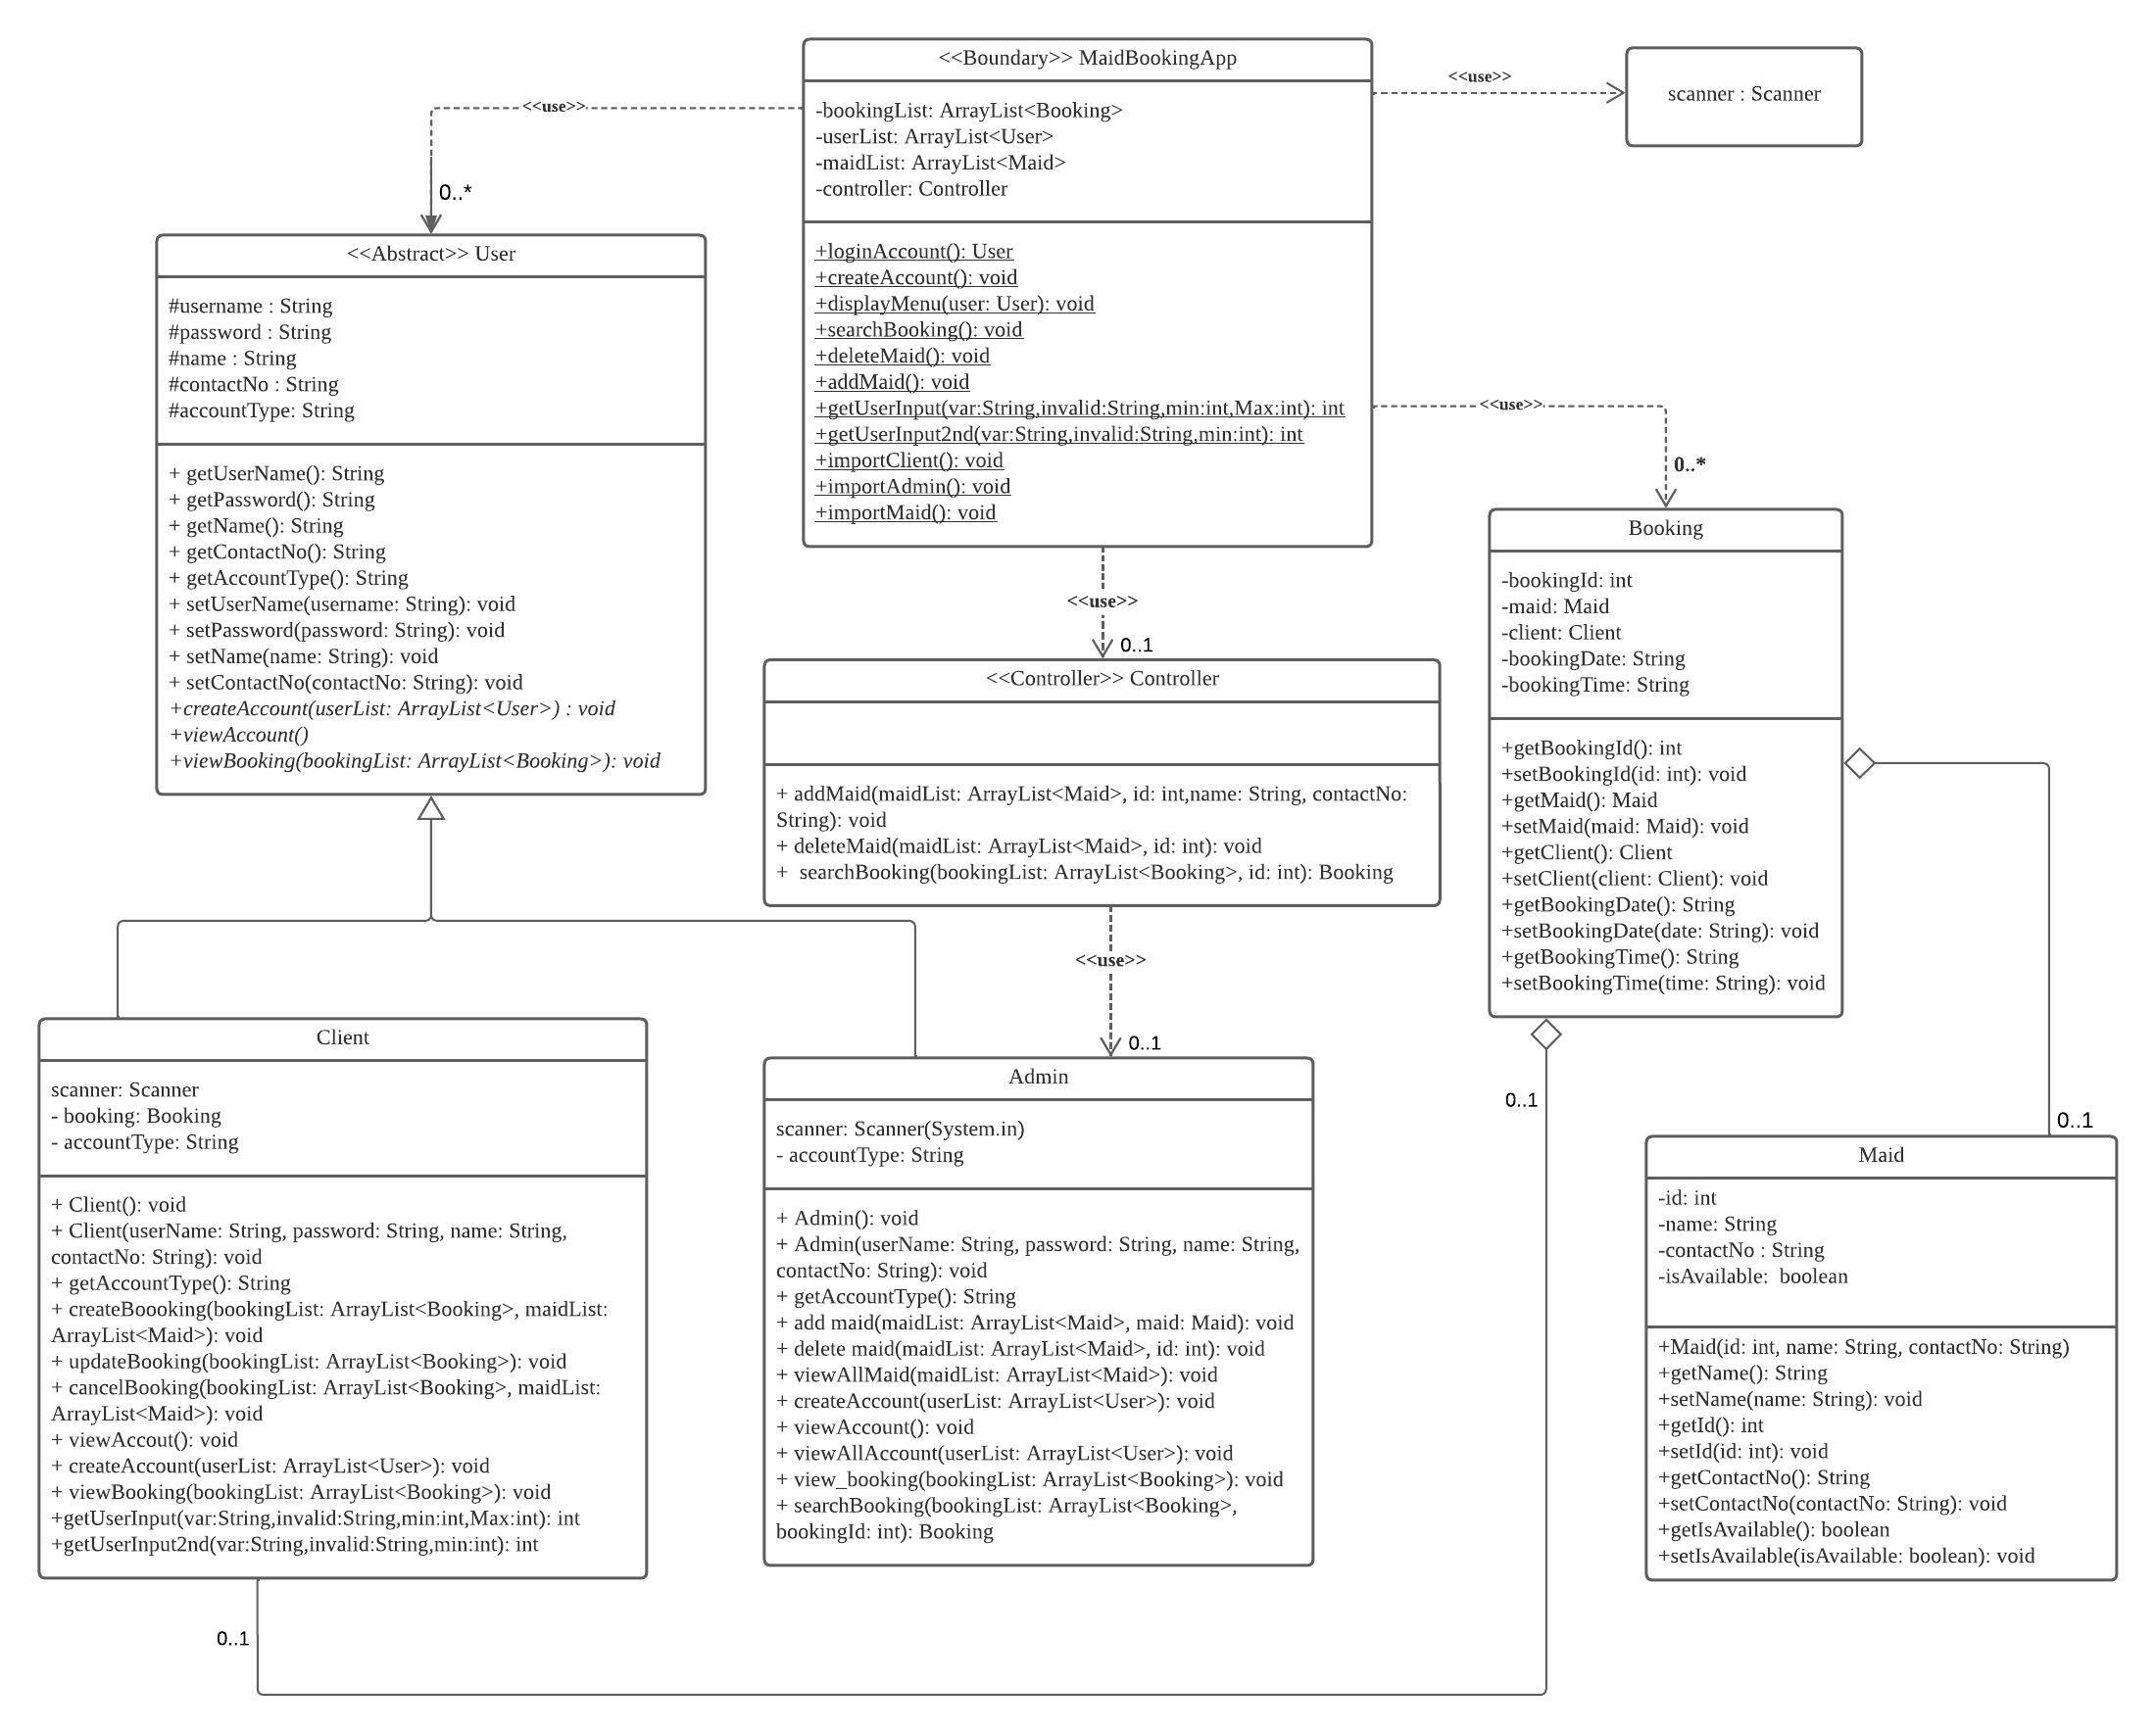

**Package Diagram**

