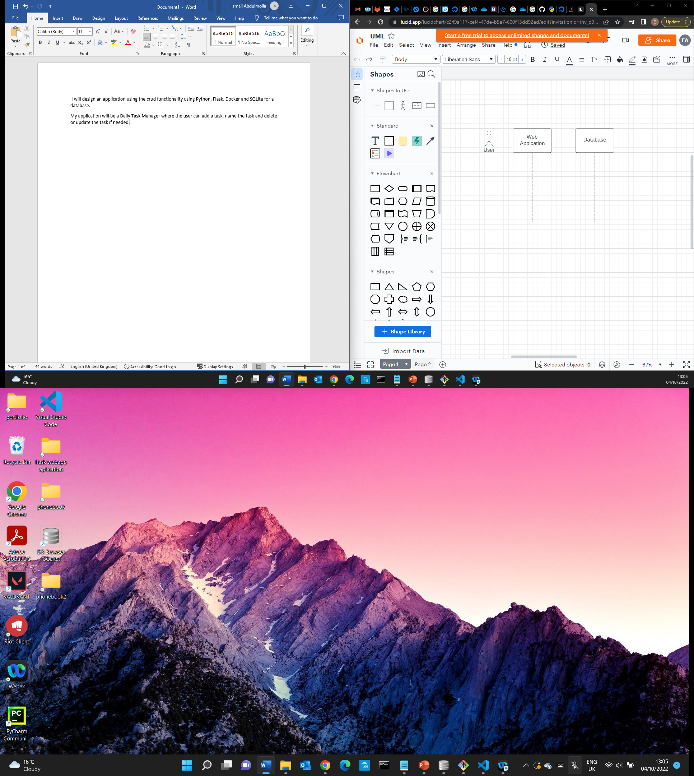

Task edited

Information ok

Information received

Edit information task

(Else)

Alternative

(If task is edited)

No Task created

Information invalid

(Else)

(If task input is valid)

Alternative

new task added

Information ok

Information filled

Insert information regarding task

Information invalid

No Task edited

Delete task

Remove information

Information removed

Task deleted