Hi Azza,

Can you make me a website that resembles this

You can change where it says orders of over 40 to **“ Free Shipping on orders over $75 Enter Code: Freeshipping75”**

Where it says company name you can place the logo



Ill send you an updated logo picture later where it will be white background and black writing so it matches with the website.

For the tabs next to/ a little above the logo tabs will be Home Shop Contact US About US

In replace of the 3 pictures below, I would like a slide show of 3 pictures I will also attach separately and on here so you have an idea of what the look will be

 slide 1

 slide 2

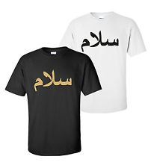 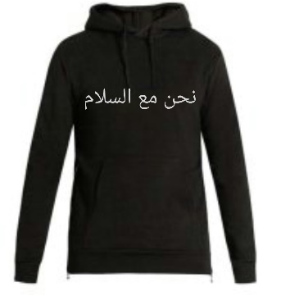 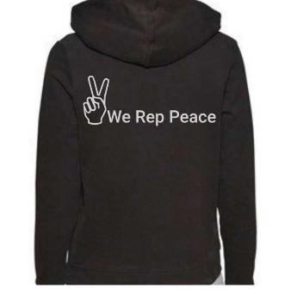slide 3

I want the slide show to be the same size as all 3 of the images below if they were 1 picture.

Under the slide show were going to write about the purpose of the brand and clothing, you can just leave space there for now for 2 short paragraphs

Under that we can have where it says SHOP

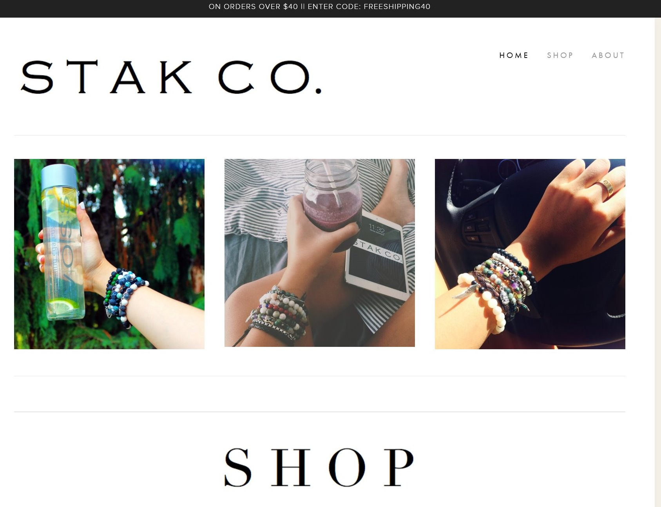

We are going to put 3items on the home page under shop and a click for view all after the 2 so they can be redirected to the shop page. Ill say 2 for now until we see what it looks like and if its too plane then we can switch them and make it 3 or 4. (let me know if that’s okay)

The 3 images under shop will be:

 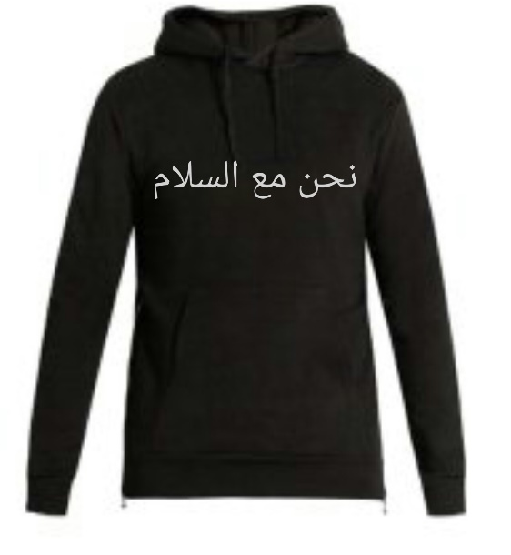

Salam/Peace Tee We Represent Peace

Colour: Colour:

Size: Size:

Quantity: Quantity:

$19.99 CAD $19.99 CAD

Add To Cart Add To Cart

(Can you make the add to cart an oval button)

At the bottom of the page you can make it black with white writing

We Rep Peace

Company Info Customer Care Follow us on

About US My account

Contact Us Return Policy Be the first to know about our deals Terms & Conditions Shipping & Handling |Enter Email | Sign Up

(put a white box for email here) email

Payment Methods

  

©2017 We Rep Peace .Co