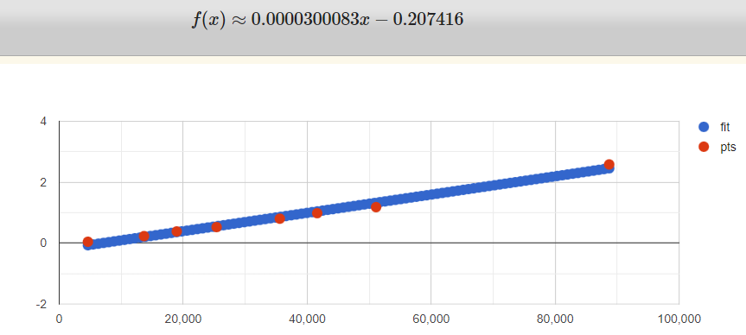IOC Attack:

|  |  |
| --- | --- |
| Length | Time |
| 4627 | 0.04506850242614746 |
| 13677 | 0.22993063926696777 |
| 18960 | 0.3840038776397705 |
| 25385 | 0.5260591506958008 |
| 35581 | 0.8019378185272217 |
| 41616 | 0.9830572605133057 |
| 51109 | 1.1799919605255127 |
| 88713 | 2.582995891571045 |

Shifted Text Attack:

|  |  |
| --- | --- |
| Length | Time |
| 4627 | 0.017000436782836914 |
| 13677 | 0.027997732162475586 |
| 18960 | 0.03899526596069336 |
| 25385 | 0.050998687744140625 |
| 35581 | 0.06307029724121094 |
| 41616 | 0.07199931144714355 |
| 51109 | 0.0899953842163086 |
| 88713 | 0.2090592384338379 |

Kasiski Attack

|  |  |
| --- | --- |
| Length | Time |
| 4627 | 0.052999019622802734 |
| 13677 | 0.4799988269805908 |
| 18960 | 0.6149959564208984 |
| 25385 | 1.3850171566009521 |
| 35581 | 3.501004695892334 |
| 41616 | 3.4640588760375977 |
| 51109 | 8.498991966247559 |
| 88713 | 23.649993181228638 |