**Instructions:** 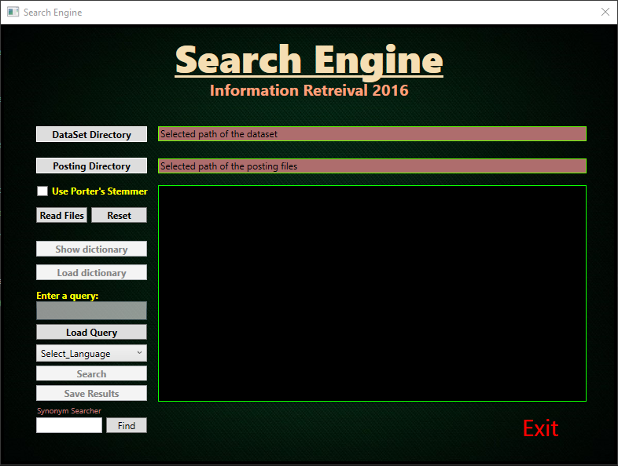

**Creating & Indexing the corpus**

1. Open the solution/.exe file.
2. Browse and select the collection folder using the ‘DataSet Directory’ Button.
3. Browse and select the posting folder using the ‘Posting Directory’ Button.
4. **Optional –** select the check box whether to use ‘Porter Stemmer’ or not.
5. Press the ‘Read Files’ files and stand by.
6. Press the ‘Show Dictionary’ once it is enabled.

**Queries & Ranking Documents**

1. Either create a new dictionary or load a dictionary after selecting the posting directory.
2. Write a query in the text box or load a query file with optional multiple queries with the ‘Load Query’ button.
3. **Optional –** select the check box whether to use ‘Porter Stemmer’ or not.
4. **Optional –** select a language to seek documents in that language.
5. Press the ‘Search’ button and stand by for results.
6. Save the results file of the document ranking by pressing the ‘Save Results’ button.

**Find Synonyms**

You can find synonyms to a given word by writing it in the text box under the label “Synonym Searcher” and pressing the ‘Find’ button.

**Pre-Installation:**

**Tools > NuGet Package Manager > Package Manager Console > Write:**

**Install-Package WPFToolkit**