DP.324041599.314827478

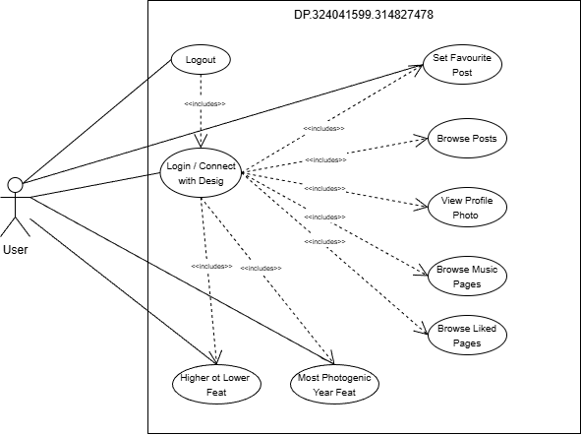
Use Case Diagram

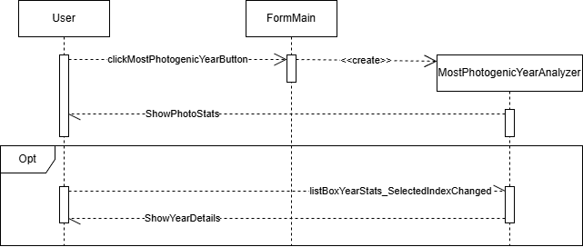
Most Photogenic Feature Sequence Diagram

Higher Or Lower Game Sequence Diagram

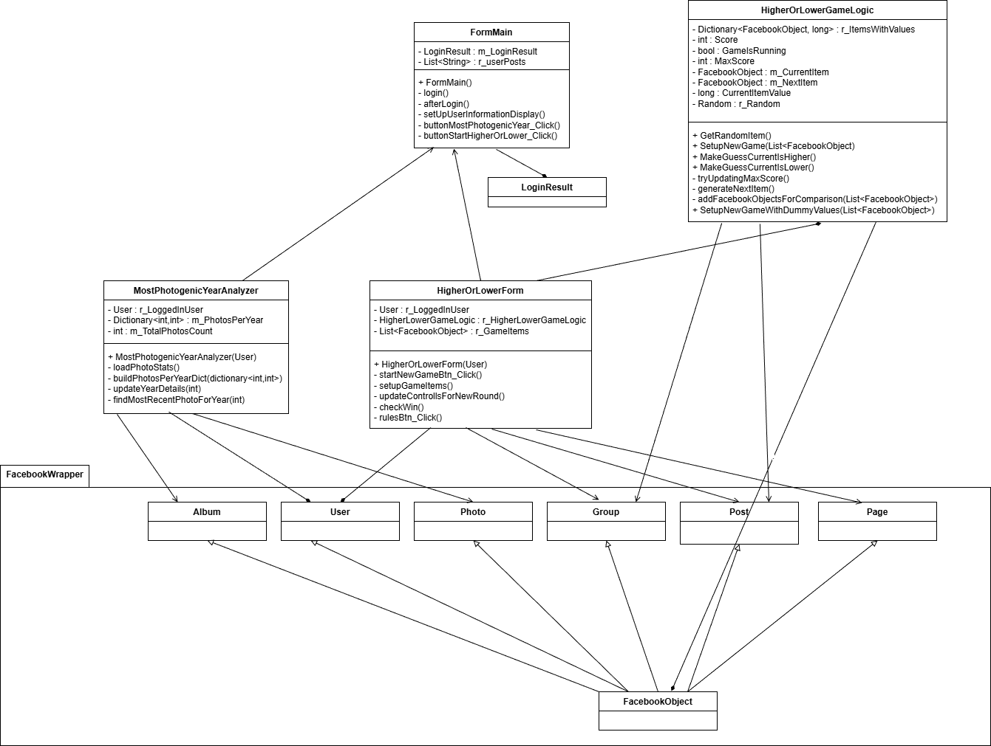
Class Diagram

