Final Project

Eitan Klein – 215013186

I Eitan Klein with the I.D. # of 215013186 declare that the answers given on this assignment are my own, without receiving answers or assistance from other students, family members, or other people.

**Part 1 – Resume**

1. Resume for 8200

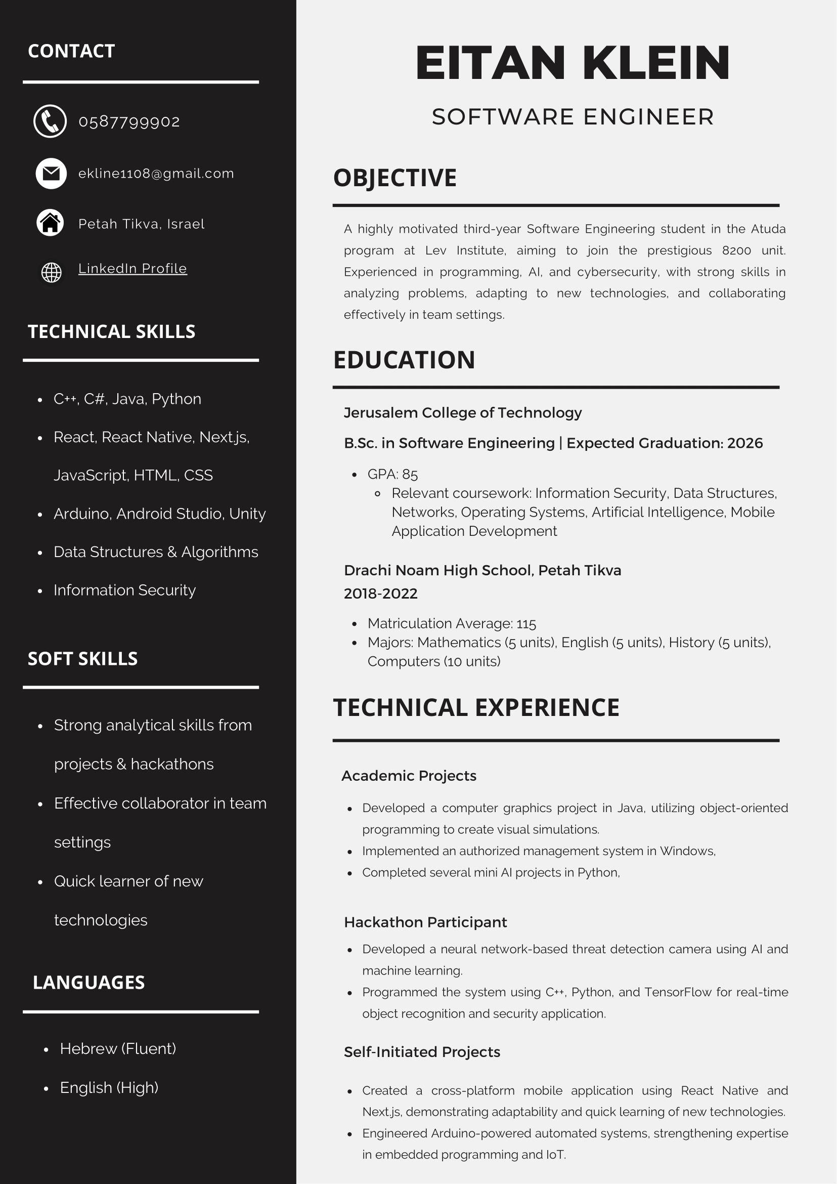

1. Rewrite for Mobile Physics: App Development Engineer

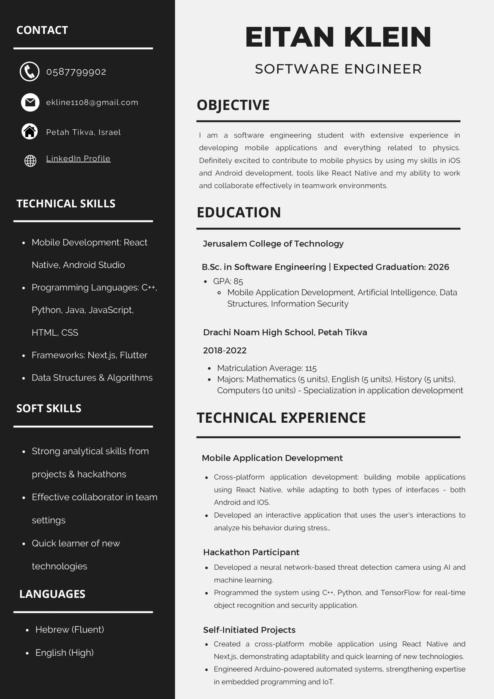

**Part 3 – Emails**

From: [EitanK@gmail.com](mailto:EitanK@gmail.com) To: [Johndainty@THATIS.com](mailto:Johndainty@THATIS.com)

Subject: Meeting with TAKA - Presentation Topic and Program Updates

Dear John.

I hope this email finds you well.

Regarding the annual meeting with TAKA on February 27, 2025, I am happy to share updates on the computer software I have developed. In addition, I would like to propose a topic for a 10-minute presentation that we can present at the meeting.

1. **Program Description and Marketing Potential:**

One of the main project s I worked on is a physics-based simulation application intended for educational and research purposes. Built using React Native, this app offers users the ability to run real-time simulations on both iOS and Android platforms. The application has significant marketing potential in the academic sector, as well as in industries that require mobile-based simulation tools.

1. **Presentation Topic Proposal:**  
   I would like to present on the topic **"The role of cyber security in economic cooperation between the US and Israel"**.

Given the criticality of cyber security in both countries, this topic will highlight the intersection of security concerns with technological innovation, making it highly relevant to both THATSIT programmers and TAKA I believe this will encourage an important discussion about how programming tools and techniques can strengthen these partnerships.

Finally, I would like to confirm my commitment to conduct myself in a professional and non-political manner throughout the meeting. In addition, I am not aware of any anti-Israel tendencies in the company, but I will let you know if anything arises.

Please feel free to reach out with any feedback on the presentation topic.

Have a nice day,

Eitan Klein | Software Engineer

[EitanK@gmail.com](mailto:EitanK@gmail.com) | 058 – 7799902

**Part 4 – Problem-Solving and Office Skills**

1. Case #1:

If Robert really does not know how to overcome the problem, he has several options to do.

First, and it may sound strange to say, but he should take a short break[1]. Sometimes our problem is not the code but the mind. Nothing will happen if you take a short break to refresh yourself.

Second, he can always ask the person responsible for him[2]. Not immediately, and not before he tried himself, but if he is really stuck - it is not a shame to ask for help. Then, if there is no other choice, he can try to avoid the problem, try to make the site work despite the problem. This process is called a workaround[3].

In conclusion, if Robert encounters a problem that he cannot solve he can try to solve it in several ways, it starts with taking a short rest to refresh himself, he can ask his superiors, and if there is no choice he can try to find ways to avoid the problem without actually solving it.

1. Case #3:

If Steve thinks his work is monotonous, he has several ways to increase the motivation to work. The first recommendation is to look at the full picture[4]. Maybe the task he got is a bit boring, but he can look at it as something important and meaningful for the whole project, it could be that without this task the whole project's meaning is stuck. Another way is to mark and "celebrate" achievements[5], even if they are small and insignificant. This way can make work easier and add interest and satisfaction. Steve could also consider diversifying the tasks he performs[6]. Carrying out several tasks or sub-tasks, if possible, can definitely help to maintain interest and motivation.

In conclusion, with the help of several steps, such as diversifying his work, rewarding himself for processes however small they may be or even just changing his general outlook on the project, Steve can maintain high motivation even in tasks he finds monotonous.

**Part 5 – Reflection**

1. Resume

* I learned that in the CV you must write certain words so that the robot that goes through them even offers you as an option
* I learned that you should insert links to GitHub and LinkedIn even though you apparently write the same things in your resume
* I learned that it is important to adapt the resume to the position you are looking for, and not to write about yourself in general and hope that they will look for you

In my opinion, the most useful thing is the keywords that should be included because you don't imagine a robot going through all the resumes and filtering them according to that and it's important to know that to get the opportunity to even be interviewed.

1. Interview

* I learned that there are questions called crooked questions, which you need to know how to prepare for and that there is a way to answer them so that the interviewer understands how you think.
* I learned the way to answer questions, which is important to constantly mention and refer to the projects and experience you have in the field, even if the question seems less related, you can link it to this.
* I learned that there are things that the interviewers want to hear, even if it sounds artificial, for example it is important to ask the interviewer questions about the job, and that even in the content of the question itself there are questions that the interviewers want to hear.

The most useful thing in my opinion is the reference and the link between answers to projects and experience. Most of the interviewers are looking for experience and if you emphasize it over and over at the end it will get into their heads.

1. Presentation

* I learned that even the simplest design is important, even the images that are on each and every slide.
* I learned that it is important to have an orderly structure for the presentation, both for the person who wrote it and for the listeners.
* I learned that it is good to concentrate on three main topics that you want to convey, no less and no more.

The most important thing we learned in this part is that you should invest in the order of the presentation. At first the presentation I made was disorganized and it was difficult for me to deliver it. After I arranged it and organized it according to the instructions they gave us, I understood it and conveyed it better, and it made order both for me and for the listeners.

1. Email

* I learned that the subject line of the email is important and should be paid more attention.
* I learned that the email shouldn't be too long, most of the time people just skim through emails and don't read to the end.
* I learned that when writing an email, you have to pay close attention to what you write and the way you express what you want.

In my opinion, the most useful thing we learned is the way in which the email is worded and written. You can write an email and invest in what is written in it but in the end, it will fail to achieve its goal or worse.

1. Office Skills

* I learned what work meetings look like, what should be said in them and how to optimize them.
* I learned about how to become an active listener, and I realized how important this is especially in workplaces.
* I learned the importance and ways to manage disputes and arguments in the workplace.

I think the most useful thing I learned in this unit is active listening. Beyond the advantages that this feature has in the workspace, I think it is also extremely important in our daily lives with the people who live around us, so it is even more relevant.

1. Problem-Solving

* I learned creative ways to solve code problems like going layer by layer or inserting a console.log to understand where the code stopped.
* I learned that if you get stuck and can't move forward even if you're an employee you can ask the boss for help and say you didn't make it and it's still legitimate and that even finding ways around the problem without solving it is fine.
* I learned ways to get some motivation during work, however boring it may be.

In my opinion, the most useful thing we learned in this unit is the ways to stay motivated. Often programming work can feel monotonous and boring especially in a commercial workplace therefore if you choose this profession as a career it is important to know about ways to maintain motivation and energy.

1. PMI

**Positive**:

The course deals with important and meaningful things that we will have to experience in the coming years upon graduation and I think that the content of the course gave me a taste and preparation for the future.

**Negative:**

I think there was a bit of a mix-up between the goal of learning English and the goal of preparing us to go to work, it was easy to miss one of the goals and maybe it would be better to focus on one goal more clearly.

**Interesting:**

It was very interesting for me to learn about the whole process of a job interview, what to say to the interviewer about methods of how to answer questions and all kinds of other tips.

**Overall Rating:**

In general, I enjoyed the course, the materials were interesting and relevant, the projects were nice and included our sharing during the learning.

1. Codemzy, " 6 ways to fix your code when you don’t know why it doesn’t work", <https://www.codemzy.com/blog/how-to-fix-code-not-working>, 2023
2. Gorick Ng (Ted Talk), "How to Succeed in Your New Job | The Way We Work, a TED series", YouTube <https://www.youtube.com/watch?v=WgR6mUSsEig>, 2023, video-minutes 1.40-1.58
3. ITFreeTraining, " Troubleshooting Basics", YouTube <https://www.youtube.com/watch?v=tKrkoxrY2wc>, 2021, video-minutes 10.25
4. Brian Tracy, " 5 Ways to Stay Motivated at Work | Brian Tracy", YouTube <https://www.youtube.com/watch?v=KIXeEJYtAG8>, 2020, video-minutes 6.05-7.05
5. Carol-Theodor Pelu, "How to Keep Yourself Motivated as a Software Developer", <https://www.freecodecamp.org/news/how-to-keep-yourself-motivated-as-a-software-developer/>, 2020,
6. .Jay B, "You're drowning in monotonous programming tasks. How can you stay focused and motivated in the chaos?", LinkedIn <https://www.linkedin.com/advice/3/youre-drowning-monotonous-programming-tasks-how-can-vrjfe>, (No Year)