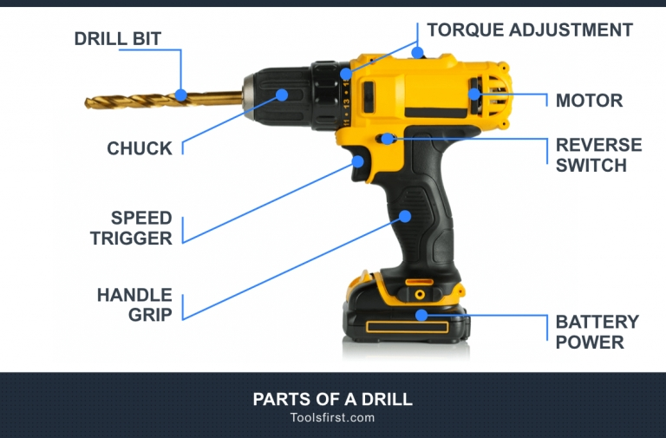

## POWER

There are two drill options, corded (AC) and cordless (DC). The power of [corded drills](https://toolsfirst.com/best-cordless-drill/) is measured in amps, while cordless drills use batteries rated in volts. A higher amp or volt rating directly correlates to more power aka rotational force or torque.

[A corded drill](https://toolsfirst.com/best-corded-drill/) is the most powerful option. They also maintain a consistent level of power output due to being connected to mains electricity and never need to be recharged. Without the need for an onboard battery, they are much lighter and smaller in design. They are, however, limited by the length of their cord, although an extension cable can be used for more range. The cord is a potential trip hazard so be sure to take care while using a corded drill.

Cordless drills are by far the more convenient of the two due to the lack of cord. This allows for complete freedom during use, ideal for a variety of jobs indoors and out. Despite the convenience, they are slightly heavier and larger because of the battery. The battery will also drain during use, leading to a gradual drop in power. Having a few batteries to switch between can negate this issue but still requires you to stop working to switch out batteries and put the used one on charge. These batteries are likely to be compatible with many other cordless tools such as a circular saw or impact driver, making them a worthy investment.

## HANDLE

The handle is self-explanatory. Today’s models have ergonomically designed handles to make the user experience as fatigue limiting and comfortable as possible.

## TRIGGER

The trigger is used to power the drill. An entry-level drill may come with a single-speed trigger while more expensive models have variable-speed triggers. Variable speed triggers allow you to control the bit rotation speed by how much pressure you apply to the trigger, great for taking on a range of jobs. They also tend to come with speed setting switch with 2-4 settings, typically ranging from 200 – 2,000 RPM.

## REVERSE MODE SWITCH

Alongside a trigger, drills have a reverse mode switch usually located just above the trigger for easy access. This switch determines whether the bit spins in forward or reverse and is used to extract material while removing the drill bit from the hole easily.

## TORQUE ADJUSTMENT COLLAR

Clutch settings on a drill are adjusted by turning the torque adjustment collar. The collar will have a range of numbers, typically 20 or more, that relate to the torque setting with 1 being the lowest. If there is too much resistance, the clutch disengages the motor. Simply adjust the collar to a higher setting until enough force is delivered by the motor to drive to your desired depth.

When using a new drill it may take some time to learn which torque setting you need to use to avoid damaging different materials while fastening screws and avoid over-tightening them. Over time you will learn which settings are appropriate for different materials.

## CHUCK

The chuck is a mechanism by which the drill or screwdriver bit is fastened. Drills originally came with keyed metal chucks which required a special tool to secure the bit into place. Nowadays, they have switched over to a keyless metal chuck design which allows the user to tighten bits by hand as opposed to using a tool. Chucks come in 1/4″, 3/8″ and 1/2″.

## DRILL BIT

Although drill bits are not part of a drill, without them they are essentially useless. Bits come in a range of shapes and sizes of various diameter, each designed for different materials and job types. The drill bit you should use depends on the type of drilling you plan on doing. For an in-depth look at two of the most popular bits, check out our [cobalt vs titanium drill bits article](https://toolsfirst.com/cobalt-vs-titanium-drill-bits/).

## SHANK

The end of the drill bit secured by the chuck is known as the shank. Different shank and chuck combinations affect performance parameters such as centering accuracy and torque. The most common shank types are hexagon and round in shape. Hex shanks are best for drilling hard material as they better secured by the chuck and thus less likely to slip.

## CONCLUSION

On the surface, a drill may be one of the easiest tools to use but if you’re to learn how to use a drill to its upmost potential you must understand all of the parts.

There is more to using this tool than simpling squeezing the trigger to drill holes and fasten screws. Everything from the bit and shank combination, chuck size and clutch setting must be taken into account. Knowing all parts of this machine is vital if you are to get the most out of it

**PROCEDURE HOW TO USE DRILL**

## Step 1: Select a Drill Bit

Prior to selecting a drill bit, it is very important to determine the size and depth of the hole you are drilling. When doing work with screws, pilot holes are very important to prevent the wood from splitting. The diameter of the drill bit for the pilot hole should be the same as the diameter of your screw without the threads.

If you plan on tapping the hole that you are drilling, that is, threading it so that you can screw a bolt in, look up the proper pilot hole sizes for the bolt you plan on threading. If you know the size of the bolt, you can use [this](https://www.lincolnmachine.com/tap_drill_chart.html)chart.

Screwdriver bits (farthest right) are useful when using a hand drill to drive screws; they do not drill holes of any kind.

Twist drill bits (second from the right) are the most frequently used and are generally used for cutting smaller, more standard holes into the material, including wood and metal. When you are planning on drilling a large hole with a twist drill bit, make sure to start with a smaller drill bit and widen the hole in stages; starting with a large bit can create a sloppy hole, make the bit more easily walk, and it might take very long to get through the material. This is important to consider once you start using drill bits greater than or equal to a quarter inch.

Forstner bits (middle) are capable of drilling large holes in wood and can go either partially or completely through the material. Forstner bits can also be used to drill angled holes into the material.

Spade bits (second from left) can more easily bore large holes into wood than a twist drill bit, and the holes can either go through the material partially or completely.

Hole saw bits (farthest left) are capable of drilling larger holes than spade bits, but cannot make partial cuts. Depending on what kind of saw the bit is made of, hole saw bits can be used on wood or metal.

## Step 2: Put the Chosen Bit Into the Drill

Loosen the chuck (the black circular section on the front of the drill) by twisting it counterclockwise to widen the diameter of the jaws that clamp onto the drill bit.

Insert the shank (smooth part) of the drill bit into the jaws, and re-tighten the chuck until the drill bit is secured. Make sure the bit is centered and that the jaws clamp onto the flat sides of the shank. Also, make sure that you don't secure the jaws around the flutes of the bit; that will increase the risk of breaking the bit you are using, especially for smaller bits.

To tighten the drill chuck more quickly and securely, you can carefully grab the chuck, being cautious to avoid holding the drill bit itself, and slowly run the drill in a clockwise direction. Similarly, grabbing the chuck and running the drill counterclockwise will loosen the chuck.

## Step 3: Check All Other Settings

Make sure the drill has a charged battery in it. Using a battery that isn't charged enough can lead to slower, ineffective drilling.

Check the speed settings on the drill -- the big switch on the top. Setting 1 is low speed and high torque, which is ideal for uses such as driving screws into the material. Setting 2 is high speed and low torque, which is good for drilling holes. You will likely be using the faster setting for most tasks, and the slower setting if you are drilling large/deep holes in wood with a twist bit.

Make sure you're drilling in the right direction. If the drill bit is facing away from you, clockwise is for cutting/ screwing into material, and counterclockwise is for removing the bit/ unscrewing. If this is hard to visualize, run the drill slowly and pay attention to the direction the flutes of the bit are moving in, and what direction they need to be moving in to cut material. The reverse direction should only be used for unscrewing fasteners/screws. Change direction using the buttons on either side of the handle, just above the trigger.

Also pay attention to the dial around the chuck of the drill; the numbers indicate torque settings, and are useful when driving screws. If the number is set too low, the drill will stop spinning and make a clicking noise under a lower amount of pressure. If the torque setting is too high, the screw bit might slip against the top of the screw and you risk rounding off the screw head. When drilling, make sure the dial is always turned to the drill bit symbol (or the highest number, if there is no symbol).

## Step 4: Set Up Your Material

Make sure the material you are drilling into is secured to a sturdy surface, either with clamps or a vice. Usually, clamping a scrap piece of wood under the material is a good idea because it allows for a cleaner edge where the drill exits.

Make sure you have enough clearance to avoid drilling into a table or a vice.

Precisely mark the holes you will be drilling into the material using proper marking techniques, covered in the marking instructable [here](https://www.instructables.com/id/How-to-Mark-Material/).

## Step 5: Drill the Hole

Make sure the tip of the drill bit is touching the material before you start drilling, and that the drill bit is held at a reasonable angle. In most cases, when going straight through the material, this means that the drill bit will be perpendicular to the material.

Pull the trigger and start drilling slowly. Once the bit cuts slightly into the material, you can speed up and apply constant pressure until you have cut all the way into the material.

Once you are through, make sure the drill is spinning in the same direction and pull the bit out. This helps clean the hole that you just drilled.

## Step 6: Examine the Hole

If the hole you have drilled was for a fastener, make sure that fastener fits in the hole relatively easily (bolts, screws, rivets). If it doesn't, either go through the hole again with a slightly larger drill bit, or use the same drill bit and ream out the edges by twisting the drill slightly in a circular direction while drilling.

## Step 7: Clean Up

When all of your holes are drilled, make sure to remove the drill bit and put it back i

n its appropriate place. Put the drill away and the battery in a charging dock, and then vacuum any chips or dust on your work surface or the ground.

**SAFETY PRECAUTIONS**

Make sure your workspace does not have any slippery hazards on the floor. If there is any slip contact, you might slip and fall on any of these machines, and that can be disastrous.

Make sure you ensure the chuck guard is always in position.

Make sure the key to the chuck is removed when not in used. Do not make that mistake; make sure the key is removed.

Be familiar with the on/off switch of the e-shop, get used to it, and ensure that you know how to turn it off and on when need be.

Make sure you correct every clamp and ensure that the rules are adhere correctly in the shop.

Make sure you create a safe path away from the work area.

Ensure the drill speed of the cutter is well spindled to suit it well.

Faulty-equipment must-not be used. Immediately-report suspect equipment. Make sure that at the slightest error of fault on any machine, you try to fix it.

Do not leave the-drill press on while it is still being used, never do that.

Anything you going to clean the place or the machines, make sure you switch off the machines before you start cleaning. Never assume the machines are off before you start cleaning. If you are not sure, please check well.

Always make sure you feed the drill cutting machine at the downwards rate, to ensure you are safe and avoid any accident.

Make sure the drill works through the underside, to ensure that the drill is working accurately and well.