**11.** Differentiate the Two parts of Computer;

**Hardware**

Any physical component of a computer is referred to as hardware. This includes components like keyboards, monitors, and the inside workings of gadgets like hard drives and microchips.

**Software**

Software, which includes computer programs and mobile apps, is anything that instructs hardware on what to do and how to do it.

12**. Describe the four categories of hardware. Cite example for each category.**

**Input Devices**

are tools that are used to input data or commands to the central processor unit. are categorized according on the process they employ

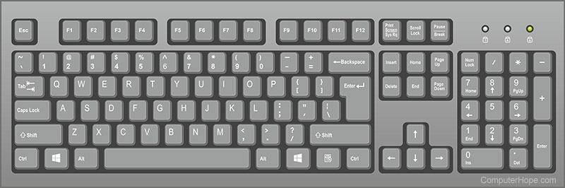**Example:**

* **Keyboard**

Using a keyboard, we as a user can enter letters, words, and numbers into your computer. When you type, you press each key on the keyboard separately.

**Output Devices**

The output category includes hardware elements that disseminate and display information as well as data. The result of a cycle that begins with the entry of raw data and processing is output. These elements fall under the categories of output for both softcopy

Example:

* **Monitor**

an output device that shows information as text or images. A discrete monitor consists of an external user control panel, a visual display, support circuitry, a power supply, and enclosure.

**Storage Devices**

It was categorized as a memory/storage device. Under primary and secondary memory, storage is separated. Either they are volatile, or they aren't.

Example:

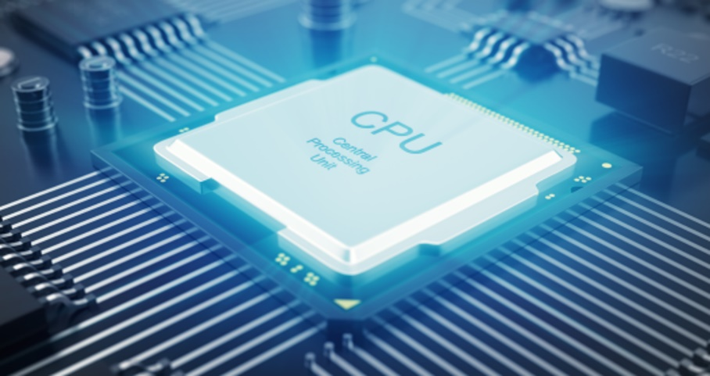**CPU**   **Computer memory devices**

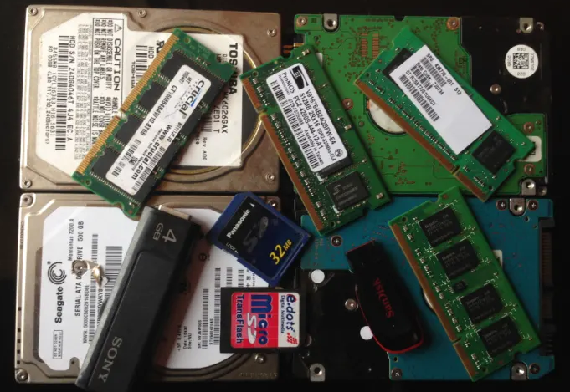

**Processing Devices**

Processing is the core function of a computer. It is the stage where raw data is transformed into information. Once data has been processed, it can be used for useful purposes.

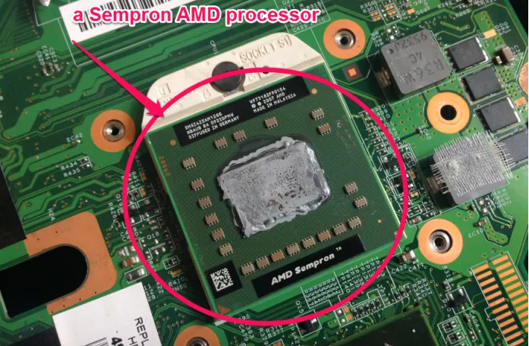**Example**

**Microprocessor**

The main item in this category is the microprocessor. It tightly coordinates its operations with primary memory. During processing, data is temporarily stored in the processor cache and main memory.