Republic of the Philippines

**TECHNOLOGICAL UNIVERSITY OF THE PHILIPPINES**

College of Industrial Education

Ayala Boulevard cor. San Marcelino St. Ermita, Manila 1000

Telefax (02) 523-2293, Tel Nos. (632) 521 – 4063, Website: <http://www.tup.edu.ph>

SEM 3 Seminar in Professional Education

Activity No. 5

**Educational Technology**

**Learning Outcomes:**

1. Employ teaching strategies, methods, instructional materials and technology, classroom management techniques appropriate to subject areas and inclusive of learners from indigenous groups.
2. Demonstrate skills in developing and using a variety of conventional and non -conventional resources including Information and Communication Technology to address learning goals and needs of various learners.

**General Instructions**: Answer the following questions.

1. Discuss the following concepts:
   1. Education
   2. Technology
   3. Educational Technology
2. Describe/Discuss the following Philosophical Framework behind Educational Technology
   1. Behaviorism
   2. Cognitivism
   3. Constructivism
3. Identify the purpose of Visual Devices
4. What are the traditional forms of Visual Aids? Describe each.
5. The following are different classification of Devices. Describe each and cite example.
   1. Extrinsic
      * 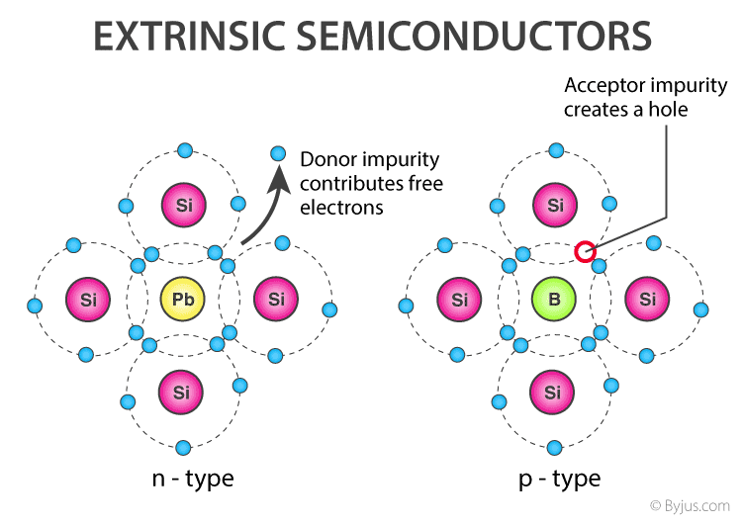Extrinsic semiconductors are **semiconductors that are doped with specific impurities**. The impurity modifies the electrical properties of the semiconductor and makes it more suitable for electronic devices such as diodes and transistors.
   2. Intrinsic
      * The standard ensures that an "intrinsically safe device" is **incapable of triggering combustion or igniting any gasses or fuels**. To put it simply, you can use it around gasses or fuels without risking static electricity or heat discharge from the device igniting the surrounding volatile gasses, powders and liquids

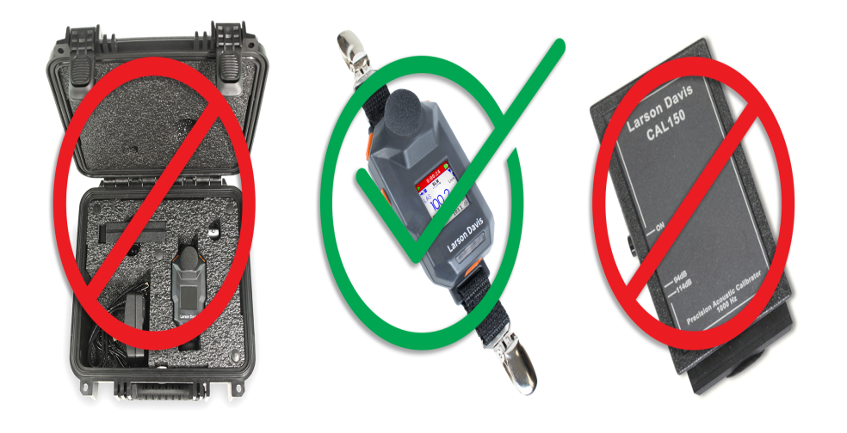

* 1. Material Devices
     + Materials for devices are materials employed in devices because of their particular properties, such as electrical, thermal, magnetic, mechanical, ferroelectric or piezoelectric properties.

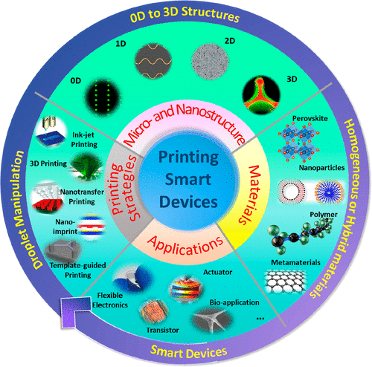

* 1. Mental Devices
     + A word, phrase, object, or process used to help a person relax.

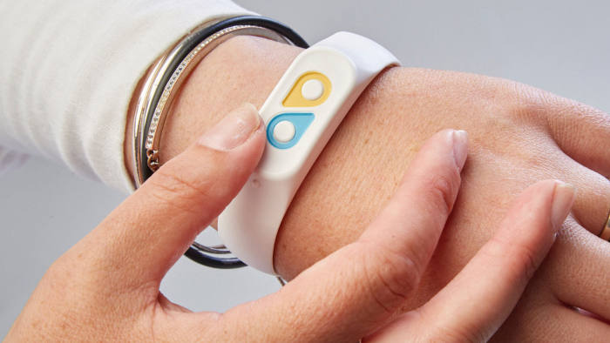

1. The following are the role of computer in the teaching and learning. Explain each.
   1. Computer as object of instruction

- They **allow students to progress at their own pace and work individually or problem solve in a group**. Computers provide immediate feedback, letting students know whether their answer is correct. If the answer is not correct, the program shows students how to correctly answer the question.

* 1. Computer as tool for instruction

- Computers have revolutionized the teaching profession in multiple ways. Teachers use computers to **record grades, calculate averages, manage attendance and access data on student performance in online programs and assessments**. Computers have also made it easier for teachers to vary their instructional delivery.

1. Explain the following:
   1. Distance Education
   2. Massive Open Online Courses (MOOC)
2. Differentiate synchronous distance learning from Asynchronous Distance Learning. Complete the matrix below.

|  |  |
| --- | --- |
| **Synchronous Distance Learning** | **Asynchronous Distance Learning** |
|  |  |

1. Describe the following theories and principles in Educational Technology. Use illustration to better explain each theories or principles.
   1. Dale’s Cone of Experience
   2. Three Fold Analysis of Experience by Jerome Bruner
   3. TPACK Framework
   4. Gagne’s 9 Instructional Events
   5. Merill’s Principle of Instruction
   6. Levels of Technology Integration
2. Illustrate and describe the following Instructional Design Model
   1. ADDIE Model
   2. ASSURE Model
3. Differentiate the Two parts of Computer;
   1. Hardware
   2. Software
4. Describe the four categories of hardware. Cite example for each category.
   1. Input Devices
   2. Output Devices
   3. Storage Devices
   4. Processing Devices