RESEARCH AND SURVEY STATISTICS – STA3022F – 2018 1st Semester
COMPUTER PRACTICAL 1
CHAPTER 6. ANOVA + ANCOVA and CHAPTER 7. MLR

- Open Rstudio
- Save the following files from VULA
prac1.R
scheffe.R
houseprices.csv
happiness2014.csv (this is your data for the practical assignment)

- Open the script file prac1.R.
From the top menu, select File > Open File
Select the file prac1.R which you saved from Vula
Click Open
The script file appears in the Window in the top left.

- Throughout the practical you will be working with houseprice data set. This dataset includes sales prices of houses advertised on gumtree by an agent and some other relevant information about the houses such as area, number of rooms etc.

Import the data file houseprices.csv into your R workspace as follows:
From the top menu, select Environment > Import Dataset > From Text File

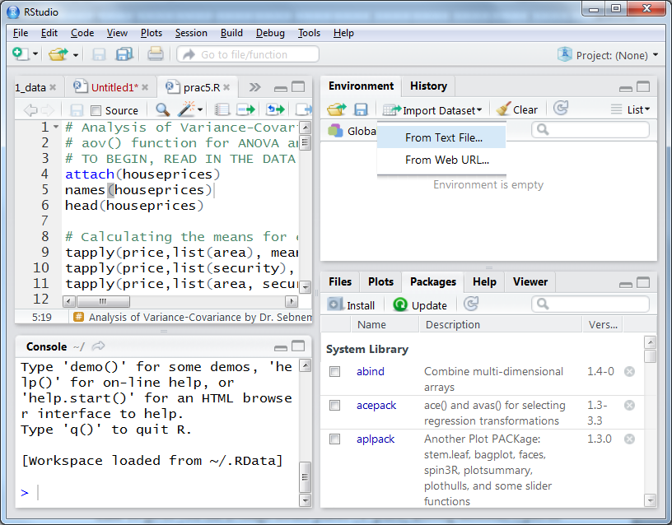

OR
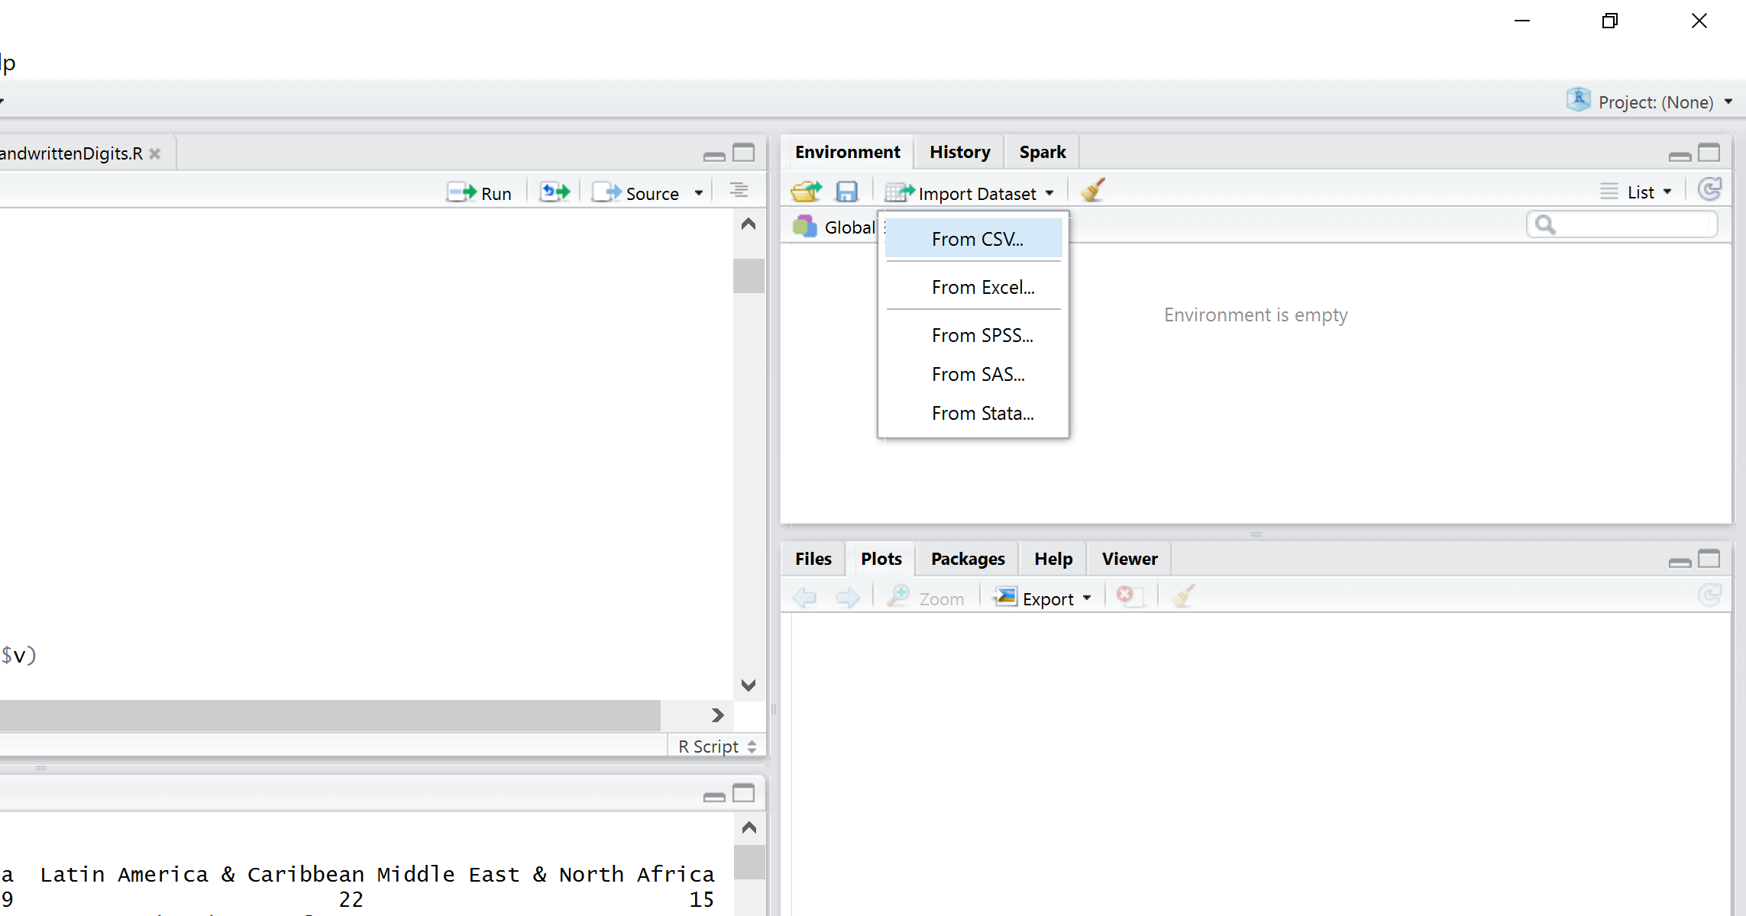

Navigate to the directory where you saved your data file houseprices.csv
Select houseprices.csv file and click OPEN

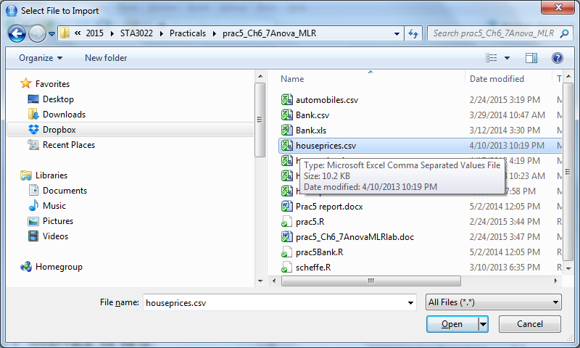

DO NOT CHANGE THE NAME
Select YES for HEADING and click IMPORT

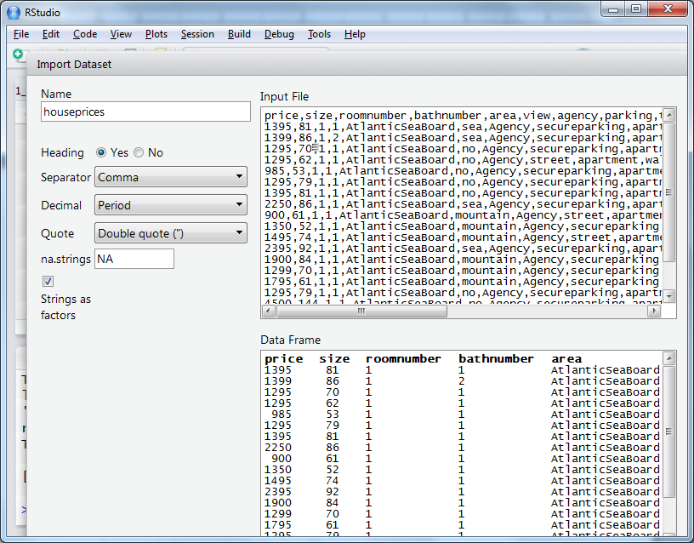

The variables in the dataset are coded as follows:

price: price of the house (in thousand rands, 1395 means that the house price is 1395000 rands)
size: size of the house (m2)
roomnumber: number of rooms in the house
bathnumber: number of baths in the house
area: Atlantic sea board/city bowl/northern suburbs)
view: no view/mountain view/ sea view)
parking: secure parking/street parking)
shops: walking distance/no shops around
balcony: yes/no
furnished: yes/no/half
pets: notmentioned/friendly
security: no/24 hour
GymPool: yes/no
Location: Location of the house

- Execute line 3 in the script file prac1.R

This will give a general name to the houseprice dataset such as “datatowork” so that for your assignment and your future work, you can simply change this line without changing the rest of the script:

- To see the names of the variables in the dataset:
execute lines 4-5 in the script file prac1.R

> names(datatowork)
[1] "price" "size" "roomnumber" "bathnumber" "area"
[6] "view" "agency" "parking" "type" "shops"
[11] "balcony" "furnished" "pets" "security" "GymPool"
[16] "Location"

- To see what the data looks like, print the first 10 rows:
execute line 6 in the script file prac1.R

- DEFINE YOUR VARIABLES

Define all of your variables. Your dependent variable is “y” and all the other variables will be “x”s.

Select lines 8-10 in the script file and run the code. This will set your “y” and “x” variables. “y” variable in this example is the house price (coded as “price” in the dataset) and the “x” variables are “area” and the “security” variables. These variables are the categorical variables.

> y = price
> x1 = area
> x2 = security

FOR CHAPTER 6 ANOVA

- To see the mean house prices according to different types of areas and security:
execute line 13-15 in the script file prac1.R

Line 13 gives you the mean house prices (y: price) among different types of areas (x1: areas).
Line 14 gives you the mean house prices (y: price) among different types of security (x2: security).
Line 15 gives you the mean house prices (y: price) among different types of areas and security (x1 and x2)

- One Way ANOVA with x1 (“area” in this example)
execute line 19-20 in the script file prac1.R

- One Way ANOVA with x2 (“security” in this example)
execute line 23-24 in the script file prac1.R

- POSTHOC TESTS
R does not have a built in function for Scheffe’s post hoc test. In order to execute the Scheffe’s Test, we need to run the function called scheffe.R
From the top menu, select Code > Source File
Select the file scheffe.R which you saved from Vula
Click Open
The function is ready to use.

For x1 (area) postdoc test:
execute line 31 in the script file prac1.R

For x2 (security) postdoc test:
execute line 33 in the script file prac1.R

If you get an error as follows:

> scheffe(datatowork,y,x1,0.05)
Error: could not find function "scheffe"

This means you HAVE NOT called the scheffe.R file into R! Go back to item 13 and read carefully!

- Two Way ANOVA without interaction
Using both x1 (area) and x2 (security) variables:
execute lines 36-37 in the script file prac1.R

- Two Way ANOVA with interactions
execute lines 40-42 in the script file prac1.R

- ANCOVA using size variable. Select line 45 and run. This will define your numerical “x” variable such that:

> x3 = size

execute lines 46-47 in the script file prac1.R to apply an ANCOVA.

FOR CHAPTER 7 REGRESSION

- To see the correlations between the numerical variables that are stored in the first 4 columns of the dataset,
execute line 52 in the script file prac1.R

- For Adding dummy variables for Categorical Variables in MLR, the categorical variables should be saved as dummy variables. For x1 Area variable:
execute lines 55-58 in the script file prac1.R

- Dummy variable for x2 security variable:
execute line 61-63 in the script file prac1.R

- Select lines 66-68 and run in order to specify the numerical “x” variables that you are going to use in R. In this example, we will use MLR to see the impacts of size, roomnumber, bathnumber, area and security variables on house prices. Therefore we have to define the variables such that:

> x3 = size
> x4 = roomnumber
> x5 = bathnumber

In order to run MLR with all the variables, execute lines 70-71 in the script file prac1.R

- For the standardized regression coefficients we have to standardize the variables:
execute line 75-78 in the script file prac1.R
- Make a prediction of the price of a house that is 100m2, has 2 rooms and 2 bathrooms located in City Bowl area with 24 hour security:
execute lines 81-82 in the script file prac1.R
- For Stepwise MLR:
execute line 85-87 in the script file prac1.R
- With this last model obtained from Stepwise MLR, make a prediction of the price of a house that is 100m2 located in City Bowl area:
execute line 90 in the script file prac1.R

Practical VULA QUIZ DATASET:

- The data you are going to be working with is “happiness2014”. The World Happiness Report 2016 Update, which ranks 156 countries by their happiness levels, was released in Rome in advance of UN World Happiness Day, March 20th. The widespread interest in the World Happiness Reports, of which this is the fourth, reflects growing global interest in using happiness and subjective well-being as primary indicators of the quality of human development. Because of this growing interest, many governments, communities and organizations are using happiness data, and the results of subjective well-being research, to enable policies that support better lives. The data set you will be working is from 2014.

Resources:
https://media.gallup.com/dataviz/www/WP_Questions_WHITE.pdf
http://worldhappiness.report/download/
https://www.kaggle.com/unsdsn/world-happiness

- The variables are defined as follows:

wp5country: Country Name
country: Country Name
code: Country Code
region: Region of the Country
incomegroup: Income Group of the Country
lifeladder: distribution of happiness among and within nations continues based on individual life evaluations, roughly 1,000 per year in each of more than 150 countries, as measured by answers to the Cantril ladder question: “Please imagine a ladder, with steps numbered from 0 at the bottom to 10 at the top. The top of the ladder represents the best possible life for you and the bottom of the ladder represents the worst possible life for you. On which step of the ladder would you say you personally feel you stand at this time?”
loggdpcap: Natural log of GDP per capita is in terms of Purchasing Power Parity (PPP) adjusted to constant 2011 international dollars, taken from the World Development Indicators (WDI) released by the World Bank.
socialsupport: Social support (or having someone to count on in times of trouble) is the national average of the binary responses (either 0 or 1) to the Gallup World Poll (GWP) question “If you were in trouble, do you have relatives or friends you can count on to help you whenever you need them, or not?”
healthlifebirth: healthy life expectancy at birth are constructed based on data from the World Health Organization (WHO) and the World Development Indicators (WDI). WHO publishes the data on healthy life expectancy for the year 2012. The time series of life expectancies, with no adjustment for health, are available in WDI. First, the healthy life expectancy is ratioed to life expectancy in 2012 for countries with both data. Then the country-specific ratios are applied to other years to generate the healthy life expectancy data.
freedomchoices: Freedom to make life choices is the national average of binary responses to the GWP question “Are you satisfied or dissatisfied with your freedom to choose what you do with your life?”
generosity: Generosity is the residual of regressing the national average of GWP responses to the question “Have you donated money to a charity in the past month?” on GDP per capita.
perceptioncorrupt: Perceptions of corruption are the average of binary answers to two GWP questions: “Is corruption widespread throughout the government or not” and “Is corruption widespread within businesses or not?” Where data for government corruption are missing, the perception of business corruption is used as the overall corruption-perception measure.
confidencegovernment: Confidence in government are the average of binary answers to the “In this country, do you have confidence in national government?” question.

- The first thing you need to do is to extract the data into your working space. (Hint: Item 4,5)
You need to now change the datatowork to happiness2014:

> datatowork = happiness2014

If you do not do this, then you will still be working with the house price data set!!!

- To see what the data looks like, print the first 10 rows. (Hint: Item 6)

- Define your y and x categorical variables. (Hint: Item 8)
> y = lifeladder
> x1 = region
> x2 = incomegroup

PART 1 - ANOVA
- We are interested in knowing whether there is a difference in average life ladder (happiness) for all income levels as well as for all regions. You need to analyse the data if the claim is actually true.
  - Hint: 1 way ANOVA with “incomegroup” (see Item10, 11, 12) ;
  - 1 way ANOVA with “region” (see Item10, 11, 12) ;
  - 2 way ANOVA with “incomegroup” and “region” (see Item13);
  - 2 way ANOVA with interactions (see Item14))

PART 2 - MLR
- We are particularly interested in the relationship between the happiness of countries and several explanatory variables. Determine which of the variables can be used in predicting the happiness of countries. Define these variables first. (Hint: Follow the regression analysis steps when you are running your codes, Items16-23)
- Attempt the quiz available on VULA.

