RESEARCH AND SURVEY STATISTICS – STA3022F
COMPUTER PRACTICAL 6
Discriminant Analysis
- Open Rstudio
- Save the following files from VULA
Prac6.R
NO2PollutionTraining.txt

The data consists of a sample of 500 observations collected by the Norwegian Public Roads Administration at a particular point on a busy stretch of road between October 2001 and August 2003. The study is an ivestigation into which factors contribute to air pollution.

- Open the script file prac6.R.
From the top menu, select File > Open File
Select the file prac6.R which you saved from Vula
Click Open
The script file appears in the Window in the top left.

- Download the following packages from CRAN repository typing in the names of the packages (OR ALTERNATIVELY install them from the zip files provided in VULA following Item5.):
MASS package
klaR package
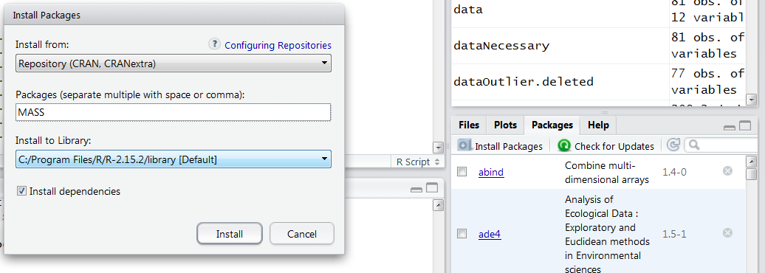

- NB: SKIP THIS STEP IF YOU MANAGED to DOWNLOAD THE PACKAGES FROM CRAN. Install the packages that you downloaded from VULA. From the right bottom menu, select packages > Install Packages > Install from > Package Archive > Browse >
Find the following packages in your computer:
MASS_7.3-23.zip
klaR_0.6-7.zip

- Open the data file NO2PollutionTraining.txt
From the top menu, select Workspace > Import Dataset > From Text File
Navigate to the directory where you saved your data file NO2PollutionTraining.txt Select NO2PollutionTraining.txt file and click OPEN
DO NOT CHANGE THE NAME
Select YES for HEADING

- In order to use the packages
execute lines 3-4 in the script file prac6.R

- To see the names of the variables in the dataset:
execute lines 7-8 in the script file prac6.R
- To see what the data looks like, print the first 10 rows:
execute line 9 in the script file prac6.R

- To define the dependent variable and the data to work:
execute line 12-13 in the script file prac6.R

- Specify the number of categories in the dependent variable:
execute line 14 in the script file prac6.R

- Step1) Stepwise Estimation: The F test of Wilks' lambda shows which variables' contributions are significant.
  - First define the formula including all of the variables
execute line 17 in the script file prac6.R

  - Secondly run the stepwise estimation
execute line 19 in the script file prac6.R
  - Thirdly, looking at your stepwise estimation result, define a new formula (formulaStepwise) by only adding the names of the variables that were found significant in the previous stepwise estimation step.
execute line 21 in the script file prac6.R
  - Finally, perform your discriminant analysis with the final set of variables.
execute lines 23-24 in the script file prac6.R

- Step2) Discriminant Score Estimates for Each Observation
execute line 27-33 in the script file prac6.R
- Plot the discriminant scores
execute lines 36-43 in the script file prac6.R

- Step3-a) Obtain the centroids and test if the centroids are significantly different from zero.
execute line 46-58 in the script file prac6.R
- Differences between the centroids
execute line 61-65 in the script file prac6.R

- Test if the centroids are significantly different from zero.
Perform the test using the F-test formula (if you need help look at your lecture notes page 164)

- Step3-b) Calculate the Hit Rate
execute line 71-83 in the script file prac6.R

- Step3-c) Overall Test of the Discriminant Function : Wilks Lambda

execute line 86-90 in the script file prac6.R

Jobclassification analysis for quiz

Repeat the above process with the jobclassifications data. You can download the file “jobclassifications.csv” from Vula.

The data is:
A large international air carrier has collected data on employees in three different job classifications: 1) customer service personnel, 2) mechanics and 3) dispatchers. The director of Human Resources wants to know if these three job classifications appeal to different personality types. Each employee is administered a battery of psychological test which include measures of interest in outdoor activity, sociability and conservativeness.

Replace NO2PollutionTraining with jobclassifications in your codes

ANSWER THE PRACTICAL QUIZ QUESTIONS BASED ON YOUR R OUTPUTS

