RESEARCH AND SURVEY STATISTICS – STA3022F
COMPUTER PRACTICAL 7
CHAPTER 9. Classification Trees
- Open Rstudio
- Save the following files from VULA
Prac7.R
jobclassifications.csv

Install the following packages from R repository and make sure that DEPENDENCIES is selected:
rpart package
partykit package
tree package
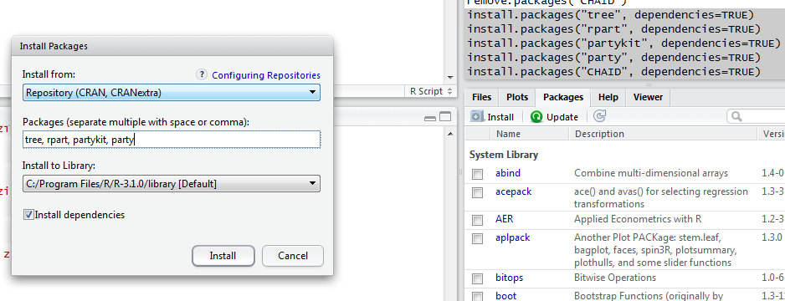

- Open the script file prac7.R.
From the top menu, select File > Open File
Select the file prac7.R which you saved from Vula
Click Open
The script file appears in the Window in the top left.

- Open the data file jobclassifications.csv
From the top menu, select Workspace > Import Dataset > From Text File
Navigate to the directory where you saved your data file jobclassifications.csv
Select jobclassifications.csv file and click OPEN
DO NOT CHANGE THE NAME
Select YES for HEADING

- In order to use the packages
execute lines 2-6 in the script file Prac7.R

- To extract the names of the variables in the dataset:
execute lines 9-10 in the script file Prac7.R

- To perform Classification trees with the following variables
outdoor, social and conservative
define the formula and the data in lines 12-13
execute line 12-13 in the script file Prac7.R

- Define your “y” variable
execute line 14 in the script file Prac7.R

- Define your “stopping criteria” (minsplitnumber)
execute line 15 in the script file Prac7.R

- CART Algorithm
execute line 17-18 in the script file Prac7.R
- Plot the classification tree constructed using CART
execute line 21-22 in the script file Prac7.R

- For nicer results and nice looking graph
execute line 25-28 in the script file Prac7.R

- For the classification matrix
execute line 31-32 in the script file Prac7.R

Answer the QUIZ Questions.

