VENDORPULSE: A FULL-STACK SUPPLIER MANAGEMENT AND PROCUREMENT PLATFORM
A PROJECT REPORT
Submitted by
MOHAMMAD EJAZ M (310624205157)
in partial fulfillment for the award of the Degree
of
BACHELOR OF TECHNOLOGY
in
INFORMATION TECHNOLOGY
FULL STACK DEVELOPMENT - 2311CSC503R

EASWARI ENGINEERING COLLEGE,
(AN AUTONOMOUS INSTITUTION) – AFFILIATED TO ANNA UNIVERSITY, CHENNAI
OCTOBER 2026

 | EASWARI ENGINEERING COLLEGE
BONAFIDE CERTIFICATE
Certified that this mini project report titled “VENDORPULSE: A FULL-STACK SUPPLIER MANAGEMENT AND PROCUREMENT PLATFORM” is the Bonafide work of “MOHAMMAD EJAZ M (310624205157)”, who carried out the project work under my supervision.

SIGNATURE  Dr.N.ANANTHI, M.E.,Ph.D.,  HEAD OF THE DEPARTMENT  Information Technology.,  Easwari Engineering College,  Ramapuram, Chennai-600089. | SIGNATURE  G. Sai Lakshmi,  SUPERVISOR  Information Technology.,  Easwari Engineering College,  Ramapuram, Chennai-600089.

 | EASWARI ENGINEERING COLLEGE
Certificate of Viva-voce-Examination
This is to certify that the Viva Voce Examination of the Project Work entitled “VENDORPULSE: A FULL-STACK SUPPLIER MANAGEMENT AND PROCUREMENT PLATFORM” submitted by Mr. MOHAMMAD EJAZ M (Reg. No. 310624205157) in partial fulfillment of the requirements for the award of the degree of BACHELOR OF TECHNOLOGY was conducted on _______________ in the Department of Information Technology, Easwari Engineering College, Ramapuram – Chennai.

Internal Examiner  Name:  Designation:  Address: | External Examiner  Name:  Designation:  Address:

Date:
ABSTRACT
Organisations that depend on external suppliers face significant operational risk when vendor performance is tracked through scattered spreadsheets, e-mail threads and disconnected ERP modules. Delayed deliveries, inconsistent product quality and subjective vendor selection are usually noticed only after a disruption has already occurred, leaving procurement teams without objective, timely evidence on which supplier to trust, monitor or replace.
To resolve these challenges, this project introduces VendorPulse, a unified full-stack Supplier Management and Procurement Platform built on the MERN stack (MongoDB, Express.js, React and Node.js). The platform maintains supplier profiles, purchase orders, quality inspections and performance assessments in a single MongoDB database and exposes them through a RESTful Express API consumed by a responsive React 19 single-page application.
At its core is an automated KPI evaluation engine that measures six indicators – on-time delivery, quality, cost competitiveness, response time, defect rate and complaint resolution – and combines them using administrator-configurable weights (default 20, 20, 20, 15, 15 and 10 percent, always totalling exactly 100) into a 0–100 overall score and a five-tier risk rating from Excellent to Critical. Marking a purchase order as delivered or logging a quality inspection generates the corresponding KPI record automatically, an alert engine raises Warning or Critical notifications with the probable reason when a supplier deteriorates, and a node-cron job recalculates every supplier report at midnight.
The interface provides a performance dashboard, supplier profiles with a linear-regression forecast of the next month’s score, a side-by-side comparison matrix that recommends the best supplier, ranking, a risk and alert log, Recharts-based analytics with a printable performance report, role-based access for Admin, Manager, Staff and Management users, and an in-app assistant. By replacing manual evaluation with continuous, objective, data-driven monitoring, VendorPulse reduces administrative effort and supports faster, better-informed sourcing decisions.
ACKNOWLEDGEMENT
We express our sincere gratitude to the Principal Dr. P. Deiva Sundari and the Management of our college for providing us with the opportunity and state-of-the-art infrastructural facilities to carry out this project work successfully.
We convey our heartfelt thanks to the Head of the Department Dr. N. Anandhi , Department of Information Technology, for the continuous encouragement, constructive suggestions, and academic support extended throughout the course of this semester.
We are extremely thankful to our Project Guide Ms.Grandhi Sai Lakshmi, Information Technology for valuable guidance, scholarly suggestions, vigilant feedback, and motivation throughout the conception, architectural design, implementation, and completion of this project.
We would also like to extend our profound gratitude to all the faculty members and technical staff of the Department of Information Technlogy for their timely advice and generous assistance during critical phases of our work.
Finally, we thank our parents and friends for their constant encouragement, selfless sacrifices, and unwavering support and help during the entire course of this project.
TABLE OF CONTENTS
CHAPTER NO. | TITLE | PAGE No.
 | ABSTRACT | iv
 | ACKNOWLEDGEMENT | v
CHAPTER 1 | INTRODUCTION | 1-3
 | 1.1 OVERVIEW | 1
 | 1.2 PROBLEM DEFINITION | 1
 | 1.3 OBJECTIVE | 2
 | 1.4 SCOPE OF THE PROJECT | 2
 | 1.5 MOTIVATION | 3
CHAPTER 2 | RELATED WORK | 4-5
 | 2.1 LITERATURE REVIEW | 4
 | 2.2 EXISTING SYSTEM | 4
 | 2.3 PROPOSED SYSTEM | 5
CHAPTER 3 | SYSTEM ANALYSIS | 6-8
 | 3.1 SYSTEM REQUIREMENTS | 6
 | 3.2 SOFTWARE AND HARDWARE REQUIREMENTS | 7
CHAPTER 4 | SYSTEM DESIGN | 9-12
 | 4.1 SYSTEM ARCHITECTURE | 9
 | 4.2 MODULE DESCRIPTION | 9
 | 4.3 CLASS DIAGRAM | 11
 | 4.4 SEQUENCE DIAGRAM | 11
CHAPTER 5 | IMPLEMENTATION | 13-15
 | 5.1 IMPLEMENTATION OVERVIEW | 13
 | 5.2 KEY FUNCTIONS (CODE EXPLANATION) | 13
CHAPTER 6 | CONCLUSION & FUTURE WORK | 16-17
 | 6.1 CONCLUSION | 16
 | 6.2 FUTURE ENHANCEMENTS | 16
APPENDIX | SOURCE CODE | 18-37
 | 1. Project Structure | 18
 | 2. Package Installation | 19
 | 3. Database Connection | 19
 | 4. Environment Variables | 19
 | 5. User Model | 19
 | 6. Supplier Model | 20
 | 7. Assessment Model | 21
 | 8. Login and Default User Seeding | 22
 | 9. Authentication Context and Role-Based Menu | 23
 | 10. Create API | 24
 | 11. Read API | 25
 | 12. Update | 25
 | 13. Delete | 25
 | 14. Express Routes | 26
 | 15. Main Server File | 26
 | 16. KPI Assessment API and Evaluation Engine | 27
 | 17. Purchase Order and Automatic Delivery KPI | 29
 | 18. Quality Inspection and Automatic Quality KPI | 30
 | 19. KPI Weight Configuration API | 31
 | 20. Notification APIs | 32
 | 21. Scheduled Daily KPI Recalculation | 33
 | 22. React Login Component | 34
 | 23. Dashboard Logic | 34
 | 24. Supplier Performance Prediction | 35
 | 25. REST API Request and Response Examples | 36
 | SCREENSHOTS OF THE PROJECT | 38-45
 | REFERENCES | 46

CHAPTER 1
INTRODUCTION
1.1 OVERVIEW
Supplier performance is one of the most important determinants of an organisation’s operational continuity. Manufacturers, retailers and service providers depend on external vendors for raw materials, components, logistics and IT services, and a single late shipment or defective batch can halt production lines, delay customer orders and erode profit margins. Yet in many enterprises the information needed to judge a supplier is scattered across spreadsheets, e-mail histories, delivery receipts and the personal impressions of buyers, so supplier evaluation remains slow, subjective and reactive.
VendorPulse is a full-stack web platform that centralises supplier profiles, purchase orders, quality inspections and performance assessments and converts them into objective, continuously updated scores. Every time a purchase order is delivered, an inspection is logged or an assessment is entered, the platform recalculates the supplier’s lifetime KPIs, assigns a risk rating, updates the supplier status and, when necessary, raises an alert. The application follows the MERN architecture: a React 19 single-page application built with Vite communicates with an Express 5 REST API running on Node.js, and all records are persisted in MongoDB through Mongoose.
1.2 PROBLEM DEFINITION
Conventional supplier management relies on manual data entry, periodic reviews and unconnected tools, which causes four recurring problems:
Data Fragmentation: Delivery records, quality reports and customer complaints are held in different spreadsheets and mailboxes, so no unified view of a supplier’s real performance exists.
Subjective Evaluation: Vendor scores depend on the reviewer’s impression and past relationship rather than on measurable delivery, quality and cost data, which leads to biased vendor selection.
Delayed Risk Identification: Because reviews are periodic, deteriorating suppliers are identified only after a disruption has already occurred, leaving no time for corrective action.
High Administrative Effort: Generating performance reports and tracking the status of purchase orders consumes considerable manual time that could be spent on sourcing decisions.
1.3 OBJECTIVE
The core objectives of the VendorPulse project are:
To engineer a web platform that consolidates supplier registration, purchase order tracking, quality inspection and performance analytics into a single unified interface.
To evaluate every supplier on six KPIs – on-time delivery, quality, cost competitiveness, response time, defect rate and complaint resolution – and combine them into a weighted overall score between 0 and 100.
To allow the Admin to configure the KPI weights while guaranteeing that they always total exactly 100 percent.
To generate KPI records automatically from procurement events, so that delivering a purchase order or logging a quality inspection updates the supplier’s score without manual calculation.
To classify suppliers into a five-tier risk rating, update their status automatically and raise Warning and Critical notifications with the probable cause when performance drops.
1.4 SCOPE OF THE PROJECT
The scope of the VendorPulse platform encompasses:
Supplier Management: Registering suppliers with auto-generated identifiers, viewing detailed profiles with KPI breakdown, trend and predicted score, and comparing up to three suppliers side by side.
Procurement Tracking: Creating purchase orders with automatic PO identifiers, tracking their status (Pending, Shipped, Delivered, Cancelled) and confirming delivery with the actual delivery date.
Quality Management: Logging inspections against a purchase order with accepted and rejected quantities and the defect type, which feed the quality and defect-rate KPIs.
Evaluation & Analytics: Manual KPI assessments, supplier ranking with filters, risk and alert logs, Recharts-based charts and a printable supplier performance report.
Administration: KPI weight configuration for the Admin, role-based menus for Admin, Manager, Staff and Management users, and a scheduled daily recalculation of all supplier reports.
1.5 MOTIVATION
A supplier failure rarely announces itself. Late shipments and rising defect rates build up silently until a production line stops or a customer order is missed. Organisations that monitor supplier performance continuously are able to negotiate better terms, diversify earlier and avoid costly disruptions. The motivation for this project is to demonstrate that a modern full-stack web application can replace scattered spreadsheets with a single, automated and objective evaluation system in which every delivery and every inspection immediately updates the supplier’s score, and in which management is informed the moment a supplier falls below an acceptable level.
CHAPTER 2
RELATED WORK
2.1 LITERATURE REVIEW
Research on supplier management has progressed from manual scorecards and enterprise resource planning (ERP) suites towards data-driven and predictive evaluation. Studies of ERP-based procurement show that centralised databases improve visibility for large enterprises, but such systems are expensive, complex to configure and slow to adapt to agile KPI tracking. Work on manual vendor scorecards demonstrates that simple KPI sheets are easy to introduce, yet they are highly subjective and time-consuming to keep up to date.
More recent investigations of standalone machine-learning tools for supplier risk prediction report high accuracy in forecasting delivery delays, but these tools are usually isolated from day-to-day procurement workflows and therefore difficult to integrate. Together these studies motivate the approach adopted in VendorPulse: a lightweight integrated platform in which procurement events generate KPI data automatically, a transparent weighted model produces the score, and a simple statistical forecast supports early warning.
2.2 EXISTING SYSTEM
The prevailing methodologies used by procurement teams today rely on disparate tools such as spreadsheets, basic CRM software and e-mail chains, and exhibit the following limitations:
Manual KPI Tracking: Vendors are assessed through periodic manual reviews of invoices and delivery receipts, so scores are outdated by the time they are compiled.
Disconnected ERP Modules: Legacy systems handle purchase orders but lack built-in dynamic risk evaluation, leaving buyers to calculate performance outside the system.
Subjective Evaluation: Human judgement and past relationships replace empirical, data-driven scoring matrices, resulting in biased vendor selection.
Delayed Risk Identification: Supply chain risks are identified only after disruptions occur because no automated alerting exists.
Lack of Automation: Generating reports and tracking real-time purchase order status require significant administrative effort.
2.3 PROPOSED SYSTEM
The proposed VendorPulse system delivers a modern, reactive single-page application built on the MERN technology stack. Each procurement event feeds an evaluation engine: a delivered purchase order adds a delivery record, a quality inspection adds quality and defect data, and a manual assessment adds cost, response and complaint data. The engine recalculates lifetime averages from all records, applies the Admin’s KPI weights and updates the supplier’s risk rating and status. Key features include:
Unified Multi-Tier Architecture: A decoupled React single-page frontend communicating through asynchronous JSON REST calls with an Express API backed by MongoDB.
Configurable Weighted Scoring: Six KPIs combined with Admin-defined weights (default 20, 20, 20, 15, 15 and 10 percent) into an overall score from 0 to 100.
Five-Tier Risk Rating: Excellent (90 and above), Good (80–89), Average (70–79), Poor (60–69) and Critical (below 60), with the supplier status updated automatically.
Automatic KPI Generation: Delivery and quality KPIs are created directly from purchase order deliveries and quality inspections, with a flag that prevents duplicate generation.
Alert Engine: Warning and Critical notifications are created when the score falls below 80 and drops by more than two points, or falls below 70, together with the most likely reason.
Decision Support: Supplier ranking, a comparison matrix with a recommended supplier and a linear-regression forecast of the next month’s score.
CHAPTER 3
SYSTEM ANALYSIS
3.1 SYSTEM REQUIREMENTS
3.1.1 Functional Requirements
User Management: Login with a username and password; each account carries one of four roles (Admin, Manager, Staff, Management) and the session persists in browser LocalStorage until logout.
Supplier Registry: Adding suppliers with automatically generated identifiers (SUP-001, SUP-002, …) and viewing supplier lists and detailed profiles.
KPI Assessment: Entering raw delivery, quality, price, response-time and complaint figures and receiving the calculated KPI values and weighted score immediately.
Purchase Orders: Raising purchase orders (PO-1001, PO-1002, …), tracking their status and marking them delivered with the actual delivery date, which generates the delivery KPI automatically.
Quality Inspections: Logging inspections (INSP-1001, …) against a purchase order with total, accepted and rejected items and the defect type, which generates quality and defect KPIs automatically.
KPI Configuration: Viewing and changing the six KPI weights; a change is accepted only when the weights total exactly 100.
Decision Support: Dashboard statistics, supplier ranking, a comparison matrix for up to three suppliers, a predicted score and a risk and alert log with unread notification count.
Reporting: Charts of KPI performance and network health and a supplier performance report that can be printed or saved as PDF.
3.1.2 Non-Functional Requirements
Usability & Responsiveness: A responsive single-page interface with dark and light themes, animated transitions, modal forms and interactive charts.
Performance: KPI recalculation is completed within a single API request, and the interface polls the notification endpoint every 15 seconds so that new alerts appear without a page reload.
Reliability & Data Integrity: All records are persisted in MongoDB with Mongoose schemas, and a scheduled job recalculates every supplier report daily at 00:00 so that stored averages never become stale.
Maintainability: A modular structure with one Mongoose model and one route file per resource, and one React page per functional area.
Security (Prototype Level): Role-based menus and read-only behaviour for the Management role restrict what each user can do in the interface. Password hashing and token-based sessions are identified as future enhancements.
3.2 SOFTWARE AND HARDWARE REQUIREMENTS
3.2.1 Hardware Requirements
Component | Development Environment | Client Machine (Minimum)
Processor | Intel Core i3 / AMD Ryzen 3 or higher | Dual Core 1.8 GHz or equivalent
RAM | 4 GB (8 GB recommended) | 4 GB RAM
Storage | 50 GB free disk space | 100 MB free disk space
Network | Broadband / Wi-Fi for package installation | Standard Internet (1 Mbps+)

3.2.2 Software Requirements
Tier / Layer | Technology / Tool | Version
Operating System | Windows 10 / 11, Linux, or macOS | 64-bit
Database Server | MongoDB Community / MongoDB Atlas | Latest stable
Backend Runtime | Node.js (CommonJS modules) | v20.19 or higher
Backend Framework | Express.js | v5.2
ODM (Object Data Modeling) | Mongoose | v9.9
Task Scheduling | node-cron | v4.6
Frontend Library | React.js (React DOM) | v19.2
Frontend Build Tool | Vite | v8.2
Routing & Client State | React Router DOM, Context API | v7.18
Data Visualization | Recharts | v3.10
Animation & Icons | Framer Motion, Lucide-React | v13.2 & v1.41
Testing | Jest, Supertest | v30.5 & v7.2

CHAPTER 4
SYSTEM DESIGN
4.1 SYSTEM ARCHITECTURE
The architecture of VendorPulse follows a clean Three-Tier Client-Server distributed design. The Presentation Tier comprises a React 19 Single Page Application (SPA), the Application Tier hosts an Express 5 REST API on Node.js that also contains the KPI evaluation engine, alert engine and scheduler, and the Data Tier leverages MongoDB for flexible document persistence.

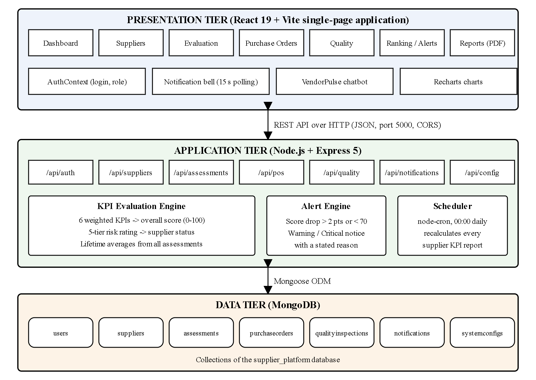
4.2 MODULE DESCRIPTION
1. Authentication & Role Module: Validates the username and password against the users collection and returns the user’s identifier, name and role. Four demonstration accounts (admin, manager, staff and management) are created at start-up if they do not exist. The client stores the user in LocalStorage and shows only the menus permitted for the role: the Admin alone sees KPI Management, Staff do not see Supplier Evaluation or Reports, and the Management role has read-only access to suppliers, purchase orders and quality records.
2. Supplier Management Module: Creates, lists, updates and deletes supplier records through /api/suppliers. Each new supplier receives an identifier of the form SUP-001. The interface provides a supplier list, an add-supplier form, a detailed profile with KPI performance, trend and prediction, and a comparison matrix for up to three suppliers with a recommended supplier.
3. KPI Evaluation Module: Converts the raw figures of an assessment into six percentages – on-time delivery, quality, cost competitiveness (market price ÷ supplier price), response time (target hours ÷ actual hours), defect rate (inverted so that higher is better) and complaint resolution – applies the configured weights to obtain the overall score, stores the assessment and then recomputes the supplier’s lifetime averages from the sums of all of its assessments.
4. Risk Rating Module: Maps the lifetime score to five tiers: Excellent (90 and above), Good (80 to below 90), Average (70 to below 80), Poor (60 to below 70) and Critical (below 60). Excellent and Good suppliers are set to Active, Poor and Critical suppliers are moved to Under Review, and Average suppliers keep their current status.
5. Procurement Module: Creates purchase orders with automatic identifiers, records the creating user and lists orders with their supplier and status. Marking an order delivered compares the actual and expected dates, creates an automatic on-time or late delivery assessment and refreshes the supplier’s KPIs; a kpiGenerated flag prevents duplicate generation.
6. Quality Management Module: Records quality inspections against a purchase order with total, accepted and rejected items and the defect type. Each inspection automatically creates an assessment that updates the quality and defect-rate KPIs of the supplier.
7. Alert & Notification Module: After every assessment the engine compares the new lifetime score with the previous one. If the score is below 80 and has dropped by more than two points, or is below 70, a notification is created – Critical below 70, otherwise Warning – storing the previous and current scores and the probable reason. The interface polls /api/notifications every 15 seconds and shows an unread count on the bell icon.
8. Configuration, Reports & Assistant Module: Lets the Admin change the six KPI weights (rejected unless they total exactly 100), draws the KPI comparison chart, network health chart and performance breakdown table, prints the supplier performance report as PDF, answers questions through the built-in VendorPulse assistant and recalculates every supplier report daily at 00:00 through a node-cron scheduler.
4.3 CLASS DIAGRAM
The class diagram below shows the persistent Mongoose models and their relationships. A supplier has many assessments, notifications, purchase orders and quality inspections; a purchase order is created by a user and may have many quality inspections; and a single system configuration document holds the KPI weights used by every calculation.
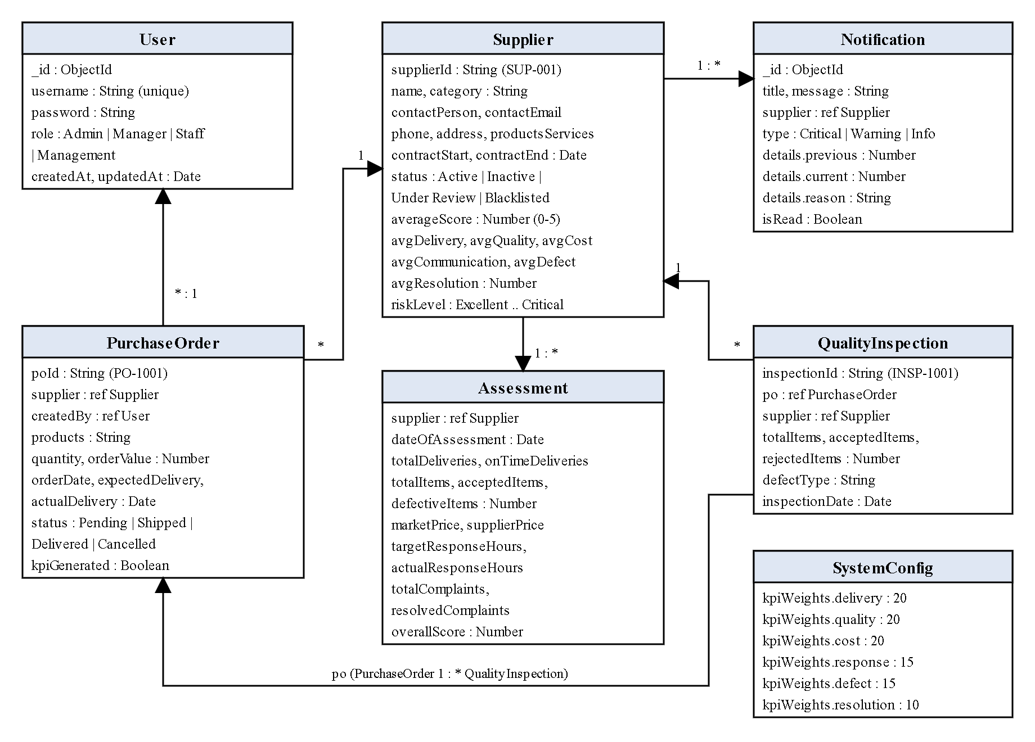
4.4 SEQUENCE DIAGRAM
The sequence diagram below illustrates the complete lifecycle of marking a purchase order as delivered, the resulting automatic KPI update and the alert that is generated when the supplier’s performance deteriorates:
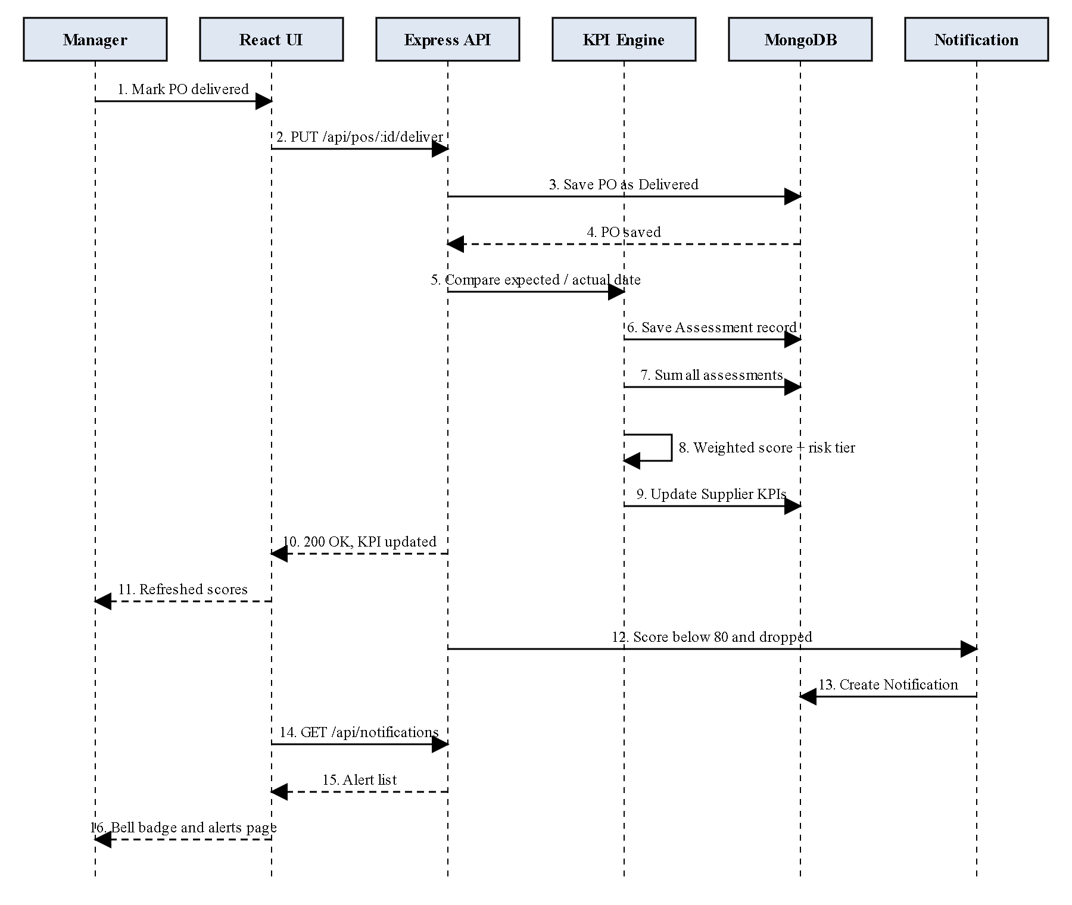
CHAPTER 5
IMPLEMENTATION
5.1 IMPLEMENTATION OVERVIEW
The implementation of VendorPulse is realized through a modern JavaScript ecosystem. The backend server is initialized in server.js with Express 5, configured with CORS and JSON body-parsing middleware, and mounts seven route modules (auth, suppliers, assessments, pos, quality, notifications and config) under the /api prefix. The server starts listening on port 5000 once the Mongoose connection to MongoDB (mongodb://127.0.0.1:27017/supplier_platform by default, overridable through the MONGODB_URI environment variable) has been established, and a node-cron scheduler is registered when the server starts.
The frontend is built using React 19 bundled with Vite 8. Routing is handled by React Router DOM, which maps the sidebar entries to the dashboard, suppliers, supplier evaluation, purchase orders, quality, ranking, risk and alerts, reports and KPI management pages. An AuthContext provider holds the logged-in user and role, Recharts renders the analytics charts, Framer Motion animates page transitions and Lucide-React supplies the icons. All pages communicate with the REST API through the fetch function, and the notification bell polls the API every 15 seconds.
A seed script (seedDemo.js) fills an empty database with four suppliers of different quality, five months of assessments, purchase orders, quality inspections and notifications so that every page of the application can be demonstrated immediately after installation.
5.2 KEY FUNCTIONS (CODE EXPLANATION)
1. Weighted KPI Score Calculation (backend/routes/assessmentRoutes.js) When an assessment is submitted, the route reads the KPI weights from the SystemConfig collection (creating default weights if none exist) and converts the raw figures into six percentages. Every division is guarded so that missing data cannot produce an invalid number, the cost and response scores are capped at 100, and the defect rate is inverted (100 minus the defect percentage). The overall score is the sum of each KPI multiplied by its weight divided by 100.
2. Lifetime Averages and Risk Rating (backend/routes/assessmentRoutes.js) After saving the assessment, the route sums the raw figures of all assessments of the supplier and recomputes each KPI from these totals, so that large assessments carry proportionally more weight than small ones. The resulting lifetime score is mapped to the five-tier rating, the supplier’s averageScore (stored on a 0–5 scale), riskLevel and KPI fields are updated, and the status is moved to Active or Under Review according to the tier.
3. Automatic KPI from Purchase Order Delivery (backend/routes/poRoutes.js) The PUT /api/pos/:id/deliver handler stores the actual delivery date, sets the kpiGenerated flag and compares the actual date with the expected date. It then saves an assessment that carries only delivery data (one delivery, on time or late) and repeats the lifetime recalculation, so a late delivery lowers the supplier’s on-time percentage immediately. Orders whose KPI has already been generated are rejected with an error message.
4. Automatic KPI from Quality Inspection (backend/routes/qualityRoutes.js) Each inspection receives an identifier of the form INSP-1001, and an assessment containing only the inspected, accepted and rejected quantities is created. Because the other counters are zero, they do not disturb the other KPIs when the lifetime averages are recomputed from the sums of all assessments.
5. Alert Engine (backend/routes/assessmentRoutes.js) The previous lifetime score is read before the update and compared with the new one. A notification is created when the new score is below 80 and has dropped by more than two points, or is below 70, which prevents repeated alerts for small fluctuations. The type is Critical below 70 and Warning otherwise, and the reason is chosen from late deliveries, quality failures, pricing non-compliance or general KPI misses.
6. KPI Weight Validation (backend/routes/configRoutes.js) The PUT /api/config handler adds up the submitted weights and rejects the request with the message “Weights must total exactly 100%” unless the sum is exactly 100, which guarantees that the overall score always remains on a 0–100 scale. Valid weights are saved in the single SystemConfig document used by every calculation.
7. Scheduled Daily Recalculation (backend/cronJobs.js) A node-cron task with the expression 0 0 * * * runs at midnight, loads the KPI weights and recalculates the report of every supplier that has assessments using the same formulas as the assessment route, so that stored averages and risk ratings never become stale.
8. Client Login and Role-Based Menu (frontend/src/context/AuthContext.jsx) The login function posts the credentials to /api/auth/login, stores the returned user (including the role) in state and in LocalStorage under the key vendorPulseUser, and exposes it through the useAuth hook. App.jsx uses the role to show or hide sidebar entries, and the purchase order, quality and supplier pages switch to read-only mode for the Management role.
9. Performance Prediction (frontend/src/pages/VendorManagement.jsx) On a supplier’s profile the monthly overall scores are fitted with a least-squares straight line and extended by one period to forecast next month’s score, capped at 100. A forecast below 70 is highlighted in red together with a warning.
CHAPTER 6
CONCLUSION & FUTURE WORK
6.1 CONCLUSION
The VendorPulse: Supplier Management and Procurement Platform successfully addresses the critical problems of fragmented supplier data, subjective evaluation and late risk detection. By recording every delivery, inspection and assessment as KPI data and by combining six indicators with configurable weights, the platform replaces manual supplier reviews with an objective, continuously updated score and a five-tier risk rating.
Automation is the main benefit of the system: delivering a purchase order or logging an inspection updates the supplier’s KPIs without any manual calculation, the alert engine explains why a supplier has deteriorated, and the nightly scheduler keeps all stored reports consistent. Ranking, comparison with a recommended supplier, a linear-regression forecast and Recharts analytics give decision makers the information they need at a glance, while role-based menus keep each user to the tasks of their role.
6.2 FUTURE ENHANCEMENTS
To extend the capabilities and real-world deployment of VendorPulse, the following enhancements are planned:
Secure Authentication: Replacing the plain-text demonstration passwords with salted password hashing (bcrypt) and signed JSON Web Token sessions, with authorisation checks on the server for every route and validation of all request bodies.
Complete Edit and Delete Workflows: Connecting the edit and delete controls of the supplier list to the existing update and delete API endpoints and adding edit support for purchase orders and inspections.
Real-Time Alert Delivery: Sending alerts by e-mail or SMS and replacing 15-second polling with WebSocket push notifications.
AI Assistant: Replacing the rule-based chatbot with a language-model assistant that can answer questions about the live supplier data.
Machine-Learning Risk Prediction: Training delivery-delay and quality-failure prediction models on the accumulated assessment history.
Enterprise Integration: Integrating with ERP and accounting systems, adding supplier self-service portals and exporting reports to Excel as well as PDF.
APPENDIX
SOURCE CODE:
1. Project Structure
Directory Tree of the VendorPulse Project:
vendorpulse/
├── backend/
│ ├── models/
│ │ ├── Assessment.js
│ │ ├── Notification.js
│ │ ├── PurchaseOrder.js
│ │ ├── QualityInspection.js
│ │ ├── Supplier.js
│ │ ├── SystemConfig.js
│ │ └── User.js
│ ├── routes/
│ │ ├── assessmentRoutes.js
│ │ ├── authRoutes.js
│ │ ├── configRoutes.js
│ │ ├── notificationRoutes.js
│ │ ├── poRoutes.js
│ │ ├── qualityRoutes.js
│ │ └── supplierRoutes.js
│ ├── cronJobs.js
│ ├── package.json
│ ├── seedDemo.js
│ └── server.js
└── frontend/
├── public/
│ ├── favicon.svg
│ └── icons.svg
├── src/
│ ├── components/
│ │ └── Chatbot.jsx
│ ├── context/
│ │ └── AuthContext.jsx
│ ├── pages/
│ │ ├── Dashboard.jsx
│ │ ├── Login.jsx
│ │ ├── ProcurementTracking.jsx
│ │ ├── QualityManagement.jsx
│ │ ├── Reports.jsx
│ │ ├── RiskAlerts.jsx
│ │ ├── SupplierAssessment.jsx
│ │ ├── SupplierRanking.jsx
│ │ ├── SystemConfig.jsx
│ │ └── VendorManagement.jsx
│ ├── App.css
│ ├── App.jsx
│ ├── index.css
│ └── main.jsx
├── index.html
├── package.json
└── vite.config.js
2. Package Installation
# Terminal commands to initialize and install backend dependencies:
cd backend
npm install express mongoose dotenv cors node-cron
npm install --save-dev jest supertest
node seedDemo.js # optional demo data
npm start # API on http://localhost:5000

# Terminal commands to install and run the frontend:
cd frontend
npm install react react-dom react-router-dom recharts framer-motion lucide-react
npm run dev # Vite dev server on http://localhost:5173
3. Database Connection
backend/server.js
const MONGODB_URI = process.env.MONGODB_URI || 'mongodb://127.0.0.1:27017/supplier_platform';

mongoose.connect(MONGODB_URI)
.then(() => {
console.log('Connected to MongoDB');
app.listen(PORT, () => {
console.log(`Server running on port ${PORT}`);
});
})
.catch((err) => {
console.error('Failed to connect to MongoDB', err);
});
4. Environment Variables
backend/.env
PORT=5000
MONGODB_URI=mongodb://127.0.0.1:27017/supplier_platform
5. User Model
backend/models/User.js
const mongoose = require('mongoose');

const userSchema = new mongoose.Schema({
username: {
type: String,
required: true,
unique: true
},
password: {
type: String,
required: true
},
role: {
type: String,
enum: ['Admin', 'Manager', 'Staff', 'Management'],
required: true
}
}, { timestamps: true });

module.exports = mongoose.model('User', userSchema);
6. Supplier Model
backend/models/Supplier.js
const mongoose = require('mongoose');

const supplierSchema = new mongoose.Schema({
supplierId: { type: String, unique: true },
name: {
type: String,
required: true,
},
contactPerson: { type: String },
contactEmail: {
type: String,
required: true,
},
phone: {
type: String,
},
address: { type: String },
category: {
type: String,
required: true,
},
productsServices: { type: String },
contractStart: { type: Date },
contractEnd: { type: Date },
status: {
type: String,
enum: ['Active', 'Inactive', 'Under Review', 'Blacklisted'],
default: 'Active'
},
averageScore: {
type: Number,
default: 0
},
avgDelivery: { type: Number, default: 0 },
avgQuality: { type: Number, default: 0 },
avgCost: { type: Number, default: 0 },
avgCommunication: { type: Number, default: 0 },
avgDefect: { type: Number, default: 0 },
avgResolution: { type: Number, default: 0 },
riskLevel: {
type: String,
enum: ['Excellent', 'Good', 'Average', 'Poor', 'Critical', 'Pending'],
default: 'Pending',
}
}, { timestamps: true });

module.exports = mongoose.model('Supplier', supplierSchema);
7. Assessment Model
backend/models/Assessment.js
const mongoose = require('mongoose');

const assessmentSchema = new mongoose.Schema({
supplier: {
type: mongoose.Schema.Types.ObjectId,
ref: 'Supplier',
required: true,
},
dateOfAssessment: {
type: Date,
default: Date.now,
},
// 1. On-Time Delivery Data
totalDeliveries: { type: Number, required: true },
onTimeDeliveries: { type: Number, required: true },

// 2 & 5. Quality and Defect Data
totalItems: { type: Number, required: true },
acceptedItems: { type: Number, required: true },
defectiveItems: { type: Number, required: true },

// 3. Cost Data
marketPrice: { type: Number, required: true },
supplierPrice: { type: Number, required: true },

// 4. Response Time Data
targetResponseHours: { type: Number, required: true },
actualResponseHours: { type: Number, required: true },

// 6. Complaint Resolution Data
totalComplaints: { type: Number, required: true },
resolvedComplaints: { type: Number, required: true },

// Calculated Overall Score for this specific assessment (0-100)
overallScore: { type: Number },
notes: { type: String }
}, { timestamps: true });

module.exports = mongoose.model('Assessment', assessmentSchema);
8. Login and Default User Seeding
backend/routes/authRoutes.js
const express = require('express');
const router = express.Router();
const User = require('../models/User');

// Seed default users if they don't exist
const seedUsers = async () => {
const defaultUsers = [
{ username: 'admin', password: 'password123', role: 'Admin' },
{ username: 'manager', password: 'password123', role: 'Manager' },
{ username: 'staff', password: 'password123', role: 'Staff' },
{ username: 'management', password: 'password123', role: 'Management' }
];

for (let u of defaultUsers) {
const exists = await User.findOne({ username: u.username });
if (!exists) {
await User.create(u);
console.log(`Created default user: ${u.username}`);
}
}
};
seedUsers();

// Login Route
router.post('/login', async (req, res) => {
try {
const { username, password } = req.body;

// Find user
const user = await User.findOne({ username });
if (!user) {
return res.status(401).json({ message: 'Invalid credentials' });
}

// Verify password (using plain text for prototype stability)
if (user.password !== password) {
return res.status(401).json({ message: 'Invalid credentials' });
}

// Return user info (excluding password)
res.json({
_id: user._id,
username: user.username,
role: user.role
});

} catch (err) {
res.status(500).json({ message: err.message });
}
});

module.exports = router;
9. Authentication Context and Role-Based Menu
frontend/src/context/AuthContext.jsx
import React, { createContext, useContext, useState, useEffect } from 'react';

const AuthContext = createContext(null);

export const AuthProvider = ({ children }) => {
const [user, setUser] = useState(null);
const [loading, setLoading] = useState(true);

useEffect(() => {
// Check local storage for persistent session
const storedUser = localStorage.getItem('vendorPulseUser');
if (storedUser) {
setUser(JSON.parse(storedUser));
}
setLoading(false);
}, []);

const login = async (username, password) => {
try {
const res = await fetch('http://localhost:5000/api/auth/login', {
method: 'POST',
headers: { 'Content-Type': 'application/json' },
body: JSON.stringify({ username, password })
});

const data = await res.json();

if (res.ok) {
setUser(data);
localStorage.setItem('vendorPulseUser', JSON.stringify(data));
return { success: true };
} else {
return { success: false, message: data.message };
}
} catch (err) {
return { success: false, message: 'Server connection failed.' };
}
};

const logout = () => {
setUser(null);
localStorage.removeItem('vendorPulseUser');
};

if (loading) return null;

return (
<AuthContext.Provider value={{ user, login, logout }}>
{children}
</AuthContext.Provider>
);
};

export const useAuth = () => useContext(AuthContext);
frontend/src/App.jsx (role-based sidebar)
<SidebarLink to="/" icon={LayoutDashboard}>Dashboard</SidebarLink>
<SidebarLink to="/vendors" icon={Users}>Suppliers</SidebarLink>

{user.role === 'Admin' && <SidebarLink to="/config" icon={Settings}>KPI Management</SidebarLink>}
{user.role !== 'Staff' && <SidebarLink to="/assessments" icon={ClipboardCheck}>Supplier Evaluation</SidebarLink>}

<SidebarLink to="/procurement" icon={ShoppingCart}>Purchase Orders</SidebarLink>
<SidebarLink to="/quality" icon={ClipboardCheck}>Quality Management</SidebarLink>
<SidebarLink to="/ranking" icon={Trophy}>Supplier Ranking</SidebarLink>
<SidebarLink to="/alerts" icon={Bell}>Risk & Alerts</SidebarLink>

{user.role !== 'Staff' && <SidebarLink to="/reports" icon={BarChart2}>Reports</SidebarLink>}
10. Create API
backend/routes/supplierRoutes.js (POST)
// Add a new supplier
router.post('/', async (req, res) => {
try {
// Generate SUP-XXX ID
const count = await Supplier.countDocuments();
const supplierId = `SUP-${(count + 1).toString().padStart(3, '0')}`;

const supplier = new Supplier({
...req.body,
supplierId
});
const newSupplier = await supplier.save();
res.status(201).json(newSupplier);
} catch (err) {
res.status(400).json({ message: err.message });
}
});
11. Read API
backend/routes/supplierRoutes.js (GET)
// Get all suppliers
router.get('/', async (req, res) => {
try {
const suppliers = await Supplier.find();
res.json(suppliers);
} catch (err) {
res.status(500).json({ message: err.message });
}
});
12. Update
backend/routes/supplierRoutes.js (PUT)
// Update a supplier
router.put('/:id', async (req, res) => {
try {
const updatedSupplier = await Supplier.findByIdAndUpdate(
req.params.id,
req.body,
{ new: true }
);
res.json(updatedSupplier);
} catch (err) {
res.status(400).json({ message: err.message });
}
});
13. Delete
backend/routes/supplierRoutes.js (DELETE)
// Delete a supplier
router.delete('/:id', async (req, res) => {
try {
await Supplier.findByIdAndDelete(req.params.id);
res.json({ message: 'Supplier deleted' });
} catch (err) {
res.status(500).json({ message: err.message });
}
});
14. Express Routes
backend/server.js
const supplierRoutes = require('./routes/supplierRoutes');
const assessmentRoutes = require('./routes/assessmentRoutes');
const authRoutes = require('./routes/authRoutes');
const poRoutes = require('./routes/poRoutes');
const qualityRoutes = require('./routes/qualityRoutes');
const notificationRoutes = require('./routes/notificationRoutes');

// Routes
app.use('/api/suppliers', supplierRoutes);
app.use('/api/assessments', assessmentRoutes);
app.use('/api/auth', authRoutes);
app.use('/api/config', require('./routes/configRoutes'));
app.use('/api/pos', poRoutes);
app.use('/api/quality', qualityRoutes);
app.use('/api/notifications', notificationRoutes);
15. Main Server File
backend/server.js
require('dotenv').config();
const express = require('express');
const mongoose = require('mongoose');
const cors = require('cors');

const supplierRoutes = require('./routes/supplierRoutes');
const assessmentRoutes = require('./routes/assessmentRoutes');
const authRoutes = require('./routes/authRoutes');
const poRoutes = require('./routes/poRoutes');
const qualityRoutes = require('./routes/qualityRoutes');
const notificationRoutes = require('./routes/notificationRoutes');

// Initialize Cron Jobs
require('./cronJobs');

const app = express();
const PORT = process.env.PORT || 5000;

// Middleware
app.use(cors());
app.use(express.json());

// Routes
app.use('/api/suppliers', supplierRoutes);
app.use('/api/assessments', assessmentRoutes);
app.use('/api/auth', authRoutes);
app.use('/api/config', require('./routes/configRoutes'));
app.use('/api/pos', poRoutes);
app.use('/api/quality', qualityRoutes);
app.use('/api/notifications', notificationRoutes);

// MongoDB Connection
// Normally this would be a secure URI from .env, but for local dev we use a standard local string
const MONGODB_URI = process.env.MONGODB_URI || 'mongodb://127.0.0.1:27017/supplier_platform';

mongoose.connect(MONGODB_URI)
.then(() => {
console.log('Connected to MongoDB');
app.listen(PORT, () => {
console.log(`Server running on port ${PORT}`);
});
})
.catch((err) => {
console.error('Failed to connect to MongoDB', err);
});
16. KPI Assessment API and Evaluation Engine
backend/routes/assessmentRoutes.js (score calculation)
router.post('/', async (req, res) => {
try {
const raw = req.body;

// Fetch global KPI weights
let config = await SystemConfig.findOne();
if (!config) {
config = await SystemConfig.create({}); // fallback defaults
}
const w = config.kpiWeights;

// --- EXACT MATHEMATICAL FORMULAS ---
const deliveryRaw = raw.totalDeliveries > 0 ? (raw.onTimeDeliveries / raw.totalDeliveries) * 100 : 100;
const qualityRaw = raw.totalItems > 0 ? (raw.acceptedItems / raw.totalItems) * 100 : 100;

let costRaw = raw.supplierPrice > 0 ? (raw.marketPrice / raw.supplierPrice) * 100 : 100;
if (costRaw > 100) costRaw = 100;

let responseRaw = raw.actualResponseHours > 0 ? (raw.targetResponseHours / raw.actualResponseHours) * 100 : 100;
if (responseRaw > 100) responseRaw = 100;

const defectRate = raw.totalItems > 0 ? (raw.defectiveItems / raw.totalItems) * 100 : 0;
const defectRaw = 100 - defectRate; // Invert so higher is better

const resolutionRaw = raw.totalComplaints > 0 ? (raw.resolvedComplaints / raw.totalComplaints) * 100 : 100;

// Weighted Overall Score for this specific assessment
const overallScore = (
(deliveryRaw * (w.delivery / 100)) +
(qualityRaw * (w.quality / 100)) +
(costRaw * (w.cost / 100)) +
(responseRaw * (w.response / 100)) +
(defectRaw * (w.defect / 100)) +
(resolutionRaw * (w.resolution / 100))
);
backend/routes/assessmentRoutes.js (risk rating and alerts)
// 5-Tier Rating System Logic
let riskLevel = 'Pending';
let statusUpdate = null;

if (lifetimeOverall >= 90) {
riskLevel = 'Excellent';
statusUpdate = 'Active';
} else if (lifetimeOverall >= 80) {
riskLevel = 'Good';
statusUpdate = 'Active';
} else if (lifetimeOverall >= 70) {
riskLevel = 'Average';
} else if (lifetimeOverall >= 60) {
riskLevel = 'Poor';
statusUpdate = 'Under Review';
} else {
riskLevel = 'Critical';
statusUpdate = 'Under Review';
}

// --- AUTOMATED NOTIFICATION ENGINE (MODULE 15) ---
if (oldSupplier && newScore100 < 80) { // If they drop into at-risk territory or are already there
const Notification = require('../models/Notification');

let reason = 'Overall performance deterioration.';
let type = 'Warning';

if (newScore100 < 70) type = 'Critical';

// Pinpoint reason
if (avgDelivery < 70) reason = 'Late deliveries increased significantly.';
else if (avgQuality < 70) reason = 'Severe quality failures detected in recent batches.';
else if (avgCost < 70) reason = 'Pricing non-compliance detected.';
else if (newScore100 < oldScore100) reason = 'KPI targets missed across multiple metrics.';

// Only alert if it's a significant drop or a new critical state to avoid spam
if (newScore100 < oldScore100 - 2 || newScore100 < 70) {
await Notification.create({
title: `Supplier performance dropped below ${newScore100 < 70 ? '70' : 'target'}.`,
supplier: raw.supplier,
type,
details: {
previous: oldScore100,
current: newScore100,
reason
}
});
}
}
17. Purchase Order and Automatic Delivery KPI
backend/routes/poRoutes.js
router.post('/', async (req, res) => {
try {
const count = await PurchaseOrder.countDocuments();
const poId = `PO-${(1001 + count)}`;
...
router.put('/:id/deliver', async (req, res) => {
try {
const { actualDelivery } = req.body;
const po = await PurchaseOrder.findById(req.params.id);

if (!po) return res.status(404).json({ message: 'PO not found' });
if (po.kpiGenerated) return res.status(400).json({ message: 'KPI already generated for this PO' });

po.status = 'Delivered';
po.actualDelivery = new Date(actualDelivery);
po.kpiGenerated = true;
await po.save();

// ---- AUTOMATED KPI GENERATION ----
// 1. Compare dates
const expected = new Date(po.expectedDelivery).setHours(0,0,0,0);
const actual = new Date(po.actualDelivery).setHours(0,0,0,0);

const isOnTime = actual <= expected;

// 2. Create synthetic Assessment record targeting ONLY Delivery metric
// Our math engine safely ignores 0/0 for other metrics (defaults them to 100% or 0% logically without skewing if we recalculate properly)
// Actually, to perfectly integrate without repeating math, we just insert the assessment and run the same sum logic
const raw = {
supplier: po.supplier,
totalDeliveries: 1,
onTimeDeliveries: isOnTime ? 1 : 0,
totalItems: 0, acceptedItems: 0, defectiveItems: 0,
marketPrice: 0, supplierPrice: 0,
targetResponseHours: 0, actualResponseHours: 0,
totalComplaints: 0, resolvedComplaints: 0,
notes: `Automated KPI generation from ${po.poId}`
};

let config = await SystemConfig.findOne() || { kpiWeights: { delivery: 20, quality: 20, cost: 20, response: 15, defect: 15, resolution: 10 } };
const w = config.kpiWeights;
18. Quality Inspection and Automatic Quality KPI
backend/routes/qualityRoutes.js
router.post('/', async (req, res) => {
try {
const count = await QualityInspection.countDocuments();
const inspectionId = `INSP-${(1001 + count)}`;

const insp = new QualityInspection({
...req.body,
inspectionId
});
const newInsp = await insp.save();

// ---- AUTOMATED KPI GENERATION ----
// Create synthetic Assessment record targeting ONLY Quality & Defect metrics
const raw = {
supplier: req.body.supplier,
totalDeliveries: 0, onTimeDeliveries: 0,
totalItems: req.body.totalItems,
acceptedItems: req.body.acceptedItems,
defectiveItems: req.body.rejectedItems,
marketPrice: 0, supplierPrice: 0,
targetResponseHours: 0, actualResponseHours: 0,
totalComplaints: 0, resolvedComplaints: 0,
notes: `Automated Quality KPI from ${inspectionId}. Defect Type: ${req.body.defectType || 'None'}`
};

let config = await SystemConfig.findOne() || { kpiWeights: { delivery: 20, quality: 20, cost: 20, response: 15, defect: 15, resolution: 10 } };
const w = config.kpiWeights;
19. KPI Weight Configuration API
backend/routes/configRoutes.js
const express = require('express');
const router = express.Router();
const SystemConfig = require('../models/SystemConfig');

// Get configuration
router.get('/', async (req, res) => {
try {
let config = await SystemConfig.findOne();
if (!config) {
config = await SystemConfig.create({});
}
res.json(config);
} catch (err) {
res.status(500).json({ message: err.message });
}
});

// Update configuration
router.put('/', async (req, res) => {
try {
const { weights } = req.body;

// Validate they sum to 100
const sum = Object.values(weights).reduce((a, b) => a + b, 0);
if (sum !== 100) {
return res.status(400).json({ message: 'Weights must total exactly 100%' });
}

let config = await SystemConfig.findOne();
if (!config) {
config = new SystemConfig();
}

config.kpiWeights = weights;
const updatedConfig = await config.save();

res.json(updatedConfig);
} catch (err) {
res.status(500).json({ message: err.message });
}
});

module.exports = router;
20. Notification APIs
backend/routes/notificationRoutes.js
const express = require('express');
const router = express.Router();
const Notification = require('../models/Notification');

// Get all notifications (sorted by newest, filterable by supplierId)
router.get('/', async (req, res) => {
try {
const query = req.query.supplierId ? { supplier: req.query.supplierId } : {};
const notifications = await Notification.find(query).populate('supplier').sort({ createdAt: -1 });
res.json(notifications);
} catch (err) {
res.status(500).json({ message: err.message });
}
});

// Mark notification as read
router.put('/:id/read', async (req, res) => {
try {
const notification = await Notification.findByIdAndUpdate(req.params.id, { isRead: true }, { new: true });
res.json(notification);
} catch (err) {
res.status(400).json({ message: err.message });
}
});

// Create a generic notification (utility endpoint)
router.post('/', async (req, res) => {
try {
const notification = new Notification(req.body);
const saved = await notification.save();
res.status(201).json(saved);
} catch (err) {
res.status(400).json({ message: err.message });
}
});

module.exports = router;
21. Scheduled Daily KPI Recalculation
backend/cronJobs.js
const cron = require('node-cron');
const Supplier = require('./models/Supplier');
const Assessment = require('./models/Assessment');
const SystemConfig = require('./models/SystemConfig');
const Notification = require('./models/Notification');

// Run every day at midnight (00:00)
cron.schedule('0 0 * * *', async () => {
console.log('Running daily supplier KPI report recalculation...');
try {
let config = await SystemConfig.findOne();
if (!config) {
config = await SystemConfig.create({}); // fallback defaults
}
const w = config.kpiWeights;

const suppliers = await Supplier.find();

for (const supplier of suppliers) {
const allAssessments = await Assessment.find({ supplier: supplier._id });
if (allAssessments.length === 0) continue;

const sums = allAssessments.reduce((acc, curr) => {
acc.totDel += curr.totalDeliveries || 0;
acc.onTime += curr.onTimeDeliveries || 0;
acc.totItems += curr.totalItems || 0;
acc.accItems += curr.acceptedItems || 0;
acc.defItems += curr.defectiveItems || 0;
acc.mktPrice += curr.marketPrice || 0;
acc.supPrice += curr.supplierPrice || 0;
acc.tgtResp += curr.targetResponseHours || 0;
acc.actResp += curr.actualResponseHours || 0;
acc.totComp += curr.totalComplaints || 0;
acc.resComp += curr.resolvedComplaints || 0;
return acc;
}, {
totDel: 0, onTime: 0, totItems: 0, accItems: 0, defItems: 0,
mktPrice: 0, supPrice: 0, tgtResp: 0, actResp: 0, totComp: 0, resComp: 0
});

const avgDelivery = sums.totDel > 0 ? ((sums.onTime / sums.totDel) * 100) : 100;
22. React Login Component
frontend/src/pages/Login.jsx (submit logic)
const Login = () => {
const [username, setUsername] = useState('');
const [password, setPassword] = useState('');
const [error, setError] = useState('');
const [loading, setLoading] = useState(false);

const { login } = useAuth();

const handleSubmit = async (e) => {
e.preventDefault();
setError('');
setLoading(true);

const result = await login(username, password);

if (!result.success) {
setError(result.message);
setLoading(false);
}
};
23. Dashboard Logic
frontend/src/pages/Dashboard.jsx (data fetching)
const Dashboard = () => {
const [stats, setStats] = useState({ total: 0, active: 0, avgScore: 0, highRisk: 0 });
const [networkAverages, setNetworkAverages] = useState({ delivery: 0, quality: 0, cost: 0, response: 0 });
const [topSuppliers, setTopSuppliers] = useState([]);
const [atRiskSuppliers, setAtRiskSuppliers] = useState([]);

useEffect(() => {
const fetchData = async () => {
try {
const res = await fetch('http://localhost:5000/api/suppliers');
if (res.ok) {
const vendors = await res.json();
const scored = vendors.filter(v => v.averageScore > 0);

// Network Averages for Progress Bars
let tDel = 0, tQual = 0, tCost = 0, tResp = 0;
scored.forEach(v => {
tDel += v.avgDelivery || 0;
tQual += v.avgQuality || 0;
tCost += v.avgCost || 0;
tResp += v.avgCommunication || 0;
});
const len = scored.length || 1;

setNetworkAverages({
delivery: Math.round(tDel / len),
quality: Math.round(tQual / len),
cost: Math.round(tCost / len),
response: Math.round(tResp / len)
});

// Using < 80/100 as the threshold for appearing in the Risk Panel
const atRisk = scored.filter(v => (v.averageScore * 20) < 80);

setStats({
total: vendors.length,
active: vendors.filter(v => v.status === 'Active').length,
avgScore: scored.length ? ((scored.reduce((sum, v) => sum + v.averageScore, 0) / scored.length) * 20).toFixed(1) : 0,
highRisk: atRisk.length
});

const topList = [...scored]
.sort((a,b) => b.averageScore - a.averageScore)
.slice(0, 3)
.map(v => ({ ...v, score100: parseFloat((v.averageScore * 20).toFixed(1)) }));

setTopSuppliers(topList);
setAtRiskSuppliers(atRisk);
24. Supplier Performance Prediction
frontend/src/pages/VendorManagement.jsx (linear regression)
// Automated Performance Prediction (Linear Regression)
if (chartData.length >= 2) {
const n = chartData.length;
let sumX = 0, sumY = 0, sumXY = 0, sumXX = 0;
chartData.forEach((d, i) => {
sumX += i;
sumY += d.score;
sumXY += (i * d.score);
sumXX += (i * i);
});
const m = (n * sumXY - sumX * sumY) / (n * sumXX - sumX * sumX);
const b = (sumY - m * sumX) / n;
let nextPrediction = (m * n + b);
// Cap at 100 max
if (nextPrediction > 100) nextPrediction = 100;
setPrediction(nextPrediction.toFixed(1));
} else if (chartData.length === 1) {
setPrediction(chartData[0].score.toFixed(1));
}
25. REST API Request and Response Examples
Sample 1: User Authentication (POST /api/auth/login)
// HTTP Request Body (POST /api/auth/login)
{
"username": "manager",
"password": "********"
}

// HTTP Response Body (Status: 200 OK)
{
"_id": "6ad7a265cfee243a4118bee3",
"username": "manager",
"role": "Manager"
}
Sample 2: Mark a Purchase Order as Delivered (PUT /api/pos/:id/deliver)
// HTTP Request Body
{
"actualDelivery": "2026-10-22"
}

// HTTP Response Body (Status: 200 OK)
{
"message": "PO Delivered and KPI Automatically Updated",
"po": {
"poId": "PO-1005",
"status": "Delivered",
"kpiGenerated": true,
"actualDelivery": "2026-10-22T00:00:00.000Z"
}
}
Sample 3: Submit a KPI Assessment (POST /api/assessments)
// HTTP Request Body (POST /api/assessments)
{
"supplier": "6ad7a25f7cecdb30bfb8f442",
"totalDeliveries": 100, "onTimeDeliveries": 60,
"totalItems": 1000, "acceptedItems": 700,
"defectiveItems": 300,
"marketPrice": 100, "supplierPrice": 125,
"targetResponseHours": 24, "actualResponseHours": 60,
"totalComplaints": 20, "resolvedComplaints": 6
}

// HTTP Response Body (Status: 201 Created)
{
"supplier": "6ad7a25f7cecdb30bfb8f442",
"overallScore": 61.5,
"dateOfAssessment": "2026-10-20T17:27:51.602Z"
}
Sample 4: Invalid KPI Weights (PUT /api/config)
// HTTP Request Body (weights total 95)
{
"weights": { "delivery": 30, "quality": 30, "cost": 10,
"response": 10, "defect": 10, "resolution": 5 }
}

// HTTP Response Body (Status: 400 Bad Request)
{
"message": "Weights must total exactly 100%"
}
SCREENSHOTS OF THE PROJECT
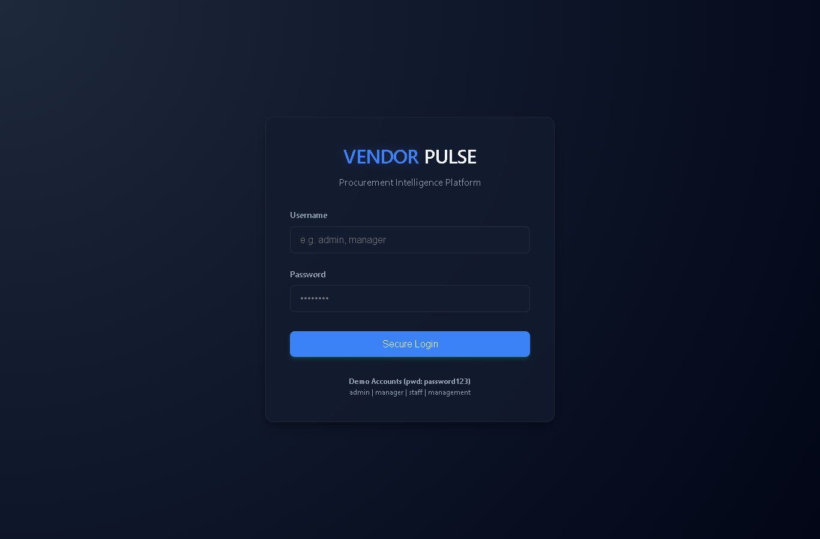
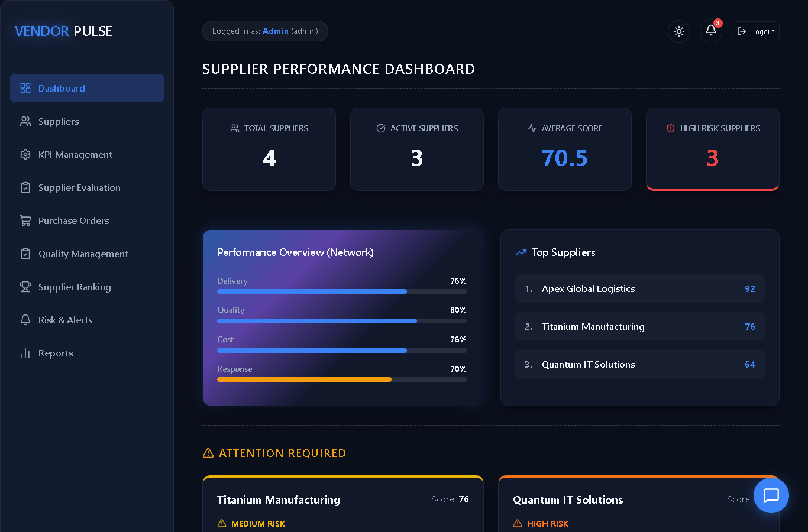
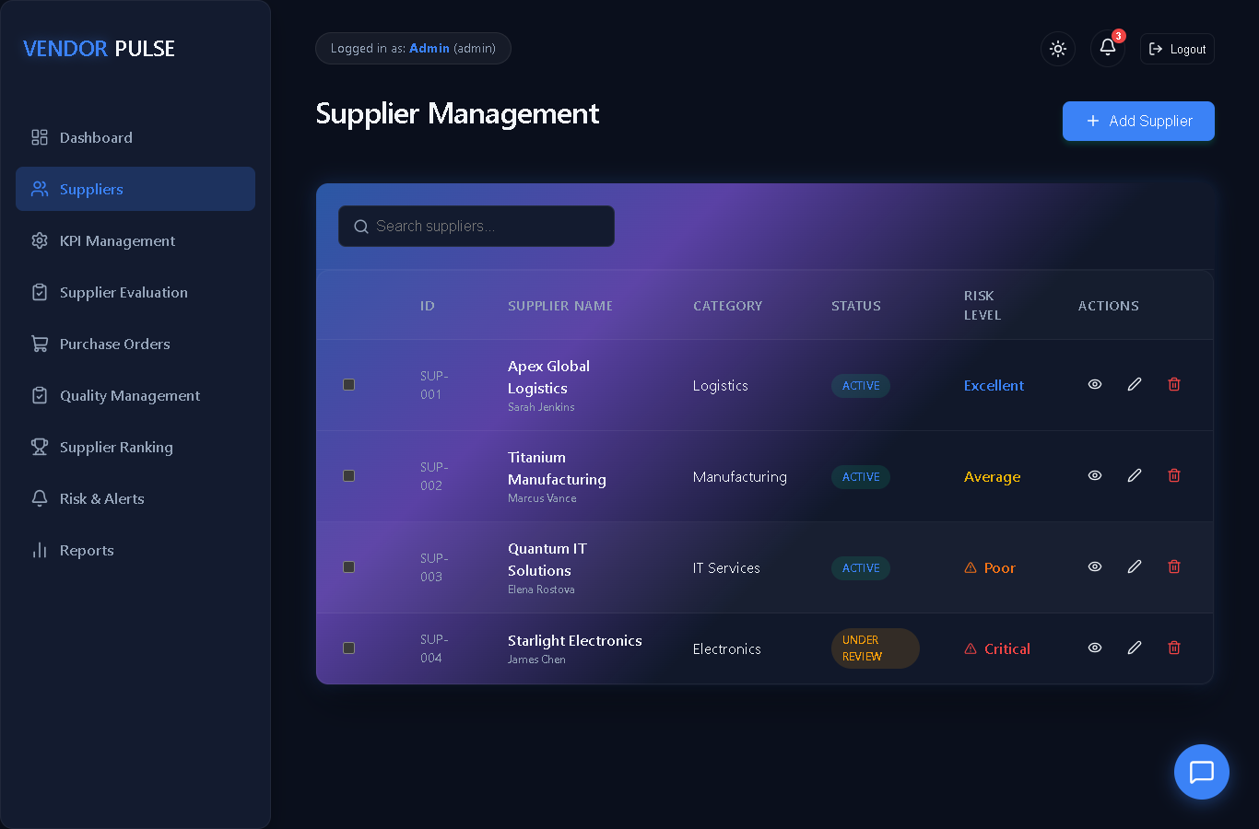
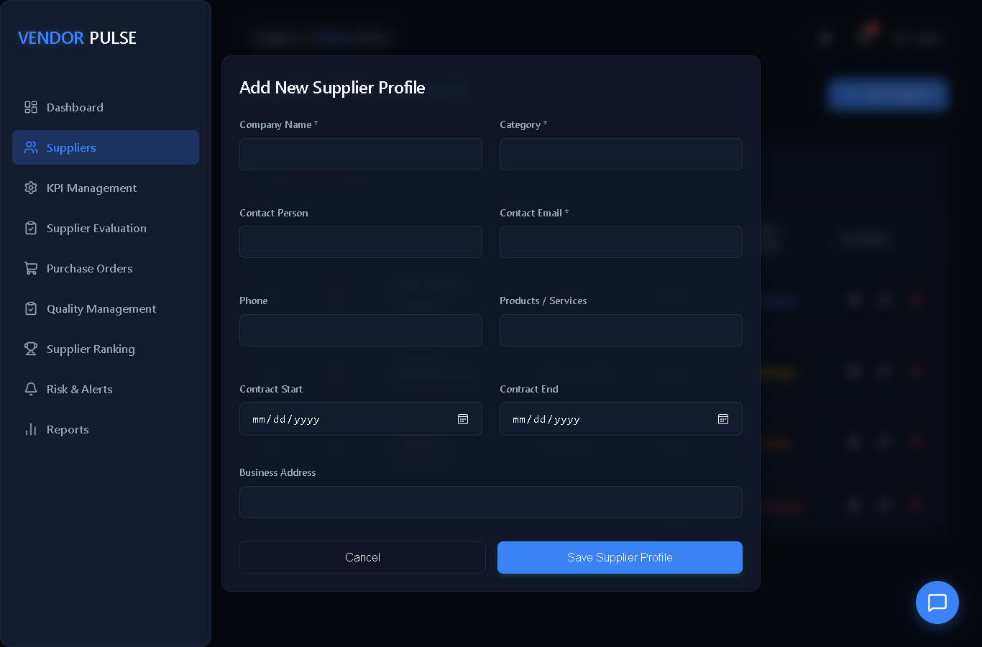
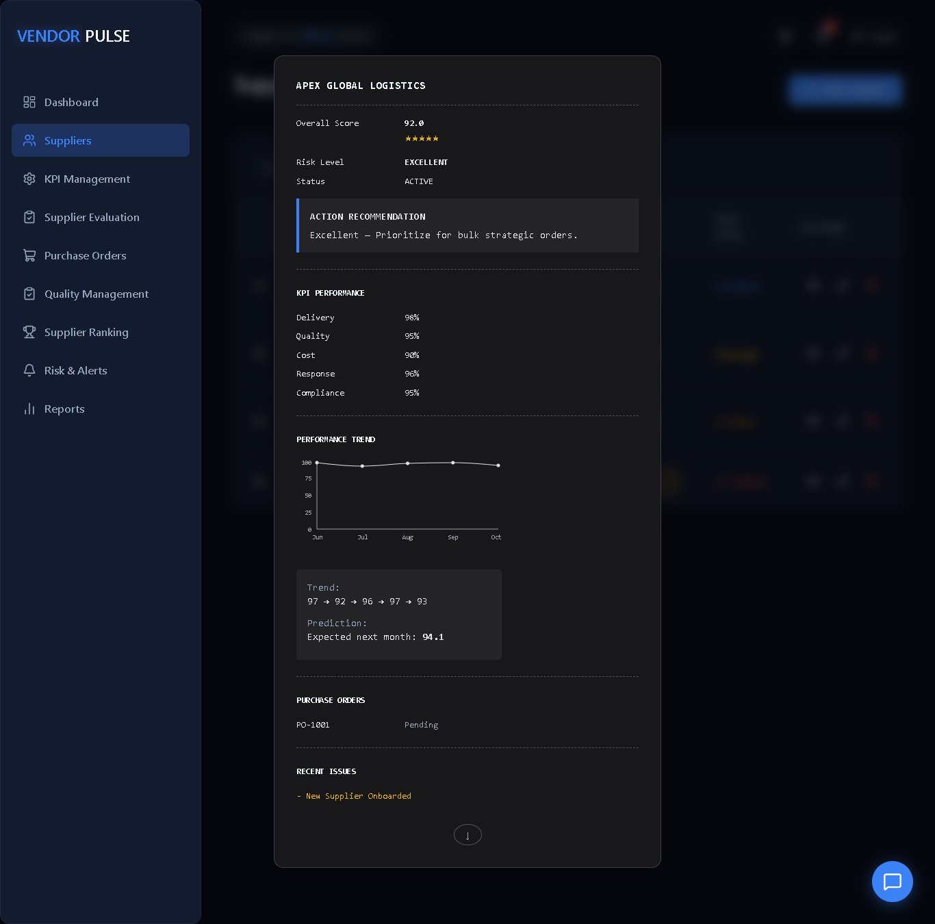
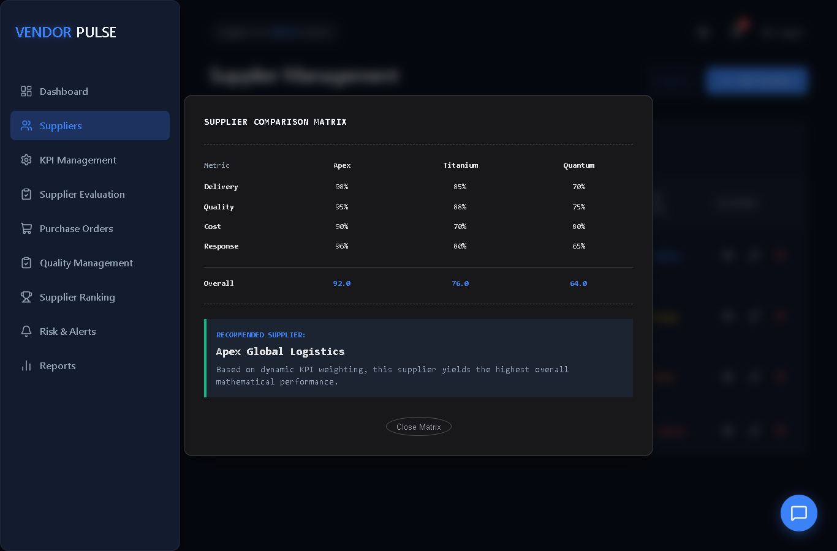
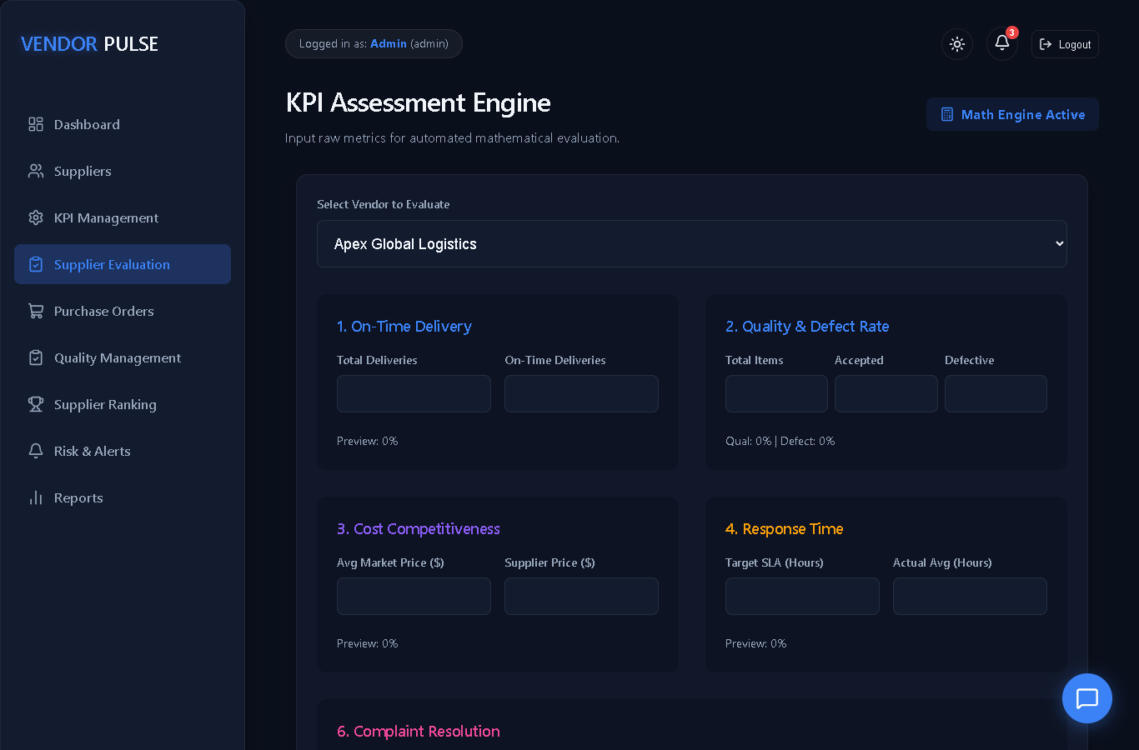
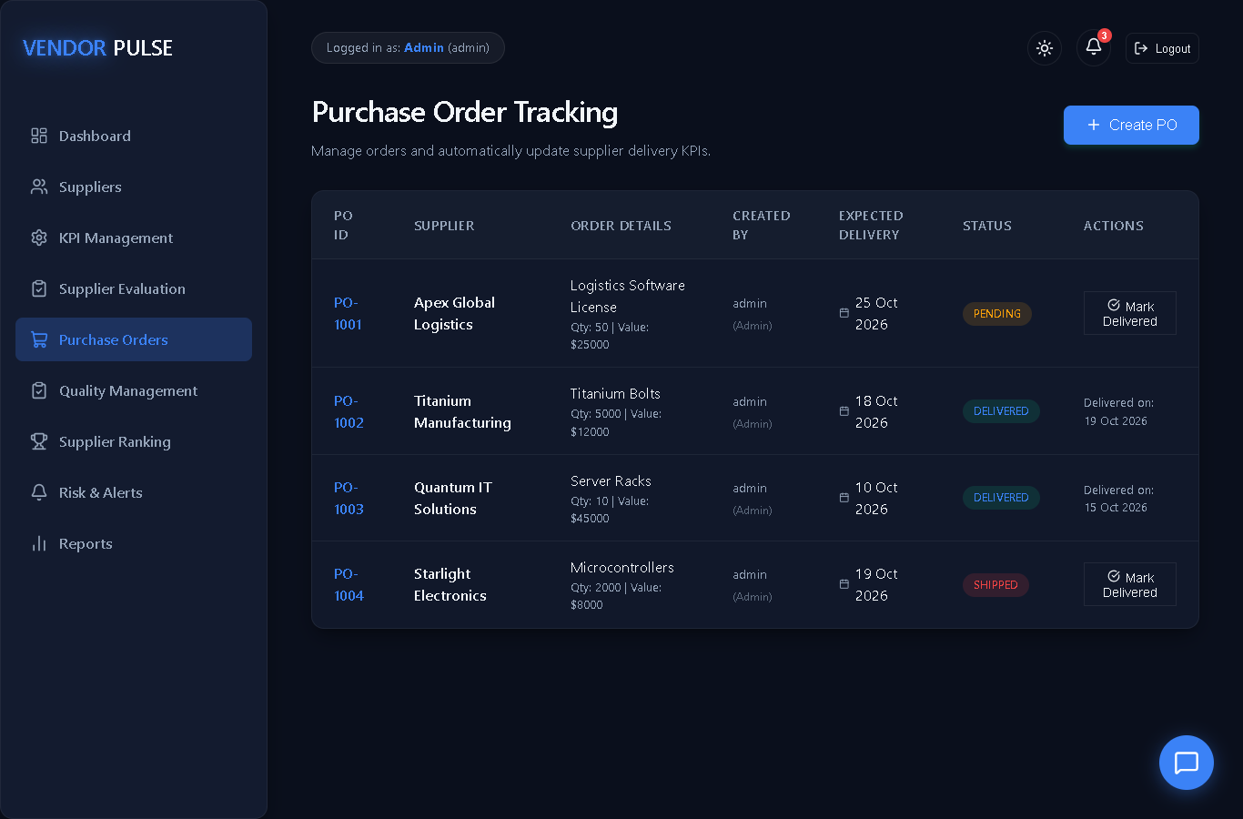
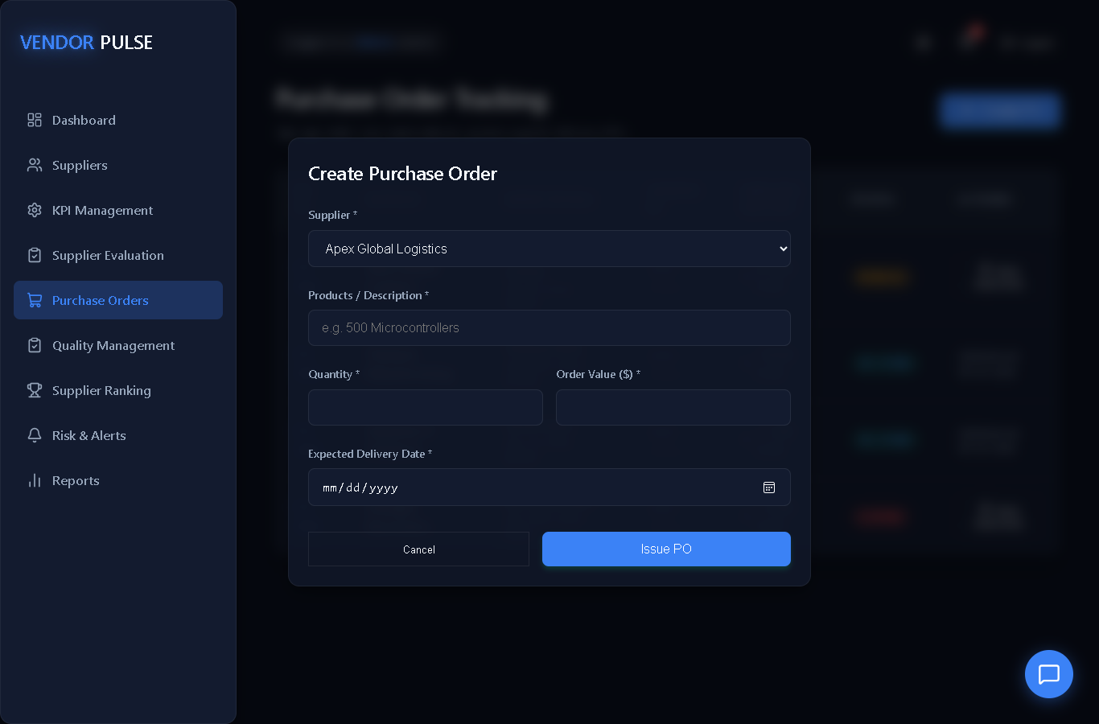
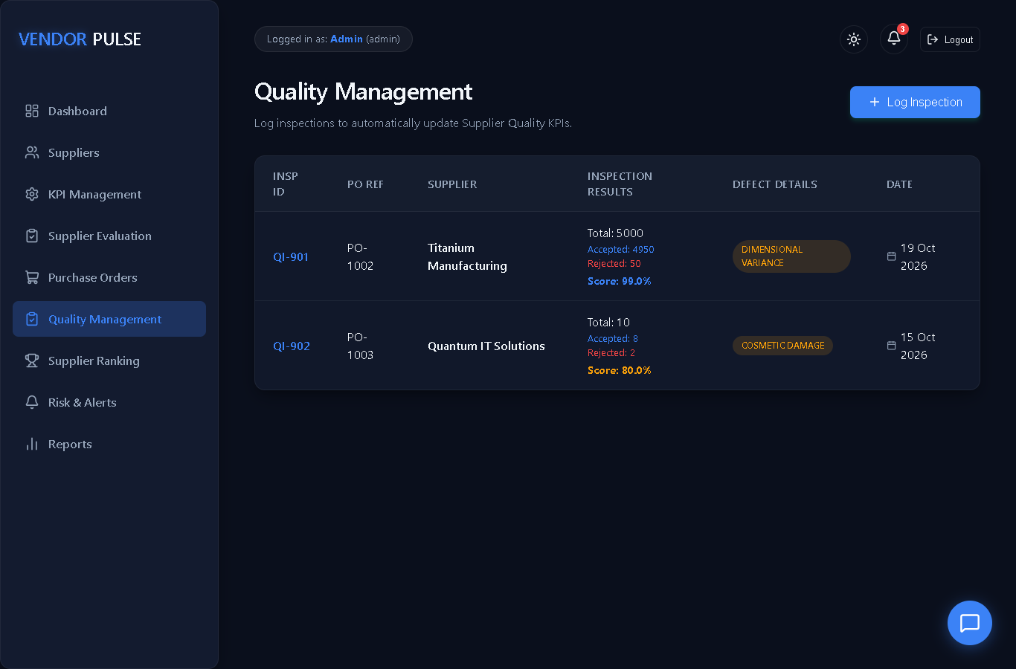
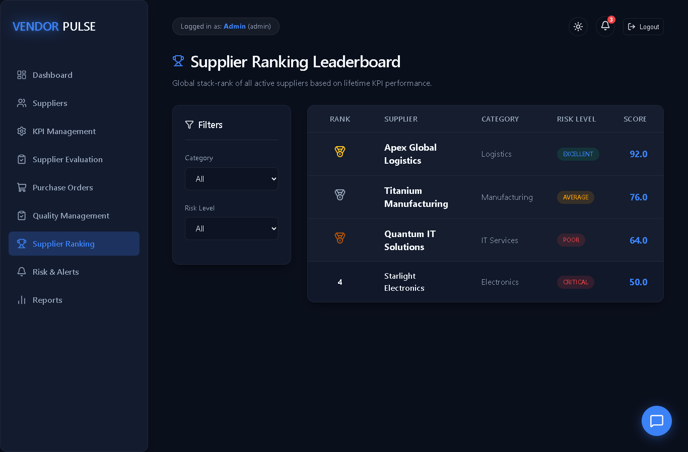
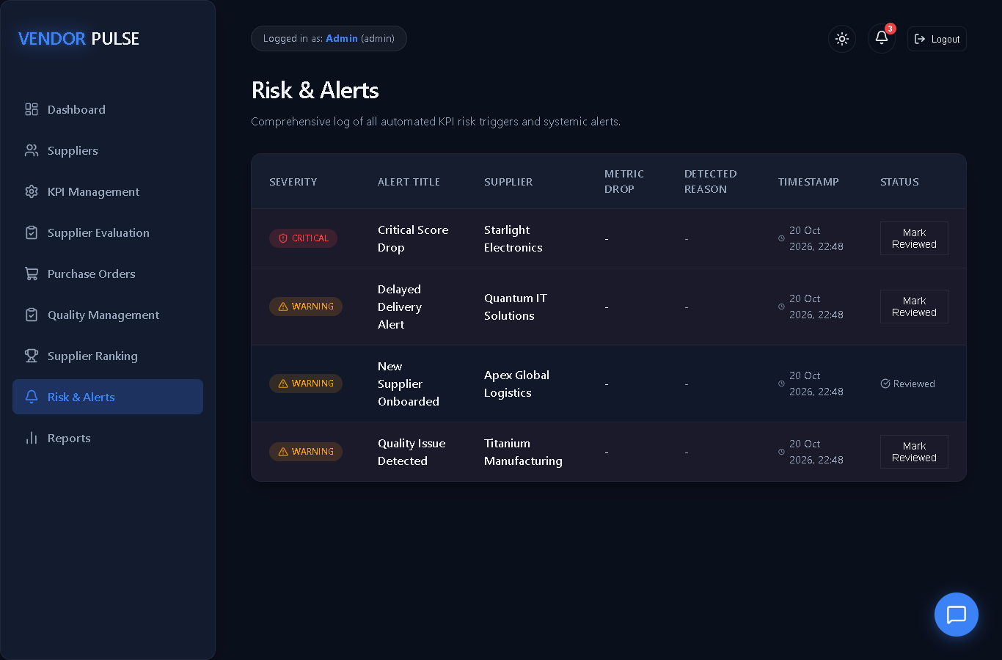
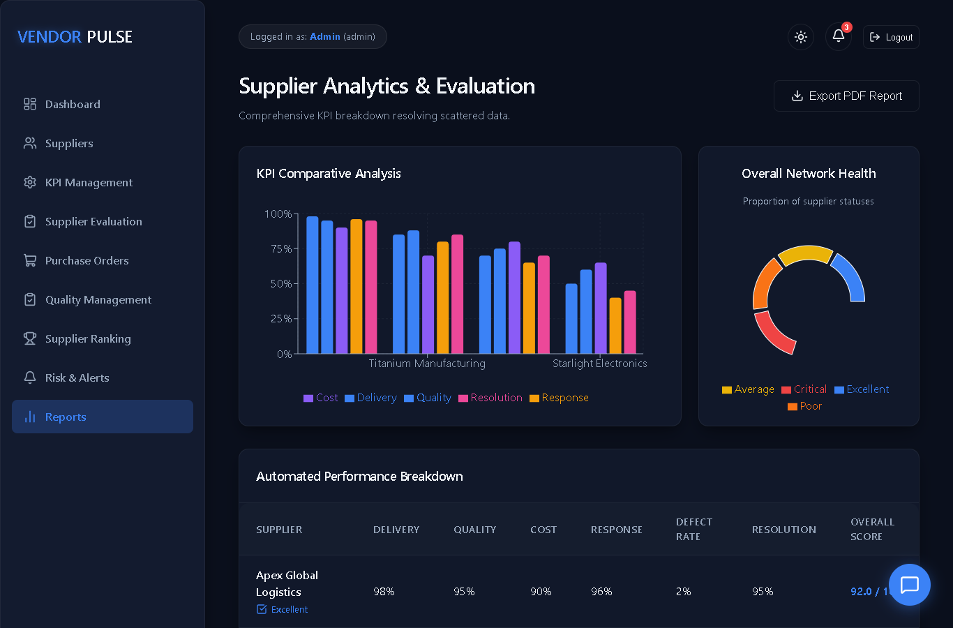
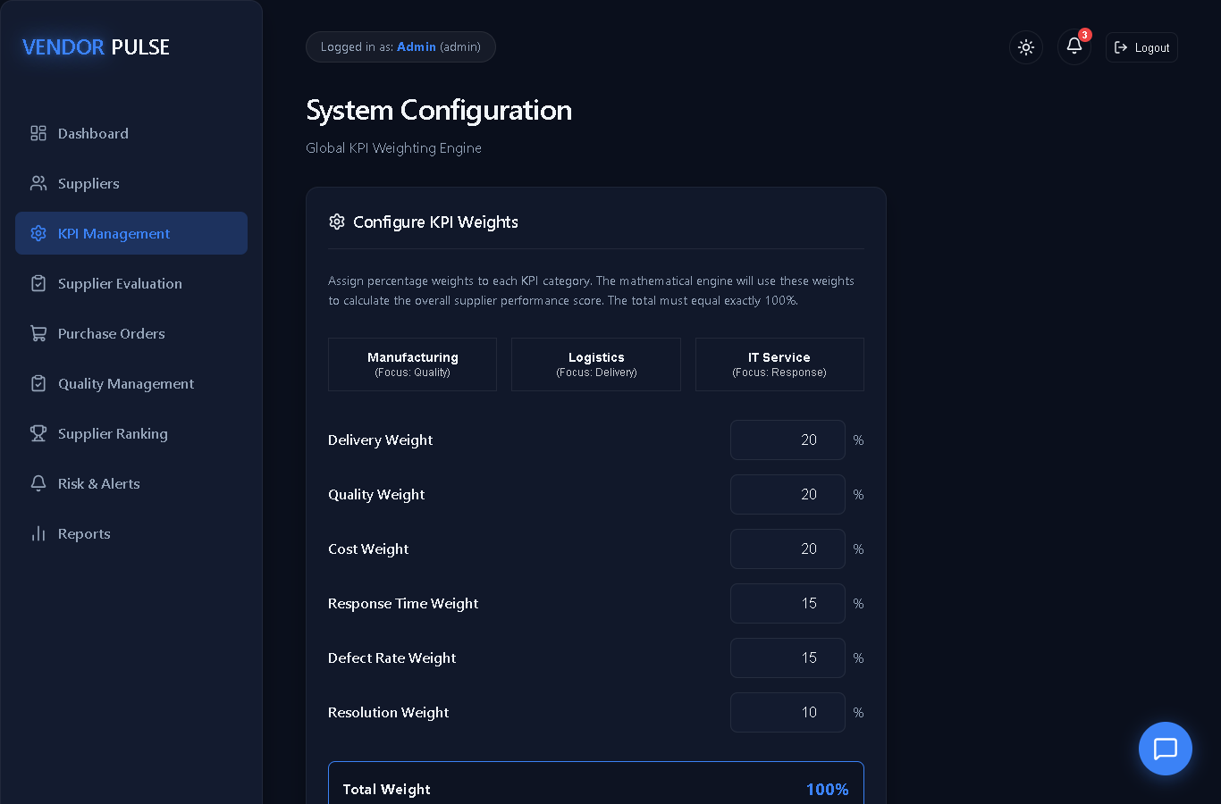
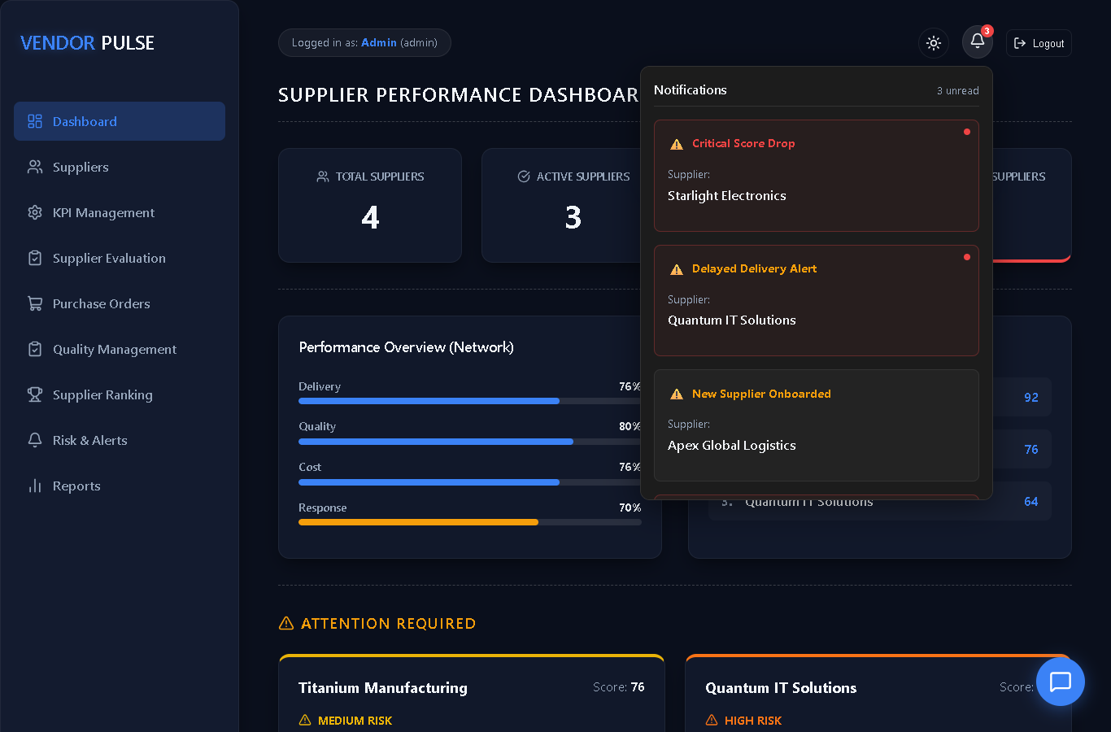
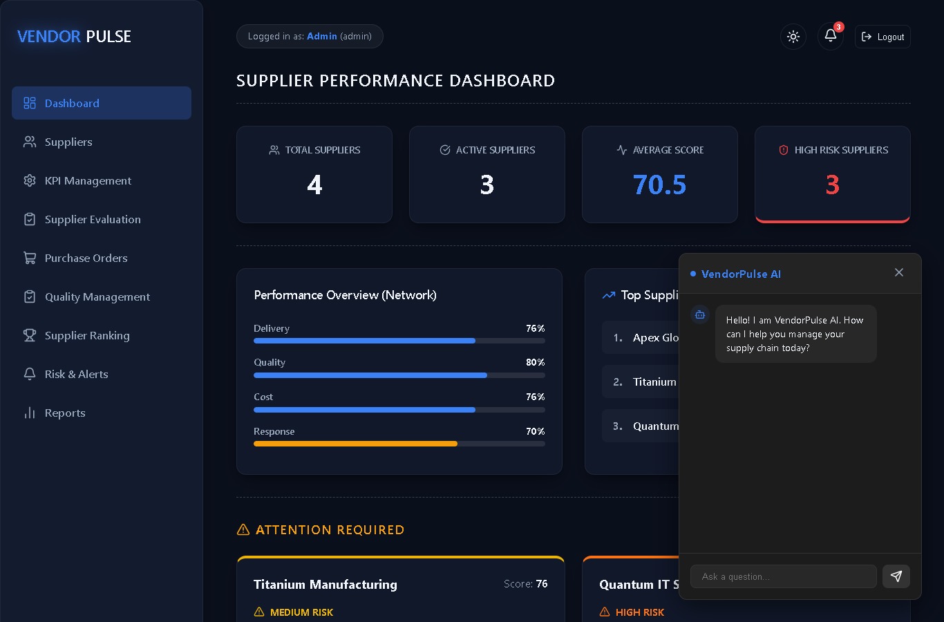
REFERENCES
1. A. Banks and E. Porcello, Learning React: Modern Patterns for Developing React Apps, 2nd ed. Sebastopol, CA, USA: O’Reilly Media, 2020.
2. K. Chodorow, MongoDB: The Definitive Guide: Powerful and Scalable Data Storage, 3rd ed. Sebastopol, CA, USA: O’Reilly Media, 2019.
3. M. Cantelon, M. Harter, T. J. Holowaychuk, and N. Rajlich, Node.js in Action, 2nd ed. Shelter Island, NY, USA: Manning Publications, 2017.
4. S. Chopra and P. Meindl, Supply Chain Management: Strategy, Planning, and Operation, 6th ed. Harlow, U.K.: Pearson, 2016.
5. D. Simchi-Levi, P. Kaminsky, and E. Simchi-Levi, Designing and Managing the Supply Chain: Concepts, Strategies, and Case Studies, 3rd ed. New York, NY, USA: McGraw-Hill, 2008.
6. Meta Platforms, Inc., “React Documentation.” [Online]. Available: https://react.dev/
7. MongoDB, Inc., “MongoDB Manual.” [Online]. Available: https://www.mongodb.com/docs/
8. OpenJS Foundation, “Express – Fast, unopinionated, minimalist web framework for Node.js.” [Online]. Available: https://expressjs.com/
9. Automattic, Inc., “Mongoose ODM Documentation.” [Online]. Available: https://mongoosejs.com/docs/
10. Recharts Group, “Recharts: A composable charting library built on React components.” [Online]. Available: https://recharts.org/
11. node-cron contributors, “node-cron: Task scheduler for Node.js based on cron syntax.” [Online]. Available: https://github.com/node-cron/node-cron
12. Harvard Business Review, “Supply Chain Management.” [Online]. Available: https://hbr.org/topic/supply-chain-management

