VENDORPULSE: A FULL-STACK SUPPLIER MANAGEMENT AND PROCUREMENT PLATFORM
A PROJECT REPORT
Submitted by
MUTHUVEER M (310624205166)
in partial fulfillment for the award of the Degree
of
BACHELOR OF TECHNOLOGY
in
INFORMATION TECHNOLOGY
FULL STACK DEVELOPMENT - 2311CSC503R

EASWARI ENGINEERING COLLEGE,
(AN AUTONOMOUS INSTITUTION) – AFFILIATED TO ANNA UNIVERSITY, CHENNAI
OCTOBER 2026
EASWARI ENGINEERING COLLEGE
BONAFIDE CERTIFICATE
Certified that this mini project report titled “VENDORPULSE: A FULL-STACK SUPPLIER MANAGEMENT AND PROCUREMENT PLATFORM” is the Bonafide work of “MUTHUVEER M (310624205166)”, who carried out the project work under my supervision.

SIGNATURE | SIGNATURE
Dr.N.ANANTHI, M.E.,Ph.D., | G. Sai Lakshmi,
HEAD OF THE DEPARTMENT | SUPERVISOR
Information Technology., | Information Technology.,
Easwari Engineering College, | Easwari Engineering College,
Ramapuram, Chennai-600089. | Ramapuram, Chennai-600089.

EASWARI ENGINEERING COLLEGE
Certificate of Viva-voce-Examination
This is to certify that the Viva Voce Examination of the Project Work entitled “VENDORPULSE: A FULL-STACK SUPPLIER MANAGEMENT AND PROCUREMENT PLATFORM” submitted by Mr. MUTHUVEER M (Reg. No. 310624205166) in partial fulfillment of the requirements for the award of the degree of BACHELOR OF TECHNOLOGY was conducted on ____________ in the Department of Information Technology, Easwari Engineering College, Ramapuram – Chennai.

Internal Examiner | External Examiner
Name : | Name :
Designation : | Designation :
Address : | Address :
Date:
ABSTRACT
Managing suppliers through spreadsheets, e-mail threads and disconnected ERP modules leads to delayed deliveries, inconsistent quality, subjective vendor selection and risks that are noticed only after a disruption has already happened. This project presents VendorPulse, a full-stack supplier management and procurement platform built on the MERN stack (MongoDB, Express, React and Node.js) that converts raw delivery, quality, cost, responsiveness and complaint data into objective, continuously updated supplier scores.
The platform stores suppliers, purchase orders, quality inspections and assessments in MongoDB. A KPI evaluation engine computes six indicators – on-time delivery, quality, cost competitiveness, response time, defect rate and complaint resolution – and combines them with administrator-defined weights (default 20, 20, 20, 15, 15 and 10 percent) into a score from 0 to 100, which maps to a five-tier risk rating from Excellent to Critical. Marking a purchase order as delivered or logging a quality inspection generates the corresponding KPI record automatically, an alert engine raises Warning or Critical notifications when a supplier deteriorates, and a node-cron job recalculates every supplier report at midnight.
The React 19 interface offers role-based access for Admin, Manager, Staff and Management users, a dashboard, supplier profiles with a linear-regression forecast of next month’s score, a side-by-side comparison matrix that recommends the best supplier, ranking, risk and alert logs, Recharts analytics with a printable report and an in-app assistant. The result is a single, scalable system that reduces manual effort and supports data-driven sourcing decisions.
ACKNOWLEDGEMENT
I express my sincere gratitude to the Principal Dr. P. Deiva Sundari and the Management of our college for providing me with the opportunity to carry out this project work.
I convey my heartfelt thanks to the Head of the Department, Department of INFORMATION TECHNOLOGY, for the continuous encouragement and support.
I am extremely thankful to my Project Guide, G. Sai Lakshmi, Department of INFORMATION TECHNOLOGY, for valuable guidance, suggestions, and motivation throughout the completion of this project.
I would also like to extend my gratitude to all the faculty members of the Department of INFORMATION TECHNOLOGY for their support.
Finally, I thank my parents and friends for their constant encouragement and help during the course of this project.
TABLE OF CONTENTS
CHAPTER NO. TITLE PAGE No.
ABSTRACT i
ACKNOWLEDGEMENT ii
LIST OF TABLES v
LIST OF FIGURES vi
LIST OF ABBREVIATIONS vii
1 INTRODUCTION 1–3
1.1 OVERVIEW 1
1.2 PROBLEM DEFINITION 1
1.3 OBJECTIVE 2
1.4 SCOPE OF THE PROJECT 3
1.5 MOTIVATION 3
2 RELATED WORK 4–6
2.1 LITERATURE REVIEW 4
2.2 EXISTING SYSTEM 4
2.3 PROPOSED SYSTEM 5
3 SYSTEM ANALYSIS 7–9
3.1 SYSTEM REQUIREMENTS 7
3.2 SOFTWARE AND HARDWARE REQUIREMENTS 8
4 SYSTEM DESIGN 10–15
4.1 SYSTEM ARCHITECTURE 10
4.2 MODULE DESCRIPTION 11
4.3 CLASS DIAGRAM 13
4.4 SEQUENCE DIAGRAM 14
5 IMPLEMENTATION 16–21
5.1 IMPLEMENTATION OVERVIEW 16
5.2 KEY FUNCTIONS (CODE EXPLANATION) 16
6 CONCLUSION & FUTURE WORK 22–23
6.1 CONCLUSION 22
6.2 FUTURE ENHANCEMENTS 22
APPENDIX 24–48
SCREENSHOTS OF THE PROJECT 49–56
REFERENCES 57
LIST OF TABLES
TABLE NO. TITLE PAGE NO.
2.1 Literature survey 4
3.1 Software requirements 8
3.2 Hardware requirements 8
4.1 Role-based access in VendorPulse 11
4.2 KPI formulas and default weights 12
4.3 Five-tier supplier risk rating 12
LIST OF FIGURES
FIGURE NO. TITLE PAGE NO.
4.1 System architecture of VendorPulse 10
4.2 Class diagram 14
4.3 Sequence diagram of a purchase order delivery 15
A.1 Login page 49
A.2 Supplier performance dashboard 49
A.3 Supplier management list 50
A.4 Adding a new supplier profile 50
A.5 Supplier profile with KPI performance, trend and predicted score 51
A.6 Supplier comparison matrix with recommended supplier 51
A.7 KPI assessment engine form 52
A.8 Purchase order tracking 52
A.9 Creating a purchase order 53
A.10 Quality management and inspections 53
A.11 Supplier ranking with category and risk filters 54
A.12 Risk and alerts log 54
A.13 Supplier analytics and evaluation report 55
A.14 KPI weight configuration (Admin) 55
A.15 Notification panel with unread alerts 56
A.16 VendorPulse assistant chatbot 56
LIST OF ABBREVIATIONS
Abbreviations
AI Artificial Intelligence
API Application Programming Interface
CORS Cross-Origin Resource Sharing
CRUD Create, Read, Update and Delete
CSS Cascading Style Sheets
ERP Enterprise Resource Planning
HTML HyperText Markup Language
HTTP Hypertext Transfer Protocol
ID Identifier
JSON JavaScript Object Notation
KPI Key Performance Indicator
MERN MongoDB, Express, React and Node.js
ODM Object Document Mapper
PDF Portable Document Format
PO Purchase Order
REST Representational State Transfer
SPA Single-Page Application
UI User Interface
URI Uniform Resource Identifier
CHAPTER 1

INTRODUCTION

1.1 OVERVIEW
Organisations that buy goods and services from many vendors depend on those vendors for the continuity of their own operations. Deciding which supplier to trust, which to monitor and which to replace is therefore one of the most important and most error-prone activities in procurement. In many enterprises this decision is still taken from spreadsheets, e-mail histories and the personal judgement of buyers, so information is scattered, evaluations are subjective and a deteriorating supplier is noticed only after a delivery has already failed.
VendorPulse is a full-stack web platform that centralises supplier data, purchase orders, quality inspections and performance assessments and turns them into objective, continuously updated scores. Every time a purchase order is delivered, an inspection is logged or an assessment is entered, the platform recalculates the supplier’s lifetime KPIs, assigns a risk rating, updates the supplier status and, when necessary, raises an alert. The application is built with the MERN stack: a React 19 single-page application, built with Vite, talks to an Express 5 REST API running on Node.js, and all data is stored in MongoDB through Mongoose.
The system supports four user roles (Admin, Manager, Staff and Management), seven functional areas (dashboard, suppliers, supplier evaluation, purchase orders, quality management, ranking and risk alerts) together with reports, KPI weight configuration and an in-app assistant, as described in the following chapters.

1.2 PROBLEM DEFINITION
Supplier management in most organisations relies on manual data entry, periodic reviews and unconnected tools. These practices cause four recurring problems:
- Data fragmentation: delivery records, quality reports and complaints live in different spreadsheets and mailboxes, so no unified view of a supplier exists.
- Subjective evaluation: scores depend on the reviewer’s impression and past relationship rather than on measurable delivery, quality and cost data, which leads to biased vendor selection.
- Delayed risk identification: because reviews are periodic, deteriorating suppliers are identified only after a disruption has occurred.
- High administrative effort: generating performance reports and tracking the status of purchase orders consumes considerable manual time.
The problem addressed by this project is therefore to build an integrated platform that records procurement and quality events as they happen, evaluates every supplier with a transparent, configurable scoring model, warns management before a supplier becomes a risk and presents the results in an easily understood form.

1.3 OBJECTIVE
The objectives of the project are:
- To maintain a central register of suppliers with contact, category, contract and status information and automatically generated supplier identifiers.
- To evaluate suppliers on six KPIs – on-time delivery, quality, cost competitiveness, response time, defect rate and complaint resolution – and combine them into a weighted score from 0 to 100.
- To allow an administrator to configure the KPI weights, while guaranteeing that they always total exactly 100 percent.
- To track purchase orders from creation to delivery and to generate delivery and quality KPI records automatically from delivery dates and inspection results.
- To classify every supplier into a five-tier risk rating, to update the supplier status accordingly and to raise Warning and Critical notifications when performance drops.
- To support decision making through ranking, side-by-side comparison with a recommended supplier, a predicted next-month score and graphical analytics with a printable report.
- To control access with four roles and to deliver the whole system as a responsive MERN web application.

1.4 SCOPE OF THE PROJECT
The project covers the complete supplier evaluation and procurement-tracking workflow of a small or medium-sized organisation:
- Suppliers: creation, listing, comparison of up to three suppliers and detailed profiles with KPI breakdown, trend and prediction.
- Procurement: purchase order creation with automatic PO identifiers, status tracking (Pending, Shipped, Delivered, Cancelled) and delivery confirmation.
- Quality: inspection logging against a purchase order, with accepted and rejected quantities and the defect type.
- Evaluation and analytics: manual KPI assessments, automatic KPI generation, ranking, risk and alert logs, charts and a printable performance report.
- Administration: KPI weight management, role-based menus and a daily scheduled recalculation of all supplier reports.
- Out of scope: ERP integration, invoicing and payment processing, e-mail or SMS delivery of alerts and supplier-facing portals are not part of this version.

1.5 MOTIVATION
A supplier failure rarely announces itself. Late shipments and rising defect rates build up silently until a production line stops or a customer order is missed. Organisations that monitor supplier performance continuously are able to negotiate better, diversify earlier and avoid such disruptions. The motivation of this project is to show that a modern full-stack web application can replace scattered spreadsheets with a single, automated and objective evaluation system in which every delivery and every inspection immediately updates the supplier’s score, and in which management is informed the moment a supplier falls below an acceptable level.
CHAPTER 2

RELATED WORK

2.1 LITERATURE REVIEW
Research on supplier management has moved from manual scorecards and enterprise resource planning (ERP) suites towards data-driven and predictive evaluation. Table 2.1 summarises the works that most influenced the design of the platform.
Table 2.1 Literature survey
Author | Year | Description | Pros | Cons
Smith et al. | 2019 | Evaluated traditional ERP systems for procurement. | Centralized database for large enterprises. | Expensive, complex, and lacks agile KPI tracking.
Johnson & Lee | 2020 | Proposed manual KPI scorecards for vendors. | Easy to understand and implement initially. | Highly subjective and time-consuming to update.
Gupta et al. | 2021 | Investigated standalone machine-learning tools for risk prediction. | High accuracy in predicting delivery delays. | Hard to integrate into daily procurement workflows.

These studies show that ERP suites provide centralised data but are heavy and slow to adapt, that manual scorecards are simple but subjective, and that predictive tools are accurate but isolated from day-to-day procurement. Together they motivate the approach adopted here: a lightweight integrated platform in which procurement events generate KPI data automatically, a transparent weighted model produces the score and a simple statistical forecast supports early warning.

2.2 EXISTING SYSTEM
Current supplier management processes often involve disparate tools such as spreadsheets, basic CRM software and e-mail chains. They fall into three groups:
- Manual KPI tracking: vendors are assessed through periodic manual reviews of invoices and delivery receipts.
- Disconnected ERP modules: legacy systems handle purchase orders but lack built-in dynamic risk evaluation.
- Subjective evaluation: human judgement and past relationships replace empirical, data-driven scoring matrices.

Disadvantages of the existing system
- Data fragmentation – information is scattered across e-mails and spreadsheets, making a unified view impossible.
- Delayed risk identification – periodic reviews reveal supply chain risks only after disruptions occur.
- Subjective decision making – manual evaluations lead to biased vendor selection and reduce overall supply chain quality.
- Lack of automation – generating reports and tracking real-time purchase order status requires significant administrative effort.

2.3 PROPOSED SYSTEM
The proposed system integrates supplier tracking, automated KPI scoring and purchase order management into a single MERN stack application. Each procurement event feeds the evaluation engine: a delivered purchase order adds a delivery record, a quality inspection adds quality and defect data and a manual assessment adds cost, response and complaint data. The engine recalculates lifetime averages from all records, applies the administrator’s KPI weights, updates the supplier’s risk rating and status and, when performance drops, creates an alert that explains the likely reason.
Flow: Procurement event (PO delivered / inspection / assessment) → KPI record → Lifetime recalculation → Risk rating → Alert → Dashboard.

Advantages of the proposed system
- Real-time analytics: continuous monitoring of vendor KPIs reduces the risk of supply chain failure.
- Objective evaluation: data-driven automated scoring with configurable weights removes human bias from supplier selection.
- Centralised management: purchase orders, quality inspections, assessments and alerts are held in one platform.
- Decision support: ranking, comparison with a recommended supplier and a predicted next-month score guide sourcing decisions.
- Scalability and automation: the MERN architecture handles growing volumes of procurement data, and a nightly job keeps all reports current.
CHAPTER 3

SYSTEM ANALYSIS

3.1 SYSTEM REQUIREMENTS

Functional requirements
- FR1. Users sign in with a username and password; each account has one of four roles (Admin, Manager, Staff, Management) and the session persists until logout.
- FR2. Users can add suppliers (identifiers SUP-001, SUP-002, … are generated automatically) and view supplier lists and detailed profiles.
- FR3. Authorised users can enter a KPI assessment from raw delivery, quality, price, response-time and complaint figures and receive the calculated score immediately.
- FR4. Users can raise purchase orders (PO-1001, PO-1002, …), follow their status and mark them as delivered with the actual delivery date, which generates a delivery KPI automatically.
- FR5. Users can log quality inspections against a purchase order, which generates quality and defect KPIs automatically.
- FR6. The Admin can view and change the six KPI weights; changes are accepted only when the weights total exactly 100.
- FR7. The system shows dashboard statistics, a supplier ranking, a comparison matrix for up to three suppliers, a predicted score and a risk and alert log, and notifies users of unread alerts.
- FR8. Authorised users can view charts of KPI performance and network health and print a supplier performance report as PDF.
- FR9. Users can ask the built-in assistant how the KPI engine, risk alerts, prediction and comparison features work.

Non-functional requirements
- Usability: a responsive single-page interface with dark and light themes, animated transitions, modal forms and interactive charts.
- Performance: KPI recalculation is performed in a single request; the interface polls the notification endpoint every 15 seconds so that new alerts appear without a page reload.
- Reliability: all records are persisted in MongoDB; a scheduled job recalculates every supplier report daily at 00:00 so that stored averages never become stale.
- Maintainability: a modular structure with one Mongoose model and one route file per resource, and one React page per functional area.
- Security (prototype level): role-based menus and read-only behaviour for the Management role restrict what each user can do in the interface; seeded demonstration accounts are created at start-up. Password hashing and token-based sessions are identified as future enhancements.

3.2 SOFTWARE AND HARDWARE REQUIREMENTS
The software and hardware needed to build and run VendorPulse are listed in Table 3.1 and Table 3.2.
Table 3.1 Software requirements
Item | Specification
Operating system | Windows 10/11, Linux or macOS
Runtime | Node.js 22 or above with npm
Database | MongoDB (local installation, Docker or MongoDB Atlas)
Front end | React 19, React Router 7, Vite 8, Recharts 3, Framer Motion, Lucide React, HTML5 and CSS3
Back end | Express 5, Mongoose 9, node-cron, cors, dotenv
Programming language | JavaScript (ES6+)
Testing | Jest and Supertest
Browser | Any current version of Chrome, Edge or Firefox

Table 3.2 Hardware requirements
Item | Specification
Processor | Intel Core i3 or equivalent (minimum)
RAM | 4 GB (8 GB recommended)
Hard disk | 50 GB free space
Monitor | Standard display; 1366 × 768 or higher recommended
Network | Local network or Internet connection for package installation and cloud database access

Both tables list the minimum environment on which the platform was developed and demonstrated; a production deployment would normally place the API and database on separate servers.
CHAPTER 4

SYSTEM DESIGN

4.1 SYSTEM ARCHITECTURE
VendorPulse follows a three-tier architecture, as shown in Figure 4.1.
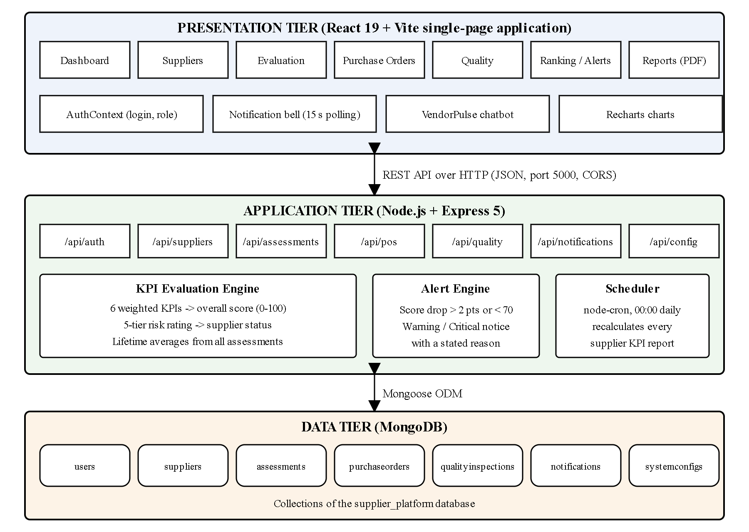
Figure 4.1 System architecture of VendorPulse
The presentation tier is a React single-page application built with Vite. It provides the login page, dashboard, supplier management, KPI assessment, purchase order, quality, ranking, risk and alert, report and configuration pages together with the notification bell and the chatbot. It communicates with the server only through the JSON REST API on port 5000 and keeps the logged-in user in the browser’s local storage.
The application tier is an Express 5 server running on Node.js. Seven route modules (auth, suppliers, assessments, pos, quality, notifications and config) expose the API. The KPI evaluation logic that converts raw figures into scores and risk ratings runs in this tier, as does the alert engine that creates notifications, and a node-cron scheduler recalculates all supplier reports every day at midnight.
The data tier is MongoDB, accessed through Mongoose. Users, suppliers, assessments, purchase orders, quality inspections, notifications and the system configuration are stored in separate collections of the supplier_platform database.

4.2 MODULE DESCRIPTION

Authentication and role module
Validates the username and password against the users collection and returns the user’s identifier, name and role. Four demonstration accounts (admin, manager, staff and management) are created at start-up if they do not exist. The front end stores the user and shows only the menus allowed for the role, as summarised in Table 4.1.
Table 4.1 Role-based access in VendorPulse
Role | Access
Admin | All pages, including KPI Management (weight configuration); can add suppliers, create purchase orders and log inspections.
Manager | All pages except KPI Management; can add suppliers, evaluate suppliers, create purchase orders and log inspections.
Staff | Dashboard, suppliers, purchase orders, quality, ranking and alerts; can add suppliers, create purchase orders and log inspections. Supplier Evaluation, Reports and the edit and delete controls are hidden.
Management | Read-only view of suppliers, purchase orders and quality records, with access to evaluation and reports.

Supplier management module
Creates, lists, updates and deletes supplier records through /api/suppliers. Each new supplier receives an identifier of the form SUP-001. The interface shows a supplier list, an add-supplier form, a detailed profile and a comparison matrix. A supplier’s status (Active, Inactive, Under Review or Blacklisted) is changed automatically by the evaluation engine when its rating changes.

KPI evaluation module
Receives the raw figures of an assessment, calculates the six KPI values and the weighted overall score, stores the assessment and then recomputes the supplier’s lifetime averages from the sums of all of its assessments. The formulas and default weights are given in Table 4.2.
Table 4.2 KPI formulas and default weights
KPI | Formula (result in percent) | Default weight
On-time delivery | on-time deliveries ÷ total deliveries × 100 | 20 %
Quality | accepted items ÷ total items × 100 | 20 %
Cost competitiveness | market price ÷ supplier price × 100 (capped at 100) | 20 %
Response time | target response hours ÷ actual response hours × 100 (capped at 100) | 15 %
Defect rate | 100 − (defective items ÷ total items × 100), so that higher is better | 15 %
Complaint resolution | resolved complaints ÷ total complaints × 100 | 10 %

Overall score = Σ (KPI value × weight ÷ 100). The overall score on the 0–100 scale is also stored on a 0–5 scale (score ÷ 20) for display as star ratings. The score then determines the risk rating of Table 4.3.
Table 4.3 Five-tier supplier risk rating
Overall score | Risk rating | Supplier status set
90 and above | Excellent | Active
80 to below 90 | Good | Active
70 to below 80 | Average | Unchanged
60 to below 70 | Poor | Under Review
Below 60 | Critical | Under Review

Procurement module
Creates purchase orders with automatic identifiers (PO-1001, PO-1002, …), records the creating user and lists orders with their supplier and status. When an order is marked as delivered the module compares the actual and expected delivery dates, creates an automatic delivery assessment (on time or late) and refreshes the supplier’s KPIs. A flag on the order prevents the KPI from being generated twice.

Quality module
Records quality inspections (INSP-1001, …) against a purchase order with total, accepted and rejected items and the defect type. Each inspection automatically creates an assessment that updates the quality and defect-rate KPIs.

Alert and notification module
After every assessment the engine compares the new lifetime score with the previous one. If the score is below 80 and has dropped by more than two points, or is below 70, a notification is created: type Critical when the score is below 70 and Warning otherwise. The notification stores the previous score, the current score and the most likely reason (late deliveries, quality failures, pricing non-compliance or general KPI misses). The interface polls the notifications endpoint every 15 seconds and shows an unread count on the bell icon.

Configuration, reports and assistant modules
The configuration module lets the Admin change the six KPI weights, rejecting any set that does not total exactly 100. The reports page draws a KPI comparison chart, a network health chart and a performance breakdown table and can print a supplier performance report as PDF. The VendorPulse assistant is a client-side chatbot that answers questions about the KPI engine, risk alerts, prediction and comparison features. A node-cron scheduler recalculates every supplier’s report daily at 00:00.

4.3 CLASS DIAGRAM
Figure 4.2 shows the persistent classes (Mongoose models) and their relationships. A supplier has many assessments, notifications, purchase orders and quality inspections; a purchase order is created by a user and may have many quality inspections; and a single system configuration document holds the KPI weights used by every calculation.
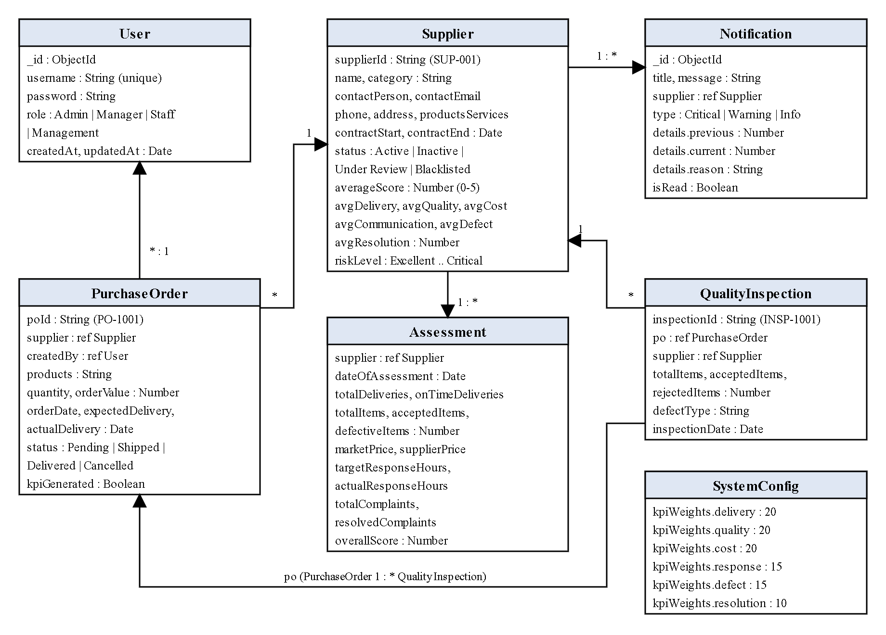
Figure 4.2 Class diagram

4.4 SEQUENCE DIAGRAM
Figure 4.3 shows what happens when a purchase order is marked as delivered. The interface sends a delivery request; the API stores the delivery, compares the dates, saves an automatic assessment, recalculates the supplier’s lifetime KPIs and risk rating and, if the score has deteriorated, creates a notification that the interface later fetches and displays.
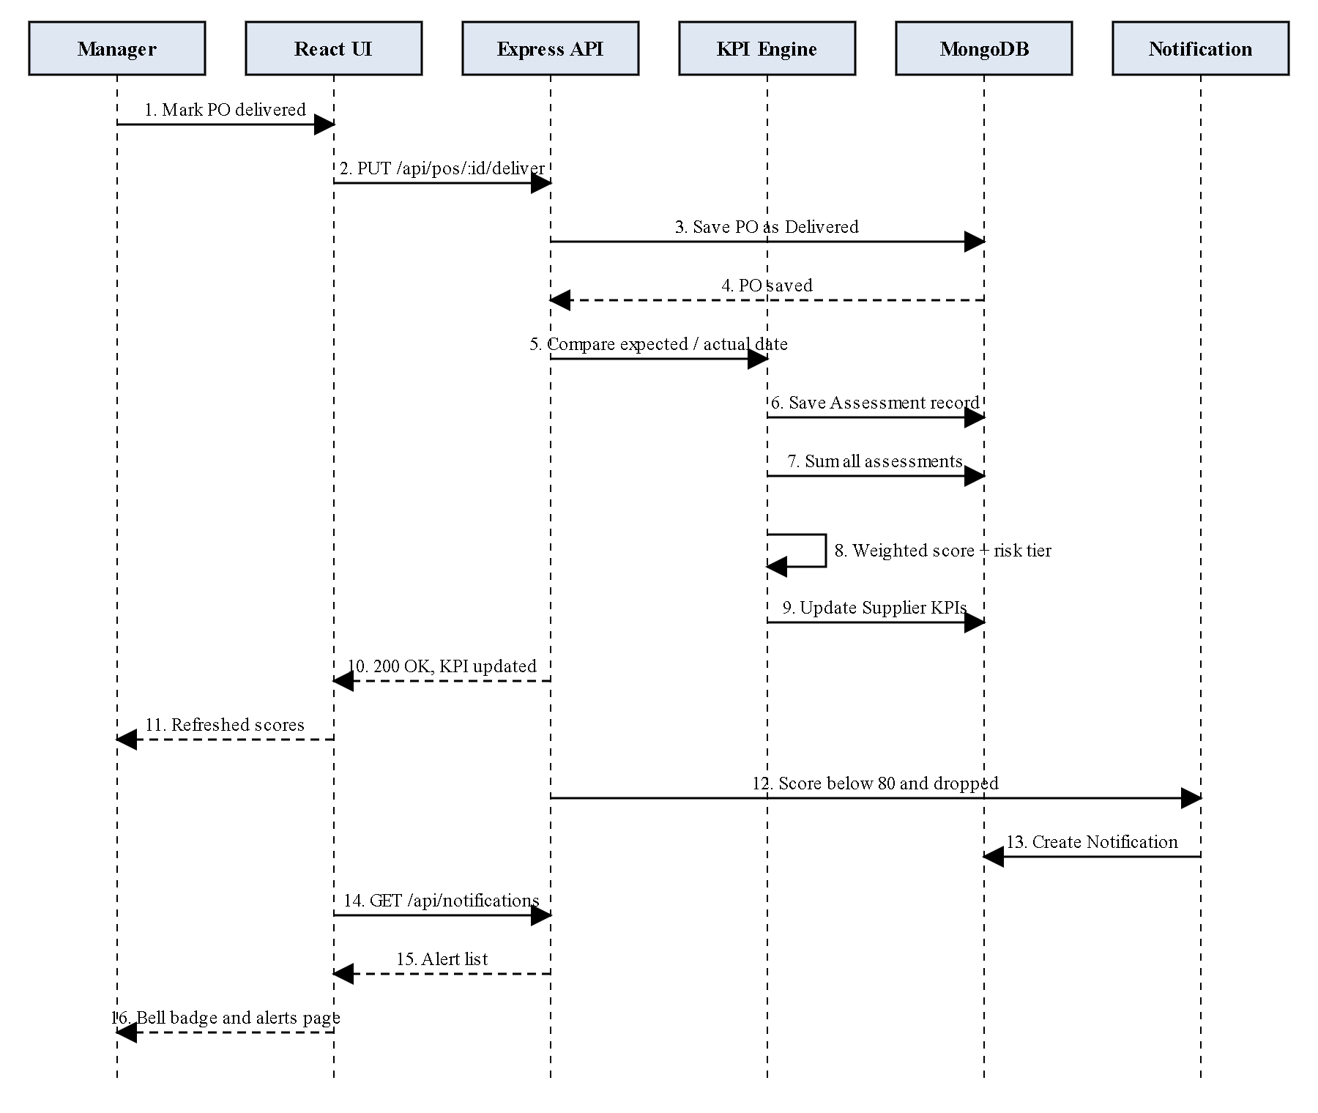
Figure 4.3 Sequence diagram of a purchase order delivery
The same sequence applies to quality inspections and manual assessments, with the corresponding KPI figures supplied by the inspection or the assessment form.
CHAPTER 5

IMPLEMENTATION

5.1 IMPLEMENTATION OVERVIEW
The project is organised as two independent packages: backend (Express API, Mongoose models, route modules and the scheduler) and frontend (React application). The server entry point loads the environment variables, registers the scheduler, applies the JSON and CORS middleware, mounts the seven route modules under /api and starts listening on port 5000 once the connection to MongoDB (mongodb://127.0.0.1:27017/supplier_platform by default) has been established.
The front end is a Vite-built React 19 application. React Router maps the sidebar entries to the page components, a React Context (AuthContext) holds the logged-in user, Recharts draws the charts, Framer Motion animates page transitions and Lucide React supplies the icons. All pages call the REST API with the fetch function and refresh their data when they are opened.
A seed script (seedDemo.js) fills an empty database with four suppliers of different quality, five months of assessments, purchase orders, inspections and notifications so that every page can be demonstrated immediately.

5.2 KEY FUNCTIONS (CODE EXPLANATION)

Calculating the weighted KPI score
When an assessment is submitted, the route reads the current KPI weights and converts the raw figures into six percentages. Divisions are guarded so that missing data does not produce an invalid number, and cost and response scores are capped at 100. The overall score is the weighted sum of the six values.
// --- EXACT MATHEMATICAL FORMULAS ---
const deliveryRaw = raw.totalDeliveries > 0 ? (raw.onTimeDeliveries / raw.totalDeliveries) * 100 : 100;
const qualityRaw = raw.totalItems > 0 ? (raw.acceptedItems / raw.totalItems) * 100 : 100;

let costRaw = raw.supplierPrice > 0 ? (raw.marketPrice / raw.supplierPrice) * 100 : 100;
if (costRaw > 100) costRaw = 100;

let responseRaw = raw.actualResponseHours > 0 ? (raw.targetResponseHours / raw.actualResponseHours) * 100 : 100;
if (responseRaw > 100) responseRaw = 100;

const defectRate = raw.totalItems > 0 ? (raw.defectiveItems / raw.totalItems) * 100 : 0;
const defectRaw = 100 - defectRate; // Invert so higher is better

const resolutionRaw = raw.totalComplaints > 0 ? (raw.resolvedComplaints / raw.totalComplaints) * 100 : 100;

// Weighted Overall Score for this specific assessment
const overallScore = (
(deliveryRaw * (w.delivery / 100)) +
(qualityRaw * (w.quality / 100)) +
(costRaw * (w.cost / 100)) +
(responseRaw * (w.response / 100)) +
(defectRaw * (w.defect / 100)) +
(resolutionRaw * (w.resolution / 100))
);

Assigning the risk rating and supplier status
After the lifetime averages are recomputed from the sums of all assessments, the lifetime score is mapped to the five-tier rating of Table 4.3. Excellent and Good suppliers are set to Active, Poor and Critical suppliers are moved to Under Review and Average suppliers keep their status.
// 5-Tier Rating System Logic
let riskLevel = 'Pending';
let statusUpdate = null;

if (lifetimeOverall >= 90) {
riskLevel = 'Excellent';
statusUpdate = 'Active';
} else if (lifetimeOverall >= 80) {
riskLevel = 'Good';
statusUpdate = 'Active';
} else if (lifetimeOverall >= 70) {
riskLevel = 'Average';
} else if (lifetimeOverall >= 60) {
riskLevel = 'Poor';
statusUpdate = 'Under Review';
} else {
riskLevel = 'Critical';
statusUpdate = 'Under Review';
}

Raising alerts
The alert engine compares the previous and the new score. An alert is created only for a significant drop or a critical state, which avoids repeated notifications for small fluctuations, and it records the reason that is most likely responsible.
// --- AUTOMATED NOTIFICATION ENGINE (MODULE 15) ---
if (oldSupplier && newScore100 < 80) { // If they drop into at-risk territory or are already there
const Notification = require('../models/Notification');

let reason = 'Overall performance deterioration.';
let type = 'Warning';

if (newScore100 < 70) type = 'Critical';

// Pinpoint reason
if (avgDelivery < 70) reason = 'Late deliveries increased significantly.';
else if (avgQuality < 70) reason = 'Severe quality failures detected in recent batches.';
else if (avgCost < 70) reason = 'Pricing non-compliance detected.';
else if (newScore100 < oldScore100) reason = 'KPI targets missed across multiple metrics.';

// Only alert if it's a significant drop or a new critical state to avoid spam
if (newScore100 < oldScore100 - 2 || newScore100 < 70) {
await Notification.create({
title: `Supplier performance dropped below ${newScore100 < 70 ? '70' : 'target'}.`,
supplier: raw.supplier,
type,
details: {
previous: oldScore100,
current: newScore100,
reason
}
});
}
}

Automatic KPI generation from a delivered purchase order
Marking an order as delivered stores the actual date, sets the kpiGenerated flag so that the KPI is created only once and then compares the actual date with the expected date. The result is saved as an assessment that contains only delivery data, after which the same lifetime recalculation is performed.
router.put('/:id/deliver', async (req, res) => {
try {
const { actualDelivery } = req.body;
const po = await PurchaseOrder.findById(req.params.id);

if (!po) return res.status(404).json({ message: 'PO not found' });
if (po.kpiGenerated) return res.status(400).json({ message: 'KPI already generated for this PO' });

po.status = 'Delivered';
po.actualDelivery = new Date(actualDelivery);
po.kpiGenerated = true;
await po.save();

// ---- AUTOMATED KPI GENERATION ----
// 1. Compare dates
const expected = new Date(po.expectedDelivery).setHours(0,0,0,0);
const actual = new Date(po.actualDelivery).setHours(0,0,0,0);

const isOnTime = actual <= expected;

// 2. Create synthetic Assessment record targeting ONLY Delivery metric
// Our math engine safely ignores 0/0 for other metrics (defaults them to 100% or 0% logically without skewing if we recalculate properly)
// Actually, to perfectly integrate without repeating math, we just insert the assessment and run the same sum logic
const raw = {
supplier: po.supplier,
totalDeliveries: 1,
onTimeDeliveries: isOnTime ? 1 : 0,
totalItems: 0, acceptedItems: 0, defectiveItems: 0,
marketPrice: 0, supplierPrice: 0,
targetResponseHours: 0, actualResponseHours: 0,
totalComplaints: 0, resolvedComplaints: 0,
notes: `Automated KPI generation from ${po.poId}`
};

let config = await SystemConfig.findOne() || { kpiWeights: { delivery: 20, quality: 20, cost: 20, response: 15, defect: 15, resolution: 10 } };
const w = config.kpiWeights;

Validating the KPI weights
The Admin’s configuration request is accepted only when the six weights add up to exactly 100, which guarantees that the overall score always stays on a 0–100 scale.
// Update configuration
router.put('/', async (req, res) => {
try {
const { weights } = req.body;

// Validate they sum to 100
const sum = Object.values(weights).reduce((a, b) => a + b, 0);
if (sum !== 100) {
return res.status(400).json({ message: 'Weights must total exactly 100%' });
}

let config = await SystemConfig.findOne();
if (!config) {
config = new SystemConfig();
}

config.kpiWeights = weights;
const updatedConfig = await config.save();

res.json(updatedConfig);
} catch (err) {
res.status(500).json({ message: err.message });
}
});

Scheduled daily recalculation
The scheduler runs at midnight every day, loads the KPI weights and recalculates the report of every supplier that has assessments, using the same formulas as the assessment route.
cron.schedule('0 0 * * *', async () => {
console.log('Running daily supplier KPI report recalculation...');
try {
let config = await SystemConfig.findOne();
if (!config) {
config = await SystemConfig.create({}); // fallback defaults
}
const w = config.kpiWeights;

const suppliers = await Supplier.find();

Logging in on the client
The login function of the authentication context posts the credentials, stores the returned user (including the role) in local storage and exposes it to the whole application. The sidebar uses the role to show or hide menu entries.
const login = async (username, password) => {
try {
const res = await fetch('http://localhost:5000/api/auth/login', {
method: 'POST',
headers: { 'Content-Type': 'application/json' },
body: JSON.stringify({ username, password })
});

const data = await res.json();

if (res.ok) {
setUser(data);
localStorage.setItem('vendorPulseUser', JSON.stringify(data));
return { success: true };
} else {
return { success: false, message: data.message };
}
} catch (err) {
return { success: false, message: 'Server connection failed.' };
}
};

<SidebarLink to="/" icon={LayoutDashboard}>Dashboard</SidebarLink>
<SidebarLink to="/vendors" icon={Users}>Suppliers</SidebarLink>

{user.role === 'Admin' && <SidebarLink to="/config" icon={Settings}>KPI Management</SidebarLink>}
{user.role !== 'Staff' && <SidebarLink to="/assessments" icon={ClipboardCheck}>Supplier Evaluation</SidebarLink>}

<SidebarLink to="/procurement" icon={ShoppingCart}>Purchase Orders</SidebarLink>
<SidebarLink to="/quality" icon={ClipboardCheck}>Quality Management</SidebarLink>
<SidebarLink to="/ranking" icon={Trophy}>Supplier Ranking</SidebarLink>
<SidebarLink to="/alerts" icon={Bell}>Risk & Alerts</SidebarLink>

{user.role !== 'Staff' && <SidebarLink to="/reports" icon={BarChart2}>Reports</SidebarLink>}

Predicting the next score
On a supplier’s profile, the monthly scores are fitted with a least-squares straight line and the line is extended by one period to forecast next month’s score, capped at 100. A forecast below 70 is highlighted in red.
// Automated Performance Prediction (Linear Regression)
if (chartData.length >= 2) {
const n = chartData.length;
let sumX = 0, sumY = 0, sumXY = 0, sumXX = 0;
chartData.forEach((d, i) => {
sumX += i;
sumY += d.score;
sumXY += (i * d.score);
sumXX += (i * i);
});
const m = (n * sumXY - sumX * sumY) / (n * sumXX - sumX * sumX);
const b = (sumY - m * sumX) / n;
let nextPrediction = (m * n + b);
// Cap at 100 max
if (nextPrediction > 100) nextPrediction = 100;
setPrediction(nextPrediction.toFixed(1));
} else if (chartData.length === 1) {
setPrediction(chartData[0].score.toFixed(1));
}

CHAPTER 6

CONCLUSION & FUTURE WORK

6.1 CONCLUSION
This project designed and implemented VendorPulse, a full-stack supplier management and procurement platform built on the MERN stack. By recording every delivery, inspection and assessment as KPI data and by combining six indicators with configurable weights, the platform replaces subjective supplier reviews with an objective, continuously updated score and a five-tier risk rating.
Automation is the main benefit of the system: delivering a purchase order or logging an inspection updates the supplier’s KPIs without any manual calculation, the alert engine explains why a supplier has deteriorated, and the nightly scheduler keeps all stored reports consistent. Ranking, comparison with a recommended supplier, a linear-regression forecast and Recharts analytics give decision makers the information they need at a glance, while role-based menus keep each user to the tasks of their role.

6.2 FUTURE ENHANCEMENTS
- Replace the plain-text demonstration passwords with salted password hashing (for example bcrypt) and issue signed JSON Web Token sessions, with authorisation checks on the server for every route.
- Validate all request bodies on the server and add pagination for large supplier, purchase order and notification lists.
- Connect the edit and delete controls of the supplier list to the existing update and delete API endpoints and add edit support for purchase orders and inspections.
- Send alerts by e-mail or SMS and add real-time delivery of notifications with WebSockets instead of polling.
- Replace the rule-based chatbot with a language-model assistant that can answer questions about the live supplier data.
- Integrate with ERP and accounting systems, add supplier self-service portals and export reports to Excel as well as PDF.
- Introduce machine-learning models for delivery-delay and quality-failure prediction using the accumulated assessment history, and add automated test suites and a CI pipeline.
APPENDIX
SOURCE CODE:
1. Project Structure
Project Folder Structure
fsd project v2/
backend/
models/
Assessment.js
Notification.js
PurchaseOrder.js
QualityInspection.js
Supplier.js
SystemConfig.js
User.js
routes/
assessmentRoutes.js
authRoutes.js
configRoutes.js
notificationRoutes.js
poRoutes.js
qualityRoutes.js
supplierRoutes.js
cronJobs.js
seedDemo.js
server.js
package.json
frontend/
public/
favicon.svg
icons.svg
src/
assets/
components/
Chatbot.jsx
context/
AuthContext.jsx
pages/
Dashboard.jsx
Login.jsx
ProcurementTracking.jsx
QualityManagement.jsx
Reports.jsx
RiskAlerts.jsx
SupplierAssessment.jsx
SupplierRanking.jsx
SystemConfig.jsx
VendorManagement.jsx
App.jsx
App.css
index.css
main.jsx
index.html
package.json
vite.config.js
generate_ppt.py
VendorPulse_Presentation.pptx

2. Package Installation and Running the Application
# backend: install dependencies and start the API on port 5000
cd backend
npm install
npm start

# optional: load demonstration data into an empty database
node seedDemo.js

# frontend: install dependencies and start the Vite dev server (port 5173)
cd frontend
npm install
npm run dev

# production build of the front end
npm run build

3. Database Connection and Main Server File
backend/server.js
require('dotenv').config();
const express = require('express');
const mongoose = require('mongoose');
const cors = require('cors');

const supplierRoutes = require('./routes/supplierRoutes');
const assessmentRoutes = require('./routes/assessmentRoutes');
const authRoutes = require('./routes/authRoutes');
const poRoutes = require('./routes/poRoutes');
const qualityRoutes = require('./routes/qualityRoutes');
const notificationRoutes = require('./routes/notificationRoutes');

// Initialize Cron Jobs
require('./cronJobs');

const app = express();
const PORT = process.env.PORT || 5000;

// Middleware
app.use(cors());
app.use(express.json());

// Routes
app.use('/api/suppliers', supplierRoutes);
app.use('/api/assessments', assessmentRoutes);
app.use('/api/auth', authRoutes);
app.use('/api/config', require('./routes/configRoutes'));
app.use('/api/pos', poRoutes);
app.use('/api/quality', qualityRoutes);
app.use('/api/notifications', notificationRoutes);

// MongoDB Connection
// Normally this would be a secure URI from .env, but for local dev we use a standard local string
const MONGODB_URI = process.env.MONGODB_URI || 'mongodb://127.0.0.1:27017/supplier_platform';

mongoose.connect(MONGODB_URI)
.then(() => {
console.log('Connected to MongoDB');
app.listen(PORT, () => {
console.log(`Server running on port ${PORT}`);
});
})
.catch((err) => {
console.error('Failed to connect to MongoDB', err);
});

4. Environment Variables
backend/.env (optional – defaults are built into server.js)
# Port of the API (default 5000)
PORT=5000

# MongoDB connection string (local, Docker, or MongoDB Atlas)
MONGODB_URI=mongodb://127.0.0.1:27017/supplier_platform

5. Data Models
User model – backend/models/User.js
const mongoose = require('mongoose');

const userSchema = new mongoose.Schema({
username: {
type: String,
required: true,
unique: true
},
password: {
type: String,
required: true
},
role: {
type: String,
enum: ['Admin', 'Manager', 'Staff', 'Management'],
required: true
}
}, { timestamps: true });

module.exports = mongoose.model('User', userSchema);

Supplier model – backend/models/Supplier.js
const mongoose = require('mongoose');

const supplierSchema = new mongoose.Schema({
supplierId: { type: String, unique: true },
name: {
type: String,
required: true,
},
contactPerson: { type: String },
contactEmail: {
type: String,
required: true,
},
phone: {
type: String,
},
address: { type: String },
category: {
type: String,
required: true,
},
productsServices: { type: String },
contractStart: { type: Date },
contractEnd: { type: Date },
status: {
type: String,
enum: ['Active', 'Inactive', 'Under Review', 'Blacklisted'],
default: 'Active'
},
averageScore: {
type: Number,
default: 0
},
avgDelivery: { type: Number, default: 0 },
avgQuality: { type: Number, default: 0 },
avgCost: { type: Number, default: 0 },
avgCommunication: { type: Number, default: 0 },
avgDefect: { type: Number, default: 0 },
avgResolution: { type: Number, default: 0 },
riskLevel: {
type: String,
enum: ['Excellent', 'Good', 'Average', 'Poor', 'Critical', 'Pending'],
default: 'Pending',
}
}, { timestamps: true });

module.exports = mongoose.model('Supplier', supplierSchema);

Assessment model – backend/models/Assessment.js
const mongoose = require('mongoose');

const assessmentSchema = new mongoose.Schema({
supplier: {
type: mongoose.Schema.Types.ObjectId,
ref: 'Supplier',
required: true,
},
dateOfAssessment: {
type: Date,
default: Date.now,
},
// 1. On-Time Delivery Data
totalDeliveries: { type: Number, required: true },
onTimeDeliveries: { type: Number, required: true },

// 2 & 5. Quality and Defect Data
totalItems: { type: Number, required: true },
acceptedItems: { type: Number, required: true },
defectiveItems: { type: Number, required: true },

// 3. Cost Data
marketPrice: { type: Number, required: true },
supplierPrice: { type: Number, required: true },

// 4. Response Time Data
targetResponseHours: { type: Number, required: true },
actualResponseHours: { type: Number, required: true },

// 6. Complaint Resolution Data
totalComplaints: { type: Number, required: true },
resolvedComplaints: { type: Number, required: true },

// Calculated Overall Score for this specific assessment (0-100)
overallScore: { type: Number },
notes: { type: String }
}, { timestamps: true });

module.exports = mongoose.model('Assessment', assessmentSchema);

Purchase Order model – backend/models/PurchaseOrder.js
const mongoose = require('mongoose');

const poSchema = new mongoose.Schema({
poId: { type: String, unique: true },
supplier: {
type: mongoose.Schema.Types.ObjectId,
ref: 'Supplier',
required: true,
},
createdBy: {
type: mongoose.Schema.Types.ObjectId,
ref: 'User',
required: true,
},
products: { type: String, required: true },
quantity: { type: Number, required: true },
orderValue: { type: Number, required: true },
orderDate: { type: Date, default: Date.now },
expectedDelivery: { type: Date, required: true },
actualDelivery: { type: Date },
status: {
type: String,
enum: ['Pending', 'Shipped', 'Delivered', 'Cancelled'],
default: 'Pending'
},
kpiGenerated: { type: Boolean, default: false } // To ensure we only log the KPI once
}, { timestamps: true });

module.exports = mongoose.model('PurchaseOrder', poSchema);

Quality Inspection model – backend/models/QualityInspection.js
const mongoose = require('mongoose');

const qualitySchema = new mongoose.Schema({
inspectionId: { type: String, unique: true },
po: {
type: mongoose.Schema.Types.ObjectId,
ref: 'PurchaseOrder',
required: true,
},
supplier: {
type: mongoose.Schema.Types.ObjectId,
ref: 'Supplier',
required: true,
},
totalItems: { type: Number, required: true },
acceptedItems: { type: Number, required: true },
rejectedItems: { type: Number, required: true },
defectType: { type: String },
inspectionDate: { type: Date, default: Date.now }
}, { timestamps: true });

module.exports = mongoose.model('QualityInspection', qualitySchema);

Notification model – backend/models/Notification.js
const mongoose = require('mongoose');

const notificationSchema = new mongoose.Schema({
title: { type: String, required: true },
supplier: { type: mongoose.Schema.Types.ObjectId, ref: 'Supplier' },
message: { type: String },
type: { type: String, enum: ['Critical', 'Warning', 'Info'], default: 'Info' },
details: {
previous: { type: Number },
current: { type: Number },
reason: { type: String }
},
isRead: { type: Boolean, default: false }
}, { timestamps: true });

module.exports = mongoose.model('Notification', notificationSchema);

System Configuration model – backend/models/SystemConfig.js
const mongoose = require('mongoose');

const systemConfigSchema = new mongoose.Schema({
kpiWeights: {
delivery: { type: Number, default: 20 },
quality: { type: Number, default: 20 },
cost: { type: Number, default: 20 },
response: { type: Number, default: 15 },
defect: { type: Number, default: 15 },
resolution: { type: Number, default: 10 }
}
});

module.exports = mongoose.model('SystemConfig', systemConfigSchema);

6. Authentication: Demo Users and Login
backend/routes/authRoutes.js
const express = require('express');
const router = express.Router();
const User = require('../models/User');

// Seed default users if they don't exist
const seedUsers = async () => {
const defaultUsers = [
{ username: 'admin', password: 'password123', role: 'Admin' },
{ username: 'manager', password: 'password123', role: 'Manager' },
{ username: 'staff', password: 'password123', role: 'Staff' },
{ username: 'management', password: 'password123', role: 'Management' }
];

for (let u of defaultUsers) {
const exists = await User.findOne({ username: u.username });
if (!exists) {
await User.create(u);
console.log(`Created default user: ${u.username}`);
}
}
};
seedUsers();

// Login Route
router.post('/login', async (req, res) => {
try {
const { username, password } = req.body;

// Find user
const user = await User.findOne({ username });
if (!user) {
return res.status(401).json({ message: 'Invalid credentials' });
}

// Verify password (using plain text for prototype stability)
if (user.password !== password) {
return res.status(401).json({ message: 'Invalid credentials' });
}

// Return user info (excluding password)
res.json({
_id: user._id,
username: user.username,
role: user.role
});

} catch (err) {
res.status(500).json({ message: err.message });
}
});

module.exports = router;

7. Supplier APIs: Create, Read, Update and Delete
backend/routes/supplierRoutes.js
const express = require('express');
const router = express.Router();
const Supplier = require('../models/Supplier');

// Get all suppliers
router.get('/', async (req, res) => {
try {
const suppliers = await Supplier.find();
res.json(suppliers);
} catch (err) {
res.status(500).json({ message: err.message });
}
});

// Add a new supplier
router.post('/', async (req, res) => {
try {
// Generate SUP-XXX ID
const count = await Supplier.countDocuments();
const supplierId = `SUP-${(count + 1).toString().padStart(3, '0')}`;

const supplier = new Supplier({
...req.body,
supplierId
});
const newSupplier = await supplier.save();
res.status(201).json(newSupplier);
} catch (err) {
res.status(400).json({ message: err.message });
}
});

// Update a supplier
router.put('/:id', async (req, res) => {
try {
const updatedSupplier = await Supplier.findByIdAndUpdate(
req.params.id,
req.body,
{ new: true }
);
res.json(updatedSupplier);
} catch (err) {
res.status(400).json({ message: err.message });
}
});

// Delete a supplier
router.delete('/:id', async (req, res) => {
try {
await Supplier.findByIdAndDelete(req.params.id);
res.json({ message: 'Supplier deleted' });
} catch (err) {
res.status(500).json({ message: err.message });
}
});

module.exports = router;

8. Assessment API and KPI Evaluation Engine
backend/routes/assessmentRoutes.js
const express = require('express');
const router = express.Router();
const Assessment = require('../models/Assessment');
const Supplier = require('../models/Supplier');
const SystemConfig = require('../models/SystemConfig');

// Get all assessments
router.get('/', async (req, res) => {
try {
const filter = req.query.supplierId ? { supplier: req.query.supplierId } : {};
const assessments = await Assessment.find(filter).populate('supplier');
res.json(assessments);
} catch (err) {
res.status(500).json({ message: err.message });
}
});

// Add a new assessment & Trigger Automated Mathematical Evaluation Engine
router.post('/', async (req, res) => {
try {
const raw = req.body;

// Fetch global KPI weights
let config = await SystemConfig.findOne();
if (!config) {
config = await SystemConfig.create({}); // fallback defaults
}
const w = config.kpiWeights;

// --- EXACT MATHEMATICAL FORMULAS ---
const deliveryRaw = raw.totalDeliveries > 0 ? (raw.onTimeDeliveries / raw.totalDeliveries) * 100 : 100;
const qualityRaw = raw.totalItems > 0 ? (raw.acceptedItems / raw.totalItems) * 100 : 100;

let costRaw = raw.supplierPrice > 0 ? (raw.marketPrice / raw.supplierPrice) * 100 : 100;
if (costRaw > 100) costRaw = 100;

let responseRaw = raw.actualResponseHours > 0 ? (raw.targetResponseHours / raw.actualResponseHours) * 100 : 100;
if (responseRaw > 100) responseRaw = 100;

const defectRate = raw.totalItems > 0 ? (raw.defectiveItems / raw.totalItems) * 100 : 0;
const defectRaw = 100 - defectRate; // Invert so higher is better

const resolutionRaw = raw.totalComplaints > 0 ? (raw.resolvedComplaints / raw.totalComplaints) * 100 : 100;

// Weighted Overall Score for this specific assessment
const overallScore = (
(deliveryRaw * (w.delivery / 100)) +
(qualityRaw * (w.quality / 100)) +
(costRaw * (w.cost / 100)) +
(responseRaw * (w.response / 100)) +
(defectRaw * (w.defect / 100)) +
(resolutionRaw * (w.resolution / 100))
);

const assessment = new Assessment({
...raw,
overallScore: overallScore.toFixed(2)
});
const newAssessment = await assessment.save();

// --- RECALCULATE LIFETIME AVERAGES ---
const allAssessments = await Assessment.find({ supplier: raw.supplier });

const sums = allAssessments.reduce((acc, curr) => {
acc.totDel += curr.totalDeliveries;
acc.onTime += curr.onTimeDeliveries;
acc.totItems += curr.totalItems;
acc.accItems += curr.acceptedItems;
acc.defItems += curr.defectiveItems;
acc.mktPrice += curr.marketPrice;
acc.supPrice += curr.supplierPrice;
acc.tgtResp += curr.targetResponseHours;
acc.actResp += curr.actualResponseHours;
acc.totComp += curr.totalComplaints;
acc.resComp += curr.resolvedComplaints;
return acc;
}, {
totDel: 0, onTime: 0, totItems: 0, accItems: 0, defItems: 0,
mktPrice: 0, supPrice: 0, tgtResp: 0, actResp: 0, totComp: 0, resComp: 0
});

const avgDelivery = sums.totDel > 0 ? ((sums.onTime / sums.totDel) * 100) : 100;
const avgQuality = sums.totItems > 0 ? ((sums.accItems / sums.totItems) * 100) : 100;

let avgCostCalc = sums.supPrice > 0 ? ((sums.mktPrice / sums.supPrice) * 100) : 100;
const avgCost = avgCostCalc > 100 ? 100 : avgCostCalc;

let avgCommCalc = sums.actResp > 0 ? ((sums.tgtResp / sums.actResp) * 100) : 100;
const avgCommunication = avgCommCalc > 100 ? 100 : avgCommCalc;

const avgDefectRate = sums.totItems > 0 ? ((sums.defItems / sums.totItems) * 100) : 0;
const avgDefectInv = 100 - avgDefectRate;

const avgResolution = sums.totComp > 0 ? ((sums.resComp / sums.totComp) * 100) : 100;

// Lifetime Weighted Formula
const lifetimeOverall = (
(avgDelivery * (w.delivery / 100)) +
(avgQuality * (w.quality / 100)) +
(avgCost * (w.cost / 100)) +
(avgCommunication * (w.response / 100)) +
(avgDefectInv * (w.defect / 100)) +
(avgResolution * (w.resolution / 100))
);

// 5-Tier Rating System Logic
let riskLevel = 'Pending';
let statusUpdate = null;

if (lifetimeOverall >= 90) {
riskLevel = 'Excellent';
statusUpdate = 'Active';
} else if (lifetimeOverall >= 80) {
riskLevel = 'Good';
statusUpdate = 'Active';
} else if (lifetimeOverall >= 70) {
riskLevel = 'Average';
} else if (lifetimeOverall >= 60) {
riskLevel = 'Poor';
statusUpdate = 'Under Review';
} else {
riskLevel = 'Critical';
statusUpdate = 'Under Review';
}

// Fetch old supplier stats to compare for Notifications
const oldSupplier = await Supplier.findById(raw.supplier);
const oldScore100 = oldSupplier && oldSupplier.averageScore ? parseFloat((oldSupplier.averageScore * 20).toFixed(1)) : 100;
const newScore100 = parseFloat(lifetimeOverall.toFixed(1));

// Convert 0-100 back to 0-5 for backwards compatibility in UI displays
const updateData = {
averageScore: (lifetimeOverall / 20).toFixed(2),
riskLevel,
avgDelivery: avgDelivery.toFixed(1),
avgQuality: avgQuality.toFixed(1),
avgCost: avgCost.toFixed(1),
avgCommunication: avgCommunication.toFixed(1),
avgDefect: avgDefectRate.toFixed(1), // Store raw defect rate
avgResolution: avgResolution.toFixed(1)
};

if (statusUpdate) updateData.status = statusUpdate;

await Supplier.findByIdAndUpdate(raw.supplier, updateData);

// --- AUTOMATED NOTIFICATION ENGINE (MODULE 15) ---
if (oldSupplier && newScore100 < 80) { // If they drop into at-risk territory or are already there
const Notification = require('../models/Notification');

let reason = 'Overall performance deterioration.';
let type = 'Warning';

if (newScore100 < 70) type = 'Critical';

// Pinpoint reason
if (avgDelivery < 70) reason = 'Late deliveries increased significantly.';
else if (avgQuality < 70) reason = 'Severe quality failures detected in recent batches.';
else if (avgCost < 70) reason = 'Pricing non-compliance detected.';
else if (newScore100 < oldScore100) reason = 'KPI targets missed across multiple metrics.';

// Only alert if it's a significant drop or a new critical state to avoid spam
if (newScore100 < oldScore100 - 2 || newScore100 < 70) {
await Notification.create({
title: `Supplier performance dropped below ${newScore100 < 70 ? '70' : 'target'}.`,
supplier: raw.supplier,
type,
details: {
previous: oldScore100,
current: newScore100,
reason
}
});
}
}

res.status(201).json(newAssessment);
} catch (err) {
res.status(400).json({ message: err.message });
}
});

module.exports = router;

9. Purchase Order APIs
backend/routes/poRoutes.js
const express = require('express');
const router = express.Router();
const PurchaseOrder = require('../models/PurchaseOrder');
const Supplier = require('../models/Supplier');
const Assessment = require('../models/Assessment');
const SystemConfig = require('../models/SystemConfig');

router.get('/', async (req, res) => {
try {
const query = req.query.supplierId ? { supplier: req.query.supplierId } : {};
const pos = await PurchaseOrder.find(query).populate('supplier').populate('createdBy', 'username role');
res.json(pos);
} catch (err) {
res.status(500).json({ message: err.message });
}
});

router.post('/', async (req, res) => {
try {
const count = await PurchaseOrder.countDocuments();
const poId = `PO-${(1001 + count)}`;

// Ensure createdBy is present
if (!req.body.createdBy) {
return res.status(400).json({ message: 'createdBy User ID is required to link User -> PO' });
}

const po = new PurchaseOrder({
...req.body,
poId
});
const newPo = await po.save();
res.status(201).json(newPo);
} catch (err) {
res.status(400).json({ message: err.message });
}
});

router.put('/:id/deliver', async (req, res) => {
try {
const { actualDelivery } = req.body;
const po = await PurchaseOrder.findById(req.params.id);

if (!po) return res.status(404).json({ message: 'PO not found' });
if (po.kpiGenerated) return res.status(400).json({ message: 'KPI already generated for this PO' });

po.status = 'Delivered';
po.actualDelivery = new Date(actualDelivery);
po.kpiGenerated = true;
await po.save();

// ---- AUTOMATED KPI GENERATION ----
// 1. Compare dates
const expected = new Date(po.expectedDelivery).setHours(0,0,0,0);
const actual = new Date(po.actualDelivery).setHours(0,0,0,0);

const isOnTime = actual <= expected;

// 2. Create synthetic Assessment record targeting ONLY Delivery metric
// Our math engine safely ignores 0/0 for other metrics (defaults them to 100% or 0% logically without skewing if we recalculate properly)
// Actually, to perfectly integrate without repeating math, we just insert the assessment and run the same sum logic
const raw = {
supplier: po.supplier,
totalDeliveries: 1,
onTimeDeliveries: isOnTime ? 1 : 0,
totalItems: 0, acceptedItems: 0, defectiveItems: 0,
marketPrice: 0, supplierPrice: 0,
targetResponseHours: 0, actualResponseHours: 0,
totalComplaints: 0, resolvedComplaints: 0,
notes: `Automated KPI generation from ${po.poId}`
};

let config = await SystemConfig.findOne() || { kpiWeights: { delivery: 20, quality: 20, cost: 20, response: 15, defect: 15, resolution: 10 } };
const w = config.kpiWeights;

const deliveryRaw = isOnTime ? 100 : 0;
const overallScore = deliveryRaw * (w.delivery / 100);
// The specific assessment score is low because other metrics are 0, but this doesn't matter,
// because the lifetime average uses the SUM of all raw data.

const assessment = new Assessment({ ...raw, overallScore: overallScore.toFixed(2) });
await assessment.save();

// 3. Recalculate Lifetime averages
const allAssessments = await Assessment.find({ supplier: raw.supplier });
const sums = allAssessments.reduce((acc, curr) => {
acc.totDel += curr.totalDeliveries; acc.onTime += curr.onTimeDeliveries;
acc.totItems += curr.totalItems; acc.accItems += curr.acceptedItems; acc.defItems += curr.defectiveItems;
acc.mktPrice += curr.marketPrice; acc.supPrice += curr.supplierPrice;
acc.tgtResp += curr.targetResponseHours; acc.actResp += curr.actualResponseHours;
acc.totComp += curr.totalComplaints; acc.resComp += curr.resolvedComplaints;
return acc;
}, { totDel: 0, onTime: 0, totItems: 0, accItems: 0, defItems: 0, mktPrice: 0, supPrice: 0, tgtResp: 0, actResp: 0, totComp: 0, resComp: 0 });

const avgDelivery = sums.totDel > 0 ? ((sums.onTime / sums.totDel) * 100) : 100;
const avgQuality = sums.totItems > 0 ? ((sums.accItems / sums.totItems) * 100) : 100;
let avgCostCalc = sums.supPrice > 0 ? ((sums.mktPrice / sums.supPrice) * 100) : 100;
const avgCost = avgCostCalc > 100 ? 100 : avgCostCalc;
let avgCommCalc = sums.actResp > 0 ? ((sums.tgtResp / sums.actResp) * 100) : 100;
const avgCommunication = avgCommCalc > 100 ? 100 : avgCommCalc;
const avgDefectRate = sums.totItems > 0 ? ((sums.defItems / sums.totItems) * 100) : 0;
const avgDefectInv = 100 - avgDefectRate;
const avgResolution = sums.totComp > 0 ? ((sums.resComp / sums.totComp) * 100) : 100;

const lifetimeOverall = (
(avgDelivery * (w.delivery / 100)) + (avgQuality * (w.quality / 100)) + (avgCost * (w.cost / 100)) +
(avgCommunication * (w.response / 100)) + (avgDefectInv * (w.defect / 100)) + (avgResolution * (w.resolution / 100))
);

let riskLevel = 'Pending';
let statusUpdate = null;
if (lifetimeOverall >= 90) { riskLevel = 'Excellent'; statusUpdate = 'Active'; }
else if (lifetimeOverall >= 80) { riskLevel = 'Good'; statusUpdate = 'Active'; }
else if (lifetimeOverall >= 70) { riskLevel = 'Average'; }
else if (lifetimeOverall >= 60) { riskLevel = 'Poor'; statusUpdate = 'Under Review'; }
else { riskLevel = 'Critical'; statusUpdate = 'Under Review'; }

const updateData = {
averageScore: (lifetimeOverall / 20).toFixed(2),
riskLevel,
avgDelivery: avgDelivery.toFixed(1),
avgQuality: avgQuality.toFixed(1),
avgCost: avgCost.toFixed(1),
avgCommunication: avgCommunication.toFixed(1),
avgDefect: avgDefectRate.toFixed(1),
avgResolution: avgResolution.toFixed(1)
};
if (statusUpdate) updateData.status = statusUpdate;

await Supplier.findByIdAndUpdate(raw.supplier, updateData);

res.json({ message: 'PO Delivered and KPI Automatically Updated', po });
} catch (err) {
res.status(500).json({ message: err.message });
}
});

module.exports = router;

10. Quality Inspection APIs
backend/routes/qualityRoutes.js
const express = require('express');
const router = express.Router();
const QualityInspection = require('../models/QualityInspection');
const Supplier = require('../models/Supplier');
const Assessment = require('../models/Assessment');
const SystemConfig = require('../models/SystemConfig');

router.get('/', async (req, res) => {
try {
const insps = await QualityInspection.find().populate('supplier').populate('po');
res.json(insps);
} catch (err) {
res.status(500).json({ message: err.message });
}
});

router.post('/', async (req, res) => {
try {
const count = await QualityInspection.countDocuments();
const inspectionId = `INSP-${(1001 + count)}`;

const insp = new QualityInspection({
...req.body,
inspectionId
});
const newInsp = await insp.save();

// ---- AUTOMATED KPI GENERATION ----
// Create synthetic Assessment record targeting ONLY Quality & Defect metrics
const raw = {
supplier: req.body.supplier,
totalDeliveries: 0, onTimeDeliveries: 0,
totalItems: req.body.totalItems,
acceptedItems: req.body.acceptedItems,
defectiveItems: req.body.rejectedItems,
marketPrice: 0, supplierPrice: 0,
targetResponseHours: 0, actualResponseHours: 0,
totalComplaints: 0, resolvedComplaints: 0,
notes: `Automated Quality KPI from ${inspectionId}. Defect Type: ${req.body.defectType || 'None'}`
};

let config = await SystemConfig.findOne() || { kpiWeights: { delivery: 20, quality: 20, cost: 20, response: 15, defect: 15, resolution: 10 } };
const w = config.kpiWeights;

const qualityRaw = (raw.acceptedItems / raw.totalItems) * 100;
const defectRate = (raw.defectiveItems / raw.totalItems) * 100;
const defectRaw = 100 - defectRate;

const overallScore = (qualityRaw * (w.quality / 100)) + (defectRaw * (w.defect / 100));

const assessment = new Assessment({ ...raw, overallScore: overallScore.toFixed(2) });
await assessment.save();

// Recalculate Lifetime averages
const allAssessments = await Assessment.find({ supplier: raw.supplier });
const sums = allAssessments.reduce((acc, curr) => {
acc.totDel += curr.totalDeliveries; acc.onTime += curr.onTimeDeliveries;
acc.totItems += curr.totalItems; acc.accItems += curr.acceptedItems; acc.defItems += curr.defectiveItems;
acc.mktPrice += curr.marketPrice; acc.supPrice += curr.supplierPrice;
acc.tgtResp += curr.targetResponseHours; acc.actResp += curr.actualResponseHours;
acc.totComp += curr.totalComplaints; acc.resComp += curr.resolvedComplaints;
return acc;
}, { totDel: 0, onTime: 0, totItems: 0, accItems: 0, defItems: 0, mktPrice: 0, supPrice: 0, tgtResp: 0, actResp: 0, totComp: 0, resComp: 0 });

const avgDelivery = sums.totDel > 0 ? ((sums.onTime / sums.totDel) * 100) : 100;
const avgQuality = sums.totItems > 0 ? ((sums.accItems / sums.totItems) * 100) : 100;
let avgCostCalc = sums.supPrice > 0 ? ((sums.mktPrice / sums.supPrice) * 100) : 100;
const avgCost = avgCostCalc > 100 ? 100 : avgCostCalc;
let avgCommCalc = sums.actResp > 0 ? ((sums.tgtResp / sums.actResp) * 100) : 100;
const avgCommunication = avgCommCalc > 100 ? 100 : avgCommCalc;
const avgDefectRate = sums.totItems > 0 ? ((sums.defItems / sums.totItems) * 100) : 0;
const avgDefectInv = 100 - avgDefectRate;
const avgResolution = sums.totComp > 0 ? ((sums.resComp / sums.totComp) * 100) : 100;

const lifetimeOverall = (
(avgDelivery * (w.delivery / 100)) + (avgQuality * (w.quality / 100)) + (avgCost * (w.cost / 100)) +
(avgCommunication * (w.response / 100)) + (avgDefectInv * (w.defect / 100)) + (avgResolution * (w.resolution / 100))
);

let riskLevel = 'Pending';
let statusUpdate = null;
if (lifetimeOverall >= 90) { riskLevel = 'Excellent'; statusUpdate = 'Active'; }
else if (lifetimeOverall >= 80) { riskLevel = 'Good'; statusUpdate = 'Active'; }
else if (lifetimeOverall >= 70) { riskLevel = 'Average'; }
else if (lifetimeOverall >= 60) { riskLevel = 'Poor'; statusUpdate = 'Under Review'; }
else { riskLevel = 'Critical'; statusUpdate = 'Under Review'; }

const updateData = {
averageScore: (lifetimeOverall / 20).toFixed(2),
riskLevel,
avgDelivery: avgDelivery.toFixed(1),
avgQuality: avgQuality.toFixed(1),
avgCost: avgCost.toFixed(1),
avgCommunication: avgCommunication.toFixed(1),
avgDefect: avgDefectRate.toFixed(1),
avgResolution: avgResolution.toFixed(1)
};
if (statusUpdate) updateData.status = statusUpdate;

await Supplier.findByIdAndUpdate(raw.supplier, updateData);

res.status(201).json(newInsp);
} catch (err) {
res.status(400).json({ message: err.message });
}
});

module.exports = router;

11. KPI Configuration API
backend/routes/configRoutes.js
const express = require('express');
const router = express.Router();
const SystemConfig = require('../models/SystemConfig');

// Get configuration
router.get('/', async (req, res) => {
try {
let config = await SystemConfig.findOne();
if (!config) {
config = await SystemConfig.create({});
}
res.json(config);
} catch (err) {
res.status(500).json({ message: err.message });
}
});

// Update configuration
router.put('/', async (req, res) => {
try {
const { weights } = req.body;

// Validate they sum to 100
const sum = Object.values(weights).reduce((a, b) => a + b, 0);
if (sum !== 100) {
return res.status(400).json({ message: 'Weights must total exactly 100%' });
}

let config = await SystemConfig.findOne();
if (!config) {
config = new SystemConfig();
}

config.kpiWeights = weights;
const updatedConfig = await config.save();

res.json(updatedConfig);
} catch (err) {
res.status(500).json({ message: err.message });
}
});

module.exports = router;

12. Notification APIs
backend/routes/notificationRoutes.js
const express = require('express');
const router = express.Router();
const Notification = require('../models/Notification');

// Get all notifications (sorted by newest, filterable by supplierId)
router.get('/', async (req, res) => {
try {
const query = req.query.supplierId ? { supplier: req.query.supplierId } : {};
const notifications = await Notification.find(query).populate('supplier').sort({ createdAt: -1 });
res.json(notifications);
} catch (err) {
res.status(500).json({ message: err.message });
}
});

// Mark notification as read
router.put('/:id/read', async (req, res) => {
try {
const notification = await Notification.findByIdAndUpdate(req.params.id, { isRead: true }, { new: true });
res.json(notification);
} catch (err) {
res.status(400).json({ message: err.message });
}
});

// Create a generic notification (utility endpoint)
router.post('/', async (req, res) => {
try {
const notification = new Notification(req.body);
const saved = await notification.save();
res.status(201).json(saved);
} catch (err) {
res.status(400).json({ message: err.message });
}
});

module.exports = router;

13. Scheduled Daily KPI Recalculation
backend/cronJobs.js
const cron = require('node-cron');
const Supplier = require('./models/Supplier');
const Assessment = require('./models/Assessment');
const SystemConfig = require('./models/SystemConfig');
const Notification = require('./models/Notification');

// Run every day at midnight (00:00)
cron.schedule('0 0 * * *', async () => {
console.log('Running daily supplier KPI report recalculation...');
try {
let config = await SystemConfig.findOne();
if (!config) {
config = await SystemConfig.create({}); // fallback defaults
}
const w = config.kpiWeights;

const suppliers = await Supplier.find();

for (const supplier of suppliers) {
const allAssessments = await Assessment.find({ supplier: supplier._id });
if (allAssessments.length === 0) continue;

const sums = allAssessments.reduce((acc, curr) => {
acc.totDel += curr.totalDeliveries || 0;
acc.onTime += curr.onTimeDeliveries || 0;
acc.totItems += curr.totalItems || 0;
acc.accItems += curr.acceptedItems || 0;
acc.defItems += curr.defectiveItems || 0;
acc.mktPrice += curr.marketPrice || 0;
acc.supPrice += curr.supplierPrice || 0;
acc.tgtResp += curr.targetResponseHours || 0;
acc.actResp += curr.actualResponseHours || 0;
acc.totComp += curr.totalComplaints || 0;
acc.resComp += curr.resolvedComplaints || 0;
return acc;
}, {
totDel: 0, onTime: 0, totItems: 0, accItems: 0, defItems: 0,
mktPrice: 0, supPrice: 0, tgtResp: 0, actResp: 0, totComp: 0, resComp: 0
});

const avgDelivery = sums.totDel > 0 ? ((sums.onTime / sums.totDel) * 100) : 100;
const avgQuality = sums.totItems > 0 ? ((sums.accItems / sums.totItems) * 100) : 100;

let avgCostCalc = sums.supPrice > 0 ? ((sums.mktPrice / sums.supPrice) * 100) : 100;
const avgCost = avgCostCalc > 100 ? 100 : avgCostCalc;

let avgCommCalc = sums.actResp > 0 ? ((sums.tgtResp / sums.actResp) * 100) : 100;
const avgCommunication = avgCommCalc > 100 ? 100 : avgCommCalc;

const avgDefectRate = sums.totItems > 0 ? ((sums.defItems / sums.totItems) * 100) : 0;
const avgDefectInv = 100 - avgDefectRate;

const avgResolution = sums.totComp > 0 ? ((sums.resComp / sums.totComp) * 100) : 100;

// Lifetime Weighted Formula
const lifetimeOverall = (
(avgDelivery * (w.delivery / 100)) +
(avgQuality * (w.quality / 100)) +
(avgCost * (w.cost / 100)) +
(avgCommunication * (w.response / 100)) +
(avgDefectInv * (w.defect / 100)) +
(avgResolution * (w.resolution / 100))
);

// 5-Tier Rating System Logic
let riskLevel = 'Pending';
let statusUpdate = supplier.status;

if (lifetimeOverall >= 90) {
riskLevel = 'Excellent';
statusUpdate = 'Active';
} else if (lifetimeOverall >= 80) {
riskLevel = 'Good';
statusUpdate = 'Active';
} else if (lifetimeOverall >= 70) {
riskLevel = 'Average';
} else if (lifetimeOverall >= 60) {
riskLevel = 'Poor';
statusUpdate = 'Under Review';
} else {
riskLevel = 'Critical';
statusUpdate = 'Under Review';
}

const updateData = {
averageScore: (lifetimeOverall / 20).toFixed(2),
riskLevel,
avgDelivery: avgDelivery.toFixed(1),
avgQuality: avgQuality.toFixed(1),
avgCost: avgCost.toFixed(1),
avgCommunication: avgCommunication.toFixed(1),
avgDefect: avgDefectRate.toFixed(1),
avgResolution: avgResolution.toFixed(1),
status: statusUpdate
};

await Supplier.findByIdAndUpdate(supplier._id, updateData);
}
console.log('Daily supplier KPI report recalculation completed successfully.');
} catch (err) {
console.error('Error in daily cron job:', err);
}
});

14. React Entry Point and Authentication Context
frontend/src/main.jsx
import { StrictMode } from 'react'
import { createRoot } from 'react-dom/client'
import './index.css'
import App from './App.jsx'

createRoot(document.getElementById('root')).render(
<StrictMode>
<App />
</StrictMode>,
)

frontend/src/context/AuthContext.jsx
import React, { createContext, useContext, useState, useEffect } from 'react';

const AuthContext = createContext(null);

export const AuthProvider = ({ children }) => {
const [user, setUser] = useState(null);
const [loading, setLoading] = useState(true);

useEffect(() => {
// Check local storage for persistent session
const storedUser = localStorage.getItem('vendorPulseUser');
if (storedUser) {
setUser(JSON.parse(storedUser));
}
setLoading(false);
}, []);

const login = async (username, password) => {
try {
const res = await fetch('http://localhost:5000/api/auth/login', {
method: 'POST',
headers: { 'Content-Type': 'application/json' },
body: JSON.stringify({ username, password })
});

const data = await res.json();

if (res.ok) {
setUser(data);
localStorage.setItem('vendorPulseUser', JSON.stringify(data));
return { success: true };
} else {
return { success: false, message: data.message };
}
} catch (err) {
return { success: false, message: 'Server connection failed.' };
}
};

const logout = () => {
setUser(null);
localStorage.removeItem('vendorPulseUser');
};

if (loading) return null;

return (
<AuthContext.Provider value={{ user, login, logout }}>
{children}
</AuthContext.Provider>
);
};

export const useAuth = () => useContext(AuthContext);

15. React Routing, Role-Based Menu and Notification Polling
frontend/src/App.jsx – routes
const AnimatedRoutes = () => {
const location = useLocation();
return (
<AnimatePresence mode="wait">
<Routes location={location} key={location.pathname}>
<Route path="/" element={<PageWrapper><Dashboard /></PageWrapper>} />
<Route path="/vendors" element={<PageWrapper><VendorManagement /></PageWrapper>} />
<Route path="/assessments" element={<PageWrapper><SupplierAssessment /></PageWrapper>} />
<Route path="/procurement" element={<PageWrapper><ProcurementTracking /></PageWrapper>} />
<Route path="/quality" element={<PageWrapper><QualityManagement /></PageWrapper>} />
<Route path="/ranking" element={<PageWrapper><SupplierRanking /></PageWrapper>} />
<Route path="/alerts" element={<PageWrapper><RiskAlerts /></PageWrapper>} />
<Route path="/reports" element={<PageWrapper><Reports /></PageWrapper>} />
<Route path="/config" element={<PageWrapper><SystemConfig /></PageWrapper>} />
</Routes>
</AnimatePresence>
);
};

frontend/src/App.jsx – role-based sidebar
<SidebarLink to="/" icon={LayoutDashboard}>Dashboard</SidebarLink>
<SidebarLink to="/vendors" icon={Users}>Suppliers</SidebarLink>

{user.role === 'Admin' && <SidebarLink to="/config" icon={Settings}>KPI Management</SidebarLink>}
{user.role !== 'Staff' && <SidebarLink to="/assessments" icon={ClipboardCheck}>Supplier Evaluation</SidebarLink>}

<SidebarLink to="/procurement" icon={ShoppingCart}>Purchase Orders</SidebarLink>
<SidebarLink to="/quality" icon={ClipboardCheck}>Quality Management</SidebarLink>
<SidebarLink to="/ranking" icon={Trophy}>Supplier Ranking</SidebarLink>
<SidebarLink to="/alerts" icon={Bell}>Risk & Alerts</SidebarLink>

{user.role !== 'Staff' && <SidebarLink to="/reports" icon={BarChart2}>Reports</SidebarLink>}

frontend/src/App.jsx – notification polling
const fetchNotifications = async () => {
try {
const res = await fetch('http://localhost:5000/api/notifications');
if (res.ok) {
const data = await res.json();
setNotifications(data);
}
} catch (err) {
console.error(err);
}
};
fetchNotifications();

const interval = setInterval(fetchNotifications, 15000);
return () => clearInterval(interval);

16. React Login Component
frontend/src/pages/Login.jsx
const Login = () => {
const [username, setUsername] = useState('');
const [password, setPassword] = useState('');
const [error, setError] = useState('');
const [loading, setLoading] = useState(false);

const { login } = useAuth();

const handleSubmit = async (e) => {
e.preventDefault();
setError('');
setLoading(true);

const result = await login(username, password);

if (!result.success) {
setError(result.message);
setLoading(false);
}
};

17. REST API Request and Response Examples
The following requests and responses were captured from the running application (identifiers shortened where noted).
Request – sign in
POST /api/auth/login HTTP/1.1
Content-Type: application/json

{
"username": "manager",
"password": "********"
}

Response
HTTP/1.1 200
{
"_id": "6ad7a265cfee243a4118bee3",
"username": "manager",
"role": "Manager"
}

Request – add a supplier
POST /api/suppliers HTTP/1.1
Content-Type: application/json

{
"name": "Nova Packaging Co.",
"contactPerson": "Priya Nair",
"contactEmail": "priya@novapack.com",
"phone": "555-0505",
"category": "Packaging",
"status": "Active"
}

Response
HTTP/1.1 201
{
"supplierId": "SUP-005",
"name": "Nova Packaging Co.",
"category": "Packaging",
"status": "Active",
"averageScore": 0,
"riskLevel": "Pending",
"_id": "6ad7a497cfee243a4118bee6",
"createdAt": "2026-10-20T17:27:51.045Z"
}

Request – create a purchase order
POST /api/pos HTTP/1.1
Content-Type: application/json

{
"supplier": "6ad7a25f7cecdb30bfb8f442",
"createdBy": "6ad7a265cfee243a4118bee3",
"products": "Packaging Film Rolls",
"quantity": 300,
"orderValue": 9000,
"expectedDelivery": "2026-10-18"
}

Response
HTTP/1.1 201
{
"poId": "PO-1005",
"products": "Packaging Film Rolls",
"quantity": 300,
"orderValue": 9000,
"expectedDelivery": "2026-10-18T00:00:00.000Z",
"status": "Pending",
"kpiGenerated": false
}

Request – mark the purchase order as delivered (late)
PUT /api/pos/6ad7a497cfee243a4118bee7/deliver HTTP/1.1
Content-Type: application/json

{
"actualDelivery": "2026-10-22"
}

Response
HTTP/1.1 200
{
"message": "PO Delivered and KPI Automatically Updated",
"po": {
"poId": "PO-1005",
"status": "Delivered",
"kpiGenerated": true,
"actualDelivery": "2026-10-22T00:00:00.000Z"
}
}

Request – submit a KPI assessment
POST /api/assessments HTTP/1.1
Content-Type: application/json

{
"supplier": "6ad7a25f7cecdb30bfb8f442",
"totalDeliveries": 100, "onTimeDeliveries": 60,
"totalItems": 1000, "acceptedItems": 700,
"defectiveItems": 300,
"marketPrice": 100, "supplierPrice": 125,
"targetResponseHours": 24, "actualResponseHours": 60,
"totalComplaints": 20, "resolvedComplaints": 6
}

Response
HTTP/1.1 201
{
"supplier": "6ad7a25f7cecdb30bfb8f442",
"overallScore": 61.5,
"dateOfAssessment": "2026-10-20T17:27:51.602Z"
}

Request – change KPI weights that do not total 100
PUT /api/config HTTP/1.1
Content-Type: application/json

{
"weights": { "delivery": 30, "quality": 30, "cost": 10,
"response": 10, "defect": 10, "resolution": 5 }
}

Response
HTTP/1.1 400
{
"message": "Weights must total exactly 100%"
}

Request – read notifications
GET /api/notifications HTTP/1.1

Response
HTTP/1.1 200
[
{
"title": "Critical Score Drop",
"supplier": { "supplierId": "SUP-004", "name": "Starlight Electronics" },
"message": "Starlight Electronics score has dropped below the critical
threshold of 60.",
"type": "Critical",
"isRead": false
}, ...
]

SCREENSHOTS OF THE PROJECT
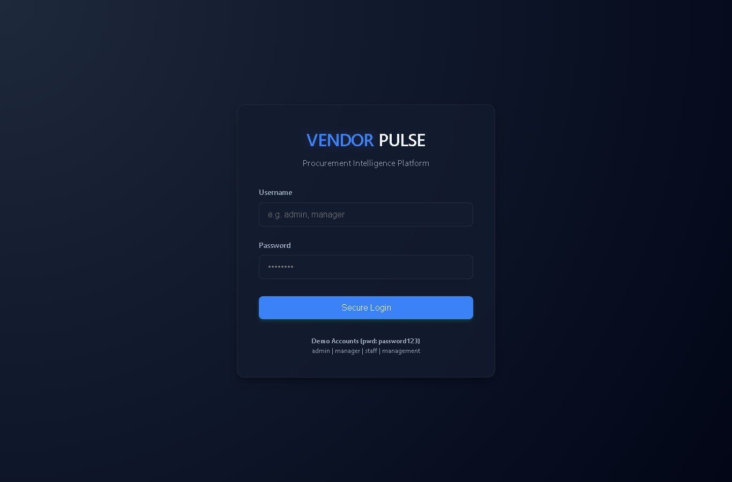
Figure A.1 Login page
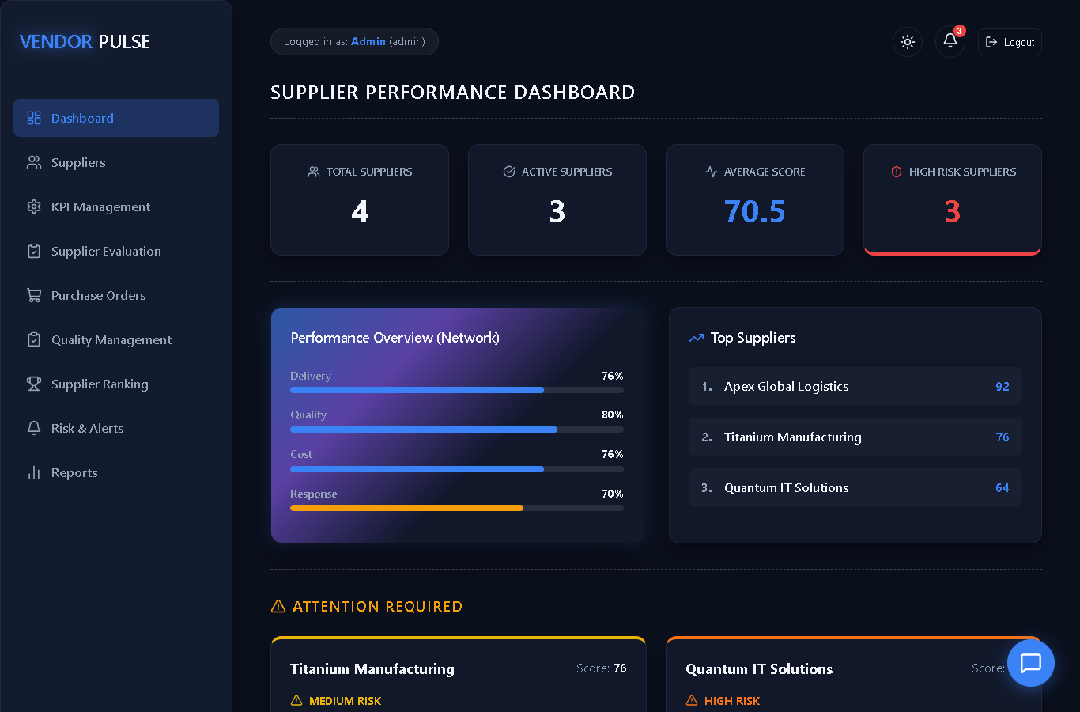
Figure A.2 Supplier performance dashboard
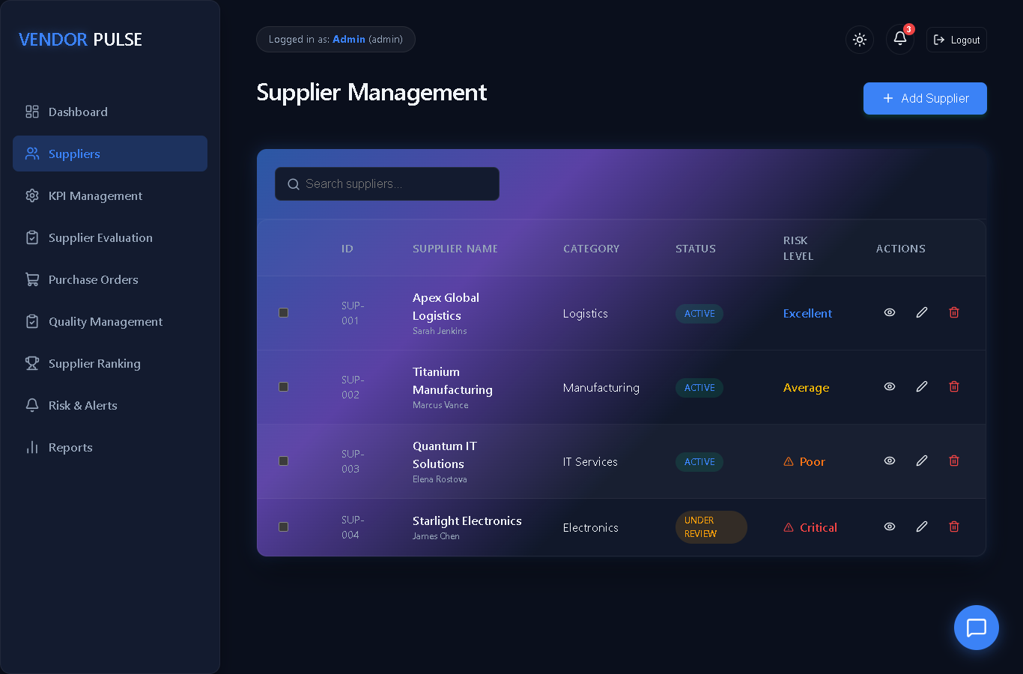
Figure A.3 Supplier management list
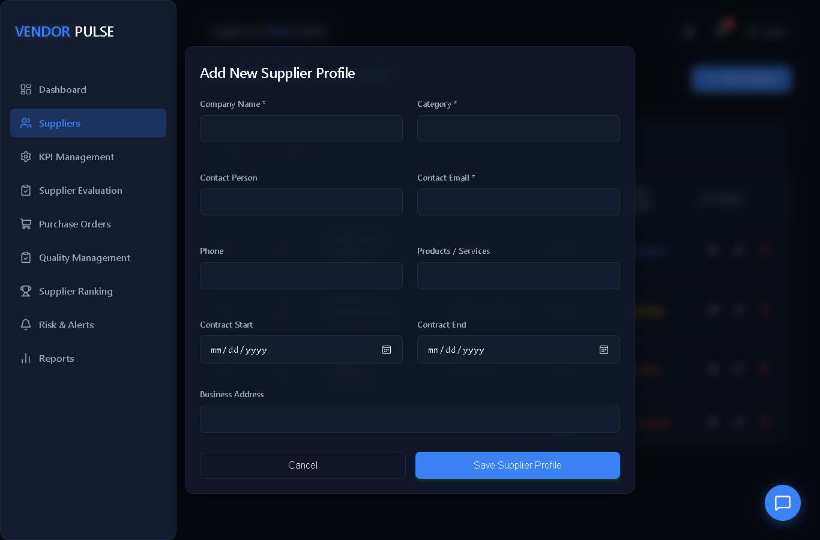
Figure A.4 Adding a new supplier profile
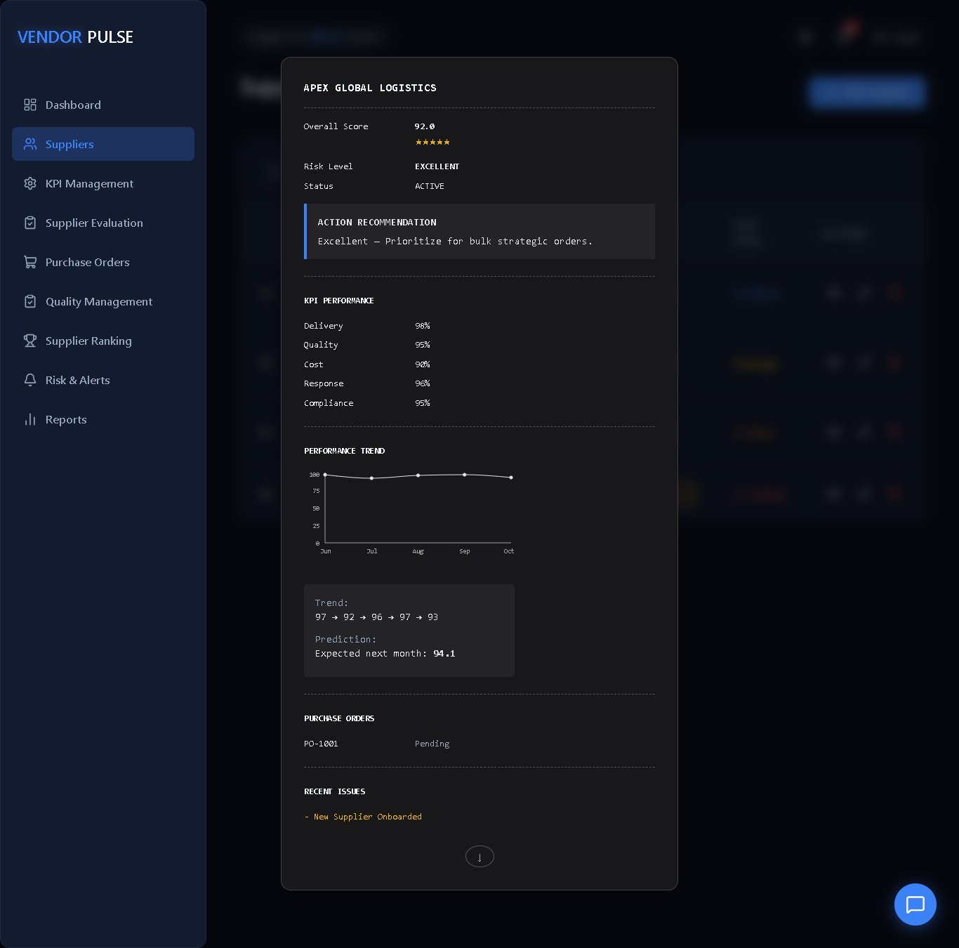
Figure A.5 Supplier profile with KPI performance, trend and predicted score
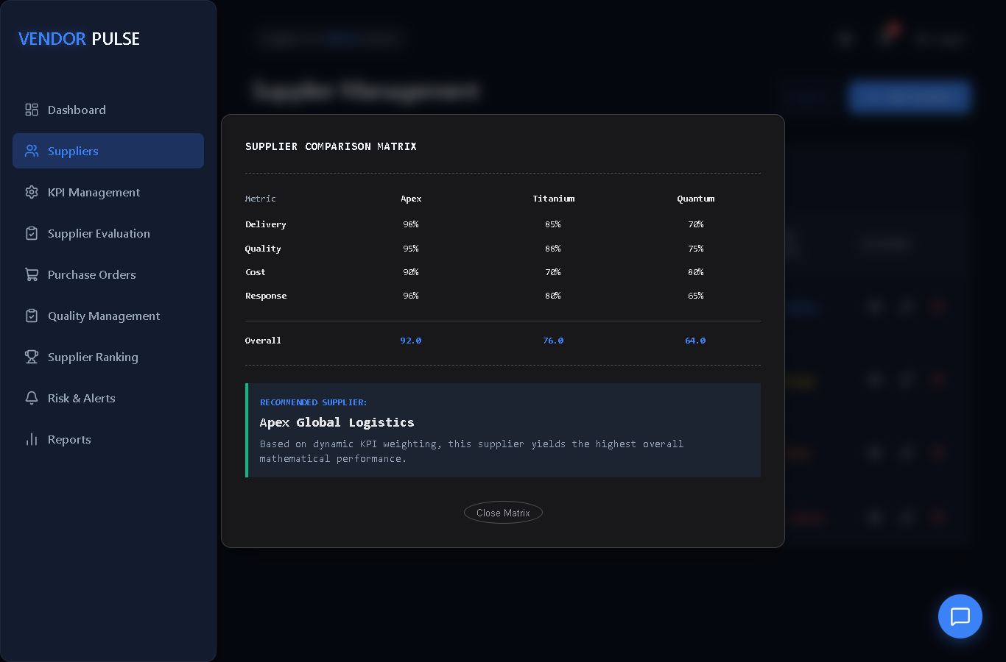
Figure A.6 Supplier comparison matrix with recommended supplier
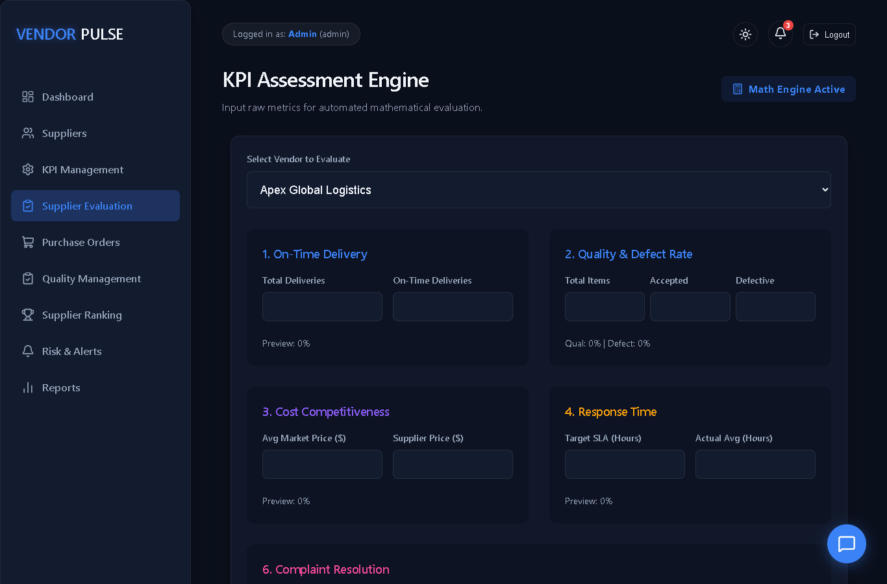
Figure A.7 KPI assessment engine form
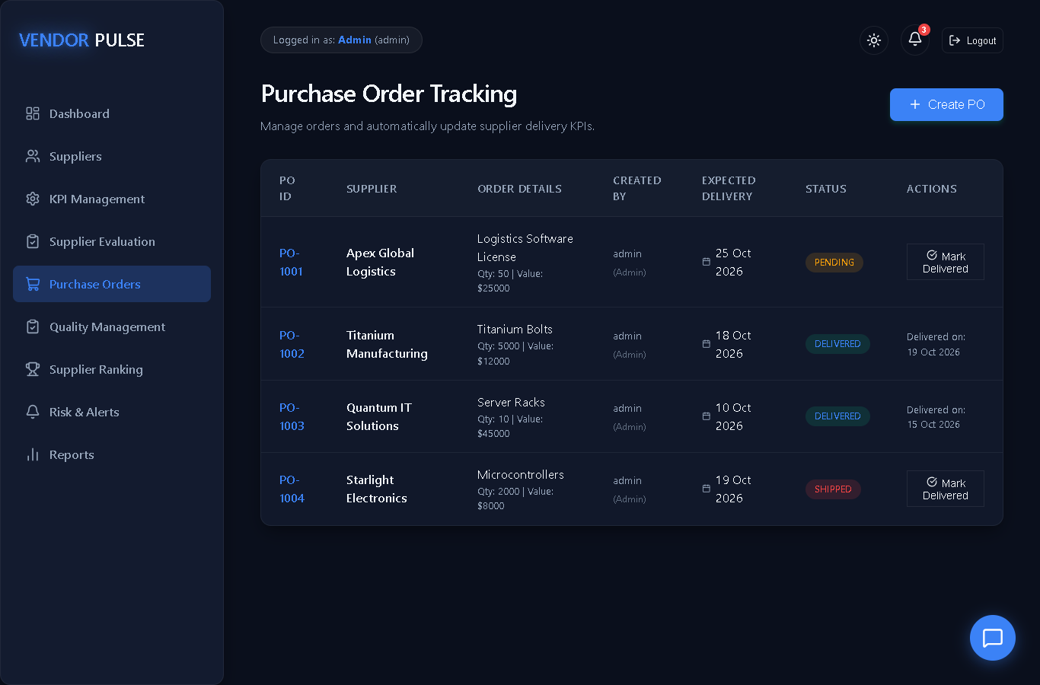
Figure A.8 Purchase order tracking
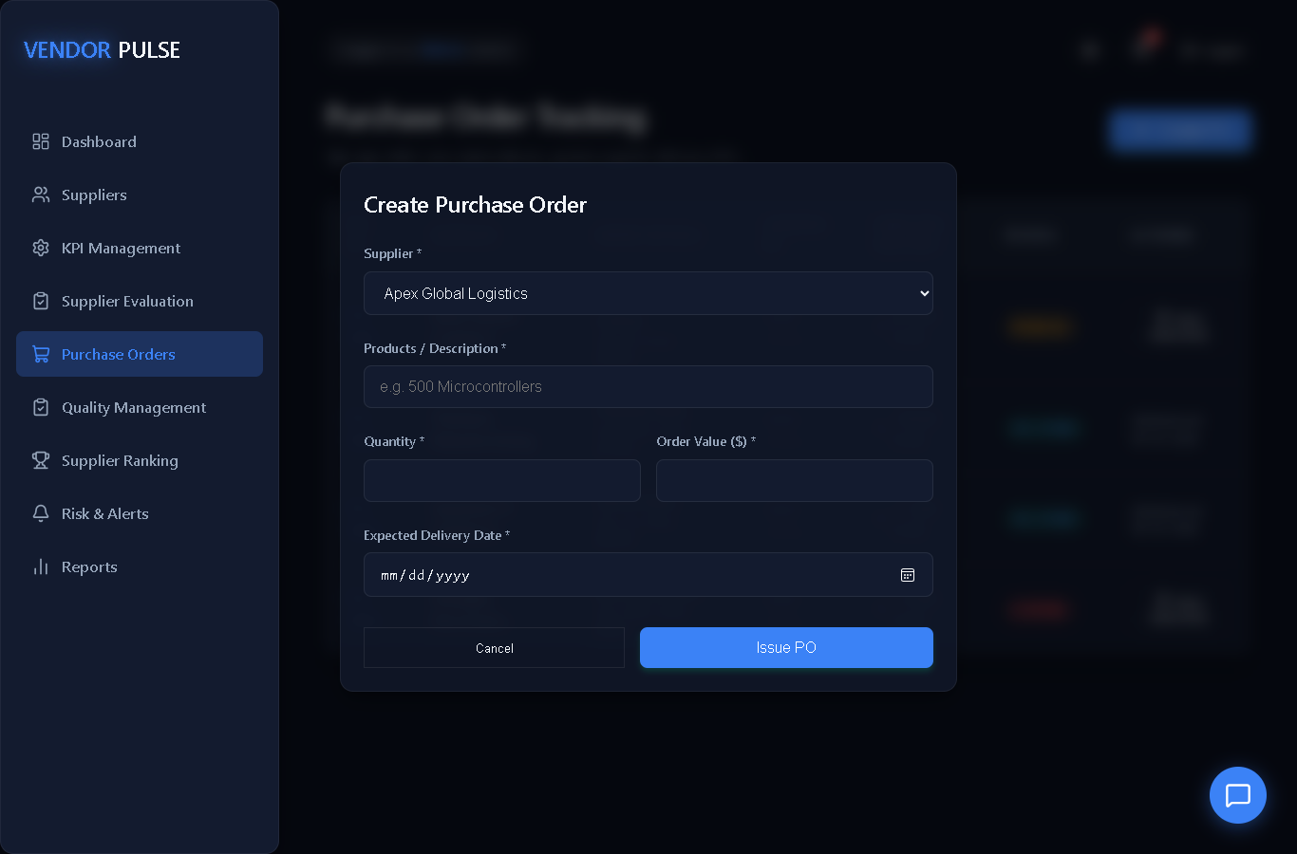
Figure A.9 Creating a purchase order
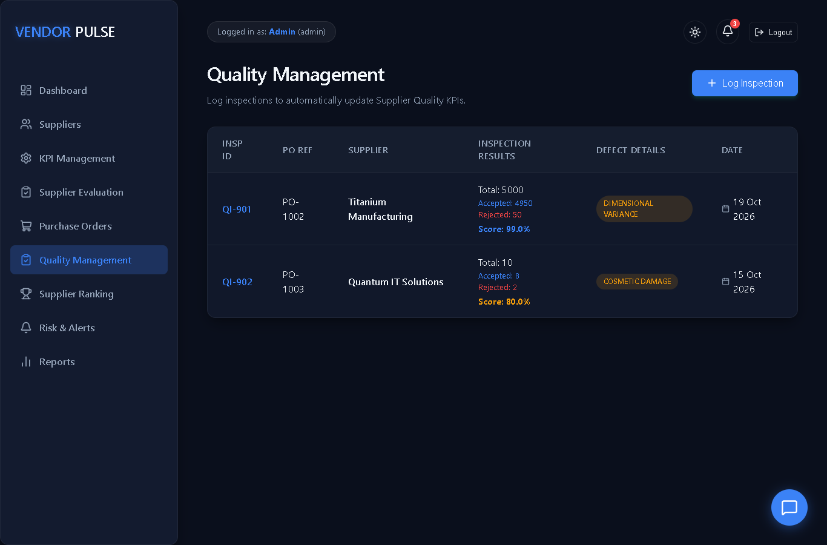
Figure A.10 Quality management and inspections
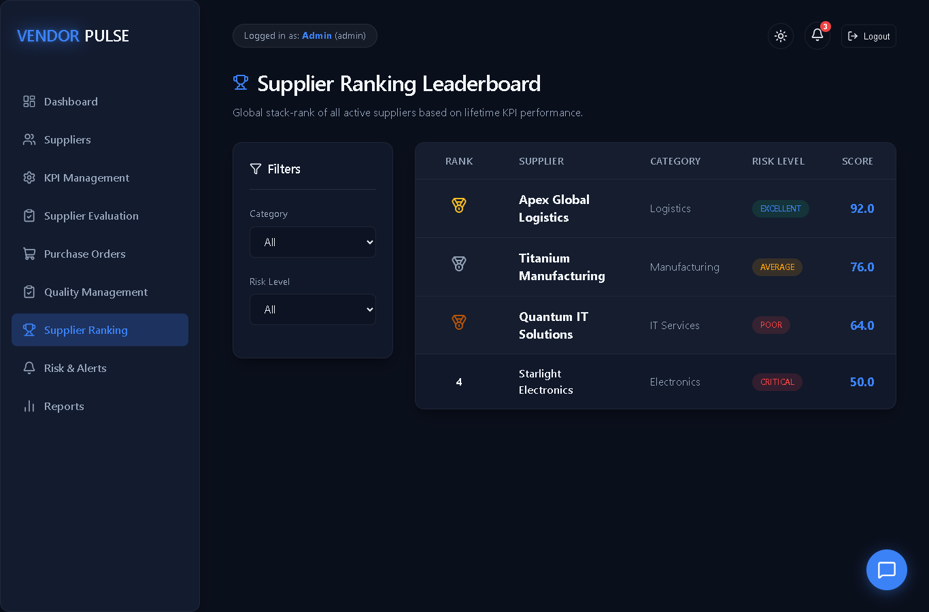
Figure A.11 Supplier ranking with category and risk filters
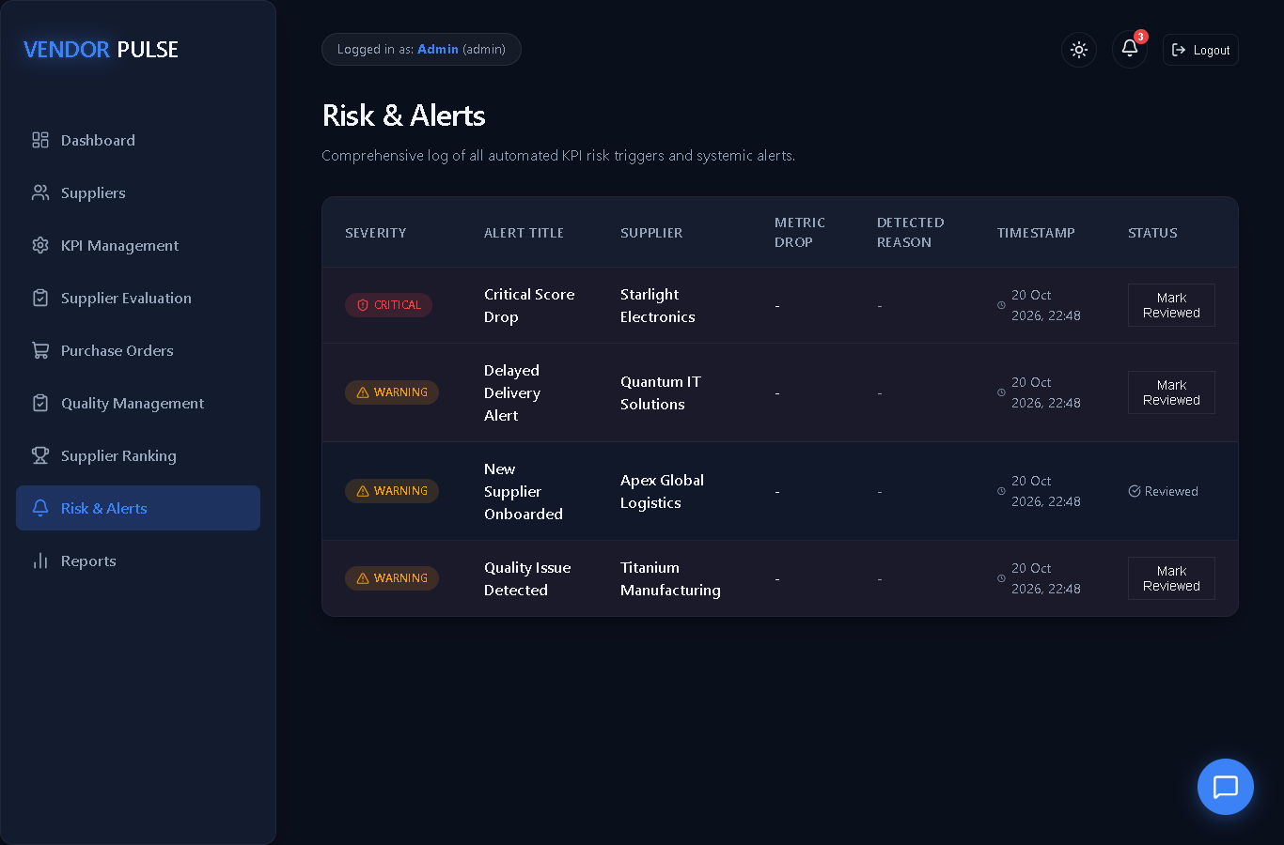
Figure A.12 Risk and alerts log
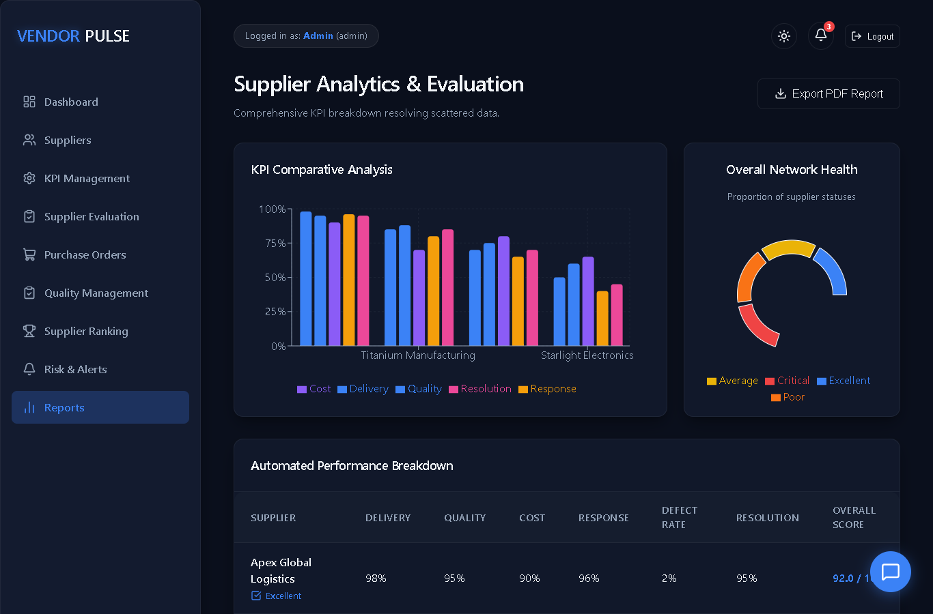
Figure A.13 Supplier analytics and evaluation report
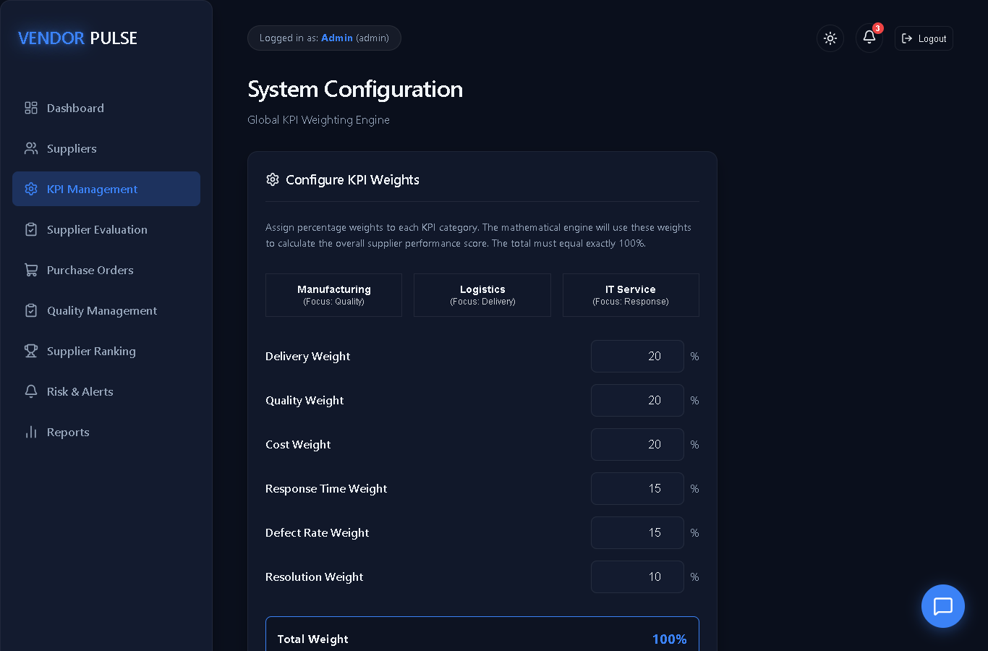
Figure A.14 KPI weight configuration (Admin)
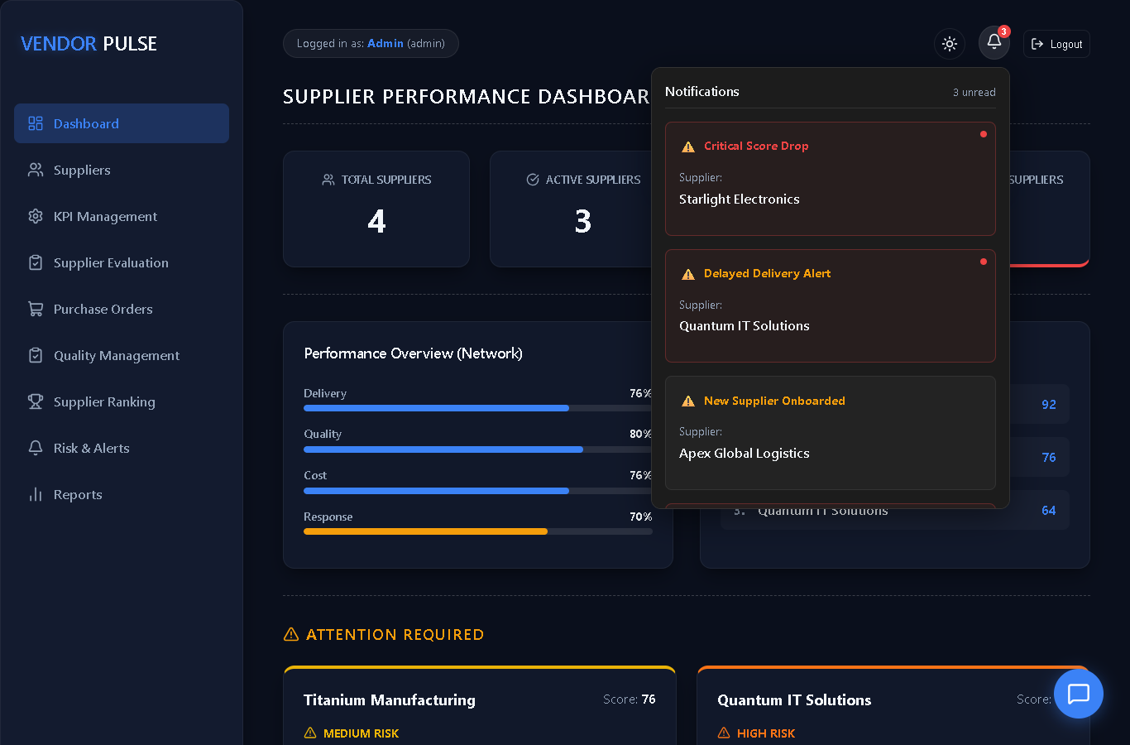
Figure A.15 Notification panel with unread alerts
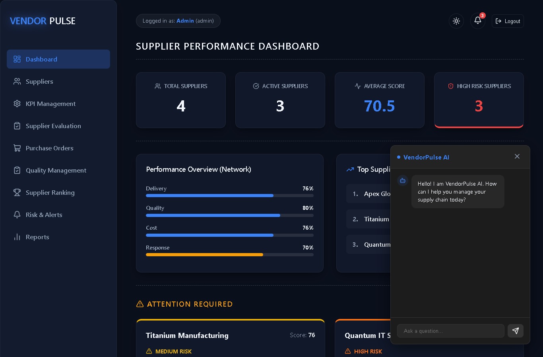
Figure A.16 VendorPulse assistant chatbot

REFERENCES
[1] React Documentation. Available online: https://react.dev/.
[2] MongoDB Manual. Available online: https://www.mongodb.com/docs/.
[3] Express – Fast, unopinionated, minimalist web framework for Node.js. Available online: https://expressjs.com/.
[4] Mongoose ODM Documentation. Available online: https://mongoosejs.com/docs/.
[5] Node.js Documentation. Available online: https://nodejs.org/en/docs.
[6] Recharts – A composable charting library built on React components. Available online: https://recharts.org/.
[7] node-cron – Task scheduler for Node.js based on cron syntax. Available online: https://github.com/node-cron/node-cron.
[8] Vite – Next generation front-end tooling. Available online: https://vite.dev/.
[9] Supply Chain Management Best Practices, Harvard Business Review. Available online: https://hbr.org/topic/supply-chain-management.
[10] Smith et al., “Evaluation of traditional ERP systems for procurement,” 2019; Johnson and Lee, “Manual KPI scorecards for vendor evaluation,” 2020; Gupta et al., “Machine-learning tools for supplier risk prediction,” 2021 (as surveyed in Table 2.1).

